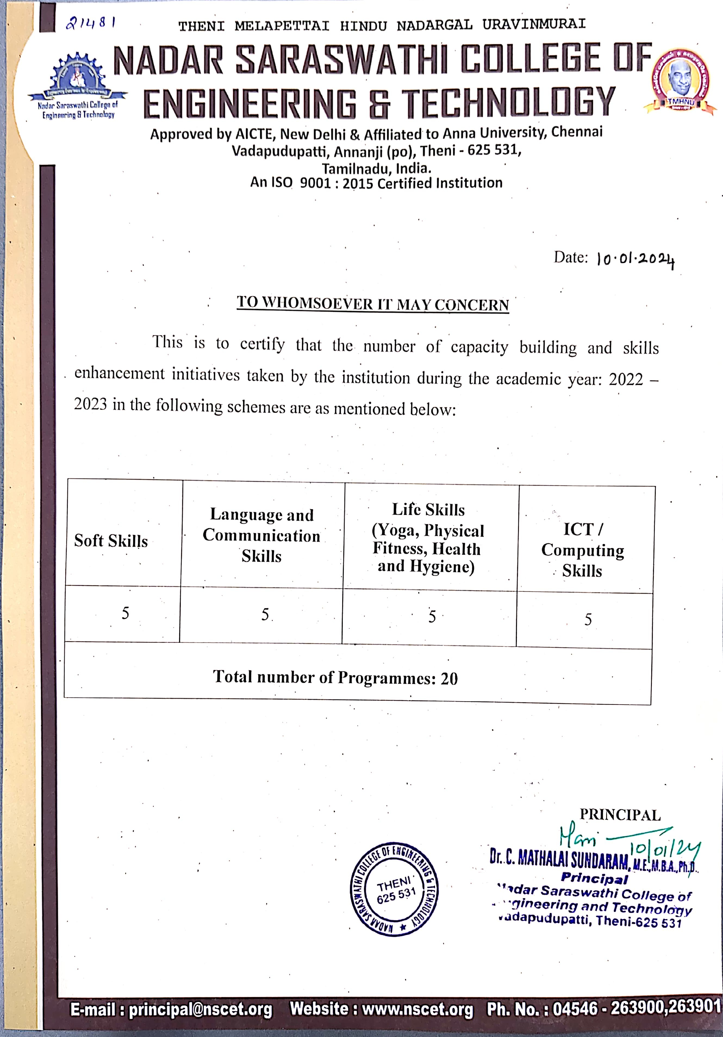



INDEX

S. No | Details | Documents | Link
1 | Soft Skills | Circular / Brochure | VIEW
2 | Language and Communication Skills | Circular / Brochure | VIEW
3 | Life Skills | Circular / Brochure | VIEW
4 | ICT/Computing Skills | Circular / Brochure | VIEW

