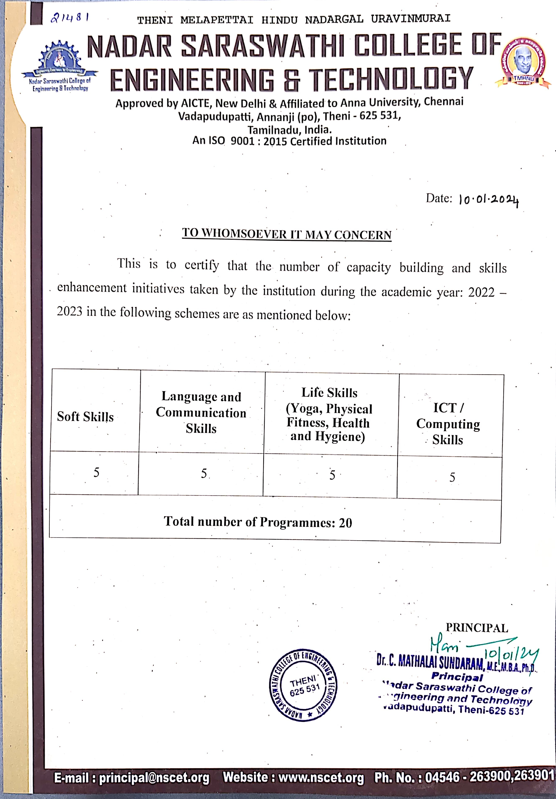



INDEX

S. No | Details | Documents | Link
1 | Soft Skills | Photographs with date and caption | VIEW
2 | Language and Communication Skills | Photographs with date and caption | VIEW
3 | Life Skills | Photographs with date and caption | VIEW
4 | ICT/Computing Skills | Photographs with date and caption | VIEW

