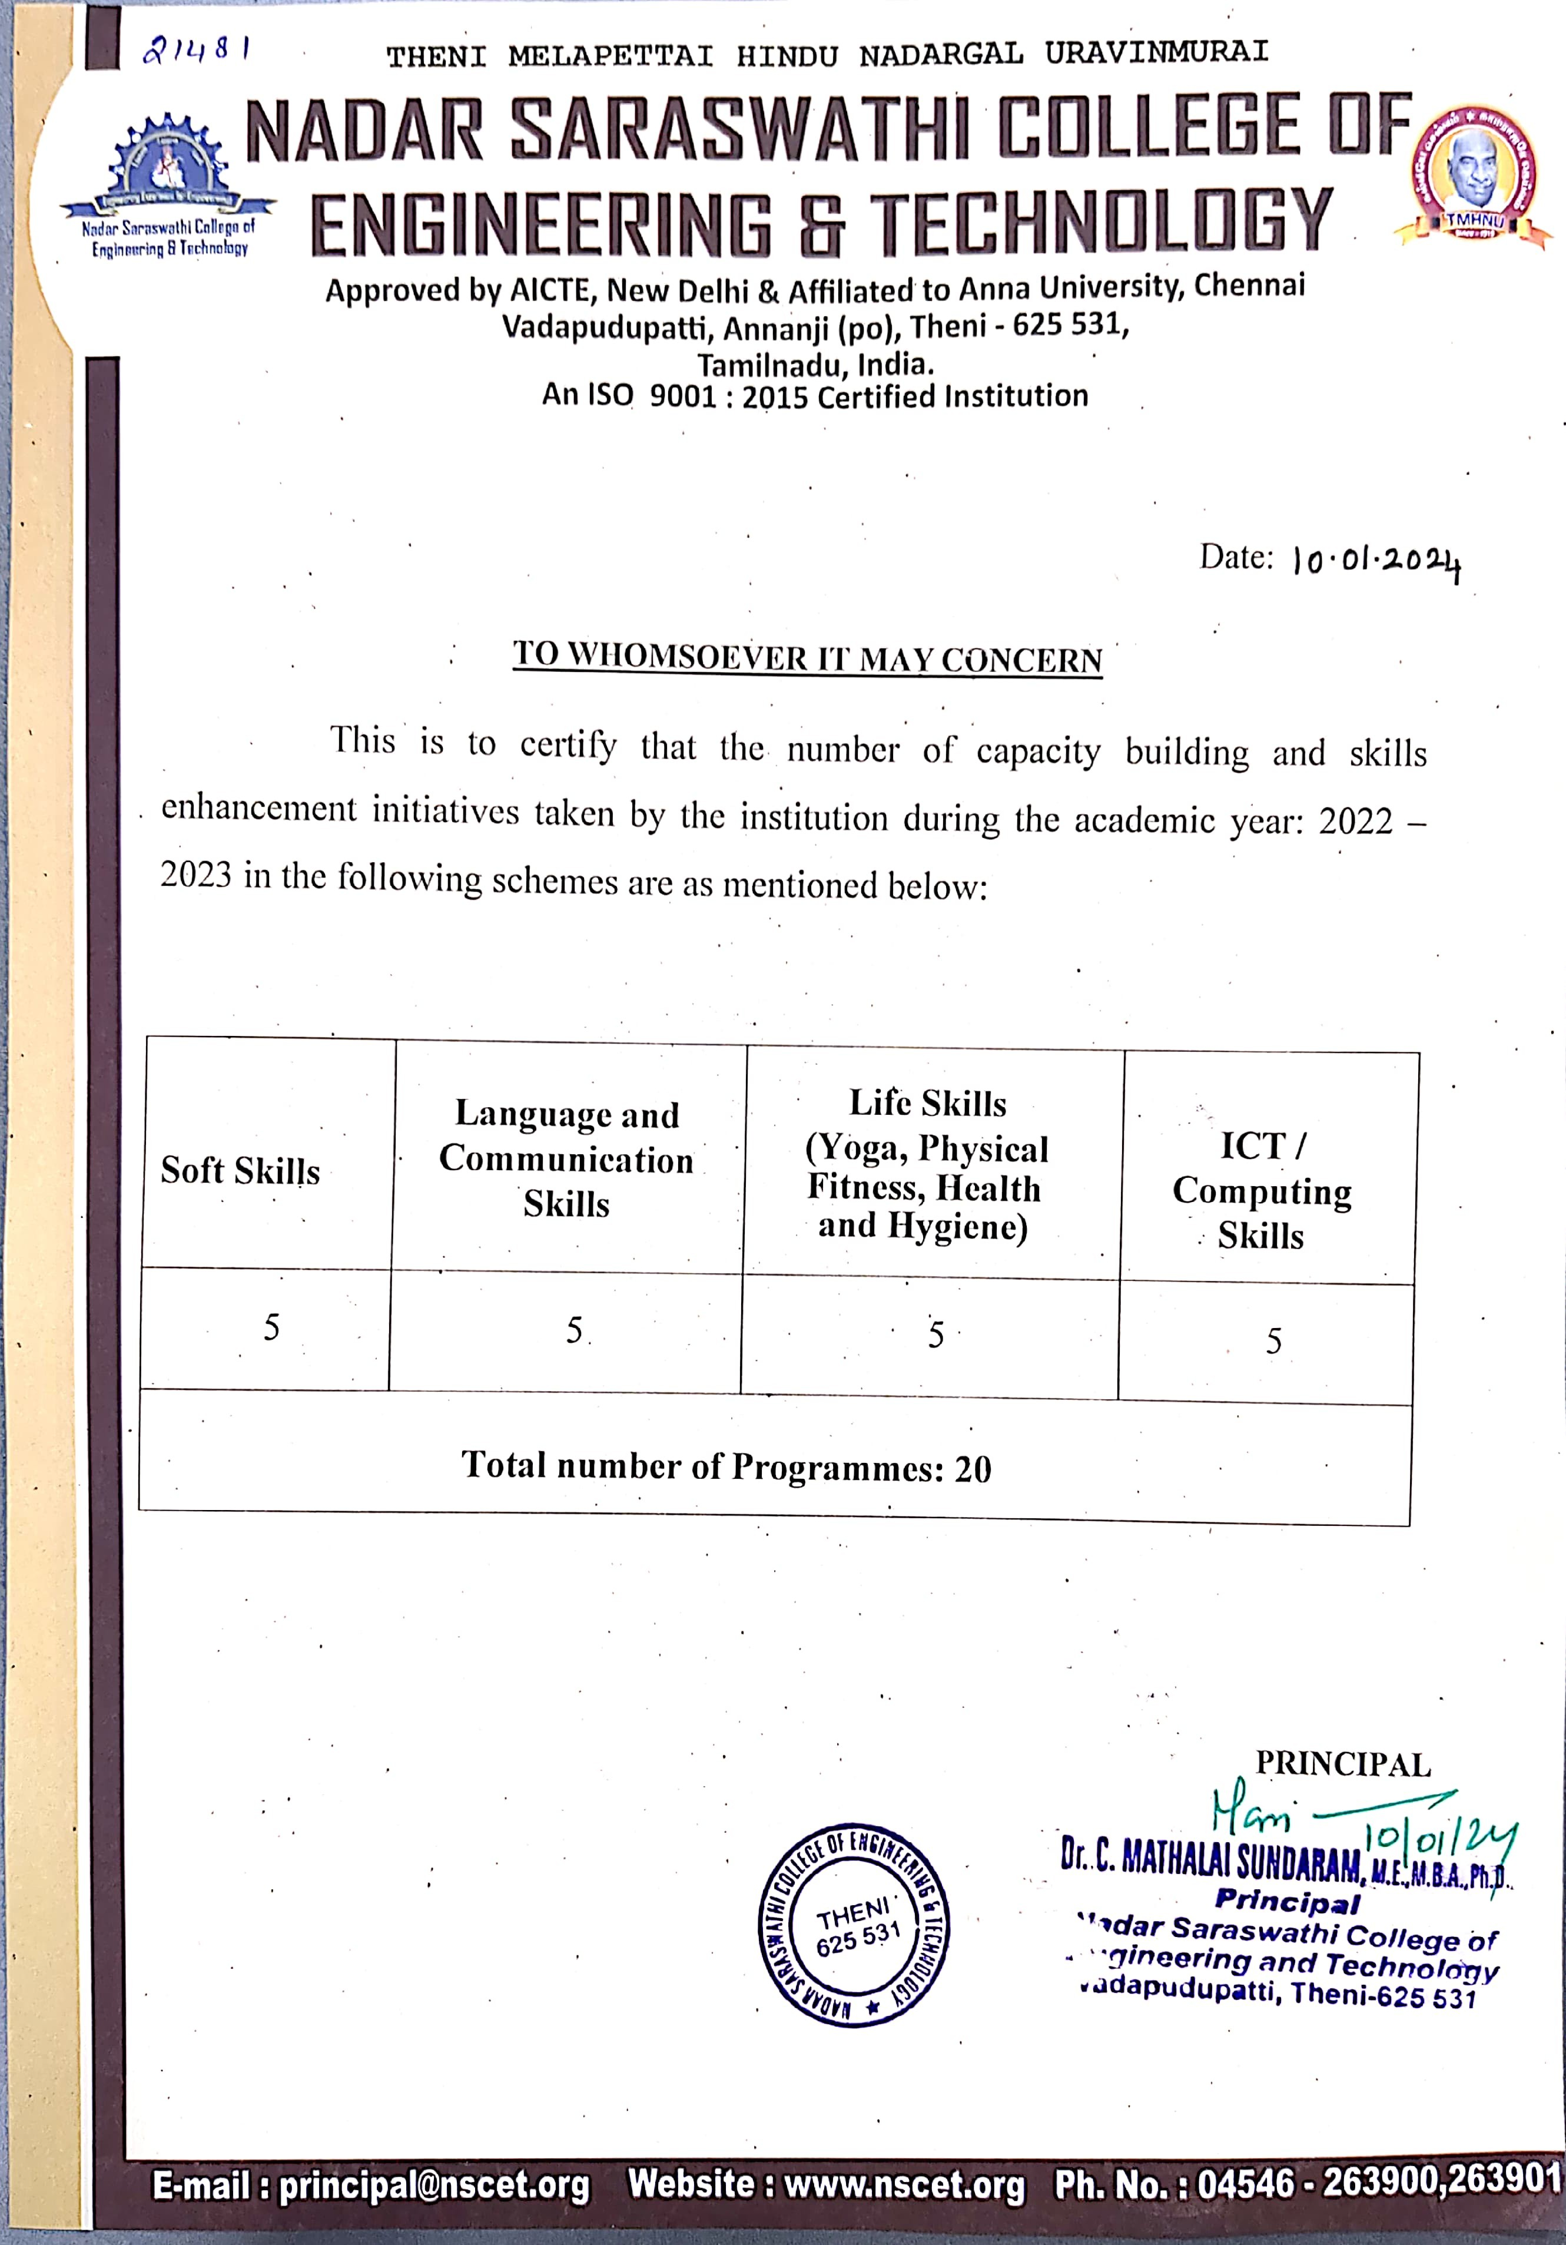



INDEX

S. No | Details | Documents | Link
1 | Soft Skills | Report of the event | VIEW
2 | Language and Communication Skills | Report of the event | VIEW
3 | Life Skills | Report of the event | VIEW
4 | ICT/Computing Skills | Report of the event | VIEW
 | Website Link |  | VIEW

