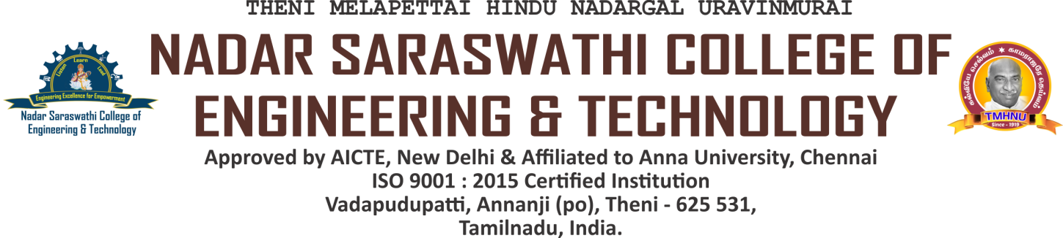

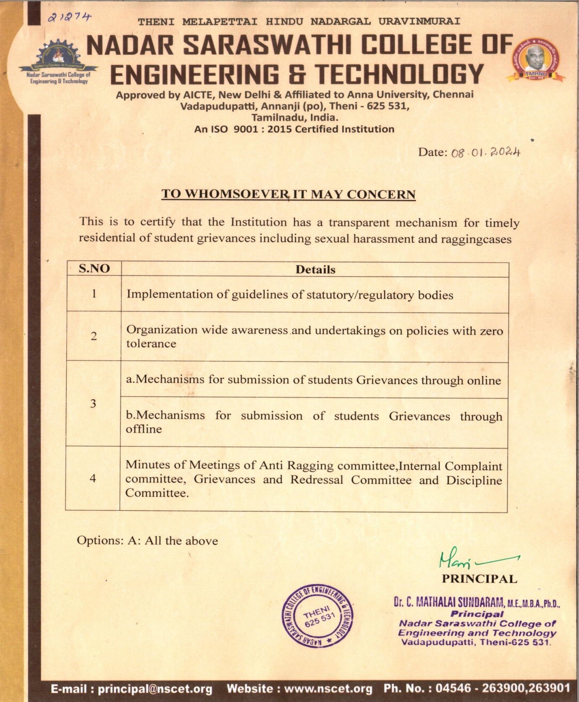



5.1.4 The Institution has a transparent mechanism for timely redressal of

student grievances including sexual harassment and ragging cases

Annual report of the committee motioning the activities and number of grievances redressed to prove timely redressal of the grievances

INDEX

| **S.NO.** | **COMMITTEE NAME** | **LINK** |
| --- | --- | --- |
| 1 | Anti-Ragging Committee and Anti-Ragging Squad | [VIEW](https://nscet.org/ssr/dvv-clarification/c5/5.1.4-DVV/Anti-ragging.pdf) |
| 2 | Students Grievances and Redressal Committee | [VIEW](https://nscet.org/ssr/dvv-clarification/c5/5.1.4-DVV/GRIVENCE.pdf) |
| 3 | Internal Complaints Committee | [VIEW](https://nscet.org/ssr/dvv-clarification/c5/5.1.4-DVV/ICC.pdf) |