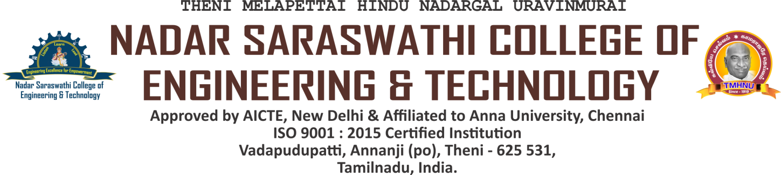

5.1.4 The Institution has a transparent mechanism for timely redressal of

student grievances including sexual harassment and ragging cases

INDEX

| **S.NO.** | **COMMITTEE NAME** | **LINK** |
| --- | --- | --- |
| 1 | Details of statutory/regulatory Committees | [VIEW](https://nscet.org/ssr/dvv-clarification/c5/5.1.4-DVV/5.1.4-B1.pdf) |
| 2 | Organisation wide awareness and undertakings on policies with zero tolerance | [VIEW](https://nscet.org/ssr/dvv-clarification/c5/5.1.4-DVV/5.1.4-B2.pdf) |