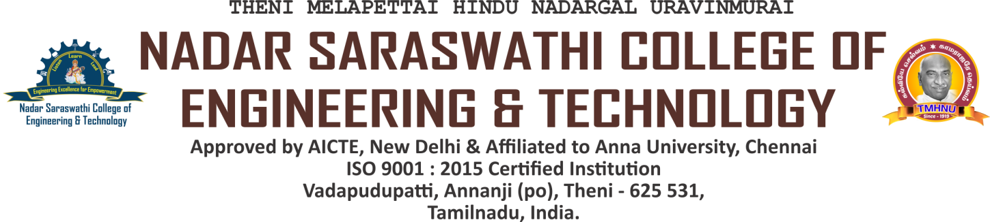

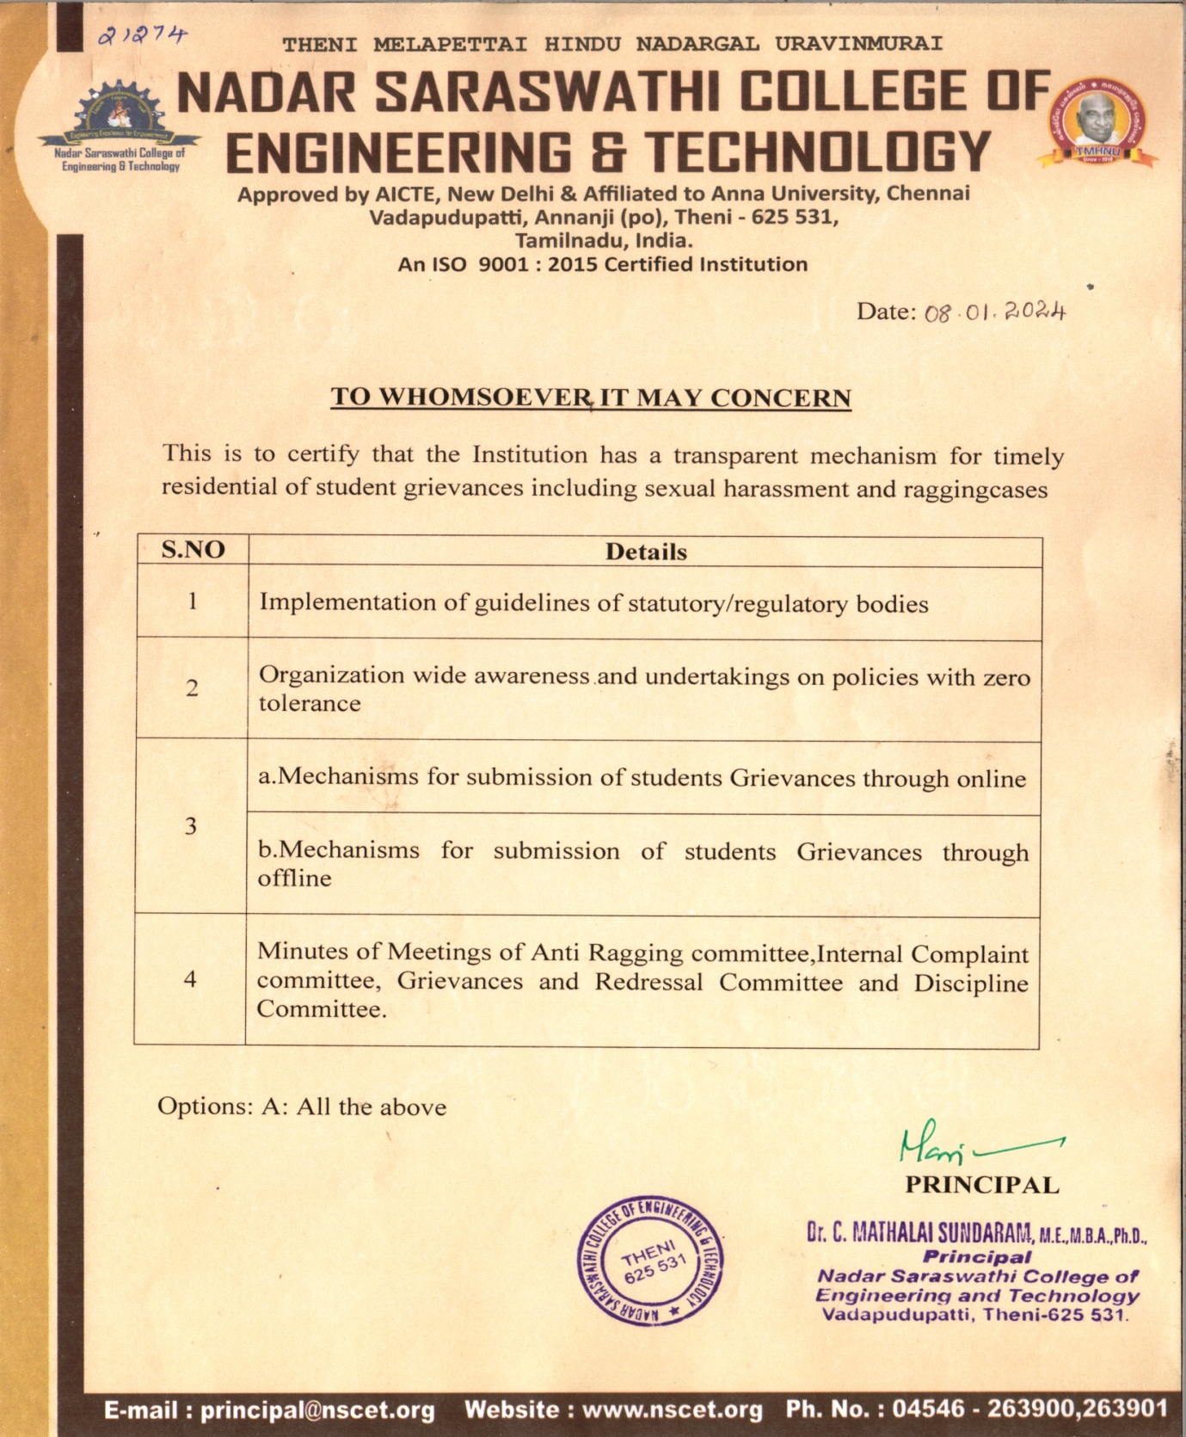



5.1.4 The Institution has a transparent mechanism for timely redressal of

student grievances including sexual harassment and ragging cases

Implementation of guidelines of statutory/regulatory bodies

INDEX

| **S.NO.** | **COMMITTEE NAME** | **LINK** |
| --- | --- | --- |
| 1 | Anti-Ragging Committee and Anti-Ragging Squad | [VIEW](https://nscet.org/ssr/dvv-clarification/c5/5.1.4-DVV/IMPLEMENTATION1.pdf) |
| 2 | Students Grievances and Redressal Committee | [VIEW](https://nscet.org/ssr/dvv-clarification/c5/5.1.4-DVV/IMPLEMENTATION2.pdf) |
| 3 | Internal Complaints Committee | [VIEW](https://nscet.org/ssr/dvv-clarification/c5/5.1.4-DVV/IMPLEMENTATION3.pdf) |
| 4 | SC/ST Committee | [VIEW](https://nscet.org/ssr/dvv-clarification/c5/5.1.4-DVV/IMPLEMENTATION4.pdf) |