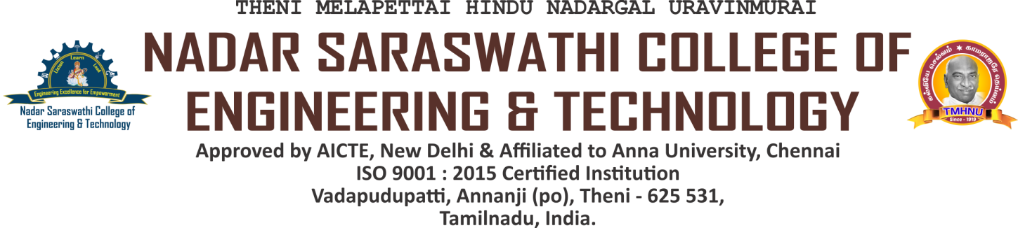

**CRITERION 5 - STUDENT SUPPORT AND PROGRESSION**

**NAAC DVV CLARIFICATION**

| **Metric** | **Particulars** |
| --- | --- |
| 5.1.4 | The Institution has a transparent mechanism for timely redressal of student grievances including sexual harassment and ragging cases  1.Implementation of guidelines of statutory/regulatory bodies  2.Organisation wide awareness and undertakings on policies with zero tolerance  3. Mechanisms for submission of online/offline students’ grievances  4. Timely redressal of the grievances through appropriate committees |

**HEI INPUT - A. All of the above**

| DVV CLARIFICATION | HEI RESPONSE |
| --- | --- |
| 1) Provide the Minutes of the meetings of student grievance committee, as per metric. | The Minutes of the meetings of student grievance committee, as per metric is provided |
| 2) Provide the Circular/web-link/ committee report justifying the objective of the metric | The Circular/web-link/ committee report justifying the objective of the metric is provided. |
| 3) Provide the Proof of constitution of Internal committees / Grievances Committee formation / other committees as per UGC | Proof of constitution of Internal committees / Grievances Committee formation / other committees as per UGC norms is provided. |

LIST OF DOCUMENTS TO BE UPLOADED

| Sl. No | Particulars of Document | Link to Relevant Documents |
| --- | --- | --- |
| 1 | Minutes of the meetings of student grievance committee | [VIEW](https://nscet.org/ssr/dvv-clarification/c5/5.1.4-DVV/5.1.4-A.pdf) |
| 2 | Circular/web-link/ committee report | [VIEW](https://nscet.org/ssr/dvv-clarification/c5/5.1.4-DVV/5.1.4-B.pdf) |
| 3 | Constitution of Internal committees / Grievances Committee formation / other committees as per UGC norms | [VIEW](https://nscet.org/ssr/dvv-clarification/c5/5.1.4-DVV/5.1.4-C.pdf) |