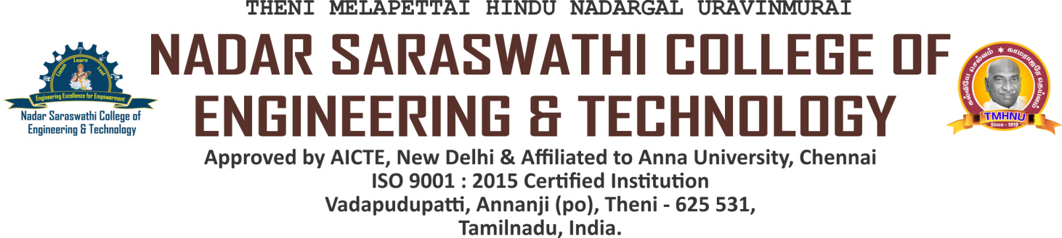

NAAC DVV CLARIFICATIONS

CRITERION 5 - STUDENT SUPPORT AND PROGRESSION

|  |  |
| --- | --- |
| **Metric No.** | **Particulars** |
| 5.2.2 | Percentage of students qualifying in State/National/ International level examinations during the last five years |

5.2.2.1. Number of students qualifying in State/ National/ International level examinations year wise during last five years (eg:IIT/JAM/NET/SLET/GATE /GMAT/GPAT/ CLAT/CAT/ GRE/TOEFL/ IELTS/Civil Services/State government examinations etc.)

HEI Input:

|  |  |  |  |  |
| --- | --- | --- | --- | --- |
| **2022-23** | **2021-22** | **2020-21** | **2019-20** | **2018-19** |
| **2** | **1** | **Nil** | **3** | **3** |

|  |  |
| --- | --- |
| **DVV Clarification** | **HEI Response** |
| Provide:   1. List of qualified students year- wise under each category | 1)List of qualified students year- wise under each category is provided |
| 2) Qualifying Certificates of the students will only be considered. | 2)Qualifying Certificates of the students will only be considered is provided |

LIST OF DOCUMENTS UPLOADED

|  |  |  |
| --- | --- | --- |
| **S. No.** | **Contents** | **Link** |
| 1. | List of qualified students year- wise under each category | [VIEW](https://nscet.org/ssr/dvv-clarification/c5/5.2.2/5.2.2%20List%20of%20qualified%20students%20year-%20wise%20under%20each%20category.pdf) |
| 2. | Qualifying Certificates of the students will only be considered. | [VIEW](https://nscet.org/ssr/dvv-clarification/c5/5.2.2/3_merged.pdf) |