# Iteration 4 Report

Group RightAfterDeadline

05/01/2020

Design Diagram:

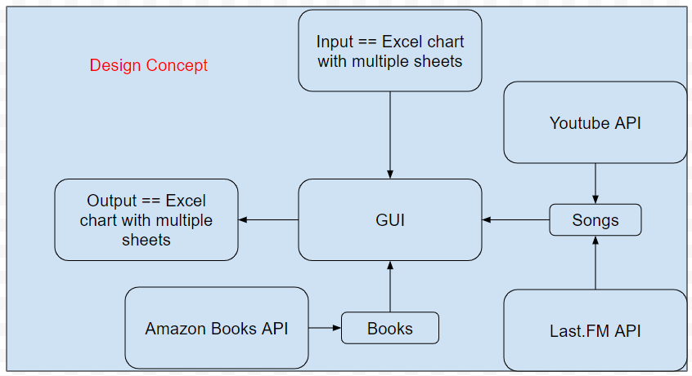

|  |  |
| --- | --- |
| Sicong Huang | SCRUM master, product owner, last.fm API |
| Aditya Atul Vijayvergia | Amazon Books API |
| Chen Liang | User Interface and File I/O |
| David Qin | YouTube API |
| Joseph Cisneros | Spotify API |
| Fengqiao Wang | Google Books API |

Pivotal Tracker: <https://www.pivotaltracker.com/n/projects/2437225>

GitHub repo: <https://github.com/Innoversa/Law-School-Copyright>

Meeting with Client: 05/04/2020

Update from last iteration:

Cannot implement Spotify API because it’s cannot find play counts of songs

Last.FM API was used to replace the Spotify API and now functional with client’s input

## Amazon Books API

Tested the Amazon books information extractor for various books. Made improvements to searching books by name on Amazon. Made the process more robust and easier to implement and more user friendly.Some bugs were found for extracting prices for some books. Check the reason and change the code accordingly to always extract the correct information.Searching books on Amazon returns books in random order sometimes which results in the most suitable book being sent lower in search. This causes program to pick different book than the one searched. Needs more testing

## User Interface and File I/O

1. Update Controller for multithread and multiprocessing support

2. Merge all other scraping functions to UI

YouTube API quota limit is troublesome and looking for solutions for different ways scraping function works makes it difficult to merge all together

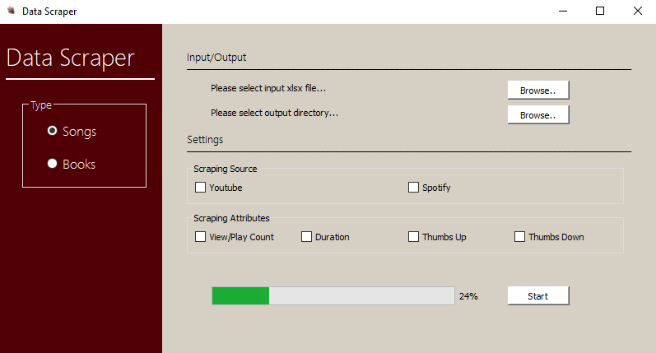

Image of the User Interface.

## YouTube API

Fixed up output of dates, which were in a less than agreeable encoding Final week now, must talk with sponsor. YT api unfortunately can't be expanded. Still silence on their end.

## Spotify API

Started trying to scrape from Spotify

Finish scraping from Spotify and verify that authentication stays valid

No technical issues, just illness and energy

## Google Book API

Researched and helped Sicong with Last.fm API. Researched on the ISBNdb books api and Amazon books api to find another possible solution for ebooks. Wrapping up the project with teammates integrate different parts. Having API errors. A lot of api errors. Can find one specific for ebooks. End up using the kindle version price on Amazon.

## Last.FM API

The process for replacing spotify with this API went smoothly. I managed to make resolve the conflicts and successfully implemented the functionality including inputting and outputting excel correctly. However, minor issues with the data source from Last.FM where occasionally they cannot find the songs the client requires (5 out of 200 samples the client gave)