Contents

Division of body part 2

Preliminary 3

Line equation 3

Bisector equation 3

Binary image from polygon’s vertices 4

Body segmentation 6

HEAD SEGMENTATION 6

ARM SEGMENTATION 7

Upper arm segmentation 7

Forearm segmentation 8

LEG SEGMENTATION 9

Thigh segmentation 9

Calf segmentation 10

# Division of body part

We divide the body into 10 parts:

* Head 1
* 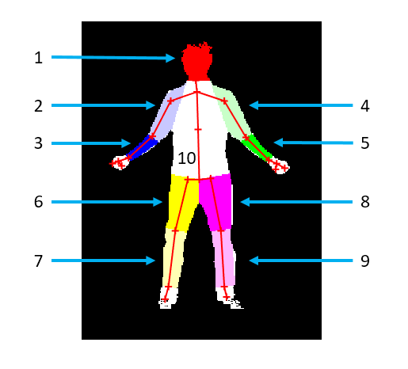Left arm
  + Upper arm 2
  + Forearm 3
* Right arm
  + Upper arm 4
  + Forearm 5
* Left leg
  + Thigh 6
  + Calf 7
* Right leg
  + Thigh 8
  + Calf 9
* Middle body 10

# Preliminary

## Line equation

*Find the line equation through two points A and B*

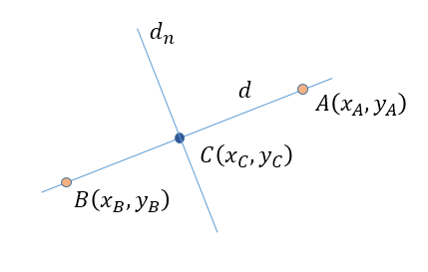

The equation of the line $d$ is

$$d:\left(y_{B}-y_{A}\right)\left(x-x_{A}\right)-\left(x_{B}-x_{A}\right)\left(y-y_{A}\right)=0$$

The equation of the line $d_{n}$ that goes through a point $C\left(x_{C},y_{C}\right)$ and perpendicular to AB

$$d_{n}:\left(x_{B}-x_{A}\right)\left(x-x_{C}\right)+\left(y_{B}-y_{A}\right)\left(y-y_{C}\right)=0$$

## Bisector equation

*Find the bisector of two vectors $\vec{AB}$ and $\vec{AC}$*

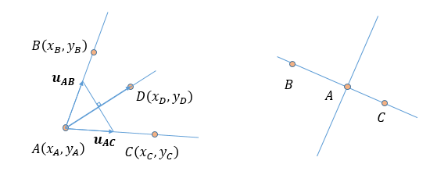

To find the bisector of $\vec{AB}$ and $\vec{AC}$:

1. Find the normalize direction vector $u_{AB}=\vec{AB}/\left|\vec{AB}\right|$ and $u_{AC}=\vec{AC}/\left|\vec{AC}\right|$
2. Take the sum of $u_{AB}$ and $u_{AC}$, $\vec{AD}=u_{AB}+u_{AC}$

Thus, $\vec{AD}$ becomes the bisectors of two vector $\vec{AB}$ and $\vec{AC}$ and

$$AD:\left(y_{C}+y_{B}-2y_{A}\right)\left(x-x_{A}\right)-\left(x_{C}+x_{B}-2x_{A}\right)\left(y-y_{A}\right)=0$$

In case of A, B, C are right on the line, the bisector $\vec{AD}$ is the perpendicular of $\vec{AB}$

## Binary image from polygon’s vertices

*Find the* ***binary image*** *from polygon vertices*

In case of **convex polygon**:

We will apply to each pixel in the image to check whether this pixel is inside the polygon or not.

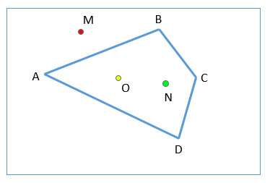

For example, there is a 4-sided polygon and the point $O\left(x_{O},y_{O}\right)$ is **inside the polygon**. We note that once $N$ is inside the polygon, both $O$ and $N$ will be in the same side with the lines AB, BC, CD, and DA. In opposite, when M is outside the polygon, the point O and M are in the different side of the line AB.

* A particular point is inside the polygon if and only if that point and point O are in the same side with all the polygon’s sides.

To determine whether the point P and point O is in the same side of a line $AB:ax+by+c=0$, we take the formula:

$$α=\left(ax_{O}+by_{O}+c\right)\left(ax_{P}+by_{P}+c\right)$$

* If $α>0$, both P and O are in the same side of AB
* If $α<0$, P and O are in the different side of AB
* If $α=0$, P is on the line AB

For this case, we will use the GPU to process each pixel at the same time.

In case of **concave polygon**:

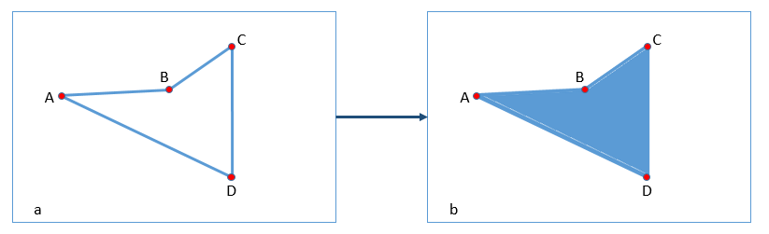

From the particular points A, B, C, and D, we will calculate the equation of each side and then create the outline as in figure a). Then we will use the hole-filling algorithm based on morphological reconstruction (Soille, P., Morphological Image Analysis: Principles and Applications, Springer-Verlag, 1999, pp. 173-174).

# Body segmentation

## HEAD SEGMENTATION

We use 5 points to create a polygon:

1. Left neck
2. Right neck
3. Upper right head
4. Upper left head

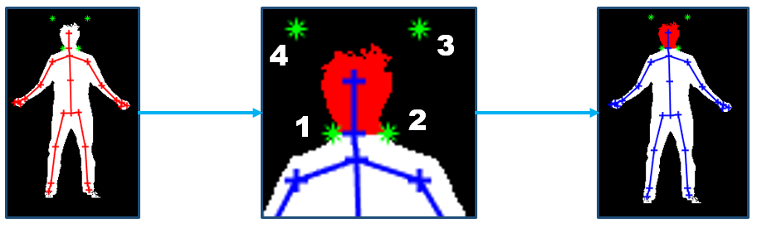

## ARM SEGMENTATION

### Upper arm segmentation

We use 5 points to create a polygon:

1. Left elbow
2. Right elbow
3. Armpit
4. Left neck
5. Left shoulder

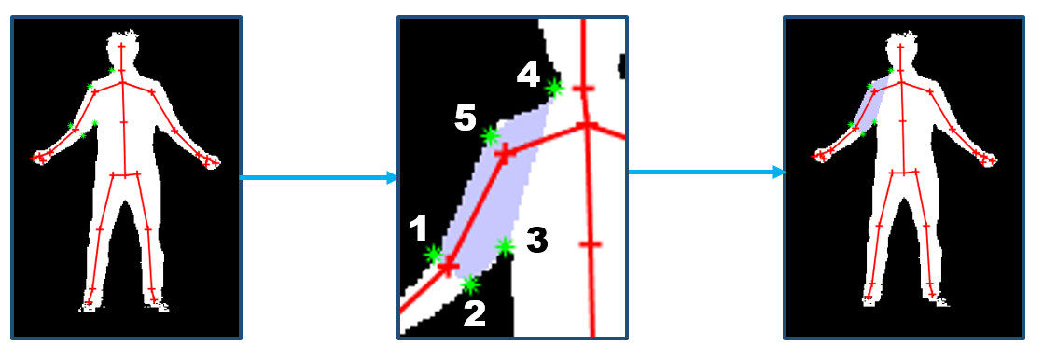

### Forearm segmentation

We use 4 points to create a polygon:

1. Left elbow
2. Right elbow
3. Right wrist
4. Left wrist

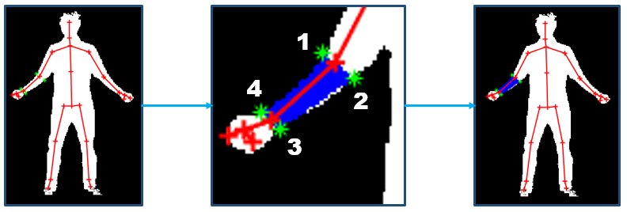

## LEG SEGMENTATION

### Thigh segmentation

We use 5 points to create a polygon:

1. Left Hip
2. Base spine
3. Peak
4. Right knee
5. Left knee

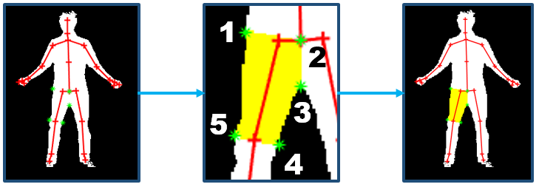

### Calf segmentation

We use 4 points to create a polygon:

1. Left knee
2. Right knee
3. Right ankle
4. Left ankle

