CHAPTER 3

SYSTEM DESIGN AND COST ANALYSIS
This chapter presents the design of LacoQR, the real-time event attendance management system described in Chapters 1 and 2. It shows how data move through the system, which processes read and write each data store, and how much the system costs to build and to operate. The chapter closes with a cost-benefit analysis that compares the recurring cost of the system with the value of the work that it replaces.

3.1 Context Flow Diagram
The context flow diagram, also called the data flow diagram at Level 0, treats the whole system as a single process. It defines the system boundary and shows only the data that enter and leave LacoQR. Everything inside the boundary is hidden from view: the web dashboard, the mobile application, the Express application programming interface, the token service, the attendance service, and the Supabase Postgres database. Everything outside the boundary is either an external entity or an external service.
The system has four external entities. Admin, Organizer, and Student are the three human roles defined in Chapter 1. The fourth is Superadmin, the highest-privilege account that owns programs, accounts, and global settings. The system also depends on three external services. Supabase Auth owns the credentials, Supabase Storage owns the student photos, and Supabase Realtime pushes attendance changes to the live dashboard. These three services are hosted by the same cloud provider, but they remain outside the system boundary because the system does not own or control them.
Figure 1 shows the context flow diagram. Table 4 lists the external entities and the data that they exchange with the system. Table 5 lists the fourteen data flows that cross the boundary.
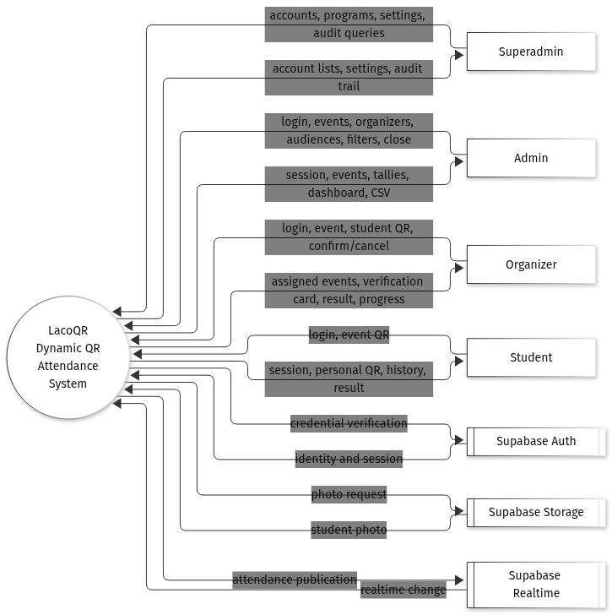
Figure 1. Context flow diagram of LacoQR.
Table 4. External entities of LacoQR.
Entity | Type | Description | Data sent to the system | Data received from the system
Superadmin | Person | Highest-privilege web user who owns accounts, programs, and global settings. | Account requests, program data, settings, audit queries. | Account lists, settings, audit trail, all reports.
Admin | Person | Event and report manager on the web dashboard. | School ID and birthdate, event details, organizer and audience assignments, report filters, close request. | Session, event list and detail, tallies, live dashboard, CSV report.
Organizer | Person | Mobile gatekeeper who checks the student photo at the entrance. | School ID and birthdate, event selection, student QR payload, confirm or cancel decision. | Assigned events, verification card, scan result, event progress.
Student | Person | Mobile attendee who owns a rotating personal QR code. | School ID and birthdate, event display QR payload, self check-in request. | Session, personal QR and expiry, attendance history, check-in result.
Supabase Auth | External service | Identity provider that stores the credentials. | Credential verification request, refresh request. | Identity, access token, refresh token, expiry.
Supabase Storage | External service | Object storage that holds the student photos. | Authenticated photo path or signed URL request. | Student photo, or a signed URL to the photo.
Supabase Realtime | External service | Pushes database changes to subscribed clients. | Publication of an inserted or updated attendance row. | Realtime attendance change event.

Table 5. Context-level data flows.
No. | Data flow | Source | Destination | Composition
C1 | Account and setting request | Superadmin | 0.0 LacoQR | Account action, program record, setting key and value, audit filter.
C2 | Administration result | 0.0 LacoQR | Superadmin | Account list, program list, settings, audit entries, all reports.
C3 | Admin request | Admin | 0.0 LacoQR | School ID and birthdate, event fields, organizer IDs, program IDs, report filters, close command.
C4 | Admin result | 0.0 LacoQR | Admin | Access token, event list and detail, tally, dashboard rows, CSV file.
C5 | Organizer request | Organizer | 0.0 LacoQR | School ID and birthdate, event ID, student QR token, confirm or cancel flag.
C6 | Organizer result | 0.0 LacoQR | Organizer | Assigned events, verification card, attendance result, progress counts.
C7 | Student request | Student | 0.0 LacoQR | School ID and birthdate, event ID, event QR token, self check-in.
C8 | Student result | 0.0 LacoQR | Student | Access token, personal QR token and expiry, attendance history, check-in result.
C9 | Credential verification | 0.0 LacoQR | Supabase Auth | Synthetic email, derived password, refresh token.
C10 | Session | Supabase Auth | 0.0 LacoQR | User ID, access token, refresh token, expiry.
C11 | Photo request | 0.0 LacoQR | Supabase Storage | Authenticated photo path or signed URL request.
C12 | Student photo | Supabase Storage | 0.0 LacoQR | Image bytes or a signed URL.
C13 | Attendance publication | 0.0 LacoQR | Supabase Realtime | Inserted or updated attendance row.
C14 | Realtime change | Supabase Realtime | 0.0 LacoQR | Attendance change event with the row payload.

3.2 Data Flow Diagram
The data flow diagram at Level 1 opens process 0.0 into seven processes and twelve data stores. The diagrams use Yourdon and DeMarco notation. A rectangle is an external entity, a circle is a process, an open-ended rectangle is a data store, and a labeled arrow is a data flow. Mermaid, the tool used to draw these figures, does not provide an open-ended rectangle, so a cylinder is used for the data store. Solid arrows carry data between an entity and a process, or between two processes. Dotted arrows carry data between a process and a data store.
Process 1.0 authenticates every user and loads the role profile. Process 2.0 manages events, organizers, and audiences. Process 3.0 issues and rotates the QR tokens. Process 4.0 validates a scan and records attendance. Process 5.0 monitors attendance while an event is running. Process 6.0 closes an event and generates reports. Process 7.0 administers accounts, programs, settings, and the audit trail.
Figure 2 shows the complete Level 1 diagram. Table 6 describes each process, Table 7 describes each data store, and Table 8 shows which process creates, reads, updates, or deletes each store.
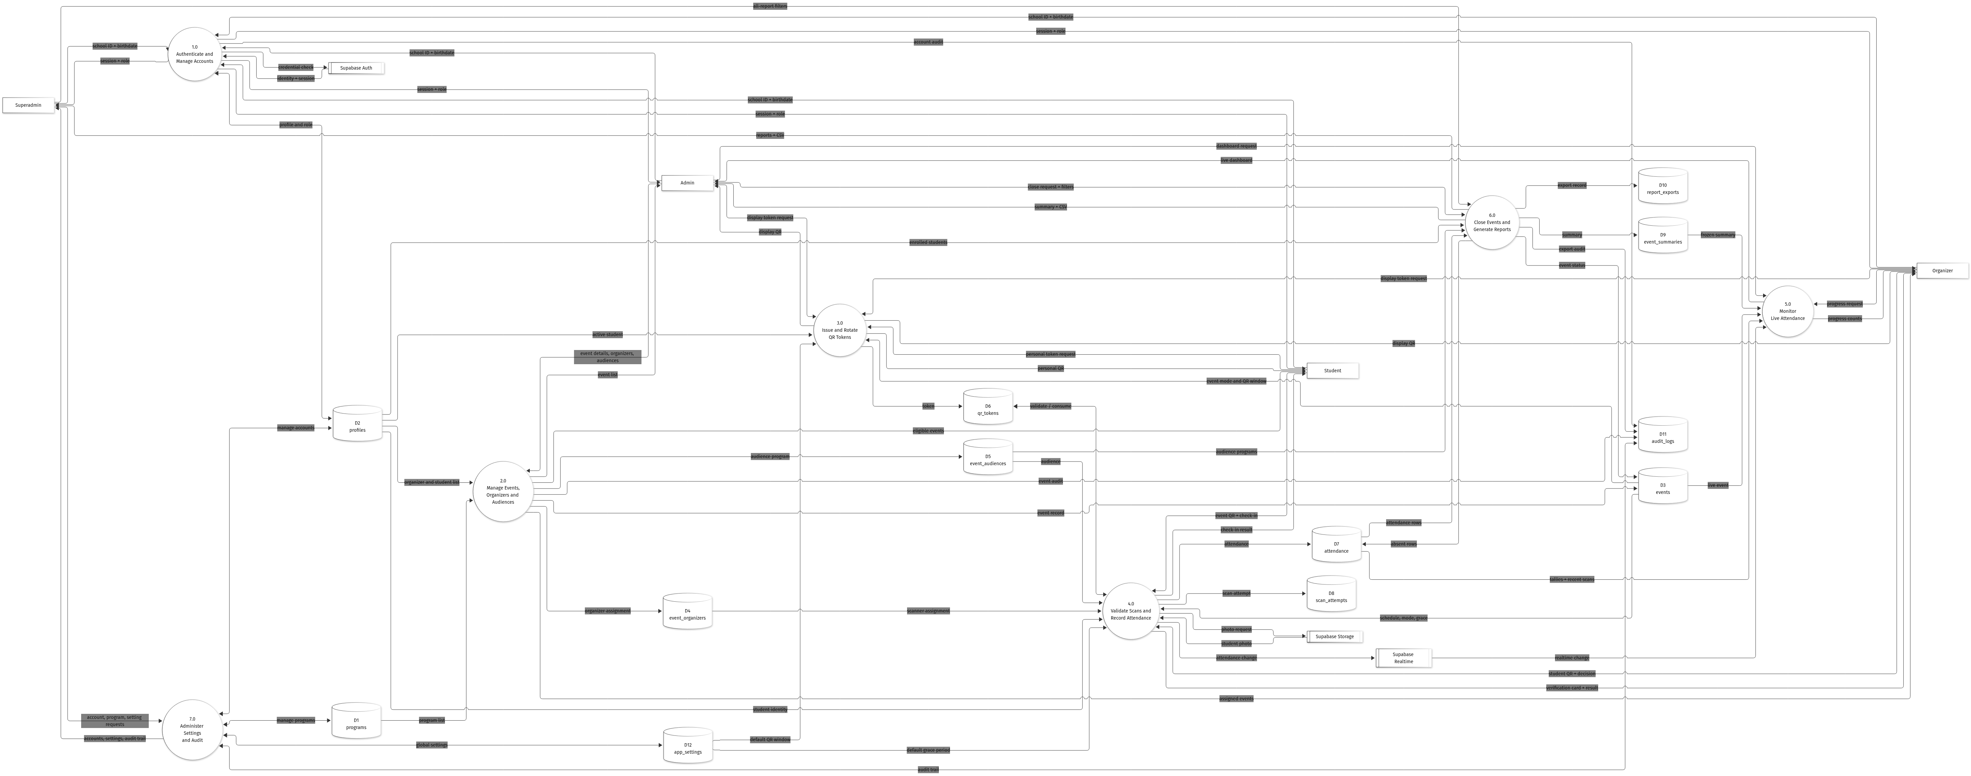
Figure 2. Data flow diagram, Level 1.
Table 6. Level 1 processes.
ID | Process | Purpose | Main inputs | Main outputs
1.0 | Authenticate and Manage Accounts | Verify the school ID and birthdate, issue a session, load the role profile, and reject inactive accounts. | School ID, birthdate, Auth session, profile row. | Access token, role profile, account audit entry.
2.0 | Manage Events, Organizers and Audiences | Create, edit, cancel, and scope events, then assign organizers and audience programs. | Event fields, organizer IDs, program IDs. | Event record, assignment records, scoped event lists.
3.0 | Issue and Rotate QR Tokens | Issue a 30-second student or event token and replace the previous token of the same subject. | Token request, subject identity, event window. | QR payload, token row, issued and expiry times.
4.0 | Validate Scans and Record Attendance | Validate the token, event, scanner, audience, and duplicate state, then save attendance. | QR payload, event ID, scanner decision. | Verification card, attendance row, scan attempt row.
5.0 | Monitor Live Attendance | Compute and display present, late, and absent counts with the most recent scans. | Live event, attendance rows, frozen summary, realtime change. | Dashboard rows, progress counts.
6.0 | Close Events and Generate Reports | Insert absent rows, freeze the summary, mark the event completed, filter records, and export. | Close request, report filters. | Summary, completed status, CSV file, export audit.
7.0 | Administer Settings and Audit | Manage accounts, programs, global defaults, and the audit trail. | Account, program, and setting requests. | Account list, settings, audit trail.

Table 7. Data stores.
ID | Data store | Contents | Written by | Read by
D1 | programs | Academic program code and name. | 7.0 | 2.0, 7.0
D2 | profiles | School ID, name, role, program, year level, photo, active flag. | 1.0, 7.0 | 1.0 to 7.0
D3 | events | Name, venue, date, time, grace period, scan mode, status, QR window. | 2.0, 6.0 | 2.0 to 6.0
D4 | event_organizers | Event-to-organizer assignment. | 2.0 | 2.0, 4.0
D5 | event_audiences | Event-to-program audience. | 2.0 | 4.0, 5.0, 6.0
D6 | qr_tokens | Subject type, subject ID, token hash, issue, expiry, and consumption time. | 3.0, 4.0 | 3.0, 4.0
D7 | attendance | One row per student per event: status, method, time, scanner, token. | 4.0, 6.0 | 4.0, 5.0, 6.0
D8 | scan_attempts | Every accepted, cancelled, or rejected scan with its reason. | 4.0 | 7.0
D9 | event_summaries | Frozen enrolled, present, late, and absent counts with the attendance rate. | 6.0 | 5.0, 6.0
D10 | report_exports | Export format, filters, file reference, exporter, and timestamp. | 6.0 | 7.0
D11 | audit_logs | Actor, action, entity, details, and timestamp. | 1.0, 2.0, 6.0, 7.0 | 7.0
D12 | app_settings | Global defaults such as the QR window and the grace period. | 7.0 | 3.0, 4.0, 7.0

Table 8. Process-to-store matrix. C = create, R = read, U = update, D = delete, listed in that order.
Process | D1 | D2 | D3 | D4 | D5 | D6 | D7 | D8 | D9 | D10 | D11 | D12
1.0 | — | RU | — | — | — | — | — | — | — | — | C | —
2.0 | R | R | CRUD | CRUD | CRUD | — | — | — | — | — | C | R
3.0 | — | R | R | — | — | CRUD | — | — | — | — | — | R
4.0 | — | R | R | R | R | RU | CR | C | — | — | — | R
5.0 | — | — | R | — | — | — | R | — | R | — | — | —
6.0 | — | R | RU | — | R | — | CRU | — | CRU | C | C | —
7.0 | CRUD | CRU | — | — | — | — | — | R | — | R | CR | CRUD

Because the complete diagram is dense, the same flows are also presented per external entity. Figures 3 to 6 show only the processes and the data stores that a single actor touches. These views are easier to follow during the presentation, and they contain no data flow that is missing from Figure 2.
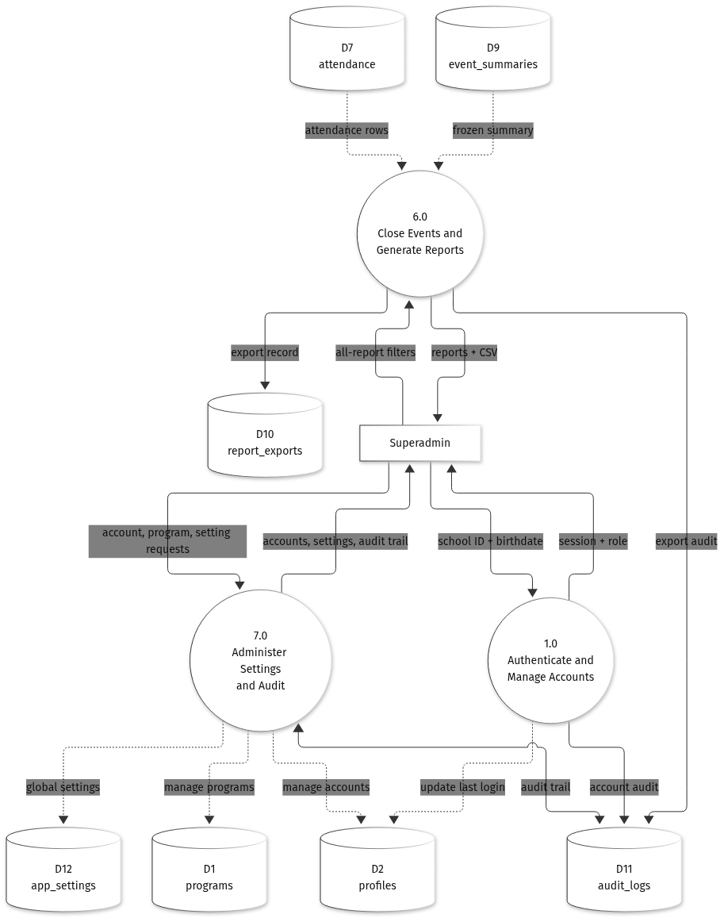
Figure 3. Data flows for the Superadmin.
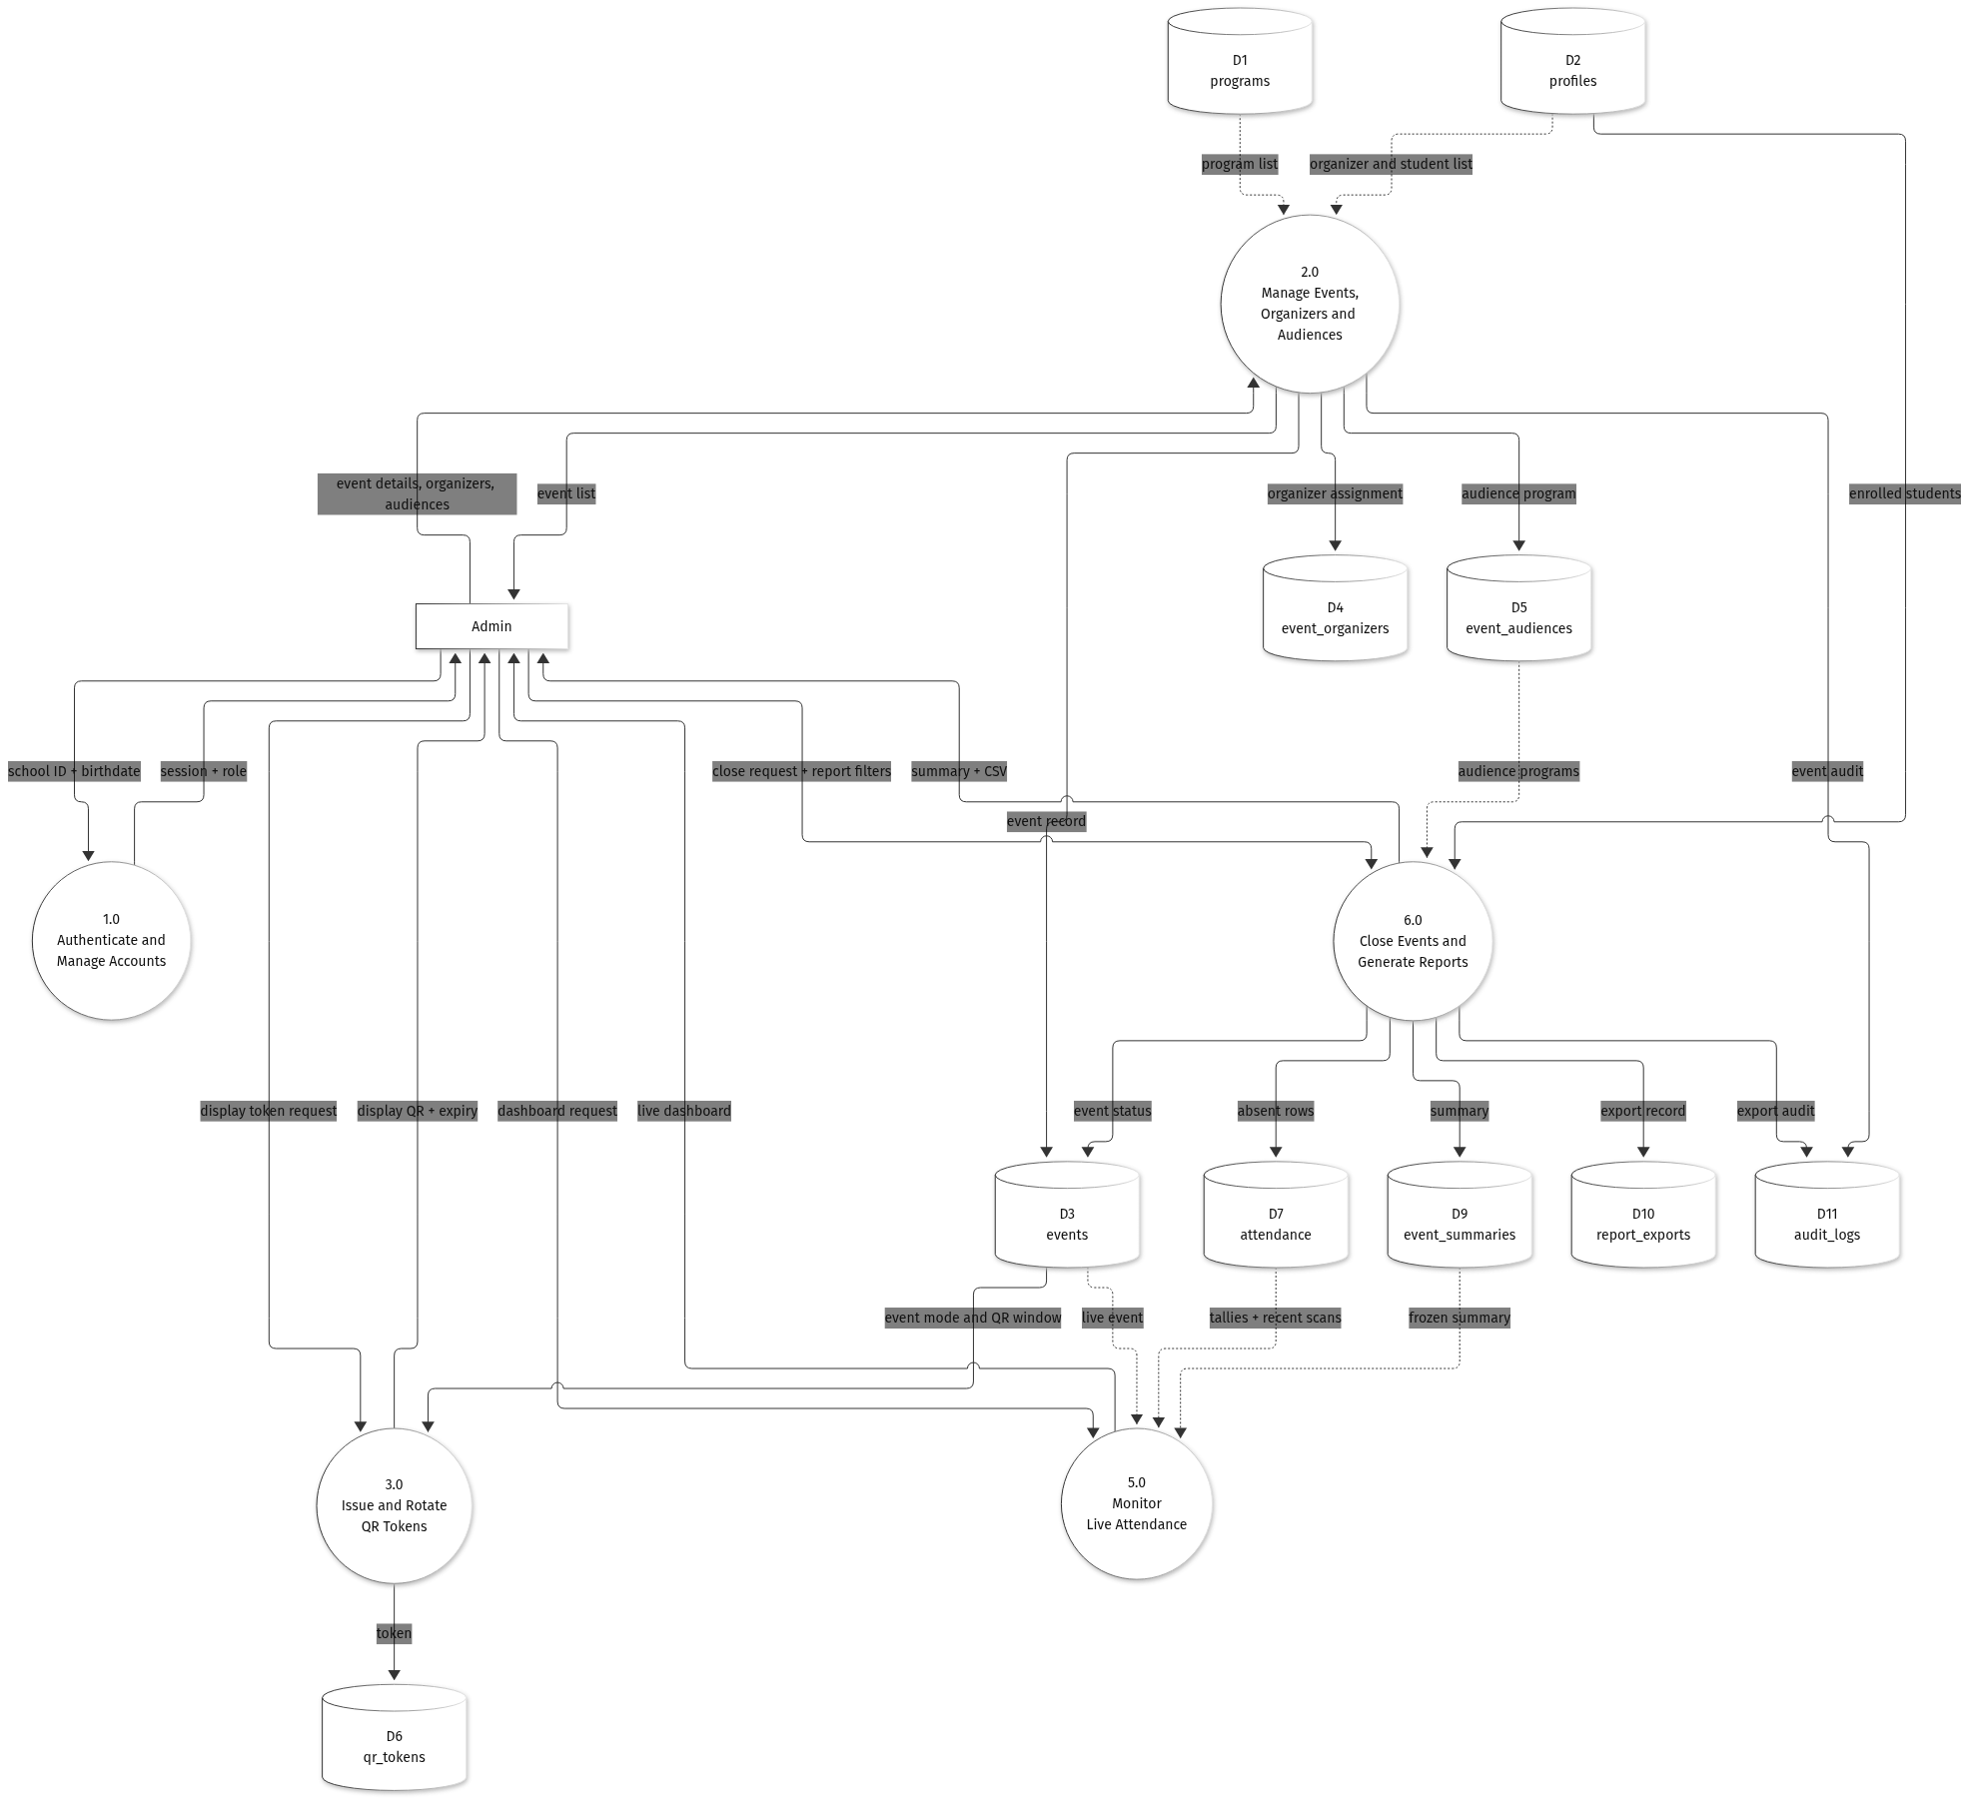
Figure 4. Data flows for the Admin.
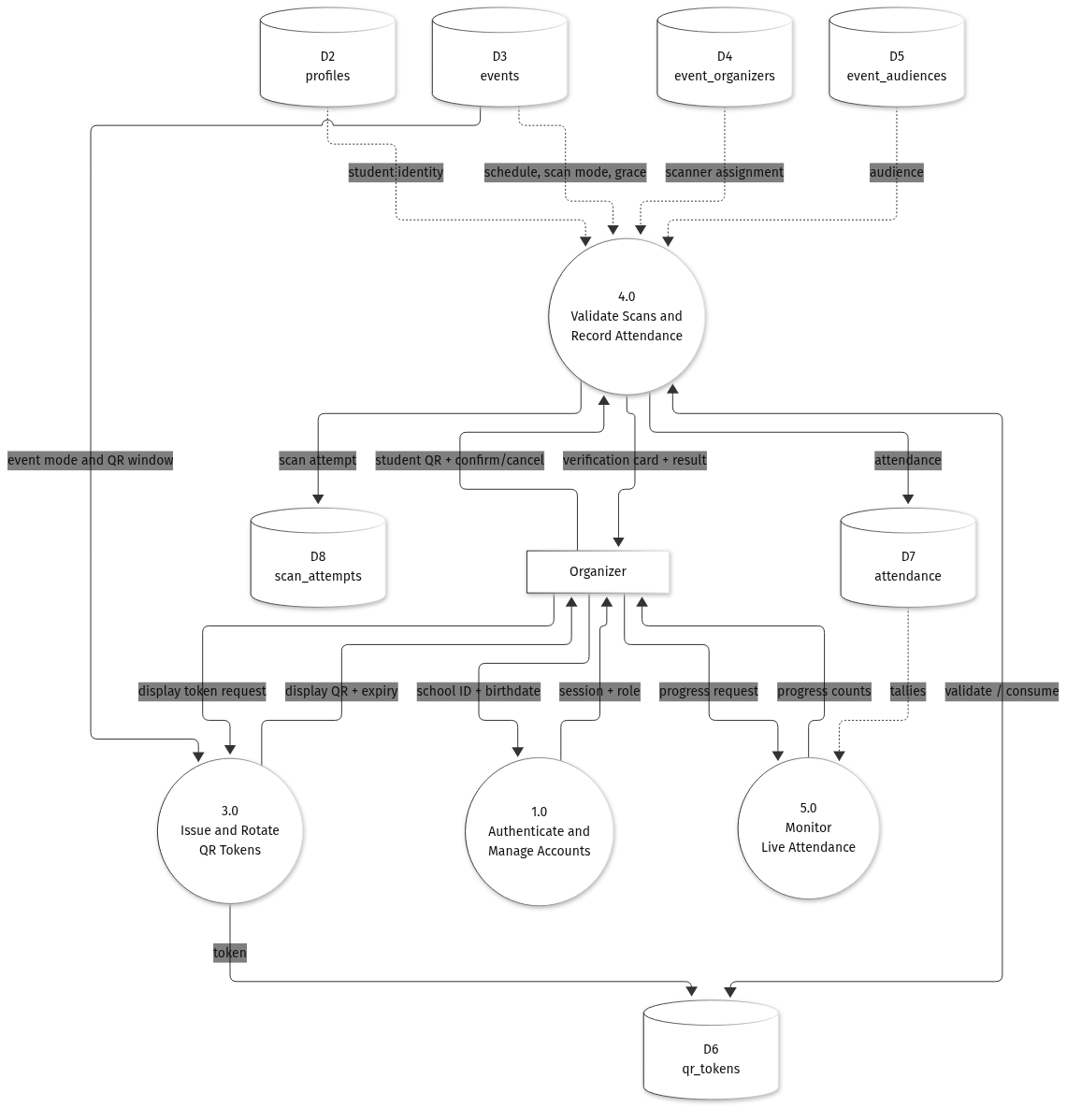
Figure 5. Data flows for the Organizer.
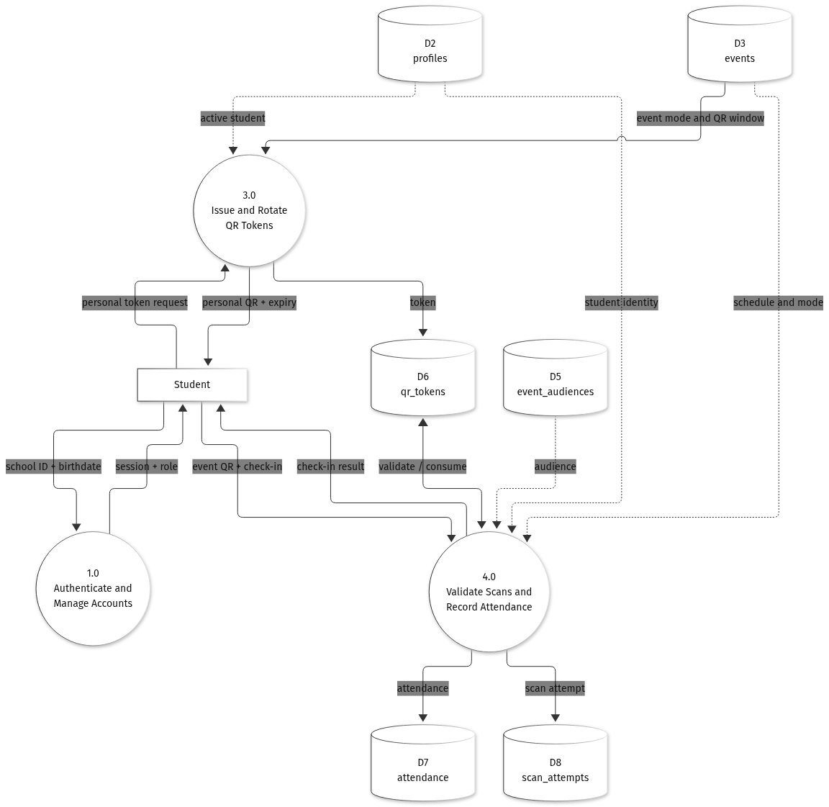
Figure 6. Data flows for the Student.

3.3 Development Cost
The developmental cost is the one-time cost of building the system. Two figures are reported. The first is the actual out-of-pocket cost of the student team, which uses existing hardware and free cloud tiers. The second is the commercial replacement value, which is what an institution would pay a four-person team to build the same scope over four months. All amounts are in Philippine pesos and are based on prices gathered in November 2026.
Table 9. Developmental cost, thesis and out-of-pocket scenario.
Item | Quantity | Unit cost (PHP) | Amount (PHP)
Domain name (.com, one year) | 1 | 700.00 | 700.00
Internet share (four months) | 4 | 1,500.00 | 6,000.00
Printing, binding, and defense copies | 1 | 5,000.00 | 5,000.00
Test consumables (QR printouts, labels, lanyards) | 1 | 1,500.00 | 1,500.00
Cloud hosting during development | 4 | 0.00 | 0.00
Hardware (existing laptops and phones) | 1 | 0.00 | 0.00
Subtotal |  |  | 13,200.00
Contingency (10 percent) |  |  | 1,320.00
Total developmental cost |  |  | 14,520.00

The team spends 14,520.00 pesos in cash. The 1,280 person-hours of the four members are not paid in this scenario. If those hours were billed at the commercial rates below, the labor value alone would be 444,000.00 pesos.
Table 10. Developmental cost, commercial replacement-value scenario.
Cost group | Amount (PHP) | Share of subtotal
Personnel (four roles, four months) | 444,000.00 | 75.5%
Hardware (two laptops, one phone, one tablet) | 108,000.00 | 18.4%
Software, tools, and cloud during development | 15,740.00 | 2.7%
Other project costs (internet, documentation, training) | 20,000.00 | 3.4%
Subtotal | 587,740.00 | 100.0%
Contingency (10 percent of subtotal) | 58,774.00 | —
Total developmental cost | 646,514.00 | —

The gap between the two figures is labor and hardware, not software. The system is built almost entirely on free and open-source tools, so the commercial total reflects the market value of the hours and the equipment rather than the cost of licenses.

3.4 Operating Cost
The operating cost is the recurring cost of running the system after launch. It covers hosting, the domain name, maintenance, monitoring, and consumables. It does not include the developmental cost. Two scenarios are again reported: a free-tier setup for the thesis pilot or a small campus deployment, and a production setup with paid hosting, backups, and part-time professional maintenance.
Table 11. Operating cost, free-tier scenario.
Item | Monthly (PHP) | Annual (PHP) | Basis
Domain name (amortized) | 58.33 | 699.96 | 700.00 pesos per year.
Internet share | 1,500.00 | 18,000.00 | Shared campus or home connection.
Maintenance (student) | 600.00 | 7,200.00 | 4 hours per month at 150.00 pesos per hour.
Consumables and printing | 100.00 | 1,200.00 | Backup QR sheets and labels.
Cloud services | 0.00 | 0.00 | Supabase Free, GitHub Free, Expo Free, free static hosting.
Subtotal | 2,258.33 | 27,099.96
Contingency (10 percent) | 225.83 | 2,709.96
Total | 2,484.16 | 29,809.92

Table 12. Operating cost, production scenario.
Item | Monthly (PHP) | Annual (PHP) | Basis
Supabase Pro | 1,450.00 | 17,400.00 | Managed Postgres, Auth, Storage, Realtime, daily backups.
API hosting (Starter) | 410.00 | 4,920.00 | Always-on instance for the Express API.
Domain name (amortized) | 58.33 | 699.96 | 700.00 pesos per year.
Expo EAS Starter | 1,120.00 | 13,440.00 | Mobile build and update service.
Monitoring and backups | 600.00 | 7,200.00 | Uptime monitoring, error tracking, off-site copy.
Maintenance (professional) | 4,000.00 | 48,000.00 | 8 hours per month at 500.00 pesos per hour.
Internet and office share | 1,500.00 | 18,000.00 | Campus connection share.
Consumables | 100.00 | 1,200.00 | Printed fallback materials.
Subtotal | 9,238.33 | 110,859.96
Contingency (10 percent) | 923.83 | 11,085.96
Total | 10,162.16 | 121,945.92

Maintenance labor is the largest recurring item at 39.4 percent of the production budget, followed by the internet share at 14.8 percent and Supabase Pro at 14.3 percent. If the information technology office of the institution absorbs maintenance and the internet connection, the cash operating cost of the production setup falls to about 6,162.16 pesos per month.

3.5 Cost Benefit Analysis
The cost-benefit analysis compares the recurring cost of the system with the value of the work that it replaces. The base case is 1,000 students and 20 events per year, or 20,000 check-ins. Two activities are replaced: the manual check-in line and the encoding of the attendance records.
Manual check-in takes about fifteen seconds per student, or 4.17 hours for 1,000 students. Encoding and verifying the records takes about thirty seconds per record, or 8.33 hours. The manual process therefore consumes about 12.5 hours per event. With LacoQR a scan takes about three seconds, or 0.83 hour per event, and encoding is eliminated. The system therefore saves about 11.67 hours per event, or 233.33 hours per year. At 150.00 pesos per hour the saved labor is worth 35,000.00 pesos per year.
The system also removes the printing of attendance sheets. At 1,000 sheets per event and 0.50 peso per sheet, twenty events consume 20,000 sheets and 10,000.00 pesos of paper per year. The total quantifiable benefit is therefore 45,000.00 pesos per year, or 2.25 pesos per check-in.
Table 13. Quantified annual benefit at the base case.
Benefit | Basis | Annual value (PHP)
Labor saved on check-in and encoding | 233.33 hours at 150.00 pesos per hour | 35,000.00
Printing and forms avoided | 20,000 sheets at 0.50 peso per sheet | 10,000.00
Total quantifiable benefit |  | 45,000.00

Table 14 compares this benefit with the two operating scenarios. In the free-tier setup the system returns a net benefit of 15,190.08 pesos per year, a benefit-cost ratio of 1.51, and it recovers its 14,520.00-peso development cost in about 0.96 year, or roughly eleven and a half months. In the production setup the annual cost of 121,945.92 pesos is larger than the benefit at the base case, so the ratio is 0.37 and the net benefit is negative. The production setup is therefore justified only when the volume is larger, or when the institution absorbs hosting and maintenance as part of its existing information technology budget.
Table 14. Cost-benefit summary at the base case.
Item | Free-tier setup | Production setup
Annual benefit | 45,000.00 | 45,000.00
Annual operating cost | 29,809.92 | 121,945.92
Net annual benefit | 15,190.08 | (76,945.92)
Benefit-cost ratio | 1.51 | 0.37
Return on operating cost | 50.96% | (63.10%)
Development cost | 14,520.00 | 646,514.00
Payback period on development | 0.96 year | Not recovered at this volume
Three-year net (benefit less development and operating cost) | 31,050.24 | (877,351.76)

Table 15 shows how the net benefit changes with the number of check-ins. The free-tier setup breaks even at about 13,249 check-ins per year, or 13.2 events. The production setup breaks even at about 54,199 check-ins, or 54.2 events, which is close to three events per week for a full academic year. Below those volumes the free-tier setup should be used.
Table 15. Net annual benefit by check-in volume.
Check-ins per year | Equivalent events | Annual benefit (PHP) | Net, free tier (PHP) | Net, production (PHP)
10,000 | 10 | 22,500.00 | (7,309.92) | (99,445.92)
20,000 | 20 | 45,000.00 | 15,190.08 | (76,945.92)
40,000 | 40 | 90,000.00 | 60,190.08 | (31,945.92)
60,000 | 60 | 135,000.00 | 105,190.08 | 13,054.08
80,000 | 80 | 180,000.00 | 150,190.08 | 58,054.08

The analysis covers only the benefits that can be measured in pesos. The system also produces benefits that are harder to quantify. It reduces proxy attendance because a screenshot of the token expires after thirty seconds and because the organizer checks the student photo before confirming. It reduces disputes because every accepted or rejected scan is recorded with its reason. It gives administrators a live view of an event instead of a report that arrives days later. It removes the paper forms, which also removes the storage and the manual filing that come with them. These benefits support the decision even when the peso figures are close to the break-even point.
Taken together, the cost of the system is modest compared with the attendance work that it replaces. The free-tier setup is affordable for a single campus and returns its cost within the first year of operation. The production setup is a larger commitment, and the analysis shows the event volume that it needs before the institution should consider it.

