REAL-TIME EVENT ATTENDANCE MANAGEMENT SYSTEM USING DUAL DYNAMIC QR CODES WITH HUMAN-IN-THE-LOOP VISUAL VERIFICATION

A Thesis Proposal Presented to the Faculty of the
School of Business & Information Technology
La Consolacion College Bacolod
In Partial Fulfillment of the Requirements for the Degree
Bachelor of Science in Information Technology

By
Ino Garcia
Matthew Geriane

Adviser: Mrs. Bethel Tisuela, MSCS
October 2026

TABLE OF CONTENTS
CHAPTER 1: INTRODUCTION 3
Statement of the Problem 3
Statement of the Objectives 5
Scope and Limitations of the Study 5
Significance of the Study 6
Definition of Terms 7
CHAPTER 2: REVIEW OF RELATED LITERATURE AND STUDIES 9
Foreign Related Literature 9
Local Related Literature 9
Synthesis of Related Literature 10
Foreign Related Studies 10
Local Related Studies 11
Synthesis of Related Studies 12
REFERENCES 14
CHAPTER 3: SYSTEM DESIGN AND COST ANALYSIS 16
3.1 Context Flow Diagram 16
3.2 Data Flow Diagram 18
3.3 Development Cost 24
3.4 Operating Cost 25
3.5 Cost Benefit Analysis 26

CHAPTER 1: INTRODUCTION
School events are part of student life. Seminars, orientations, masses, fund-raising activities, and student organization programs help students learn beyond the classroom. Attendance is often required in these events. It is used to monitor participation, check compliance, and prepare reports for advisers and administrators. When attendance is not recorded properly, students may be marked absent even if they attended, and organizers may find it hard to explain the results.
At La Consolacion College Bacolod, many events still use paper attendance sheets or printed QR codes. Paper sheets are slow to sign, easy to lose, and hard to read. Printed QR codes are faster, but they can be screenshotted and shared. A student who is not at the event can send the QR code to a friend. Manual encoding also takes time, so reports are not available right away.
Dynamic QR codes can solve part of this problem. A dynamic QR code changes after a short time, so an old screenshot does not work. The proposed system will use a 30-second rotating token. It will also use human-in-the-loop visual verification. In gatekeeper mode, an organizer scans the student’s code and checks the student’s photo before confirming attendance. In self-service mode, the student scans the event QR shown on a screen. The system will have a web dashboard for administrators and a mobile app for students and organizers.

Statement of the Problem
Attendance during school events is still slow and prone to errors. Paper forms can be lost, names can be unreadable, and the data still has to be encoded. Printed QR codes can be shared, so proxy attendance is possible. Organizers also have no live view of who has already checked in. Reports are prepared only after the event, which delays decisions and follow-ups.
These problems affect students, organizers, and administrators. Students wait in long lines. Organizers spend time checking names and fixing duplicates. Administrators receive incomplete or delayed reports. A system is needed to make event attendance faster, more accurate, and harder to fake.
General Problem. The main problem is that the current event attendance process at La Consolacion College Bacolod is slow, manual, and easy to falsify. Paper-based and static QR methods can cause long lines, duplicate records, proxy attendance, and delayed reports. This study will address this problem by developing a real-time event attendance management system that uses dynamic QR codes and human visual verification.
Specifically, this study seeks to answer the following questions:
1. How can the system generate and refresh dynamic QR codes for students and event displays every 30 seconds?
2. How can gatekeeper mode show the student’s photo and details and require organizer confirmation before saving attendance?
3. How can self-service mode validate the event QR code, check if the student belongs to the audience, and prevent duplicate or expired check-ins?
4. How can the admin dashboard monitor attendance in real time and generate exportable reports?
5. How can the system be evaluated in terms of scan speed, rejection of expired tokens, and usability?

Statement of the Objectives
This study aims to design and develop a real-time event attendance management system using dual dynamic QR codes with human-in-the-loop visual verification for La Consolacion College Bacolod.
Specifically, this study aims to:
1. Design a dynamic QR token generator that creates a new student or event token every 30 seconds.
2. Develop a gatekeeper mode that displays the student’s photo and details and requires organizer confirmation before recording attendance.
3. Develop a self-service mode that validates the event QR code, checks audience membership, and blocks duplicate or expired check-ins.
4. Build a web dashboard that shows attendance in real time and exports reports for administrators and organizers.
5. Evaluate the system in terms of scan speed (target of less than three seconds), expired-token rejection (target of zero percent acceptance), and usability.

Scope and Limitations of the Study
This study covers the design, development, and evaluation of a real-time event attendance management system for La Consolacion College Bacolod. The system has a web dashboard for administrators and organizers and a mobile app for students and organizers. It supports three roles: admin, organizer, and student.
The system covers event creation, audience assignment, dynamic QR generation, attendance checking, live monitoring, and report export. It uses 30-second dynamic QR tokens for student codes and event display codes. It supports gatekeeper mode, self-service mode, and dual mode. In gatekeeper mode, the organizer scans the student’s code and checks the student’s photo and details before confirming attendance. In self-service mode, the student scans the event QR shown on a screen. In dual mode, both options are available for the same event.
The system records attendance in a cloud database and updates the dashboard as check-ins happen. It exports attendance reports in CSV and PDF format. It also keeps a log of attendance confirmations and report exports for accountability. The system will be tested with selected events and users at La Consolacion College Bacolod.
The study does not cover fingerprint scanning, facial recognition, or other biometric verification. It relies on a photo and human visual checking. It does not replace the official school records or grading system. It covers event attendance only, not daily classroom attendance. It does not support offline mode, so scanning and syncing may fail if the network is down. It is limited to admin, organizer, and student roles. The system’s speed also depends on the device, camera quality, and network signal. Finally, the system cannot completely stop a student from sharing a live QR code within the 30-second window; visual verification is still needed.

Significance of the Study
This study is significant to the following:
Students. The system gives students a faster and more organized way to check in to events. It reduces long lines and helps ensure that their attendance is recorded correctly.
Organizers. The system makes scanning and confirmation easier. Organizers can see who has checked in, avoid duplicate entries, and focus on managing the event instead of fixing paper records.
Administrators. The system provides accurate attendance records, real-time monitoring, and exportable reports. These can help administrators review participation and plan future events.
La Consolacion College Bacolod. The system supports better event management and gives the institution a modern, accountable way to record attendance.
Future Researchers. The study can serve as a baseline for future work on dynamic QR codes, visual verification, and event attendance systems. Future researchers can extend it with biometrics, offline mode, or deeper analytics.

Definition of Terms
Attendance. The record that shows whether a student was present at an event.
Dynamic QR code. A QR code that changes after a set time. In this study, it changes every 30 seconds.
QR token. The temporary code inside the QR code that the system validates.
Gatekeeper mode. An attendance mode where an organizer scans the student’s code and checks the student’s photo before confirming attendance.
Self-service mode. An attendance mode where the student scans an event QR code shown on a screen.
Dual mode. A setup where both gatekeeper and self-service modes are available for an event.
Human-in-the-loop visual verification. A process where a person checks the student’s photo and details before attendance is confirmed.
Admin. The user who manages events, users, and reports.
Organizer. The user who runs an event and scans or monitors attendance.
Student. The user who attends events and owns a dynamic QR code.
Real-time dashboard. A screen that updates attendance counts as check-ins happen.
Expired token. A QR token that is no longer valid because its 30-second period has ended.
Report export. The process of downloading attendance data as a CSV or PDF file.
Audience. The group of students allowed to attend and check in to an event.
Grace period. A short time allowed for late check-ins, if the organizer enables it.

CHAPTER 2: REVIEW OF RELATED LITERATURE AND STUDIES
This chapter presents foreign and local literature and studies about attendance systems, QR codes, and identity verification. It also shows how the proposed system is different from existing work.

Foreign Related Literature
Nugroho et al. (2021) proposed a framework for employee attendance using QR codes during the COVID-19 pandemic. The framework can guide the design of a QR-based attendance system. It shows how QR codes can be used to organize attendance records. However, the study focused on employees and did not discuss student events or dual-mode checking.
Srivastava et al. (2023) presented an advanced QR code-based attendance management system. The paper focuses on the use of QR codes for attendance management. It is useful for understanding how QR codes can support organized attendance records. However, it does not focus on school events or on the specific combination of gatekeeper and self-service modes used in this study.

Local Related Literature
Alpasan (2021) developed a web-based attendance monitoring system with SMS notification for a public high school. The system helped advisers and coordinators monitor attendance and print reports in real time. It shows that real-time records and notifications can improve attendance monitoring. However, it used a web-based system without dynamic QR codes or photo verification.
Gumban (2026) designed a camera-based QR code reader with a graphical user interface for attendance monitoring. The study noted that manual logbooks and manual entry can cause misreporting, proxy attendance, and disputes. It shows that QR scanning can improve reliability and speed. However, it did not focus on school events, 30-second tokens, or gatekeeper and self-service modes.

Synthesis of Related Literature
The foreign and local literature agree that attendance systems benefit from automation. QR codes are low-cost, easy to use, and faster than paper. Real-time records and reports also help organizers and administrators make timely decisions. However, the literature mostly covers employee, faculty, or classroom attendance. It gives little attention to school events where many students arrive at once and where proxy attendance is a concern. The literature also does not combine dynamic QR codes, gatekeeper and self-service modes, and human visual verification in one system. This study addresses that gap.

Foreign Related Studies
Table 1
Summary of Foreign Related Studies
Author and Year | Method and Setting | Main Finding | Limitation
Liew and Tan (2021) | Mobile QR attendance app tested at Sunway University; checked class hour, registered device, and geolocation. | The system recorded attendance and added checks to prevent cheating. | Classroom setting; event audience check and human photo verification were not reported.
Yovan Felix et al. (2024) | Mobile application with QR code for attendance. | The study developed a mobile QR attendance system. | Limited to a mobile QR attendance system; event-specific features were not reported.

Liew and Tan (2021) developed a QR code-based student attendance system. The system checked the class hour, the registered mobile device, and the student’s geolocation before recording attendance. These checks were meant to prevent attendance cheating. The study shows that QR attendance can be made more secure when the system validates more than the QR code itself. However, it was designed for classroom attendance and did not use a human visual check or event audience validation.
Yovan Felix et al. (2024) developed a mobile application with QR code for attendance. The study shows that a mobile app can support attendance recording. It is useful for understanding how students and organizers can use phones for check-in. However, it did not focus on school events, 30-second rotating tokens, or the combination of gatekeeper and self-service modes.

Local Related Studies
Table 2
Summary of Local Related Studies
Author and Year | Method and Setting | Main Finding | Limitation
Agripa and Astillero (2022) | Rational Unified Process and descriptive evaluation at Sorsogon State University, Castilla Campus. | QR attendance made retrieval of employee information, travel orders, leave credits, and reports easier, more cost-effective, and less error-prone. | Employee attendance; event-specific features such as dynamic tokens and visual verification were not reported.
Barabad et al. (2026) | Descriptive-developmental study at the University of Perpetual Help System Manila; QR, device UID, selfie verification, and business intelligence dashboards; evaluated with ISO/IEC 25010:2023. | The system improved attendance accuracy and security and supported data-driven decisions. | Faculty attendance; event-specific gatekeeper and self-service dual modes were not reported.

Agripa and Astillero (2022) developed an employee attendance and management system using QR codes at Sorsogon State University, Castilla Campus. The study used the Rational Unified Process and a descriptive evaluation. Results showed that the system made it easier to retrieve employee information, create travel orders, compute leave credits, and generate reports. It was also cost-effective and reduced errors. The study is relevant because it shows the value of QR attendance in a Philippine institution. However, it focused on employees and did not use dynamic tokens or visual verification for students.
Barabad et al. (2026) developed iTrack QR for the University of Perpetual Help System Manila. The system used QR code scanning, device UID validation, selfie-based identity verification, and business intelligence dashboards. It was evaluated using ISO/IEC 25010:2023 with IT experts and faculty members. The study found that the system improved attendance accuracy and security and supported data-driven decisions. It is close to the proposed study because it also uses identity verification. However, it was designed for faculty attendance, not student events, and it did not use gatekeeper and self-service modes.

Synthesis of Related Studies
The foreign studies focus on making QR attendance harder to cheat. Liew and Tan (2021) used class hour, registered device, and geolocation checks. Yovan Felix et al. (2024) used a mobile app for attendance. The local studies focus on employee and faculty attendance. Agripa and Astillero (2022) showed that QR attendance can improve records and reports. Barabad et al. (2026) added device validation, selfie verification, and dashboards. Across the studies, QR codes improve speed and accuracy, and verification is important. However, no study combines 30-second dynamic QR codes, gatekeeper, self-service, and dual modes, human-in-the-loop visual verification, real-time monitoring, and report export for school events. This is the gap that the proposed system will address.
Table 3
Comparison of Related Studies and the Proposed System
Feature | Liew and Tan (2021) | Yovan Felix et al. (2024) | Agripa and Astillero (2022) | Barabad et al. (2026) | Proposed System
30-second dynamic QR | Not reported | Not reported | Not reported | Not reported | Yes
Gatekeeper mode | Not reported | Not reported | Not reported | Not reported | Yes
Self-service mode | Not reported | Not reported | Not reported | Not reported | Yes
Human visual verification | Not reported | Not reported | Not reported | Partial (selfie) | Yes
Real-time dashboard | Not reported | Not reported | Not reported | Partial (BI dashboards) | Yes
School event attendance | Not reported | Not reported | Not reported | Not reported | Yes
Admin, organizer, and student roles | Not reported | Not reported | Not reported | Not reported | Yes

Table 3 shows that the related studies cover important features such as QR scanning, device validation, selfie verification, and dashboards. However, they do not report the combination of 30-second dynamic QR codes, gatekeeper and self-service modes, human visual verification, and school event attendance in one system. The proposed system will combine these features for La Consolacion College Bacolod.

REFERENCES
Agripa, D. J. B., & Astillero, S. F. (2022). Development of employee attendance and management system using Quick Response (QR) code in Sorsogon State University, Castilla Campus, Philippines. European Journal of Education Studies, 9(11). https://doi.org/10.46827/ejes.v9i11.4545
Alpasan, B. G. B. (2021). Public high school web-based attendance monitoring system with SMS notification. International Journal of Social Science and Human Research, 4(12). https://doi.org/10.47191/ijsshr/v4-i12-67
Barabad, J. C., Mariscotes, E. E., Tungol, R., & Villanueva, A. L. (2026). iTrack QR: An intelligent faculty attendance monitoring system with QR code and business intelligence integration for the University of Perpetual Help System Manila. International Journal for Multidisciplinary Research, 8(2), Article 74124. https://doi.org/10.36948/ijfmr.2026.v08i02.74124
Gumban, E. S. (2026). Graphical user interface (GUI) for camera-based QR code reader attendance monitoring system. International Journal of Engineering Trends and Technology, 74(3), 369–375. https://doi.org/10.14445/22315381/ijett-v74i3p125
Liew, K. J., & Tan, T. H. (2021). QR code-based student attendance system. In 2021 2nd Asia Conference on Computers and Communications (ACCC) (pp. 10–14). IEEE. https://doi.org/10.1109/ACCC54619.2021.00009
Nugroho, E. A., Sumarsono, S., & Gunawan, E. H. (2021). Framework of the employee attendance system with QR code in the pandemic Covid-19. In 2021 International Conference on Software Engineering & Computer Systems and 4th International Conference on Computational Science and Information Management (ICSECS-ICOCSIM) (pp. 503–506). IEEE. https://doi.org/10.1109/ICSECS52883.2021.00098
Srivastava, S., Srivastava, V., Pundir, P., Vats, N., Aggarwal, P. K., & Kaushik, S. (2023). Advance QR code-based attendance management system. In 2023 1st DMIHER International Conference on Artificial Intelligence in Education and Industry 4.0 (IDICAIEI) (pp. 1–4). IEEE. https://doi.org/10.1109/IDICAIEI58380.2023.10406947
Yovan Felix, A., Vignesh, S., & Jonathan Andrew, M. (2024). Mobile application and QR code for attendance system. AIP Conference Proceedings, 3075, 020236. https://doi.org/10.1063/5.0217048

CHAPTER 3: SYSTEM DESIGN AND COST ANALYSIS
This chapter presents the design of LacoQR, the real-time event attendance management system described in Chapters 1 and 2. It shows how data move through the system, which processes read and write each data store, and how much the system costs to build and to operate. The chapter closes with a cost-benefit analysis that compares the recurring cost of the system with the value of the work that it replaces.

3.1 Context Flow Diagram
The context flow diagram, also called the data flow diagram at Level 0, treats the whole system as a single process. It defines the system boundary and shows only the data that enter and leave LacoQR. Everything inside the boundary is hidden from view: the web dashboard, the mobile application, the Express application programming interface, the token service, the attendance service, and the Supabase Postgres database. Everything outside the boundary is either an external entity or an external service.
The system has four external entities. Admin, Organizer, and Student are the three human roles defined in Chapter 1. The fourth is Superadmin, the highest-privilege account that owns programs, accounts, and global settings. The system also depends on three external services. Supabase Auth owns the credentials, Supabase Storage owns the student photos, and Supabase Realtime pushes attendance changes to the live dashboard. These three services are hosted by the same cloud provider, but they remain outside the system boundary because the system does not own or control them.
Figure 1 shows the context flow diagram. Table 4 lists the external entities and the data that they exchange with the system. Table 5 lists the fourteen data flows that cross the boundary.
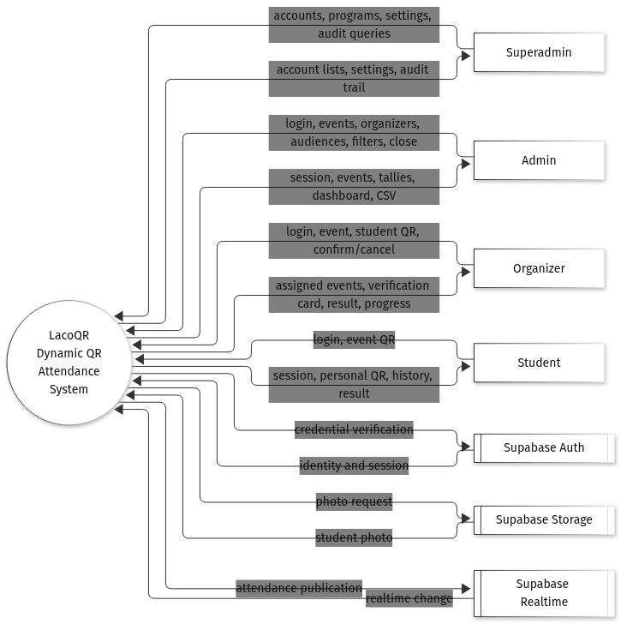
Figure 1. Context flow diagram of LacoQR
Table 4
External entities of LacoQR
Entity | Type | Description | Data sent to the system | Data received from the system
Superadmin | Person | Highest-privilege web user who owns accounts, programs, and global settings. | Account requests, program data, settings, audit queries. | Account lists, settings, audit trail, all reports.
Admin | Person | Event and report manager on the web dashboard. | School ID and birthdate, event details, organizer and audience assignments, report filters, close request. | Session, event list and detail, tallies, live dashboard, CSV report.
Organizer | Person | Mobile gatekeeper who checks the student photo at the entrance. | School ID and birthdate, event selection, student QR payload, confirm or cancel decision. | Assigned events, verification card, scan result, event progress.
Student | Person | Mobile attendee who owns a rotating personal QR code. | School ID and birthdate, event display QR payload, self check-in request. | Session, personal QR and expiry, attendance history, check-in result.
Supabase Auth | External service | Identity provider that stores the credentials. | Credential verification request, refresh request. | Identity, access token, refresh token, expiry.
Supabase Storage | External service | Object storage that holds the student photos. | Authenticated photo path or signed URL request. | Student photo, or a signed URL to the photo.
Supabase Realtime | External service | Pushes database changes to subscribed clients. | Publication of an inserted or updated attendance row. | Realtime attendance change event.

Table 5
Context-level data flows
No. | Data flow | Source | Destination | Composition
C1 | Account and setting request | Superadmin | 0.0 LacoQR | Account action, program record, setting key and value, audit filter.
C2 | Administration result | 0.0 LacoQR | Superadmin | Account list, program list, settings, audit entries, all reports.
C3 | Admin request | Admin | 0.0 LacoQR | School ID and birthdate, event fields, organizer IDs, program IDs, report filters, close command.
C4 | Admin result | 0.0 LacoQR | Admin | Access token, event list and detail, tally, dashboard rows, CSV file.
C5 | Organizer request | Organizer | 0.0 LacoQR | School ID and birthdate, event ID, student QR token, confirm or cancel flag.
C6 | Organizer result | 0.0 LacoQR | Organizer | Assigned events, verification card, attendance result, progress counts.
C7 | Student request | Student | 0.0 LacoQR | School ID and birthdate, event ID, event QR token, self check-in.
C8 | Student result | 0.0 LacoQR | Student | Access token, personal QR token and expiry, attendance history, check-in result.
C9 | Credential verification | 0.0 LacoQR | Supabase Auth | Synthetic email, derived password, refresh token.
C10 | Session | Supabase Auth | 0.0 LacoQR | User ID, access token, refresh token, expiry.
C11 | Photo request | 0.0 LacoQR | Supabase Storage | Authenticated photo path or signed URL request.
C12 | Student photo | Supabase Storage | 0.0 LacoQR | Image bytes or a signed URL.
C13 | Attendance publication | 0.0 LacoQR | Supabase Realtime | Inserted or updated attendance row.
C14 | Realtime change | Supabase Realtime | 0.0 LacoQR | Attendance change event with the row payload.

3.2 Data Flow Diagram
The data flow diagram at Level 1 opens process 0.0 into seven processes and twelve data stores. The diagrams use Yourdon and DeMarco notation. A rectangle is an external entity, a circle is a process, an open-ended rectangle is a data store, and a labeled arrow is a data flow. Mermaid, the tool used to draw these figures, does not provide an open-ended rectangle, so a cylinder is used for the data store. Solid arrows carry data between an entity and a process, or between two processes. Dotted arrows carry data between a process and a data store.
Process 1.0 authenticates every user and loads the role profile. Process 2.0 manages events, organizers, and audiences. Process 3.0 issues and rotates the QR tokens. Process 4.0 validates a scan and records attendance. Process 5.0 monitors attendance while an event is running. Process 6.0 closes an event and generates reports. Process 7.0 administers accounts, programs, settings, and the audit trail.
Figure 2 shows the complete Level 1 diagram. Table 6 describes each process, Table 7 describes each data store, and Table 8 shows which process creates, reads, updates, or deletes each store.
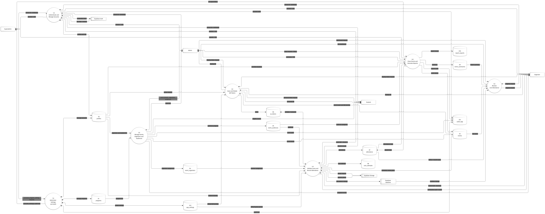
Figure 2. Data flow diagram, Level 1
Table 6
Level 1 processes
ID | Process | Purpose | Main inputs | Main outputs
1.0 | Authenticate and Manage Accounts | Verify the school ID and birthdate, issue a session, load the role profile, and reject inactive accounts. | School ID, birthdate, Auth session, profile row. | Access token, role profile, account audit entry.
2.0 | Manage Events, Organizers and Audiences | Create, edit, cancel, and scope events, then assign organizers and audience programs. | Event fields, organizer IDs, program IDs. | Event record, assignment records, scoped event lists.
3.0 | Issue and Rotate QR Tokens | Issue a 30-second student or event token and replace the previous token of the same subject. | Token request, subject identity, event window. | QR payload, token row, issued and expiry times.
4.0 | Validate Scans and Record Attendance | Validate the token, event, scanner, audience, and duplicate state, then save attendance. | QR payload, event ID, scanner decision. | Verification card, attendance row, scan attempt row.
5.0 | Monitor Live Attendance | Compute and display present, late, and absent counts with the most recent scans. | Live event, attendance rows, frozen summary, realtime change. | Dashboard rows, progress counts.
6.0 | Close Events and Generate Reports | Insert absent rows, freeze the summary, mark the event completed, filter records, and export. | Close request, report filters. | Summary, completed status, CSV file, export audit.
7.0 | Administer Settings and Audit | Manage accounts, programs, global defaults, and the audit trail. | Account, program, and setting requests. | Account list, settings, audit trail.

Table 7
Data stores
ID | Data store | Contents | Written by | Read by
D1 | programs | Academic program code and name. | 7.0 | 2.0, 7.0
D2 | profiles | School ID, name, role, program, year level, photo, active flag. | 1.0, 7.0 | 1.0 to 7.0
D3 | events | Name, venue, date, time, grace period, scan mode, status, QR window. | 2.0, 6.0 | 2.0 to 6.0
D4 | event_organizers | Event-to-organizer assignment. | 2.0 | 2.0, 4.0
D5 | event_audiences | Event-to-program audience. | 2.0 | 4.0, 5.0, 6.0
D6 | qr_tokens | Subject type, subject ID, token hash, issue, expiry, and consumption time. | 3.0, 4.0 | 3.0, 4.0
D7 | attendance | One row per student per event: status, method, time, scanner, token. | 4.0, 6.0 | 4.0, 5.0, 6.0
D8 | scan_attempts | Every accepted, cancelled, or rejected scan with its reason. | 4.0 | 7.0
D9 | event_summaries | Frozen enrolled, present, late, and absent counts with the attendance rate. | 6.0 | 5.0, 6.0
D10 | report_exports | Export format, filters, file reference, exporter, and timestamp. | 6.0 | 7.0
D11 | audit_logs | Actor, action, entity, details, and timestamp. | 1.0, 2.0, 6.0, 7.0 | 7.0
D12 | app_settings | Global defaults such as the QR window and the grace period. | 7.0 | 3.0, 4.0, 7.0

Table 8
Process-to-store matrix (C = create, R = read, U = update, D = delete, listed in that order)
Process | D1 | D2 | D3 | D4 | D5 | D6 | D7 | D8 | D9 | D10 | D11 | D12
1.0 | — | RU | — | — | — | — | — | — | — | — | C | —
2.0 | R | R | CRUD | CRUD | CRUD | — | — | — | — | — | C | R
3.0 | — | R | R | — | — | CRUD | — | — | — | — | — | R
4.0 | — | R | R | R | R | RU | CR | C | — | — | — | R
5.0 | — | — | R | — | — | — | R | — | R | — | — | —
6.0 | — | R | RU | — | R | — | CRU | — | CRU | C | C | —
7.0 | CRUD | CRU | — | — | — | — | — | R | — | R | CR | CRUD

Because the complete diagram is dense, the same flows are also presented per external entity. Figures 3 to 6 show only the processes and the data stores that a single actor touches. These views are easier to follow during the presentation, and they contain no data flow that is missing from Figure 2.
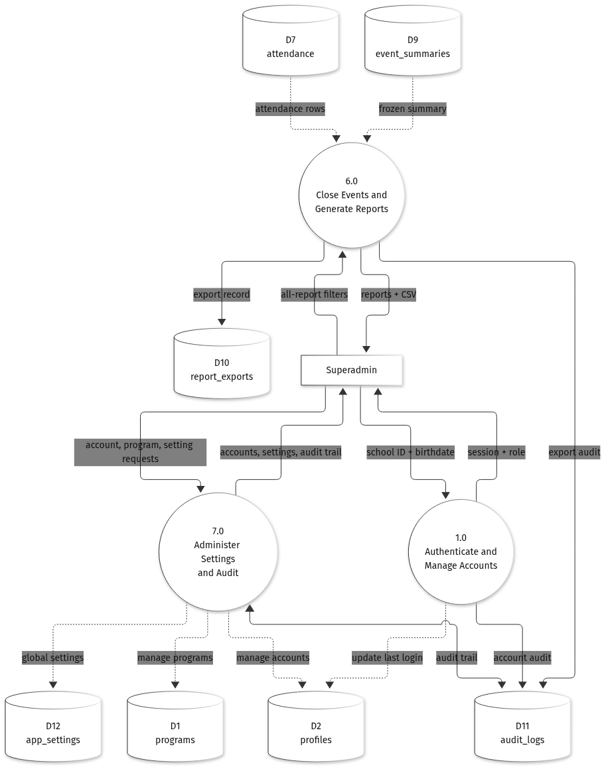
Figure 3. Data flows for the Superadmin
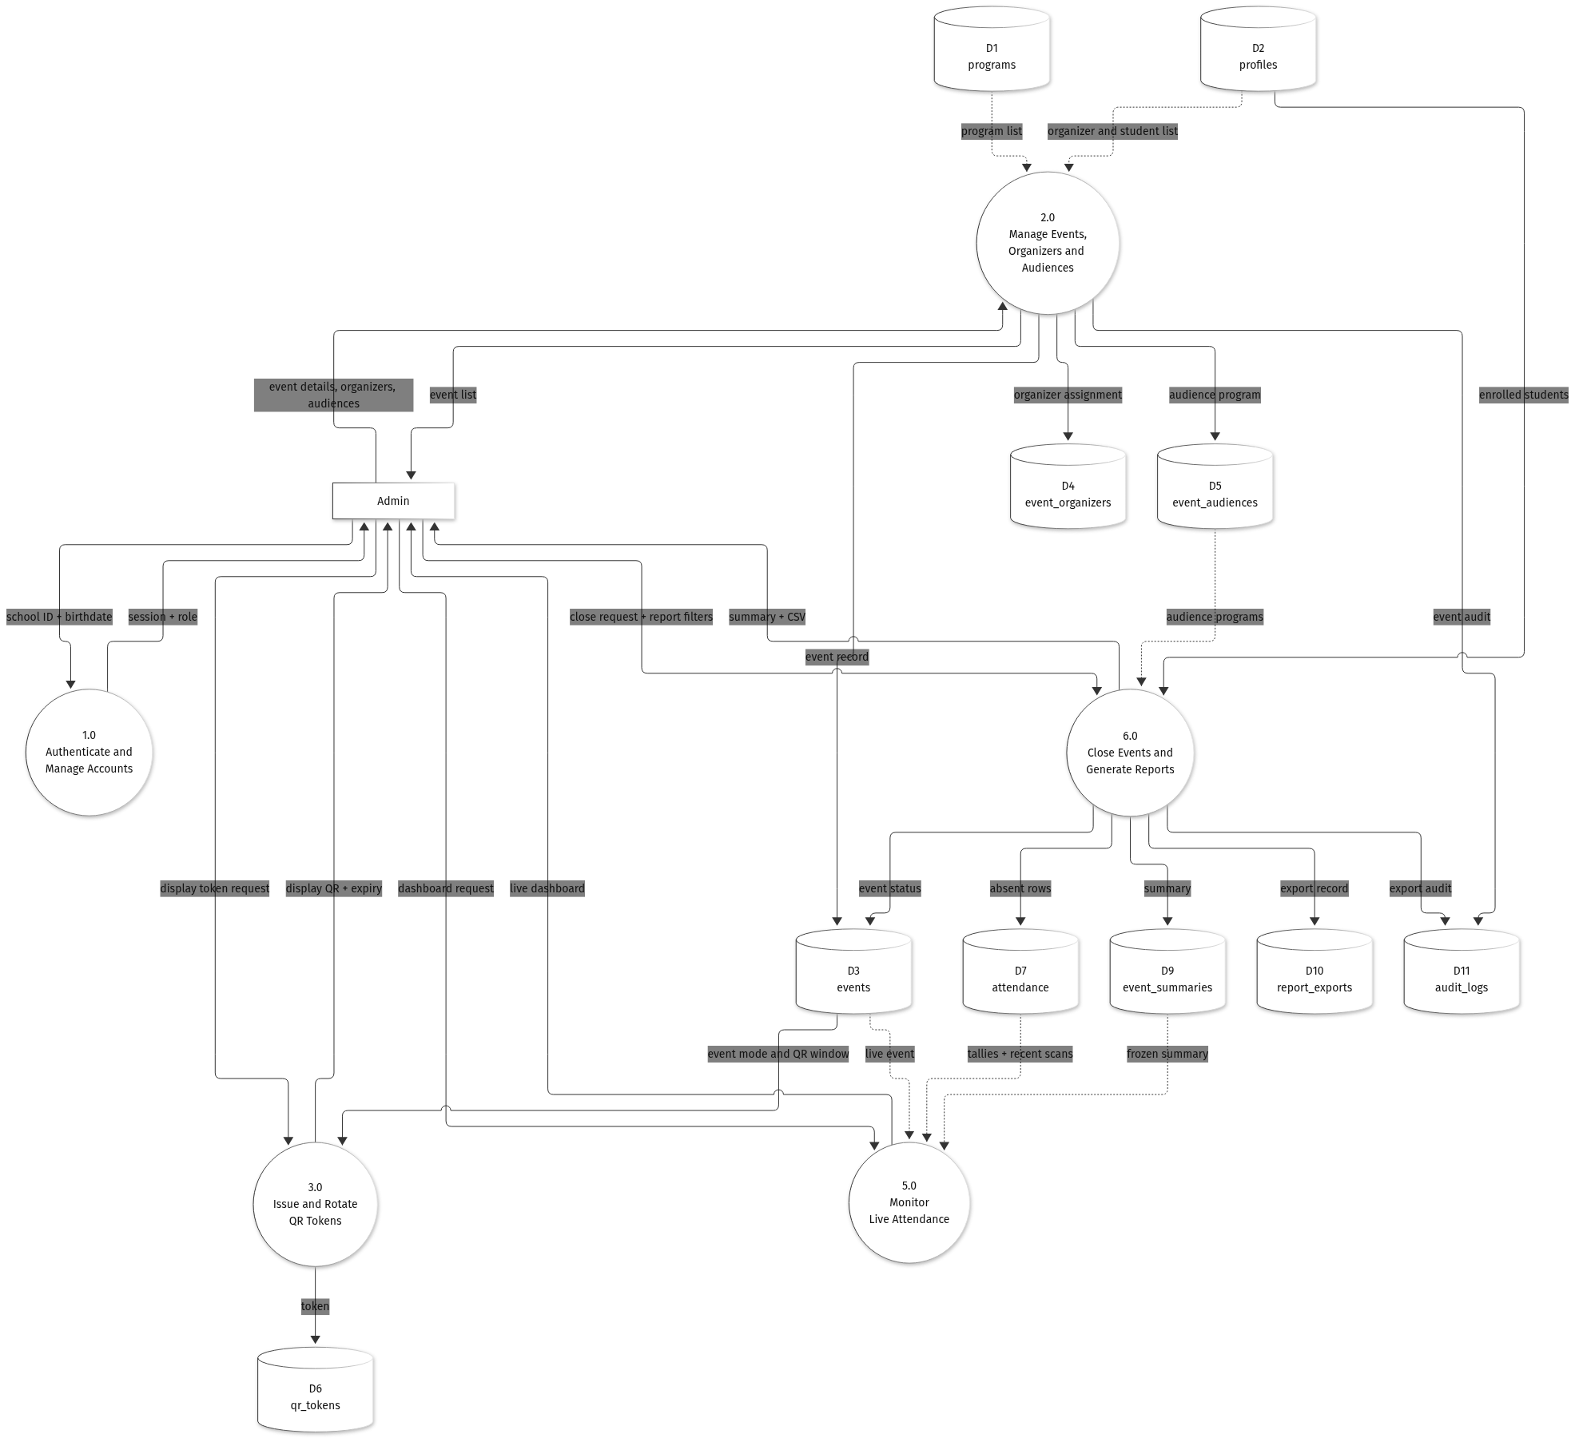
Figure 4. Data flows for the Admin
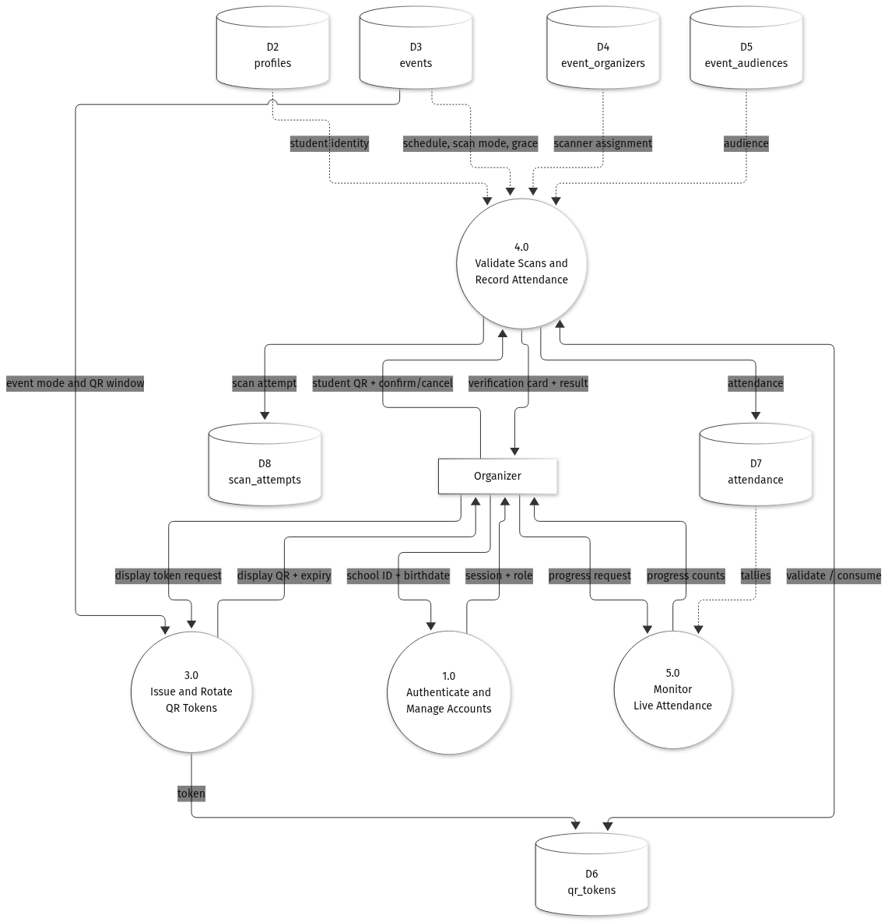
Figure 5. Data flows for the Organizer
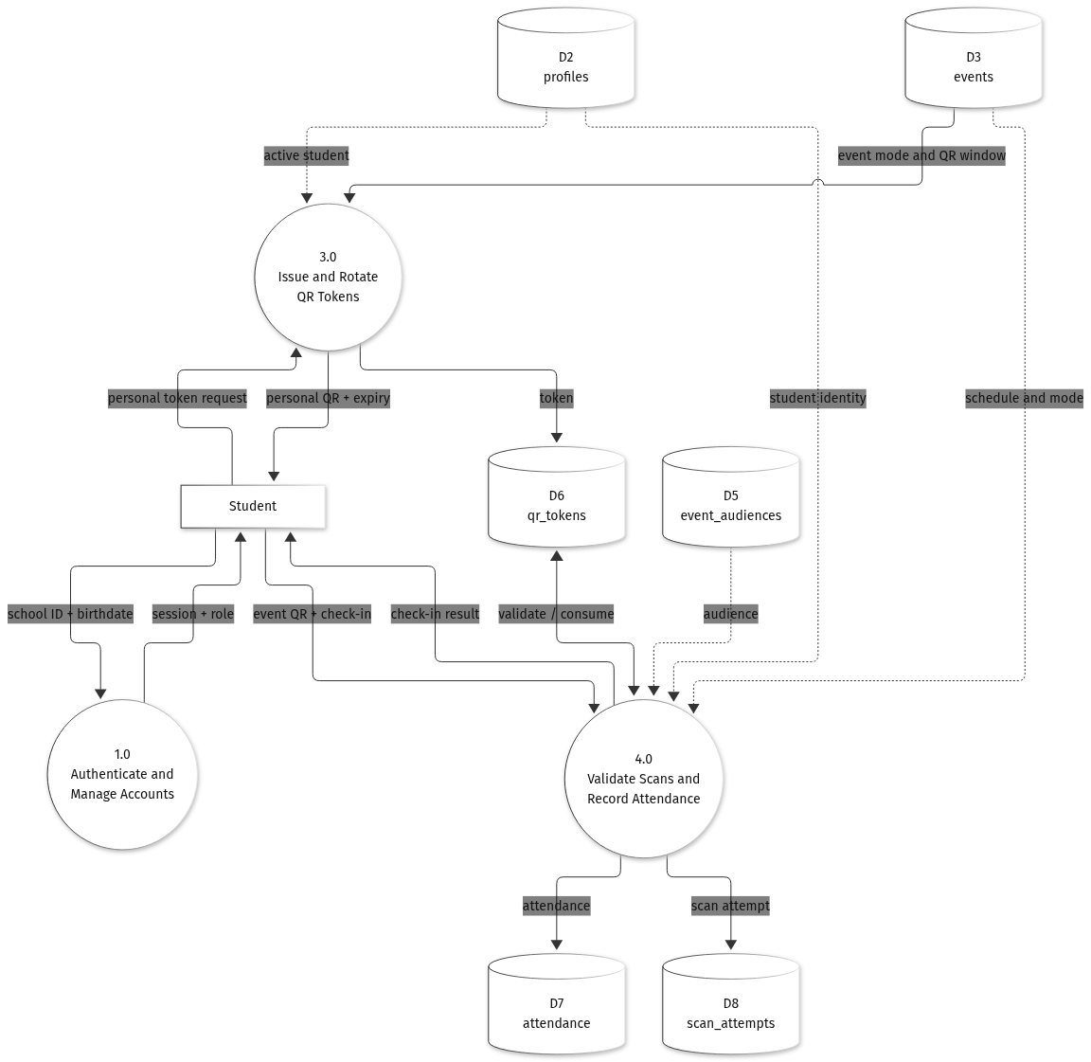
Figure 6. Data flows for the Student

3.3 Development Cost
The developmental cost is the one-time cost of building the system. Two figures are reported. The first is the actual out-of-pocket cost of the student team, which uses existing hardware and free cloud tiers. The second is the commercial replacement value, which is what an institution would pay a four-person team to build the same scope over four months. All amounts are in Philippine pesos and are based on prices gathered in November 2026.
Table 9
Developmental cost, thesis and out-of-pocket scenario
Item | Quantity | Unit cost (PHP) | Amount (PHP)
Domain name (.com, one year) | 1 | 700.00 | 700.00
Internet share (four months) | 4 | 1,500.00 | 6,000.00
Printing, binding, and defense copies | 1 | 5,000.00 | 5,000.00
Test consumables (QR printouts, labels, lanyards) | 1 | 1,500.00 | 1,500.00
Cloud hosting during development | 4 | 0.00 | 0.00
Hardware (existing laptops and phones) | 1 | 0.00 | 0.00
Subtotal |  |  | 13,200.00
Contingency (10 percent) |  |  | 1,320.00
Total developmental cost |  |  | 14,520.00

The team spends 14,520.00 pesos in cash. The 1,280 person-hours of the four members are not paid in this scenario. If those hours were billed at the commercial rates below, the labor value alone would be 444,000.00 pesos.
Table 10
Developmental cost, commercial replacement-value scenario
Cost group | Amount (PHP) | Share of subtotal
Personnel (four roles, four months) | 444,000.00 | 75.5%
Hardware (two laptops, one phone, one tablet) | 108,000.00 | 18.4%
Software, tools, and cloud during development | 15,740.00 | 2.7%
Other project costs (internet, documentation, training) | 20,000.00 | 3.4%
Subtotal | 587,740.00 | 100.0%
Contingency (10 percent of subtotal) | 58,774.00 | —
Total developmental cost | 646,514.00 | —

The gap between the two figures is labor and hardware, not software. The system is built almost entirely on free and open-source tools, so the commercial total reflects the market value of the hours and the equipment rather than the cost of licenses.

3.4 Operating Cost
The operating cost is the recurring cost of running the system after launch. It covers hosting, the domain name, maintenance, monitoring, and consumables. It does not include the developmental cost. Two scenarios are again reported: a free-tier setup for the thesis pilot or a small campus deployment, and a production setup with paid hosting, backups, and part-time professional maintenance.
Table 11
Operating cost, free-tier scenario
Item | Monthly (PHP) | Annual (PHP) | Basis
Domain name (amortized) | 58.33 | 699.96 | 700.00 pesos per year.
Internet share | 1,500.00 | 18,000.00 | Shared campus or home connection.
Maintenance (student) | 600.00 | 7,200.00 | 4 hours per month at 150.00 pesos per hour.
Consumables and printing | 100.00 | 1,200.00 | Backup QR sheets and labels.
Cloud services | 0.00 | 0.00 | Supabase Free, GitHub Free, Expo Free, free static hosting.
Subtotal | 2,258.33 | 27,099.96
Contingency (10 percent) | 225.83 | 2,709.96
Total | 2,484.16 | 29,809.92

Table 12
Operating cost, production scenario
Item | Monthly (PHP) | Annual (PHP) | Basis
Supabase Pro | 1,450.00 | 17,400.00 | Managed Postgres, Auth, Storage, Realtime, daily backups.
API hosting (Starter) | 410.00 | 4,920.00 | Always-on instance for the Express API.
Domain name (amortized) | 58.33 | 699.96 | 700.00 pesos per year.
Expo EAS Starter | 1,120.00 | 13,440.00 | Mobile build and update service.
Monitoring and backups | 600.00 | 7,200.00 | Uptime monitoring, error tracking, off-site copy.
Maintenance (professional) | 4,000.00 | 48,000.00 | 8 hours per month at 500.00 pesos per hour.
Internet and office share | 1,500.00 | 18,000.00 | Campus connection share.
Consumables | 100.00 | 1,200.00 | Printed fallback materials.
Subtotal | 9,238.33 | 110,859.96
Contingency (10 percent) | 923.83 | 11,085.96
Total | 10,162.16 | 121,945.92

Maintenance labor is the largest recurring item at 39.4 percent of the production budget, followed by the internet share at 14.8 percent and Supabase Pro at 14.3 percent. If the information technology office of the institution absorbs maintenance and the internet connection, the cash operating cost of the production setup falls to about 6,162.16 pesos per month.

3.5 Cost Benefit Analysis
The cost-benefit analysis compares the recurring cost of the system with the value of the work that it replaces. The base case is 1,000 students and 20 events per year, or 20,000 check-ins. Two activities are replaced: the manual check-in line and the encoding of the attendance records.
Manual check-in takes about fifteen seconds per student, or 4.17 hours for 1,000 students. Encoding and verifying the records takes about thirty seconds per record, or 8.33 hours. The manual process therefore consumes about 12.5 hours per event. With LacoQR a scan takes about three seconds, or 0.83 hour per event, and encoding is eliminated. The system therefore saves about 11.67 hours per event, or 233.33 hours per year. At 150.00 pesos per hour the saved labor is worth 35,000.00 pesos per year.
The system also removes the printing of attendance sheets. At 1,000 sheets per event and 0.50 peso per sheet, twenty events consume 20,000 sheets and 10,000.00 pesos of paper per year. The total quantifiable benefit is therefore 45,000.00 pesos per year, or 2.25 pesos per check-in.
Table 13
Quantified annual benefit at the base case
Benefit | Basis | Annual value (PHP)
Labor saved on check-in and encoding | 233.33 hours at 150.00 pesos per hour | 35,000.00
Printing and forms avoided | 20,000 sheets at 0.50 peso per sheet | 10,000.00
Total quantifiable benefit |  | 45,000.00

Table 14 compares this benefit with the two operating scenarios. In the free-tier setup the system returns a net benefit of 15,190.08 pesos per year, a benefit-cost ratio of 1.51, and it recovers its 14,520.00-peso development cost in about 0.96 year, or roughly eleven and a half months. In the production setup the annual cost of 121,945.92 pesos is larger than the benefit at the base case, so the ratio is 0.37 and the net benefit is negative. The production setup is therefore justified only when the volume is larger, or when the institution absorbs hosting and maintenance as part of its existing information technology budget.
Table 14
Cost-benefit summary at the base case
Item | Free-tier setup | Production setup
Annual benefit | 45,000.00 | 45,000.00
Annual operating cost | 29,809.92 | 121,945.92
Net annual benefit | 15,190.08 | (76,945.92)
Benefit-cost ratio | 1.51 | 0.37
Return on operating cost | 50.96% | (63.10%)
Development cost | 14,520.00 | 646,514.00
Payback period on development | 0.96 year | Not recovered at this volume
Three-year net (benefit less development and operating cost) | 31,050.24 | (877,351.76)

Table 15 shows how the net benefit changes with the number of check-ins. The free-tier setup breaks even at about 13,249 check-ins per year, or 13.2 events. The production setup breaks even at about 54,199 check-ins, or 54.2 events, which is close to three events per week for a full academic year. Below those volumes the free-tier setup should be used.
Table 15
Net annual benefit by check-in volume
Check-ins per year | Equivalent events | Annual benefit (PHP) | Net, free tier (PHP) | Net, production (PHP)
10,000 | 10 | 22,500.00 | (7,309.92) | (99,445.92)
20,000 | 20 | 45,000.00 | 15,190.08 | (76,945.92)
40,000 | 40 | 90,000.00 | 60,190.08 | (31,945.92)
60,000 | 60 | 135,000.00 | 105,190.08 | 13,054.08
80,000 | 80 | 180,000.00 | 150,190.08 | 58,054.08

The analysis covers only the benefits that can be measured in pesos. The system also produces benefits that are harder to quantify. It reduces proxy attendance because a screenshot of the token expires after thirty seconds and because the organizer checks the student photo before confirming. It reduces disputes because every accepted or rejected scan is recorded with its reason. It gives administrators a live view of an event instead of a report that arrives days later. It removes the paper forms, which also removes the storage and the manual filing that come with them. These benefits support the decision even when the peso figures are close to the break-even point.
Taken together, the cost of the system is modest compared with the attendance work that it replaces. The free-tier setup is affordable for a single campus and returns its cost within the first year of operation. The production setup is a larger commitment, and the analysis shows the event volume that it needs before the institution should consider it.

