Batch: A1 Roll No.: 1311016
Experiment No. 8
Grade: AA / AB / BB / BC / CC / CD /DD

Signature of the Staff In-charge with date

Title: Mini Project using any of the cloud tech. studied

Objective: To create an android app that gives information about the light conditions in the room using Arduino and Cloud.

Expected Outcome of Experiment:

CO | Outcome
3 | Implement infrastructure, storage as a Service

Books/ Journals/ Websites referred:

https://learn.sparkfun.com/tutorials/pushing-data-to-datasparkfuncom
https://www.youtube.com/watch?v=ZjjiHJS8lL0

Abstract:-
The application gives a routine check of the lighting of the room and displays it with a visual image.
The light sensor connected to the nodemcu sends the data stream to the cloud Sparkfun through wifi on a regular interval. The cloud then sends the information to the app when the user requests for the information.
Related Theory: -
In our mini project android, Arduino and cloud are combined and used.
The cloud Used here is SparkFun
SparkFun’s Data.SparkFun.com service allows you to easily push your data to the “cloud.” Whether you’re posting weather readings, office environment conditions, or anything else, it can come in handy to have a central, online location to store those sensor readings. By sending a simple HTTP request to the Data.SparkFun.com server, your project data is stored and displayed in a simple database where it can be retrieved or reviewed at your leisure.
Any electronics project that can be Internet-connected should be able to post data to the SparkFun data service. Luckily, these days – with Internet-of-Things applications taking off – there is no shortage of hardware gateways to the web. Basic Arduino’s can rely on shields for WiFi or Ethernet access, while many advanced development platforms already have Wifi or Ethernet built-in.
NodeMCU:
NodeMCU is an eLua based firmware for the ESP8266 WiFi SOC from Espressif. The firmware is based on the Espressif NON-OS SDK and uses a file system based on spiffs. The code repository consists of 98.1% C-code that glues the thin Lua veneer to the SDK. It is used since it has esp8266 and this helps connecting the development kit to wifi.
Light sensor :
This device is connected to the nodemcu and senses the amount of light in the room .
MIT appinventor
This website is used in our project to build an android application. It is a visuals, block language for building the android application.
Implementation Details:
- Enlist all the Steps followed and various options explored

The NodeMCU is set up and the connections are made with the light sensor

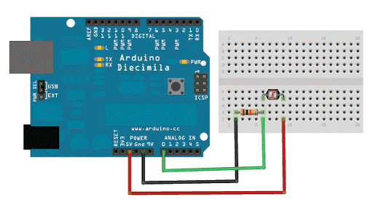

The steps and code to connect the nodeMCU with the SparkFun cloud service :

- Include the ESP8266 WiFi library. (Works a lot like the Arduino WiFi library.)
#include <ESP8266WiFi.h>
- Include the SparkFun Phant library.
#include <Phant.h>

- Set your network name and password
const char WiFiSSID[] = "YourNetwork";
const char WiFiPSK[] = "YourPassword";

- define constants for pin control and node number
const int LED_PIN = 5; // green LED
const int ANALOG_PIN = A0;
const int NODE_NUM = 1; //node identifier
const char parseKey[] = "stamp";
bool pData = false; //used to toggle between posting data and getting data

- declare phant address and security keys
const char PhantHost[] = "data.sparkfun.com";
const char pPublicKey[] = "PublicKeyForPosting";
const char pPrivateKey[] = "PrivateKeyForPosting";
const char gPublicKey[] = "PublicKeyForGetting";
const char gPrivateKey[] = "PublicKeyForGetting";

- specify the rate that you post data to cloud
const unsigned long postRate = 15000;
unsigned long lastPost = 0;

void setup()
{
initHardware(); //setup arduino hardware
connectWiFi(); //Connect your WiFi network
digitalWrite(LED_PIN, HIGH);
}

- loop until it is time to post data to phant cloud

void loop()
{
if (lastPost + postRate <= millis())
{
if(pData) {
if (postToPhant()) lastPost = millis();
else lastPost = millis(); //Even if we fail delay whole cycle before we try again
}
else {
if (getFromPhant()) lastPost = millis();
else lastPost = millis(); //Even if we fail delay whole cycle before we try again
}
}
}

- function used to connect to WiFi network
void connectWiFi()
{
byte ledStatus = LOW;

- Set WiFi mode to station (as opposed to AP or AP_STA)
WiFi.mode(WIFI_STA);

- initiates a WiFI connection
WiFI.begin([ssid], [passkey])

- to the stated [ssid], using the [passkey] as a WPA, WPA2, or WEP passphrase.
WiFi.begin(WiFiSSID, WiFiPSK);

- Use the WiFi.status() function to check if the ESP8266 is connected to a WiFi network.
while (WiFi.status() != WL_CONNECTED)
{
- Blink the LED
digitalWrite(LED_PIN, ledStatus);
- Write LED high/low

ledStatus = (ledStatus == HIGH) ? LOW : HIGH;

- Delays allow the ESP8266 to perform critical task defined outside of the sketch. These tasks include setting up, and maintaining, a WiFi connection.
delay(100);
- Potentially infinite loops are generally dangerous. Add delays -- allowing the processor to perform other tasks -- wherever possible.
}
}

- function that sets up some initial hardware states
void initHardware()
{
Serial.begin(9600);
pinMode(LED_PIN, OUTPUT);
digitalWrite(LED_PIN, LOW);
}

- function that handles posting and getting data from phant cloud
int getFromPhant()
{
- Set phant data
Phant phant(PhantHost, gPublicKey, gPrivateKey);

- Create client object to communicate with the phant server

WiFiClient client; Create client object to communicate with the phant server

- Attempt to connect to phant server using port 80

if (!client.connect(PhantHost, 80)) { If we fail to connect, return 0.
return 0;
}

- Get data from phant cloud
client.print(phant.get());
client.println();
int cTrack = 0;

- variable that tracks count to spell stamp tracks when we have a match with "stamp" and we can then get control data

bool match = false;
- variable used to track whe we have control data
int pCount = 0;

- loop until we get data and server closes connection

while(1) {

- if data is available from phant server
if (client.available()) {
char c = client.read();
if(!match) {
- check if we have a character match with word "stamp"
if(c == parseKey[cTrack])
{
if(cTrack == (sizeof(parseKey)-2)) match = true;
cTrack++;
}
else {
cTrack = 0;
}
}

- if true it means we found a match to "stamp" and we are ready to get control data

else {
if(pCount == 1) { //if true we are at the point in the data to read control data for node

int dControl = c - '0';
if(dControl == 1 | dControl == 0) digitalWrite(LED_PIN, dControl);
}
pCount++;
}
}

- if the server's disconnected, stop the client if you don't have this you will create too many clients and server won't let you connect anymore
if (!client.connected()) {
client.stop();
break;
}
}
- set to true so we post data to cloud next loop
pData = true;
return 1;
}

- this function takes data and posts it to the cloud
int postToPhant()
{
- Declare an object from the Phant library - phant
Phant phant(PhantHost, pPublicKey, pPrivateKey);
- These functions build data and field string that will be sent to phant cloud
phant.add("adcdata", analogRead(ANALOG_PIN));
phant.add("wifinode", NODE_NUM);

- Now connect to data.sparkfun.com, and post our data:
WiFiClient client; //declare client object that will post the data
const int httpPort = 80; //specify port to post through

- attempt to connect to phant
if (!client.connect(PhantHost, httpPort))
{

return 0;
}
- Send post to phant
client.print(phant.post());

- Read all the lines of the reply from server and print them to Serial
while(client.available()){
String line = client.readStringUntil('\r');
Serial.print(line); // Trying to avoid using serial
}
- set to false so we get data from cloud next loop
pData = false;
return 1; // Return success
}

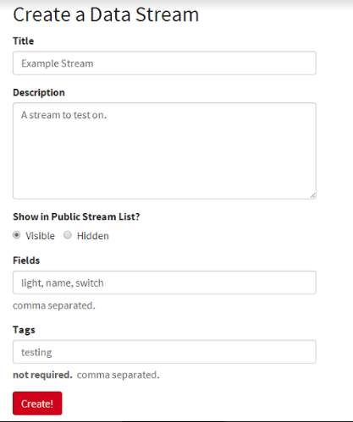

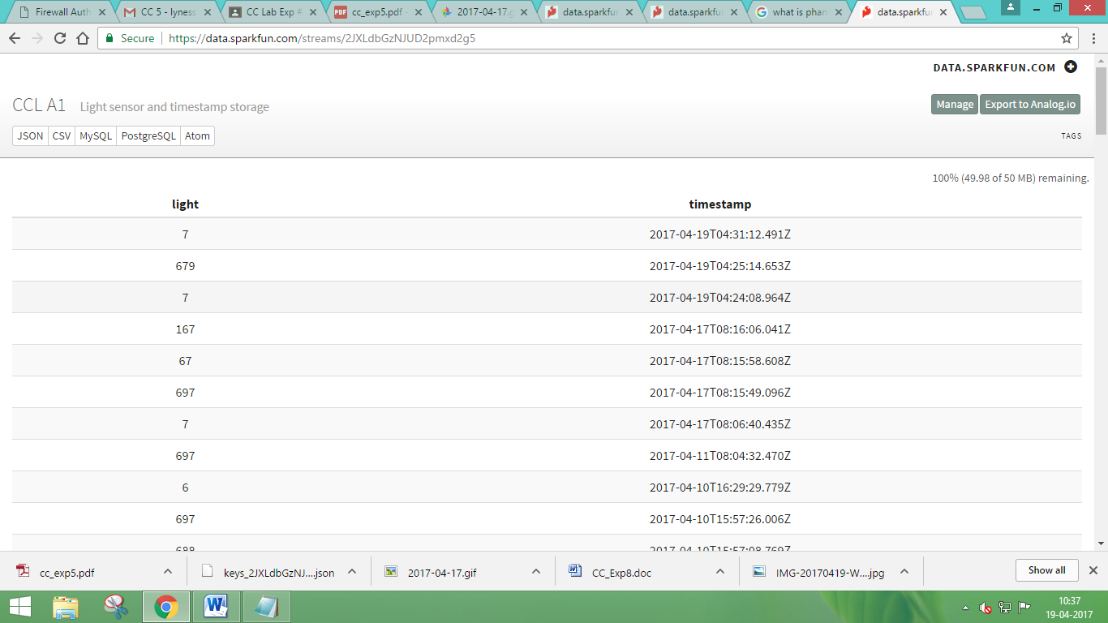

The light values 0-100 is interpreted as day.
The light values 100-400 is interpreted as evening.
The light values 400-600 is interpreted as evening.

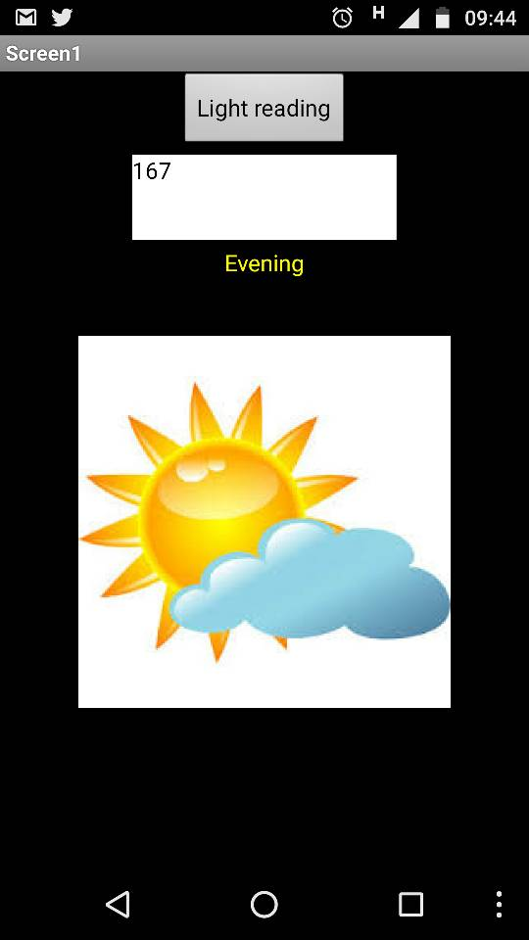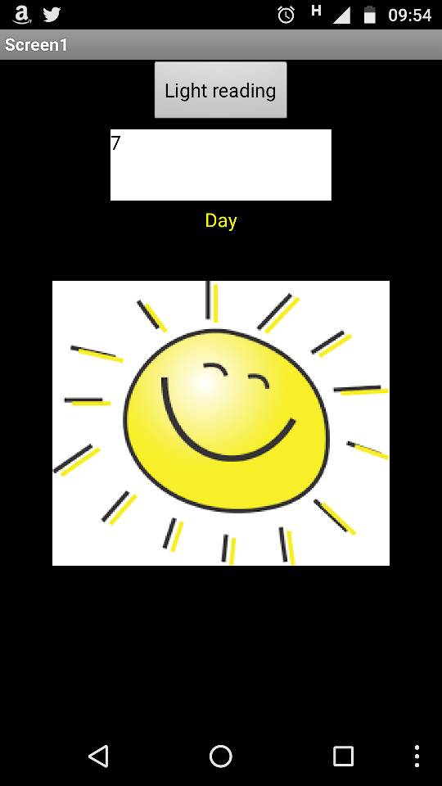

2. Explain the Importance of the approach followed by you
The project helps a person know the light condition of their room independent of their location.
The NodeMCU has ESP8266 which is enabled with WIFi and connects the light sensor and sends the data collected from the sensor to the cloud SparkFun.
The android application then will tell the user what are the light conditions of their room through internet connection.

This project can be further expanded for temperature etc. and is useful for IOT applications.

Conclusion:-
Thus we created an android app that gives information about the light conditions in the room using Arduino and Cloud.

Date: _____________ Signature of faculty in-charge

