SparkFun's [Data.SparkFun.com](https://data.sparkfun.com/) service allows you to easily push your data to the "cloud." Whether you're posting [weather readings](https://learn.sparkfun.com/tutorials/weather-station-wirelessly-connected-to-wunderground), [office environment conditions](https://learn.sparkfun.com/tutorials/internet-datalogging-with-arduino-and-xbee-wifi), or anything else, it can come in handy to have a central, online location to store those sensor readings. By sending a simple HTTP request to the Data.SparkFun.com server, your project data is stored and displayed in a simple database where it can be retrieved or reviewed at your leisure.

[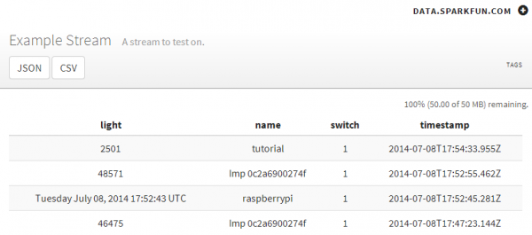](https://cdn.sparkfun.com/assets/learn_tutorials/2/6/0/stream-example.png)

Any electronics project that can be **Internet-connected** should be able to post data to the SparkFun data service. Luckily, these days -- with Internet-of-Things applications taking off -- there is no shortage of hardware gateways to the web. Basic Arduino's can rely on shields for WiFi or Ethernet access, while many advanced development platforms already have WiFi or Ethernet built-in.

<https://data.sparkfun.com/streams>

<http://ai2.appinventor.mit.edu/>

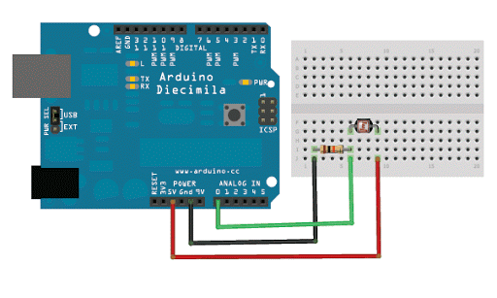

<http://forcetronic.blogspot.com/2016_09_01_archive.html>