|  |  |
| --- | --- |
| INGAME  IMMERSIVE NEXT GENERATION ADAPTABLE MOTION emulator | Abstract  INGAME is a modular, wireless and adaptable motion emulator which inculcates virtual reality to improve gaming experience while playing first person shooting or adventure games. |

**Table of Contents**

|  |  |  |
| --- | --- | --- |
| Sr. No. | Content | Page No. |
| 1 | Introduction | 2 |
| 2 | HID module | 3 |
| 3 | Controller module | 4 |
| 4 | Pedometer module | 5 |
| 5 | Additional information and contact | 6 |

**Summary**

Games are a fascinating form of entertainment but they have drastic effect on our health. We sit in a cosy place and play for hours affecting our physical development and, in most cases, leading to obesity. INGAME is a motion emulator that ensures user health is not affected while having fun during game play. Not only can this emulator be used for gaming but also for training soldiers in a virtual environment. Soldiers can have drill exercises for various combat situations using this project.

**Introduction**

INGAME is a motion emulator with virtual reality features for playing first person shooting/adventure games. Virtual reality (VR) is a simulated experience that can be similar to or completely different from the real world. INGAME has been designed to provide the user with the feeling of being 'IN-the-GAME'. INGAME is modular in nature and consists of the following modules.

1. HID module
2. Controller module
3. Pedometer module
4. VR headset

The first three modules listed above have been explained in detail later in the document. The VR headset provides split stereo video to the user. The following image shows the functional block diagram of the INGAME system

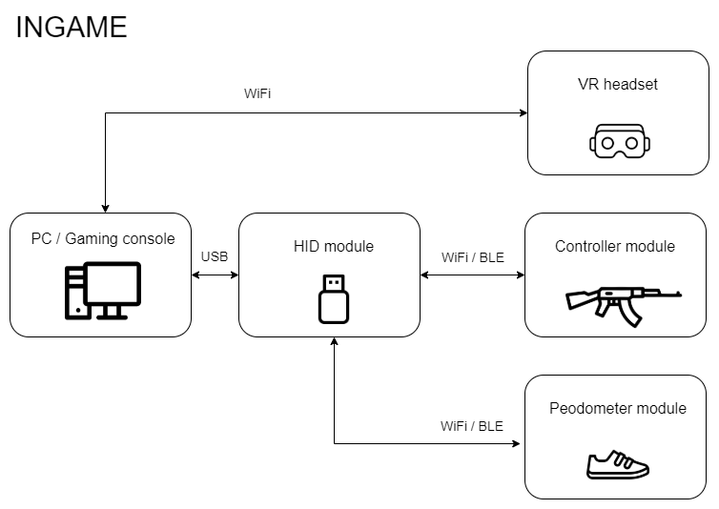

Block Diagram of INGAME

**Salient features**

* Modular to support addons
* Tangle free gaming since the entire system is wireless
* Adaptable to any first person shooting/adventure game
* Minimal lag during gaming due to high-speed data transfer
* Power saving mode to make the battery last longer
* Product certifications: CE certified and ROHS compliant

1. **HID module**

|  |  |
| --- | --- |
| **Purpose** | * Act as a wireless gateway between the modules worn by the user and the computer. * Switch the game controls mapping depending on the use selected game |
| **Microcontroller** | ATmega32U4 & ESP32 WROOM |
| **Communication protocols** | UART, USB, Wi-Fi / BLE |
| **Power source** | * 5V via USB |
| **Hardware block diagram** |  |
| **Functions** | * Connect with other modules wirelessly and the computer via USB as an HID device * Receive data, map the data to controls of the selected game and send appropriate key strokes tothe computer * Display a menu showing information about the system especially the game set by the user using the buttons |

1. **Controller module**

|  |  |
| --- | --- |
| **Purpose** | * Send user commands associated with the game such as fire, reload and many more * Observe the changes in orientation and heading and send equivalent mouse movement to the HID module |
| **Microcontroller** | ESP32 WROOM |
| **Communication Protocols** | I2C, Wi-Fi / BLE |
| **Power source** | * 3.3V via LiPo battery with Battery Management System (BMS) |
| **Hardware block diagram** |  |
| **Functions** | * Connect with the HID module wirelessly * Send data associated with a button when a button is pressed * Read accelerometer and gyroscope data, convert to Euler angles, compute equivalent mouse movement and send the data to the HID module * Automatically calibrate the device position when the calibration button is pressed * Monitor battery level and sound a buzzer when the battery is low * Switch to power saving mode upon used inactivity * [Optional] Control a vibration motor to simulate gunfire which increases in intensity per trigger |

1. **Pedometer module**

|  |  |
| --- | --- |
| **Purpose** | * Send user commands associated with walking and running to the HID module |
| **Microcontroller** | ESP32 WROOM |
| **Communication Protocols** | I2C, Wi-Fi / BLE |
| **Power source** | * 3.3V via LiPo battery with Battery Management System (BMS) |
| **Hardware block diagram** |  |
| **Functions** | * Connect with the HID module wirelessly * Read accelerometer data, compute steps and send the data to the HID module * Automatically calibrate the device position when the calibration button is pressed * Monitor battery level and sound a buzzer when the battery is low * Switch to power saving mode upon used inactivity |

**Additional information**

|  |  |
| --- | --- |
| Preliminary project | <https://github.com/InputBlackBoxOutput/FPS-Game-Controller.git> |
| Test videos | [**https://youtu.be/OMMtv63pKW0**](https://youtu.be/OMMtv63pKW0)  [**https://youtu.be/l_5sFRqFQrU**](https://youtu.be/l_5sFRqFQrU)  [**https://youtu.be/bxPnDj941OU**](https://youtu.be/bxPnDj941OU)  [**https://youtu.be/br-LWBGPxnw**](https://youtu.be/br-LWBGPxnw) |

**For more information, please contact us using the following information**

|  |  |  |
| --- | --- | --- |
| Rutuparn Pawar | 9158797404 | rutuparn.17U253@viit.ac.in |
| Piyush Mathurkar | 9850017294 | piyush.mathurkar@viit.ac.in |