**BRACT’s**

**Vishwakarma Institute of Information Technology**

**An Autonomous Institute affiliated to Savitribai Phule Pune University**

“Nirmaan”: A Project Competition by EESA (2020-21)

Image Steganographer

Secretly hiding encrypted text inside an image using cryptography and digital image steganography

**Rutuparn Pawar, 17U253, E&TC**

**Index**

|  |  |  |
| --- | --- | --- |
| ****Sr. No.**** | **Content** | **Page No.** |
| **1** | **Introduction** | **2** |
| **2** | **Motivation** | **2** |
| **3** | **Literature Survey** | **2** |
| **4** | **Methodology** | **2** |
| **5** | **Work Plan and distribution of tasks** | **3** |
| **6** | **Costing & Estimates** | **3** |
| **7** | **Troubleshooting** | **3** |
| **8** | **Results & Discussion** | **4** |
| **9** | **Contributions by team members** | **4** |
| **10** | **What has the team learned through this project?** | **4** |
| **11** | **SWOT Analysis of the project in brief.** | **5** |
| **12** | **Challenges/failures faced and overcome if any** | **5** |
| **13** | **Conclusions** | **5** |
| **14** | **Future Scope** | **6** |
| **15** | **References** | **6** |

**1. Introduction**

A website which performs digital image steganography on an image to embed text encrypted using Vigenere’s cipher.

**2.** **Motivation**

Trust in all government agencies was broken when Edward Snowden revealed to the world about how the NSA breached everyone's privacy. Since then most internet users have lost trust in encryption provided by service they are using for sending private data.

In this project, I have tried to build a system which requires user input to decrypt the message in order to guarantee privacy. The system was also designed taking online sniffing of encrypted data into consideration.

**3.** **Literature Survey**

The project began with understanding digital image steganography & cryptography related to the text.

Several steganography approaches we reviewed before the computationally simple but efficient one of them was selected.

After a brief understanding of ciphers was achieved, comparison and selection were made for the cipher to be used to encrypt the text.

**4.** **Methodology**

We get an image, a keyword and a text from the user. The text is encrypted with the help of the user-provided keyword by using Vigenere’s cipher.

The initial few bytes of the image data is modified to represent the encrypted message. The image looks perfectly normal to the human eye even after embedding the message in the image.

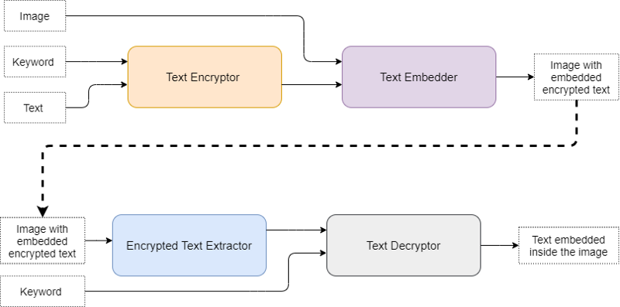

When someone wants to access the message, he/she has to provide the image and the keyword. The encrypted message is extracted from the image and then decrypted using the keyword.

**5.** **Work Plan and distribution of tasks**

The work on this project began on 5 Jun 2020 and was completed on 16 Jul 2020.

**6.** **Costing & Estimates**

No costs were involved since the project is software. The website which was created to use this tool has been hosted free of cost by Github pages.

**7.** **Troubleshooting**

A **few of the problems that occurred** during the design and deployment of the project **where**

* Conversion of an HTML canvas into a .png image lead to blank images because of wrong transparency parameters
* Tainted canvas leading to domain conflicts while downloading the image

They we resolved after looking up the manuals/docs or after asking other developers for assistance on StackOverflow.

**8.** **Results & Discussion**

I was able to successfully deploy a website which performs digital image steganography on an image to hide text encrypted using Vigenere’s cipher.

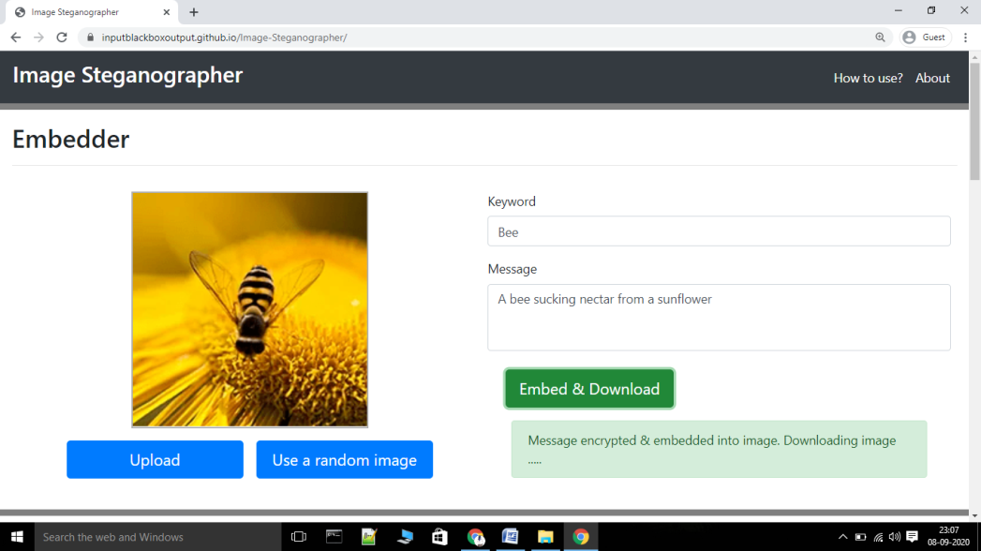

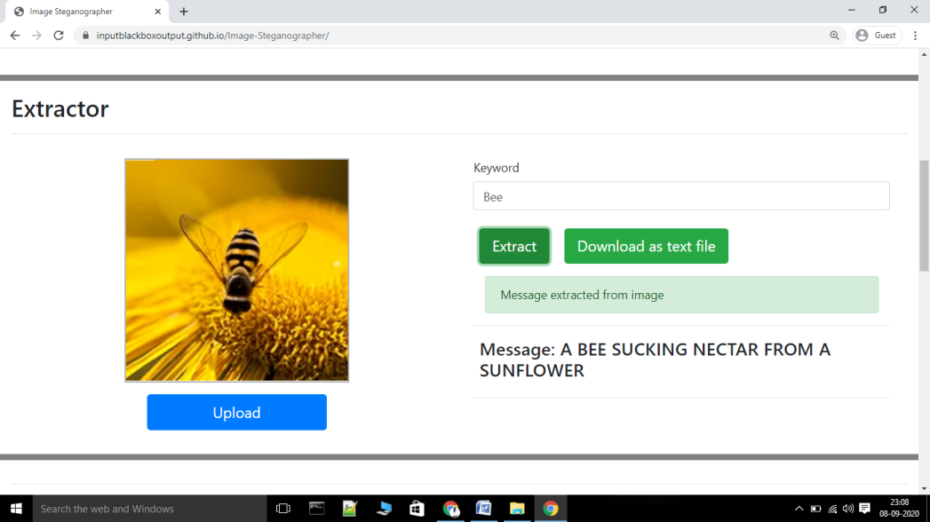

**9.** **Contributions by team members**

This team consists of only one person.

**10.** **What has the team learned through this project?**

* Digital image steganographer
* Cryptography (especially ciphers)
* Web development (JavaScript, HTML, CSS, and Bootstrap)

**11.** **SWOT Analysis of the project in brief.**

***Strengths*:**

* **Nobody will know that a text is hidden inside in the image**
* **Requires users to enter a keyword, thus locking the text from unauthorized access**

***Weaknesses*:**

* **This implementation requires more computation and a new image when there is a large amount of text.**
* **If the keyword is lost by the user there is no way in which the user can decrypt the message.**

***Opportunities*:**

* **Adding support for other media types. (For instance hiding an image inside an image.)**

***Threats*:**

* **If the user uses a keyword which correlates with an object/entity inside the image to be used, the text can be accessed after a correct guess.**

**12.** **Challenges/failures faced and overcome if any**

* The process used to hide the text fails to maintain the format of the image. All image formats get converted to .png format.
* Even if we hide the text, the original image can be compared with the modified image to get the changed values. To overcome this I had to encrypt the text which on a downside adds more computation.

**13.** **Conclusions**

Successfully designed a method to encrypt the text using a user-provided keyword and then embed it into an image also provided by the user.

This method was then implemented on a website to make the service available to everyone.

A link to the website is given below:

<https://inputblackboxoutput.github.io/Image-Steganographer/>

**14.** **Future Scope**

Adding support for multiple types of media: Audio & Image

To aid future development of the project all files are publically available at the following link

<https://github.com/InputBlackBoxOutput/Image-Steganographer>

**15.** **References**

<https://www.researchgate.net/publication/216052617_DIGITAL_IMAGE_STEGANOGRAPHY#:~:text=Digital%20Image%20Steganography%20system%20allows,in%20a%20digital%20image%20file.&text=Digital%20Image%20Steganography%20system%20features,a%20key%20to%20the%20encryption>.

<https://pages.mtu.edu/~shene/NSF-4/Tutorial/VIG/Vig-Base.html>