An interface to EARLINET SCC
A tool to prepare your lidar raw data for SCC

Introduction
This tool is meant to visually support the conversion of lidar raw data into the EARLINET SCC raw data format. The raw data are visualized with an interactive graphic. The user can select interesting time periods directly within the displayed quicklook. The selected profiles can be converted into the SCC raw data format for standard measurements or depolarization calibration measurements.

Gettings started

Requirements
Before using this tool. it is necessary to implement the lidar site, the lidar system and its configuration, as well as its channels into the ERLINET SCC.
This tool works only with the raw data of PollyXT lidars. The implementation of other raw data formats is planned for future upgrates.

Hardware and software requirements
- Windows10 or Linux (installation guidelines for Linux are not yet provided, sorry)
- Anaconda5 with Python 3.6 64bit
- Git, e.g. https://git-scm.com/downloads
- developers need Pycharm or other Python IDE, end users need any text editor

Installation on Windows for enduser

Installation on Windows for developer
the following descriptions are for the installation path c:\inqbus.lidar, but any other path can be used as well.
- checkout code from repository
  - git bash starten
  - cd c:\
  - git clone https://github.com/Inqbus/inqbus.lidar.git

- create virtual environment
  - start Anaconda Navigator
  - create a new environment and name it scc_gui
  - start a terminal session within this environment
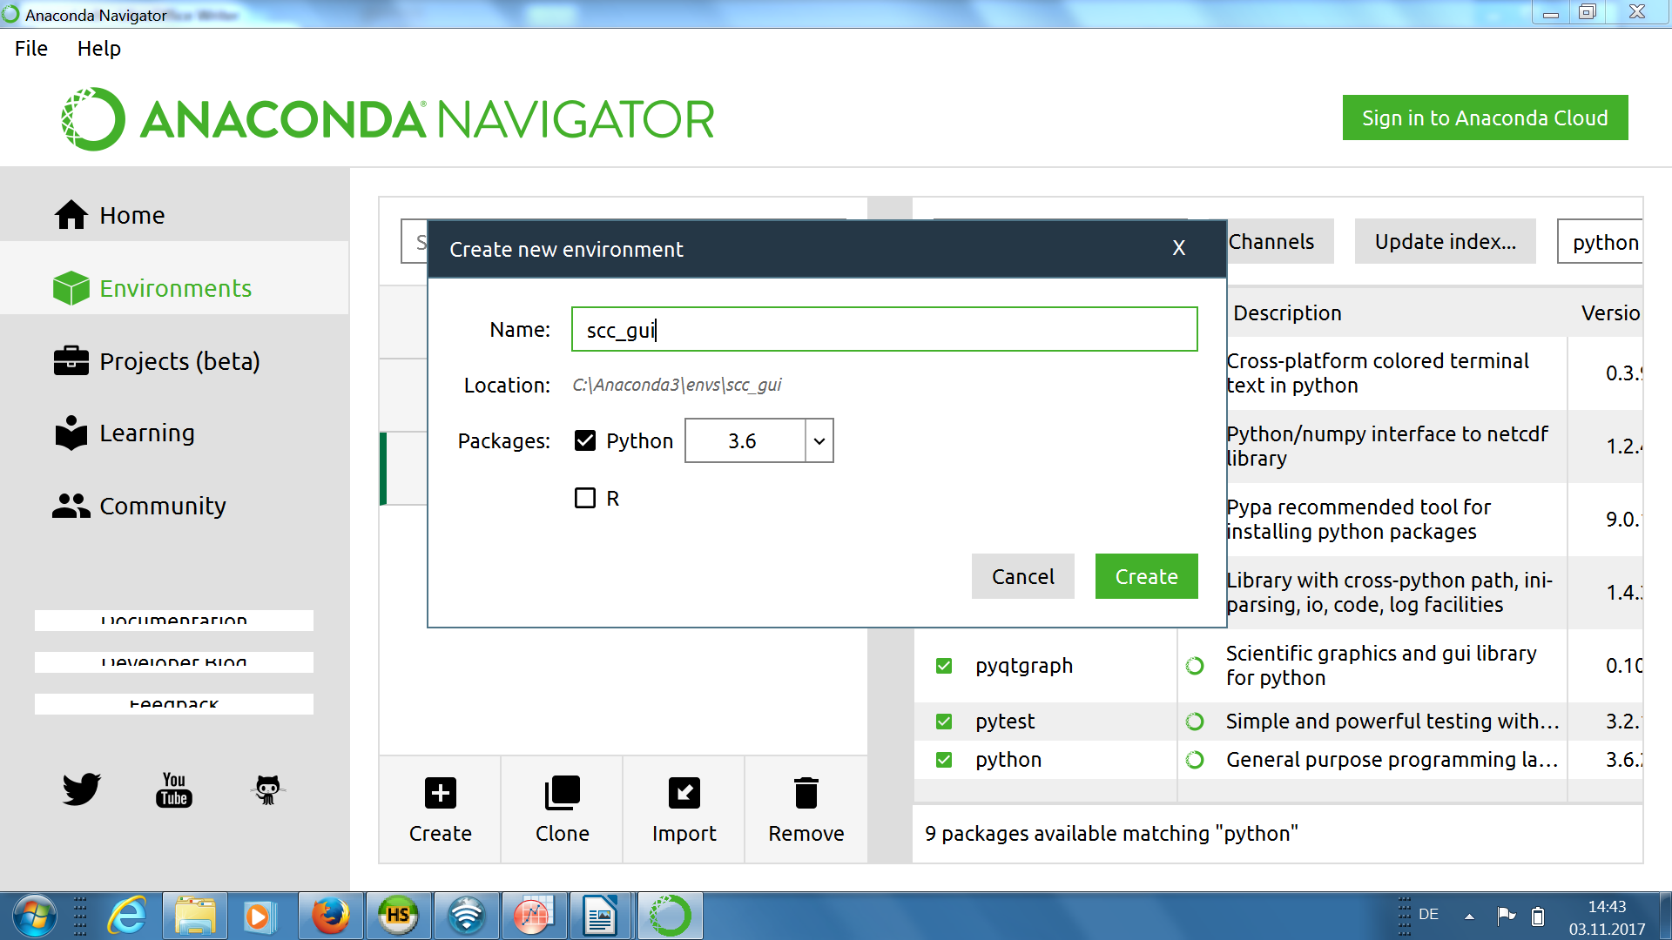
2)
1)
Abbildung 1: create a virtual environment
  - within the terminal, type the following commands
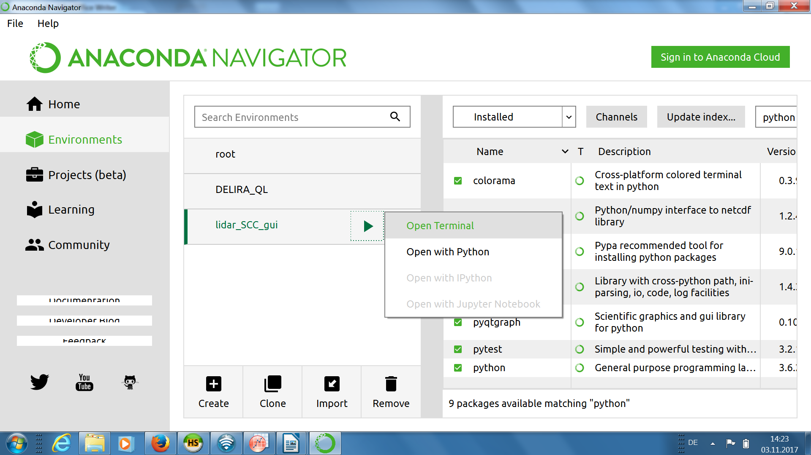
1)
2)
Abbildung 2: start a terminal within the virtual environment
- install and setup PyCharm community edition https://www.jetbrains.com/pycharm/download/#section=windows
> cd c:\inqbus.lidar\
> conda install -- file requirements.txt
> pip install netcdf4
> cd inqbus.lidar.components
> python setup.py develop
> cd ../inqbus.lidar.gui
> python setup.py develop
  - start PyCharm
  - Menu → File → Open →select folder c:\inqbus.lidar\
  - Menu → File → Settings
  - add local interpreter C:\Users\xxx\Anaconda3\envs\scc_gui\python.exe
  - Menu → Run → Edit configurations
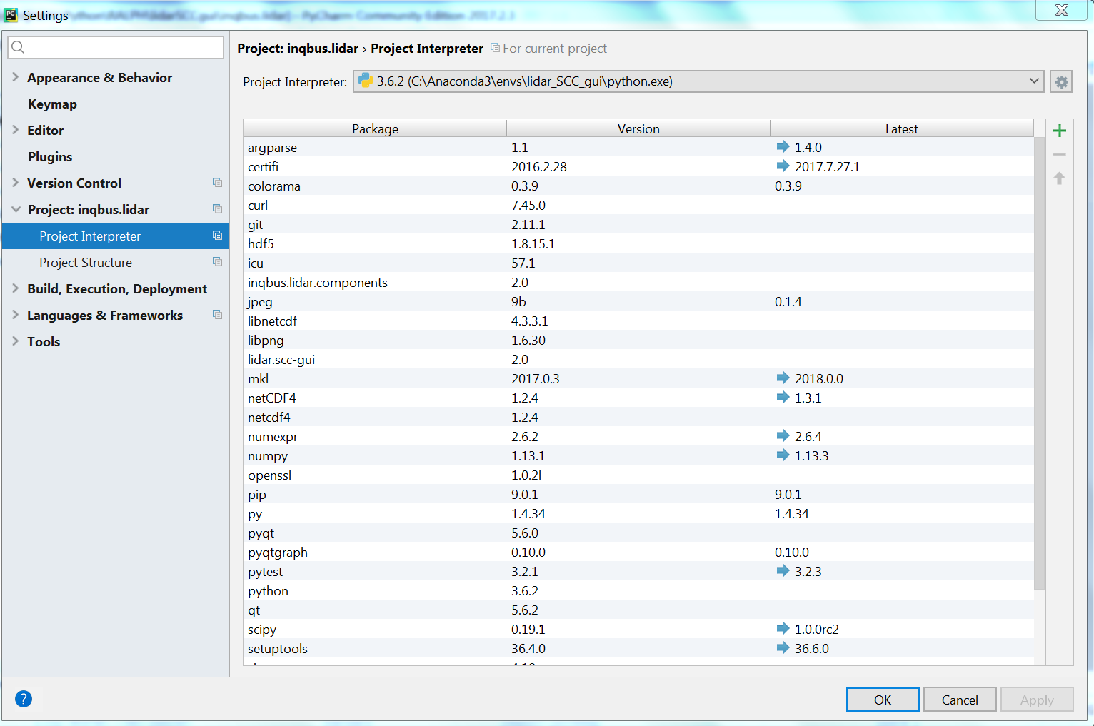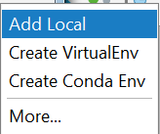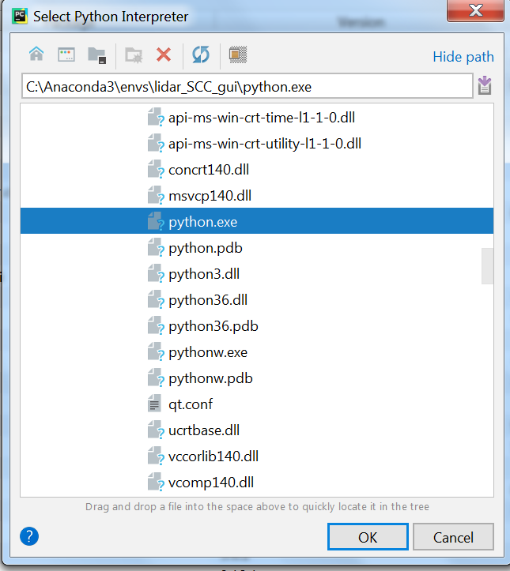
1)
2)
3)
Abbildung 3: setup PyCharm: select python interpreter from virtual environment
    - (1) set path to main program c:\inqbus.lidar\ inqbus.lidar\inqbus.lidar.scc_gui\src\inqbus\lidar\scc_gui\app.py
    - (2) set command line parameters -l configs\lidarconfig_xx.py -p configs\pcconfig_xxx.py
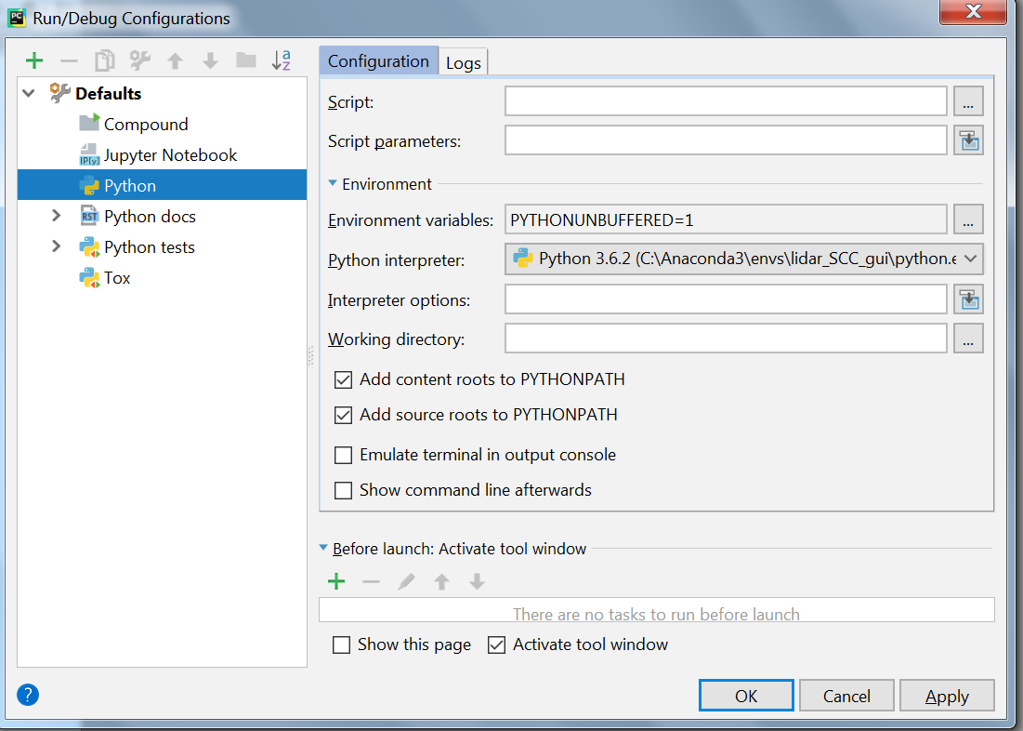Abbildung 4: Setup PyCharm: set main program and command line parameters
1)
2)

Modify lidar settings and pathes
Two configuration files have to be adopted according to your lidar system and PC.
- The config files are in the path c:\inqbus.lidar\ inqbus.lidar\inqbus.lidar.scc_gui\src\inqbus\lidar\scc_gui\config
- The lidarconfig file contains all information about your lidar system:
  - channel IDs corresponding to the definition in the SCC interface
  - which channel shall be used to generate the quicklook?
  - what is the angle of the polarization filter for regular measurements ?
  - what is your first valid altitude bin?
  - which altitde bins shall be used for background calculation?
  - which colors shall be used to plot the signal profiles?
  - further details are explained within the file
- The pcconfig file contains all information about your PC, mainly pathes, e.g.
  - The path, where your PollyXT raw data are located
  - A temporary path, wherein the PollyXT zip files can be extracted
  - a path where the radio sonde files are located
  - a path where the generated scc raw data files shall be stored
  - a path for the log output
  - further details are explained within the file.
- If you use only one lidar and only one computer and do not wish to contribute to the code development, you may modify the default config files lidarconfig_default.py and pcconfig_default.py.
- If you want to participate in the code development or use the programm for more than one lidar or lidar configuration (e.g. old and new system) you should create one copy of the lidarconfig_default.py file (e.g. lidarconfig_my_old_system.py ) for each lidar or lidar configuration and modify these copies.
- If you want to participate in the code development or use the programm on more than one computer, you should create one copy of the pcconfig_default.py file (e.g. pcconfig_laptop.py ) for each computer and modify these copies.
- If you have created own config files, you need to provide one or both of them to the program as command line parameter: -l lidarconfig_file -p pcconfig_file

Usage
The programm must be started within the virtual environment that was created earlier. There are two options:
- starting the program with command line
- from a python IDE (e.g. PyCharm).

Starting the program with command line
If you do not want to modify the code, this option is the best choice for you.
- start Anaconda Navigator
- start a terminal session within the scc_gui environment (see above)
- within the terminal, type the following commands

Starting the program with PyCharm
> cd c:\inqbus.lidar\ inqbus.lidar\inqbus.lidar.scc_gui\src\inqbus\lidar\scc_gui
> python app.py -l configs\lidarconfig_xx.py -p configs\pcconfig_xx.py

Menu → Run → run or Menu → Run → debug

Getting an overview on the measurement
- Menu: New → Quicklook
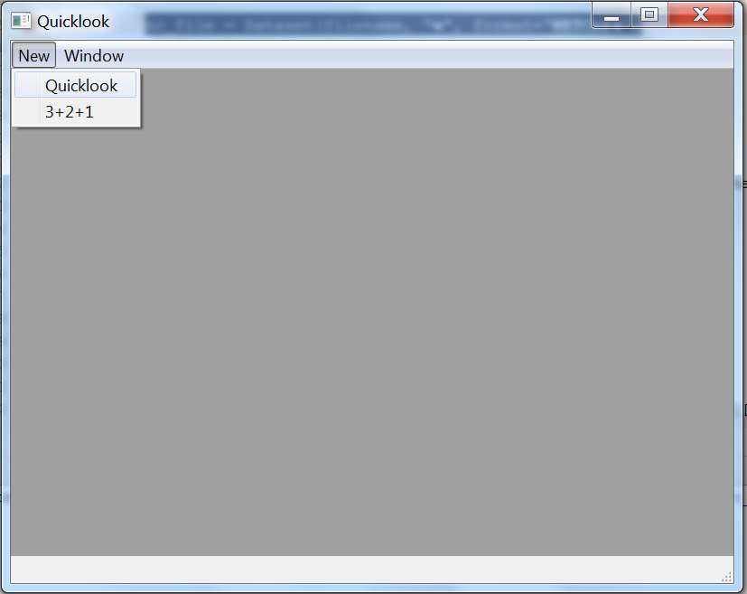
Abbildung 5: open a data file
- Select one raw data file. This can be
  - a PollyXT netCDF file
  - or a zipped PollyXT netCDF file
  - Note: it is not yet possible to open more than one file.
- A quicklook plot appears (left) and averaged signal profiles (right). Those plots can be optimized.
  - The color map can be selected by right mouse click on the color bar (1)
  - The color scale of the quicklook can be modified using the handlers at the color bar. (2)
  - The altitude axis (y axis) can be modified by right mouse click on the quiclook or profile plot. The altitude axes of both plots are linked. (3)
  - The time axis of the quicklook and x-axis of the profile plot can be changed by right mouse click on the corresponding plot.
  - Zooming is possible with the mouse wheel. Also in this case, both altitude axes are linked.
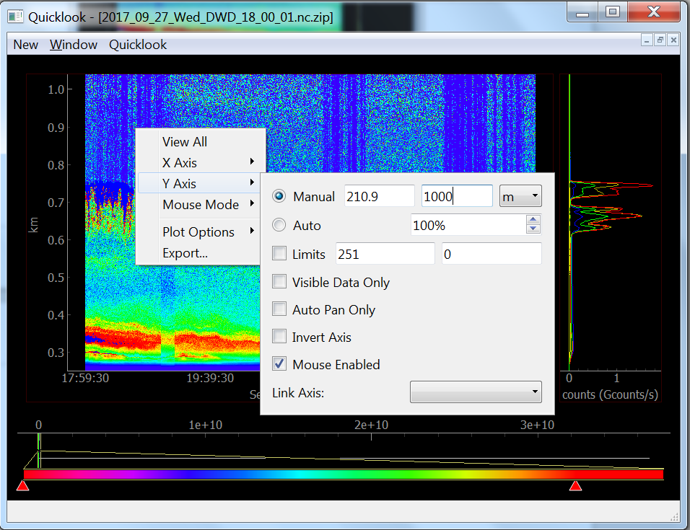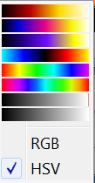
2)
2)
1)
3)
Abbildung 6: Optimize plots

Select time periods (regions) for further analysis
- A double click with the center mouse botton (or mouse wheel) on the quicklook will create a new region which appears in blue transparent color. The edges of the region can be easily shifted with the mouse. Note, there is still a small cloud visible in the profile plot of the example.
- a right mouse click into this region brings a menu with the following options:
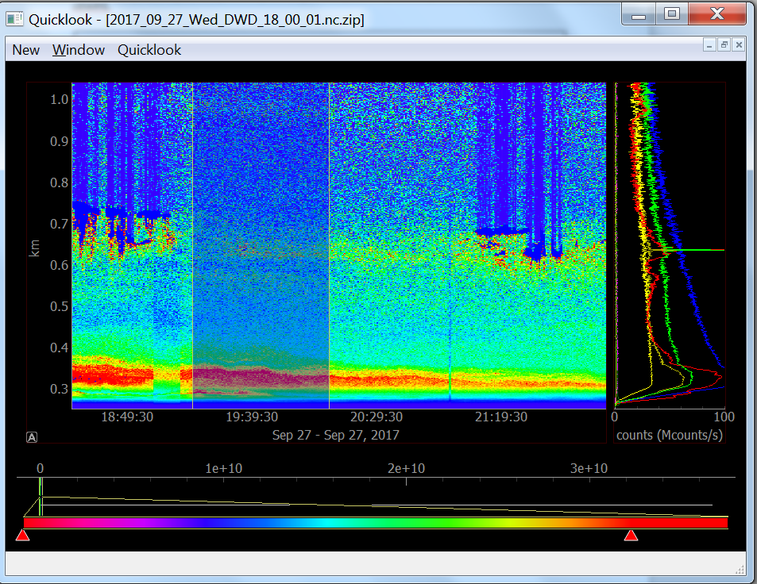
Abbildung 7: create a region
  - set region invalid →all data within the region can be marked as ‚invalid‘ (e.g. clouds) and are excluded from further analysis. invalid regions appear in red transparent color.
  - delete region →the region (not the data!) can be deleted from the plot
  - from start / to end →the region can be extended to the start / end of the measurement
  - set time period →the region can be defined with a specific time period
  - show →profile plot shows the average of all signal profiles in the region
- Regions can be stacked. E.g. if a small cloud is within the selected region, it can be excluded, by adding another region at the cloud position only and setting this second region as invalid. Note, the cloud in the example signal profile vanished.

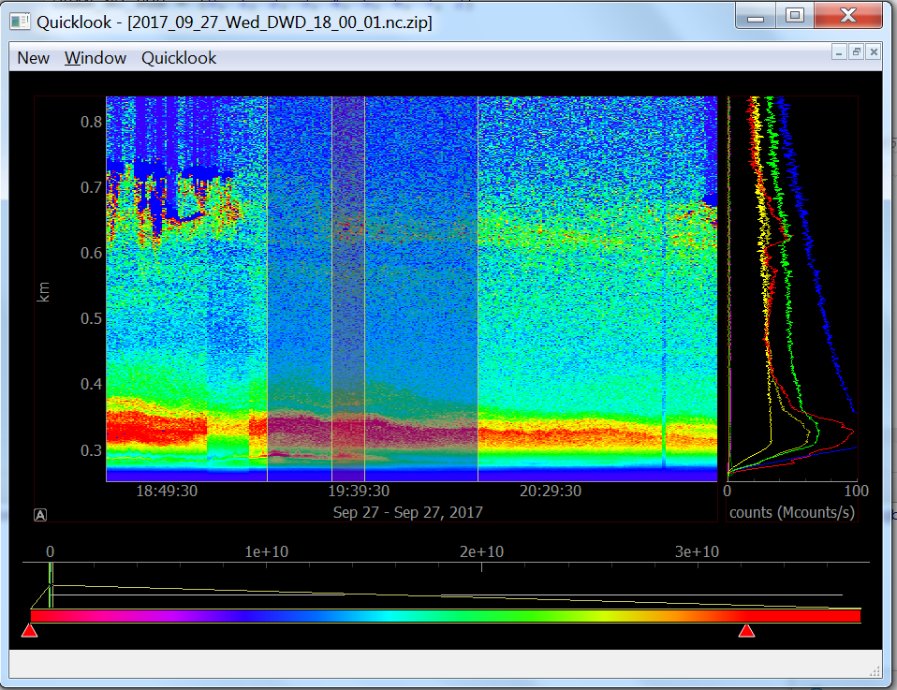
Abbildung 8: setting a region as invalid

Exporting data to SCC
- When a time period (region) was selected properly, the signal data can be exported into SCC raw data format. A right mouse click into the region brings a menu which has the following 2 options for the export:
  - Filter and save as scc file
    - All signal profiles within the selected period are exported into SCC raw data format, except those profiles
      - which were labeled as invalid
      - signal profiles with polarization filter positions other than CAL_ANGLE_MEASUREMENT
    - The export dialog allows to set a measurement ID, to write a comment filed for the raw data file, and to define a radio sonde for the data analysis.
    - If no radio sonde name file is selected - the raw data file is created using the analysis option standard atmosphere.
    - If a radio sonde file is provided, also the sonde data are converted into SCC raw data format. the radio sonde must be in Wyoming data format (incl. footer) and must have the extension *.txt . An example file is provided in the repository.
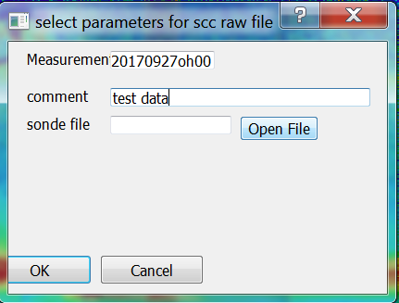
  - filter and save as depol cal file
    - all signal profiles within the selected period which have polarization filter positions other filter position for regular measurements (CAL_ANGLE_MEASUREMENT) are exported as SCC raw signal for depolarization calibration measurements.
    - It is not necessary to select the calibration period carefully, since the filtering process will eliminate all profiles which are measured with the regular measurement position and all profiles which have filter positions which do not belong to the two most frequent values (profiles with moving polarization filter)
- all created files (SCC measurements, sonde files, calibration files) are stored in the OUT_PATH directory.

