CSC110AB
MinilabMusicArray

The problem: You are to write a class called MusicArray. It should play 3 tunes of 5 to 12 notes. We will write the notes for first tune in class together, we will use loops. You will write three methods: a) play a 2D music song array using a for-each loop, b) play 3D music song array using nested for-loops, and c) play a 3D music song array with nested for-each loops. (Hint: “foreach” loops will work for any number of notes.)

Music in the West is based on octaves of 12 evenly space notes (technically, it is evenly exponential or logarithmic). To go up an octave, or twelve notes, you must double the frequency. The frequency of each individual note is the 12th root of 2.0 ( ¹²√ 2 ) greater than the last note. The 12th root of 2.0 is called a HALF step. To go down a HALF step, you divide by the 12th root of 2.0. A FULL step is a HALF step squared or HALF step*HALF step. A typical C-Major scale (Do Re Mi Fa So La Ti Do), skipping the sharp ( ♯ ) and flat ( b ) black notes, starts at “C5” (523.2 Hz) and follows only the white piano notes with the sequence:
Do C5 523.2 Hz
Re FULL step (D5),
Mi FULL step (E5),
Fa HALF step (F5)
So FULL step (G5)
La FULL step (A5)
Ti FULL step (B5)
Do HALF step (C6)
A flat ( b ) means go down a HALF step, while a sharp ( ♯ ) means go up a HALF step.
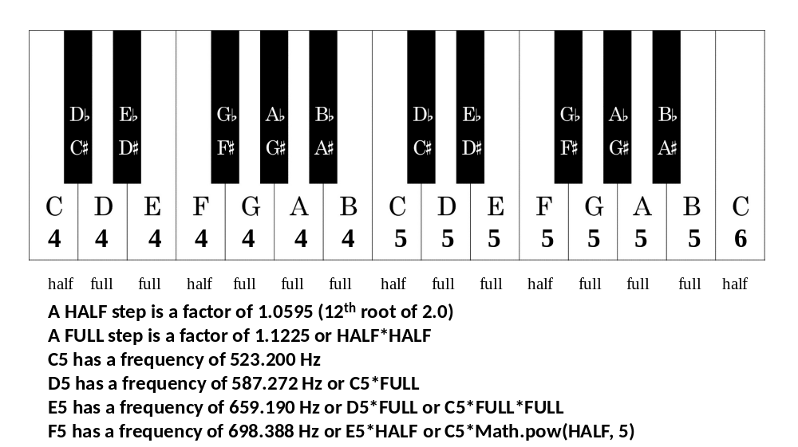
The notes of your songs or tunes are stored in a 2 and 3-dimensional array
song2d[12][2].
1st dimension: Notes 0, 1, 2, … 11. Unused notes are set to null or not used.
2nd dimension: Frequency [index 0] and Millisecond Duration [index 1]

double[][] song2d =
{
null, null, null, null, null, null,
null, null, null, null, null, null //no tune
};

songs3d[2][12][2].
1st dimension: Songs 0, 1. Unused songs are set to null.
2nd dimension: Notes 0, 1, 2, … 11. Unused notes are set to null or not used. You may increase
the number of notes, if you wish.
3rd dimension: Frequency [index 0] and Millisecond Duration [index 1]

double[][][] songs3d =
{
{ null }, //no tunes
{ null }
};

A pleasant duration for a note is 650 milliseconds or 0.65 or 2/3rds of a second.

Pick two tunes or parts of songs and calculate the frequencies of the notes and set a duration for each note.

In class, we will calculate the five notes from Close Encounters of the Third Kind (Youtube: https://www.youtube.com/watch?v=E5ey_pSRBV0 ), which the aliens used to say “hello”. The notes are D5, E5, C5, C4, G4.

final double MSEC = 650; //milliseconds (0.65 secs)
final double HALF = Math.pow(2.0, 1/12.0);
final double FULL = HALF * HALF;
double C5 = 523.2;
double D5 = C5 * FULL;
double E5 = C5 * Math.pow(HALF,4); //or =D5 * FULL;

double[][] song2d =
{
//song2d – Close Encounters FIVE NOTES
{D5,MSEC}, {E5,MSEC}, {C5,MSEC}, null, null
};

Methods to write:

- A static void method called playSong( ) that takes a song2d[ ][ ] array as an argument using a for-each loop. Beware of null! You might need to test !=null for each note. Pause for 2-3 seconds before starting each song. Hint: you will need to declare throwing an Exception like in main(). Use the for-each loop (with the colon) to get to the notes:
for( double[ ] note : list)
- A static void method called playForLoop3D() that takes a song3d[ ][ ][ ] array as an argument using nested for-loops. Beware of null! You might need to test !=null for each note. Pause for 2-3 seconds before starting each song. Hint: you will need to declare throwing an Exception like in main(). Use two nested standard for-loops (with the semi-colons) to get to the notes:
for( int song=0; CONDITION; s ong++)
for( int note=0; CONDITION; note++)
- A static void method called playSongList( ) that takes a song3d[ ][ ][ ] array as an argument using for-each loops. Beware of null! You might need to test !=null for each song. Hint: you can call playSong(). Hint: you will need to declare throwing an Exception like in main().
Use two nested for-each loop (with the colon) to get to the notes:
for( double[ ][ ] song : list)
for( double[ ] note : song)

Please submit: Code 3 songs, one for the 2D array, two for the 3D array, and then ZIP your mlMusicArray project and submit using Canvas.

