CSC110AB
Program4

The problem:

You will have to create a “Tank” and guide it through a “Landscape” in order to move around a simple obstacle course to reach a “Target.” Everything you need will be provided to you in predefined classes; you have to use the classes and your own logic to tell the Tank how to reach the Target.

Classes you will use:

To use each of these classes, you will get an instance of the class (either created by you or returned from a method) and then tell it to do things (its methods).

The following classes are built into Java. We have previously used some of them. They are all documented on the java.sun.com website under “APIs”. The package they are in is shown at the very top of the documentation; if the class is in a specific package (other than java.lang), be sure and import that package.

- String We have used this class already.
- Scanner Can be used to get keyboard input (we have done this already)
- Random Used to create a random number generator. After you create one, you can tell it to return its nextInt(<num>), which will return a random number between 0 and <num> -1. (we have used this already, but you can use Math.random() instead if you’d rather).
- Point Represents an (x,y) coordinate. Note that when you tell a Point to getX(), it will return the value as a double. Since we are working with pixels on a screen (integers), you will have to typecast it to an int.
- Color Represents a color. It stores each of the RGB (Red, Green, Blue) components of the color as an integer from 0-255. So the statement:

Color myColor = new Color(255, 0, 255);

would create a Color that has as much red as possible, no green, and as much blue as possible. The result would be purple. The Color class also has some “static” values. For example, the statement:

Color myColor = Color.BLUE;

would create a Color that is blue. See the java documentation for the predefined Colors.

You are also given 3 classes that I wrote. The classes are:

- Direction Gives the orientation of the Tank: LEFT, RIGHT, UP, DOWN, NE, SE, SW, NW

- Tank Describes a drawable “Tank” (which is drawn as a square). You are not to change its code. It has the following constructors and methods (if you look at Tank.java, you may see a few others that you can use if you want, but the ones below are the ones you will need). Note that the following show how they are defined (like the listings in the java.sun.com classes), not the exact way they would be called…
//default constructor - sets it to Black and VERY slow
public Tank()

//"parameterized constructor" - receives a color and a speed (1-30)
public Tank(Color theColor, int theSpeed)

// move - changes its position by 1 pixel, either forward or backwards
public void move()

// reverse – change tank transmission to move backwards
public void reverse()

// forward – change Tank transmission to move forward
public void forward()

// getTankOrientation – get the Direction the Tank is facing
public Direction getTankOrientation()

// getDimension - returns the dimension
// (both length and width, since it’s a square)
public int getDimension()

// getPositionX() - returns its x coordinate
public int getPositionX()

// getPositionY() - returns its y coordinate
public int getPositionY()

// setPosition – sets its position to whatever x and y are passed in
public void setPosition(int x, int y)
(you are not allowed to use this method)

// setColor - sets its color to whatever is passed in
public void setColor(Color newColor)

// turn - "turns" by changing its orientation
public void turn(String whichWay)
(you can pass in “left” or “right”)
(you can also turn “half-left” and “half-right” for 45-degrees motion)

//toString - returns its representation as a String
public String toString()

- Landscape Describes a drawable “Landscape” which is a simple obstacle course consisting
of 2

Walls (with an opening that can fit a Tank) and a “Target.” You are not to change its code.

Landscape’s constructors and methods are listed below. Note that the following show how they are defined (like the listings in the java.sun.com classes), not the exact way they would be called…

// Default constructor - generates a random position for the green opening, the orange
// opening, and the target.
public Landscape()

// Parameterized constructor which receives an int that is the landscapeID
public Landscape(int theID) (must be between 0000 and 9999)

An example of a Landscape instance, along with some relevant notes, is shown below:
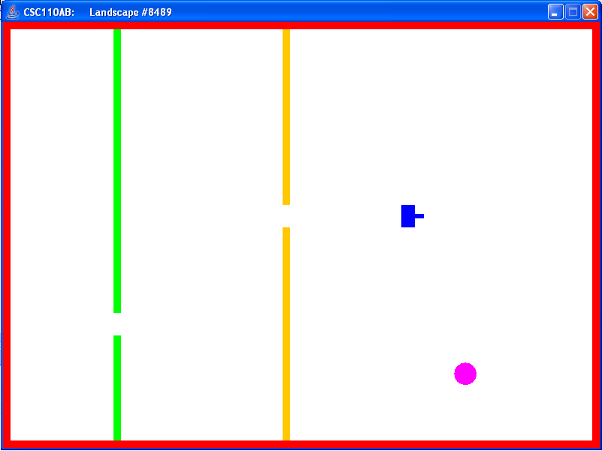
A Tank’s coordinates are always at the upper left hand corner

The Target’s coordinates are at the upper left hand corner of the “bounding rectangle”.

The green opening’s coordinates are here. coordinates are always at the upper left hand corner

The orange opening’s coordinates are here. coordinates are always at the upper left hand corner

y increases
downward
x increases
to the right
The green and orange walls are at constant x-coordinates

// getOrangeOpening - returns the opening in the orange wall as a Point
// (the top/left point of the lower section)
public Point getOrangeOpening()

// getGreenOpening - returns the opening in the green wall as a Point
// (the top/left point of the lower section)
public int getGreenOpening()

// addTank - adds the Tank that is received to this instance of Landscape
public void addTank(Tank t)

// targetMovement – allows Target to move (pass true to allow Target to move)
public void targetMovement(boolean truefalse)

// getTargetLocation - returns a Point which is the location of the target
// (actually the upper/left point of its bounding rectangle)
public Point getTargetLocation()

// getTargetOrientation – get the Direction the Target is facing
// (Target is always pointing NE, SE, SW, NW)
public Direction getTargetOrientation()

// directionToTarget – which way the Tank must move toward the Target
public Direction directionToTarget()

// distanceToTarget – number of pixels from Tank to Target
public int distanceToTarget()

// targetHit – has Target been hit?
public Boolean targetHit()

Your program:

Your program should be named Program4.java. It will contain the main method; inside main should be code to do the following:

  - Prompt the user to enter their name then use the Scanner class to read it in

  - If their name is “Costello” (don’t use == for Strings; use equalsIgnoreCase here), then
    - Create a new Color that consists of a random amount of Red, a random amount of Green, and a Random amount of Blue (different random numbers).
    - Create a new instance of a Tank, passing in the Color you created and any speed you want.
  - But if their name is “Abbott” (don’t use == for Strings; use equalsIgnoreCase here), then
    - Create a new instance of a Tank, passing in some shade of Green and any speed you want. The shade of Green can be either the “static” value you get from the class (see my brief description of the Color class above), or a custom Color you created with no Red, some amount of Green, and no Blue.
  - Otherwise, create a new instance of a Tank with whatever non-Green Color you want (see my brief description of the Color class above) and any speed you want.

  - Once your Tank is created, you should create a new instance of a Landscape. You should call its default constructor, which will create one with random openings in the walls and target location. The ID for that particular Landscape will be displayed at the top.
    - NOTE: for testing purposes, you can create a new instance of a Landscape by passing the ID into the constructor. That way, you test your logic against a particular Landscape over and over as you debug it. Your final version of Program4 should call its default constructor so that it creates a random Landscape.

  - Tell your Landscape to add your Tank to itself.

  - Tell your Landscape and Tank to return whatever unchanging data (location of openings, dimension of the Tank, location of the target) you will need to program the commands that tell the Tank to successfully move through the Landscape.
    - Note: when you ask the Landscape to getGreenOpening(), it will return it as a Point. What you will eventually need is the x and y values, so be sure and get those values out of the Point that is returned. The same is true for other methods that return a Point.

  - Once you have all the unchanging data, figure out and program the logic to tell your Tank to move through the openings and to the target.
    - You can only move() one pixel at a time, so if you want to move any distance you should put the move() statement in a loop.
    - The location of the Tank will change as it moves. To keep your calculations up to date, you will have to ask the Tank over and over what its position is.
    - You need to move through the openings in both wall BACKWARDS!. Turn 180 degrees and then tell the Tank to reverse(). Once you are through both openings, turn 180 degrees again and command the Tank to go forward().

  - If you want 50 points of extra credit, try setting myLandscape.targetMovement(true); Now the Target will move around and is no longer in a fixed location. Now some of the other Target methods will be handy:
    - myLandscape.targetHit()
    - myLandscape.directionToTarget()

The Target only moves in NE, SE, SW, NW directions, so half turns can be handy:
    - myTank.turn("half-left")
    - myTank.turn("half-right")

Testing your program: Please note:

- Every time a Landscape is created, its 4-digit ID number will be displayed in the title bar. Landscape has a constructor that will allow you to pass in a 4-digit ID number if you want to keep testing with the same Landscape.
- If you cannot figure out how to get it to work for any Landscape, you can get a small amount of partial credit for making it work for #6147 and way you can (“hard-coding” the Tank’s movements).
- If you put System.out.println’s in your code for debugging, they will print in the black DOS window behind the Landscape frame.

Please submit: Zip up your pgm4Tank project and submit via Canvas.

Grading: The following Rubric shows how your program will be graded for functionality. Deductions for not following requirements, lateness, maintainability (commenting, variable names, indenting, etc) will be taken off in addition.

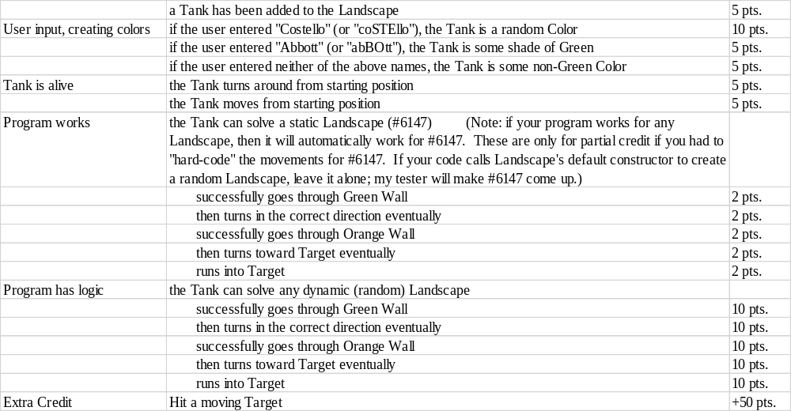

I have test code that I will add to your Program4 to run 13 different landscapes with your Program6.java main.

2014 CHANGES:

- The Tank is now a Polygon instead of a Rectangle. The Tank can be drawn facing any 45 degrees increment.
- Tank turn commands must now always be lowercase: "left", "right".
- Direction is now in 45 degrees increments (or PI/4 radians counter-clockwise order): RIGHT, NE, UP, NW, LEFT, SW, DOWN, SE. DirectionVariable.value will return the ordinal value 0..7 of the enumeration.
- Tank turn(), move() and draw() have been simplified using arrays, instead of if-else-if logic. Also, the Direction/orientation is easier since they are in circular order: a turn("left") of an orientation of RIGHT is simply a +2 to orientation UP. All direction/orientation computations always use positive numbers and modulus 8. A turn("half-right") of an direction of DOWN=6 is a +7 MOD 8 to direction SW=5.
- draw() is efficient with SINs and COSs of the eight 45 degrees rotations being stored in a static array at Tank construction.
- The Landscape run() infinite loop has a “finished” Boolean that allows the loop to exit. The .stopMe() method allows the run() code to exit gracefully.
- The Target may move now. By default, motion is off. To turn on Target motion, call myLandscape.targetMovement(true) to start the Target moving. The movement direction is random in diagonal directions: NE, NW, SW, SE. The Target will “bounce” off a wall when it gets within half its width. The Target should always be slower than the Tank.
- New Landscape methods:
  - Direction getTargetOrientation()
  - Direction directionToTarget()
  - int distanceToTarget()
  - boolean targetHit()
  - void targetMovement(boolean)
- New Tank methods:
  - Direction getTankOrientation()

