CSC110AB
Minilab Menu Order GUI

The program: You are to write a program called MinilabMenuOrderGUI which allows a user to order a main meal, one or two side items, and a beverage. You should have fun with this. (Can you add any images or logos? Put some Romulan Ale on your menu?)
- Create a JFrame Windows application for your mainline.
- For the main meal, have a combo-box (dropdown list) of at least three meal items.
- For at least three side items, use checkboxes to allow selecting more than one side.
- For at least three beverages, use mutually-exclusive radio buttons. (You will need to use a ButtonGroup.)
- At the bottom of your GUI, put a [Submit Order] button which will display a JOptionPane to summarize the order. You will need to link in an event to your button. Be careful, the user may not make all three selections.

Example: Here is an example of what your GUI could look like. This is just a suggestion, and your GUI should not be identical.

GUI:
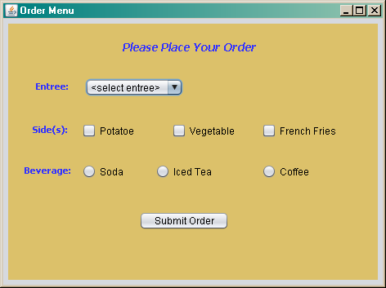

JOptionPane Order Summary
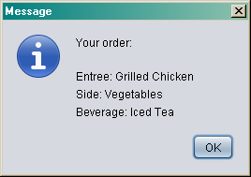

To submit: Please use Canvas to submit your Zipped mlMenuOrderGUI project.

