**7. System Evaluation**

**7.1. Usability Evaluation Strategy**

The process of judgment of system's usability and elasticity is called Evaluation. In the beginning a series of questions is set to take an interview with the client. In this session the client is asked about the functionality of the system, how he/she wants their system to be designed. After the system is designed the system is further asked about the system performance after he/she uses it. Some of the sample questions are discussed below.

1. On the whole, how was your experience using the system?
2. Did you face any complication?
3. Are all functionality working as per you need?
4. Did you found any errors in the system?
5. Do you need any help using the system?

**7.2. System Pilot Trials**

**User 1:**

1. How was your experience using the system?

|  |  |
| --- | --- |
| Excellent |  |
| Good | Green Check Mark Icon In A Circle. Tick Symbol In Green Color,.. Royalty  Free Cliparts, Vectors, And Stock Illustration. Image 136058493. |
| Satisfactory |  |
| Bad |  |

1. Are all functionality working as per you need?

|  |  |
| --- | --- |
| Yes | Green Check Mark Icon In A Circle. Tick Symbol In Green Color,.. Royalty  Free Cliparts, Vectors, And Stock Illustration. Image 136058493. |
| No |  |

1. Did you face any complication?

|  |  |
| --- | --- |
| Yes | Green Check Mark Icon In A Circle. Tick Symbol In Green Color,.. Royalty  Free Cliparts, Vectors, And Stock Illustration. Image 136058493. |
| No |  |

1. Did you found any errors in the system?

|  |  |
| --- | --- |
| Yes | Green Check Mark Icon In A Circle. Tick Symbol In Green Color,.. Royalty  Free Cliparts, Vectors, And Stock Illustration. Image 136058493. |
| No |  |

1. Do you need any help using the system?

|  |  |
| --- | --- |
| Yes | Green Check Mark Icon In A Circle. Tick Symbol In Green Color,.. Royalty  Free Cliparts, Vectors, And Stock Illustration. Image 136058493. |
| No |  |

**User 2:**

1. How was your experience using the system?

|  |  |
| --- | --- |
| Excellent | Green Check Mark Icon In A Circle. Tick Symbol In Green Color,.. Royalty  Free Cliparts, Vectors, And Stock Illustration. Image 136058493. |
| Good |  |
| Satisfactory |  |
| Bad |  |

1. Are all functionality working as per you need?

|  |  |
| --- | --- |
| Yes | Green Check Mark Icon In A Circle. Tick Symbol In Green Color,.. Royalty  Free Cliparts, Vectors, And Stock Illustration. Image 136058493. |
| No |  |

1. Did you face any complication?

|  |  |
| --- | --- |
| Yes |  |
| No | Green Check Mark Icon In A Circle. Tick Symbol In Green Color,.. Royalty  Free Cliparts, Vectors, And Stock Illustration. Image 136058493. |

1. Did you found any errors in the system?

|  |  |
| --- | --- |
| Yes | Green Check Mark Icon In A Circle. Tick Symbol In Green Color,.. Royalty  Free Cliparts, Vectors, And Stock Illustration. Image 136058493. |
| No |  |

1. Do you need any help using the system?

|  |  |
| --- | --- |
| Yes |  |
| No | Green Check Mark Icon In A Circle. Tick Symbol In Green Color,.. Royalty  Free Cliparts, Vectors, And Stock Illustration. Image 136058493. |

**User 3:**

1. How was your experience using the system?

|  |  |
| --- | --- |
| Excellent |  |
| Good |  |
| Satisfactory | Green Check Mark Icon In A Circle. Tick Symbol In Green Color,.. Royalty  Free Cliparts, Vectors, And Stock Illustration. Image 136058493. |
| Bad |  |

1. Are all functionality working as per you need?

|  |  |
| --- | --- |
| Yes | Green Check Mark Icon In A Circle. Tick Symbol In Green Color,.. Royalty  Free Cliparts, Vectors, And Stock Illustration. Image 136058493. |
| No |  |

1. Did you face any complication?

|  |  |
| --- | --- |
| Yes | Green Check Mark Icon In A Circle. Tick Symbol In Green Color,.. Royalty  Free Cliparts, Vectors, And Stock Illustration. Image 136058493. |
| No |  |

1. Did you found any errors in the system?

|  |  |
| --- | --- |
| Yes | Green Check Mark Icon In A Circle. Tick Symbol In Green Color,.. Royalty  Free Cliparts, Vectors, And Stock Illustration. Image 136058493. |
| No |  |

1. Do you need any help using the system?

|  |  |
| --- | --- |
| Yes | Green Check Mark Icon In A Circle. Tick Symbol In Green Color,.. Royalty  Free Cliparts, Vectors, And Stock Illustration. Image 136058493. |
| No |  |

**7.3. System Trial Results**

From the feedback result of the users we have made following conclusions:

|  |  |  |
| --- | --- | --- |
| S.no. | System Evaluation | Average Evaluation Results |
| 1. | System Usability | Simple To Use |
| 2. | System complication | Good |
| 3. | Errors | No errors |
| 4. | System Functionalities | Proper as expected |
| 5. | Help for system use | Required |
| 6. | Overall feedback | Good |

**8. Project Management**

Project management is the method of driving the work of a group to attain objectives and meet good result criteria at a specified time. The essential challenge of project administration is to attain all the project objectives inside the given elicitation.

The project is managed using trello and github. All the group members have put their task in github. Different cards were made in trello where the assigned task for all the members as put and members have given their update. Similarly, in github the assigned code was pushed.

Due to the proper help of our respected teacher Mr. Suresh Gautam, we were able to finish this project within given time. While working on this project we were able to learn about API’s, test cases, BON chart and many other things related to the assignment. With the help of this project, we have learnt about group management and the working procedure with group within a industry.

Below are different attributes that define the proper process for the management of project.

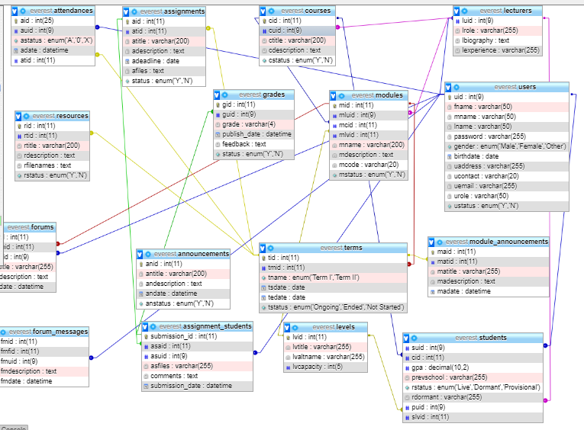

|  |  |  |
| --- | --- | --- |
| **Attribute** | **Datatype** | **Constraint** |
| users | | |
| uid | INT(9) | PK |
| fname | VARCHAR2(50) |  |
| mname | VARCHAR2(50) |  |
| lname | VARCHAR2(50) |  |
| password | VARCHAR2(255) |  |
| gender | ENUM(“male”, “female”, “other”) |  |
| Birthdate | DATE |  |
| uaddress | VARCHAR2(255) |  |
| ucontact | VARCHAR2(20) |  |
| uemail | VARCHAR2(255) |  |
| urole | VARCHAR2(50) |  |
| usatus | ENUM(“Y”, “N”) |  |

|  |  |  |
| --- | --- | --- |
| **Attribute** | **Datatype** | **Constraint** |
| grades | | |
| gid | INT(11) | PK |
| guid | INT(9) |  |
| grade | VARCHAR2(4) |  |
| Pubish_date | DATE TIME |  |
| feedback | TEXT |  |
| status | ENUM(“Y”, “N”) |  |

|  |  |  |
| --- | --- | --- |
| **Attribute** | **Datatype** | **Constraint** |
| assignment_students | | |
| Submission_id | INT(11) | PK |
| asaid | INT(11) |  |
| asuid | INT(9) |  |
| asfiles | VARCHAR2(255) |  |
| comment | TEXT |  |
| submission_date | ENUM(“Y”, “N”) |  |

|  |  |  |
| --- | --- | --- |
| **Attribute** | **Datatype** | **Constraint** |
| courses | | |
| cid | INT(11) | PK |
| cuid | INT(9) |  |
| ctitle | VARCHAR2(255) |  |
| cdescription | TEXT |  |
| cstatus | TEXT |  |

|  |  |  |
| --- | --- | --- |
| **Attribute** | **Datatype** | **Constraint** |
| announcements | | |
| anid | INT(11) | PK |
| antitle | VARCHAR2(255) |  |
| andescription | TEXT |  |
| andate | DATE TIME |  |
| anstatus | ENUM(“Y”, “N”) |  |

|  |  |  |
| --- | --- | --- |
| **Attribute** | **Datatype** | **Constraint** |
| module_announcement | | |
| maid | INT(11) | PK |
| matid | INT(11) |  |
| matitle | VARCHAR2(255) |  |
| madescription | TEXT |  |
| madate | DATE TIME |  |

|  |  |  |
| --- | --- | --- |
| **Attribute** | **Datatype** | **Constraint** |
| Forum_message | | |
| fmid | INT(11) | PK |
| fmftid | INT(11) |  |
| fmuid | INT(9) |  |
| fmdescription | TEXT |  |
| fmdate | DATE TIME |  |

|  |  |  |
| --- | --- | --- |
| **Attribute** | **Datatype** | **Constraint** |
| forum | | |
| fid | INT(11) | PK |
| fmtid | INT(11) |  |
| fuid | INT(9) |  |
| fdescription | TEXT |  |
| fdate | DATE TIME |  |

|  |  |  |
| --- | --- | --- |
| **Attribute** | **Datatype** | **Constraint** |
| levels | | |
| lvid | INT(11) | PK |
| lvtitle | VARCHAR(255) |  |
| lvalname | VARCHAR(255) |  |
| lvcapacity | INT(5) |  |

|  |  |  |
| --- | --- | --- |
| **Attribute** | **Datatype** | **Constraint** |
| students | | |
| suid | INT(9) | PK |
| cid | VARCHAR2(50) |  |
| gpa | DECIMAL(10,2) |  |
| prevschool | VARCHAR2(50) |  |
| rstatus | VARCHAR2(255) |  |
| rdormant | ENUM(‘LIVE’,’DORMANT’, ‘PROVISIONAL’) |  |
| puid | INT(9) |  |
| slvid | INT(11) |  |

|  |  |  |
| --- | --- | --- |
| **Attribute** | **Datatype** | **Constraint** |
| lectures | | |
| luid | INT(9) | PK |
| lrole | VARCHAR2(50) |  |
| lbiography | TEXT |  |
| lexoerience | VARCHAR2(50) |  |

|  |  |  |
| --- | --- | --- |
| **Attribute** | **Datatype** | **Constraint** |
| terms | | |
| tid | INT(11) | PK |
| tmid | INT(11) |  |
| tname | ENUM(‘TERM I’, ‘TERM II’) |  |
| tsdate | DATE |  |
| tedate | DATE |  |
| tstatus | ENUM(‘ONGOING’, ENDED, ‘NOT STARTED’) |  |

|  |  |  |
| --- | --- | --- |
| **Attribute** | **Datatype** | **Constraint** |
| assignments | | |
| aid | INT(25) | PK |
| atid | INT(11) |  |
| atitle | VARCHAR(200) |  |
| adescription | TEXT |  |
| adeadline | DATE |  |
| afiles | TEXT |  |
| status | ENUM(‘Y’, ‘N’) |  |

|  |  |  |
| --- | --- | --- |
| **Attribute** | **Datatype** | **Constraint** |
| Resources | | |
| Rid | INT(11) | PK |
| rtid | INT(11) |  |
| rtitle | VARCHAR(200) |  |
| rdescription | TEXT |  |
| rfilenames | TEXT |  |
| rstatus | ENUM(‘Y’, ‘N’) |  |

|  |  |  |
| --- | --- | --- |
| **Attribute** | **Datatype** | **Constraint** |
| Resources | | |
| Rid | INT(11) | PK |
| rtid | INT(11) |  |
| rtitle | VARCHAR(200) |  |
| rdescription | TEXT |  |
| rfilenames | TEXT |  |
| rstatus | ENUM(‘Y’, ‘N’) |  |

|  |  |  |
| --- | --- | --- |
| **Attribute** | **Datatype** | **Constraint** |
| modules | | |
| mid | INT(11) | PK |
| mluid | INT(9) |  |
| mcid | INT(11) |  |
| mlvid | INT(11) |  |
| mname | VARCHAR(200) |  |
| mdescription | TEXT |  |
| module | VARCHAR(20) |  |
| mstatus | ENUM(‘Y’, ‘N’) |  |