Initial concept:
FocusFlow — an AI productivity app.
Hero:
Get more done.
Focus on what actually matters.
Features:
- Smart task planning
- AI-powered prioritisation
- Productivity analytics
Footer:
- Product
- Features
- About
- Contact
Responsiveness:
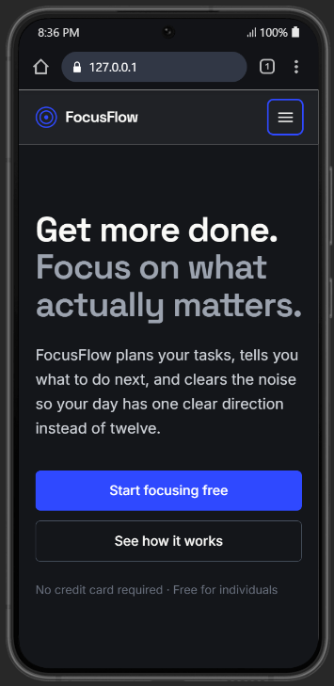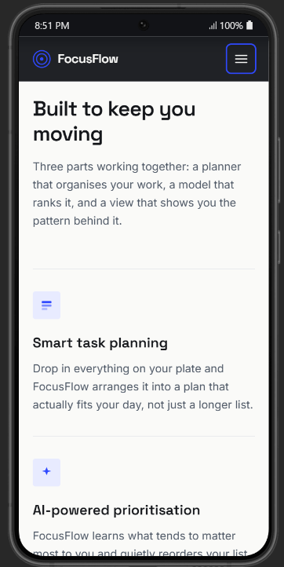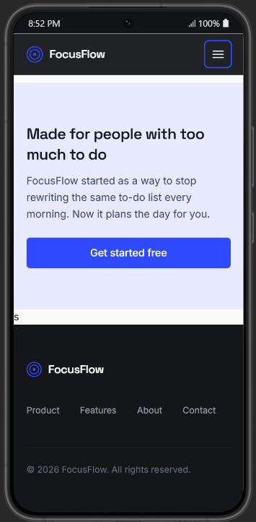
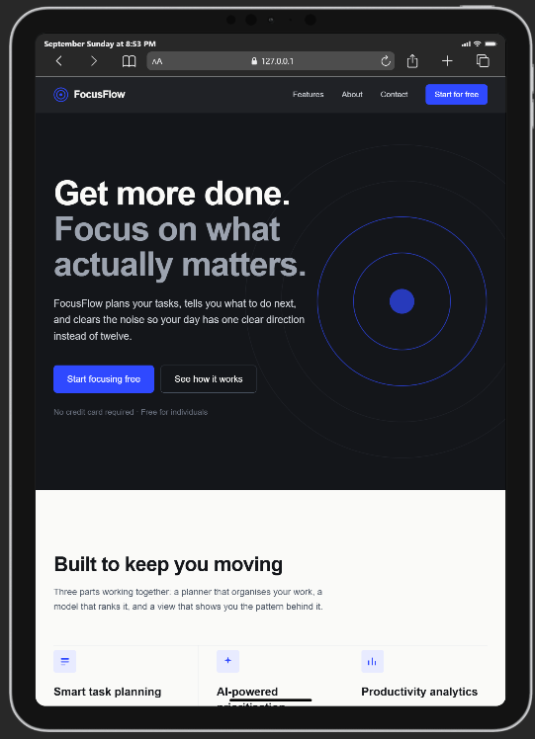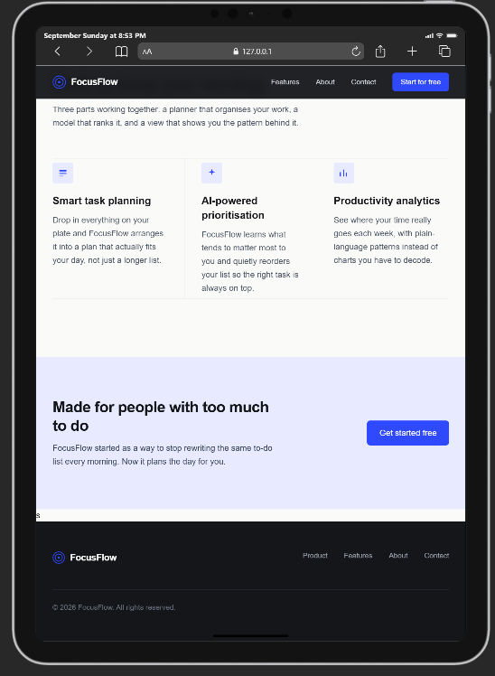
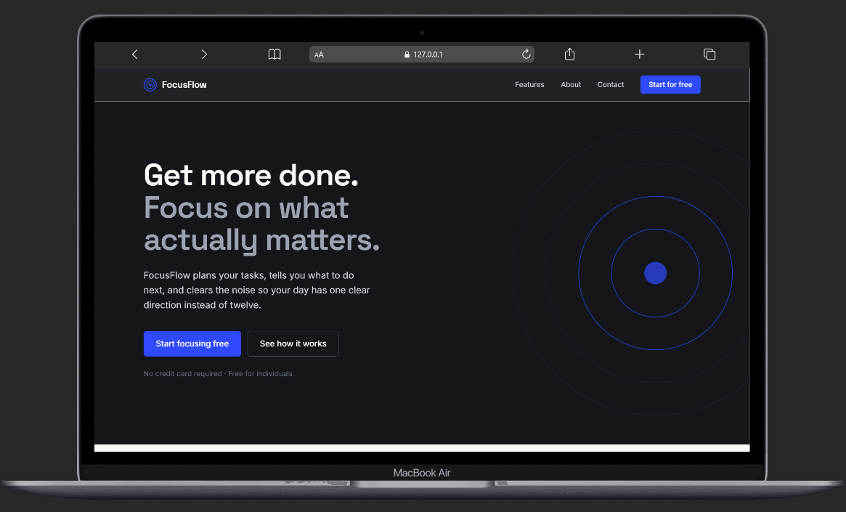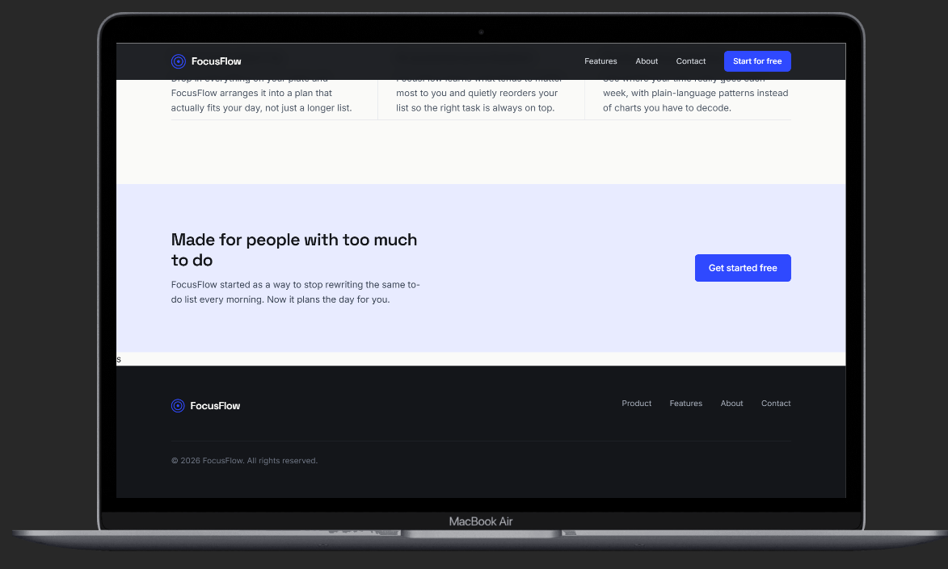

Reflection:
Claude provided the initial Tailwind scaffold for my FocusFlow landing page, including the overall layout, navigation, feature section, and footer. I hand-refined the page by correcting the CTA from "Start Focusing Free" to "Start Focusing for Free," adding my contact information, and adjusting the layout and spacing for different screen sizes. I also improved accessibility by ensuring the page is compatibl

