老段：



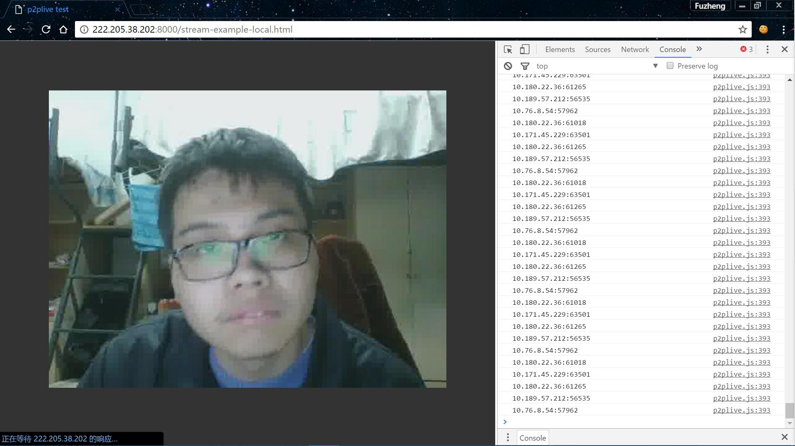

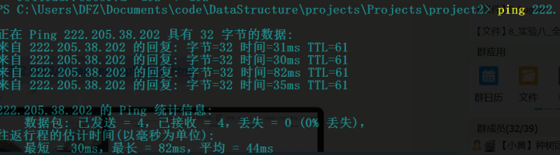

TG：



叶子：

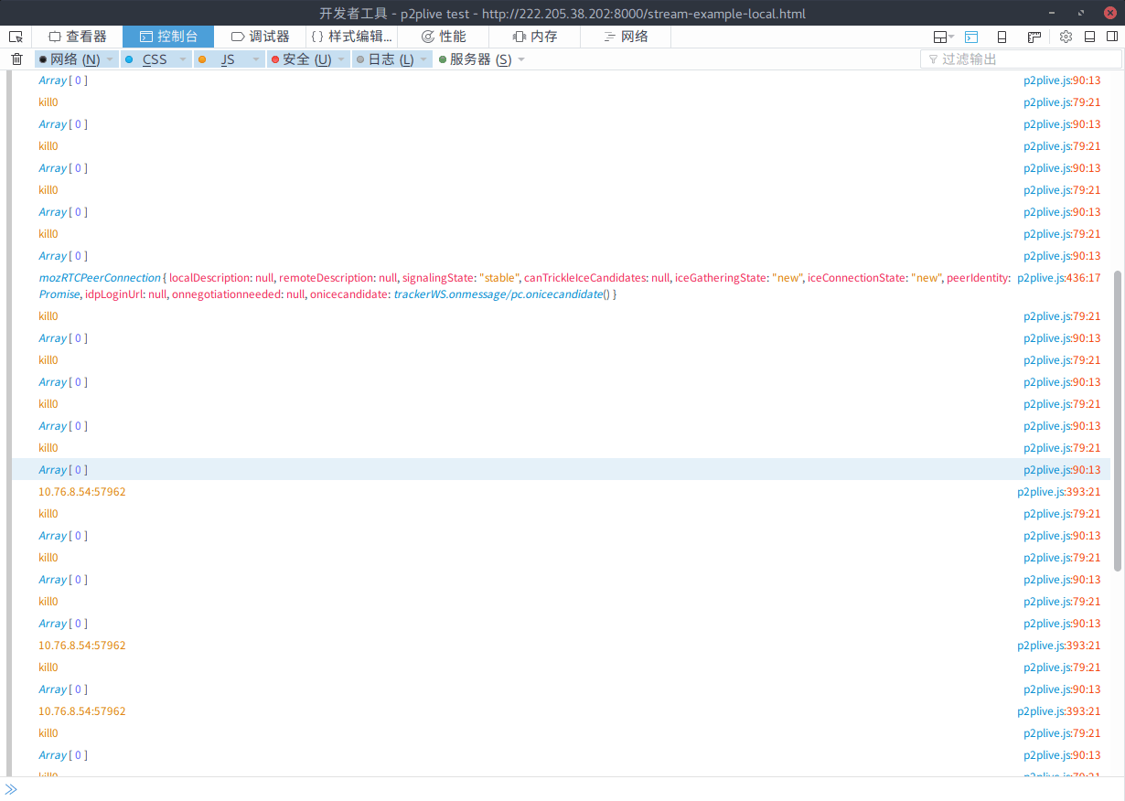

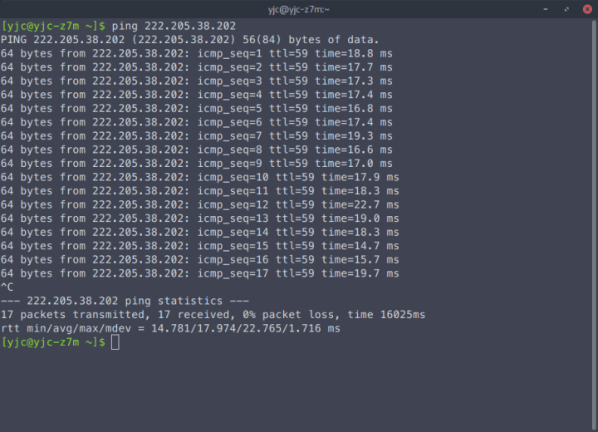

Tracker记录：

2016/11/26 23:22:23 [INFO] Register: 200 OK

2016/11/26 23:22:25 [INFO] Resource: client:222.205.38.202:56779 has connected.

2016/11/26 23:22:25 [INFO] Sourcepeeker: DirectClient:0 ForwardAvaildable:1 so make a direct pull

2016/11/26 23:24:30 [INFO] Resource: client:222.205.38.202:56779 has been removed.

2016/11/26 23:24:39 [INFO] Resource: client:222.205.38.202:56869 has connected.

2016/11/26 23:24:39 [INFO] Sourcepeeker: DirectClient:0 ForwardAvaildable:1 so make a direct pull

2016/11/26 23:25:11 [INFO] Resource: client:222.205.17.191:1148 has connected.

2016/11/26 23:26:55 [INFO] Resource: client:222.205.17.191:1148 has been removed.

2016/11/26 23:28:12 [INFO] Resource: client:222.205.17.191:1477 has connected.

2016/11/26 23:28:37 [INFO] Resource: client:10.180.22.36:61018 has connected.

2016/11/26 23:28:55 [INFO] Resource: client:10.180.22.36:61153 has connected.

2016/11/26 23:28:59 [INFO] Resource: client:10.180.22.36:61153 has been removed.

2016/11/26 23:29:17 [INFO] Resource: client:10.180.22.36:61265 has connected.

2016/11/26 23:29:17 [INFO] Resource: client:10.171.45.229:63501 has connected.

2016/11/26 23:29:22 [INFO] Resource: client:10.171.45.229:63501 has been removed.

2016/11/26 23:30:10 [INFO] Resource: client:10.189.57.212:56535 has connected.

2016/11/26 23:30:16 [INFO] Resource: client:10.189.102.199:54492 has connected.

2016/11/26 23:30:41 [INFO] Resource: client:10.180.22.36:61265 has been removed.

2016/11/26 23:30:51 [INFO] Resource: client:10.76.8.54:57644 has connected.

2016/11/26 23:31:01 [INFO] Resource: client:10.189.102.199:54492 has been removed.

2016/11/26 23:31:59 [INFO] Resource: client:10.76.8.54:57644 has been removed.

2016/11/26 23:31:59 [INFO] Resource: client:10.76.8.54:57962 has connected.

2016/11/26 23:33:45 [INFO] Resource: client:10.189.191.21:53926 has connected.

2016/11/26 23:33:54 [INFO] Resource: client:10.189.191.21:53926 has been removed.

2016/11/26 23:34:36 [INFO] Resource: client:10.189.57.212:56535 has been removed.

2016/11/26 23:34:57 [INFO] Resource: client:222.205.17.191:1477 has been removed.

2016/11/26 23:34:58 [INFO] Resource: client:222.205.17.191:19974 has connected.

2016/11/26 23:35:36 [INFO] Resource: client:222.205.17.191:19974 has been removed.

2016/11/26 23:35:39 [INFO] Resource: client:10.76.8.54:57962 has been removed.

2016/11/26 23:35:40 [INFO] Resource: client:222.205.38.202:56869 has been removed

Forward记录：

2016/11/26 23:22:26 [INFO] Wshandler: Client 127.0.0.1:56780 has come, index:0

2016/11/26 23:24:30 [INFO] Wshandler: Client 127.0.0.1:56780 has gone.

2016/11/26 23:24:39 [INFO] Wshandler: Client 127.0.0.1:56871 has come, index:0

2016/11/26 23:35:40 [INFO] Wshandler: Client 127.0.0.1:56871 has gone..