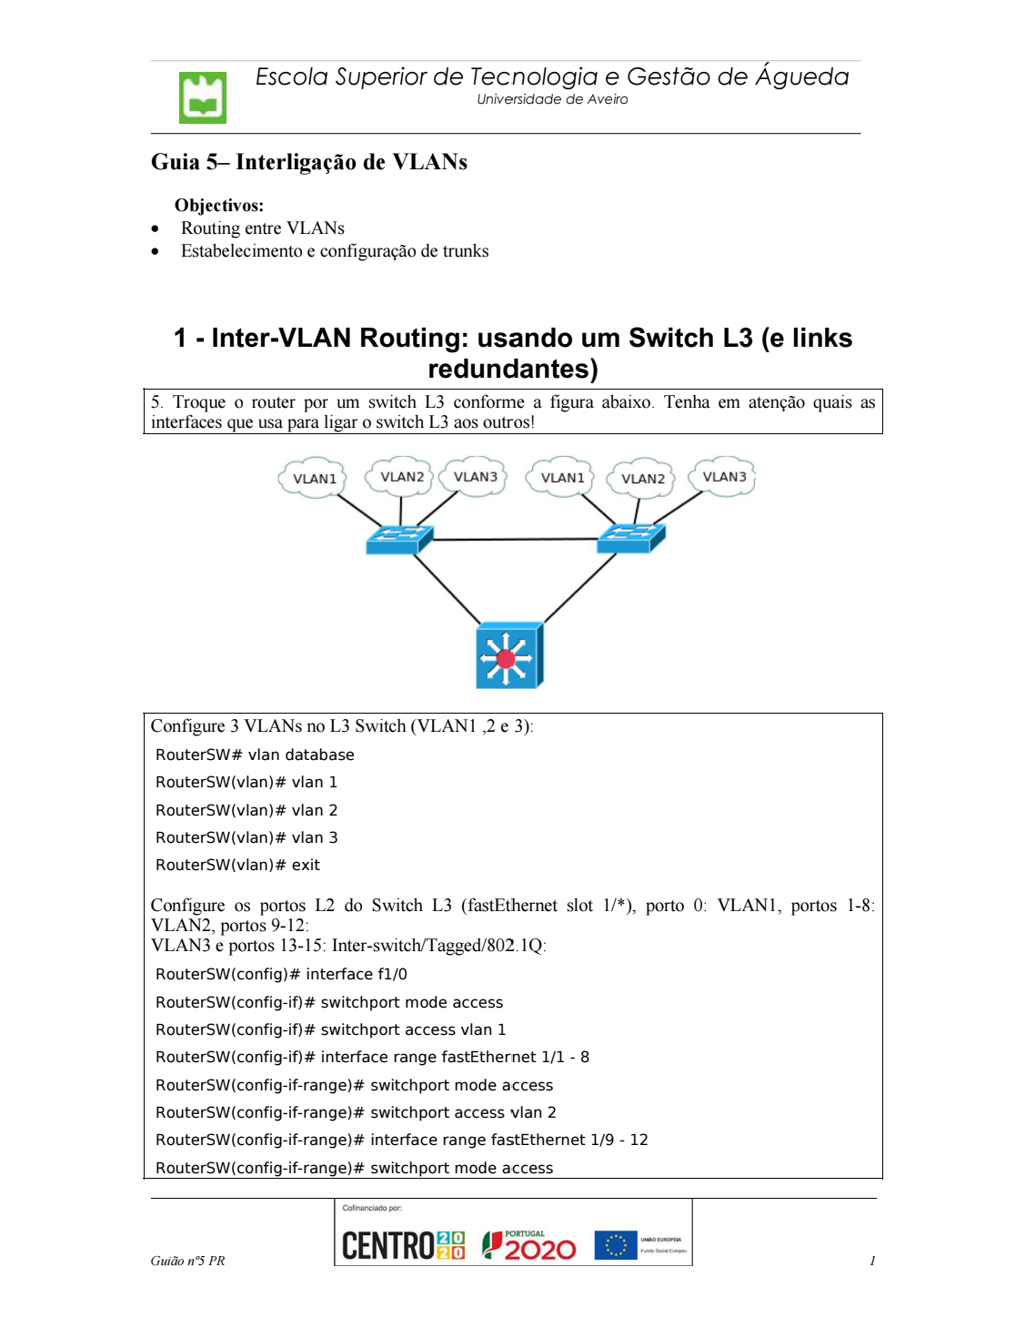

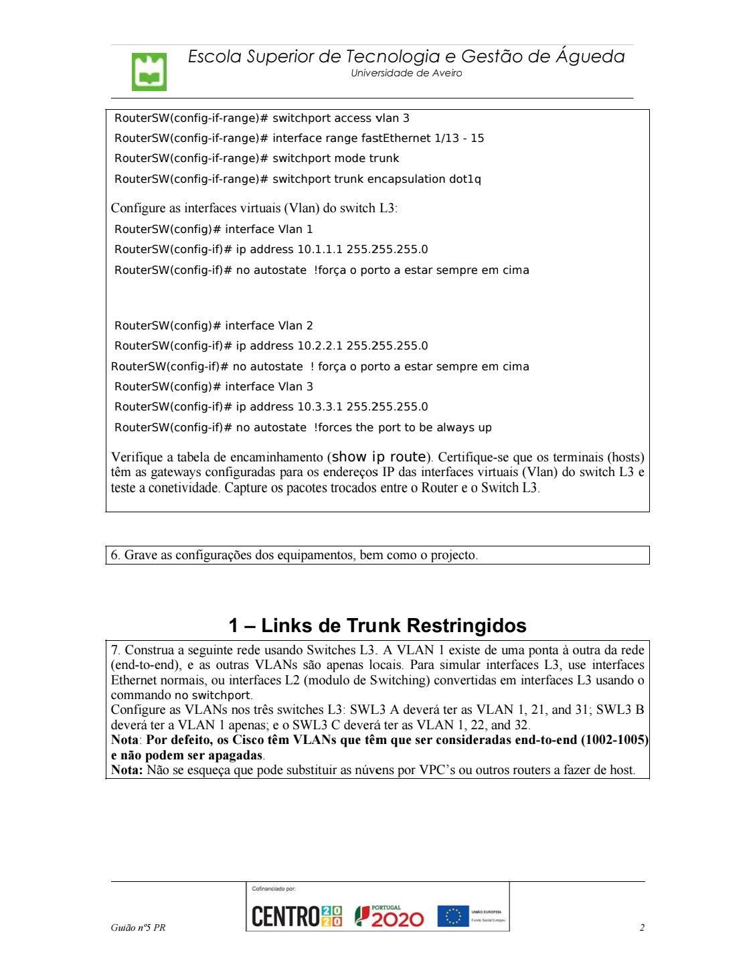

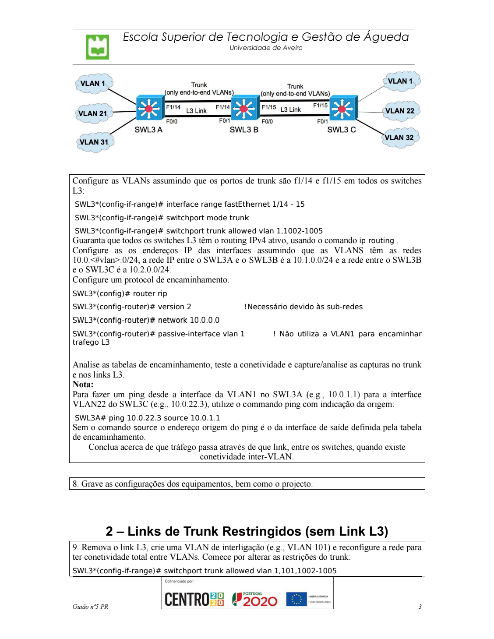

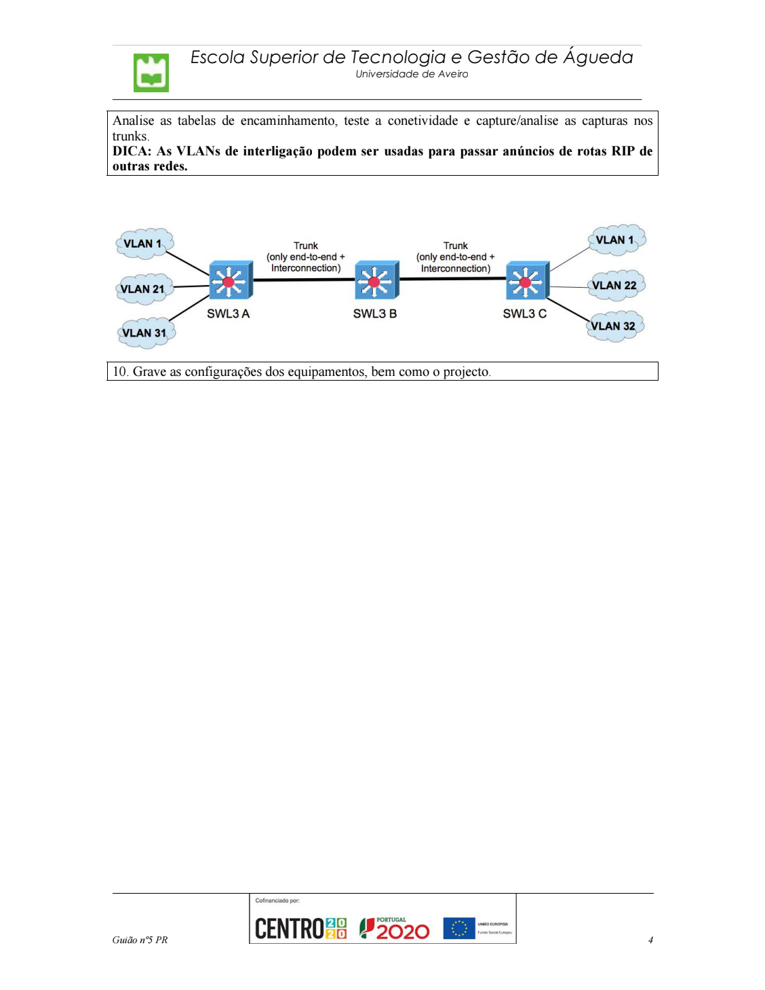
Inter-VLAN Routing: usando um Switch L3 (e links redundantes)

5.
Topologia da rede:
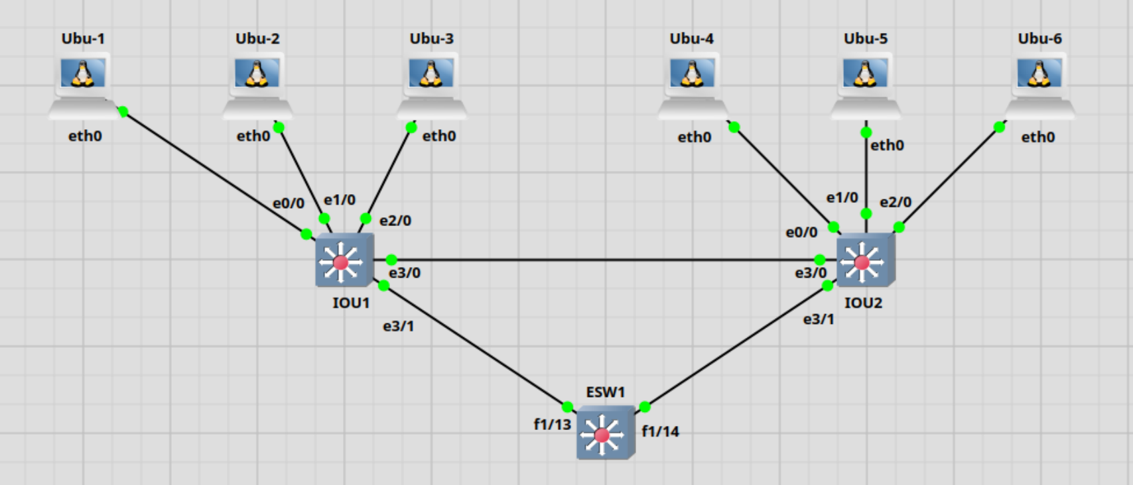

Configuração do Switch de Layer 3 ESW1:

ESW1#sh run
Building configuration...

Current configuration : 3096 bytes
!
version 12.4
service timestamps debug datetime msec
service timestamps log datetime msec
no service password-encryption
no service dhcp
!
hostname ESW1
!
boot-start-marker
boot-end-marker
!
!
no aaa new-model
memory-size iomem 5
no ip icmp rate-limit unreachable
ip cef

!
!
!
!
no ip domain lookup
ip auth-proxy max-nodata-conns 3
ip admission max-nodata-conns 3
!
!
!
!
!
!
!
!
!
!
!
!
!
!
!
vtp file nvram:vlan.dat

!
!
ip tcp synwait-time 5
!
!
!
!
!
interface FastEthernet0/0
description *** Unused for Layer2 EtherSwitch ***
no ip address
shutdown
duplex auto
speed auto
!
interface FastEthernet0/1
description *** Unused for Layer2 EtherSwitch ***
no ip address
shutdown
duplex auto
speed auto
!
interface FastEthernet1/0
duplex full
speed 100
!
interface FastEthernet1/1

switchport access vlan 2
duplex full
speed 100
!
interface FastEthernet1/2
switchport access vlan 2
duplex full
speed 100
!
interface FastEthernet1/3
switchport access vlan 2
duplex full
speed 100
!
interface FastEthernet1/4
switchport access vlan 2
duplex full
speed 100
!
interface FastEthernet1/5
switchport access vlan 2
duplex full
speed 100
!
interface FastEthernet1/6
switchport access vlan 2
duplex full
speed 100
!
interface FastEthernet1/7
switchport access vlan 2
duplex full
speed 100
!
interface FastEthernet1/8
switchport access vlan 2
duplex full
speed 100
!
interface FastEthernet1/9
switchport access vlan 3
duplex full
speed 100
!
interface FastEthernet1/10
switchport access vlan 3
duplex full
speed 100
!
interface FastEthernet1/11
switchport access vlan 3

duplex full
speed 100
!
interface FastEthernet1/12
switchport access vlan 3
duplex full
speed 100
!
interface FastEthernet1/13
switchport mode trunk
duplex full
speed 100
!
interface FastEthernet1/14
switchport mode trunk
duplex full
speed 100
!
interface FastEthernet1/15
switchport mode trunk
duplex full
speed 100
!
interface FastEthernet2/0
no ip address
shutdown
duplex auto
speed auto
!
interface Vlan1
ip address 10.1.1.1 255.255.255.0
no autostate
!
interface Vlan2
ip address 10.2.2.1 255.255.255.0
no autostate
!
interface Vlan3
ip address 10.3.3.1 255.255.255.0
no autostate
!
ip forward-protocol nd
!
!
no ip http server
no ip http secure-server
!
no cdp log mismatch duplex
!
!
!

!
control-plane
!
!
!
!
!
!
!
!
!
banner exec ^C

***************************************************************
This is a normal Router with a SW module inside (NM-16ESW)
It has been preconfigured with hard coded speed and duplex

To create vlans use the command "vlan database" from exec mode
After creating all desired vlans use "exit" to apply the config

To view existing vlans use the command "show vlan-switch brief"

Warning: You are using an old IOS image for this router.
Please update the IOS to enable the "macro" command!
***************************************************************

^C
!
line con 0
exec-timeout 0 0
privilege level 15
logging synchronous
line aux 0
exec-timeout 0 0
privilege level 15
logging synchronous
line vty 0 4
login
!
!
end

Há conectividade entre todas as VLANs: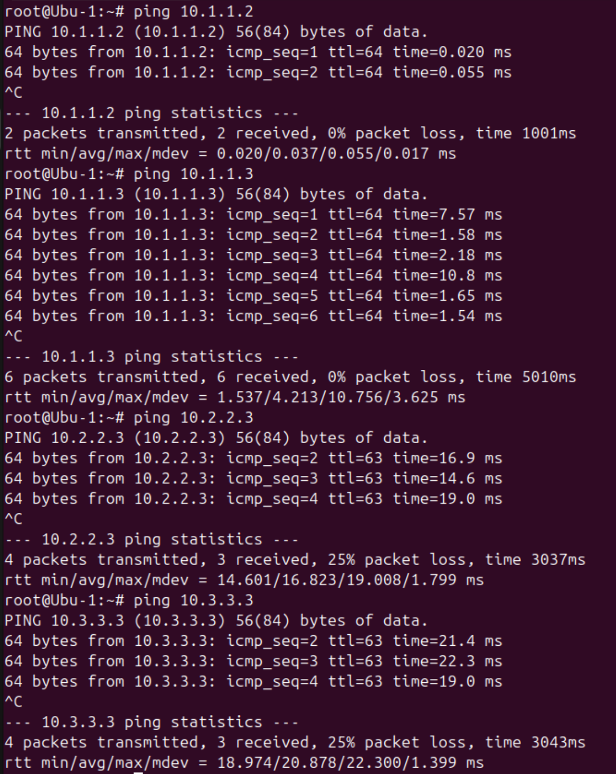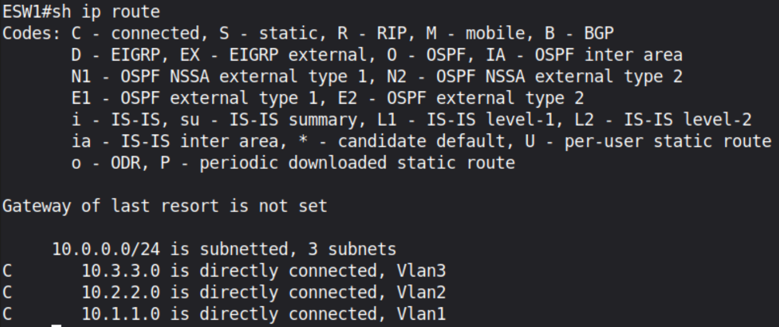

Configuração do switch Layer 2, IOU1:

IOU1#sh run
Building configuration...

Current configuration : 2124 bytes
!
! Last configuration change at 21:01:54 WET Fri Feb 27 2026
!
version 15.2
service timestamps debug datetime msec

service timestamps log datetime msec
no service password-encryption
service compress-config
!
hostname IOU1
!
boot-start-marker
boot-end-marker
!
!
logging discriminator EXCESS severity drops 6 msg-body drops EXCESSCOLL
logging buffered 50000
logging console discriminator EXCESS
!
no aaa new-model
clock timezone WET 0 0
!
!
!
!
!
no ip icmp rate-limit unreachable
!
!
!
no ip domain-lookup
ip cef
no ipv6 cef
!
!
!
spanning-tree mode rapid-pvst
spanning-tree extend system-id
!
vlan internal allocation policy ascending
!
ip tcp synwait-time 5
!
!
!
!
!
!
!
!
!
!
!
!
!
interface Ethernet0/0

switchport mode access
!
interface Ethernet0/1
switchport mode access
!
interface Ethernet0/2
switchport mode access
!
interface Ethernet0/3
switchport mode access
!
interface Ethernet1/0
switchport access vlan 2
switchport mode access
!
interface Ethernet1/1
switchport access vlan 2
switchport mode access
!
interface Ethernet1/2
switchport access vlan 2
switchport mode access
!
interface Ethernet1/3
switchport access vlan 2
switchport mode access
!
interface Ethernet2/0
switchport access vlan 3
switchport mode access
!
interface Ethernet2/1
switchport access vlan 3
switchport mode access
!
interface Ethernet2/2
switchport access vlan 3
switchport mode access
!
interface Ethernet2/3
switchport access vlan 3
switchport mode access
!
interface Ethernet3/0
switchport trunk encapsulation dot1q
switchport mode trunk
!
interface Ethernet3/1
switchport trunk encapsulation dot1q
switchport mode trunk
!

interface Ethernet3/2
switchport trunk encapsulation dot1q
switchport mode trunk
!
interface Ethernet3/3
switchport trunk encapsulation dot1q
switchport mode trunk
!
interface Vlan1
no ip address
shutdown
!
ip forward-protocol nd
!
no ip http server
no ip http secure-server
!
!
!
!
!
!
control-plane
!
!
line con 0
exec-timeout 0 0
privilege level 15
logging synchronous
line aux 0
exec-timeout 0 0
privilege level 15
logging synchronous
line vty 0 4
login
!
!
end

Configuração do switch Layer 2, IOU2:

IOU2#sh run
Building configuration...

Current configuration : 2124 bytes
!
! Last configuration change at 21:01:54 WET Fri Feb 27 2026
!
version 15.2
service timestamps debug datetime msec

service timestamps log datetime msec
no service password-encryption
service compress-config
!
hostname IOU2
!
boot-start-marker
boot-end-marker
!
!
logging discriminator EXCESS severity drops 6 msg-body drops EXCESSCOLL
logging buffered 50000
logging console discriminator EXCESS
!
no aaa new-model
clock timezone WET 0 0
!
!
!
!
!
no ip icmp rate-limit unreachable
!
!
!
no ip domain-lookup
ip cef
no ipv6 cef
!
!
!
spanning-tree mode rapid-pvst
spanning-tree extend system-id
!
vlan internal allocation policy ascending
!
ip tcp synwait-time 5
!
!
!
!
!
!
!
!
!
!
!
!
!
interface Ethernet0/0

switchport mode access
!
interface Ethernet0/1
switchport mode access
!
interface Ethernet0/2
switchport mode access
!
interface Ethernet0/3
switchport mode access
!
interface Ethernet1/0
switchport access vlan 2
switchport mode access
!
interface Ethernet1/1
switchport access vlan 2
switchport mode access
!
interface Ethernet1/2
switchport access vlan 2
switchport mode access
!
interface Ethernet1/3
switchport access vlan 2
switchport mode access
!
interface Ethernet2/0
switchport access vlan 3
switchport mode access
!
interface Ethernet2/1
switchport access vlan 3
switchport mode access
!
interface Ethernet2/2
switchport access vlan 3
switchport mode access
!
interface Ethernet2/3
switchport access vlan 3
switchport mode access
!
interface Ethernet3/0
switchport trunk encapsulation dot1q
switchport mode trunk
!
interface Ethernet3/1
switchport trunk encapsulation dot1q
switchport mode trunk
!

interface Ethernet3/2
switchport trunk encapsulation dot1q
switchport mode trunk
!
interface Ethernet3/3
switchport trunk encapsulation dot1q
switchport mode trunk
!
interface Vlan1
no ip address
shutdown
!
ip forward-protocol nd
!
no ip http server
no ip http secure-server
!
!
!
!
!
!
control-plane
!
!
line con 0
exec-timeout 0 0
privilege level 15
logging synchronous
line aux 0
exec-timeout 0 0
privilege level 15
logging synchronous
line vty 0 4
login
!
!
end

Links de Trunk Restringidos

7.
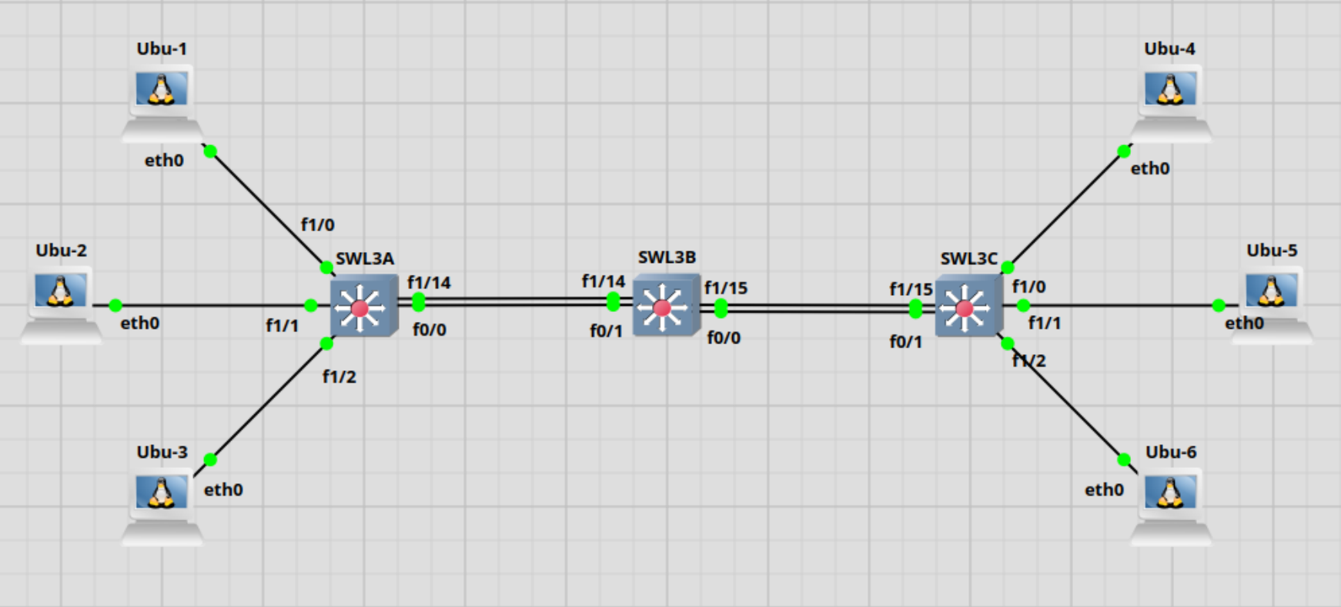Configuração do SWL3A:
SWL3A#sh run
Building configuration...

Current configuration : 2982 bytes
!
version 12.4
service timestamps debug datetime msec
service timestamps log datetime msec
no service password-encryption
no service dhcp
!
hostname ESW1
!
boot-start-marker
boot-end-marker
!
!
no aaa new-model
memory-size iomem 5
no ip icmp rate-limit unreachable
ip cef
!
!
!

!
no ip domain lookup
ip auth-proxy max-nodata-conns 3
ip admission max-nodata-conns 3
!
!
!
!
!
!
!
!
!
!
!
!
!
!
!
vtp file nvram:vlan.dat

!
!
ip tcp synwait-time 5
!
!
!
!
!
interface FastEthernet0/0
description *** Unused for Layer2 EtherSwitch ***
ip address 10.1.0.2 255.255.255.0
duplex auto
speed auto
!
interface FastEthernet0/1
description *** Unused for Layer2 EtherSwitch ***
no ip address
shutdown
duplex auto
speed auto
!
interface FastEthernet1/0
duplex full
speed 100

!
interface FastEthernet1/1
switchport access vlan 21
duplex full
speed 100
!
interface FastEthernet1/2
switchport access vlan 31
duplex full
speed 100
!
interface FastEthernet1/3
duplex full
speed 100
!
interface FastEthernet1/4
duplex full
speed 100
!
interface FastEthernet1/5
duplex full
speed 100
!
interface FastEthernet1/6
duplex full
speed 100
!
interface FastEthernet1/7
duplex full
speed 100
!
interface FastEthernet1/8
duplex full
speed 100
!
interface FastEthernet1/9
duplex full
speed 100
!
interface FastEthernet1/10
duplex full
speed 100
!
interface FastEthernet1/11
duplex full

speed 100
!
interface FastEthernet1/12
duplex full
speed 100
!
interface FastEthernet1/13
duplex full
speed 100
!
interface FastEthernet1/14
switchport trunk allowed vlan 1,1002-1005
switchport mode trunk
duplex full
speed 100
!
interface FastEthernet1/15
switchport trunk allowed vlan 1,1002-1005
switchport mode trunk
duplex full
speed 100
!
interface FastEthernet2/0
no ip address
shutdown
duplex auto
speed auto
!
interface Vlan1
ip address 10.0.1.1 255.255.255.0
no autostate
!
interface Vlan21
ip address 10.0.21.1 255.255.255.0
no autostate
!
interface Vlan31
ip address 10.0.31.1 255.255.255.0
no autostate
!
router rip
version 2
passive-interface Vlan1
network 10.0.0.0
!

ip forward-protocol nd
!
!
no ip http server
no ip http secure-server
!
no cdp log mismatch duplex
!
!
!
!
control-plane
!
!
!
!
!
!
!
!
!
banner exec ^C

***************************************************************
This is a normal Router with a SW module inside (NM-16ESW)
It has been preconfigured with hard coded speed and duplex

To create vlans use the command "vlan database" from exec mode
After creating all desired vlans use "exit" to apply the config

To view existing vlans use the command "show vlan-switch brief"

Warning: You are using an old IOS image for this router.
Please update the IOS to enable the "macro" command!
***************************************************************

^C
!
line con 0
exec-timeout 0 0
privilege level 15
logging synchronous
line aux 0
exec-timeout 0 0
privilege level 15

logging synchronous
line vty 0 4
login
!
!
end

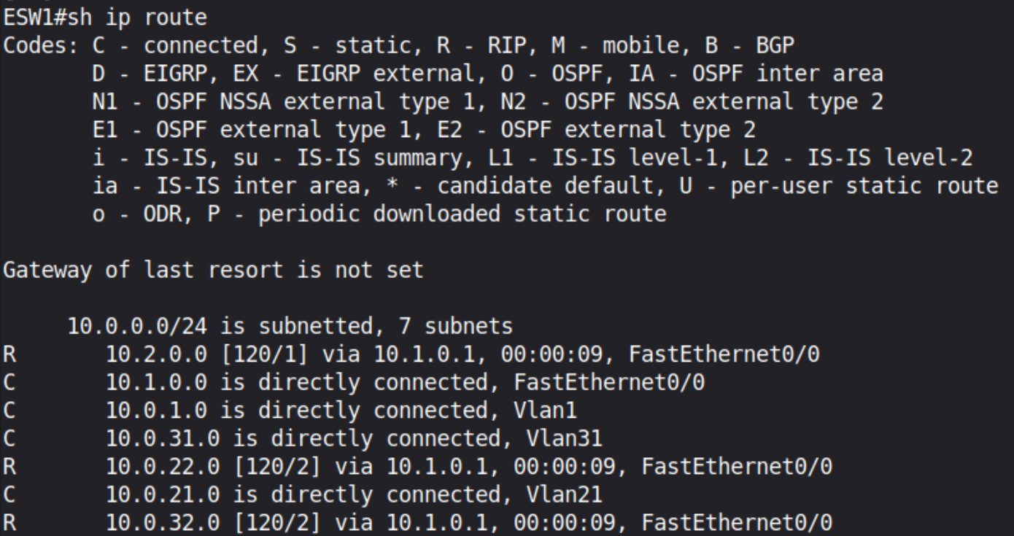

Configuração do SWL3B:
SWL3B#sh run
Building configuration...

Current configuration : 2776 bytes
!
version 12.4
service timestamps debug datetime msec
service timestamps log datetime msec
no service password-encryption
no service dhcp
!
hostname ESW2
!
boot-start-marker
boot-end-marker
!
!
no aaa new-model
memory-size iomem 5
no ip icmp rate-limit unreachable
ip cef
!
!

!
!
no ip domain lookup
ip auth-proxy max-nodata-conns 3
ip admission max-nodata-conns 3
!
!
!
!
!
!
!
!
!
!
!
!
!
!
!
vtp file nvram:vlan.dat

!
!
ip tcp synwait-time 5
!
!
!
!
!
interface FastEthernet0/0
description *** Unused for Layer2 EtherSwitch ***
ip address 10.2.0.1 255.255.255.0
duplex auto
speed auto
!
interface FastEthernet0/1
description *** Unused for Layer2 EtherSwitch ***
ip address 10.1.0.1 255.255.255.0
duplex auto
speed auto
!
interface FastEthernet1/0
duplex full
speed 100

!
interface FastEthernet1/1
duplex full
speed 100
!
interface FastEthernet1/2
duplex full
speed 100
!
interface FastEthernet1/3
duplex full
speed 100
!
interface FastEthernet1/4
duplex full
speed 100
!
interface FastEthernet1/5
duplex full
speed 100
!
interface FastEthernet1/6
duplex full
speed 100
!
interface FastEthernet1/7
duplex full
speed 100
!
interface FastEthernet1/8
duplex full
speed 100
!
interface FastEthernet1/9
duplex full
speed 100
!
interface FastEthernet1/10
duplex full
speed 100
!
interface FastEthernet1/11
duplex full
speed 100
!

interface FastEthernet1/12
duplex full
speed 100
!
interface FastEthernet1/13
duplex full
speed 100
!
interface FastEthernet1/14
switchport trunk allowed vlan 1,1002-1005
switchport mode trunk
duplex full
speed 100
!
interface FastEthernet1/15
switchport trunk allowed vlan 1,1002-1005
switchport mode trunk
duplex full
speed 100
!
interface FastEthernet2/0
no ip address
shutdown
duplex auto
speed auto
!
interface Vlan1
no ip address
shutdown
!
router rip
version 2
passive-interface Vlan1
network 10.0.0.0
!
ip forward-protocol nd
!
!
no ip http server
no ip http secure-server
!
no cdp log mismatch duplex
!
!
!

!
control-plane
!
!
!
!
!
!
!
!
!
banner exec ^C

***************************************************************
This is a normal Router with a SW module inside (NM-16ESW)
It has been preconfigured with hard coded speed and duplex

To create vlans use the command "vlan database" from exec mode
After creating all desired vlans use "exit" to apply the config

To view existing vlans use the command "show vlan-switch brief"

Warning: You are using an old IOS image for this router.
Please update the IOS to enable the "macro" command!
***************************************************************

^C
!
line con 0
exec-timeout 0 0
privilege level 15
logging synchronous
line aux 0
exec-timeout 0 0
privilege level 15
logging synchronous
line vty 0 4
login
!
!
end

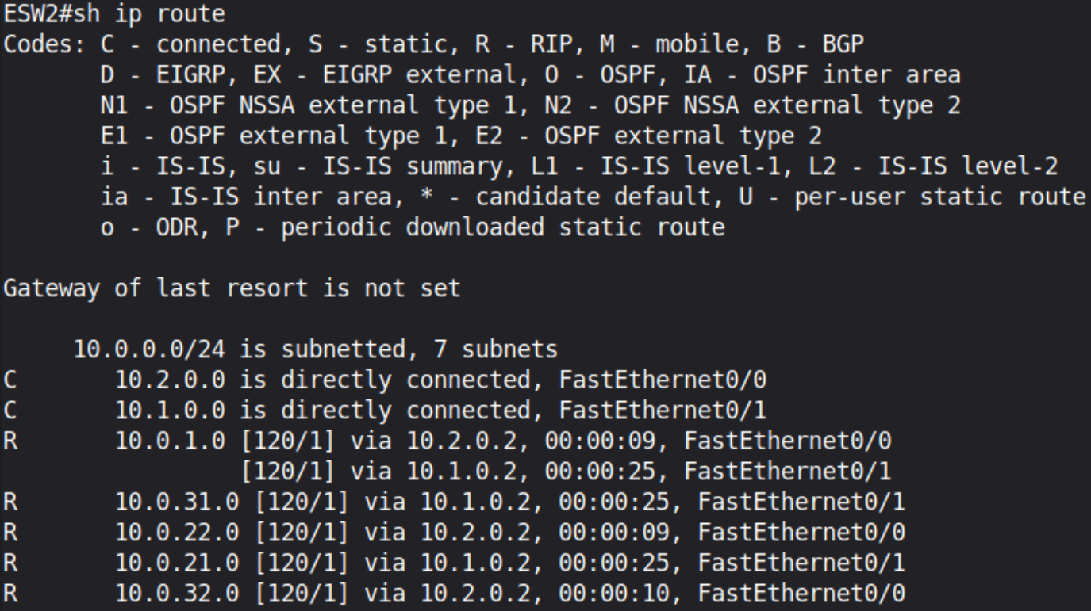

Configuração do SWL3C:

SWL3C#sh run
Building configuration...

Current configuration : 2982 bytes
!
version 12.4
service timestamps debug datetime msec
service timestamps log datetime msec
no service password-encryption
no service dhcp
!
hostname ESW3
!
boot-start-marker
boot-end-marker
!
!
no aaa new-model
memory-size iomem 5
no ip icmp rate-limit unreachable
ip cef
!
!
!
!
no ip domain lookup
ip auth-proxy max-nodata-conns 3

ip admission max-nodata-conns 3
!
!
!
!
!
!
!
!
!
!
!
!
!
!
!
vtp file nvram:vlan.dat

!
!
ip tcp synwait-time 5
!
!
!
!
!
interface FastEthernet0/0
description *** Unused for Layer2 EtherSwitch ***
no ip address
shutdown
duplex auto
speed auto
!
interface FastEthernet0/1
description *** Unused for Layer2 EtherSwitch ***
ip address 10.2.0.2 255.255.255.0
duplex auto
speed auto
!
interface FastEthernet1/0
duplex full
speed 100
!
interface FastEthernet1/1
switchport access vlan 22

duplex full
speed 100
!
interface FastEthernet1/2
switchport access vlan 32
duplex full
speed 100
!
interface FastEthernet1/3
duplex full
speed 100
!
interface FastEthernet1/4
duplex full
speed 100
!
interface FastEthernet1/5
duplex full
speed 100
!
interface FastEthernet1/6
duplex full
speed 100
!
interface FastEthernet1/7
duplex full
speed 100
!
interface FastEthernet1/8
duplex full
speed 100
!
interface FastEthernet1/9
duplex full
speed 100
!
interface FastEthernet1/10
duplex full
speed 100
!
interface FastEthernet1/11
duplex full
speed 100
!
interface FastEthernet1/12

duplex full
speed 100
!
interface FastEthernet1/13
duplex full
speed 100
!
interface FastEthernet1/14
switchport trunk allowed vlan 1,1002-1005
switchport mode trunk
duplex full
speed 100
!
interface FastEthernet1/15
switchport trunk allowed vlan 1,1002-1005
switchport mode trunk
duplex full
speed 100
!
interface FastEthernet2/0
no ip address
shutdown
duplex auto
speed auto
!
interface Vlan1
ip address 10.0.1.4 255.255.255.0
no autostate
!
interface Vlan22
ip address 10.0.22.1 255.255.255.0
no autostate
!
interface Vlan32
ip address 10.0.32.1 255.255.255.0
no autostate
!
router rip
version 2
passive-interface Vlan1
network 10.0.0.0
!
ip forward-protocol nd
!
!

no ip http server
no ip http secure-server
!
no cdp log mismatch duplex
!
!
!
!
control-plane
!
!
!
!
!
!
!
!
!
banner exec ^C

***************************************************************
This is a normal Router with a SW module inside (NM-16ESW)
It has been preconfigured with hard coded speed and duplex

To create vlans use the command "vlan database" from exec mode
After creating all desired vlans use "exit" to apply the config

To view existing vlans use the command "show vlan-switch brief"

Warning: You are using an old IOS image for this router.
Please update the IOS to enable the "macro" command!
***************************************************************

^C
!
line con 0
exec-timeout 0 0
privilege level 15
logging synchronous
line aux 0
exec-timeout 0 0
privilege level 15
logging synchronous
line vty 0 4
login

!
!
end

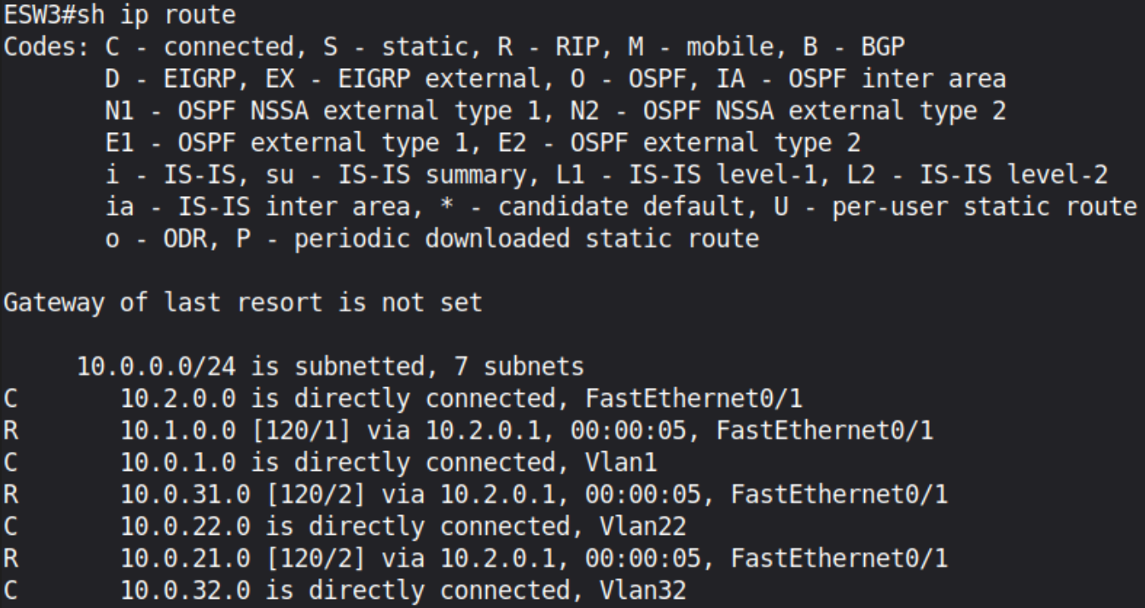

Conectividade e pacotes:

Há conectividade entre as estações da VLAN1: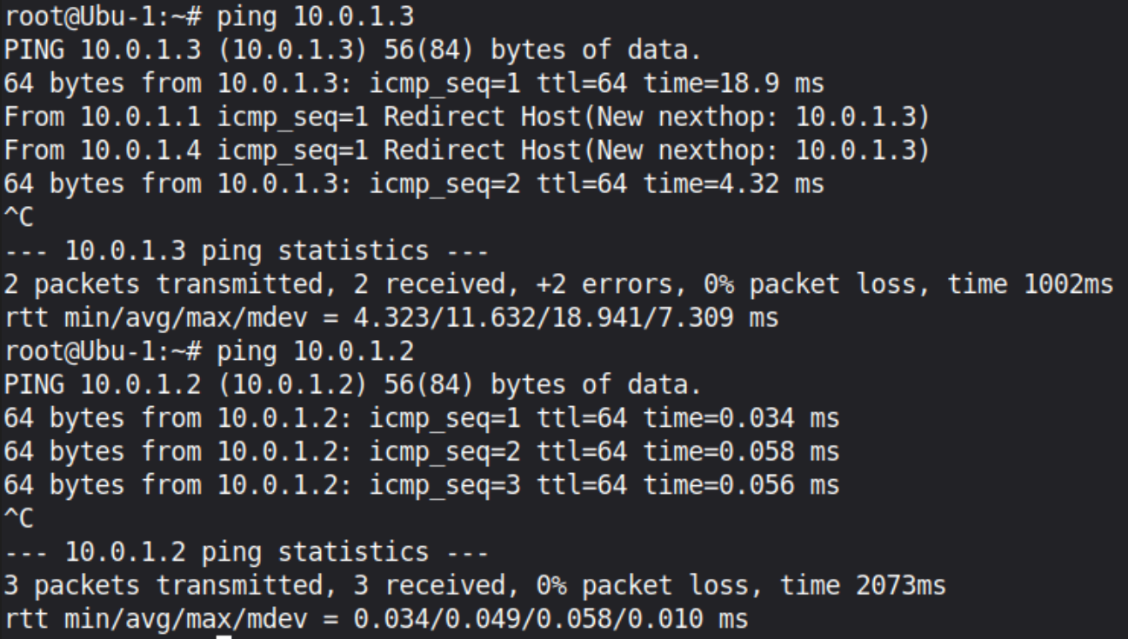

Há conectividade total entre a VLAN1 e as restantes VLANs (VLANS 21, 31, 22 e 32):

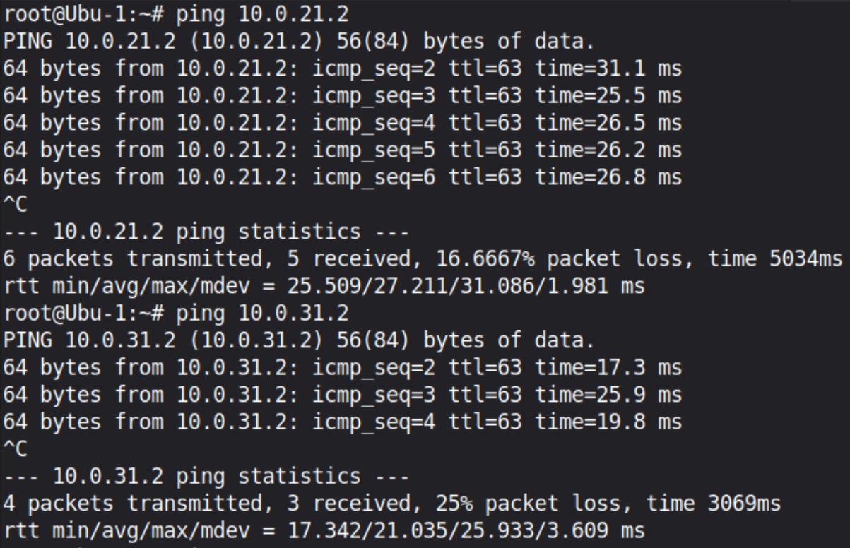
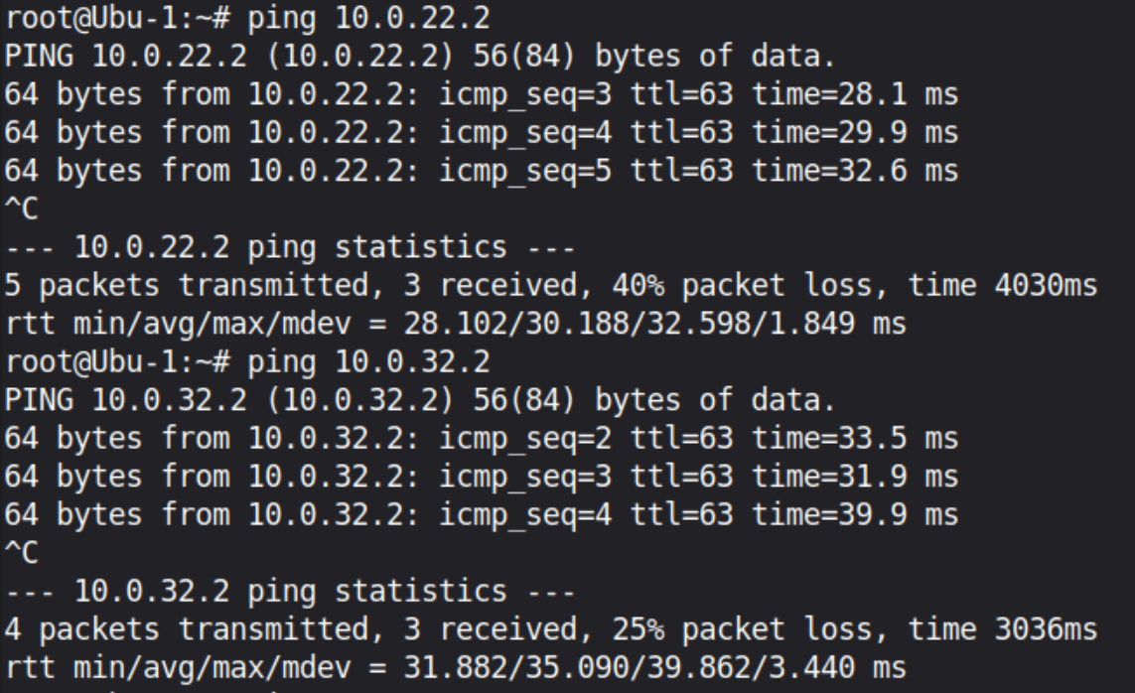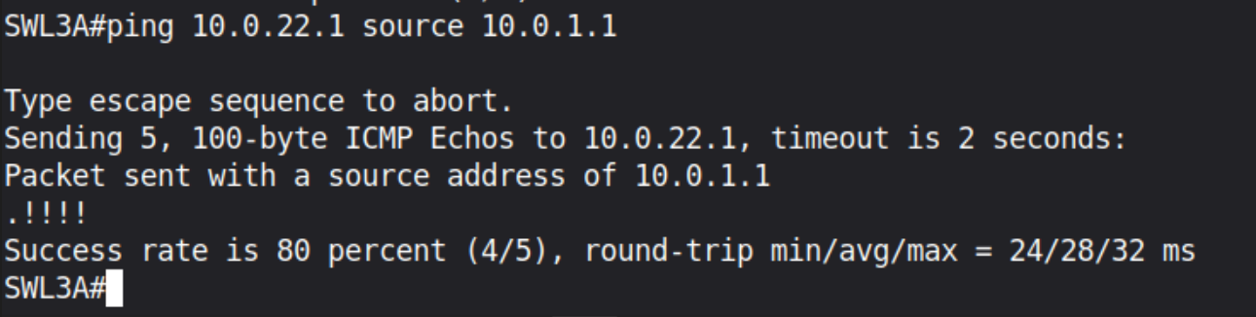

A VLAN 1 é ent-to-end, tem conectividade através dos trunks com ela mesma (devido ao comando 'switchport trunk allowed vlan 1,1002-1005'). Mas a conectividade entre a VLAN 1 e as VLANs 21, 31, 22 e 32 é feita através dos links Layer 3 e do routing por eles efetuado (interfaces f0/0 e f0/1 dos 3 SWL3).
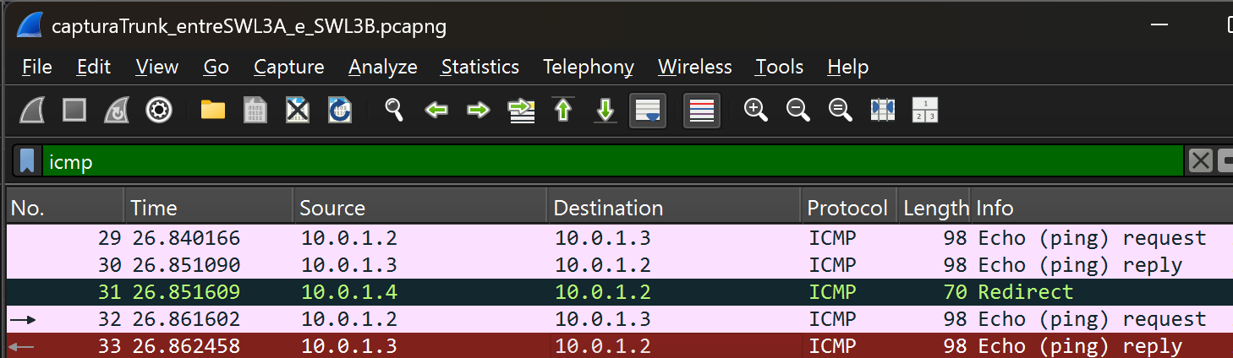

Links de Trunk Restringidos (sem Link L3)

9. 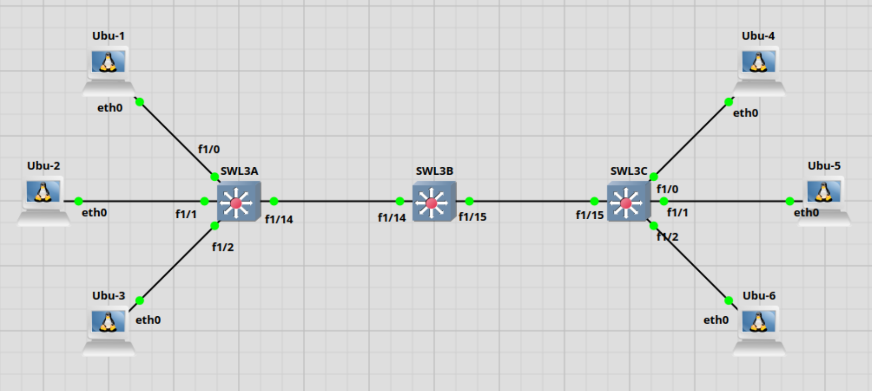

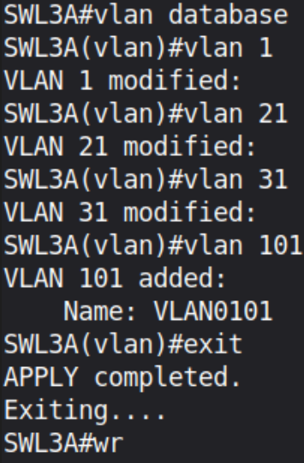
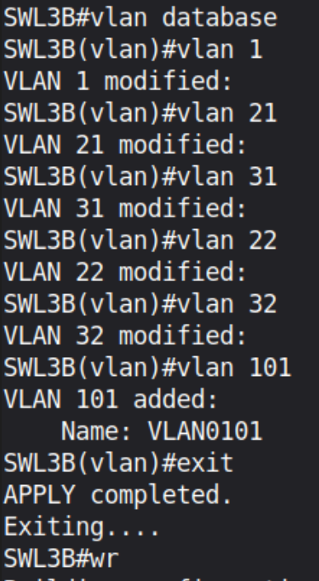
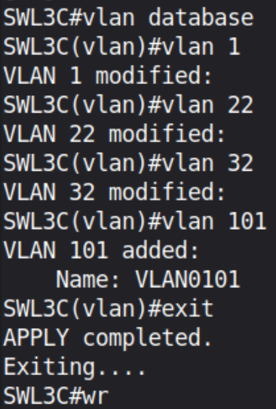
Nos três Switches L3, adicionar a vlan 101 às allowed vlans: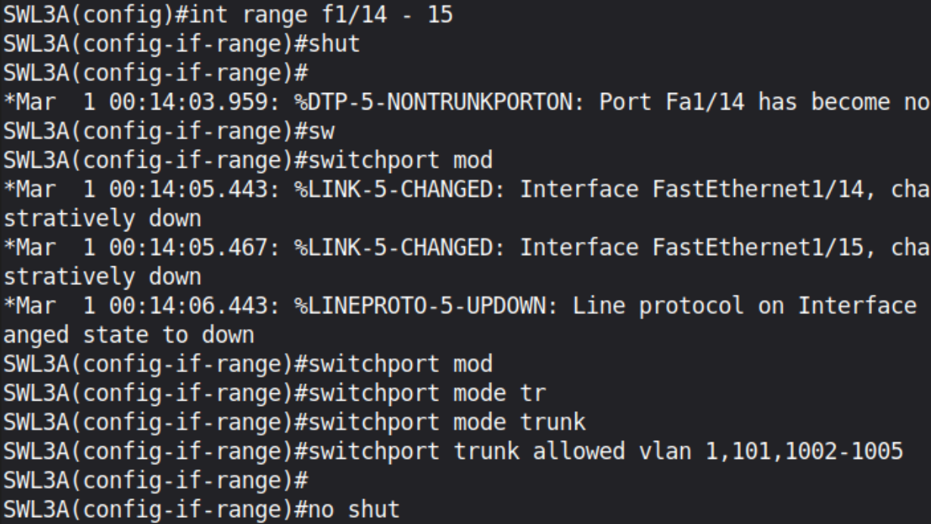

Criar interface virtual vlan 101 e atribuir IP em cada SWL3:
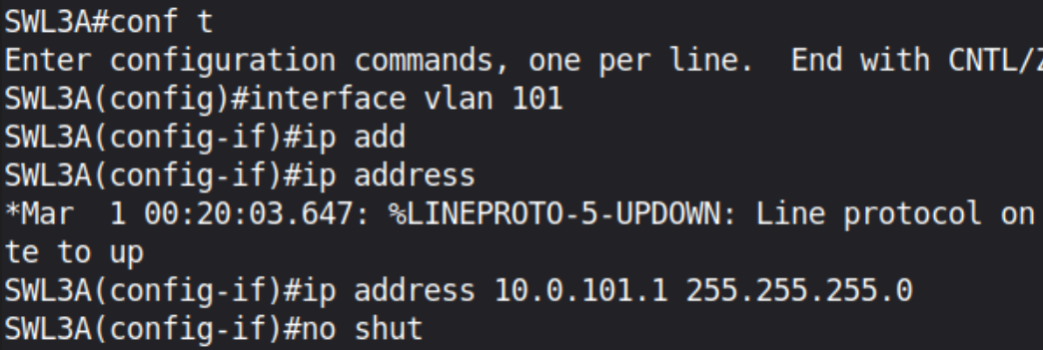
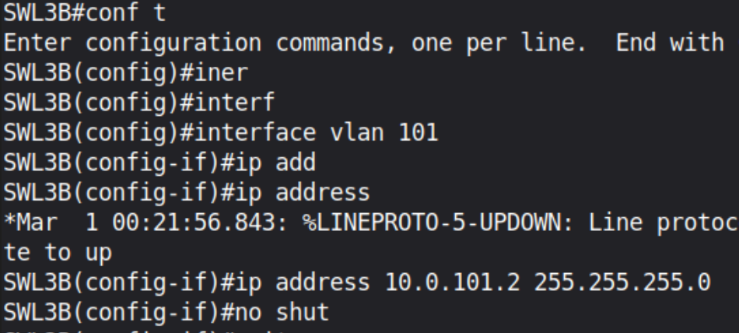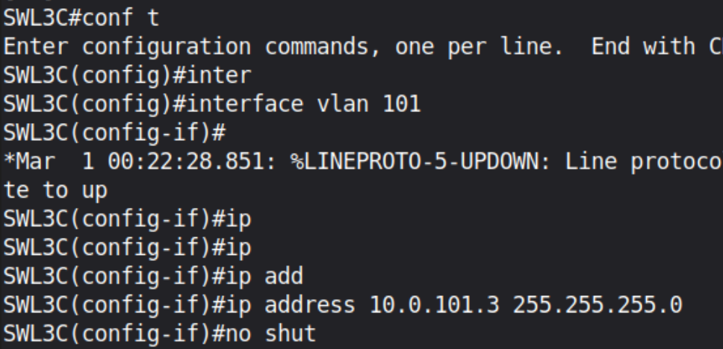

Fazer 'ip routing' de novo em cada SWL3 em global configuration mode para tornar possível o inter-vlan routing/ routing entre VLANs diferentes (agora incluindo a vlan 101).

Tabelas de encaminhamento dos SWL3: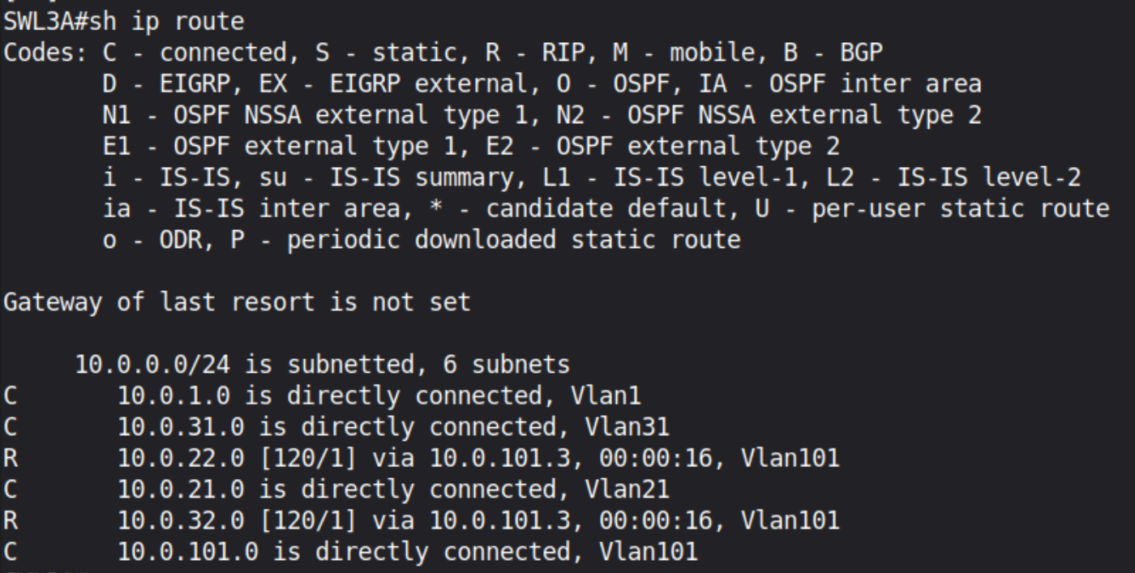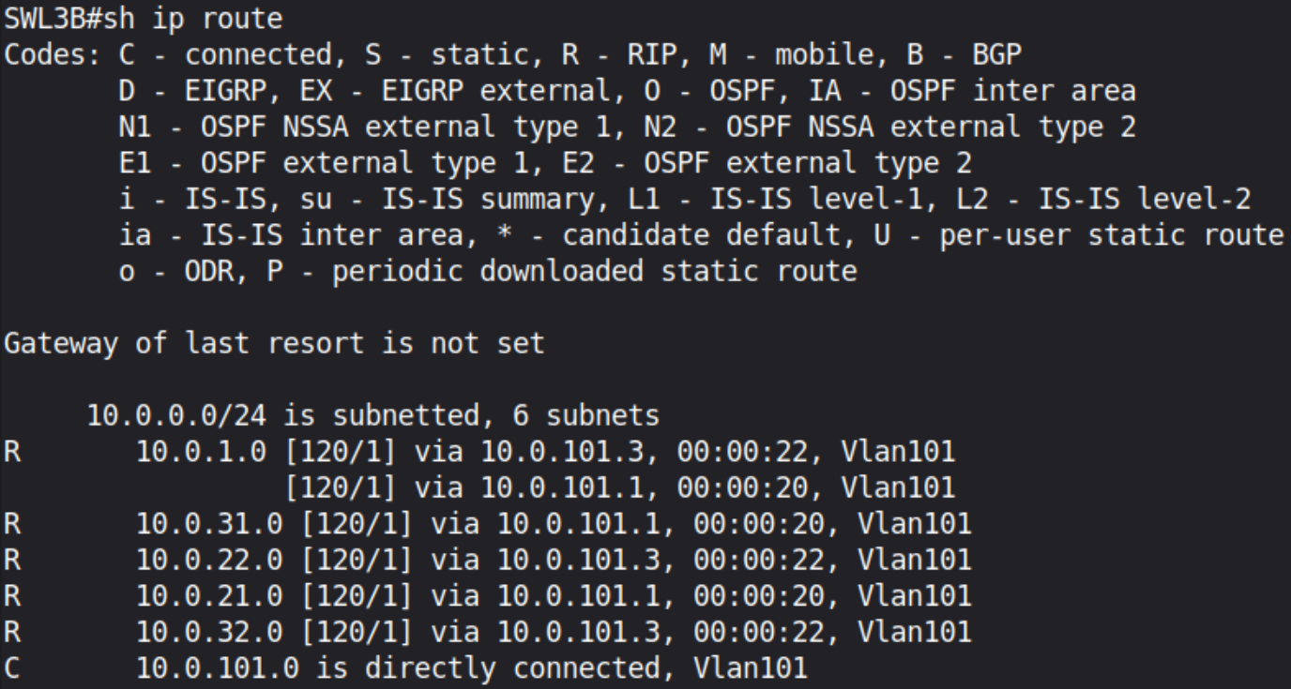

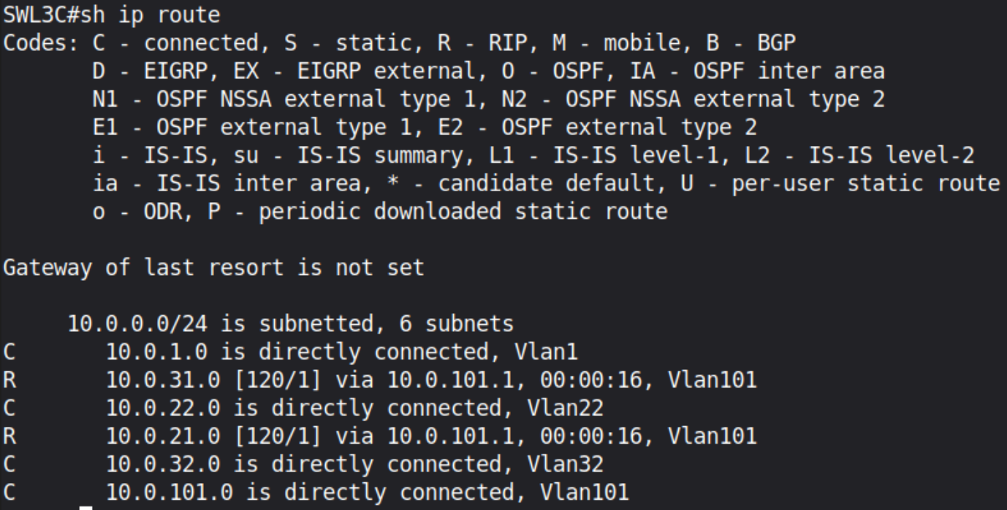

Conectividade e pacotes:

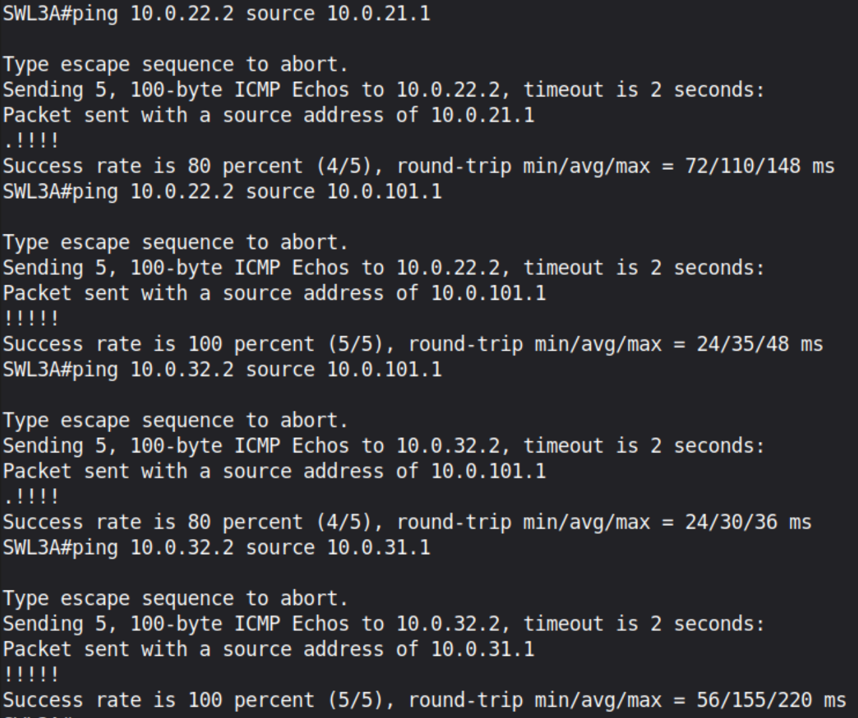

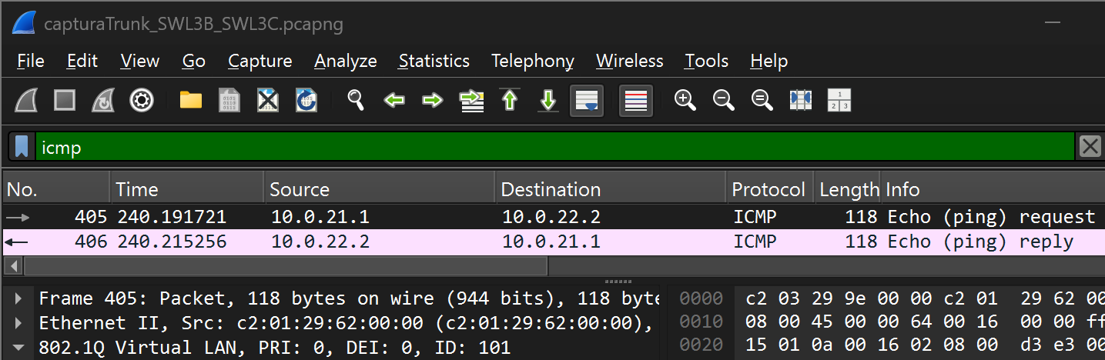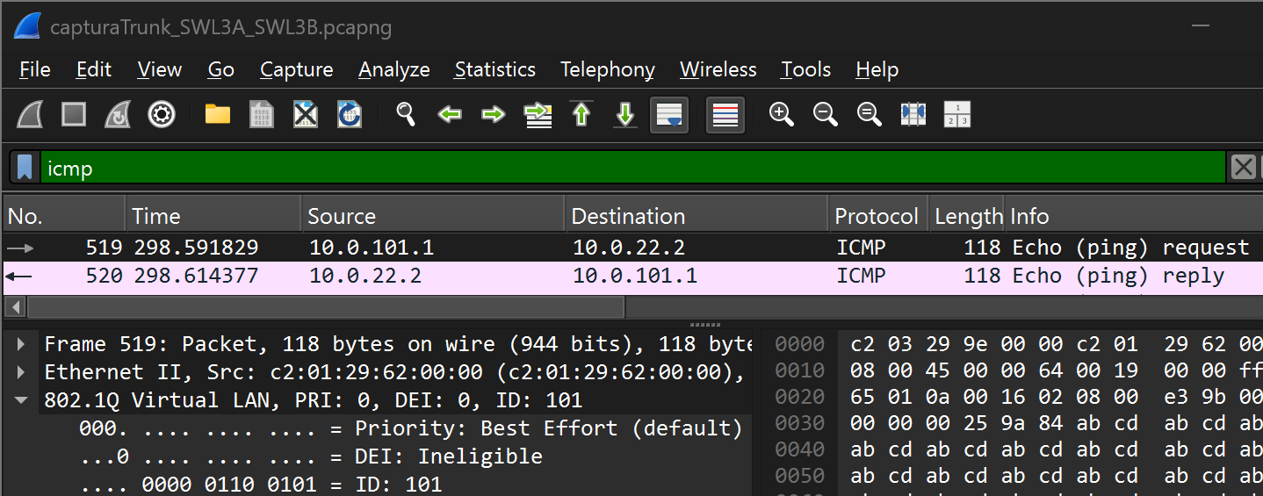
Por exemplo, nestes recortes de capturas nos trunks entre SWL3B e SWL3C e entre SWL3A e SWL3B, respetivamente, é possível verificar que o tráfego L3 inter-VLAN (entre Vlans diferentes) é feito através do trunk e encapsulado na vlan 101 ("ID: 101" numa frame com a tag 802.1Q), em que o RIPv2 agora troca rotas através da VLAN 101 e do trunk e não através de um link L3 como foi feito no exercício 7.

Conclusão: apesar de não haver links de Layer 3, a vlan 101 (de interligação) anuncia as redes 10.0.21.0, 10.0.22.0, 10.0.31.0 e 10.0.32.0 das outras VLANs através da VLAN 101. Ou seja, as rotas entre VLANs locais dos Switches L3 passaram a ser trocadas via VLAN 101 sobre os trunks.

Configuração SWL3A:

SWL3A#sh run
Building configuration...

Current configuration : 3058 bytes

!
version 12.4
service timestamps debug datetime msec
service timestamps log datetime msec
no service password-encryption
no service dhcp
!
hostname SWL3A
!
boot-start-marker
boot-end-marker
!
!
no aaa new-model
memory-size iomem 5
no ip icmp rate-limit unreachable
ip cef
!
!
!
!
no ip domain lookup
ip auth-proxy max-nodata-conns 3
ip admission max-nodata-conns 3
!
!
!
!
!
!
!
!
!
!
!
!
!
!
!
vtp file nvram:vlan.dat

!
!
ip tcp synwait-time 5
!
!
!
!
!
interface FastEthernet0/0
description *** Unused for Layer2 EtherSwitch ***

ip address 10.1.0.2 255.255.255.0
shutdown
duplex auto
speed auto
!
interface FastEthernet0/1
description *** Unused for Layer2 EtherSwitch ***
no ip address
shutdown
duplex auto
speed auto
!
interface FastEthernet1/0
duplex full
speed 100
!
interface FastEthernet1/1
switchport access vlan 21
duplex full
speed 100
!
interface FastEthernet1/2
switchport access vlan 31
duplex full
speed 100
!
interface FastEthernet1/3
duplex full
speed 100
!
interface FastEthernet1/4
duplex full
speed 100
!
interface FastEthernet1/5
duplex full
speed 100
!
interface FastEthernet1/6
duplex full
speed 100
!
interface FastEthernet1/7
duplex full
speed 100
!
interface FastEthernet1/8
duplex full
speed 100
!
interface FastEthernet1/9

duplex full
speed 100
!
interface FastEthernet1/10
duplex full
speed 100
!
interface FastEthernet1/11
duplex full
speed 100
!
interface FastEthernet1/12
duplex full
speed 100
!
interface FastEthernet1/13
duplex full
speed 100
!
interface FastEthernet1/14
switchport trunk allowed vlan 1,101,1002-1005
switchport mode trunk
duplex full
speed 100
!
interface FastEthernet1/15
switchport trunk allowed vlan 1,101,1002-1005
switchport mode trunk
duplex full
speed 100
!
interface FastEthernet2/0
no ip address
shutdown
duplex auto
speed auto
!
interface Vlan1
ip address 10.0.1.1 255.255.255.0
no autostate
!
interface Vlan21
ip address 10.0.21.1 255.255.255.0
no autostate
!
interface Vlan31
ip address 10.0.31.1 255.255.255.0
no autostate
!
interface Vlan101
ip address 10.0.101.1 255.255.255.0

!
router rip
version 2
passive-interface Vlan1
network 10.0.0.0
!
ip forward-protocol nd
!
!
no ip http server
no ip http secure-server
!
no cdp log mismatch duplex
!
!
!
!
control-plane
!
!
!
!
!
!
!
!
!
banner exec ^C

***************************************************************
This is a normal Router with a SW module inside (NM-16ESW)
It has been preconfigured with hard coded speed and duplex

To create vlans use the command "vlan database" from exec mode
After creating all desired vlans use "exit" to apply the config

To view existing vlans use the command "show vlan-switch brief"

Warning: You are using an old IOS image for this router.
Please update the IOS to enable the "macro" command!
***************************************************************

^C
!
line con 0
exec-timeout 0 0
privilege level 15
logging synchronous
line aux 0
exec-timeout 0 0
privilege level 15

logging synchronous
line vty 0 4
login
!
!
end

Configuração SWL3B:

SWL3B#sh run
Building configuration...

Current configuration : 2862 bytes
!
version 12.4
service timestamps debug datetime msec
service timestamps log datetime msec
no service password-encryption
no service dhcp
!
hostname SWL3B
!
boot-start-marker
boot-end-marker
!
!
no aaa new-model
memory-size iomem 5
no ip icmp rate-limit unreachable
ip cef
!
!
!
!
no ip domain lookup
ip auth-proxy max-nodata-conns 3
ip admission max-nodata-conns 3
!
!
!
!
!
!
!
!
!
!
!
!
!

!
!
vtp file nvram:vlan.dat

!
!
ip tcp synwait-time 5
!
!
!
!
!
interface FastEthernet0/0
description *** Unused for Layer2 EtherSwitch ***
ip address 10.2.0.1 255.255.255.0
shutdown
duplex auto
speed auto
!
interface FastEthernet0/1
description *** Unused for Layer2 EtherSwitch ***
ip address 10.1.0.1 255.255.255.0
shutdown
duplex auto
speed auto
!
interface FastEthernet1/0
duplex full
speed 100
!
interface FastEthernet1/1
duplex full
speed 100
!
interface FastEthernet1/2
duplex full
speed 100
!
interface FastEthernet1/3
duplex full
speed 100
!
interface FastEthernet1/4
duplex full
speed 100
!
interface FastEthernet1/5
duplex full
speed 100
!
interface FastEthernet1/6

duplex full
speed 100
!
interface FastEthernet1/7
duplex full
speed 100
!
interface FastEthernet1/8
duplex full
speed 100
!
interface FastEthernet1/9
duplex full
speed 100
!
interface FastEthernet1/10
duplex full
speed 100
!
interface FastEthernet1/11
duplex full
speed 100
!
interface FastEthernet1/12
duplex full
speed 100
!
interface FastEthernet1/13
duplex full
speed 100
!
interface FastEthernet1/14
switchport trunk allowed vlan 1,101,1002-1005
switchport mode trunk
duplex full
speed 100
!
interface FastEthernet1/15
switchport trunk allowed vlan 1,101,1002-1005
switchport mode trunk
duplex full
speed 100
!
interface FastEthernet2/0
no ip address
shutdown
duplex auto
speed auto
!
interface Vlan1
no ip address

shutdown
!
interface Vlan101
ip address 10.0.101.2 255.255.255.0
!
router rip
version 2
passive-interface Vlan1
network 10.0.0.0
!
ip forward-protocol nd
!
!
no ip http server
no ip http secure-server
!
no cdp log mismatch duplex
!
!
!
!
control-plane
!
!
!
!
!
!
!
!
!
banner exec ^C

***************************************************************
This is a normal Router with a SW module inside (NM-16ESW)
It has been preconfigured with hard coded speed and duplex

To create vlans use the command "vlan database" from exec mode
After creating all desired vlans use "exit" to apply the config

To view existing vlans use the command "show vlan-switch brief"

Warning: You are using an old IOS image for this router.
Please update the IOS to enable the "macro" command!
***************************************************************

^C
!
line con 0
exec-timeout 0 0
privilege level 15

logging synchronous
line aux 0
exec-timeout 0 0
privilege level 15
logging synchronous
line vty 0 4
login
!
!
end

Configuração SWL3C:

SWL3C#sh run
Building configuration...

Current configuration : 3058 bytes
!
version 12.4
service timestamps debug datetime msec
service timestamps log datetime msec
no service password-encryption
no service dhcp
!
hostname SWL3C
!
boot-start-marker
boot-end-marker
!
!
no aaa new-model
memory-size iomem 5
no ip icmp rate-limit unreachable
ip cef
!
!
!
!
no ip domain lookup
ip auth-proxy max-nodata-conns 3
ip admission max-nodata-conns 3
!
!
!
!
!
!
!
!
!
!

!
!
!
!
!
vtp file nvram:vlan.dat

!
!
ip tcp synwait-time 5
!
!
!
!
!
interface FastEthernet0/0
description *** Unused for Layer2 EtherSwitch ***
no ip address
shutdown
duplex auto
speed auto
!
interface FastEthernet0/1
description *** Unused for Layer2 EtherSwitch ***
ip address 10.2.0.2 255.255.255.0
shutdown
duplex auto
speed auto
!
interface FastEthernet1/0
duplex full
speed 100
!
interface FastEthernet1/1
switchport access vlan 22
duplex full
speed 100
!
interface FastEthernet1/2
switchport access vlan 32
duplex full
speed 100
!
interface FastEthernet1/3
duplex full
speed 100
!
interface FastEthernet1/4
duplex full
speed 100
!

interface FastEthernet1/5
duplex full
speed 100
!
interface FastEthernet1/6
duplex full
speed 100
!
interface FastEthernet1/7
duplex full
speed 100
!
interface FastEthernet1/8
duplex full
speed 100
!
interface FastEthernet1/9
duplex full
speed 100
!
interface FastEthernet1/10
duplex full
speed 100
!
interface FastEthernet1/11
duplex full
speed 100
!
interface FastEthernet1/12
duplex full
speed 100
!
interface FastEthernet1/13
duplex full
speed 100
!
interface FastEthernet1/14
switchport trunk allowed vlan 1,101,1002-1005
switchport mode trunk
duplex full
speed 100
!
interface FastEthernet1/15
switchport trunk allowed vlan 1,101,1002-1005
switchport mode trunk
duplex full
speed 100
!
interface FastEthernet2/0
no ip address
shutdown

duplex auto
speed auto
!
interface Vlan1
ip address 10.0.1.4 255.255.255.0
no autostate
!
interface Vlan22
ip address 10.0.22.1 255.255.255.0
no autostate
!
interface Vlan32
ip address 10.0.32.1 255.255.255.0
no autostate
!
interface Vlan101
ip address 10.0.101.3 255.255.255.0
!
router rip
version 2
passive-interface Vlan1
network 10.0.0.0
!
ip forward-protocol nd
!
!
no ip http server
no ip http secure-server
!
no cdp log mismatch duplex
!
!
!
!
control-plane
!
!
!
!
!
!
!
!
!
banner exec ^C

***************************************************************
This is a normal Router with a SW module inside (NM-16ESW)
It has been preconfigured with hard coded speed and duplex

To create vlans use the command "vlan database" from exec mode

After creating all desired vlans use "exit" to apply the config

To view existing vlans use the command "show vlan-switch brief"

Warning: You are using an old IOS image for this router.
Please update the IOS to enable the "macro" command!
***************************************************************

^C
!
line con 0
exec-timeout 0 0
privilege level 15
logging synchronous
line aux 0
exec-timeout 0 0
privilege level 15
logging synchronous
line vty 0 4
login
!
!
end

