Exc 2.
Topologia
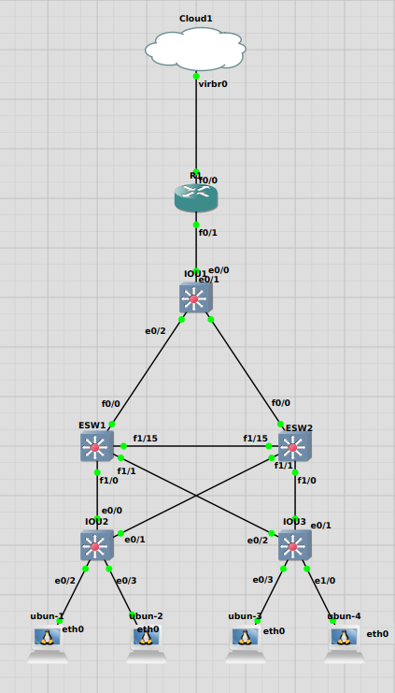

6 / 7
PC1- 10.1.1.2 Vlan1
PC2- 10.1.2.2 Vlan2
PC3- 10.1.2.3 Vlan2
PC4- 10.1.2.2 Vlan2
ESW1- Interfaces Vlan
Inicialmente é usado estes IPs como Gateways para respectivas Vlans
Vlan1 - 10.1.1.1
Vlan2 - 10.1.2.1
Vlan3- 10.1.3.1
Interface f0/0 - 10.2.1.1

ESW2- Interfaces Vlan
Vlan1- 10.1.1.254
Vlan2- 10.1.2.254
Vlan3- 10.1.3.254
Interface f0/0 - 10.2.1.2
R1- Interface f0/0 - DHCP
Interface f0/1 - 10.2.1.2

Confirmaçáo de Ligaçao entre Vlans

root@ubun-1:~# ping 10.1.2.2
PING 10.1.2.2 (10.1.2.2) 56(84) bytes of data.
64 bytes from 10.1.2.2: icmp_seq=1 ttl=63 time=21.0 ms
64 bytes from 10.1.2.2: icmp_seq=1 ttl=63 time=30.0 ms (DUP!)
64 bytes from 10.1.2.2: icmp_seq=2 ttl=63 time=22.0 ms
64 bytes from 10.1.2.2: icmp_seq=3 ttl=63 time=13.0 ms

--- 10.1.2.2 ping statistics ---
3 packets transmitted, 3 received, +1 duplicates, 0% packet loss, time 2007ms
rtt min/avg/max/mdev = 13.001/21.500/30.001/6.020 ms
root@ubun-1:~# ping 10.1.3.2
PING 10.1.3.2 (10.1.3.2) 56(84) bytes of data.
64 bytes from 10.1.3.2: icmp_seq=1 ttl=63 time=59.1 ms
64 bytes from 10.1.3.2: icmp_seq=1 ttl=63 time=72.0 ms (DUP!)
64 bytes from 10.1.3.2: icmp_seq=2 ttl=63 time=22.1 ms
^C
--- 10.1.3.2 ping statistics ---
2 packets transmitted, 2 received, +1 duplicates, 0% packet loss, time 1000ms
rtt min/avg/max/mdev = 22.079/51.046/72.001/21.153 ms

Confirmaçáo de Ligaçao entre Redes
Aqui foi usado RIP como Protocolo de Encaminhamento

root@ubun-1:~# ping 10.2.1.254
PING 10.2.1.254 (10.2.1.254) 56(84) bytes of data.
64 bytes from 10.2.1.254: icmp_seq=1 ttl=254 time=69.9 ms
64 bytes from 10.2.1.254: icmp_seq=2 ttl=254 time=22.6 ms
64 bytes from 10.2.1.254: icmp_seq=3 ttl=254 time=19.1 ms
64 bytes from 10.2.1.254: icmp_seq=4 ttl=254 time=57.6 ms
^C
--- 10.2.1.254 ping statistics ---
4 packets transmitted, 4 received, 0% packet loss, time 3005ms
rtt min/avg/max/mdev = 19.085/42.311/69.941/21.926 ms

8 / 9
Configuração NAT no R1

R1#show run | section ip nat
ip nat outside
ip nat inside
ip nat inside source list 1 interface FastEthernet0/0 overload

R1#show run | section interface
interface FastEthernet0/0
ip address dhcp
ip nat outside
ip virtual-reassembly
duplex auto
speed auto
interface FastEthernet0/1
ip address 10.2.1.254 255.255.255.0
ip nat inside
ip virtual-reassembly
duplex auto
speed auto
ip nat inside source list 1 interface FastEthernet0/0 overload
R1#show access-lists
Standard IP access list 1
10 permit 10.1.1.0, wildcard bits 0.0.0.255 (3 matches)
20 permit 10.1.2.0, wildcard bits 0.0.0.255
30 permit 10.1.3.0, wildcard bits 0.0.0.255
40 permit 10.2.1.0, wildcard bits 0.0.0.255

R1#sh ip route
Gateway of last resort configurado por dhcp

Gateway of last resort is 192.168.122.1 to network 0.0.0.0

C 192.168.122.0/24 is directly connected, FastEthernet0/0
10.0.0.0/24 is subnetted, 4 subnets
R 10.1.3.0 [120/1] via 10.2.1.2, 00:00:14, FastEthernet0/1
[120/1] via 10.2.1.1, 00:00:21, FastEthernet0/1
C 10.2.1.0 is directly connected, FastEthernet0/1
R 10.1.2.0 [120/1] via 10.2.1.2, 00:00:14, FastEthernet0/1
[120/1] via 10.2.1.1, 00:00:21, FastEthernet0/1
R 10.1.1.0 [120/1] via 10.2.1.2, 00:00:14, FastEthernet0/1
[120/1] via 10.2.1.1, 00:00:23, FastEthernet0/1
S* 0.0.0.0/0 [1/0] via 192.168.122.1

Confirmação de acesso ao exterior

root@ubun-1:~# ping 8.8.8.8
PING 8.8.8.8 (8.8.8.8) 56(84) bytes of data.
64 bytes from 8.8.8.8: icmp_seq=1 ttl=252 time=47.0 ms
64 bytes from 8.8.8.8: icmp_seq=2 ttl=252 time=49.6 ms
64 bytes from 8.8.8.8: icmp_seq=3 ttl=252 time=62.1 ms
64 bytes from 8.8.8.8: icmp_seq=4 ttl=252 time=62.0 ms
^C
--- 8.8.8.8 ping statistics ---
4 packets transmitted, 4 received, 0% packet loss, time 3009ms
rtt min/avg/max/mdev = 47.000/55.178/62.107/6.936 ms
R1#sh ip nat translation
Pro Inside global Inside local Outside local Outside global
icmp 192.168.122.3:46 10.1.1.2:46 8.8.8.8:46 8.8.8.8:46

10.

Ao simular uma falha no EWS2 perdemos redundancia mas mantemos conecção pois o gateway defenido esta no .1 das vlans

No entanto ao simular a falha no ESW1:
root@ubun-1:~# ping 10.1.2.2
PING 10.1.2.2 (10.1.2.2) 56(84) bytes of data.
^C
--- 10.1.2.2 ping statistics ---
3 packets transmitted, 0 received, 100% packet loss, time 2079ms

Como não temos HSRP configurado a network fica dependente de um só router para conecções fora da vlan
12.
ESW1#show standby brief
P indicates configured to preempt.
|
Interface Grp Prio P State Active Standby Virtual IP
Vl1 1 120 P Active local 10.1.1.254 10.1.1.10
Vl2 1 120 P Active local 10.1.2.254 10.1.2.10
Vl3 1 120 P Active local 10.1.3.254 10.1.3.10

ESW2#show standby brief
P indicates configured to preempt.
|
Interface Grp Prio P State Active Standby Virtual IP
Vl1 1 100 P Standby 10.1.1.1 local 10.1.1.10
Vl2 1 100 P Standby 10.1.2.1 local 10.1.2.10
Vl3 1 100 P Standby 10.1.3.1 local 10.1.3.10
root@ubun-1:~# ip r
default via 10.1.1.10 dev eth0
10.1.1.0/24 dev eth0 proto kernel scope link src 10.1.1.2

root@ubun-1:~# ping 10.1.1.10
PING 10.1.1.10 (10.1.1.10) 56(84) bytes of data.
64 bytes from 10.1.1.10: icmp_seq=1 ttl=255 time=84.0 ms
64 bytes from 10.1.1.10: icmp_seq=2 ttl=255 time=16.5 ms
64 bytes from 10.1.1.10: icmp_seq=3 ttl=255 time=24.8 ms
^C64 bytes from 10.1.1.10: icmp_seq=4 ttl=255 time=6.72 ms

--- 10.1.1.10 ping statistics ---
4 packets transmitted, 4 received, 0% packet loss, time 3001ms
rtt min/avg/max/mdev = 6.723/33.021/84.003/30.123 ms
root@ubun-1:~# ping 10.2.1.254
PING 10.2.1.254 (10.2.1.254) 56(84) bytes of data.
64 bytes from 10.2.1.254: icmp_seq=2 ttl=254 time=28.0 ms
64 bytes from 10.2.1.254: icmp_seq=3 ttl=254 time=26.5 ms
64 bytes from 10.2.1.254: icmp_seq=4 ttl=254 time=32.7 ms
64 bytes from 10.2.1.254: icmp_seq=5 ttl=254 time=44.0 ms
^C
--- 10.2.1.254 ping statistics ---
5 packets transmitted, 4 received, 20% packet loss, time 4048ms
rtt min/avg/max/mdev = 26.519/32.805/44.001/6.854 ms
root@ubun-1:~# ping 8.8.8.8
PING 8.8.8.8 (8.8.8.8) 56(84) bytes of data.
64 bytes from 8.8.8.8: icmp_seq=1 ttl=252 time=57.2 ms
64 bytes from 8.8.8.8: icmp_seq=2 ttl=252 time=49.5 ms
64 bytes from 8.8.8.8: icmp_seq=3 ttl=252 time=66.0 ms
64 bytes from 8.8.8.8: icmp_seq=4 ttl=252 time=46.0 ms
^C
--- 8.8.8.8 ping statistics ---
4 packets transmitted, 4 received, 0% packet loss, time 3007ms
rtt min/avg/max/mdev = 46.002/54.671/66.003/7.685 ms

R: Agora com os gateway dos PCs actualizados e HSRP configurado existe redundancia tambem nos routers e se um falhar o outro

