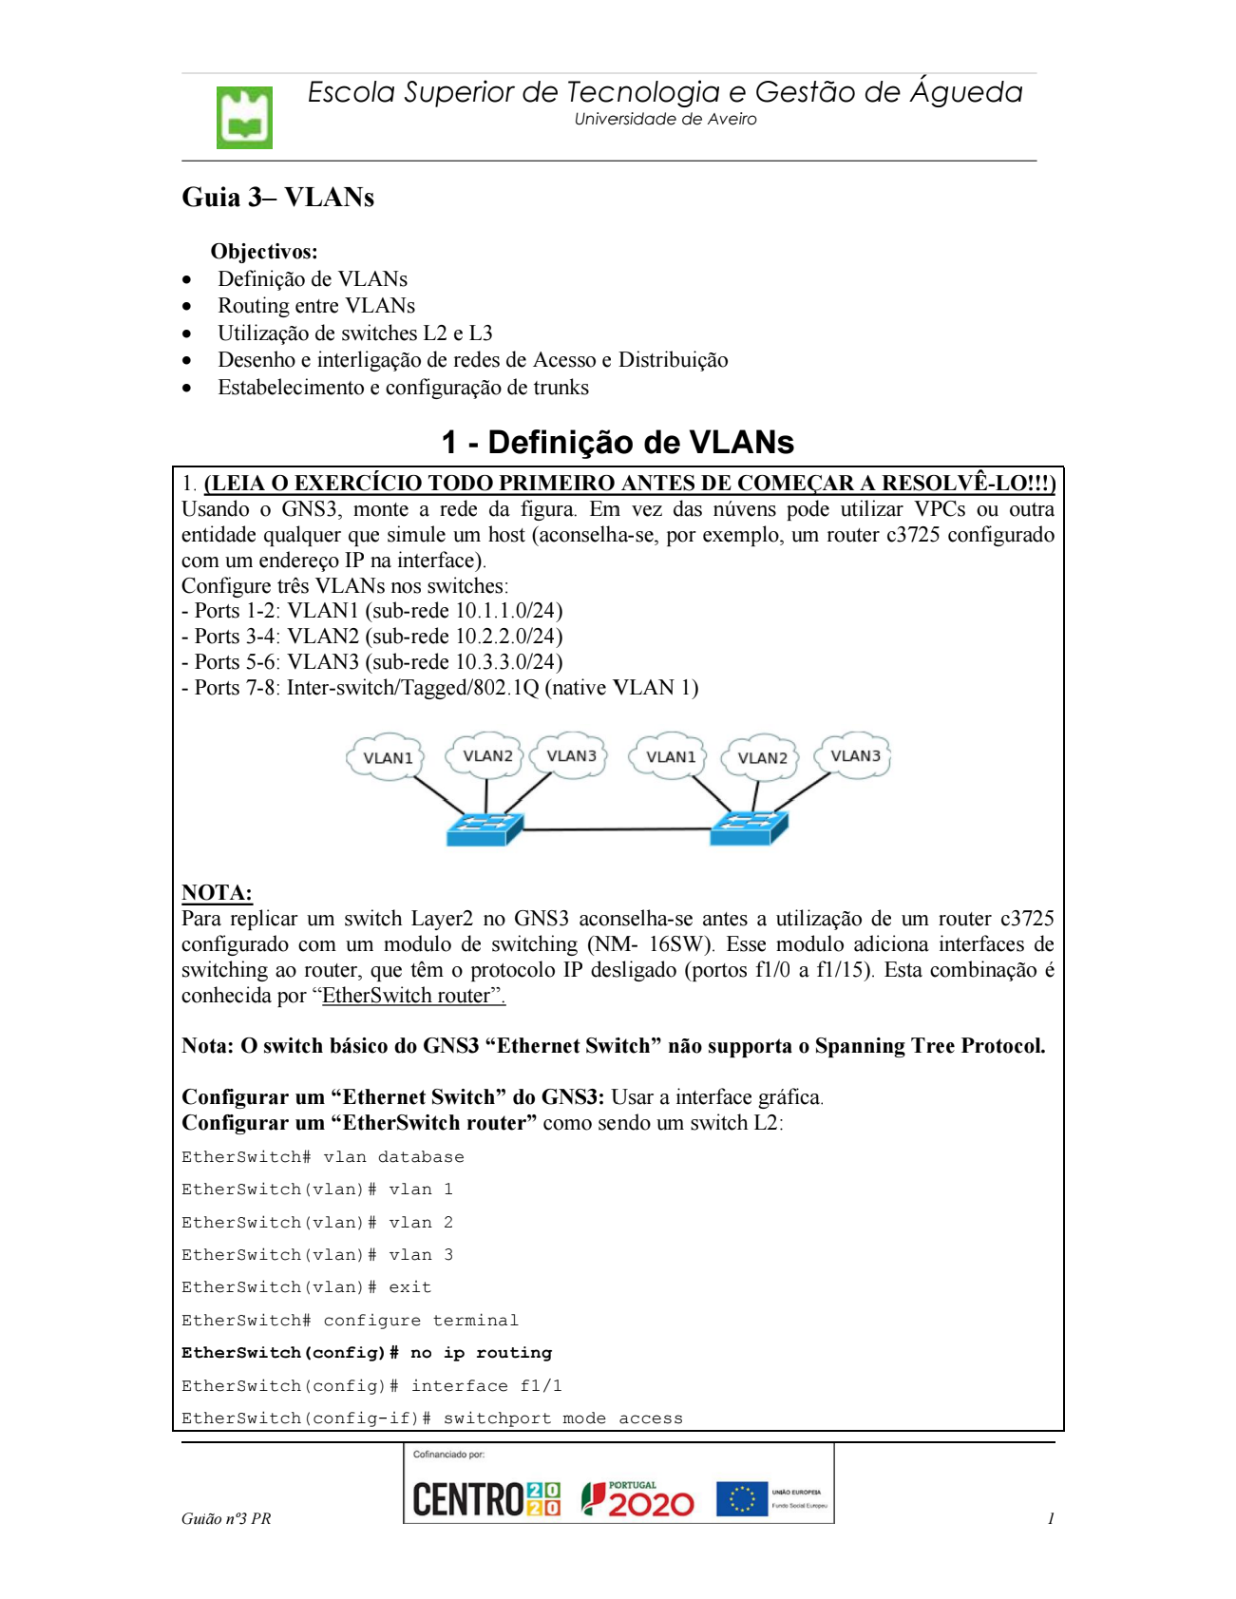

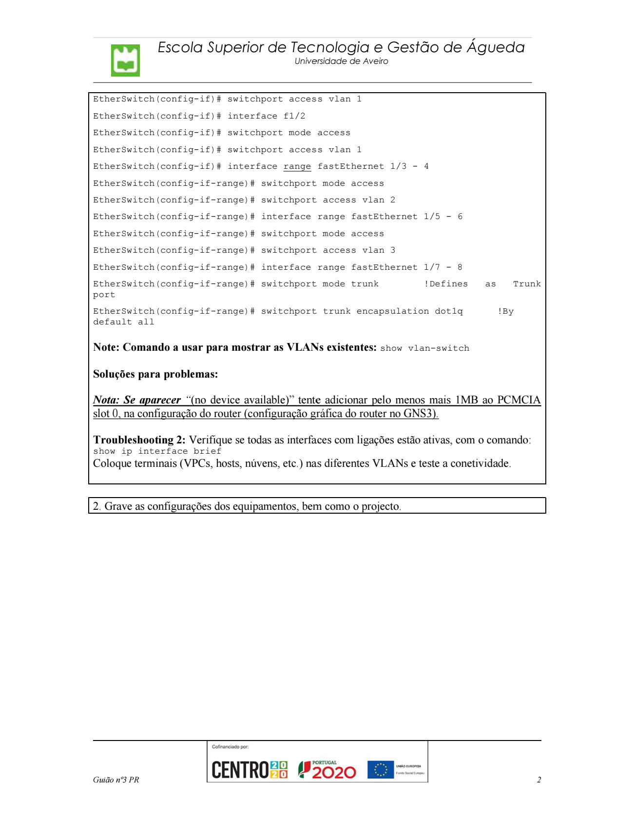

Definição de VLANs

1.
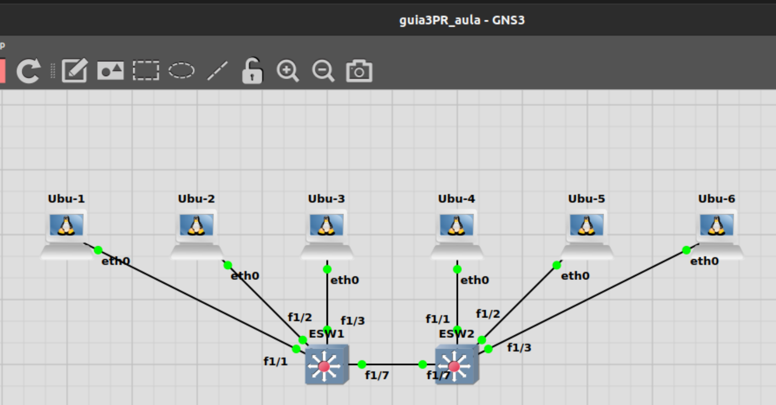
Ubu-1 e Ubu-4 pertencem à VLAN 1.
Ubu-2 e Ubu-5 pertencem à VLAN 2.
Ubu-3 e Ubu-6 pertencem à VLAN 3.

Configuração de cada host:

Vlan1
Ubu-1:
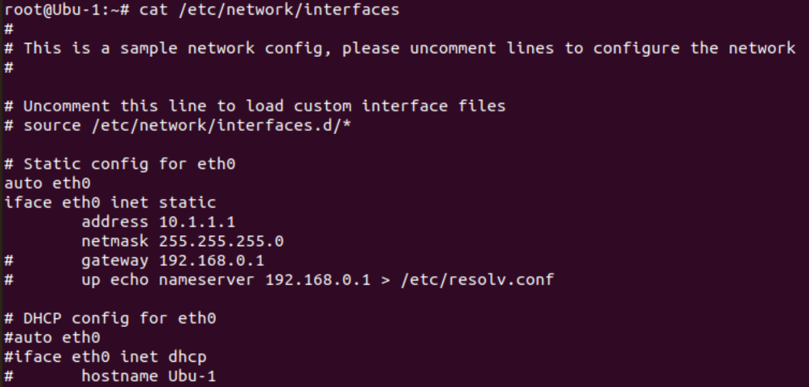

Ubu-4:
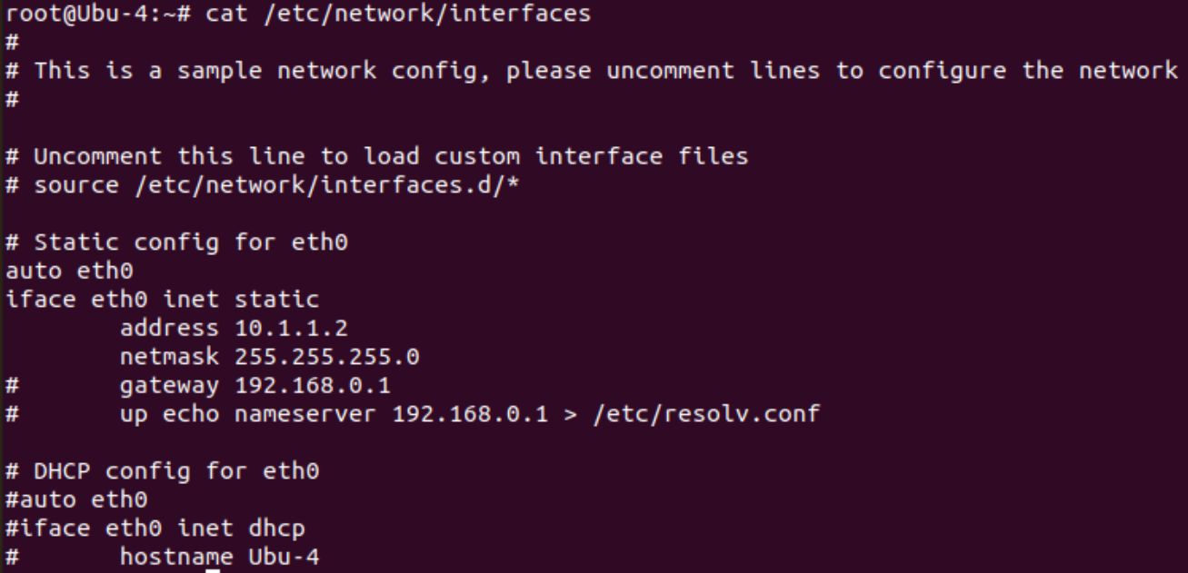

Vlan 2
Ubu-2:
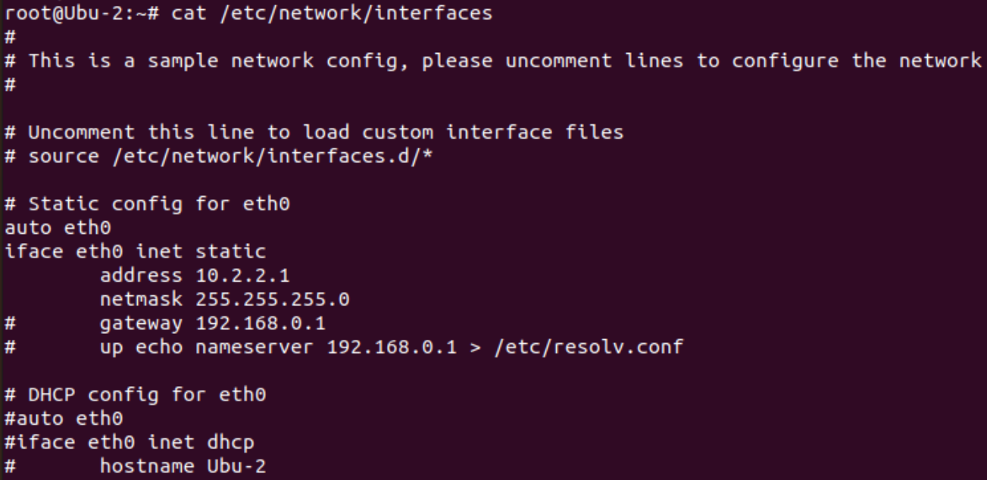
Ubu-5:
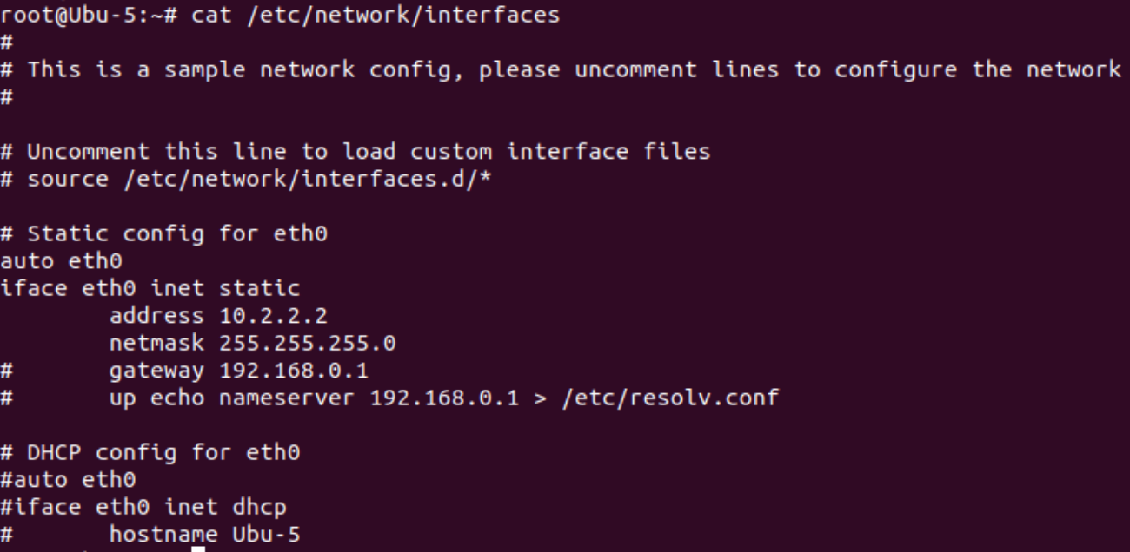

Vlan 3
Ubu-3:
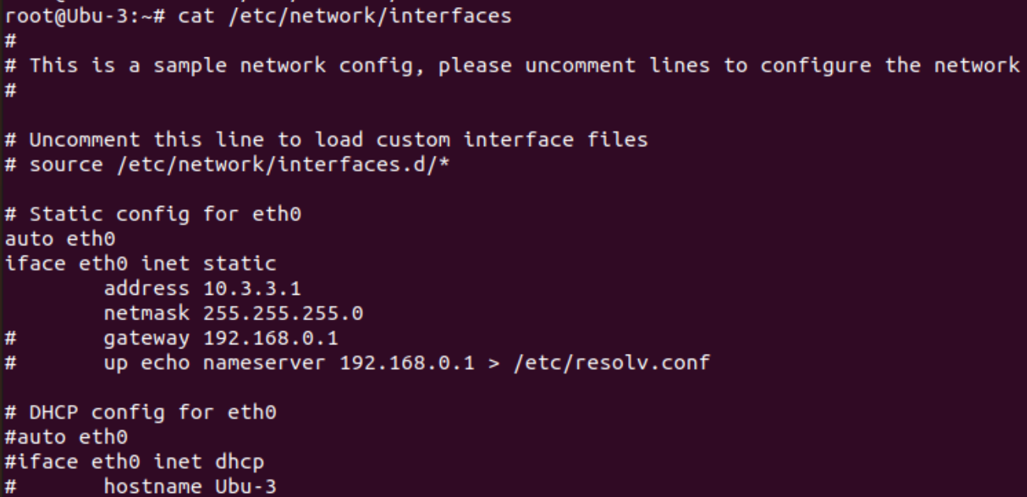
Ubu-6:
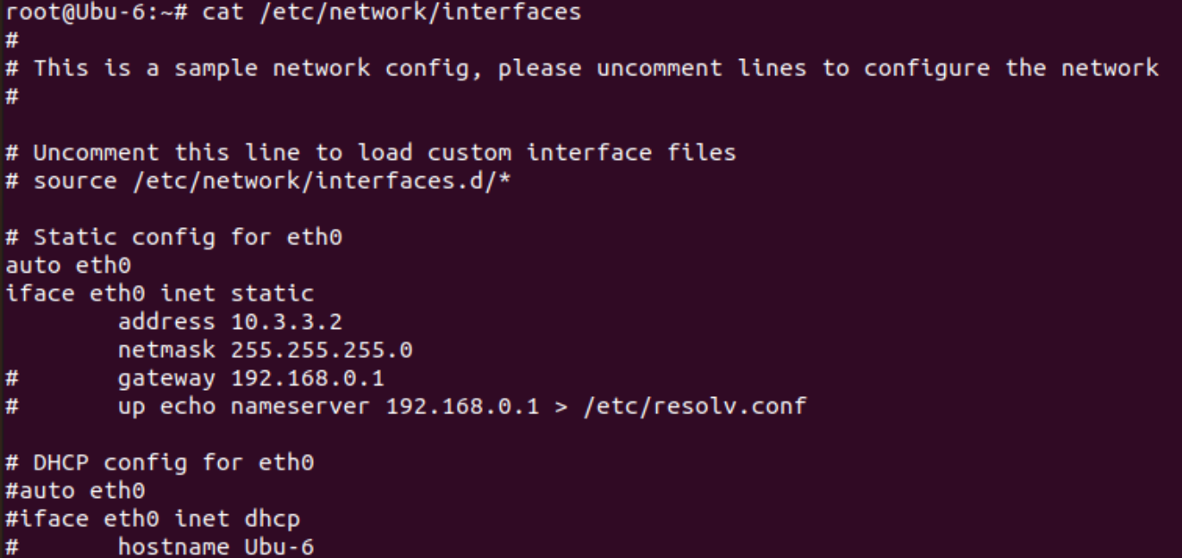

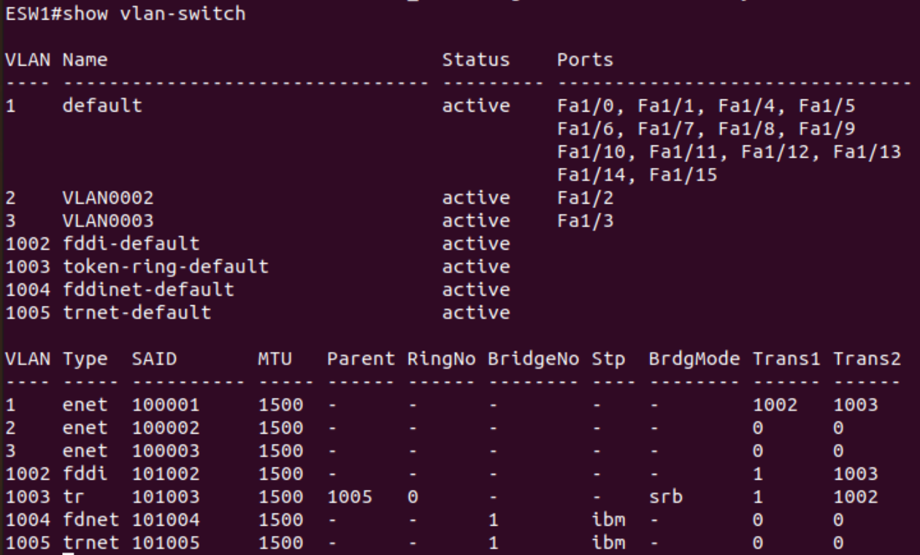

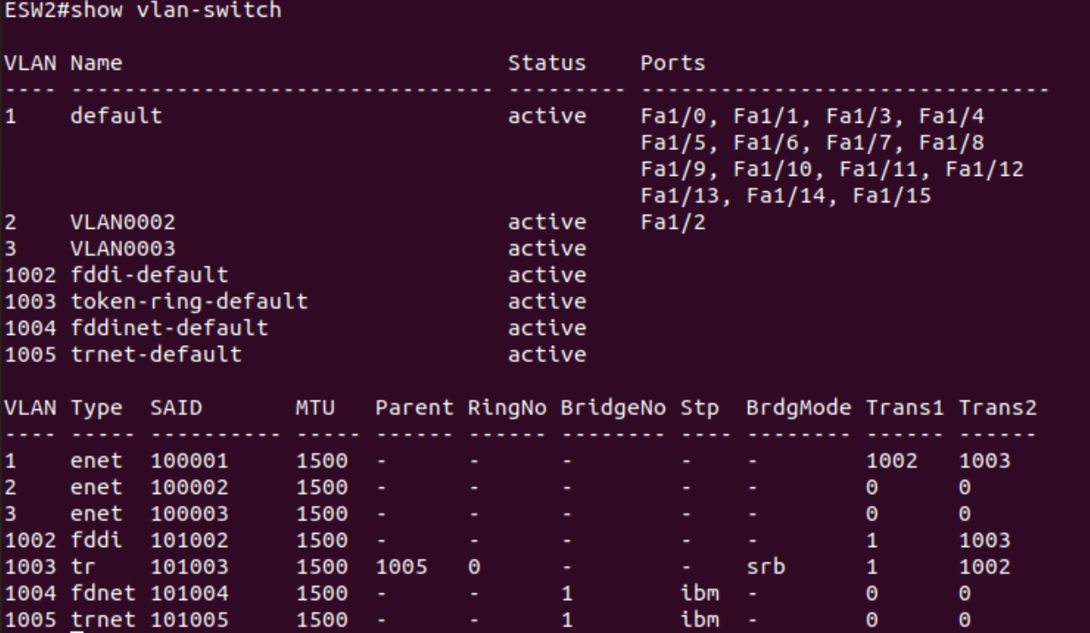

Configurações de cada EtherSwitch (fazendo show run):

ESW1#sh run
Building configuration...

Current configuration : 2628 bytes
!
version 12.4
service timestamps debug datetime msec
service timestamps log datetime msec
no service password-encryption
no service dhcp
!
hostname ESW1
!
boot-start-marker
boot-end-marker
!
!
no aaa new-model
memory-size iomem 5
no ip routing
no ip icmp rate-limit unreachable
no ip cef
!

!
!
!
no ip domain lookup
ip auth-proxy max-nodata-conns 3
ip admission max-nodata-conns 3
!
!
!
!
!
!
!
!
!
!
!
!
!
!
!
vtp file nvram:vlan.dat

!
!
ip tcp synwait-time 5
!
!
!
!
!
interface FastEthernet0/0
description *** Unused for Layer2 EtherSwitch ***
no ip address
no ip route-cache
shutdown
duplex auto
speed auto
!
interface FastEthernet0/1
description *** Unused for Layer2 EtherSwitch ***
no ip address
no ip route-cache
shutdown
duplex auto

speed auto
!
interface FastEthernet1/0
duplex full
speed 100
!
interface FastEthernet1/1
duplex full
speed 100
!
interface FastEthernet1/2
switchport access vlan 2
duplex full
speed 100
!
interface FastEthernet1/3
switchport access vlan 3
duplex full
speed 100
!
interface FastEthernet1/4
duplex full
speed 100
!
interface FastEthernet1/5
duplex full
speed 100
!
interface FastEthernet1/6
duplex full
speed 100
!
interface FastEthernet1/7
switchport mode trunk
duplex full
speed 100
!
interface FastEthernet1/8
duplex full
speed 100
!
interface FastEthernet1/9
duplex full
speed 100
!

interface FastEthernet1/10
duplex full
speed 100
!
interface FastEthernet1/11
duplex full
speed 100
!
interface FastEthernet1/12
duplex full
speed 100
!
interface FastEthernet1/13
duplex full
speed 100
!
interface FastEthernet1/14
duplex full
speed 100
!
interface FastEthernet1/15
duplex full
speed 100
!
interface Vlan1
no ip address
no ip route-cache
shutdown
!
ip forward-protocol nd
!
!
no ip http server
no ip http secure-server
!
no cdp log mismatch duplex
!
!
!
!
control-plane
!
!
!
!

!
!
!
!
!
banner exec ^C

***************************************************************
This is a normal Router with a SW module inside (NM-16ESW)
It has been preconfigured with hard coded speed and duplex

To create vlans use the command "vlan database" from exec mode
After creating all desired vlans use "exit" to apply the config

To view existing vlans use the command "show vlan-switch brief"

Warning: You are using an old IOS image for this router.
Please update the IOS to enable the "macro" command!
***************************************************************

^C
!
line con 0
exec-timeout 0 0
privilege level 15
logging synchronous
line aux 0
exec-timeout 0 0
privilege level 15
logging synchronous
line vty 0 4
login
!
!
end

ESW2#sh run
Building configuration...

Current configuration : 2628 bytes
!
version 12.4
service timestamps debug datetime msec
service timestamps log datetime msec
no service password-encryption
no service dhcp
!
hostname ESW2
!
boot-start-marker
boot-end-marker
!
!
no aaa new-model
memory-size iomem 5
no ip routing
no ip icmp rate-limit unreachable
no ip cef
!
!
!
!
no ip domain lookup
ip auth-proxy max-nodata-conns 3
ip admission max-nodata-conns 3
!
!
!
!
!
!
!
!
!
!
!
!
!
!

!
vtp file nvram:vlan.dat

!
!
ip tcp synwait-time 5
!
!
!
!
!
interface FastEthernet0/0
description *** Unused for Layer2 EtherSwitch ***
no ip address
no ip route-cache
shutdown
duplex auto
speed auto
!
interface FastEthernet0/1
description *** Unused for Layer2 EtherSwitch ***
no ip address
no ip route-cache
shutdown
duplex auto
speed auto
!
interface FastEthernet1/0
duplex full
speed 100
!
interface FastEthernet1/1
duplex full
speed 100
!
interface FastEthernet1/2
switchport access vlan 2
duplex full
speed 100
!
interface FastEthernet1/3
switchport access vlan 3
duplex full
speed 100
!

interface FastEthernet1/4
duplex full
speed 100
!
interface FastEthernet1/5
duplex full
speed 100
!
interface FastEthernet1/6
duplex full
speed 100
!
interface FastEthernet1/7
switchport mode trunk
duplex full
speed 100
!
interface FastEthernet1/8
duplex full
speed 100
!
interface FastEthernet1/9
duplex full
speed 100
!
interface FastEthernet1/10
duplex full
speed 100
!
interface FastEthernet1/11
duplex full
speed 100
!
interface FastEthernet1/12
duplex full
speed 100
!
interface FastEthernet1/13
duplex full
speed 100
!
interface FastEthernet1/14
duplex full
speed 100
!

interface FastEthernet1/15
duplex full
speed 100
!
interface Vlan1
no ip address
no ip route-cache
shutdown
!
ip forward-protocol nd
!
!
no ip http server
no ip http secure-server
!
no cdp log mismatch duplex
!
!
!
!
control-plane
!
!
!
!
!
!
!
!
!
banner exec ^C

***************************************************************
This is a normal Router with a SW module inside (NM-16ESW)
It has been preconfigured with hard coded speed and duplex

To create vlans use the command "vlan database" from exec mode
After creating all desired vlans use "exit" to apply the config

To view existing vlans use the command "show vlan-switch brief"

Warning: You are using an old IOS image for this router.
Please update the IOS to enable the "macro" command!
***************************************************************

^C
!
line con 0
exec-timeout 0 0
privilege level 15
logging synchronous
line aux 0
exec-timeout 0 0
privilege level 15
logging synchronous
line vty 0 4
login
!
!
end

Troubleshooting 2:
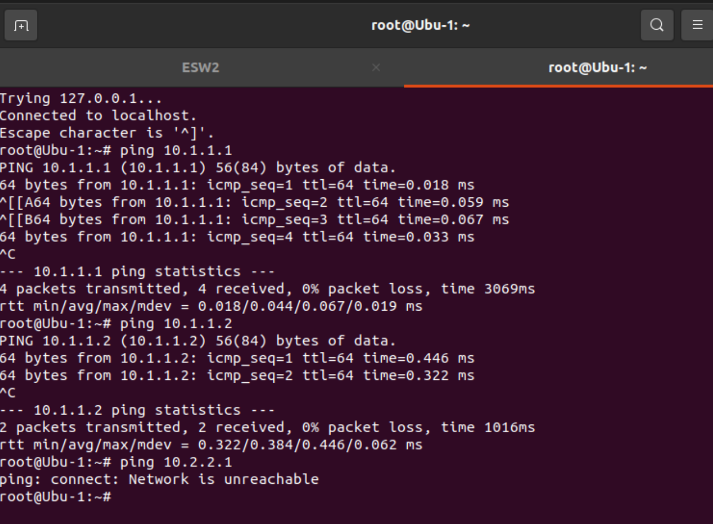

Vlan 1 comunica entre si através do trunk entre ESW1 e ESW2.
Vlans diferentes não têm conectividade.

2. Guardado.

