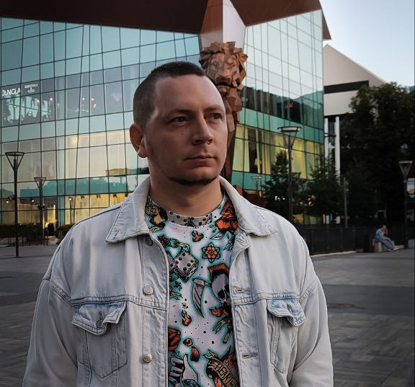**Mikhail Golikov**

**Junior-Python-developer**  
Gdansk, Poland  
<https://inspektop.github.io/Portfolio/> <https://github.com/InsPekToP>

Date of birth: 27.03.1991

### About Me:

A am a Junior Python developer with less than a year of experience.I have skills in Python, SQL, Kivy, Django, as well HTML, CSS, JavaScript, and Git. I am open to full-time, part-time, or remote work.

|  |  |  |
| --- | --- | --- |
| Project Title | Link to Website/GitHub | Descriptions |
| Portfolio | [Link](https://inspektop.github.io/Portfolio/)/[GitHub](https://github.com/InsPekToP/Portfolio) | **Portfolio with HTML, CSS and JavaScript**: suppports three languages, optimized for tablets and phones, with the options to download the resume in the selected language. |
| L2spike | [Link](https://inspektop.github.io/L2spike/)/[GitHub](https://github.com/InsPekToP/L2spike) | **Development of a Lineage 2 game server**: aimed at restoring and enhancing the original gaming experience, this project was completed by two junior programmers. |
| L2zames | [Link](https://inspektop.github.io/GitHub_Pages_test/)/[GitHub](https://github.com/InsPekToP/GitHub_Pages_test) | **Pet project developed as part of the ITproger.com courses:** utilizes jQuery to create interactive elements and modern web solutions. |
| InfinityFree | [Link](https://inspektop.infinityfreeapp.com/) | **Pet project for deploying a website on InfinityFree.com:** utilizes Bootstrap to create a responsive design. |
| Blog-Django | [GitHub](https://github.com/InsPekToP/17_module_lessons) | **Django project from ITproger.com course:** features user registration, post management, database connection, and avatar uploads. |

**Additional Education:**

**Completed the course «Python Developer Profession» at ITproger programming school.**

[**Certificate**](https://itproger.com/view-diplom/c81ddc517c4b9442dc0ea28ca0fefeea/python) **of completion:**

# **Additional Skills:**

* HTML (HTML5), CSS (CSS3) ;
* JavaScript and jQuery;
* Bootstrap framework;
* Cross-browser and cross-platform layout;
* Quick adaption to new technologies;
* Communicative, responsible, and detail-oriented.

# **Languages:**

Russian – native language;

English – reading technical documentation;

Polish – conversational;

**Work Experience:**

**2019–2024: Geodis sp. z o. o.**

* Optimization of loading processes
* Working with automated systems (barcode scanners)
* Managing data related to cargo shiping

**2019–2021: LG Chem sp. z o. o. – Machine Operator / Supervisor**

* Monitoring production equipment.
* Quality control of products.
* Process management (recording machine dowtime).
* Operating the control panel for performance monitoring.

**2016–2019: TPV sp. z o. o. – Equipment Operator**

* Operating packaging equipment.
* Transporting and distributing pallets.

**2010–2016: Waiter / Bartender / Nigthclub Administrator**

* Customer service, shift management.
* Working with cash register systems.

**Education:**

Graduated from KhNADU University in 2013 with a degree in Mechanical Engineering.

**Additional Information:**

Excellent knowledge of PCs and Windows at an advanced user level.Currently residing in Poland, I am gradually learning the basics of programming. In my free time, I enjoy visiting the pool and cycling.

Proficient in English at a level suitable for reading and using technical documentation with a dictionary.