ITEC 493: IT Security for Managers Spring 2024 - Final Project

This lab is completed as a group, and everyone earns the same grade. Make sure that you identify who does what within the lab. In very extreme and well documented cases, the grades of group members may be different. This is assessed on a case-by-case basis.

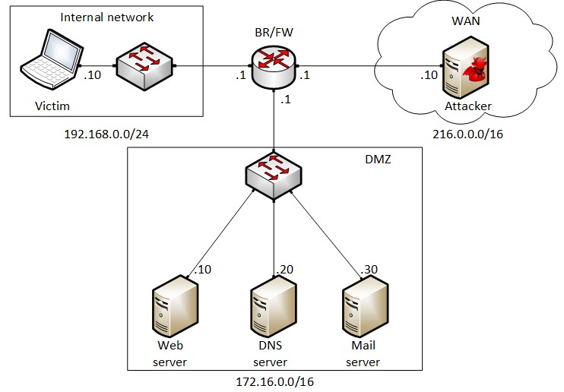Topology: Use Lab 01: Reconnaissance Scanning environment

Submission details:
Your report should include screenshots and explanations for each step. If you do not include screenshots and explanations, you will earn a zero. The explanation should be properly written. Just copying and pasting from the labs will not be acceptable.
- Must be submitted in MS Word format – (.DOCX)
- Substitute group number for xx in filename: 24SP-ITEC493-Final_Lab-Gxx.docx
- Use leading zero in single digit group numbers.
  - Group 1 should submit: 24SP-ITEC493-Final_Lab-G01.docx
- PDF File format WILL NOT BE ACCEPTED and earn a zero.

Part 1: Access Control (10 points):
In this part, you will implement simple access control rules using iptables on the Border Router (BR). Specifically, the following requirements must be considered:
- Devices in the internal network must be able to communicate with the Wide Area Network (WAN).
- Devices in the internal network must be able to communicate with the Demilitarized Zone (DMZ).
- Devices in the Wide area network must be able to communicate with devices in the DMZ zone.
- Devices in the WAN cannot initiate connections to devices in the internal network.
- The IP address 216.0.0.5 must not be able to access the web application residing on the web server.

Part 2: Scanning (10 points): Ahmed
In this part, you will be using the attacker’s machine to discover the devices and the services running in the network. The following requirements must be considered:
- We would like to know which devices are up and running in the network. The report must include the IP address of the devices.

By running Nmap -Sn 172.16.0.0/16 it will display all the devices that are running within the network. 172.16.0.10 is the web server, .20 is the DNS and .30 is the mail server.

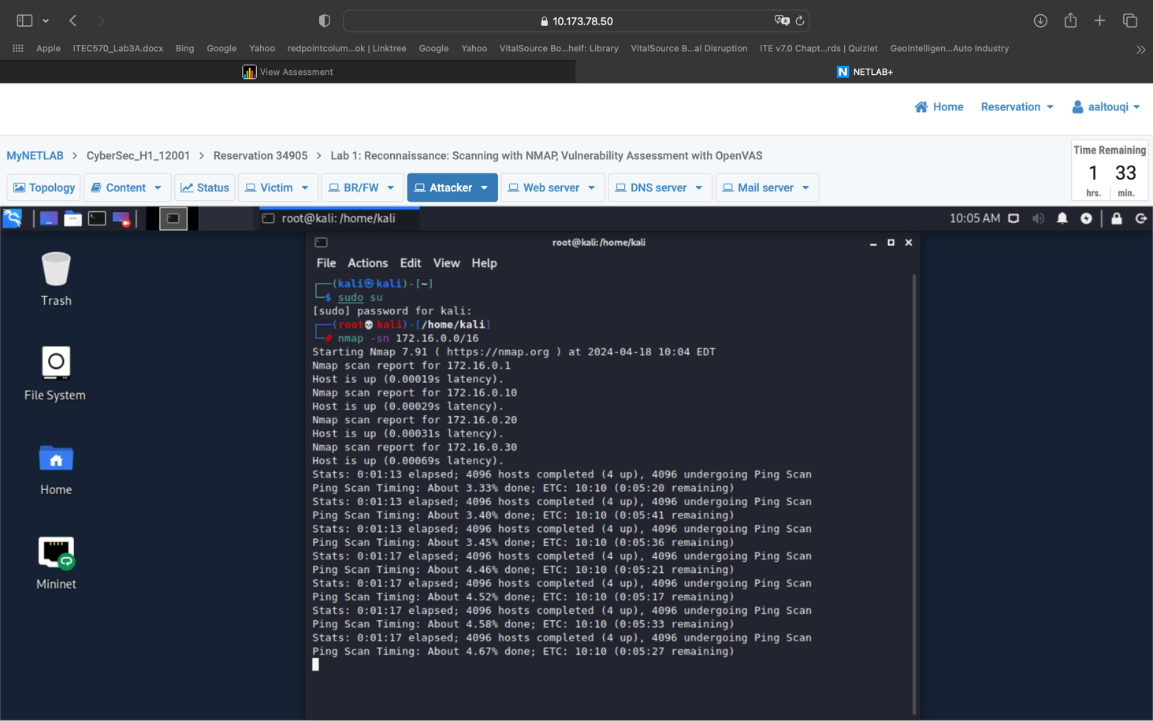

- Then, we want to determine the operating system used on the devices.

By running nmap -O 172.16.0.1 we will get information regarding the router. .10 is for the web server, .20 Is for DNS and .30 is for the mail server.
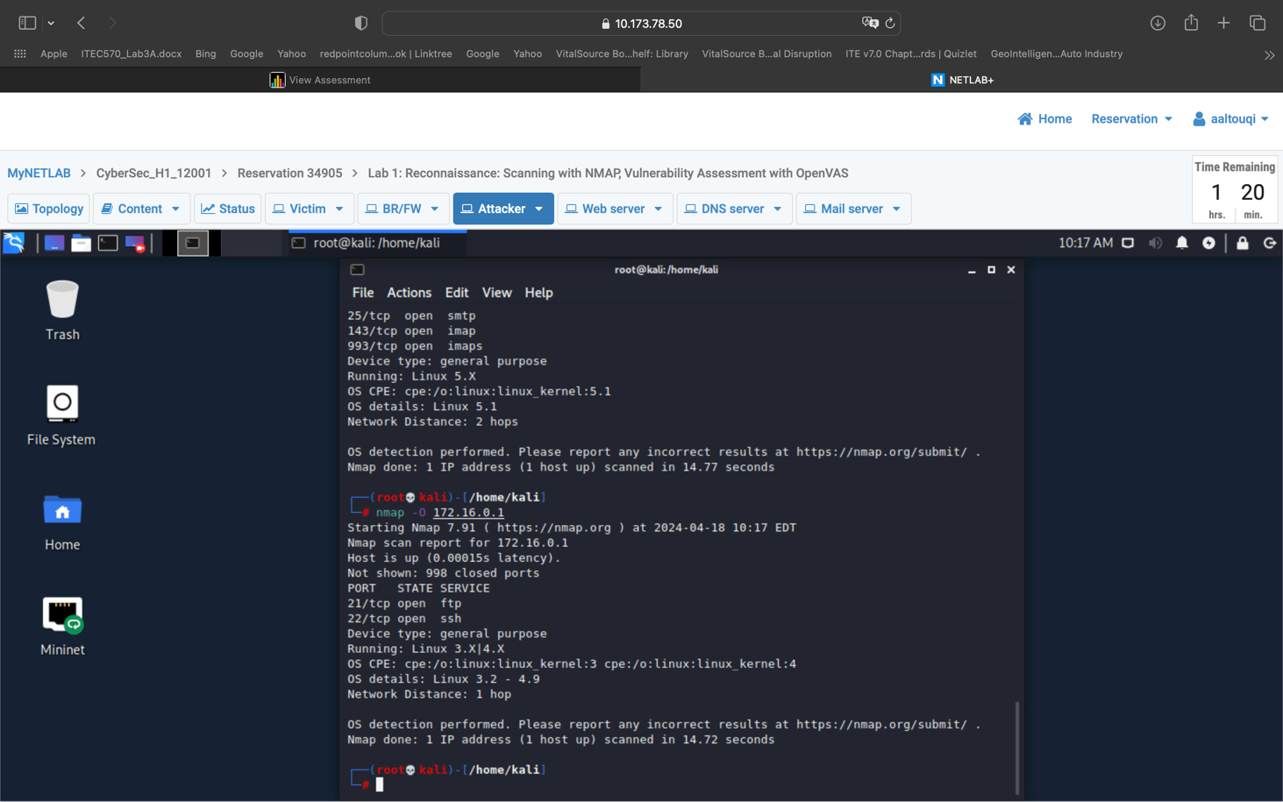

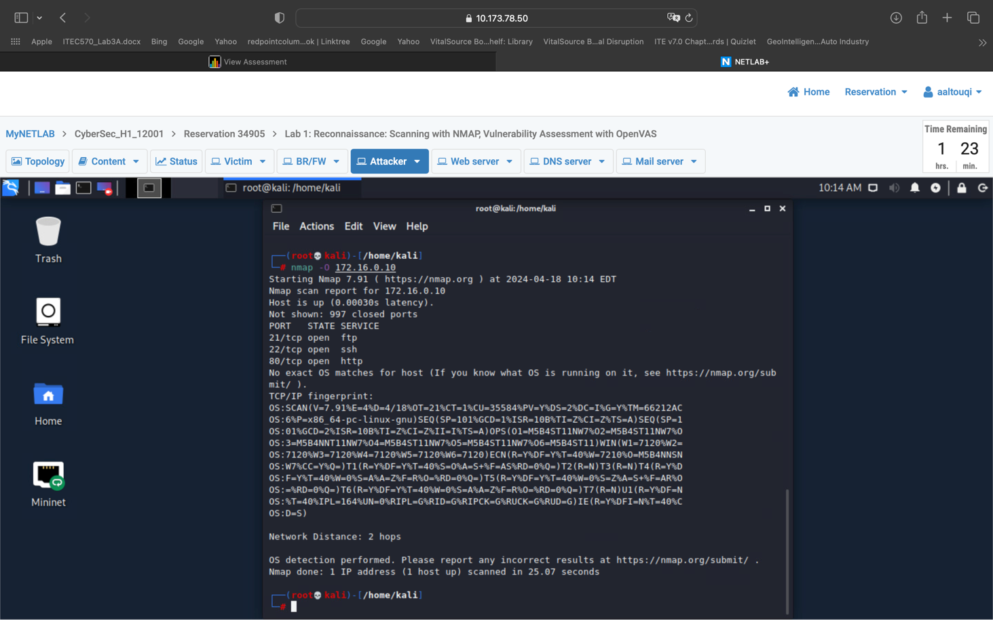

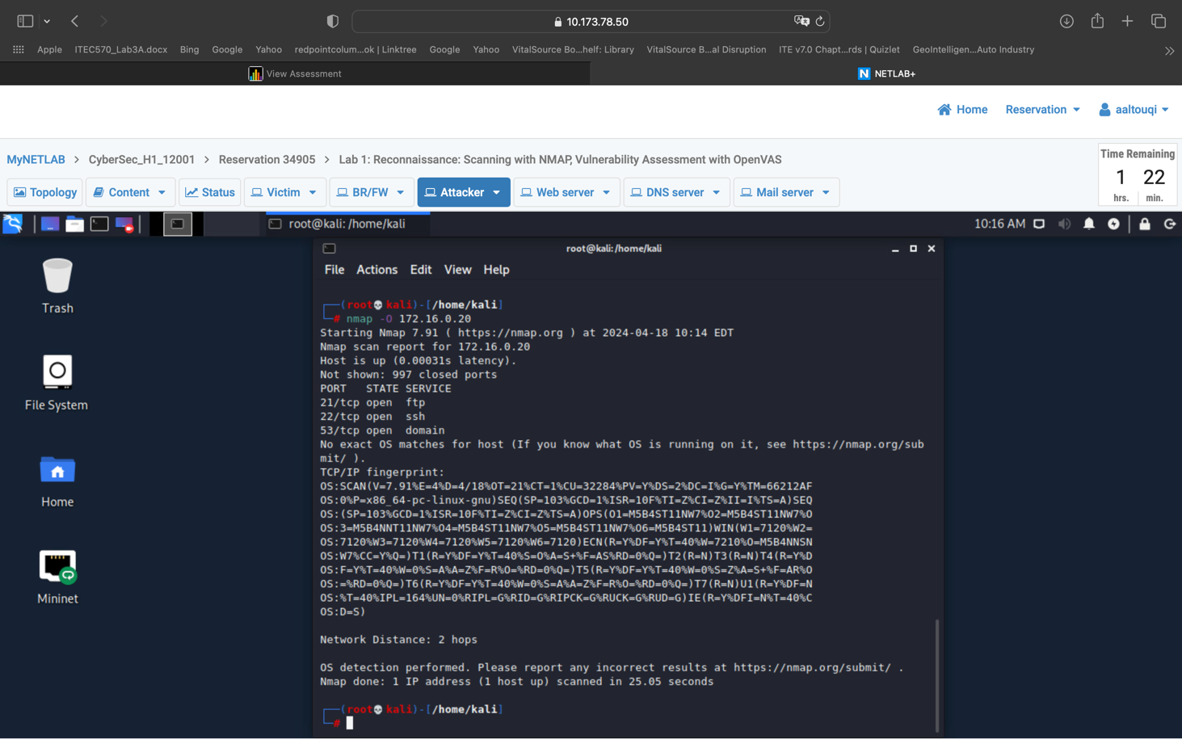

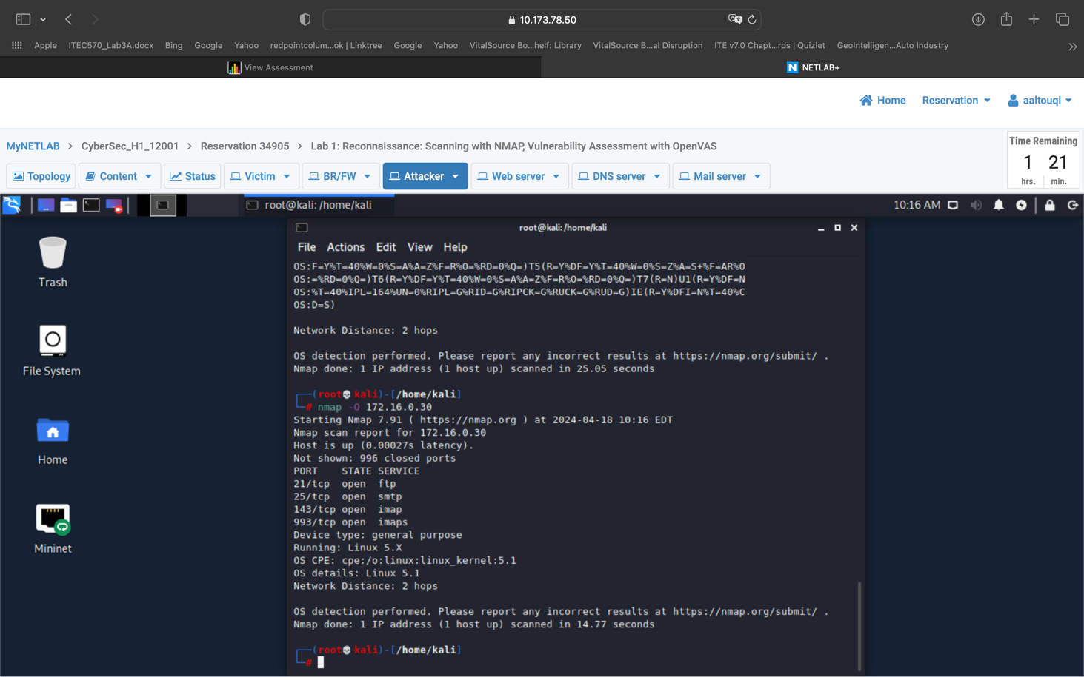
- Now we want to know which services are running on the discovered devices. For each service, we would like to know the version of the service that is running.

Nmap -sT 172.16.0.1/.10/.20/.30 will provide us information regarding the services these devices are running
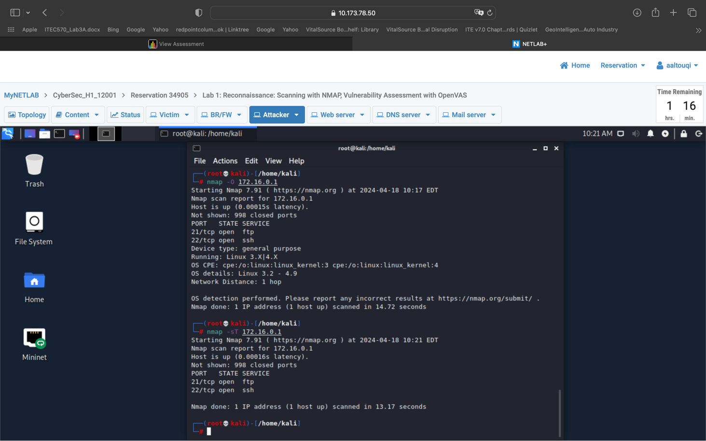

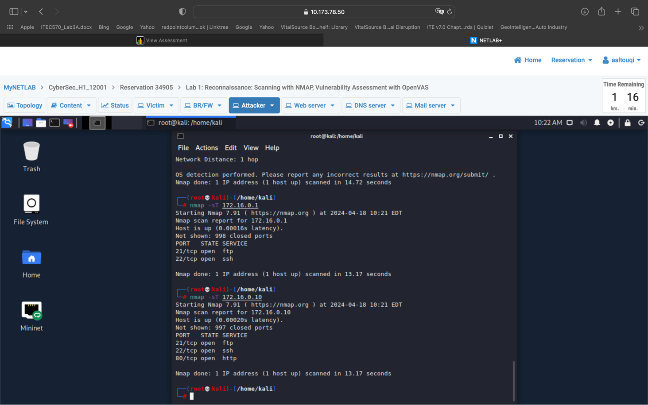

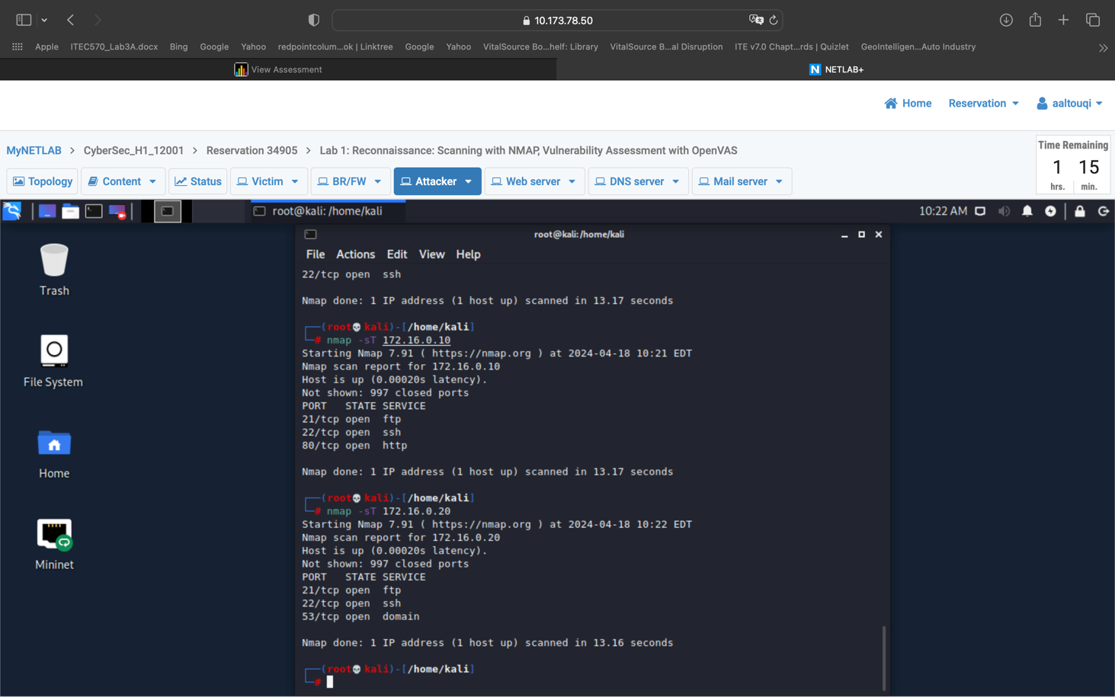

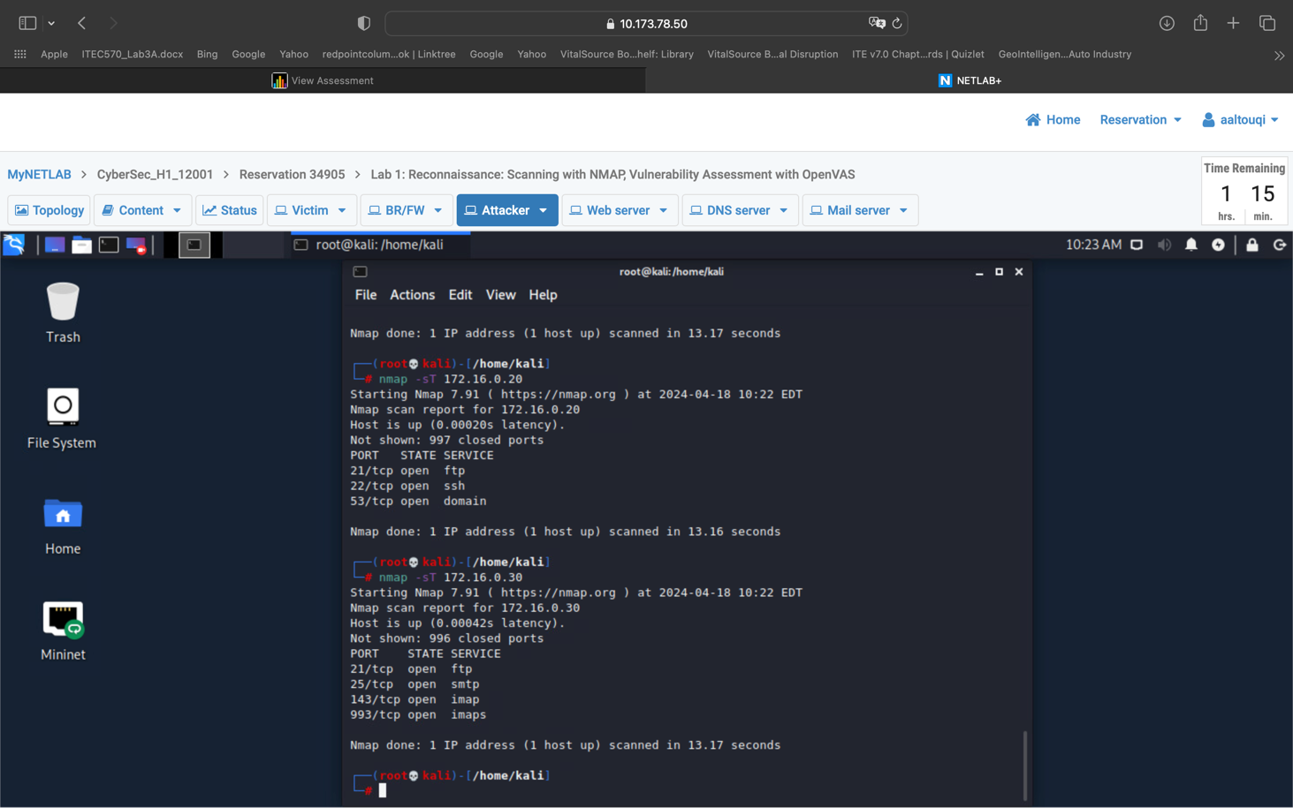

And

Nmap -sV 172.16.0.1/.10/.20/.30 will provide us information regarding the version these services are running

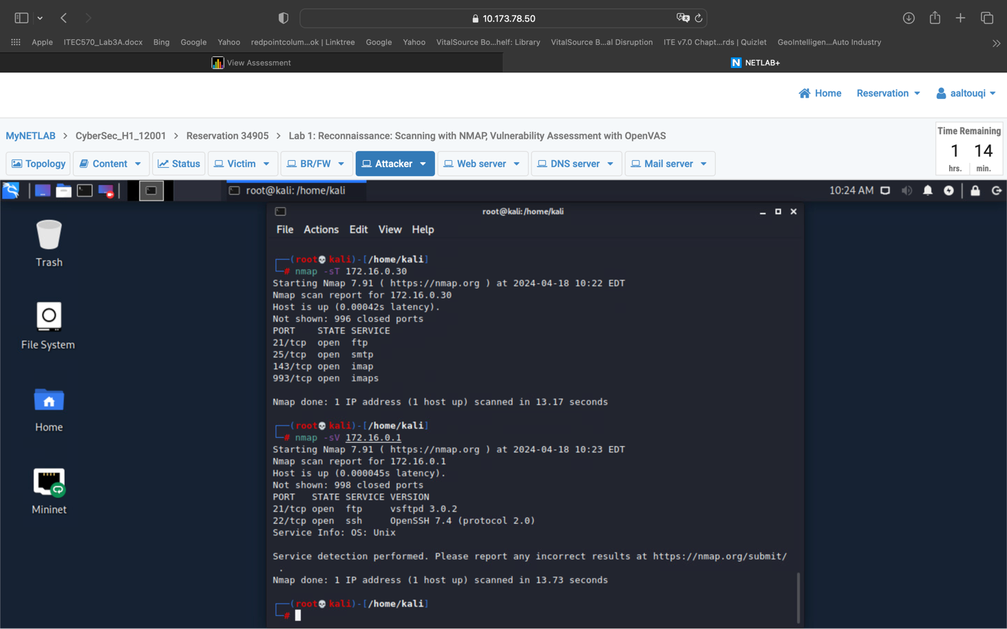
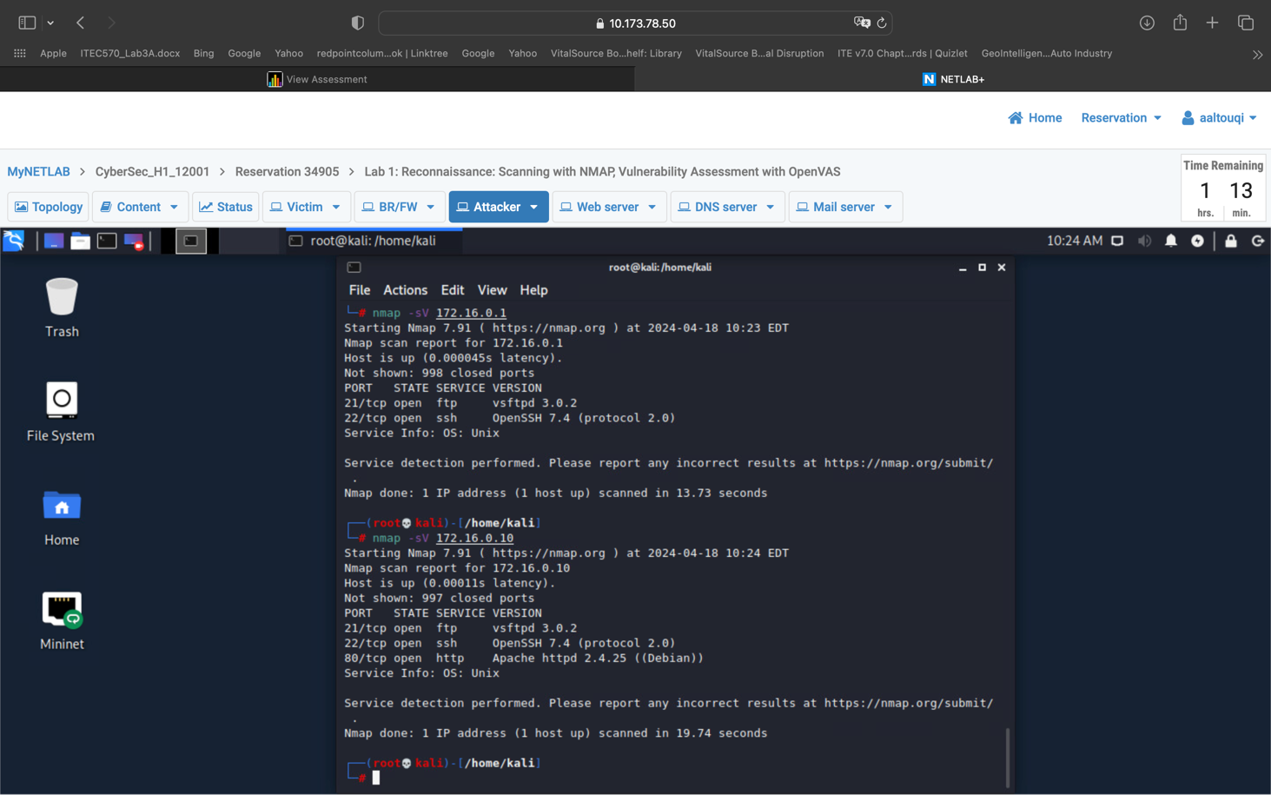

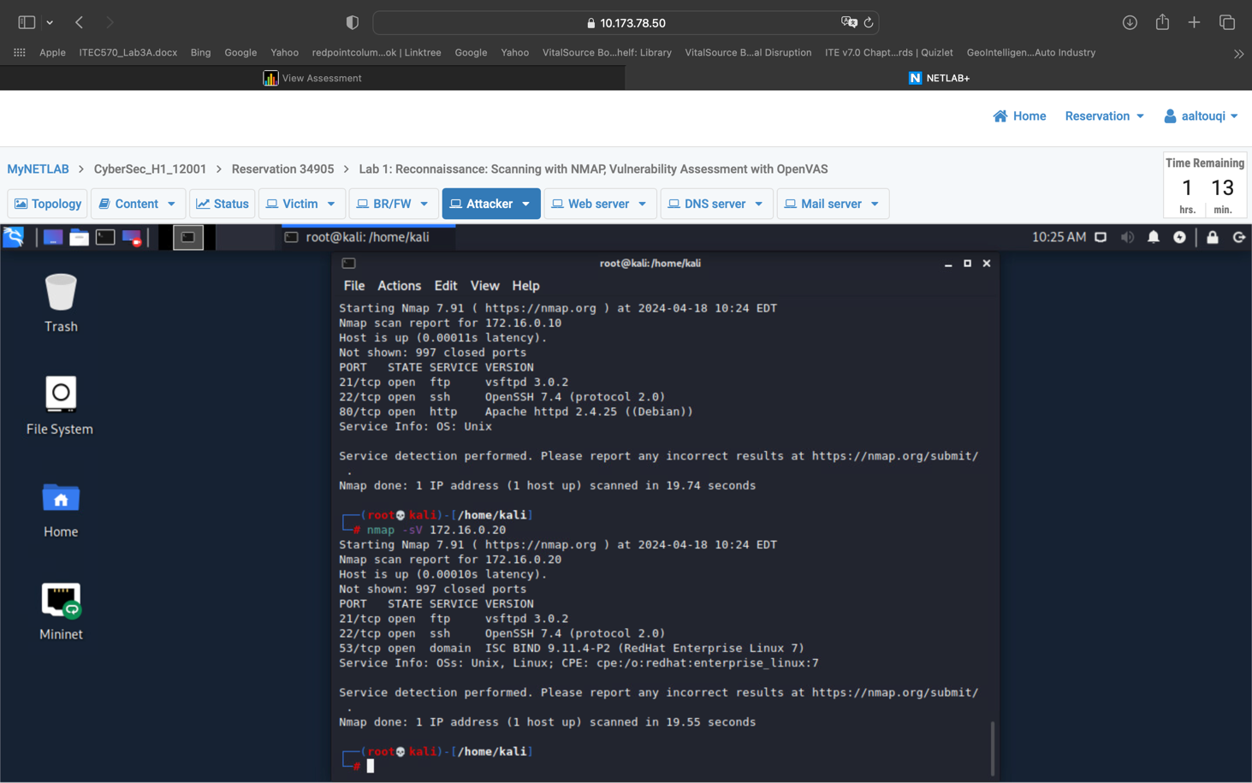
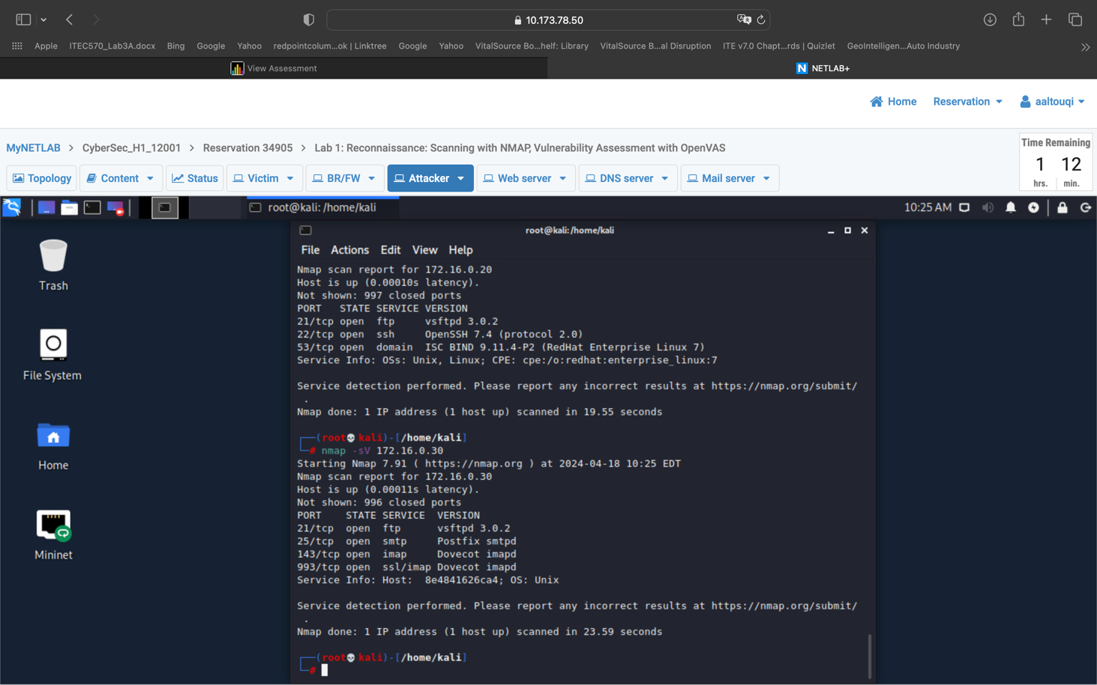

Part 3: Vulnerability assessment (10 points):
In this part, you will be using the attacker’s machine to conduct a vulnerability assessment on the devices and the services running in the network. The following requirements must be considered:
- The OpenVAS tool must be used for this task.
- The vulnerability assessment must be conducted on:
  - Web server
  - DNS server
  - Mail server
- Another vulnerability assessment for the three servers mentioned above must be conducted using the CVE database.
- A detailed report must be presented. It should be exported as a TXT file.

Part 4: Remote Access Trojan and Backdoor installation (10 points): Ahmed
In this part, you will be using the attacker’s machine to gain access to the victim’s machine. The following requirements must be considered:
- You will generate a malicious payload (Reverse_TCP Meterpreter).
To create this use setoolkit / social engineering attacks / windows reverse tcp meterpreter

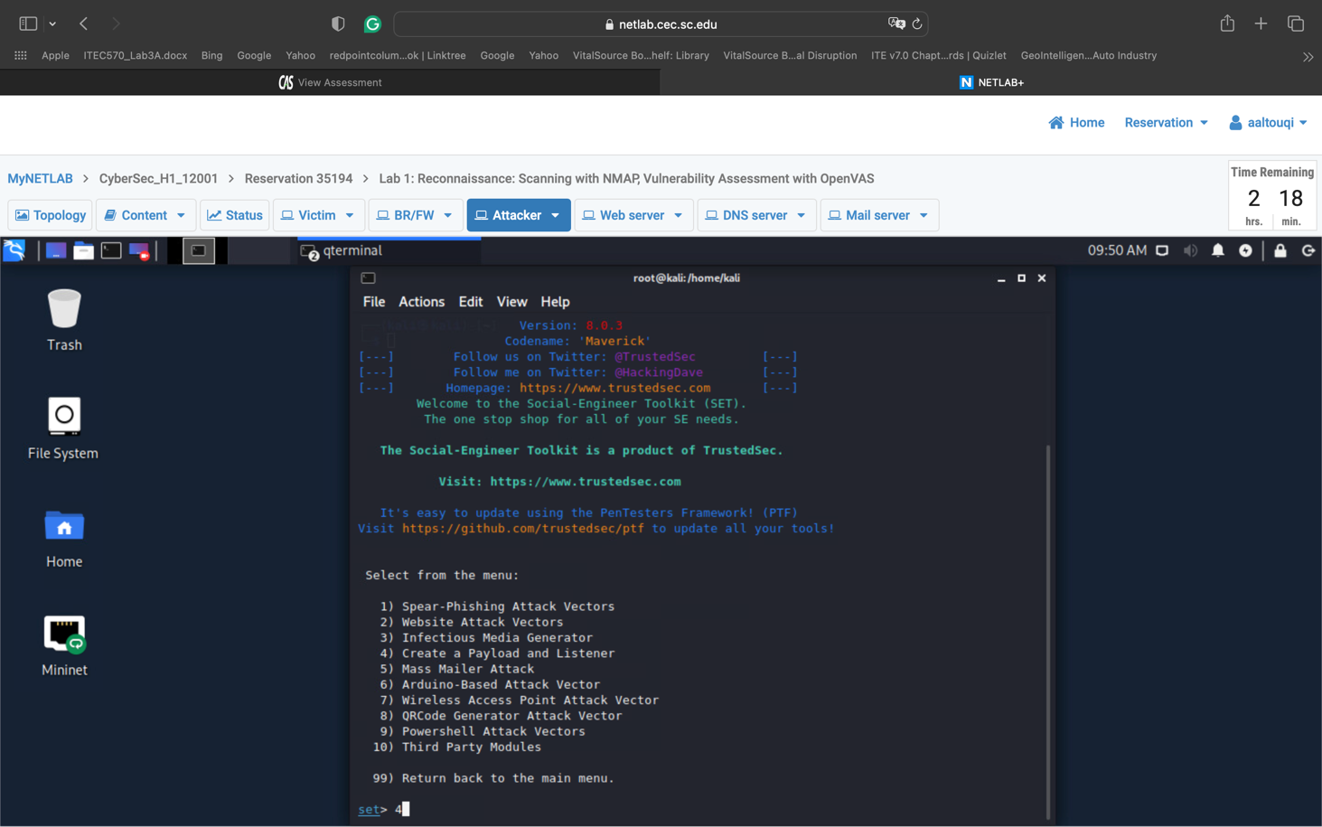

- You create a listener to accept connections from the victim.
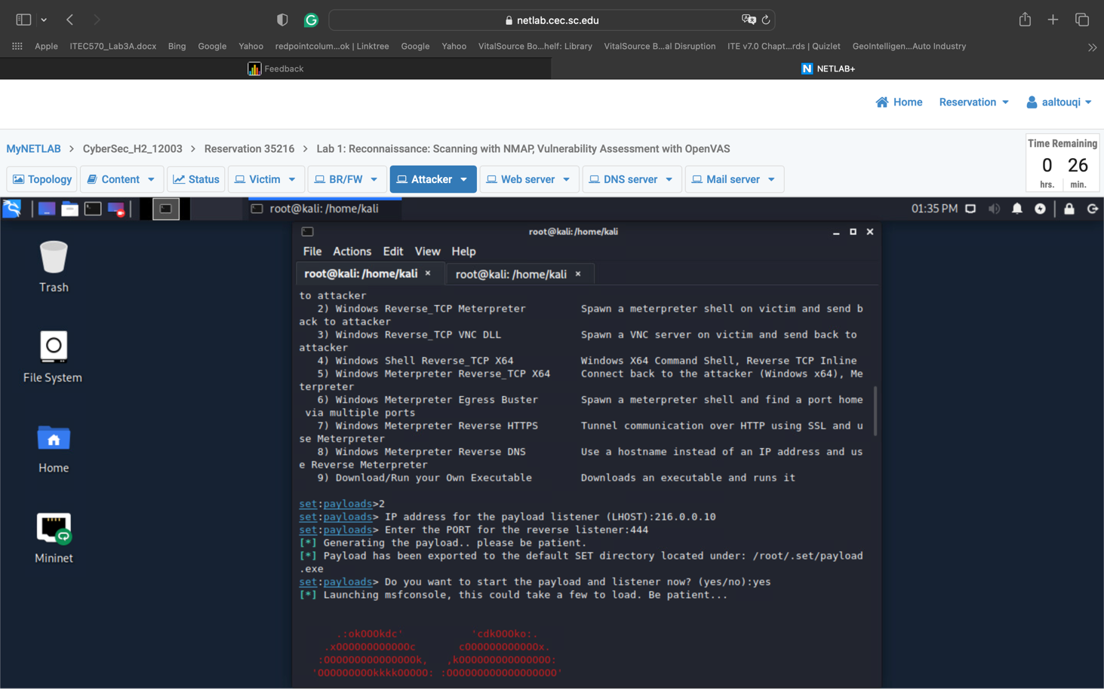

We inputted the attackers ip from IF config and used the port 444

- You will start an HTTP server and copy the malicious file to it.
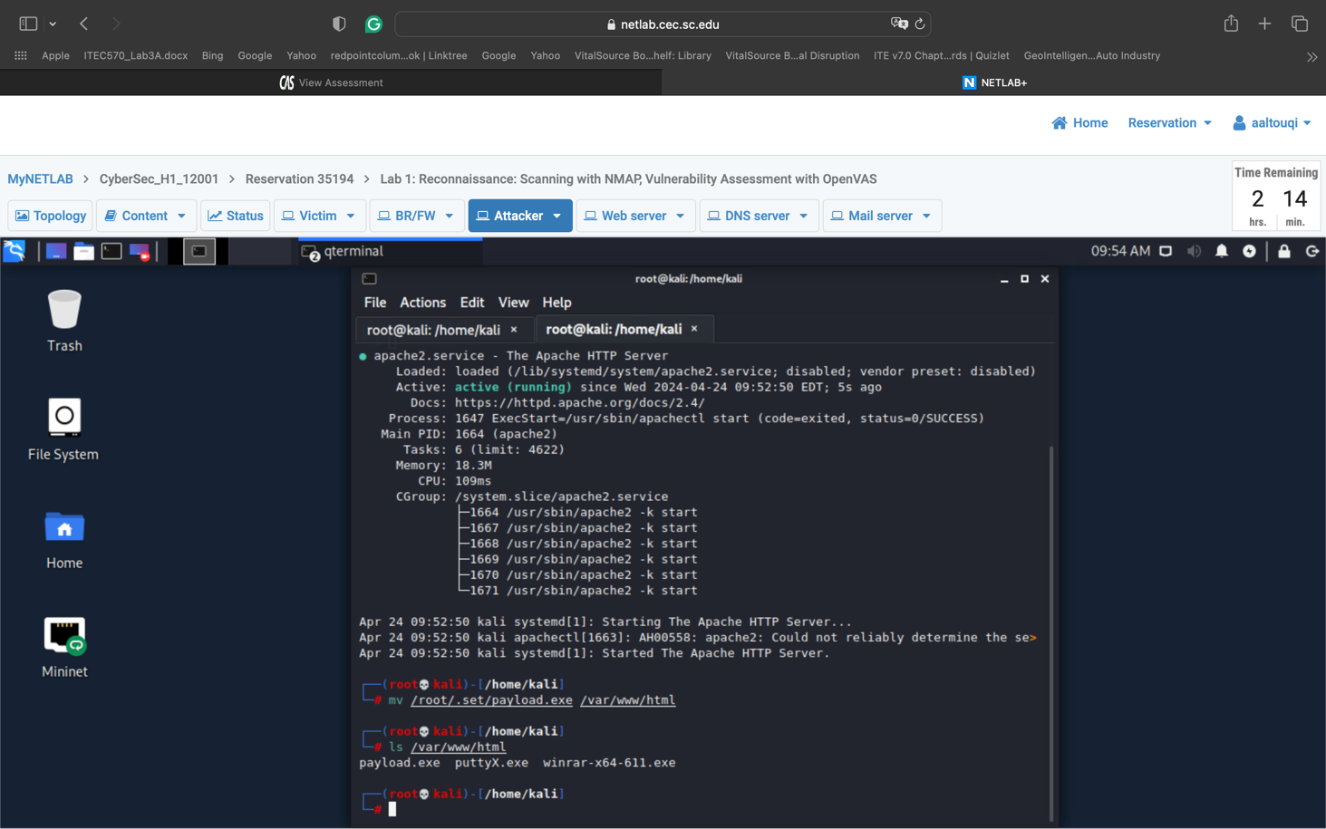
I opened a new tab and made sure the server is running then moved the file to the directory

- The victim will download that file and execute it. Note that the antivirus must be disabled on the victim for this attack to work.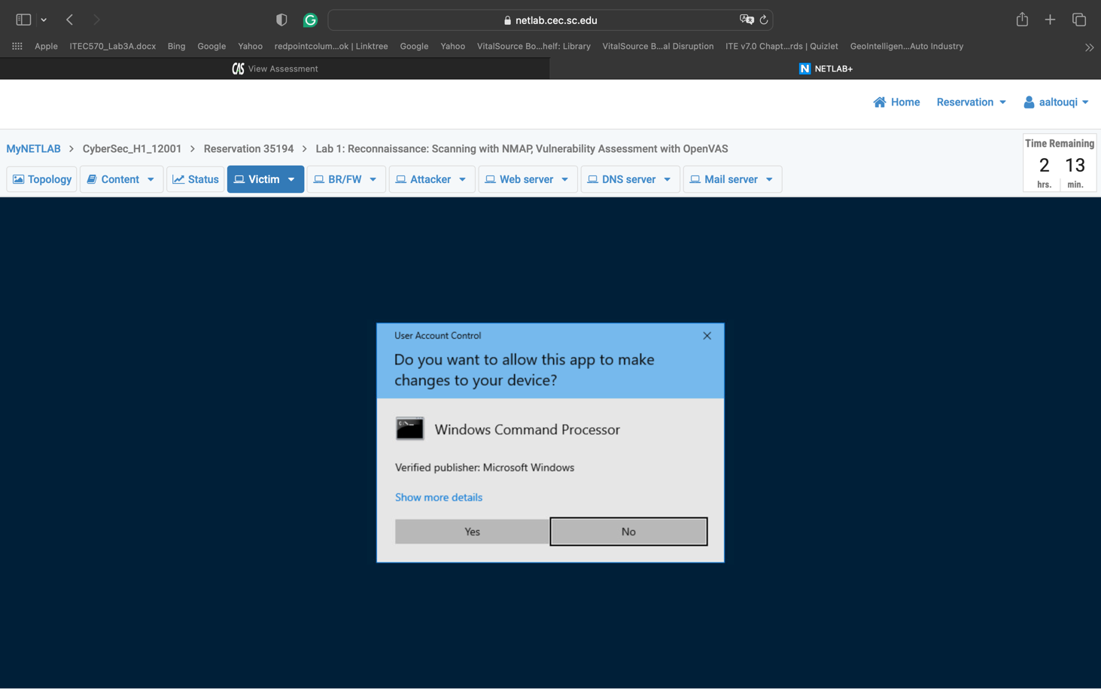
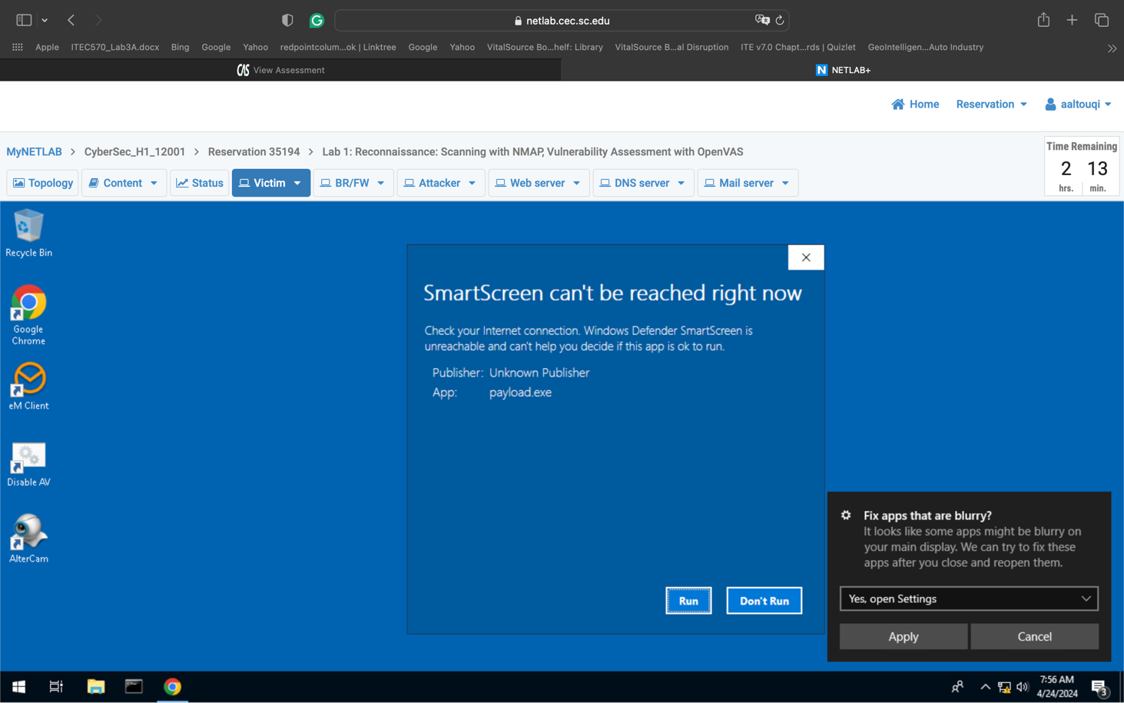

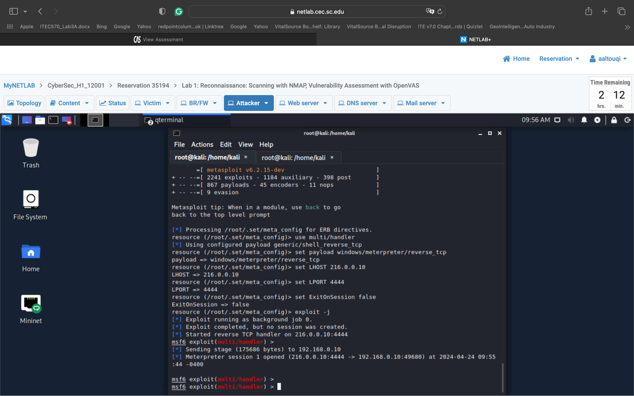

By disabling AV and downloading the file from software.com we established a connection

- Then, you will delete an arbitrary file on the victim’s machine.
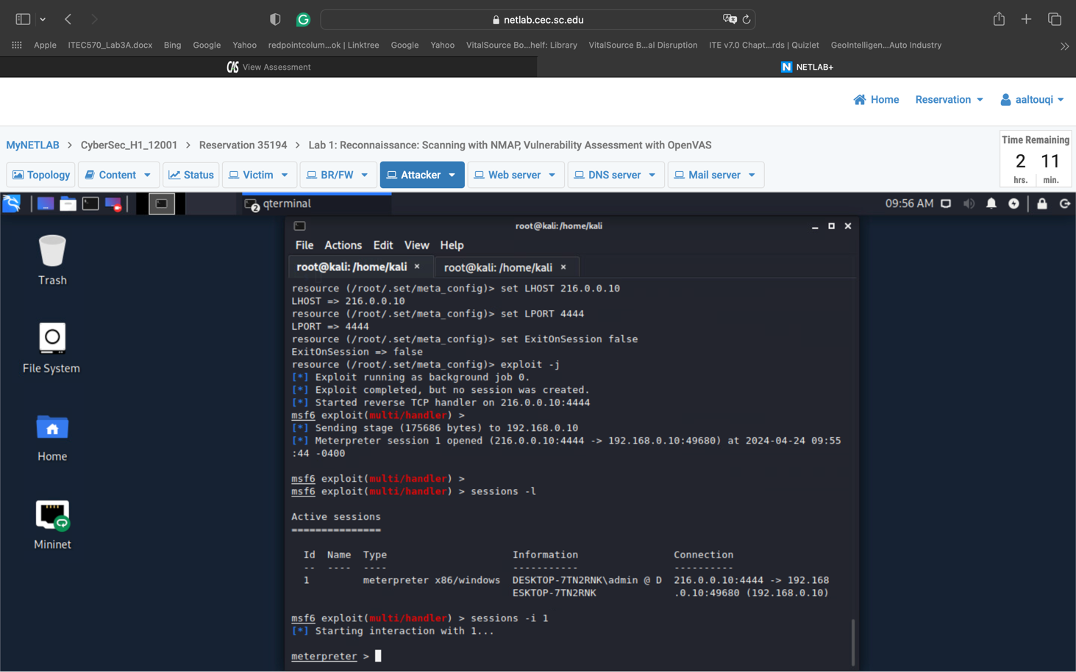

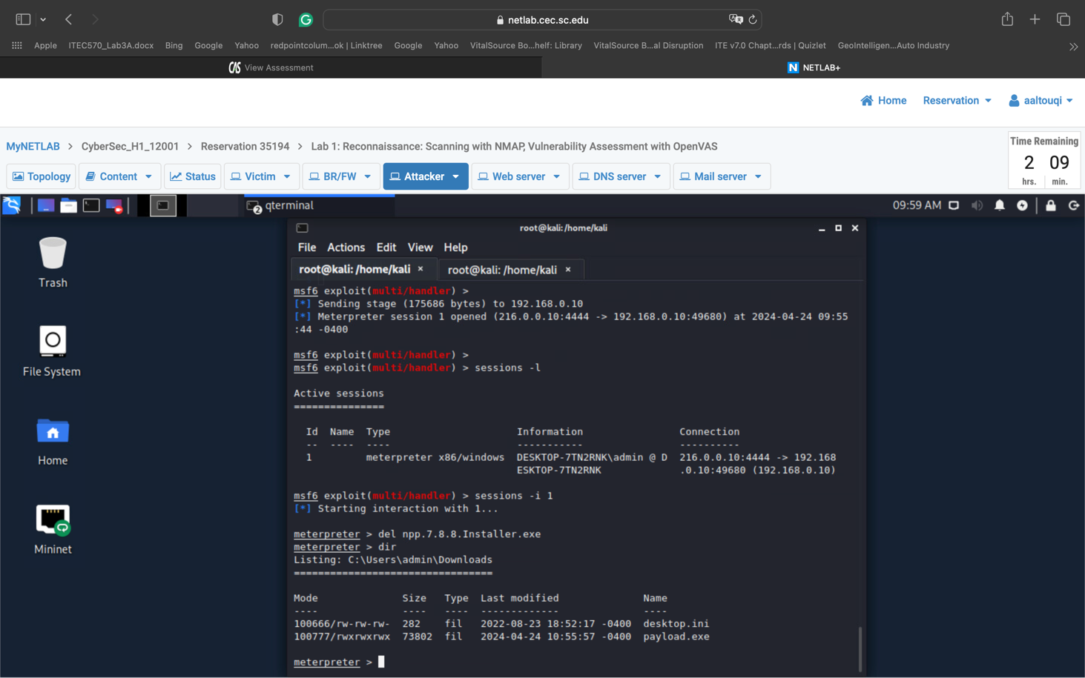

Using sessions – l we identified session no 1 was running which we then used session -I 1 to connect to that and delete the file and use dir to verify the deletion

- You must escalate privileges and gain root access to the victim.
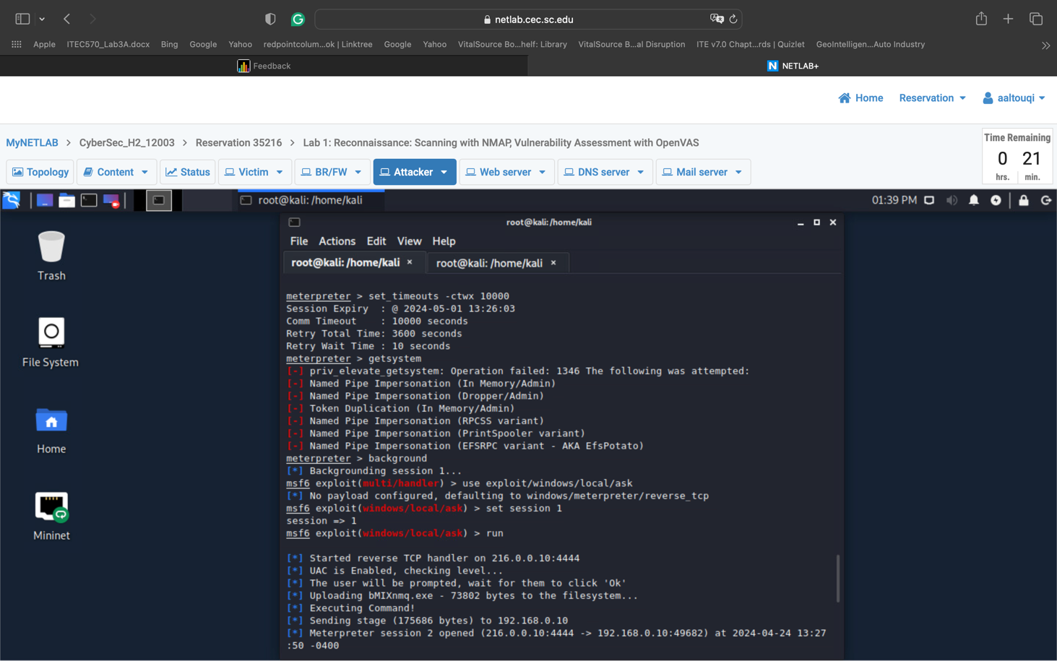

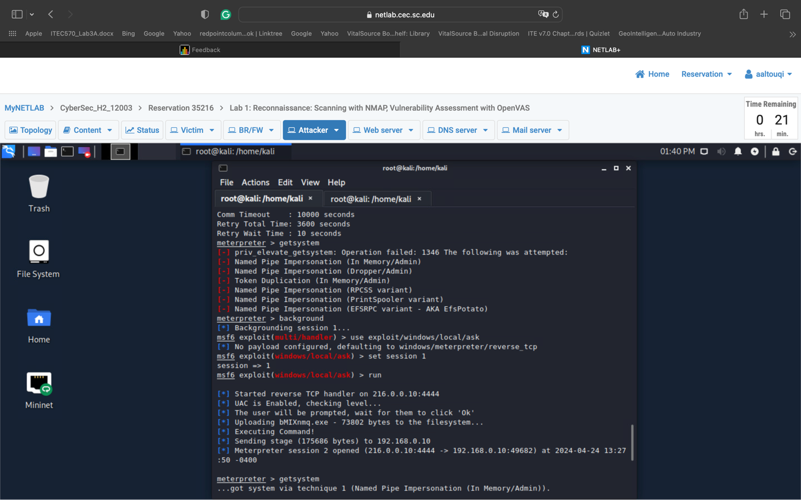

- Then, you must install a backdoor which will allow you to maintain persistent access to the victim’s machine.

Part 5: Social Engineering and Spyware (10 points):
In this part, you will be using the attacker’s machine to gain access to the victim’s machine. The following requirements must be considered:
- You will send a phishing email that contains a malicious file.
- Once the victim executes the file, you will gain access to their machine.
- Then, you will install a spyware to monitor the user’s behavior. This includes taking a screenshot, activating screenshare, and logging the keys they type on the keyboard.

Part 6: Web-based attacks (10 points): Ahmed
In this part, you will be using the attacker’s machine to access the website hosted on the web server. The following requirements must be considered:
- You will attempt to perform an SQL injection attack, different than the one shown in the lab in class.
- Then, you will perform a cross-site scripting attack. This should be like the one mentioned in the lab.

Part 7: DDoS attacks (10 points):
In this part, you will be using the attacker’s machine to flood the web server with requests as follows:
- SYN Flood. DO NOT randomize the source IP of the packets.
- UDP Flood.
- FIN Flood.
- RST Flood.
- ICMP Flood.

Part 8: Cryptography – Symmetric Encryption (10 points): Ahmed
In this part, you will be generating a symmetric key used for encrypting data. The following requirements must be considered:
- The key to be generated must be AES256.
- You will encrypt any file of your choice using that key.
- You will decrypt the file using the same key and verify that it matches the original file.
- You will encrypt using both CBC and EBC modes.

Part 9: Cryptography – Asymmetric Encryption (10 points):
In this part, you will be generating asymmetric keys used for encrypting data. The following requirements must be considered:
- Generate two RSA 2048-bit public/private key pairs. One for Alice (sender) and one for Bob (receiver).
- Create a text file that contains the following phrase:
This is the final project for ITEC493.
- Encrypt the file with the public key of Bob.
- Decrypt the file with the private key of Bob.
- Sign the file as Bob and verify Bob’s signature.
- Use Diffie-Hellman (DH) to share a secret between Alice and Bob.

Part 10: Public Key Infrastructure (10 points): Ahmed
- In this part, you will become a root Certificate Authority (CA).
- You will generate a certificate for the domain mycompany.com.
- You will sign the certificate using the CA.
- Then, you will install it on the Apache web server on the attacker’s machine.
- You should do the necessary configuration so that no warning messages are displayed when visiting the website.

