Data Model Project | - ITEC 570 SPRING 2024

Due Date 4/1/2024
Ahmed Al touqi
ITEC 570 -001
Relationship Indicators to  Use with Crow’s foot notation |  | 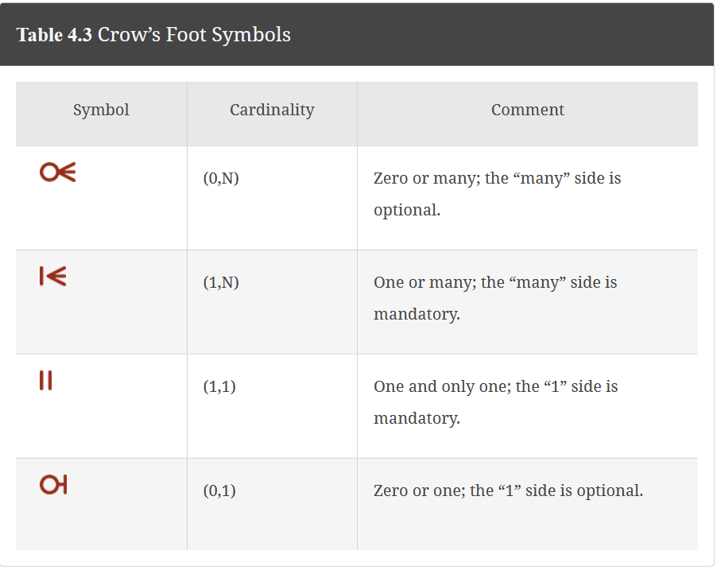
Many-to-many |  | No many to many relationships are allowed!  To eliminate many to many, create a junction/bridging entity/table with composite primary key.
ER-models and ERD |  | Hand drawn models will be given a zero.  You must use Draw.io, diagram.net or visio  Label your models  Include your name, itec 570, data model #, title  ER-model only displays two entities and relationships.  ERD displays all entities, attributes, relationships, PK and FK  Indicate the PK in bold and underlined.  Indicate FK in bold in red font.
Embed ER-models and ERD into this document.
RUBRIC.
 | Data Model 1 | Data Model 2 | Possible Points
Keys |  |  | 50
ER-models |  |  | 50
ERD-models |  |  | 100
Analysis |  |  | 50
On-time/Late |  |  | +50/-50
TOTAL |  |  | 300/250

 | Data Model #1 | Keeping track of course enrollment.
 | Business Rules | - A course can generate many classes.  - Each class is linked to one course.  - A course may or may not have a class each semester. We do not offer ITEC 562 every semester.  - A class must have one or many students enrolled.  - A student must enroll in one or more classes each semester.  - A student not enrolled should have their enrollment status changed from ‘Active’ to ‘Inactive’.  - A student is classified as either undergraduate or graduate, but not both  - Undergraduate students may or may not have a capstone project.  - Graduate students may have a thesis or dissertation.
 | Entities and relationships | - You will determine the entities and relationships from the business rules
 | Turn in:
 | Draw ER-Models  Using the business rules and entity definitions | - Title: #1-ER-Models  - If there is no relationship between the two entities, then draw with no connections and “No relationship between these two entities”. Resolve all many to many relationships.
 | Draw Final ERD  Using business rules, relationships, and PK and FK | - Title: #1-ERD  - You must include PK and FK fields.  - Use course_id, class_id, student_id, enroll_id, student_type, status_code  Other attributes to add to your ERD.  - Students also include name, email, address  - Courses also include four letter code department, 3 number code course, title, description  - Classes also include section, semester.building, room_no, schedule, professor.
 | Add Professors | - Title: #1-ERD with professors  Modify your ERD and add Professors table  - to link to for valid values in the Classes table.  - Include firstname, lastname, email, professor_id
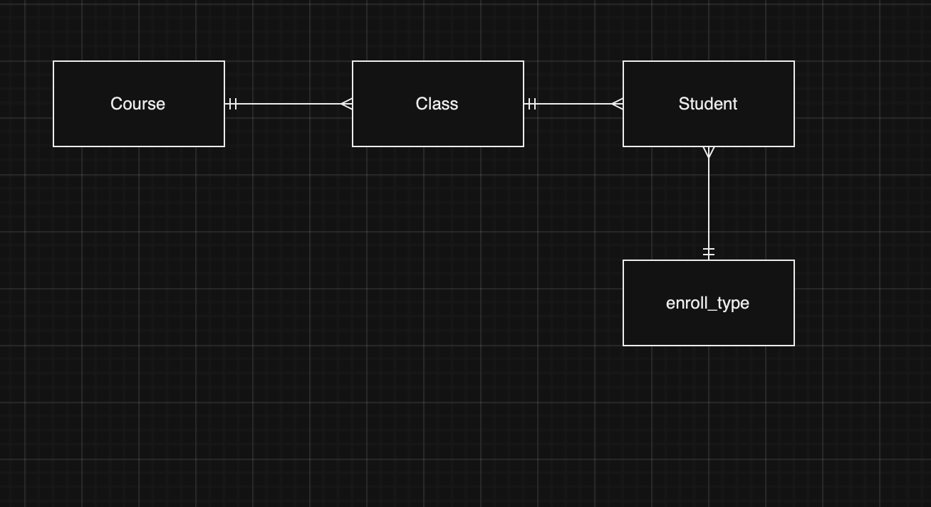

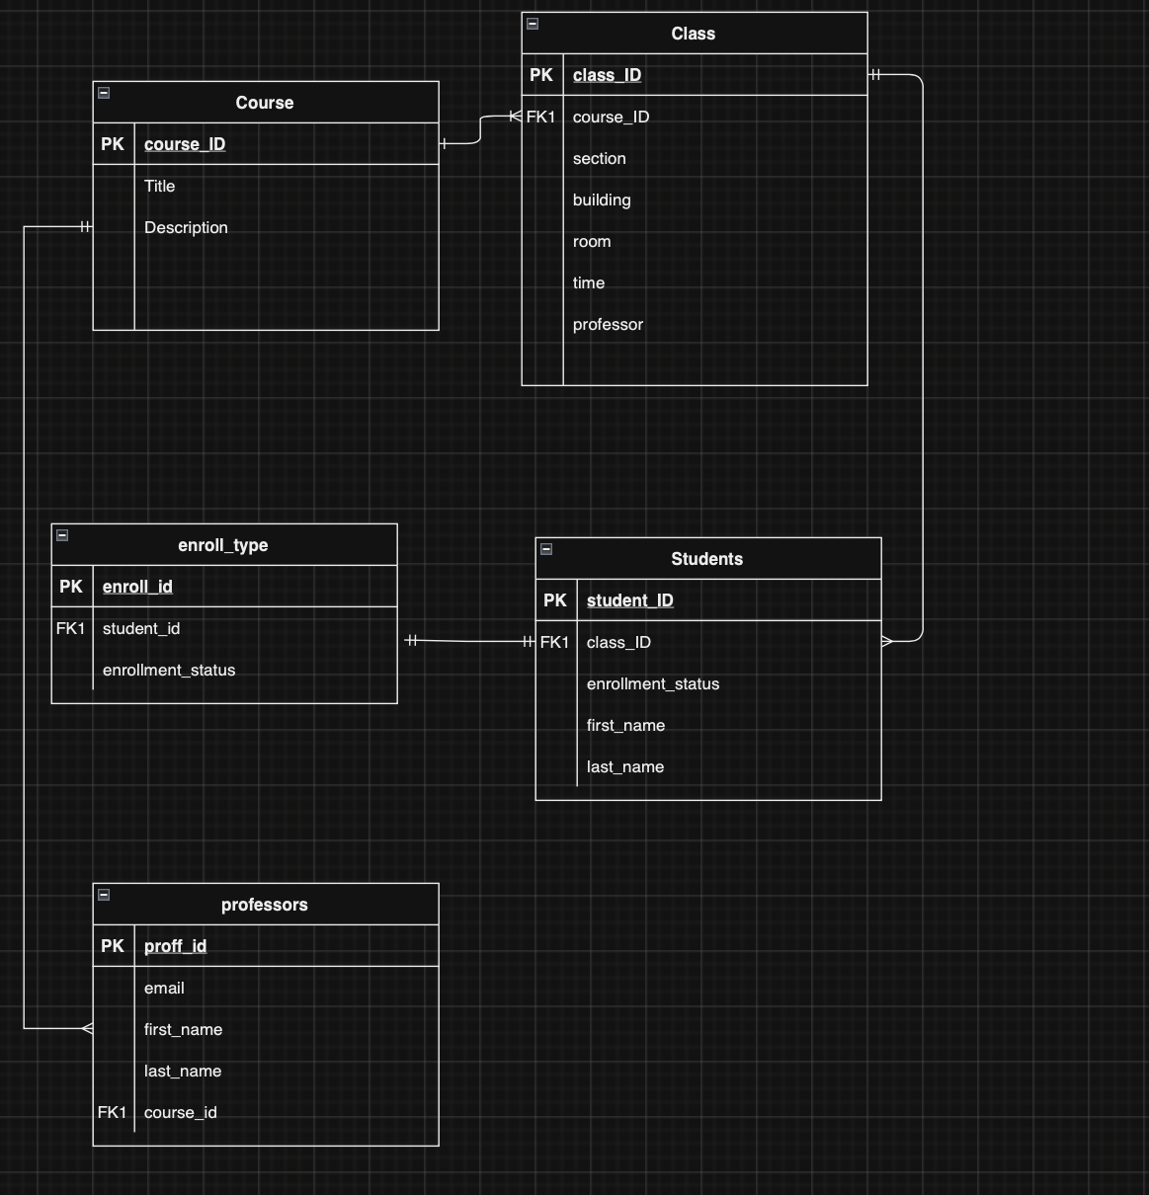

Data Model #2 | You have been asked to sketch a data model for a new on-line video streaming platform.  Here are some of the data requirements:  - Keep track of shows watched by each user.  - Replay a movie, save your progress, continue a movie.  - Each user account can save favorite actors and genres.  - Movies, TV shows, and live content.  - The library is organized by genre and title.  - Keep track of the full length movie and trailers.  Recommenders: platform automatically uses data collected to make recommendations for the user(data-driven machine learning):  - For you, top requested moives and tv shows last week based on user history.  - User recently played actors in the last week.  - User recently played movies in the last login.  - User favorite movies (up to 10)  - User favorite tv shows (up to 5)  - Just released (top 25)  - Search -allow users to search the platform based upon title and genre.  - How many users stream Daily/Monthly  - Average viewing per user  - Users who viewed certain content  - Users who watched certain content on release date.  Pick a design of an existing company’s front end to begin your design.  Cite that in your write-up. (apple +, netflix, prime tv, hulu, etc)  Indicate new features and features not included in your design.
Entities and relationships | You will determine the entities and relationships from the requirements above.  Start with users, actors, genres, plans, sessions, and devices.  User information: contains a list of all relevant users ( Current and New Users). For each user we will store their Unique ID , Name ( First and Last Name) , Email , Address , Phone Numbers , joined date , Current Plan( To determine which membership they are currently using) , Is Active ( To determine if user is still active or Opted out of service) and Payment ID. Indicate communication preference (email/address/phone)  Plans: should cover all possible monthly/yearly membership plans that user can opt for on the platform. For each plan , there is a unique ID , Plan Name , No of Screens Limit , Base Rate , Plan Start Date , Plan End Date.  Videos: Every video has a Unique ID , Description/Name, VideoType, Genre, Run time/Length , Release Date , Has Trailer, Is Downloadable.  VideoType: Movie, Series, Documentary, and more.  When video type is series then track the episodes. Series can have many episodes.  Genres:Action, Comedy, Drama, Sci-fi, etc.  Devices: mobile, tablet and desktop.  Sessions: Every session has a unique session id, user, device, video, playback start timestamp , playback end timestamp , session time, pause time. Need to determine how to store episodes and movies. Either one movie or episode per session.  Payments:keep a history of each users payments.  Recommenders: Capture snapshot data to drive recommendations for each user. Like top10 movies this month or weekly.
Turn in the following:
Draw ER-Models  Using the business rules and entity definitions | - Title: 1-ER-Model Video Streaming  - Draw only Entities and relationships. Resolve all many to many relationships.
Draw Final ERD  Using business rules, relationships, and PK and FK | - Title: 2-ERD Video Streaming  - You must include PK and FK fields.  - You should include attributes that are in-line with the project based upon your knowledge of watching shows. Some attributes have been suggested above. Add more at will.
Analysis | - While developing your sketches, you will have questions and will need to make some assumptions.  - Keep a log of questions and assumptions.


