ITEC 570 SPRING 2024

Ch 2- DataModels

Lab 1

Ahmed Altouqi
JAN 31 2024
ITEC 570-001
LAB 1

For each document submitted on-line, please include your name, username, date, ITEC 570-001, reference lab number and title(if appropriate).

Whenever possible, upload PDF files versus word or pages.

Problems.

Use Chapter 2 of your book for help.
- Use Visio, Draw.io, Lucid Chart, drawing tools to Create ER models, UML, Crow’s foot, or Object Representation

Using Figure P2.6 as your guide, work Problems 6, 7, and 8. The Tiny College relational diagram shows the initial entities and attributes for the college.

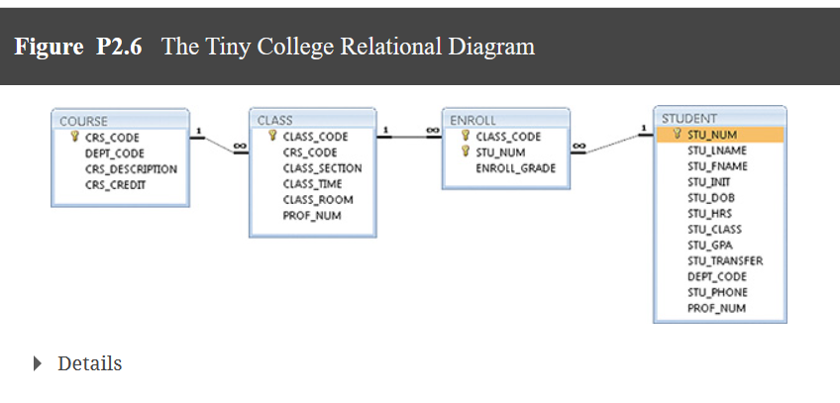

6. Identify each relationship type and write all of the business rules.
Each course could have multiple classes
Each class refer to one course
Each class could have many enrollment
Each enrollment could be assigned one class
many enrollments pertains to one student
each student can have multiple enrollment.

7. Create the basic Crow’s Foot ERD for Tiny College.

8. Create the UML class diagram that reflects the entities and relationships you identified in the relational diagram.

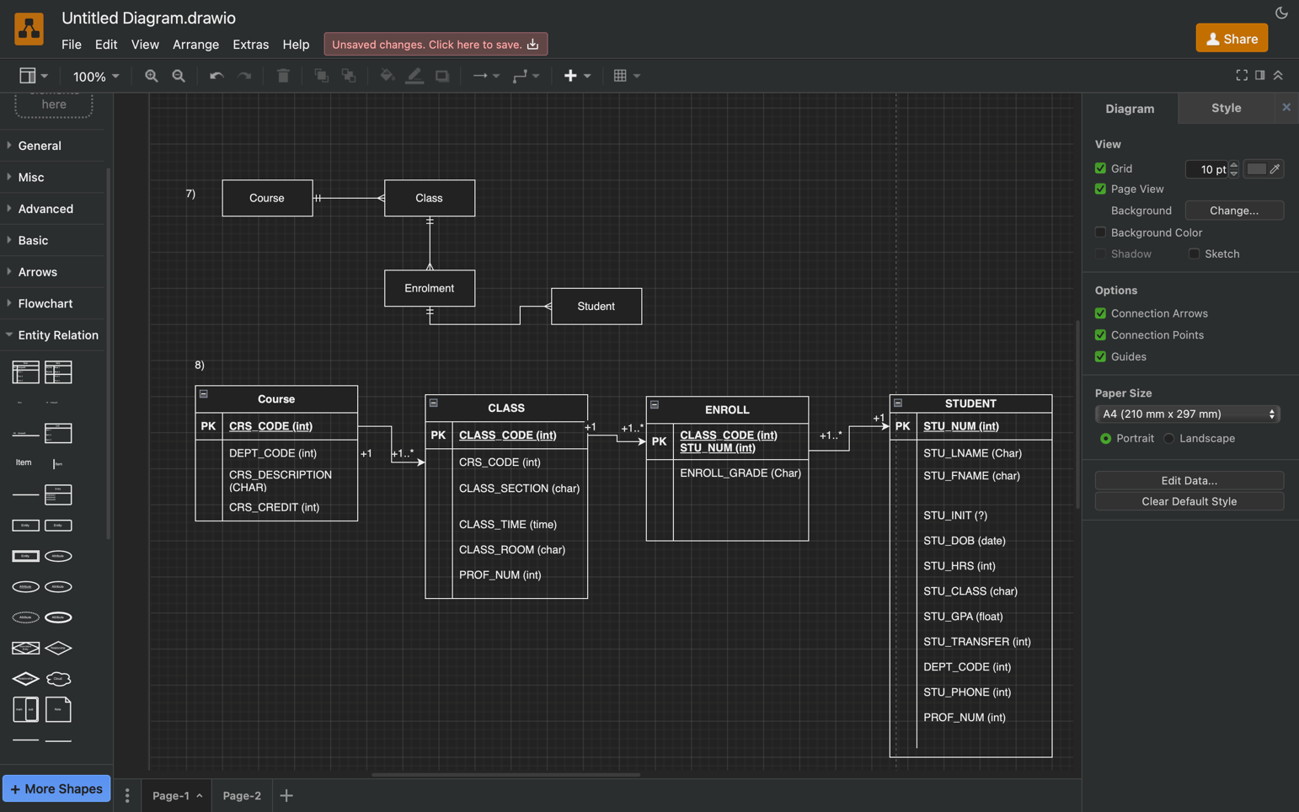

14. Create a Crow’s Foot ERD to include the following business rules for the ProdCo company:
We have 4 entities SR, Invoices, Departments, Customers

- Each sales representative writes many invoices.

- Each invoice is written by one sales representative.

- Each sales representative is assigned to one department.

- Each department has many sales representatives.

- Each customer can generate many invoices.

- Each invoice is generated by one customer.

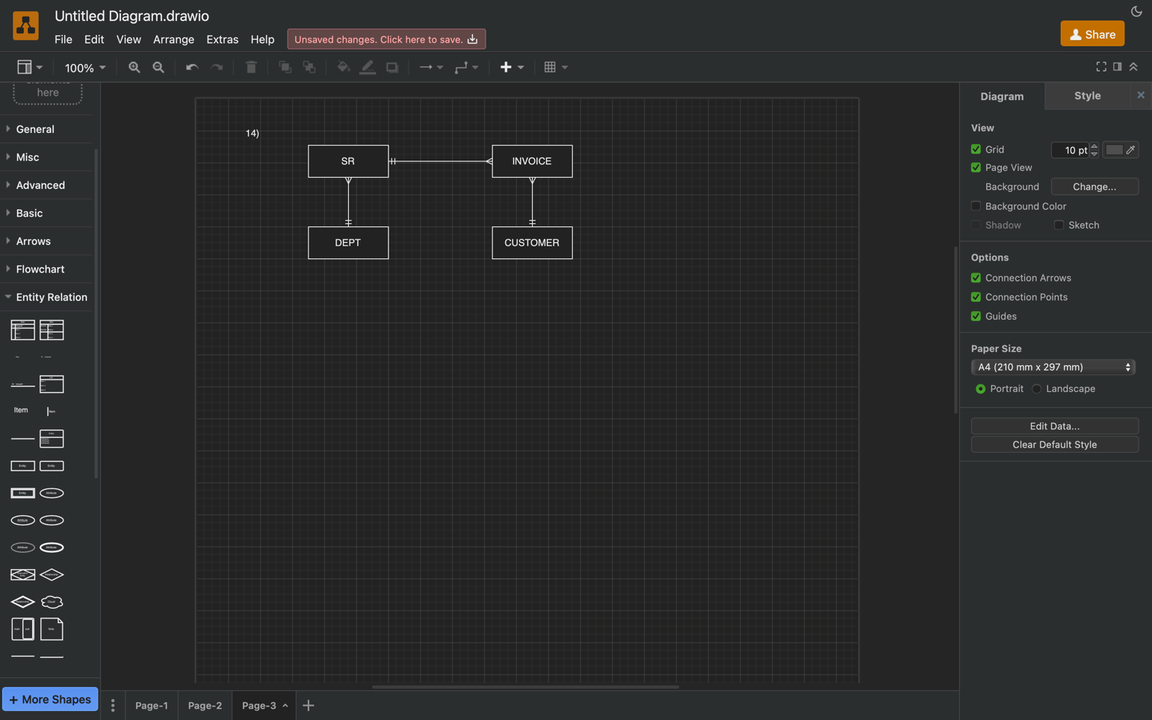

17. Create a Crow’s Foot ERD for each of the following descriptions. (Note that the word many merely means more than one in the database modeling environment.)

Department , employees, managers, divisions

- Each of the MegaCo Corporation’s divisions is composed of many departments. Each department has many employees assigned to it, but each employee works for only one department. Each department is managed by one employee, and each of those managers can manage only one department at a time.
Ebooks, customers
- During some period of time, a customer can download many ebooks from BooksOnline. Each of the ebooks can be downloaded by many customers during that period of time.
Airliner and flights
- An airliner can be assigned to fly many flights, but each flight is flown by only one airliner.
Factories region and employee
- The KwikTite Corporation operates many factories. Each factory is located in a region, and each region can be “home” to many of KwikTite’s factories. Each factory has many employees, but each employee is employed by only one factory.

Employees, degree
- An employee may have earned many degrees, and each degree may have been earned by many employees.



