ITEC 570 SPRING 2024

Lab 3B
Ch 3 Problems
For each document submitted on-line, please include your name, username, date, ITEC 570-001, reference lab number and title(if appropriate).

Ahmed Altouqi
aaltouqi
22/2/24
ITEC570-001
LAB 3B

Answer the selected review questions from Ch 3 on data models.

Ch 3.

StoreCo database tables.

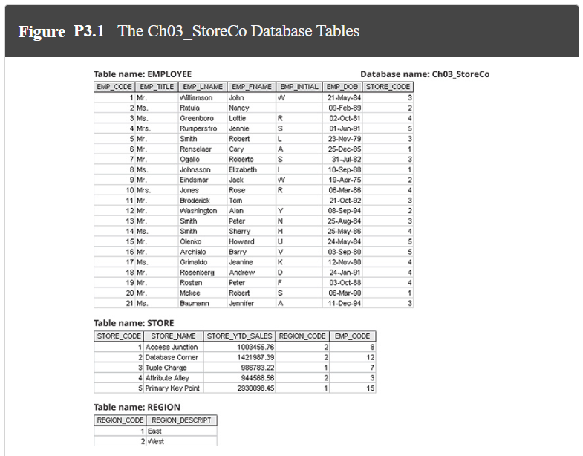

Answer the following questions and use draw.io or visio for ERD and relational diagram.

- For each table, identify the primary key and the foreign key(s). If a table does not have a foreign key, write None.
  - EMPLOYEE table has EMP_CODE as primary key, STORE_CODE is the foreign key.
  - STORE table has STORE_CODE as primary key and EMP_CODE and REGION_CODE are both foreign keys.
  - REGION table only has REGION_CODE as primary key.

- Do the tables exhibit entity integrity? Answer yes or no, and then explain your answer. (Entity means PK)
  - All tables have entity integrity as they all have PK.

- Do the tables exhibit referential integrity? Answer yes or no, and then explain your answer. Write NA (Not Applicable) if the table does not have a foreign key.
  - Only employee and store tables have referential as they are the only ones with FK.

- Describe the type(s) of relationship(s) between STORE and REGION.
  - Many to one.

- Create the ERD to show the relationship between STORE and REGION.
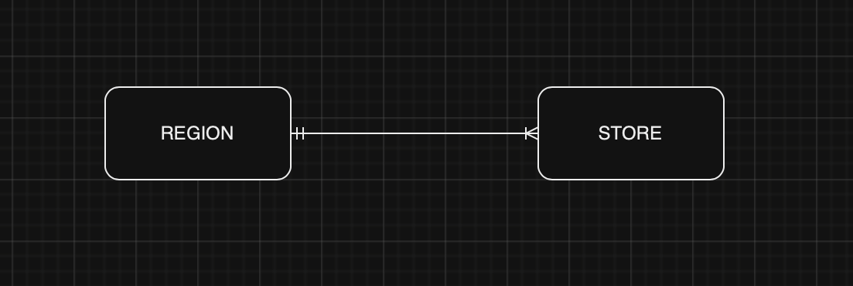
- Create the relational diagram to show the relationship between STORE and REGION.
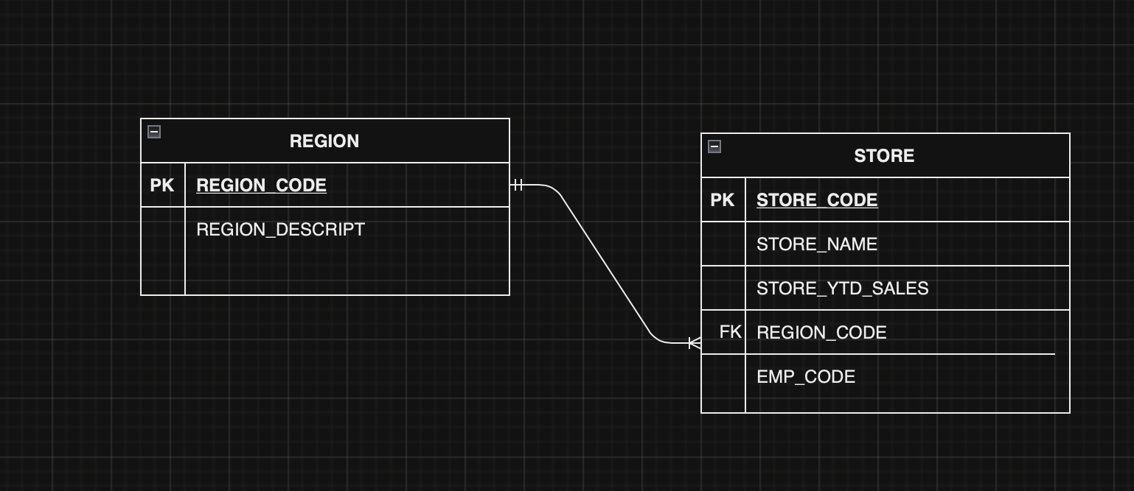
- Describe the type(s) of relationship(s) between EMPLOYEE and STORE. (Hint: Each store employs many employees, one of whom manages the store.)
  - Many to one.

- Create the ERD to show the relationships among EMPLOYEE, STORE, and REGION.
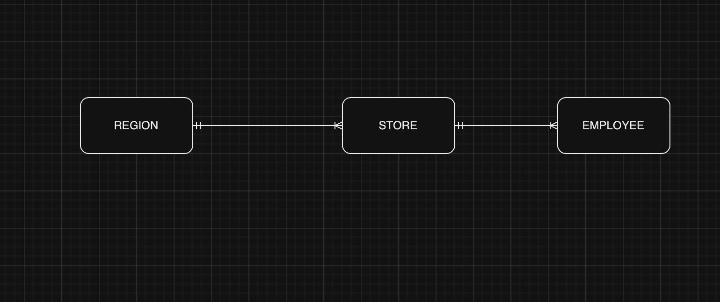
- Create the relational diagram to show the relationships among EMPLOYEE, STORE, and REGION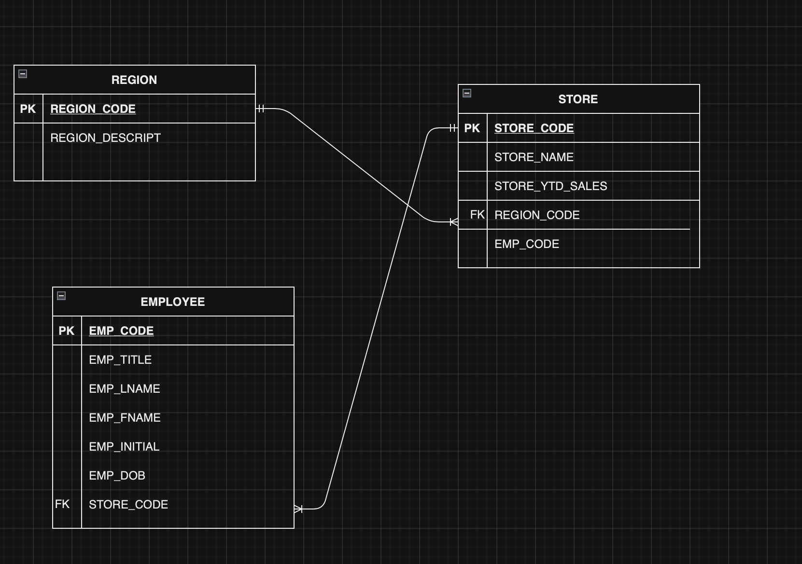
BeneCo database Tables
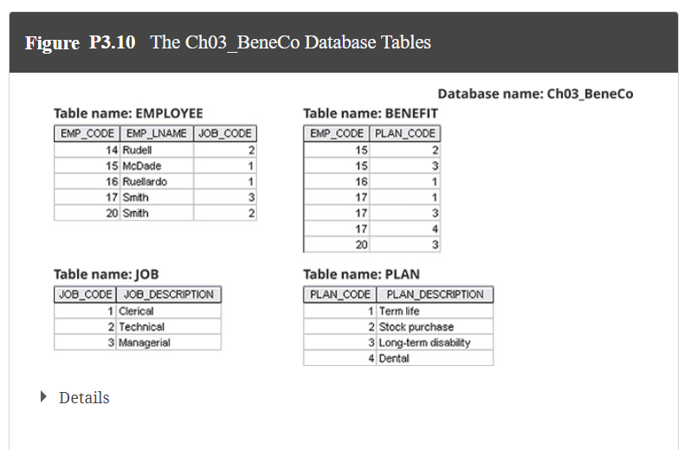

Note that the database BeneCo is composed of four tables that reflect these relationships:

- An EMPLOYEE has only one JOB_CODE, but a JOB_CODE can be held by many EMPLOYEEs.

- An EMPLOYEE can participate in many PLANs, and any PLAN can be assigned to many EMPLOYEEs.

Answer the following questions and use draw.io or visio for ERD and relational diagrams.

- For each table in the database, identify the primary key and the foreign key(s). If a table does not have a foreign key, write None.
  - EMPLOYEE PK: EMP_CODE, FK: JOB_CODE
  - BENEFIT FK: EMP_CODE, PLAN_CODE
  - JOB PK: JOB_CODE
  - PLAN PK: PLAN_CODE

- Create the ERD to show the relationship between EMPLOYEE and JOB.
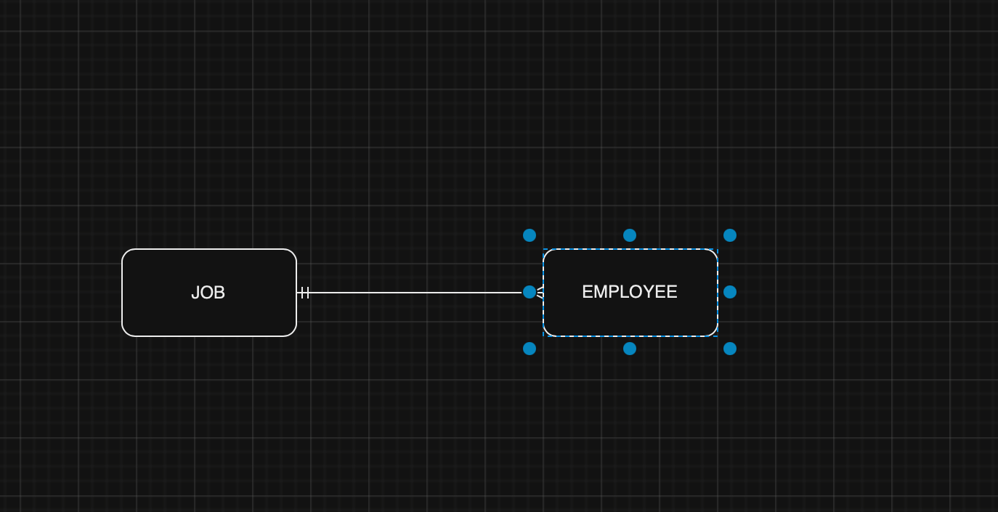
- Create the relational diagram to show the relationship between EMPLOYEE and JOB.
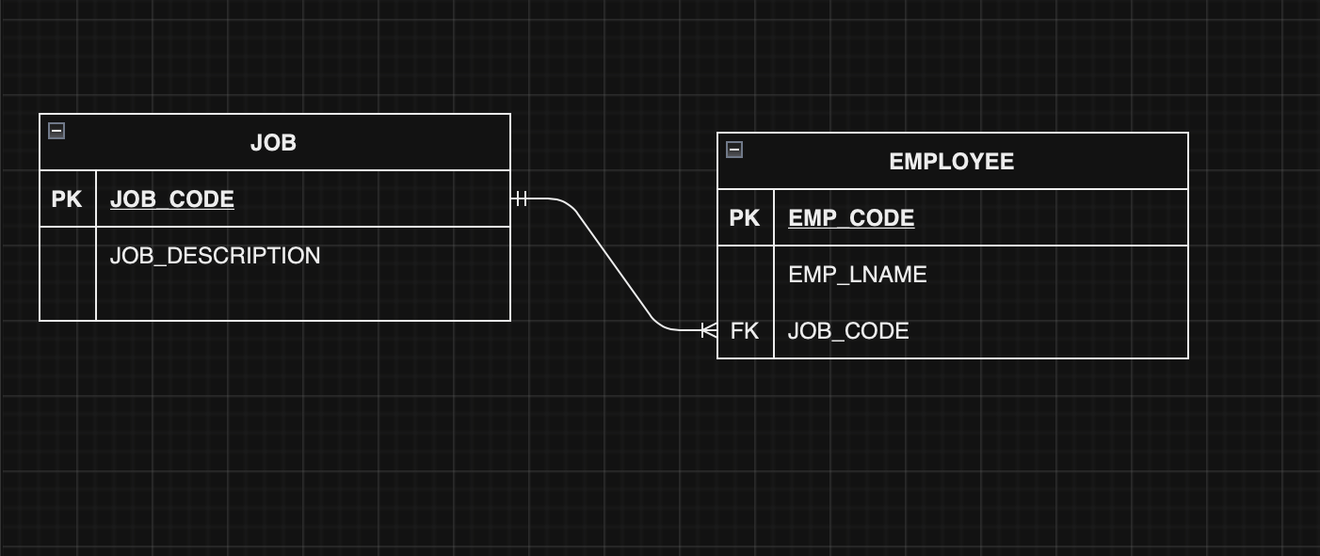
- Do the tables exhibit entity integrity? Answer yes or no, and then explain your answer.
  - Yes except for benefit as there are no PK.

- Do the tables exhibit referential integrity? Answer yes or no, and then explain your answer. Write NA (Not Applicable) if the table does not have a foreign key.
  - Yes except for job as there are no FK.

- Create the ERD to show the relationships among EMPLOYEE, BENEFIT, JOB, and PLAN.
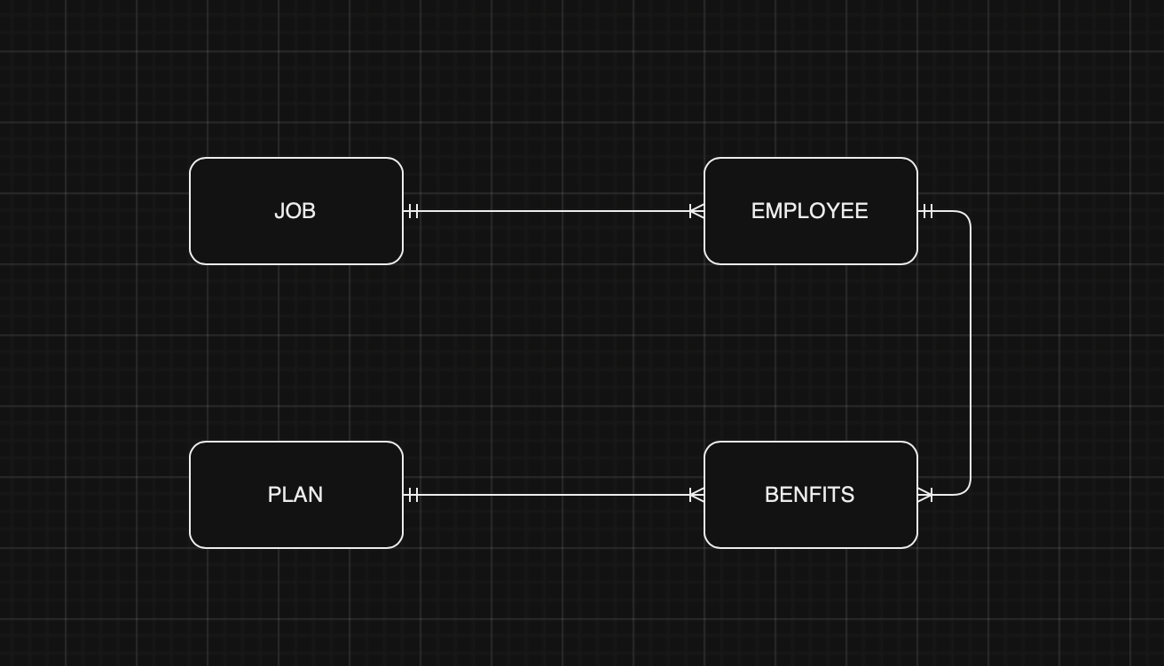
- Create the relational diagram to show the relationships among EMPLOYEE, BENEFIT, JOB, and PLAN.

