ITEC570-SPRING 2024
Lab 6 - Data Warehouse Analytics.
Ahmed Altouqi
Ch 13 Sales_Co_DW has been loaded onto our server. You all have access to these tables. This set of queries uses the ROLLUP and CUBE commands. Below is the Snowflake schema for this data warehouse. Write the SQL commands to produce each list, execute, and screenshot.
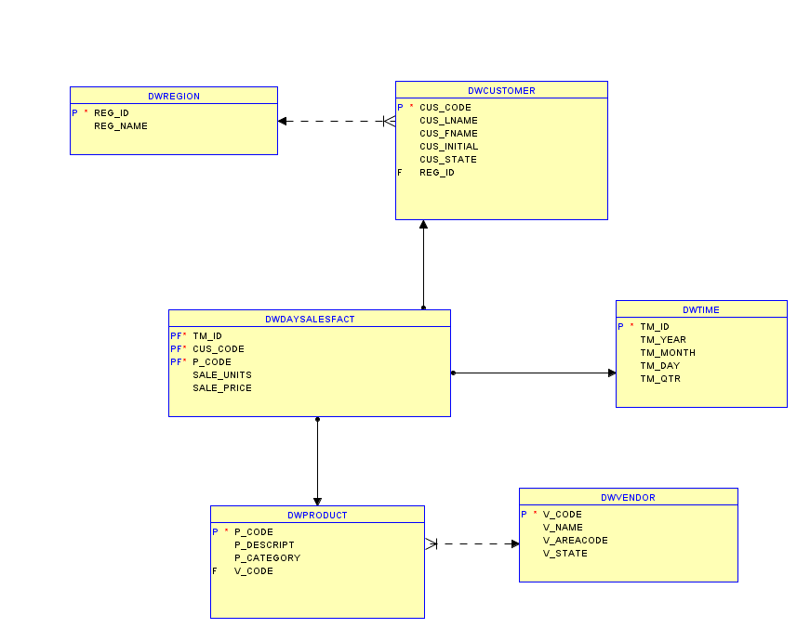

- What is the SQL command to list the total sales by customer and by product, with subtotals by customer and a grand total for all product sales? Figure P13.5 shows the abbreviated results of the query.

SELECT
cus_code,
p_code,
SUM(sale_units * sale_price) AS total_sales
FROM
DWDAYSALESFACT
GROUP BY
ROLLUP(cus_code, p_code);

OR

SELECT
cus_code,
p_code,
SUM(sale_units * sale_price) AS total_sales
FROM
DWDAYSALESFACT
GROUP BY
CUBE(cus_code, p_code);

Figure P13.5 Problem 5 Abbreviated Result
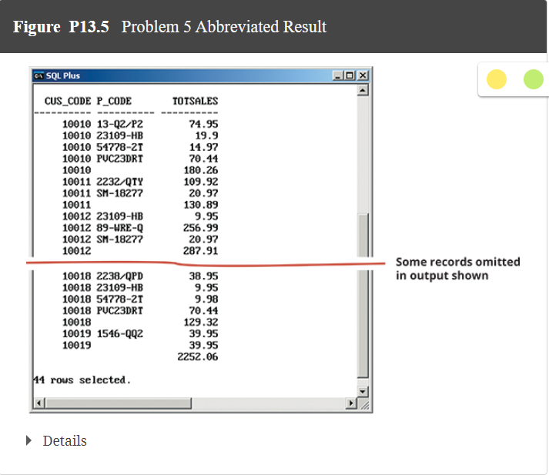

- What is the SQL command to list the total sales by customer, month, and product, with subtotals by customer and by month and a grand total for all product sales? Figure P13.6 shows the abbreviated results of the query.
SELECT
cus_code,
tm_month,
p_code,
SUM(sale_units * sale_price) AS total_sales
FROM
DWDAYSALESFACT
JOIN
dwtime ON DWDAYSALESFACT.TM_ID = dwtime.TM_id
GROUP BY
ROLLUP(cus_code, tm_month, p_code);

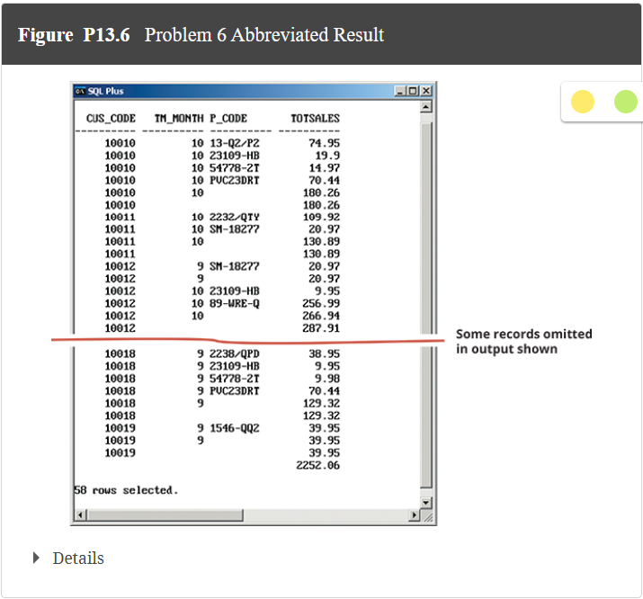

- What is the SQL command to list the total sales by region and customer, with subtotals by region and a grand total for all sales? Figure P13.7 shows the result of the query.
SELECT
r.reg_id AS region_id,
c.cus_code AS customer_code,
SUM(s.sale_units * s.sale_price) AS total_sales
FROM
DWCUSTOMER c
JOIN
DWregion r ON c.reg_id = r.reg_id
JOIN
DWDAYSALESFACT s ON c.cus_code = s.cus_code
GROUP BY
ROLLUP(r.reg_id, c.cus_code)
order by region_id;

Figure P13.7 Problem 7 Result
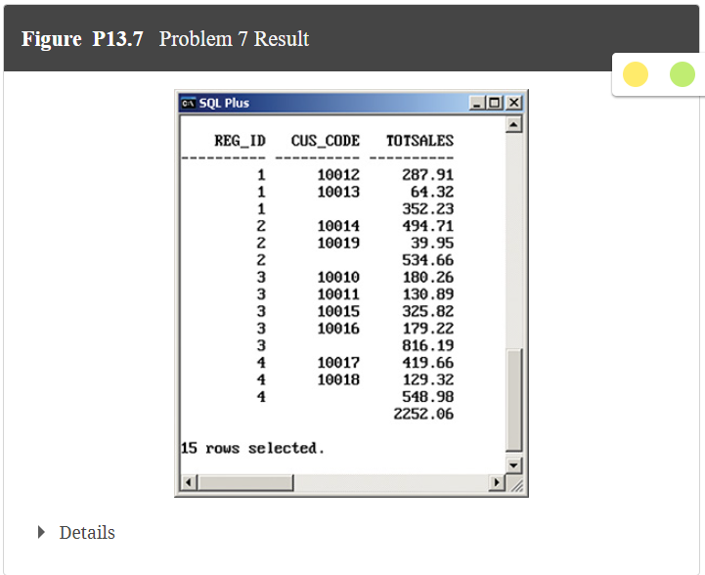

- What is the SQL command to list the total sales by month and product category, with subtotals by month and a grand total for all sales? Figure P13.8 shows the result of the query.
SELECT
t.tm_month AS month,
p.p_category AS product_category,
SUM(s.sale_units * s.sale_price) AS total_sales
FROM
DWDAYSALESFACT s
JOIN
dwtime t ON s.TM_ID = t.TM_id
JOIN
DWPRODUCT p ON s.p_code = p.p_code
GROUP BY
ROLLUP(t.tm_month, p.p_category);
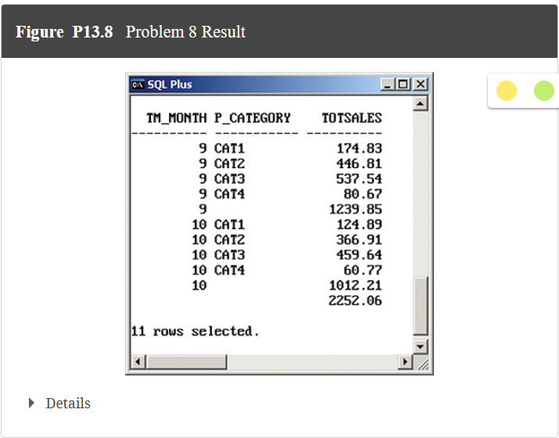

- What is the SQL command to list the number of product sales (number of rows) and total sales by month, with subtotals by month and a grand total for all sales? Figure P13.9 shows the result of the query.
SELECT
t.tm_month AS month,
COUNT(*) AS number_of_sales,
SUM(s.sale_units * s.sale_price) AS total_sales
FROM
DWDAYSALESFACT s
JOIN
dwtime t ON s.TM_ID = t.TM_id
GROUP BY
ROLLUP(t.tm_month);
Figure P13.9 Problem 9 Result

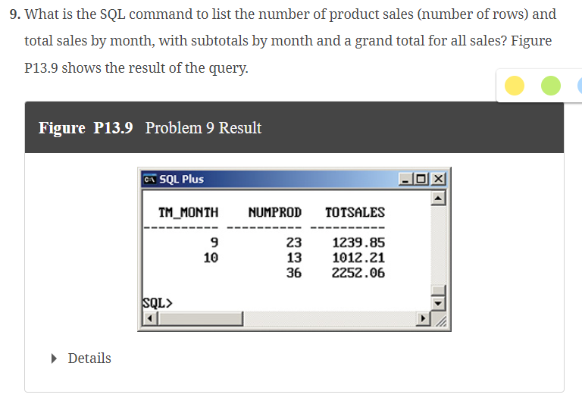

- What is the SQL command to list the number of product sales (number of rows) and total sales by month and product category, with subtotals by month and product category and a grand total for all sales? Figure P13.10 shows the result of the query.

SELECT
t.tm_month AS month,
p.p_category AS product_category,
COUNT(*) AS number_of_sales,
SUM(s.sale_units * s.sale_price) AS total_sales
FROM
DWDAYSALESFACT s
JOIN
dwtime t ON s.TM_ID = t.TM_id
JOIN
DWPRODUCT p ON s.p_code = p.p_code
GROUP BY
ROLLUP(t.tm_month, p.p_category);

Figure P13.10 Problem 10 Result
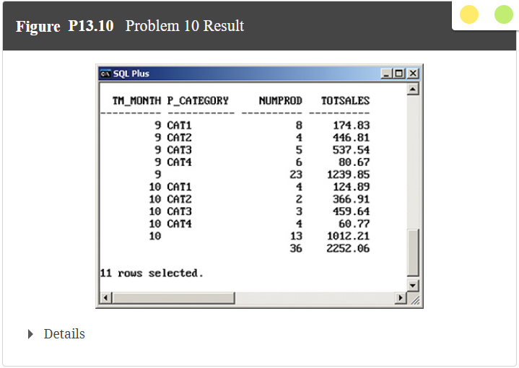

- What is the SQL command to list the number of product sales (number of rows) and total sales by month, product category, and product, with subtotals by month and product category and a grand total for all sales? Figure P13.11 shows the result of the query.
SELECT
t.tm_month AS month,
p.p_category AS product_category,
pr.p_descript AS product_description,
COUNT(*) AS number_of_sales,
SUM(s.sale_units * s.sale_price) AS total_sales
FROM
DWDAYSALESFACT s
JOIN
dwtime t ON s.TM_ID = t.TM_id
JOIN
DWPRODUCT p ON s.p_code = p.p_code
JOIN
DWPRODUCT pr ON s.p_code = pr.p_code
GROUP BY
ROLLUP(t.tm_month, p.p_category, pr.p_descript);



