FIVE STAR BUS COMPANY
Bus Reservation & Operations System · Website, Mobile App & Staff Portal
SYSTEM DOCUMENTATION & PROPOSAL
Online Booking, Operations Portal & Mobile App
What the new Five Star system will do for passengers, terminals, dispatch and management; how it is secured; what Five Star changes by itself in the CMS; and the choices we need you to make before building.
Prepared for | Five Star Bus Co., Inc. (Pangasinan Five Star Bus Co.)
Prepared by | Nueva Technology
Version | 1.0 (first draft, for review with Five Star)
Date | October 26, 2026
Scope | Public website with online booking, passenger mobile app, staff operations portal (dispatch, ticketing, boarding, CMS) and crew app. Hosted on Vercel.
Replaces | The current brochure website (fivestarph.com), phone bookings and the third-party booking link
Clickable prototype | Website, app and staff portal with sample data, published on Vercel (appendix C lists the demo accounts).
Status | Proposal. Screens are from the working prototype with sample data and a placeholder logo. Fares, buses and people are samples; terminals, routes and departure times come from fivestarph.com.

Contents
1. Summary 4
1.1 What Five Star gets 4
1.2 Problems the system solves 4
1.3 Phases 5
1.4 What to call the system (choice) 5
2. How the system is organized 6
2.1 Four parts, one system 6
2.2 Where it runs: Vercel (choice of stack) 6
2.3 Terminals 6
3. Signing in and security 7
3.1 Staff, passengers and crew 7
3.2 Failed sign-ins and the suspicious-activity flag 7
3.3 Who can unlock whom 8
3.4 Protecting bookings and payments 8
3.5 Sessions, audit logs and backups 9
4. Public website 10
4.1 Design direction 10
4.2 The homepage, section by section 10
4.3 Other pages 14
4.4 On a phone 16
4.5 Speed and Google search 16
5. Online booking and ticketing 17
5.1 Booking steps 17
5.2 Fares and discounts 19
5.3 Priority seats 19
5.4 Ticketing rules set by Five Star 19
5.5 Booking and trip statuses 20
6. Passenger mobile app 21
6.1 How to deliver the app (choice) 23
7. Staff portal: dashboard and analytics 24
8. Operations: dispatch, boarding and terminal screens 25
8.1 Dispatch board 25
8.2 Boarding and manifest 26
8.3 Departure screens 27
8.4 Crew app 28
9. Ticket counter, bookings and passengers 29
9.1 Ticket counter 29
9.2 Bookings 29
9.3 Passengers 30
10. Website CMS 31
10.1 Drafts, preview and history 33
11. Settings: everything is customizable 34
12. Integrations 35
12.1 How an online payment works 36
13. Maintenance mode 37
14. Staff, roles and permissions 38
15. Data privacy (Data Privacy Act of 2012) 39
16. Phase 2 and Phase 3 modules 40
16.1 Parcels and cargo (Phase 2) 40
16.2 Fleet, crew and cash (Phase 2) 41
16.3 Live tracking (Phase 3) 42
16.4 Bus rental / charter (request: Phase 1, management: Phase 3) 43
16.5 Growth (Phase 3) 45
17. Better ideas: choices for Five Star 46
18. Going live 47
19. Values to review 48
19.1 Security 48
19.2 Ticketing 48
19.3 Operations and system 48
20. Decisions and questions 50
20.1 Decided by Five Star in the system (no need to answer now) 50
20.2 Choices we need from Five Star 50
Appendix A. Routes and schedules (from fivestarph.com) 51
Appendix B. Terminals 51
Appendix C. Trying the prototype 51

1. Summary
Five Star has carried passengers between Metro Manila and Northern and Central Luzon for more than 30 years, with four Metro Manila terminals, terminals in seven provinces and hundreds of departures a day. Today the website is a brochure: schedules are a long text list, bookings go through a phone number or an outside booking site, and the passenger data, the fees and the customer relationship stay with someone else.
We propose one system that gives Five Star its own modern booking website and app, and the tools to run the terminals: one live seat inventory shared by the website, the app, the counters and the conductors, so a seat can never be sold twice.

1.1 What Five Star gets
Part | What it does
Public website | A fast, modern website built around a trip search: live departures board, routes and schedules, terminal finder with maps, bus classes, route map of Luzon, travel advisories, rent-a-bus quotations, parcel tracking, news and help.
Online booking | Passengers pick a trip, choose their seat on the bus seat map, enter passengers (with the legal 20% student, senior and PWD discount), confirm the mobile number by SMS code and pay with GCash, Maya, card or QR Ph. They get an e-ticket with a QR code by SMS and email.
Passenger mobile app | The same booking in an app: e-tickets that work without signal, "leaves in 2 h" reminders, delay and boarding alerts, live bus tracking, saved passengers and Star Points.
Staff operations portal | Dashboard and analytics, dispatch board (assign buses and crew, delays, cancellations, extra trips), ticket counter, boarding and manifest, bookings and refunds, passengers, departure screens for the terminal TVs. Later: parcels, fleet maintenance, crew, cash remittance, charters, live map, report builder.
Crew app | For conductors and drivers on the phone assigned to the bus: trip manifest, QR boarding, roadside tickets, trip status, pre-trip checklist and GPS.
Website CMS | Five Star manages the whole website without a programmer: homepage, slides, routes, fares, departure times, terminals, bus classes, advisories, FAQs, promos, reviews, logo and colours. Drafts, preview and version history.
Settings | Every rule is a setting Five Star controls: ticketing rules, fees, discounts, refund and change rules, priority seats, SMS wording, security, integrations, maintenance mode.
Security | The same protections as the clinic and cooperative systems we delivered: login lockout with a suspicious-activity flag, authenticator codes for staff, PIN sign-in for crew phones, roles and permissions per terminal, sessions, audit logs and encrypted backups.
Integrations | PayMongo (payments), Semaphore (SMS), Mailjet (email), Amazon S3 (files and backups), Google Maps, GPS and Cloudflare Turnstile: built in and plug and play from Settings.

1.2 Problems the system solves
Today | With the new system
Bookings by phone or through an outside site; fees and passenger data stay outside | Five Star's own booking on its own website and app. Five Star owns the passenger list, sets its own convenience fee (or none) and can message its passengers.
Counters and online sell from different seat lists | One live seat inventory: website, app, every counter and the conductor all see the same bus. A seat sold in Cubao disappears online the same second.
Schedules are a long text list | Search by route and date, real departure times, seats left and fares; holiday extra trips appear automatically.
Passengers call to ask "is my bus late?" | Delays are entered once on the dispatch board; every passenger gets an SMS and sees the new time on the website, app and terminal TVs.
Paper manifests and paper tickets | QR boarding from the phone, digital manifest per trip (names, seats, discount IDs to check), kept for LTFRB and insurance.
No numbers on what sells | Dashboard: tickets and revenue by channel and route, load factor per trip, busiest departure times, no-shows, delays.

1.3 Phases
Phase | Contents
Phase 1  Booking & terminals | Security and accounts, settings and CMS, the full website, online booking with seat selection and PayMongo, e-tickets with QR, manage booking (change, cancel, refund), passenger accounts, installable passenger app, ticket counter, dispatch board, boarding and manifest with QR scanning (web and crew app), departure screens, dashboard, rent-a-bus requests, SMS outbox, audit logs, maintenance mode, backups.
Phase 2  Operations | Parcels and cargo (waybills, tracking, SMS to receiver), fleet and maintenance (PMS, work orders, document expiry), drivers and conductors (licenses, duty limits), conductor cash remittance and counter cash closing, roadside tickets in the crew app, the app on Google Play and the App Store with push notifications.
Phase 3  Growth | Live GPS bus tracking with arrival times, charter management (quotations, deposits, contracts), Star Points loyalty, corporate accounts with monthly billing, report builder, peak-season fares, post-trip ratings and incident management.
Try it. Every Phase 2 and Phase 3 module already has a working screen in the prototype (marked P2 / P3 in the menu) so Five Star can see it before deciding the order.

1.4 What to call the system (choice)
The working title was "Bus Appointment System". Passengers book seats on trips, not appointments, so we suggest a name that says what it does. Pick one:
Option | What it means | Our view
A. Five Star Bus Reservation & Operations System | Descriptive name for the contract and documents; the public sees "Five Star" only. | Recommended for the proposal and contract.
B. Five Star Online Ticketing & Fleet Management System | Same system, name stresses ticketing and fleet. | Good if fleet management is the bigger priority.
C. "Five Star GO" (app & website) + "Five Star OPS" (staff portal) | A short brand for marketing: "Book on Five Star GO". | Nice for the app store and ads; can be added to A.
D. Bus Appointment System | Original working name. | Not recommended: sounds like a service booking.

2. How the system is organized

2.1 Four parts, one system
Part | Address (example) | Who uses it
Public website | fivestarph.com | Everyone: passengers, groups renting a bus, parcel senders and receivers.
Passenger app | fivestarph.com/app (installable) · later Google Play and App Store | Passengers who travel often.
Staff operations portal | fivestarph.com/admin | Office, terminal and dispatch staff, by role and terminal.
Crew app | fivestarph.com/app/crew on the bus phone | Conductors and drivers.
All four share one database, so a seat booked in the app is gone from the counter screen immediately, a delay entered by dispatch reaches the passenger's phone and the terminal TV at the same time, and a ticket scanned by the conductor shows as boarded in the portal.

2.2 Where it runs: Vercel (choice of stack)
As requested, the whole system is hosted on Vercel: the website, app, portal and the server functions (payments, SMS, scheduled jobs). Vercel does not keep a database itself, so the database is a managed service connected through the Vercel Marketplace and billed through the Vercel account. Choose one:
Option | What it means | Our view
A. Next.js + Postgres (Neon) + Redis (Upstash), all via Vercel | React website and portal with pages prepared on the server (fast, good for Google); a Postgres database with point-in-time restore; Redis for seat holds, one-time codes and rate limits; Vercel Cron for reminders, releasing unpaid seats and backups. | Recommended. Same React foundation as the prototype and the clinic system.
B. Same as A with Supabase Postgres | Adds built-in "realtime" so departure boards and dispatch screens update instantly instead of every few seconds. | Good if instant live boards matter a lot.
C. React single-page app (like the prototype) + Vercel Functions | Lightest build; pages are drawn in the browser. | Cheaper, but weaker on Google search and first-load speed.
- A Vercel Pro plan is needed: the free Hobby plan is for non-commercial use only.
- Files (photos, uploaded IDs, contracts, backups) are kept in a private Amazon S3 bucket; links expire after 15 minutes.
- New versions are tried on a preview copy of the system (Vercel preview deployments with a test database) before they reach the live one.
- Vercel functions do not keep open connections, so live screens refresh every few seconds (option A) or use realtime (option B). Both are fine for departure boards.

2.3 Terminals
The system is multi-terminal from day one. Each terminal has its own address, map pin, hours, phone numbers, counters, gates, cash drawers and staff. Staff are assigned to one or more terminals and see only those unless their role covers all. A new terminal is added in the CMS without a programmer.

3. Signing in and security
The security rules are the same as in the clinic and cooperative systems. Every number and message below is a setting (Settings → Security) that a Super Admin can change; starting values are in section 18.
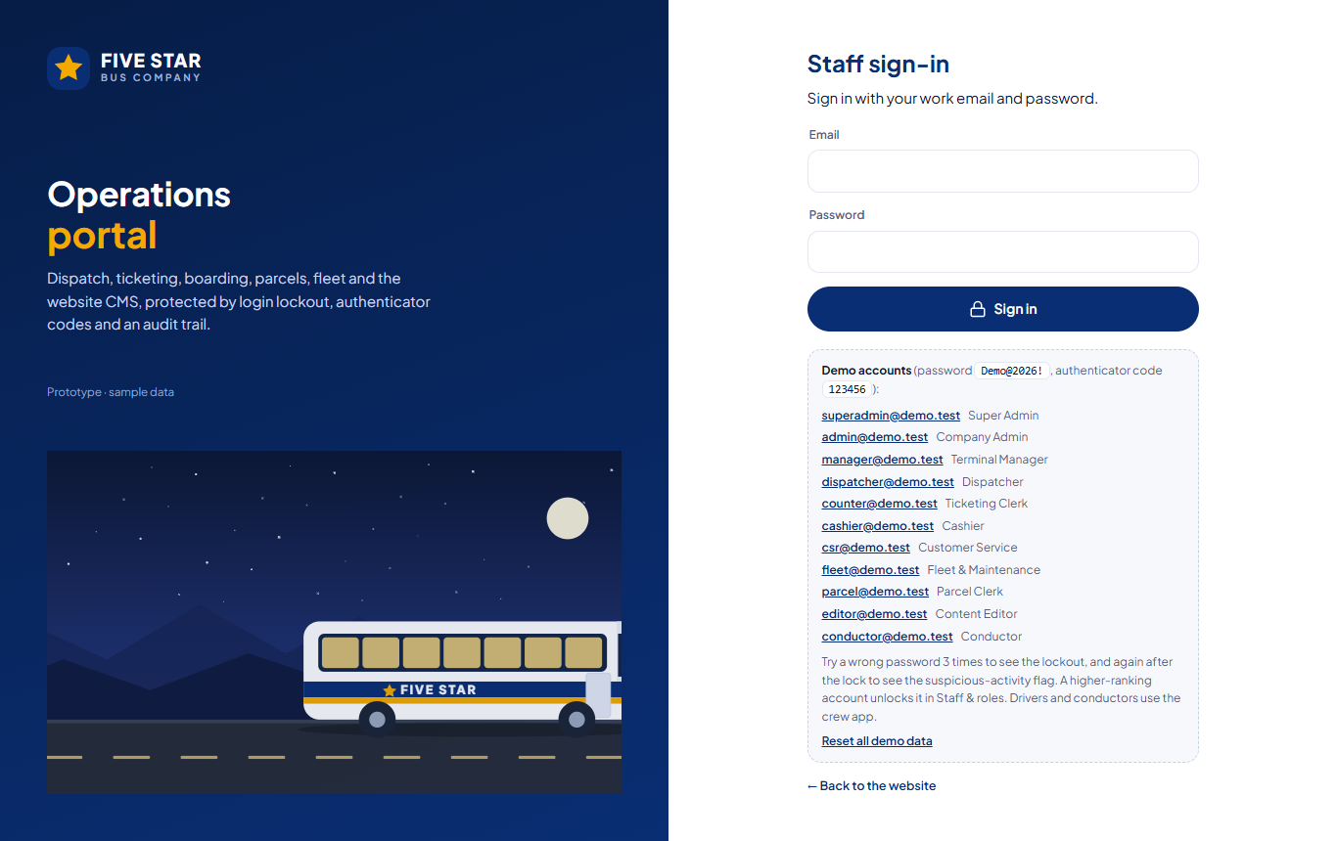
Figure 1. Staff sign-in. After the password, staff enter the 6-digit code from their authenticator app.

3.1 Staff, passengers and crew
Who | How they sign in
Office and terminal staff | Email and password, then a 6-digit authenticator code (Google or Microsoft Authenticator). "Remember this device" for 30 days on Five Star computers. Signed out after 30 minutes of inactivity (10 minutes on shared counter computers) and after 12 hours at most.
Passengers | Mobile number and a one-time SMS code (no password to remember). Booking without an account is allowed; the mobile number is still confirmed by SMS code. Guest bookings are linked to the account later by mobile number.
Conductors and drivers | Employee number and a 6-digit PIN on the phone registered to the bus. The same lockout rules apply.

3.2 Failed sign-ins and the suspicious-activity flag
What happens | Result | Message shown
1st and 2nd wrong attempt | Refused; attempts left are shown. | "The credentials you entered are incorrect. You have 2 attempts left before your account is locked."
3rd wrong attempt (within 30 minutes) | Locked 15 minutes; even the right password is refused. | "Too many failed sign-in attempts. Your account is locked for 15 minute(s)."
Locked a 2nd time within 24 hours | Flagged as suspicious: hard lock until a higher rank unlocks it; signed out everywhere; Super Admins alerted. | "This account has been flagged for suspicious sign-in activity and is locked. Please contact a Super Admin…"
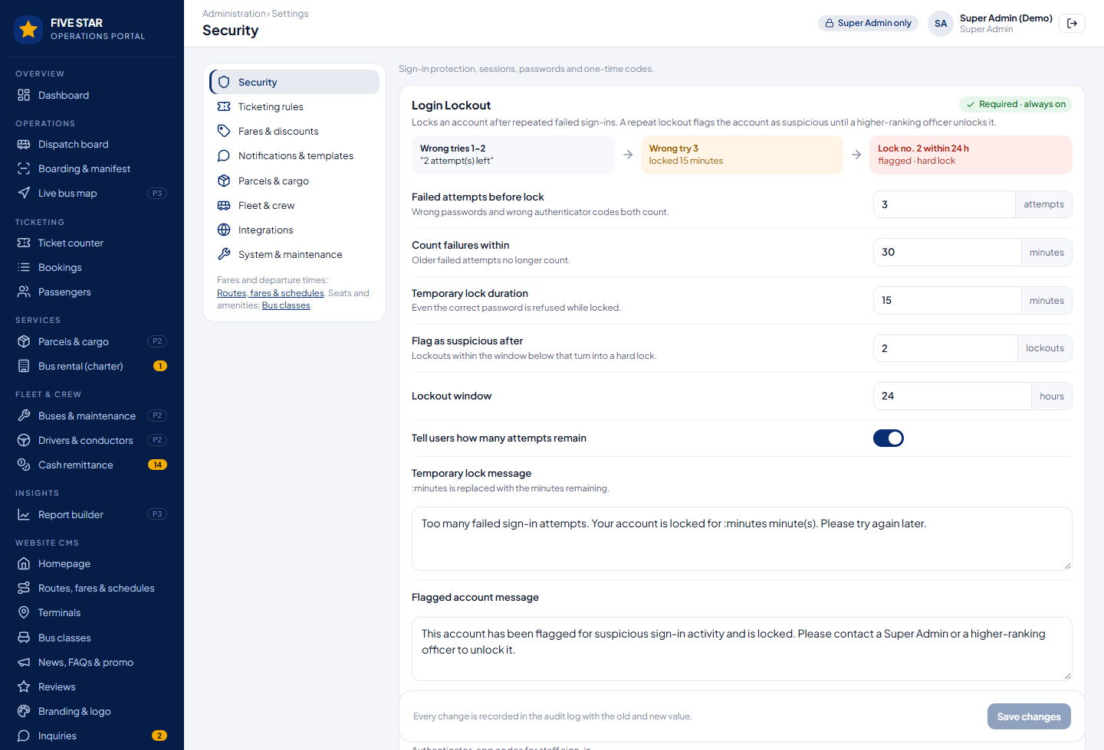
Figure 2. Settings → Security → Login Lockout. Every value can be changed; the lockout itself cannot be switched off.

3.3 Who can unlock whom
Locked account | Can be unlocked by
Passenger | Customer Service, Terminal Manager, Company Admin or Super Admin
Staff and crew below Terminal Manager | Their Terminal Manager, a Company Admin or a Super Admin
Terminal Manager | Company Admin or Super Admin
Company Admin | Super Admin only
Super Admin | Another Super Admin, or Nueva Technology from the server (emergency command)
- Nobody unlocks their own account. A reason is required and kept in the audit log.
- Resetting a password does not remove a lock or a flag.

3.4 Protecting bookings and payments
Risk | Protection
Fake bookings and seat hoarding | Mobile number confirmed by SMS code; Cloudflare Turnstile on forms; seats held only 15 minutes while paying; a limit of unpaid reservations per number; numbers with repeated no-shows can be blocked from "pay at the terminal".
Copied or forged tickets | The QR holds a signed code checked by the crew app (also offline). A ticket can be boarded once; a ticket for another trip or an unpaid reservation is refused with the reason.
Discount abuse | ID number required at booking for student, senior and PWD fares; the conductor sees "check ID" on the manifest and in the scan result.
Online payments | Card and e-wallet details never touch our server; PayMongo handles them. Payment confirmations (webhooks) are checked against a secret; repeated or forged ones are ignored and logged.
Leaked keys | PayMongo, Semaphore, Mailjet and AWS keys are stored encrypted and never shown again ("set, ends in …1234").
Attacks on the website | https only, security headers, rate limits on every form and sign-in, Vercel's DDoS protection.

3.5 Sessions, audit logs and backups
- Every sign-in is a session with device and network; users can sign out their other devices; administrators can end sessions of lower ranks.
- Audit logs record who did what, when and from where, with old and new values: sign-ins, locks and unlocks, setting changes, fare changes, CMS publishing, bookings, changes, refunds, delays and cancellations, ticket scans, cash remittances, exports. Audit logs cannot be edited or deleted, even by a Super Admin.
- Backups: the database keeps point-in-time restore (any minute of the last 7 days or more, depending on the database plan); in addition an encrypted (AES-256) copy is saved to Amazon S3 every night at 2:00 AM, kept 30 days daily and 12 months monthly. A restore drill on the preview copy every three months.

4. Public website

4.1 Design direction
- Brand: Five Star blue and gold (set in the CMS), the tagline "Kaagapay sa Masayang Paglalakbay", clean modern travel-site layout. Until Five Star sends photos of its buses and terminals, built-in bus artwork is used.
- Search first: the first thing on every visit is "where are you going?", like the airline and travel apps passengers already know.
- Phone first: most passengers come from Facebook on a phone; every page is designed for a small screen first.
- Live: departures, seats left, delays and boarding status come from the system, not from text typed into a page.
- Accessible and fast: readable contrast, keyboard and screen-reader friendly (WCAG 2.1 AA), Google PageSpeed 90+ on phones.

4.2 The homepage, section by section
Nothing on the homepage is fixed in the program: every section can be shown, hidden and reordered, and its text, photos and buttons edited in the CMS (section 10).
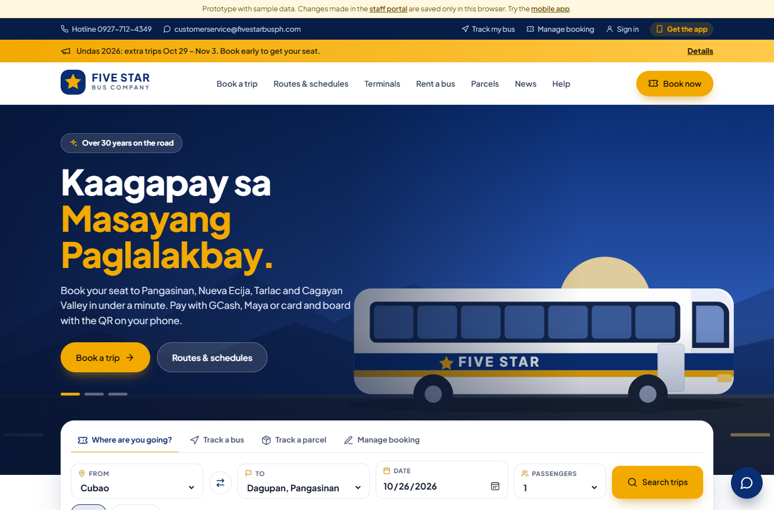
Figure 3. Top of the homepage: hotline, promo banner (Undas extra trips), header, hero slides, trip search with "Track a bus / Track a parcel / Manage booking", and pinned travel advisories.
Section | What visitors can do | Managed in the CMS
Hero slides | Read the headline, tap "Book a trip" or the second button. | 1–5 slides: photo or built-in artwork, headline (second line in gold), text, buttons and links, timing.
Trip search | From, to (only destinations served from there), date (Today / Tomorrow), passengers. | Tab label. Terminals and routes come from Routes & schedules.
Travel advisories | Read the pinned advisories (holiday trips, road works). | Written in News & advisories; pin to show.
Popular routes | Book a featured route in one tap; see travel time, trips per day and the lowest fare. | Which routes are featured; fares.
Leaving soon | Live list of the next departures per Metro Manila terminal with class, seats left and status (On time, Delayed, Boarding). | Title. Data comes from dispatch.
Route map | Tap a terminal on the map of Luzon to see where you can go from there. | Terminals and map pins.
Bus classes | Compare Regular Aircon, Deluxe and Premium: seats, layout, amenities. | Bus classes & amenities.
Why Five Star, app, more services, reviews, news & FAQs | Counters and promises; app download; rent a bus, parcels, corporate travel; approved reviews; latest news and FAQs. | All text, counters, icons; reviews approval; FAQs.
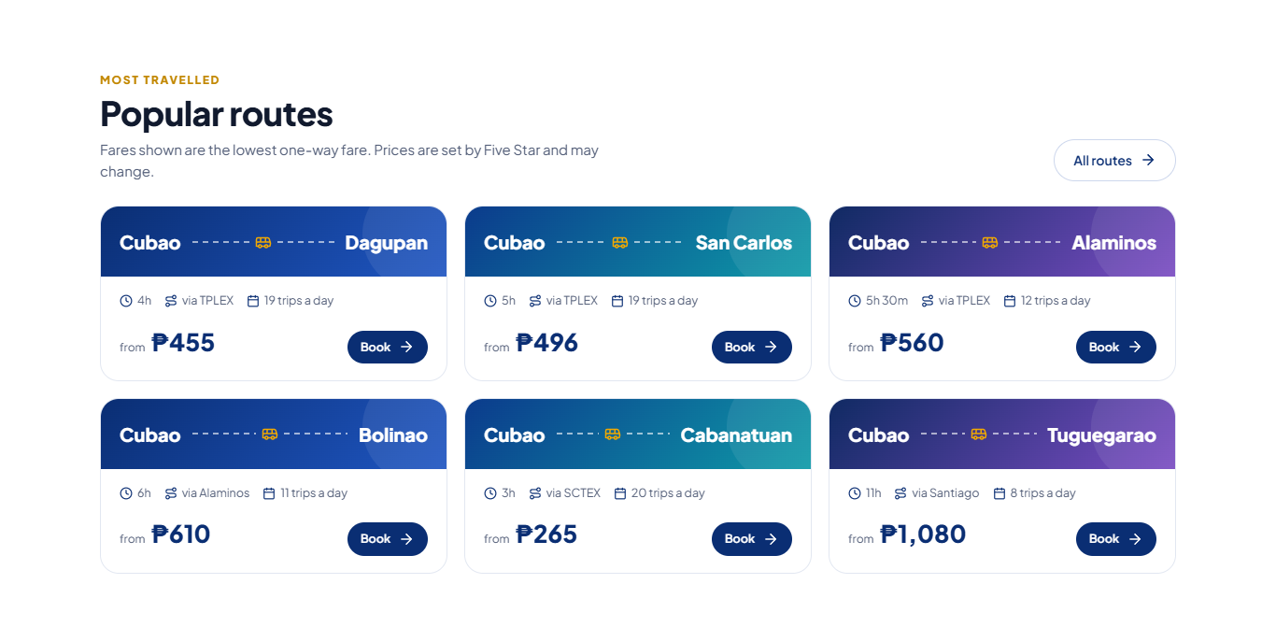
Figure 4. Popular routes with travel time, trips per day and the lowest fare (sample fares).
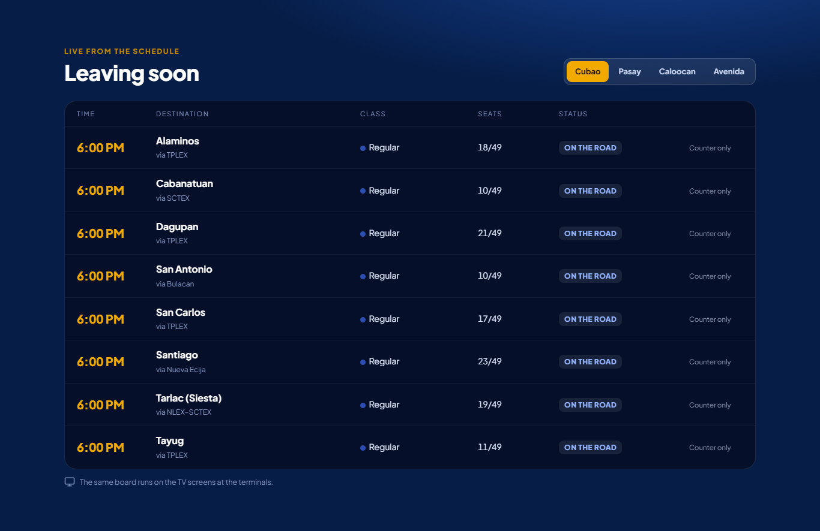
Figure 5. Leaving soon: the same live board runs on the TV screens at the terminals.
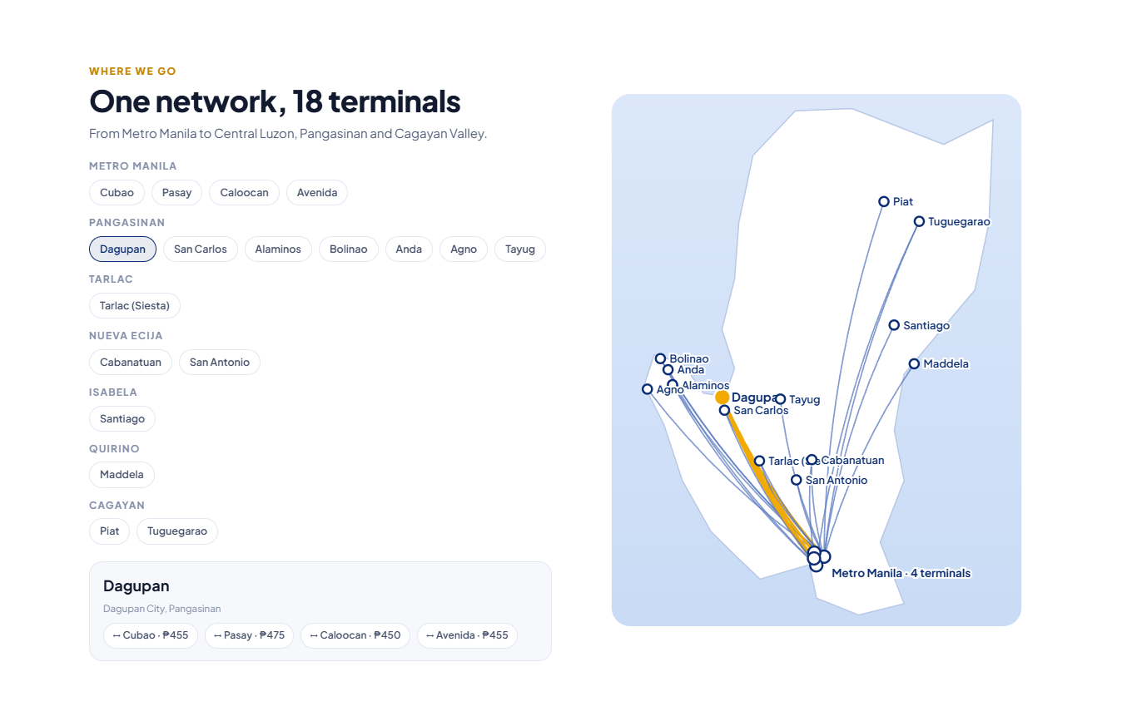
Figure 6. Route map: 18 terminals; choosing a terminal highlights its routes and fares.
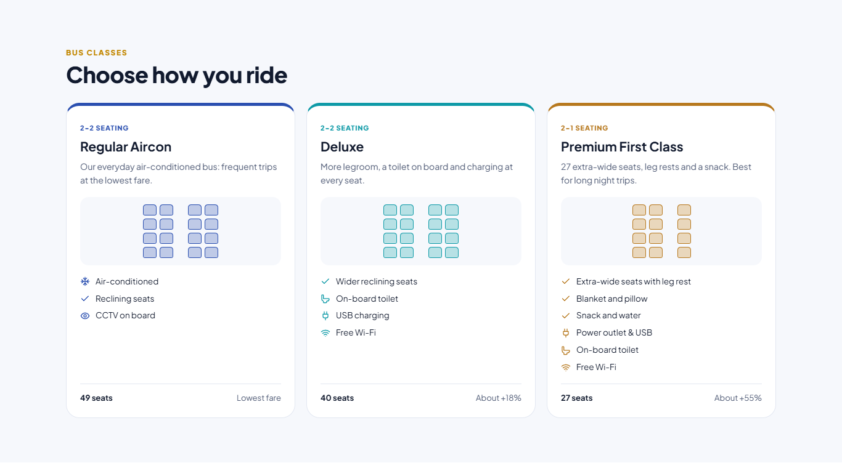
Figure 7. Bus classes with seat layout and amenities, all managed in the CMS.
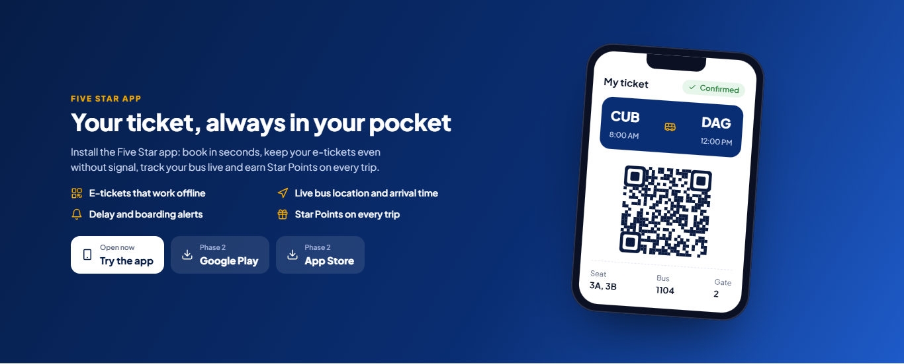
Figure 8. Mobile app section with an e-ticket preview.
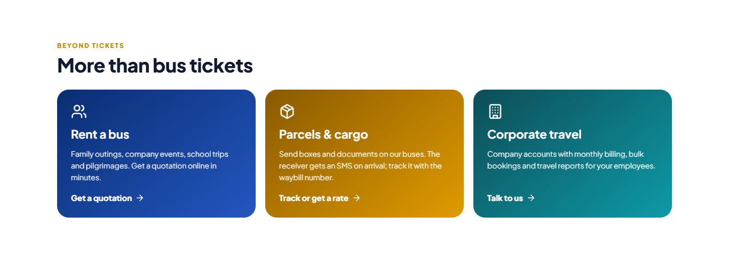
Figure 9. More services: rent a bus, parcels and cargo, corporate travel.

4.3 Other pages
Page | Contents
Book a trip | Search results, seat map, passengers, payment (section 5).
Routes & schedules | Every route from each Metro Manila terminal, both directions, departure times coloured by bus class, fares per class, drop-off points along the way, search by town.
Terminals | All terminals by province with map, address, hours, phone numbers, services (tickets, parcels, departure screens), "next departures from here", directions in Google Maps or Waze, nearest terminal from your location.
Manage booking | Find a booking by reference and mobile number: e-ticket, change trip, cancel or refund, pay a reservation.
Track my bus | Live position and arrival time (Phase 3).
Rent a bus | Quotation request with an instant indicative estimate (section 16).
Parcels | Tracking by waybill number and rate calculator (Phase 2).
News & advisories, Help, About | Articles and advisories; FAQs, privacy notice, terms of carriage and a contact form that becomes an inquiry in the portal; company story.
My account | Trips, saved passengers, Star Points, notification and privacy settings.
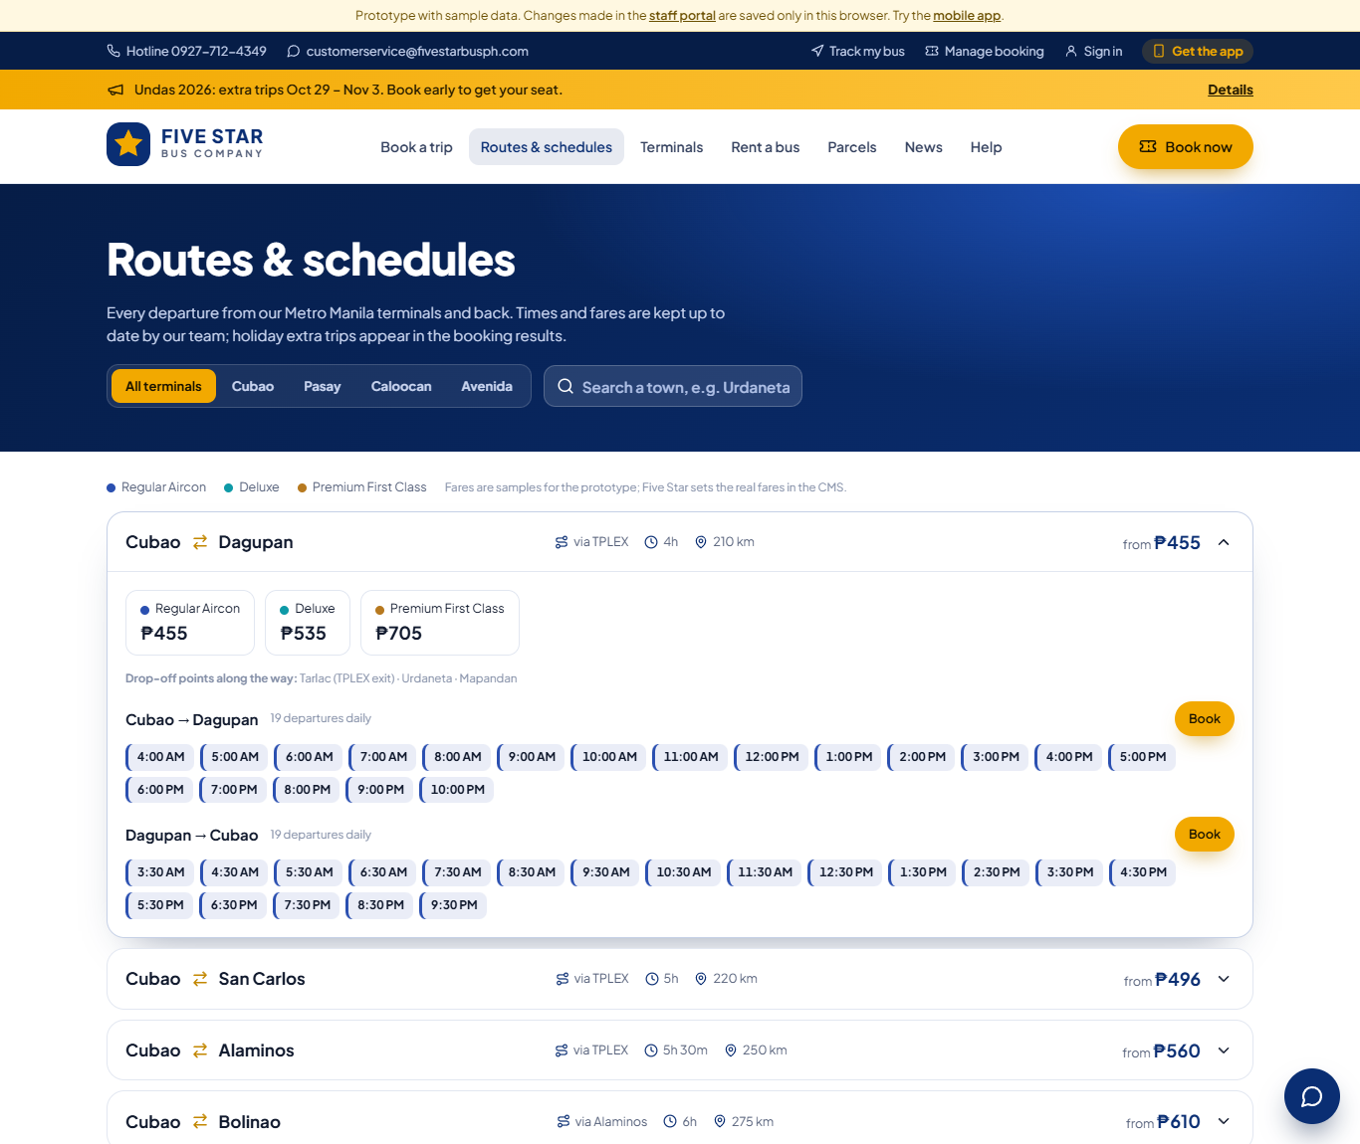
Figure 10. Routes & schedules: departure times coloured by bus class, fares per class, drop-off points (sample fares).
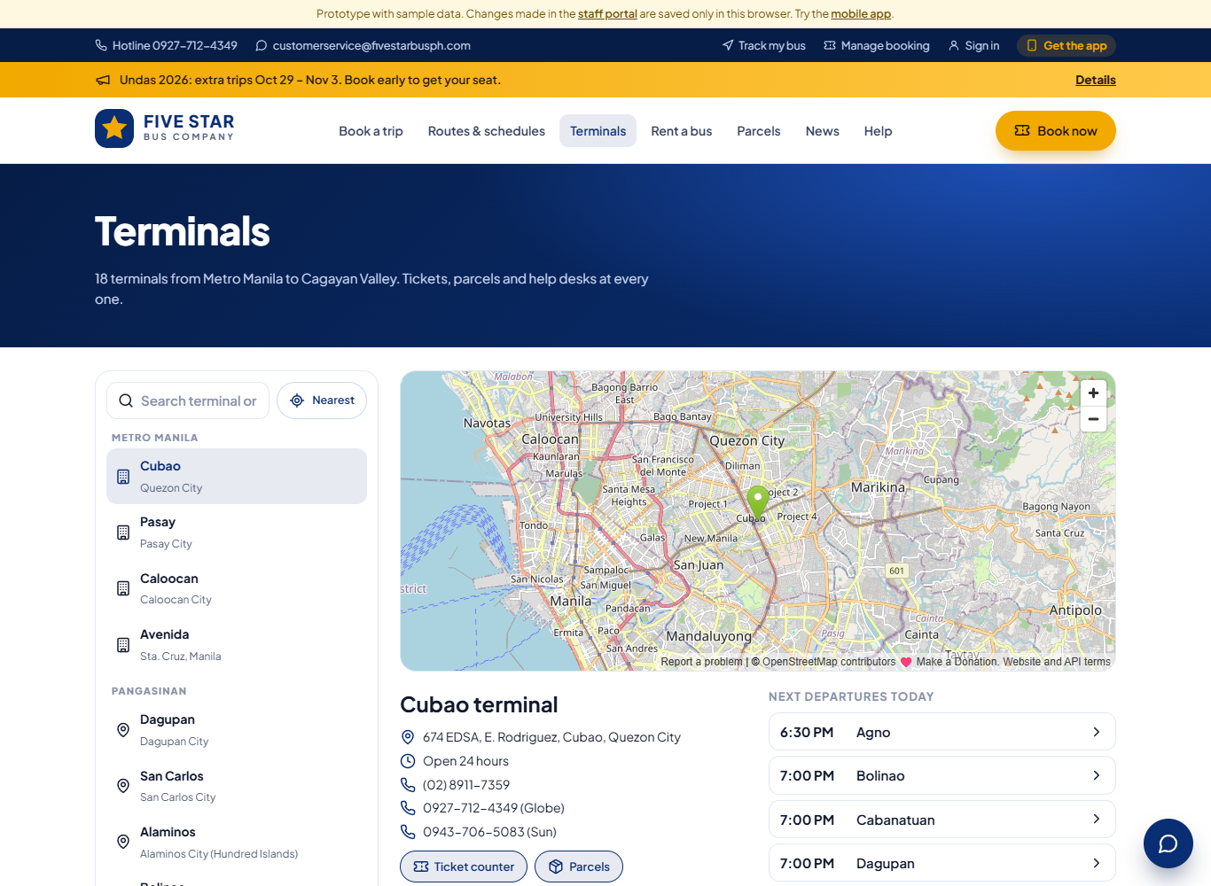
Figure 11. Terminal finder with map, details and the next departures from that terminal.

4.4 On a phone
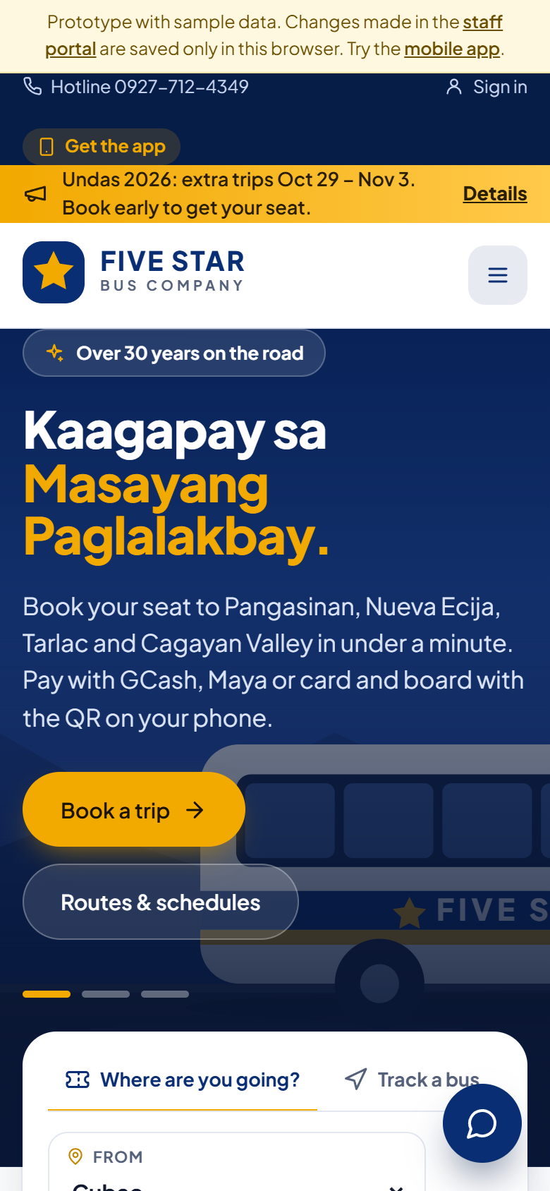
Figure 12. The homepage on a phone: search first, everything within thumb reach.

4.5 Speed and Google search
- Pages are prepared on the server and photos resized to WebP automatically.
- Each route and terminal has its own page with structured data, so "bus Cubao to Dagupan schedule" searches land on Five Star's own page instead of a third-party site.
- Titles, descriptions and sharing images per page set in the CMS; automatic sitemap; Google Analytics 4 and Meta pixel only after cookie consent.

5. Online booking and ticketing

5.1 Booking steps
- Search. From, to, date and number of passengers. Results show every trip with departure and arrival time, travel time, route (via TPLEX, SCTEX…), bus class and amenities, seats left, delays and the fare. A date strip shows the lowest fare per day. Filters: class and time of day.
- Seats and passengers. The passenger chooses seats on the seat map of that bus (window seats marked; priority seats in purple). Per seat: name as on ID and passenger type (regular, student, senior citizen, PWD) with the ID number for discounts.
- Contact. Name, mobile number confirmed by SMS code, optional email; acceptance of the privacy notice and terms of carriage.
- Payment. GCash, Maya, card or QR Ph through PayMongo. Seats are held 15 minutes while paying. Or "Reserve now, pay at the terminal" if switched on.
- E-ticket. Reference number (e.g. FS-2026-001234), QR code, seats, bus number and gate when assigned, sent by SMS and email; "add to calendar"; available in the app.
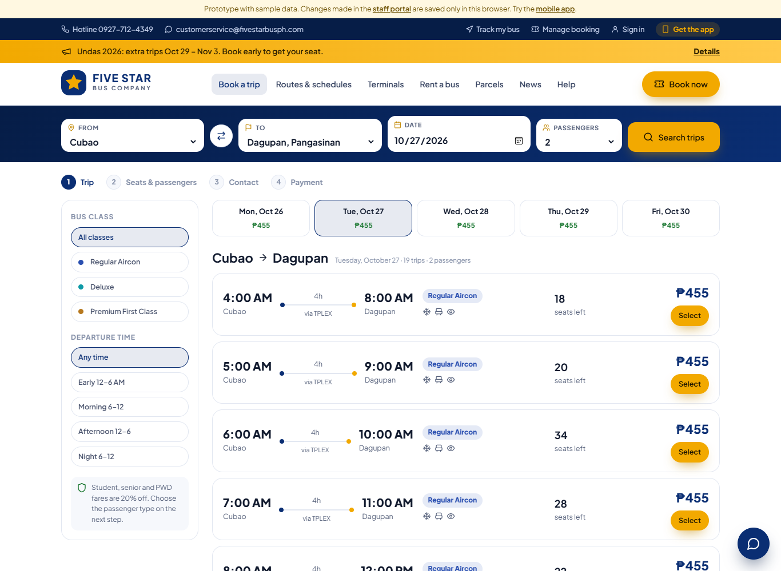
Figure 13. Search results: date strip with lowest fares, class and time filters, seats left, delays.
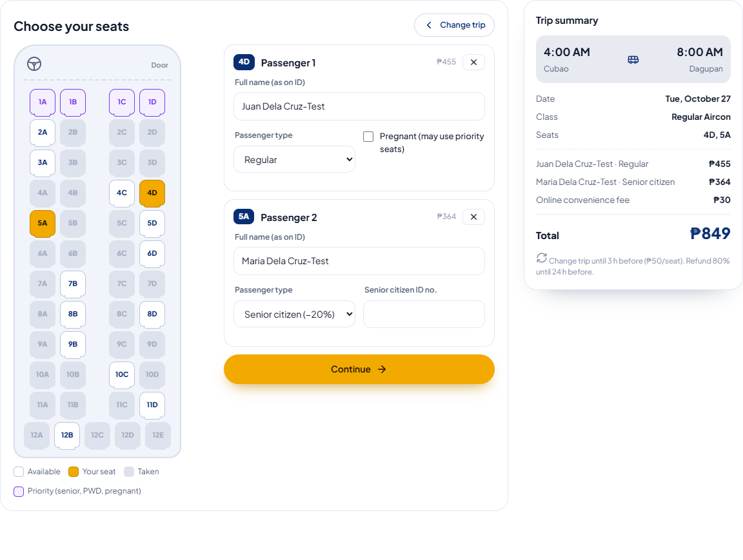
Figure 14. Seat selection and passengers, with the trip summary, fare, convenience fee and change/refund rules.
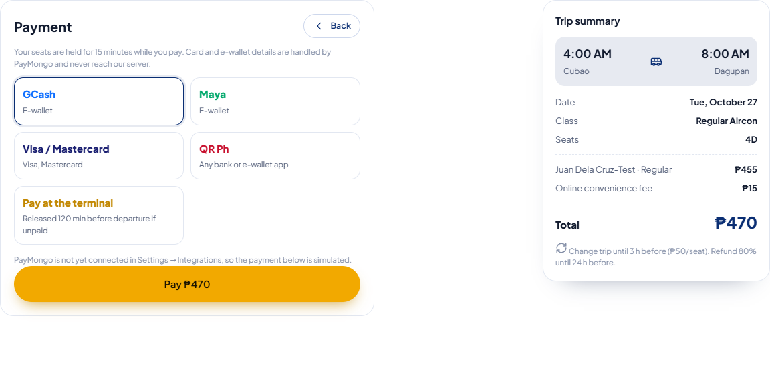
Figure 15. Payment: GCash, Maya, cards, QR Ph through PayMongo, or reserve and pay at the terminal.
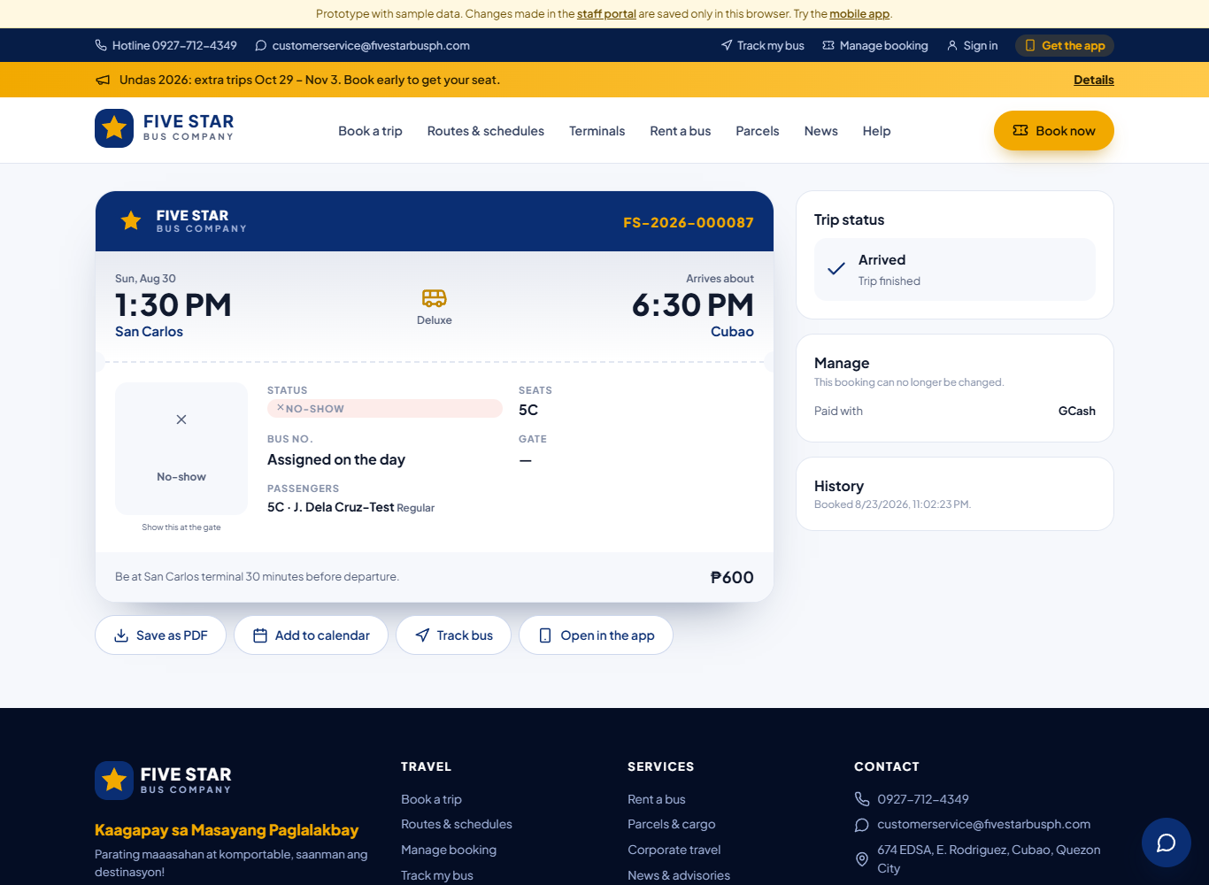
Figure 16. E-ticket with QR, live trip status, and Manage: change trip, cancel and refund, history.

5.2 Fares and discounts
- Fares are set per route and bus class in the CMS, within the fare matrix approved by LTFRB. New fares apply to new bookings; sold tickets keep their price.
- 20% discount for students (RA 11314), senior citizens (RA 9994) and persons with disability (RA 10754), applied automatically by passenger type. The ID number is required at booking and the ID is checked at boarding. Optionally a photo of the ID is uploaded when booking online.
- Children below a set height ride free on a parent's lap (setting).
- Optional peak-season fare for dates Five Star chooses (Holy Week, Undas, Christmas) within the approved fare (Phase 3).
- Optional online convenience fee per seat (setting; ₱0 = no fee). Counter tickets never have this fee.

5.3 Priority seats
The front row(s) are kept for senior citizens, persons with disability and pregnant passengers. Online, they can only be chosen for such passengers; they open to everyone a set time before departure (30 minutes). The number of rows and the time are settings.

5.4 Ticketing rules set by Five Star
Rule | What Five Star decides (Settings → Ticketing rules)
Sales window | How many days ahead tickets are sold (30) and when online sales close before departure (60 minutes). The counter can sell until departure.
Seats per booking | Up to 6 seats per booking; passengers choose seats or seats are assigned automatically.
Seat hold | How long seats are held while paying (15 minutes).
Reserve now, pay at the terminal | On or off; unpaid seats released automatically a set time before departure (120 minutes); one unpaid reservation per mobile number.
Changes | Change trip allowed until 3 hours before, ₱50 per seat plus any fare difference.
Refunds | Allowed until 24 hours before; 80% of the fare (convenience fee not refunded). A trip cancelled by Five Star is always a full refund. Terminal Managers can override with a reason.
No-shows | A ticket not boarded 5 minutes after departure is marked no-show.
Reminders | SMS the day before and 3 hours before; SMS when boarding starts with bus number and gate.

5.5 Booking and trip statuses
Booking status | Meaning
Reserved · unpaid | Seats held; to be paid at the counter before the release time.
Confirmed | Paid; QR ticket issued.
Boarded | Ticket scanned at the gate or on the bus.
Completed / No-show | After the trip: boarded or not.
Cancelled / Refunded | By the passenger or staff, with the refund amount and reason in the history.
Trips have their own status: Scheduled → Delayed → Boarding → On the road → Arrived, or Cancelled. The passenger sees it on the e-ticket, in the app and on the departure screens.

6. Passenger mobile app
The app is the same booking with features that only make sense on a phone.
Feature | Details | Phase
Book in seconds | Search, seat map, saved passengers (family members with their discount IDs), pay with GCash/Maya/card. | 1
E-tickets offline | Tickets are stored on the phone and the QR opens without signal at the terminal. | 1
Next trip card | "Leaves in 2 h 10 m", gate and bus number, one tap to the QR. | 1
Alerts | Delay, boarding and gate alerts by SMS (Phase 1) and push notifications (Phase 2). | 1–2
Track my bus | Live position and arrival time. | 3
Star Points | Points on every paid trip, used as discount. | 3
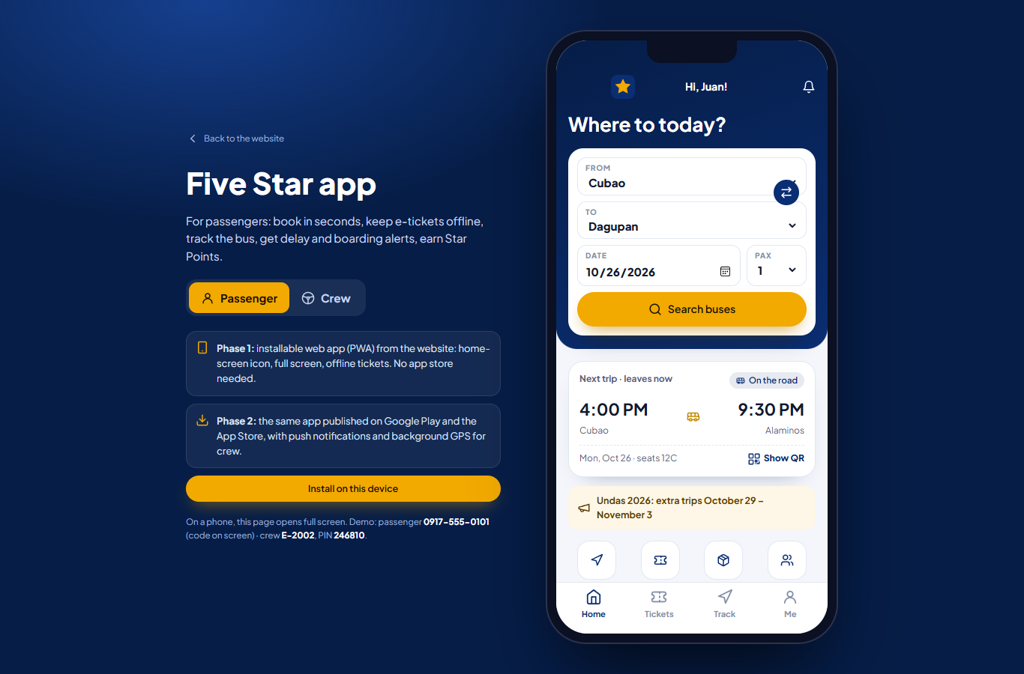
Figure 17. Passenger app: home with search, next trip, advisory and quick actions.
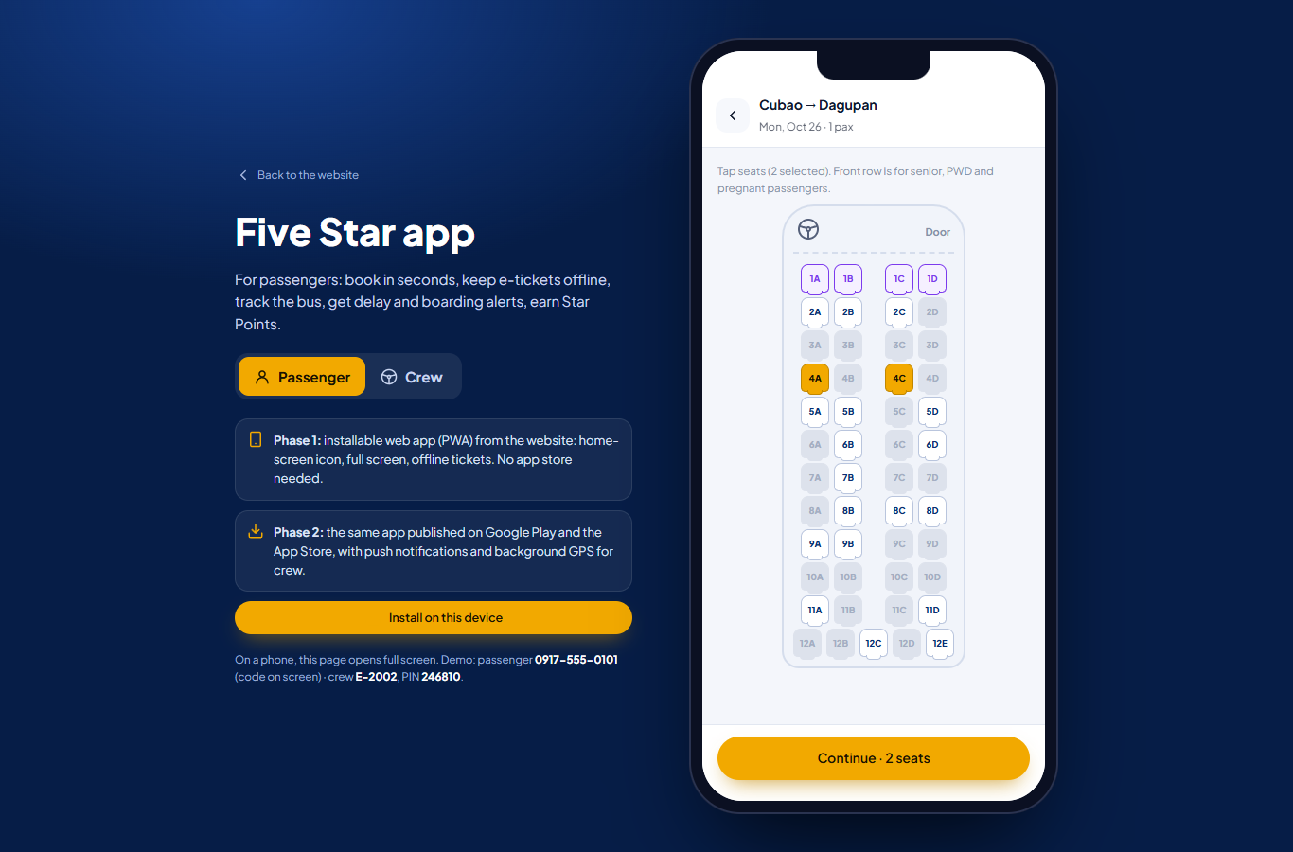
Figure 18. Passenger app: choosing seats.
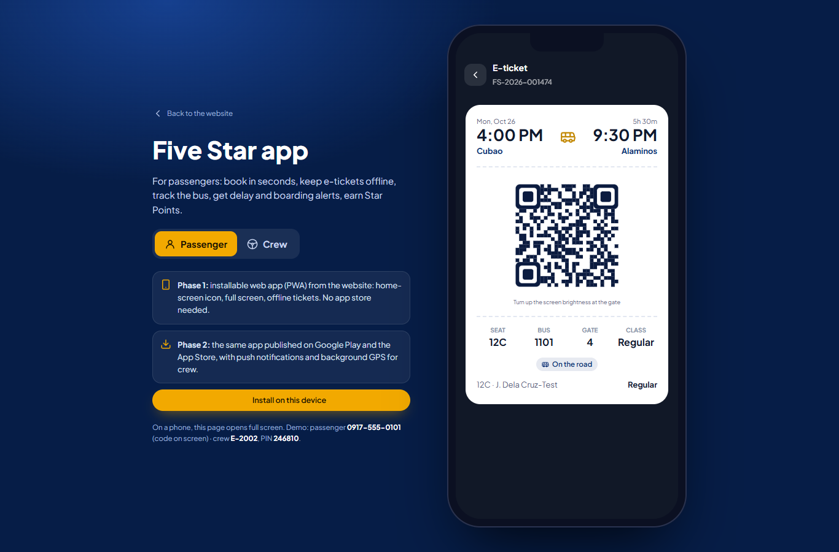
Figure 19. Passenger app: e-ticket with QR, seats, bus, gate and live status.

6.1 How to deliver the app (choice)
Option | What it means | Our view
A. Installable web app now, store apps in Phase 2 | Phase 1: the app installs from the website (home-screen icon, full screen, offline tickets), no store approval needed. Phase 2: the same code is packaged for Google Play and the App Store (Capacitor), adding push notifications and background GPS for crew. | Recommended. Fastest to launch, one code base, lowest cost.
B. Native store apps from the start | Separate React Native app published in both stores at launch. | Higher cost and longer Phase 1; store review delays.
C. Installable web app only | No store listing. | Cheapest; but many passengers look for the app in the Play Store.

7. Staff portal: dashboard and analytics
The portal opens on a dashboard limited to the person's role and terminals. Management sees all terminals; a Terminal Manager sees theirs.
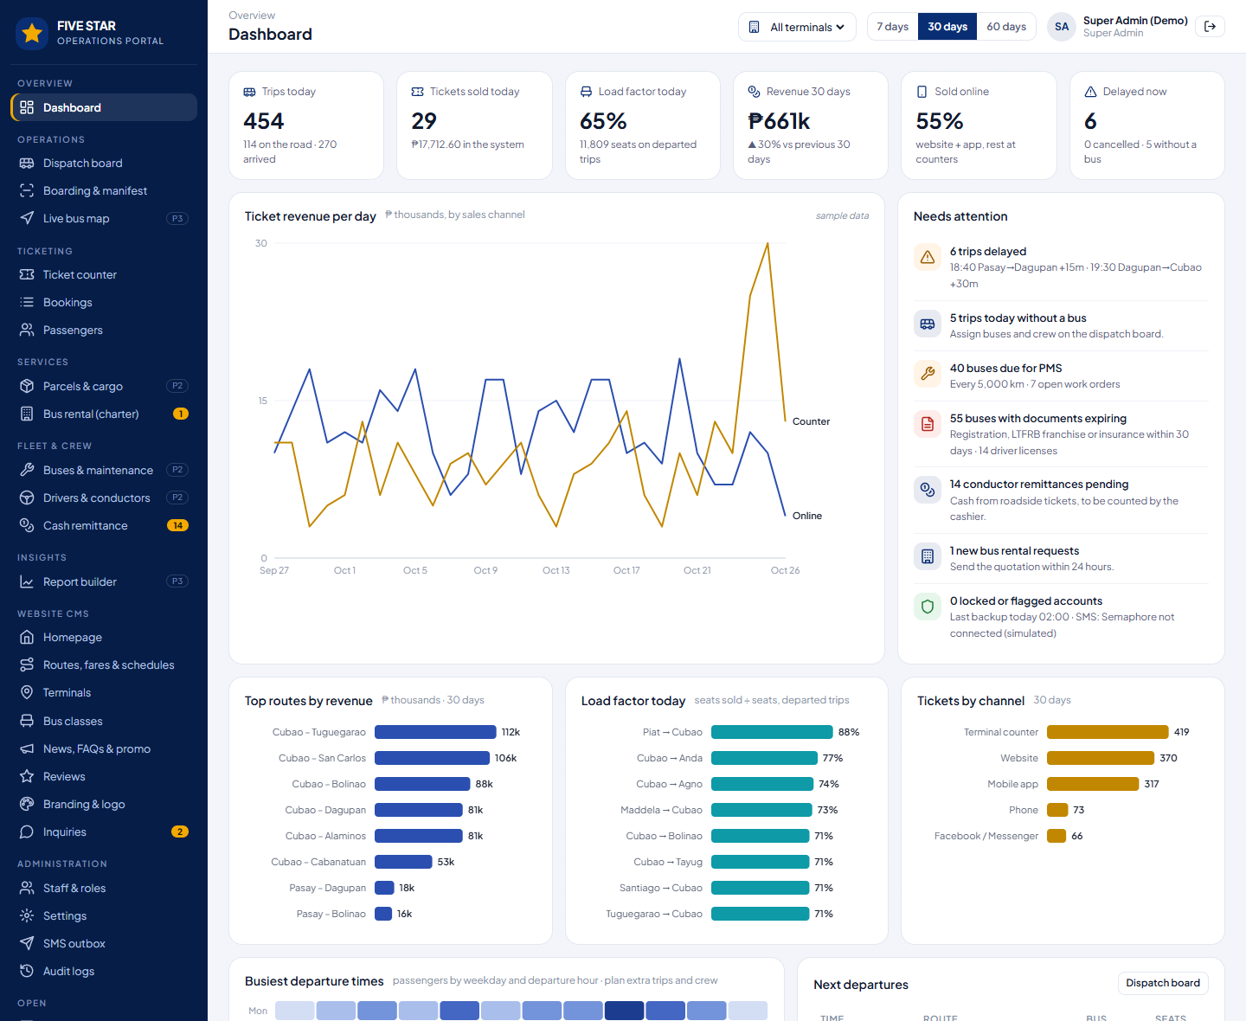
Figure 20. Dashboard (sample data): trips today, tickets sold, load factor, revenue by channel, alerts, top routes, load factor per route, busiest departure times.
Area | Figures
Today | Trips (scheduled, on the road, arrived, cancelled), tickets sold, load factor of departed trips, delays, trips without a bus.
Sales | Revenue per day by channel (online, counter), compared with the previous period; tickets by channel (website, app, counter, phone, Facebook, conductor); online share.
Routes | Top routes by revenue; load factor per route; busiest departure times by weekday (to plan extra trips and crew).
Needs attention | Delays, trips without a bus, buses due for maintenance, expiring documents and licenses, pending remittances, new rental requests, locked accounts, backups and SMS credits.
- Filters by terminal and period (7, 30, 60 days, custom); click a figure to open the list behind it; export to Excel or PDF (recorded in the audit log).

8. Operations: dispatch, boarding and terminal screens

8.1 Dispatch board
One line per departure from the terminal: bus, driver(s), conductor, gate, seats sold and status. Dispatchers assign buses and crew, start boarding, depart and arrive trips, enter delays and cancellations, and add extra trips.
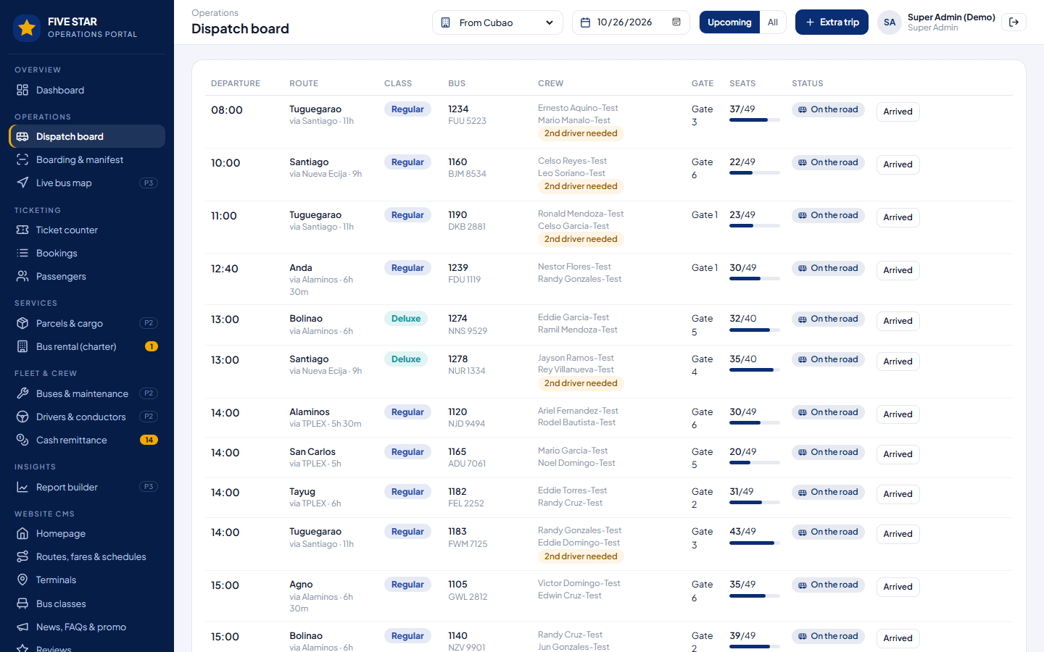
Figure 21. Dispatch board: bus and crew per trip, gate, seats sold, status and actions.
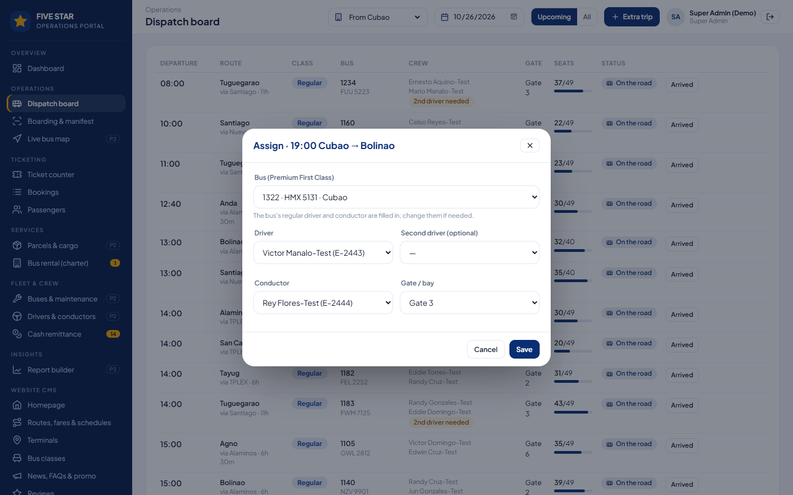
Figure 22. Assigning a bus: buses with overdue maintenance or expired papers cannot be chosen; overlapping trips and expired licenses are flagged.
- Safety checks (settings): a bus with overdue PMS or an expired registration, LTFRB franchise or insurance cannot board; a driver with an expired license cannot be assigned; trips longer than 8 hours need a second driver.
- Delays and cancellations send an SMS to every passenger with the message from Settings; the website, app and TVs show the new time; cancelled-trip passengers get a link to rebook or get a full refund.
- Extra trips (e.g. Undas) go on sale online immediately.

8.2 Boarding and manifest
At the gate the e-ticket QR is scanned with a phone, tablet or USB scanner. The result says OK with the seat and passenger name, or why not (wrong bus, unpaid, already used), and "check ID" for discounted fares. The manifest lists every passenger by seat with boarded status and prints for LTFRB and insurance.
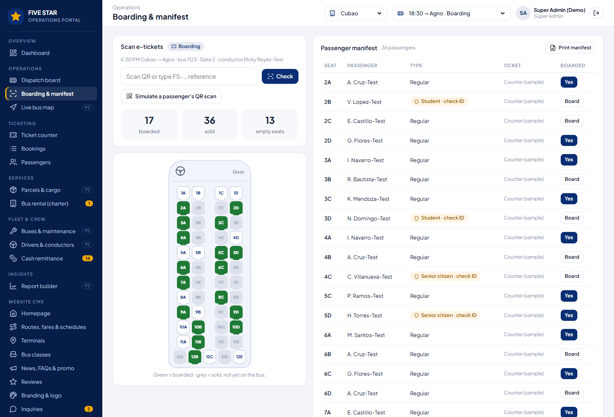
Figure 23. Boarding & manifest: scan result, boarded count, seat map (green = on the bus) and the passenger manifest.

8.3 Departure screens
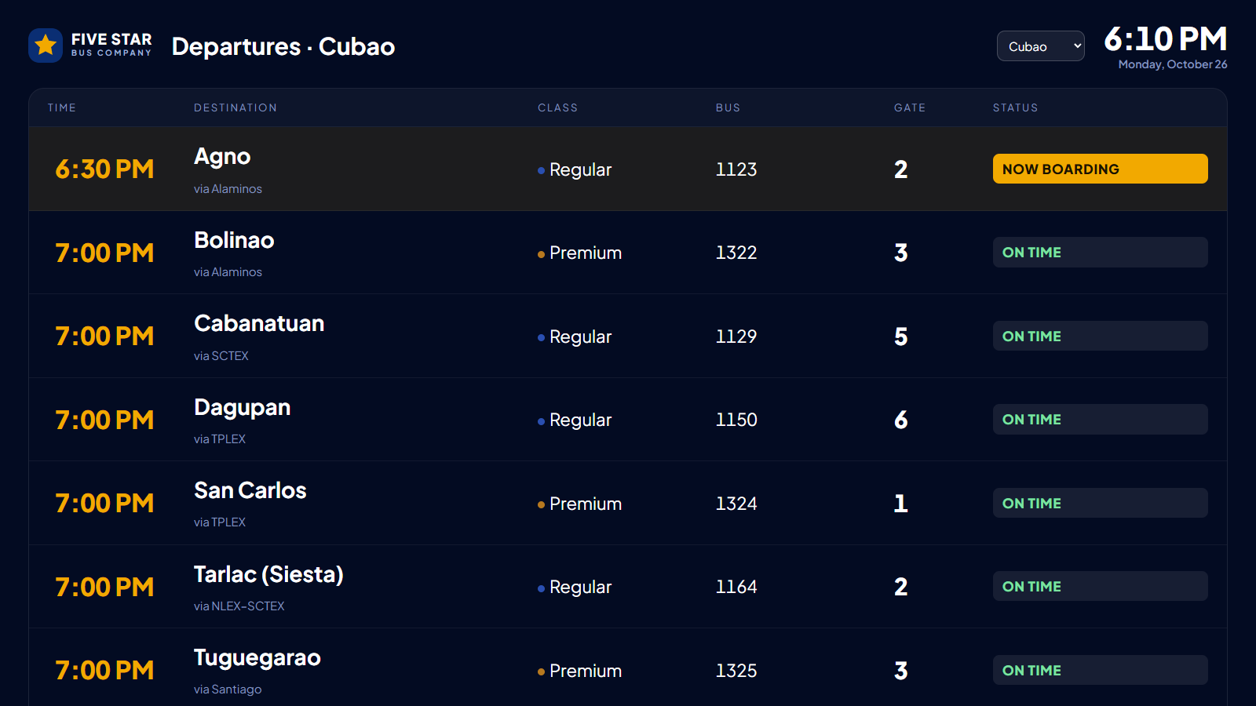
Figure 24. Departure screen for the terminal TV: time, destination, class, bus, gate and status, with advisories scrolling at the bottom.

8.4 Crew app
Conductors and drivers sign in with employee number and PIN on the phone assigned to the bus. The trip manifest is downloaded before departure so scanning works without signal.
Tab | What it does | Phase
Scan | Scan e-ticket QRs; refuses wrong-trip, unpaid or used tickets. | 1
Manifest | All passengers by seat with boarded status and discount IDs to check. | 1
Status | Start boarding, depart, arrived; "running late +15 min" informs dispatch and passengers. | 1
Checklist | Pre-trip inspection by the driver (tires, brakes, lights, aircon, first aid, CCTV). | 2
Roadside | Tickets for passengers who flag the bus on the way: fare by drop-off point, cash recorded for remittance. | 2
More | Incident report to dispatch; share GPS location. | 2–3
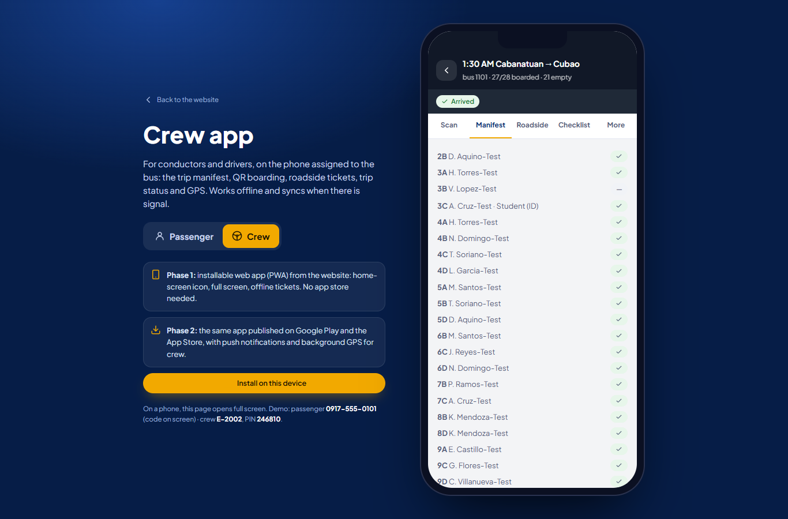
Figure 25. Crew app: trip manifest with boarded passengers.

9. Ticket counter, bookings and passengers

9.1 Ticket counter
Counter clerks sell walk-in tickets from the same seat inventory as the website: choose the destination and trip, click seats, type the names (required for the manifest) and passenger type, take cash (the change is computed) or QR Ph/GCash/card, and print the ticket with QR on a thermal printer.
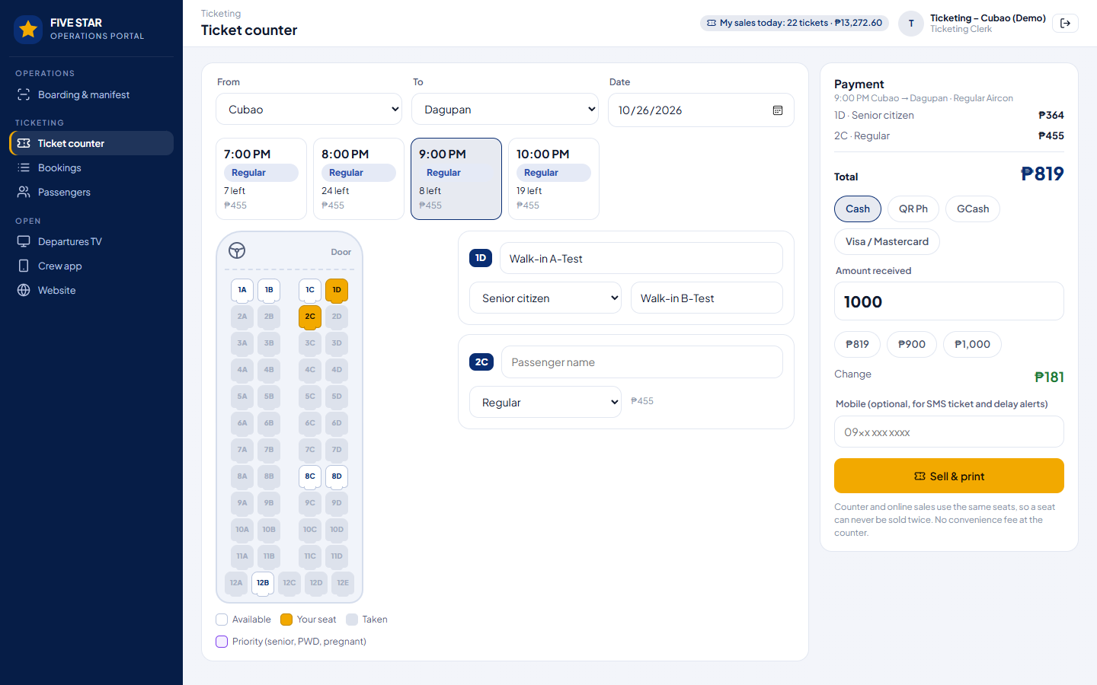
Figure 26. Ticket counter: trips with seats left, seat map, passengers, payment with change, and the clerk's sales today.

9.2 Bookings
Search any booking by reference, name or mobile; filter by trip date, status and channel. The booking drawer shows the e-ticket and lets staff receive payment for a reservation, resend the ticket, change the trip, cancel or refund (with reason). Mobile numbers are masked for lower roles.
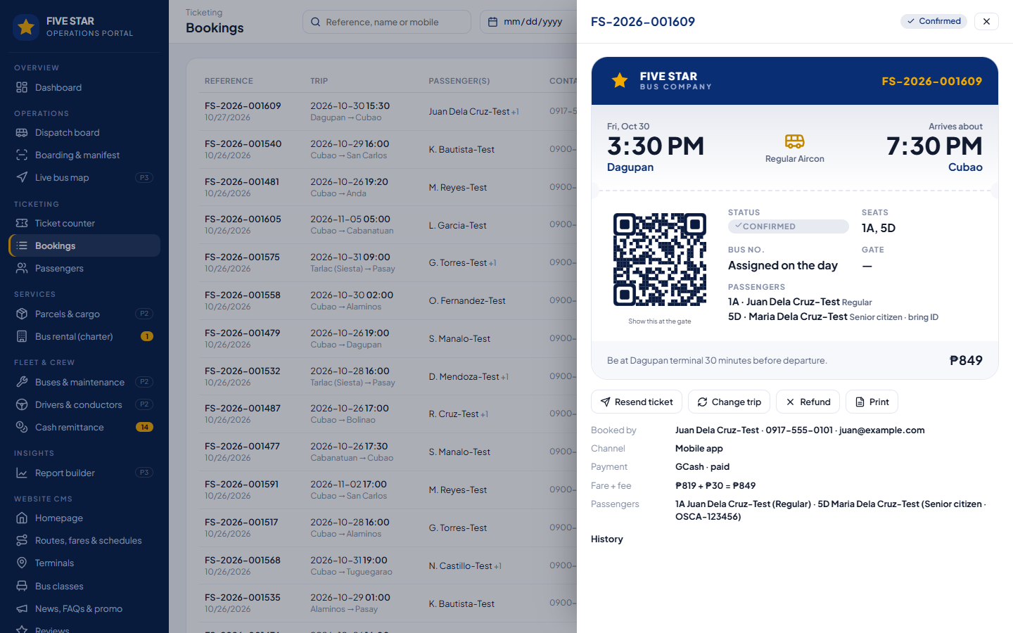
Figure 27. Bookings with the booking drawer (e-ticket, actions, history).

9.3 Passengers
- Every passenger once, matched by mobile number (guest and account bookings together): bookings, amount spent, last trip, no-shows, Star Points.
- Privacy requests (copy, correction, deletion) are tracked (section 15).

10. Website CMS
Five Star manages the whole website and everything passengers see. Content Editors can prepare drafts; publishing can be limited to Company Admins.
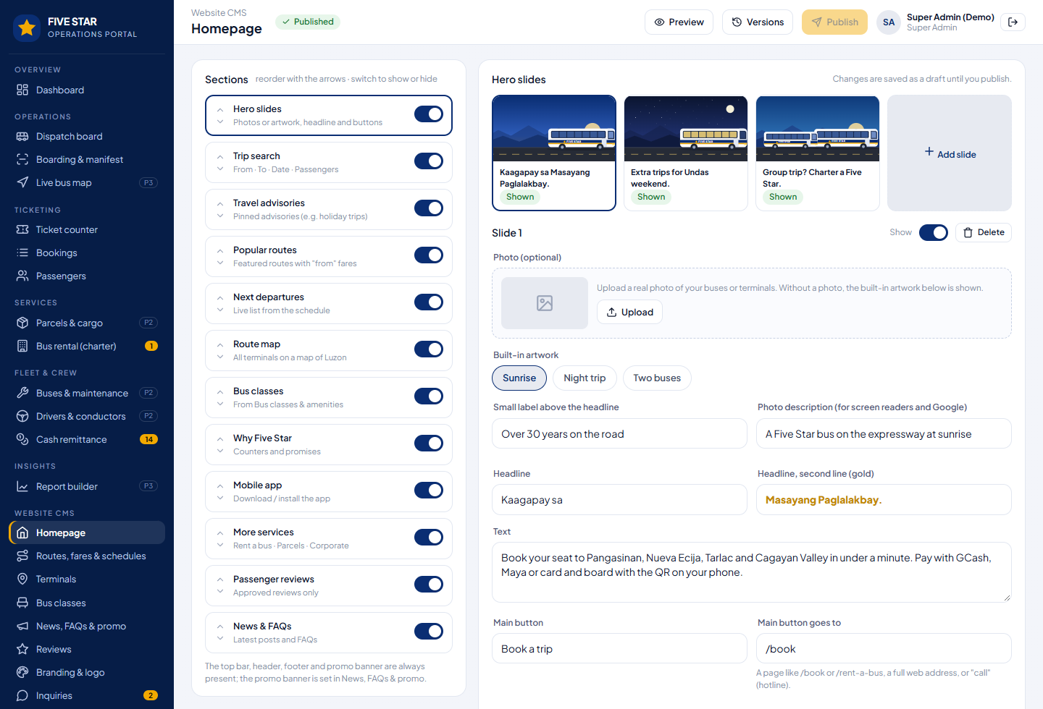
Figure 28. CMS → Homepage: sections (reorder, show or hide), slide editor, draft → preview → publish → versions.
Area | What Five Star can change
Homepage | Every section: order, show/hide, titles, texts, slides, buttons, counters, promises.
Routes, fares & schedules | Routes (from, to, via, distance, travel time), fares per bus class, departure times both ways and the bus class of each departure, drop-off points, featured on the homepage, online sales on/off, route on/off.
Terminals | Name, province, address, phone numbers, hours, map pin, photo, hub (counters and screens), parcels accepted, on/off.
Bus classes | Name, seat layout (2+2 or 2+1), rows, back row, amenities, description, colour, charter day rate. Seat maps, tickets and manifests follow the layout.
News & advisories | Advisories and news with photo, date and pin to homepage.
FAQs, promo banner | Questions and answers; the gold banner with dates and link.
Reviews and inquiries | Approve or hide reviews; reply to inquiries.
Branding | Logo, colours, tagline, slogan, about, hotline, email, social links. Colours apply everywhere immediately.
Pages and SEO | Privacy notice, terms of carriage, about; page titles, descriptions, sharing images.
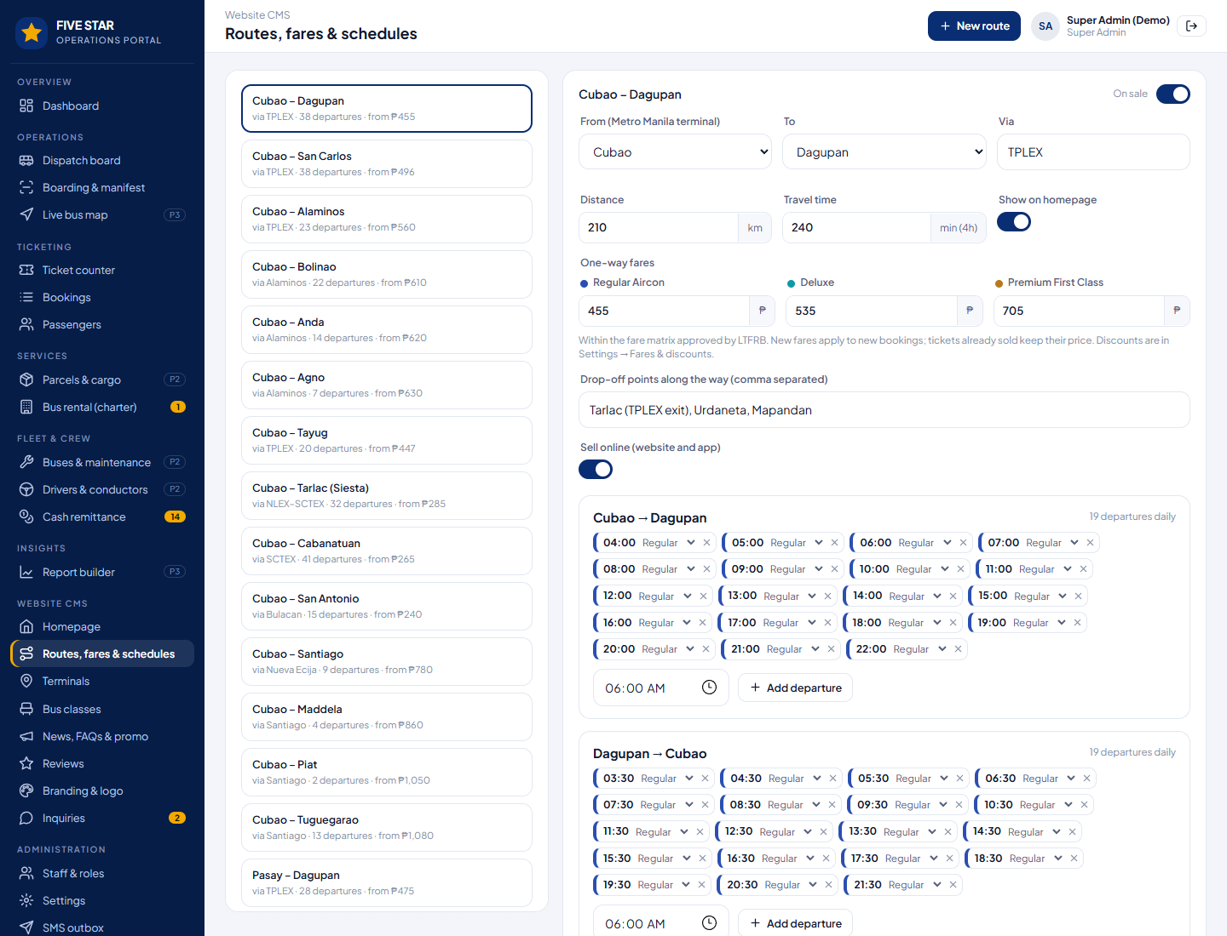
Figure 29. CMS → Routes, fares & schedules: fares per class and every departure time with its bus class.
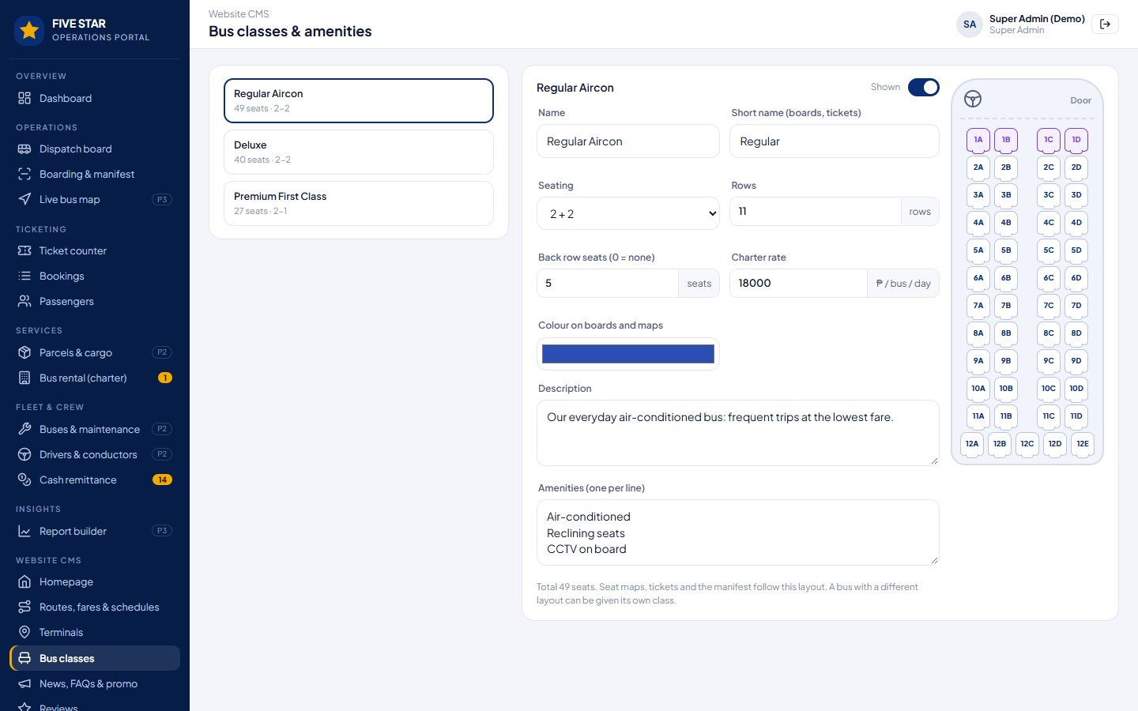
Figure 30. CMS → Bus classes: layout, amenities and a live seat-map preview.

10.1 Drafts, preview and history
- Homepage changes are drafts until published; preview on desktop and phone; the last 10 published versions can be restored in one click.
- Every CMS change (especially fares and schedules) is recorded in the audit log with who and when.

11. Settings: everything is customizable
Every rule of the system is a setting stored in the database, not in the program. Settings are grouped; each change is recorded with old and new values.
Group | Contents
Security | Login lockout, MFA, crew PIN, sessions (counter computers shorter), password policy, one-time codes.
Ticketing rules | Online sales window and cut-off, seats per booking, seat hold, convenience fee, seat choice, reserve & pay at terminal, priority seats, changes, refunds, no-shows, reminders.
Fares & discounts | Student, senior and PWD discounts, children on lap, ID rules, peak-season fare.
Notifications & templates | Wording of every SMS: one-time code, ticket confirmed, reserved, reminder, boarding, delay, cancellation, parcel arrived; quiet hours.
Parcels & cargo | Rates (minimum, per kg, per distance, valuation), maximum weight, SMS to receiver, free storage days, receiver pays.
Fleet & crew | PMS interval and warning, document expiry warnings, blocks on dispatch, duty limits, second driver rule.
Integrations | PayMongo, Semaphore, Mailjet, Amazon S3, Google Maps, GPS, Cloudflare Turnstile (section 12).
System & maintenance | Maintenance mode and backups.
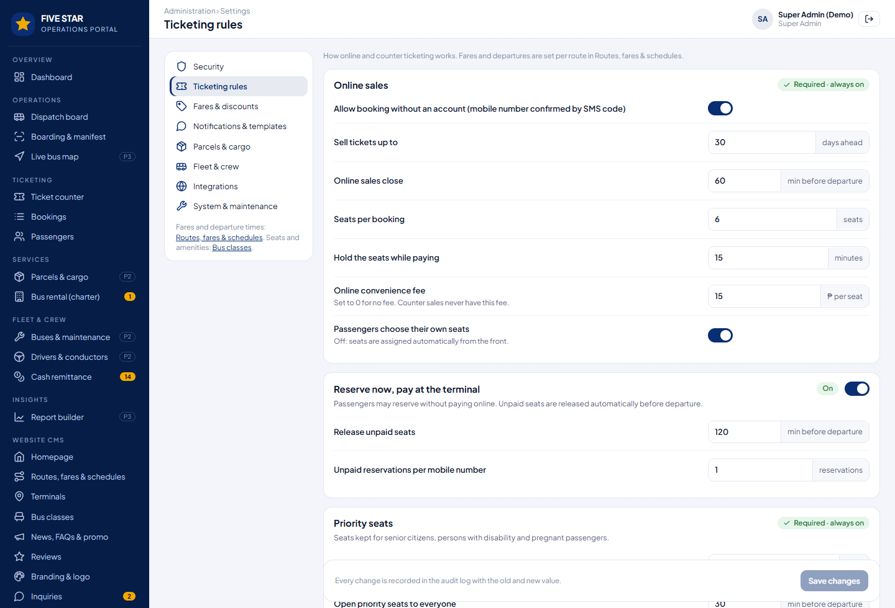
Figure 31. Settings → Ticketing rules.
Rule we follow. When a fixed rule is found during the project, it becomes a setting, so Five Star decides, not the programmer.

12. Integrations
All integrations are built in and plug and play: the admin opens Settings → Integrations, enters the credentials, presses Test and switches it on. Until then the rest of the system works (SMS is shown in the SMS outbox as "simulated"). Credentials are stored encrypted.
Service | Provider | What to enter | Used for
Online payments | PayMongo | Public and secret keys, webhook secret; test or live; GCash, Maya, Visa/Mastercard, QR Ph on/off. | Tickets, reservations paid online, change fees, refunds, charter deposits, parcel fees.
SMS | Semaphore | API key, sender name (e.g. FIVESTARBUS), low-credit warning. | One-time codes (priority route), tickets, reminders, boarding, delays, cancellations, parcel notices.
Email | Mailjet (or SMTP) | API key and secret, sender address and name. | E-tickets, receipts, password resets, staff invitations, charter quotations.
File storage & backups | Amazon S3 | Region (Singapore), bucket, access key, secret. | Photos, uploaded IDs, parcel photos, contracts, nightly encrypted backups.
Maps | Google Maps Platform | API key restricted to the domain. | Terminal maps, directions, live bus map. OpenStreetMap until connected.
GPS (Phase 3) | Crew app or the GPS provider already in the buses | Source and provider API key, update interval. | Live bus position and arrival times.
Spam protection | Cloudflare Turnstile | Site and secret keys. | Booking, charter, contact and sign-in forms.
Statistics | Google Analytics 4, Meta pixel | Measurement IDs. | Visitors and ad measurement after cookie consent.
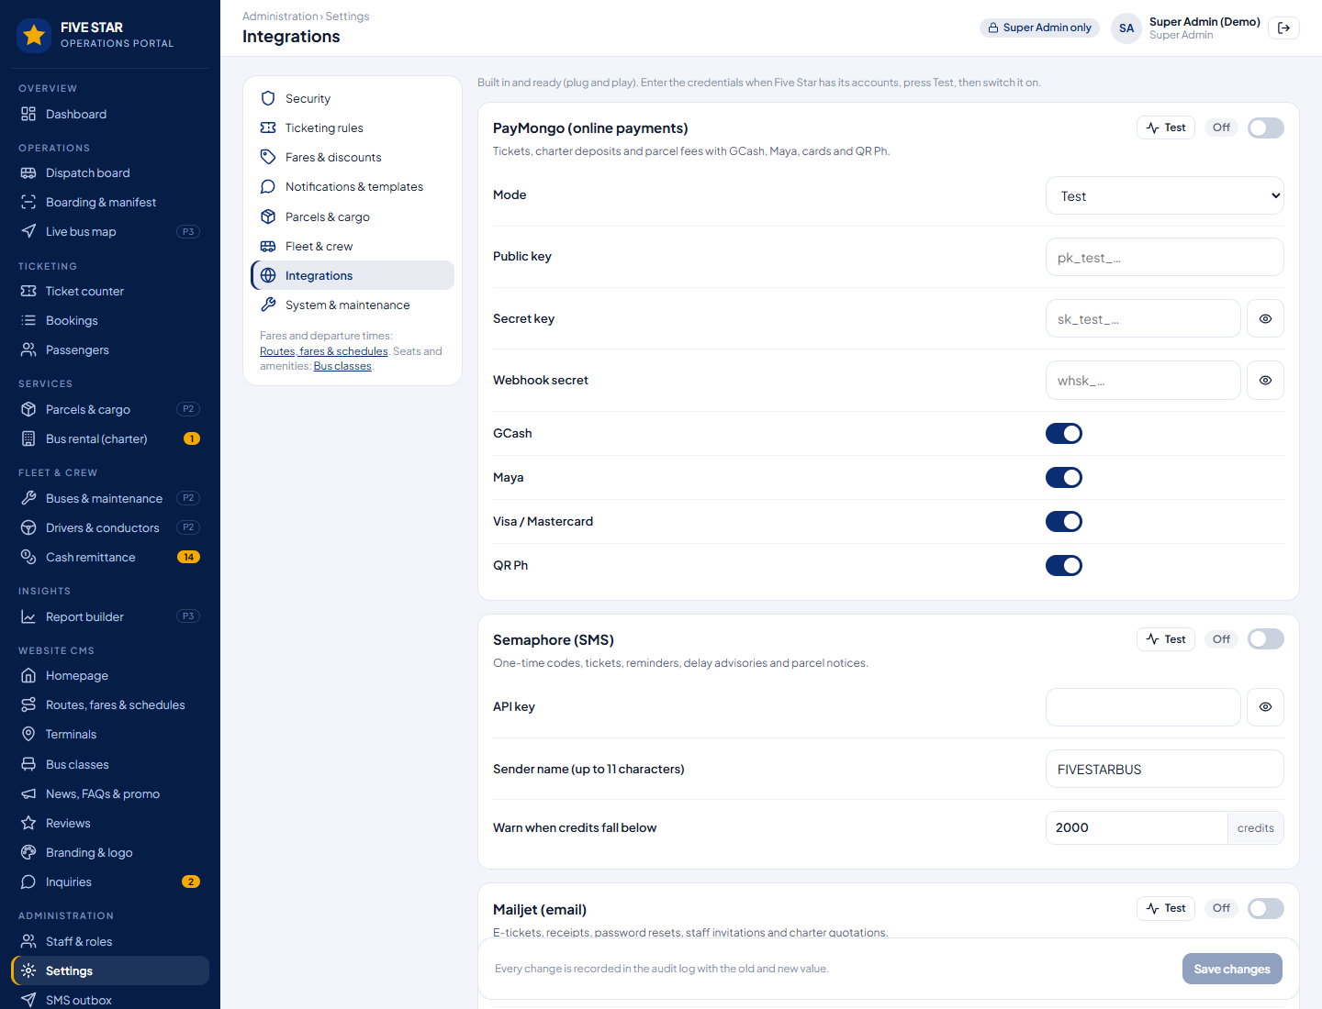
Figure 32. Settings → Integrations: enter credentials, Test, switch on.

12.1 How an online payment works
- The passenger chooses GCash, Maya, card or QR Ph; the system creates the payment in PayMongo and holds the seats for 15 minutes.
- The passenger pays in the e-wallet, card page or banking app.
- PayMongo confirms the payment to the system (webhook, checked against the secret).
- The booking is confirmed, the e-ticket is sent by SMS and email, the sale shows on the dashboard. If payment fails or times out, the seats are released.
- Refunds are started from the portal or by the passenger (within the rules) and go back to the same account through PayMongo.

13. Maintenance mode
Settings → System → Maintenance Mode pauses online booking for an upgrade without a programmer.
Setting | Choices
Who is affected | Website and passenger app only: terminals keep selling at the counter and dispatch keeps working.  Everyone except Super Admins: staff are stopped too.
Message and end time | Shown on the maintenance page; maintenance can end by itself at a set time.
Always working | Existing e-tickets stay valid; crew scanning works offline; PayMongo confirmations are still received.
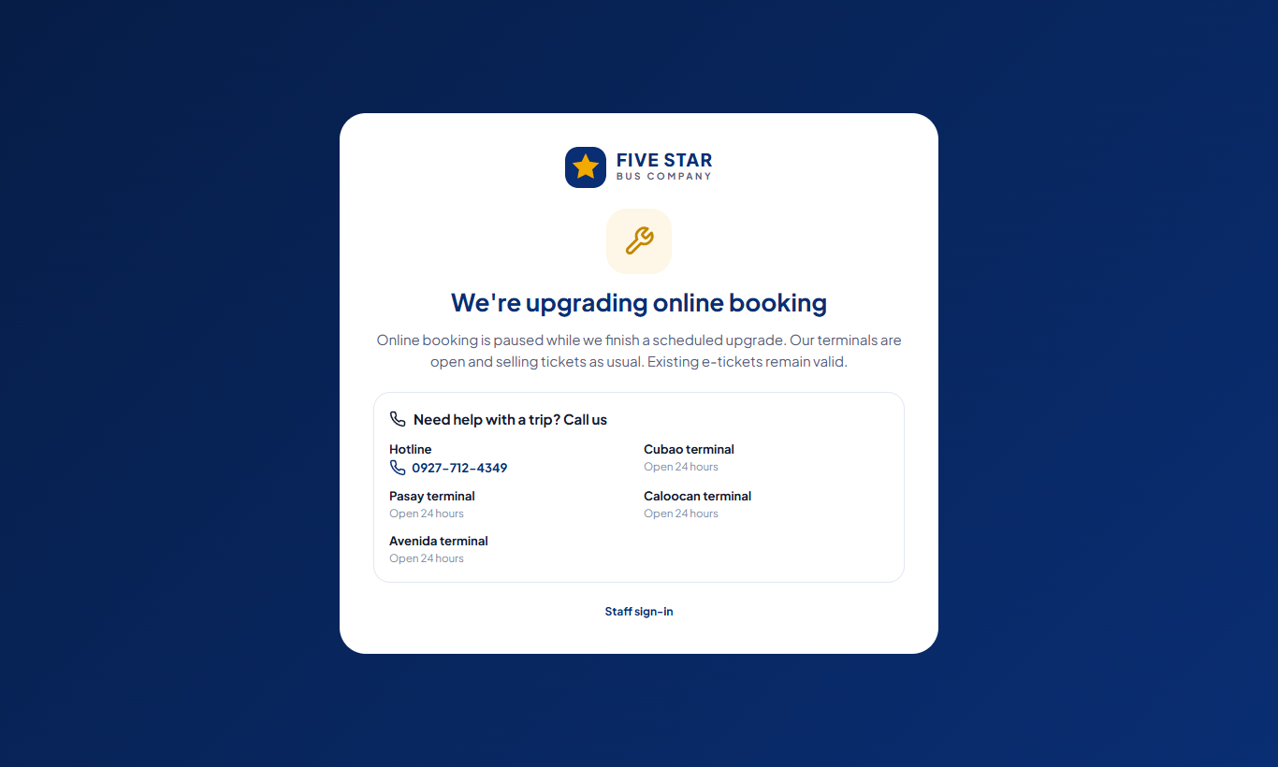
Figure 33. Maintenance page: the hotline and terminals stay visible.

14. Staff, roles and permissions
Roles are a starting list; the Super Admin can rename roles, create new ones and tick permissions per module and action. Staff work in one or more terminals. A higher rank manages only lower ranks.
Role | Rank | Typical access
Super Admin | 100 | Everything, including security, integrations, maintenance mode, backups and unlocking Company Admins.
Company Admin | 90 | All modules and terminals; ticketing, fares, fleet and message settings. Cannot manage Super Admins.
Terminal Manager | 70 | Own terminal(s): dispatch, bookings, counter, boarding, parcels, remittances, charters, reports; refund overrides; unlocks lower staff.
Dispatcher | 50 | Dispatch board, boarding, fleet status, crew, live map.
Fleet & Maintenance | 50 | Buses, documents, work orders, crew records, fleet reports.
Ticketing Clerk | 40 | Ticket counter, bookings, boarding and passenger look-up at the assigned terminal.
Cashier | 40 | Counter payments, conductor remittances, cash closing.
Customer Service | 40 | Bookings (rebook, refunds within the rules, resend), passengers, parcels look-up, charters, inquiries.
Parcel Clerk | 30 | Accept, load and release parcels.
Content Editor | 30 | Website CMS and inquiries.
Conductor / Driver | 20 | Crew app for their assigned trips.
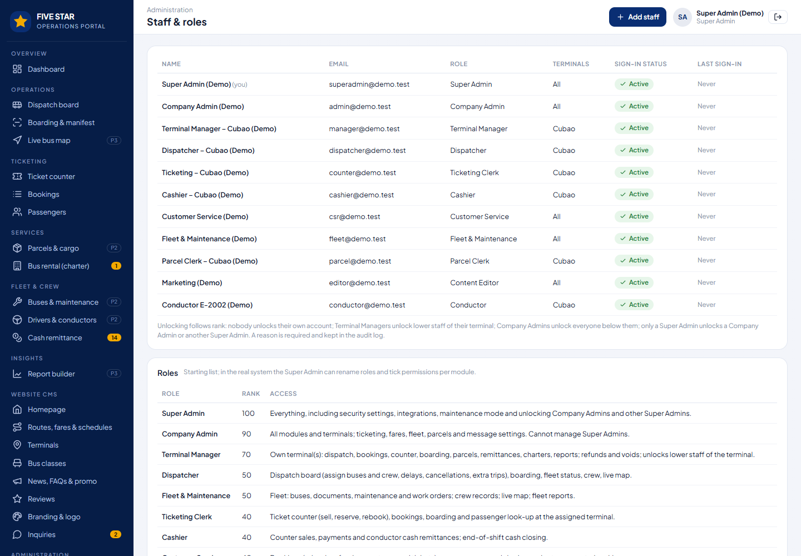
Figure 34. Staff & roles: sign-in status, unlocking by rank with a reason, roles and their access.

15. Data privacy (Data Privacy Act of 2012)
- A privacy notice and terms of carriage (written and versioned in the CMS) are accepted at booking; the accepted version is stored with the booking.
- Passengers choose separately whether they want promotional SMS and email; trip messages are part of the service.
- Passengers can request a copy, correction or deletion of their data from My account; trip and payment records required by law (manifests, receipts) are kept, the rest is removed.
- Mobile numbers and emails are masked in lists for roles that do not need them; uploaded ID photos are private and expire; every export is in the audit log.
- Five Star should name a Data Protection Officer and register with the National Privacy Commission if required; we help prepare the documents.

16. Phase 2 and Phase 3 modules

16.1 Parcels and cargo (Phase 2)
- Accept a parcel at any terminal: sender and receiver, contents (inspected), pieces, weight, declared value; the fee is computed from the rates in Settings; sender pays or receiver pays on pick-up.
- Waybill label with QR; load on a trip; statuses Received → Loaded → On the way → Ready for pick-up → Claimed; the receiver gets an SMS on arrival; tracking on the website by waybill number.
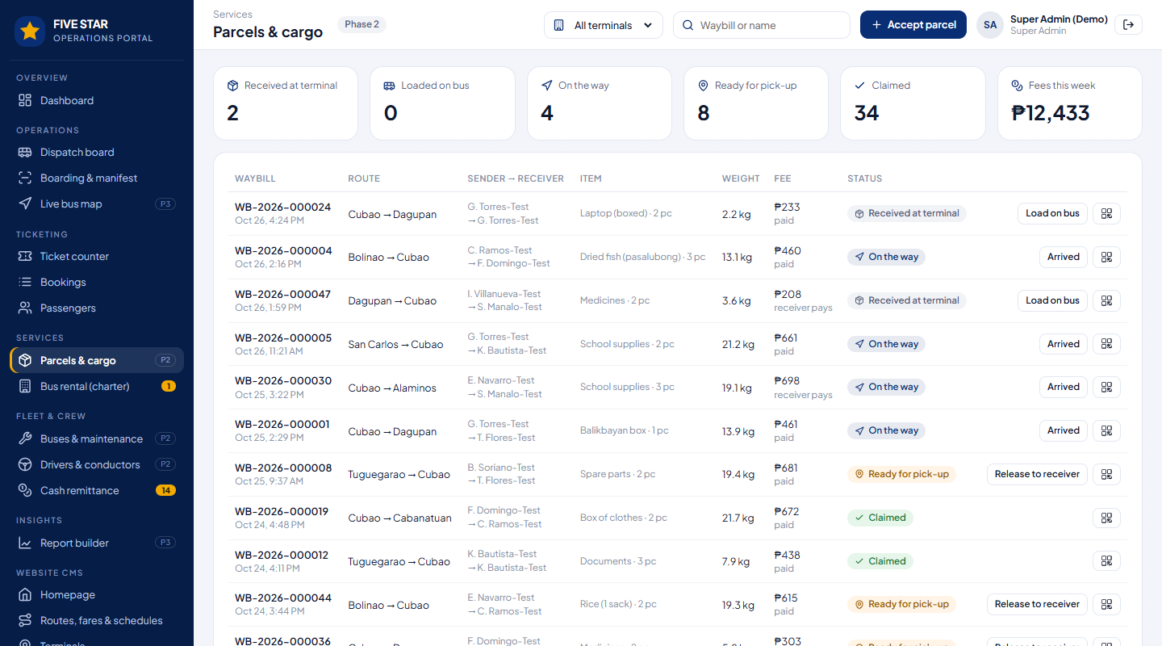
Figure 35. Parcels & cargo: counts by status, waybills, next action per parcel.
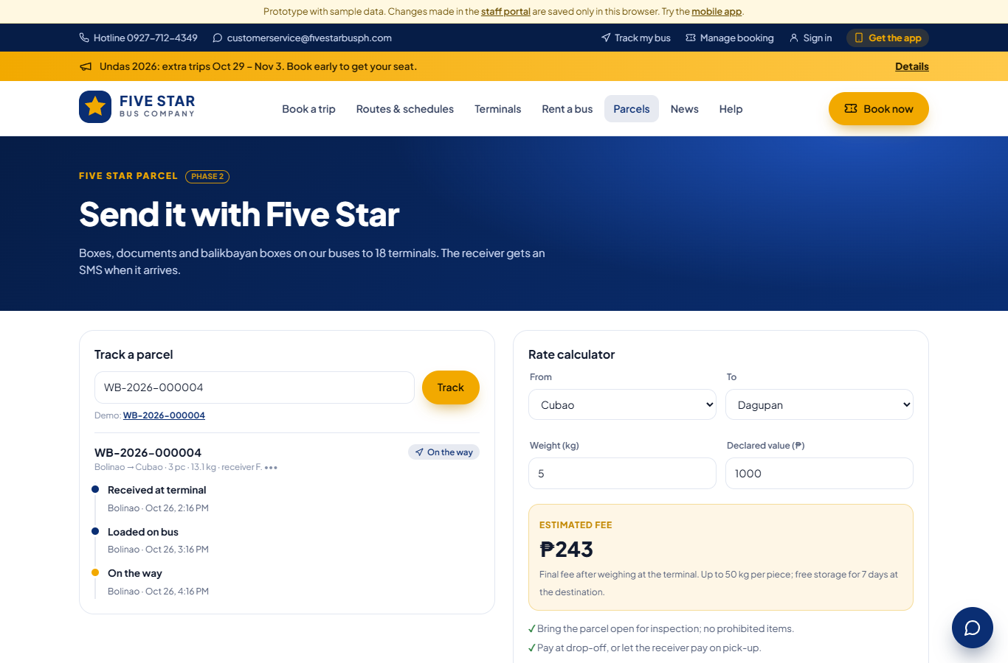
Figure 36. Website: parcel tracking timeline and rate calculator.

16.2 Fleet, crew and cash (Phase 2)
- Buses: body number, plate, model, class, home terminal, odometer, next PMS, registration (OR/CR), LTFRB franchise (CPC) and insurance expiry. Buses with overdue PMS or expired papers are blocked from dispatch.
- Work orders: PMS, repairs, tires, aircon; the bus is out of dispatch until the work order is done; costs per bus.
- Drivers and conductors: license and expiry, home terminal, duty today and hours against the limit, rating, leave.
- Cash remittance: roadside cash per trip from the crew app is counted by the cashier; differences are recorded; end-of-shift cash closing per counter clerk.
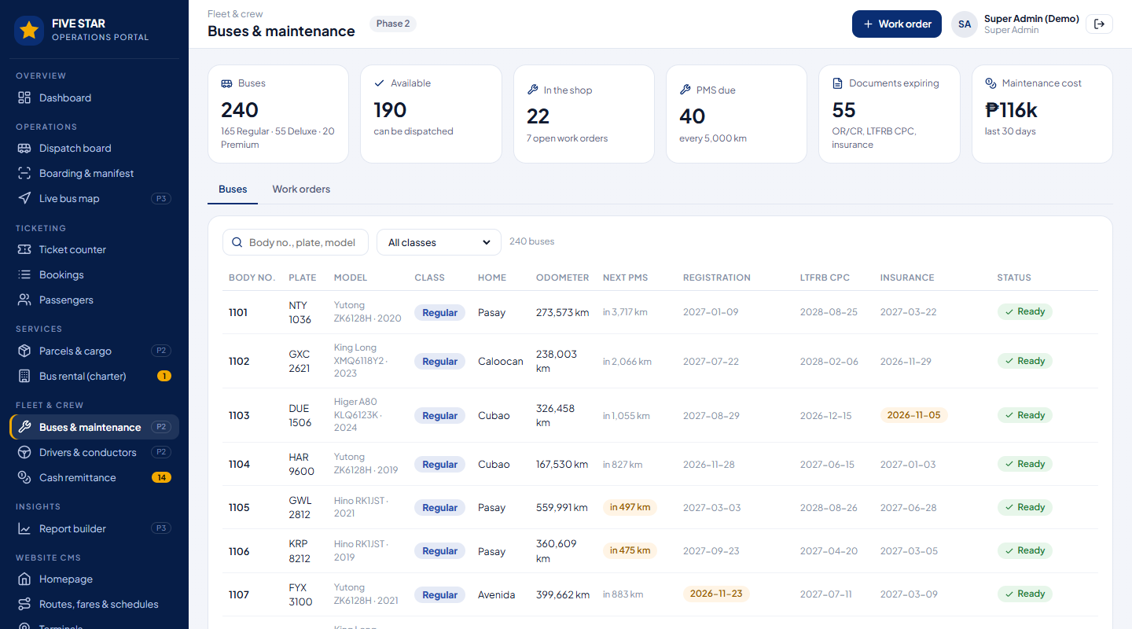
Figure 37. Buses & maintenance: PMS due, document expiry, readiness for dispatch.

16.3 Live tracking (Phase 3)
Bus positions from the crew app on the conductor's phone or from the GPS devices already installed in the buses (provider API). Passengers see their bus and arrival time; dispatch sees every bus on the road, running late, long stops and route deviations.
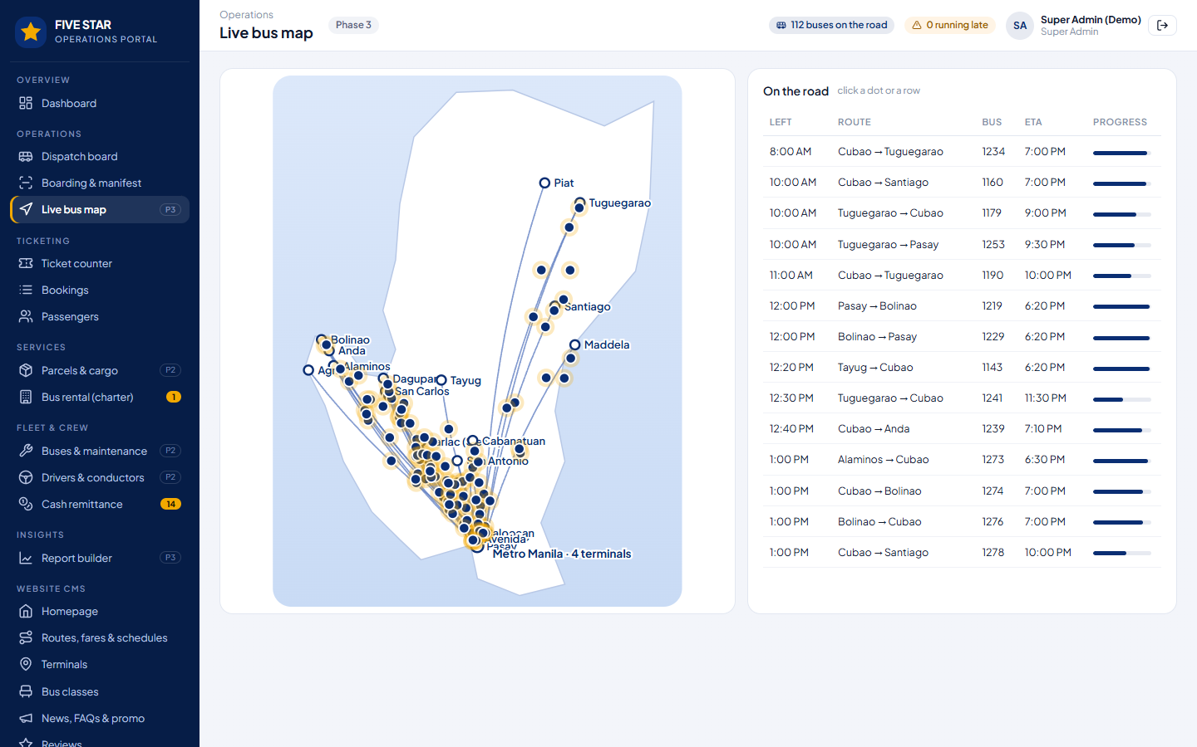
Figure 38. Live bus map in the portal: buses on the road, progress and arrival times (simulated positions in the prototype).
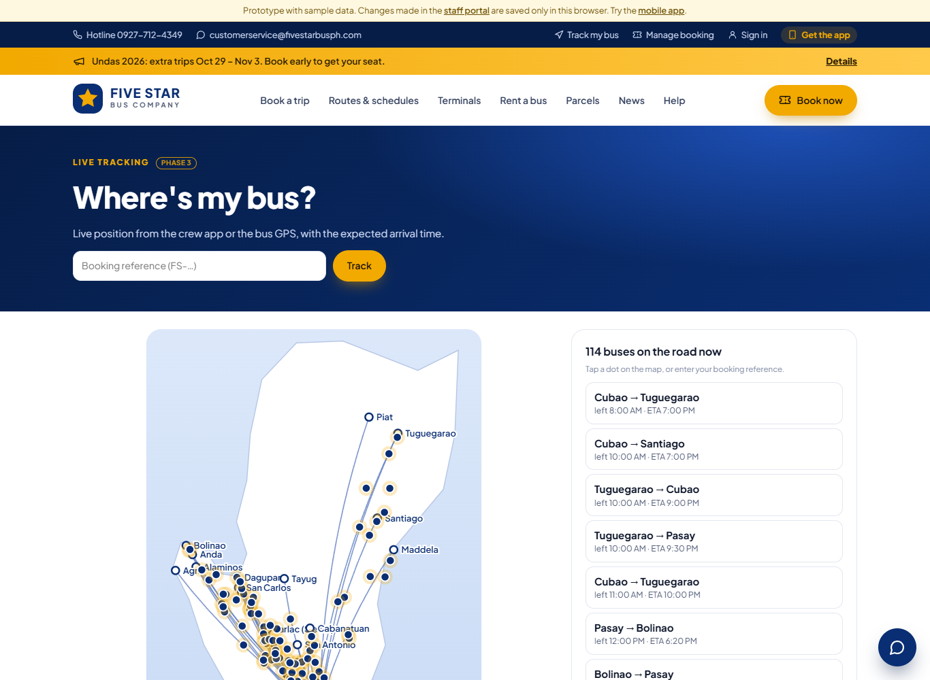
Figure 39. Website: Track my bus.

16.4 Bus rental / charter (request: Phase 1, management: Phase 3)
- The website request form shows an indicative estimate from the charter day rates per bus class (set in the CMS).
- Phase 3: quotation sent by SMS and email with a PayMongo link for the deposit; buses assigned; contract signed electronically and stored in S3; completion and billing.
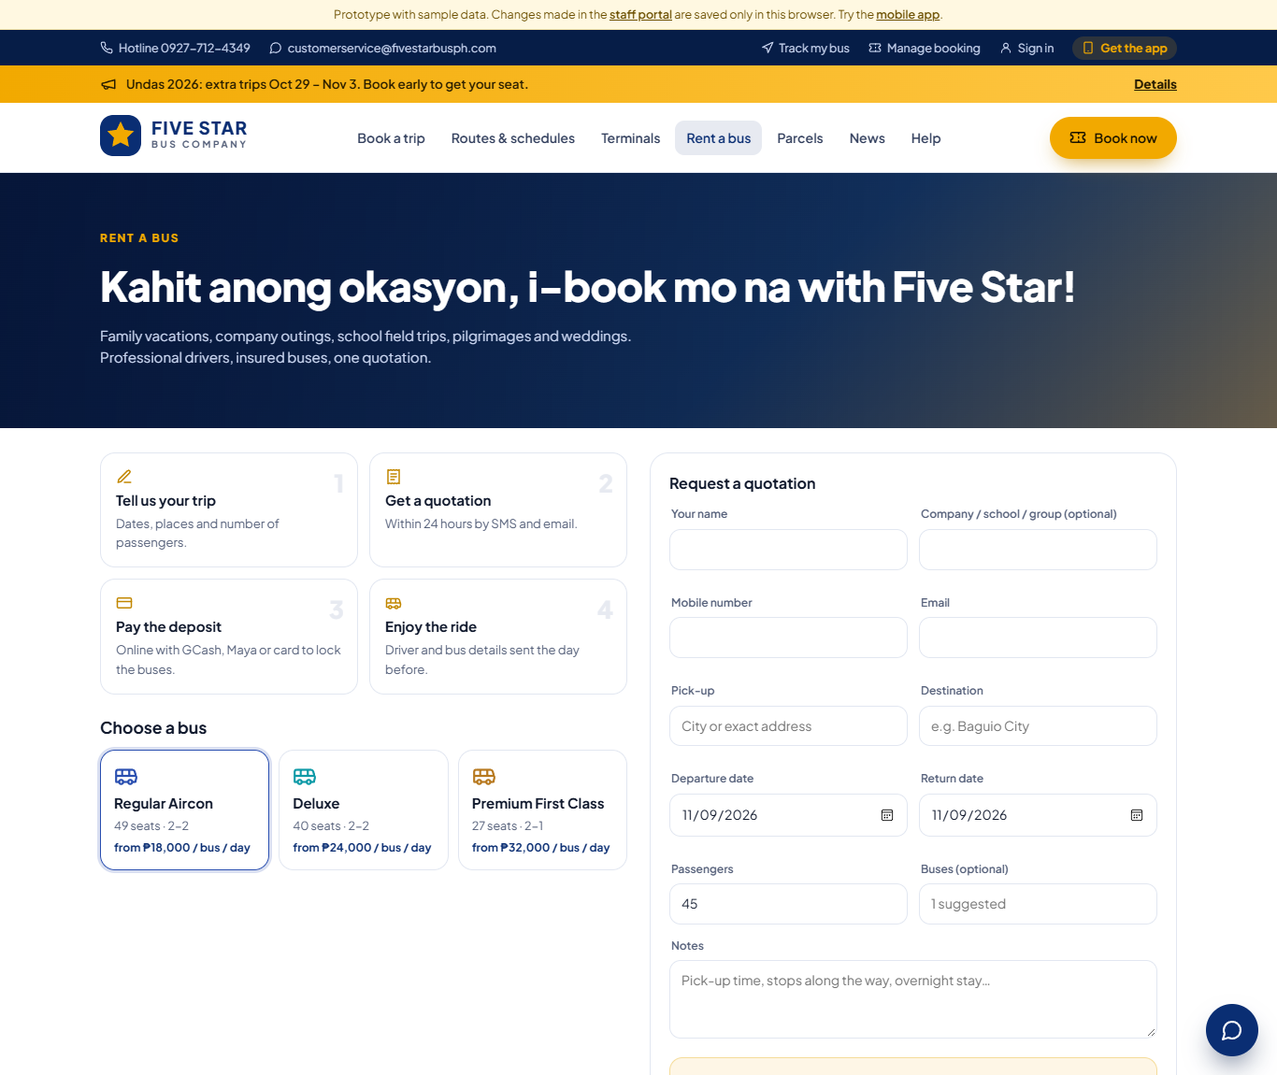
Figure 40. Website: Rent a bus with instant estimate.
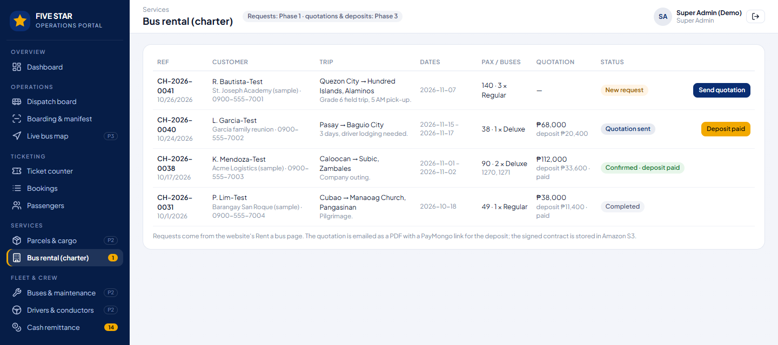
Figure 41. Portal: charter requests, quotations, deposits and bus assignment.

16.5 Growth (Phase 3)
Module | What it does
Star Points loyalty | Points per peso on paid trips (rate set in the CMS), used as discount; tiers for frequent travellers.
Corporate accounts | Companies book for employees and pay monthly by invoice; travel reports per company.
Report builder | Choose data (bookings, trips and load factor, parcels), columns and dates; export to Excel; save templates.
Peak-season fares | Holiday surcharge on chosen dates within the approved fare.
Ratings and incidents | SMS link after the trip to rate the trip, driver and bus; incident reports from the crew app followed up in the portal.
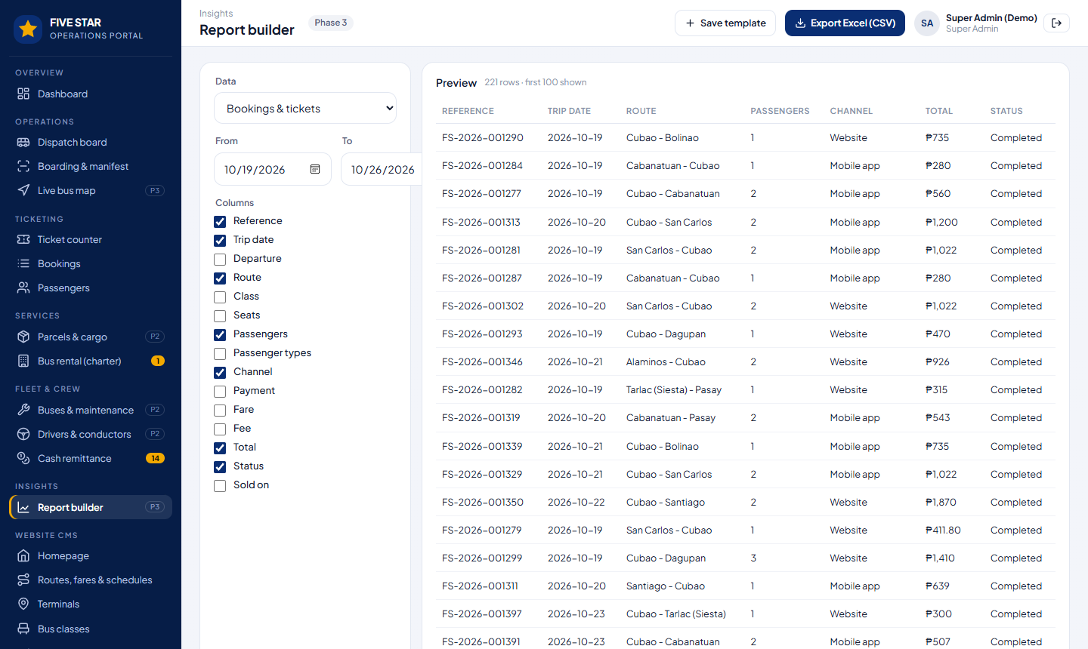
Figure 42. Report builder with column selection and Excel export.

17. Better ideas: choices for Five Star
Suggestions beyond the brief. Each can be switched on later; the column on the right is our recommendation.
Idea | Why it helps | Suggested
Own booking instead of the outside booking site | Five Star keeps the passenger data and the fees. Choice: switch off the outside site at launch, or run both for 2–3 months (we can sync seat counts if that site offers an API). | Run both briefly, then own only
Convenience fee | Choice: no fee (more online sales), a small fee per seat (covers PayMongo costs), or absorb it for app bookings only to grow the app. | Small fee on web, none in app
Reserve now, pay at the terminal | Helps passengers without e-wallets; risk of no-shows is controlled by release time and limits. | On, 1 per number
Seat selection for all classes | Passengers like choosing seats; Five Star could also charge a small fee for front or window seats in Premium. | Free in Phase 1
Self-service kiosk at Cubao | Touch-screen ticket machine with QR Ph payment; shorter counter lines on Fridays and holidays. | Later
WhatsApp / Messenger bot | Answers "what time is the next bus to Dagupan?" and sends the booking link. | Phase 3
Wi-Fi on board landing page | Passengers connecting to bus Wi-Fi see the app, promos and Star Points. | Later
Lost and found | Passengers report lost items by booking reference; crew logs found items per bus. | Phase 2
Backup internet at terminals | An LTE/5G backup line at each counter; counters can keep selling offline for a short time and sync. | Before go-live

18. Going live
- Preview copy first: Five Star tries the system with sample data on the preview copy; every later version is tested there.
- Setting up in the CMS: logo, photos, routes, fares, departure times, terminals, bus classes, buses and crew; we import buses and crew from Excel.
- Training per role: ticketing clerks, dispatchers, cashiers, conductors, customer service, content editors, managers; a short guide per role.
- Parallel run at one terminal (Cubao) for one to two weeks before all terminals.
- Hardware (to confirm): counter computers, thermal ticket printers, QR scanners or phones at the gates, one Android phone per bus for the crew app, TVs for departure screens, backup internet.
- Support: monitoring and alerts to Nueva Technology; agreed response times; updates through the preview copy.

19. Values to review
Starting values loaded into the settings. All can be changed by Five Star at any time. Please mark the ones to change.

19.1 Security
Setting | Starting value
Failed attempts before lock / within | 3 attempts / 30 minutes
Temporary lock / flag after | 15 minutes / 2 lockouts within 24 hours
Staff MFA | Required; trusted device 30 days
Staff idle timeout / counter idle / maximum session | 30 minutes / 10 minutes / 12 hours
Passenger "remember me" | 60 days
Password | At least 12 characters, upper and lower case, number and symbol
One-time SMS code | 6 digits, valid 5 minutes, 5 wrong tries, resend after 60 seconds

19.2 Ticketing
Setting | Starting value
Sell up to / online sales close | 30 days ahead / 60 minutes before departure
Seats per booking / seat hold | 6 / 15 minutes
Online convenience fee | ₱15 per seat (to be decided)
Reserve & pay at terminal | On; released 120 minutes before departure; 1 per mobile number
Priority seats | Row 1; open to all 30 minutes before departure
Change trip | Until 3 hours before; ₱50 per seat + fare difference
Refund | Until 24 hours before; 80% of the fare; full if Five Star cancels
No-show | 5 minutes after departure
Discounts | Student, senior citizen, PWD 20%; children under 100 cm free on lap
Reminders | Day before and 3 hours before; SMS when boarding starts

19.3 Operations and system
Setting | Starting value
PMS interval / warning | Every 5,000 km / 500 km before
Document expiry warning | 30 days; expired documents block dispatch
Duty limits | 10 hours driving; 8 hours rest; 2 drivers above 8 hours
Parcel rates | ₱120 minimum; ₱25/kg above 3 kg; ₱30 per 100 km; 1% valuation; 50 kg per piece; 7 days free storage
SMS sender / quiet hours | FIVESTARBUS / 9:00 PM – 7:00 AM for promotional SMS
Backups | Point-in-time restore (7+ days, by plan) + nightly encrypted S3 copy at 2:00 AM; 30 days daily, 12 months monthly
Numbers | Booking FS-2026-000001, waybill WB-2026-000001, charter CH-2026-0001

20. Decisions and questions

20.1 Decided by Five Star in the system (no need to answer now)
Topic | Where it is set
Logo, colours, taglines, photos, homepage | Website CMS → Branding, Homepage
Routes, fares, departure times, classes per departure | Website CMS → Routes, fares & schedules
Terminals, addresses, phones, hours, map pins | Website CMS → Terminals
Bus classes, seat layouts, amenities, charter rates | Website CMS → Bus classes
Fees, discounts, change and refund rules, priority seats | Settings → Ticketing rules, Fares & discounts
Wording of every SMS | Settings → Notifications & templates
PayMongo, Semaphore, Mailjet, AWS S3, Maps | Settings → Integrations

20.2 Choices we need from Five Star
- System name (section 1.4): A, B, C or D?
- Stack on Vercel (section 2.2): A (recommended), B or C?
- Mobile app delivery (section 6.1): A (recommended), B or C?
- Do you agree with the three phases? Should parcels or fleet maintenance move to Phase 1?
- The outside booking site: switch off at launch, or run in parallel for a while (section 17)?
- Convenience fee: none, per seat on web only, or for all online bookings?
- Who are the Super Admins and the Data Protection Officer?
- Website language: English, Filipino, or both (switchable)?
- GPS for Phase 3: crew phone or the GPS devices already in the buses (which provider)?

Appendix A. Routes and schedules (from fivestarph.com)
Route | Via | Travel time | Departures
Cubao – Dagupan | TPLEX | about 4 h | 4:00 AM – 10:00 PM, hourly
Cubao – San Carlos | TPLEX | about 5 h | 3:00 AM – 9:00 PM, hourly
Cubao – Alaminos / Bolinao | TPLEX, Alaminos | 5½ – 6 h | every 1–2 hours
Cubao – Anda / Agno | Alaminos | 6½ h | fixed times (e.g. 3:20 AM, 5:20 AM … 11:40 PM)
Cubao – Tayug | TPLEX | about 6 h | every 1–2 hours
Cubao – Tarlac (Siesta) | NLEX–SCTEX | 2½ h | 4:00 AM – 8:00 PM, hourly
Cubao – Cabanatuan / San Antonio | SCTEX or Bulacan | 3 h | hourly / every 1–2 hours
Cubao – Santiago / Maddela / Piat / Tuguegarao | Nueva Ecija, Santiago | 9 – 11 h | fixed times, mostly evening
Pasay – Dagupan, San Carlos, Alaminos, Bolinao, Tarlac, Cabanatuan, Tuguegarao | — | — | per published schedule
Caloocan – Dagupan · Avenida – Dagupan | TPLEX | 4 h | every 1–2 hours
Loaded as starting data in the CMS; every departure and the class of each departure is edited in Routes, fares & schedules. Fares in the prototype are samples.

Appendix B. Terminals
Area | Terminals
Metro Manila | Cubao (674 EDSA, E. Rodriguez, Quezon City) · Pasay (Aurora Blvd., head office) · Caloocan (Rizal Ave. Ext.) · Avenida (Doroteo Jose St.)
Pangasinan | Dagupan · San Carlos · Alaminos · Bolinao · Anda · Agno · Tayug
Tarlac | Tarlac City (Siesta)
Nueva Ecija | Cabanatuan · San Antonio
Cagayan Valley | Santiago (Isabela) · Maddela (Quirino) · Piat and Tuguegarao (Cagayan)
Contact on the current website: customerservice@fivestarbusph.com · (02) 8911-7359 · 0927-712-4349 (Globe) · 0943-706-5083 (Sun).

Appendix C. Trying the prototype
The prototype runs entirely in the browser with sample data; changes are saved only in that browser. "Reset all demo data" is on the staff sign-in page.
Where | What to try
/ | Website: search a trip, Leaving soon board, route map, bus classes, advisories.
/book | Book: seat map, passenger types, SMS code (shown on screen), simulated PayMongo checkout, e-ticket.
/manage, /ticket/… | Manage booking: change trip, cancel & refund, pay a reservation.
/app | Passenger app (passenger 0917-555-0101, code shown on screen).
/app/crew | Crew app (E-2002 conductor or E-2001 driver, PIN 246810).
/admin | Staff portal (accounts below, password Demo@2026!, authenticator code 123456).
/admin/departures-tv | Terminal departure screen.
Staff email |  | Role
superadmin@demo.test |  | Super Admin
admin@demo.test |  | Company Admin
manager@demo.test |  | Terminal Manager – Cubao
dispatcher@demo.test |  | Dispatcher – Cubao
counter@demo.test |  | Ticketing Clerk – Cubao
cashier@demo.test |  | Cashier – Cubao
csr@demo.test |  | Customer Service
fleet@demo.test |  | Fleet & Maintenance
parcel@demo.test |  | Parcel Clerk – Cubao
editor@demo.test |  | Content Editor
conductor@demo.test |  | Conductor (portal: boarding only)

