Final Project Proposal

*Local House Rental & Furniture Exchange*

Wei Yang, Yixuan Wang, Shaobo Li, Jiaqing Wang

# Introduction

The website is designed to make a platform to list second-hand furniture and rent lease sublets. Users can visit the website to find their desired products at a much cheaper price and the best place to live for pursuing their education or career future. Also, users can post their unwanted goods for extra gain and sublets an apartment.

There is a potential market among students to handle used products and sublet apartments. Due to the pandemic, many students need to sublet their rents and sell their used goods. We want a website to make it easier for students to sell their goods for convenience.

On the website, a secure environment is going to be provided for users to feed themselves with timely and accurate information and post goods’ information with no worry.

# Core Features

* **­­Landing Page**: The first page presented to users as well as the base navigation to rent lease sublet and furniture exchange pages.
* **Rent List Page**: The page lists all available rental accommodation options with filters on key features of the room.
* **Individual Rent Page**: Elaborated with detailed information (location, space, utility, etc.) of the room posted by users. A like/dislike bottom will be provided which is supposed to be used as a matric to rate the popularity of a posted room. There will be a comment section on this page, users would be able to interact with this feature.
* **Create Individual Rent Page**: Post creates page gives users the ability to post the room that they would like/intend to rent out. Users will be able to create/edit/delete descriptions, add priced/type/space/location, add/delete some certain type of labels that the website will provide, or even attach some related pictures.
* **Furniture List Page**: The list page will collect all furniture available for sale with a filter on commonly used features when select furniture. They can filter by user name, location, price, category.
* **Individual Furniture Page**: The Individual Furniture Page will include the details information of the selling good. A like/dislike bottom will be provided which is supposed to be used as a matric to rate the popularity of a posted room. There will be a comment section on this page, users would be able to interact with this feature.
* **Create Individual Furniture Page**: Post creates page gives users the ability to post the furniture that they would like to sell. Users will be able to create/edit/delete furniture descriptions, add priced/type, add/delete define some certain type of labels that the website will provide, attach some related pictures.

# Extra Features

1. Allow users to edit their profile and view other users’ profile pages.
2. On the rent list page and individual rent page, add a link to the furniture list page. On the furniture list page and individual furniture page, add a link to the furniture list page as well. This feature allows users to view the information about both rents and furniture in a very convenient way.
3. On the rent list page, users can filter houses by location and utilities.
4. On the furniture list page, users can filter houses by location and utilities.
5. On the individual rent page, add a Google map according to the location of the house on rent.
6. Users can report improper or offensive comments. If a comment is reported up to 50 times, the comment will be hidden.

GitHub

<https://github.com/InscribeDeeper/LHRFE>

* Wei Yang: *InscribeDeeper*
* Yixuan Wang: *yixuanwwwwwang*
* Shaobo Li: *ShaoBoD*
* Jiaqing Wang: *JWalden0909*

Framework

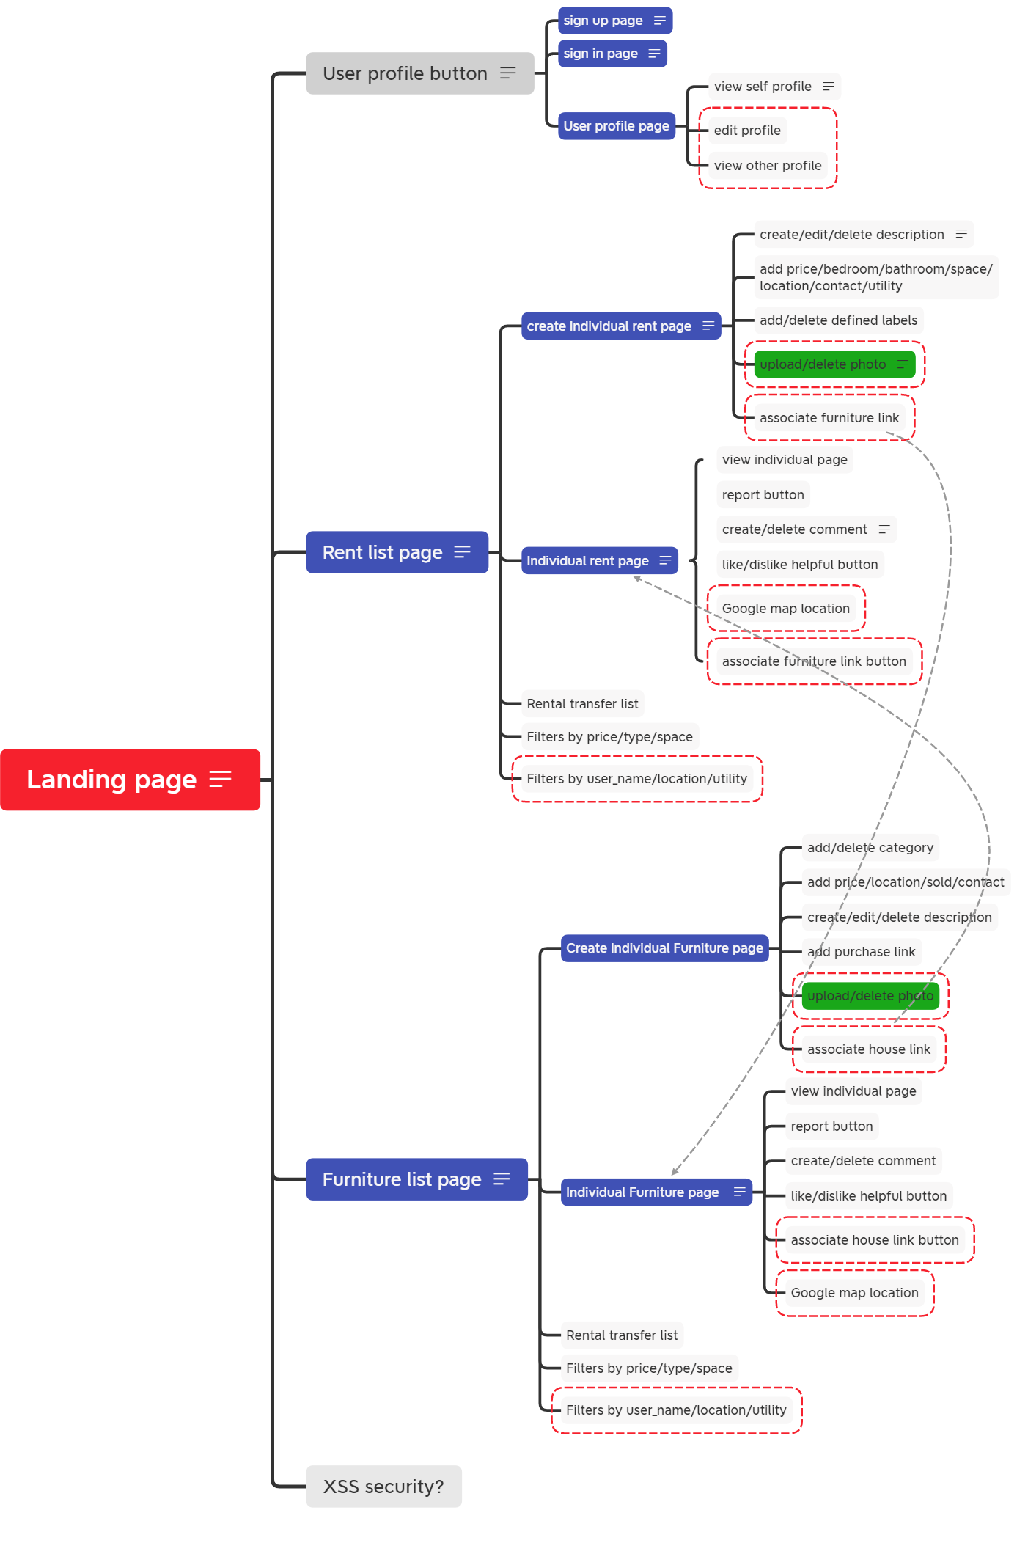

Database Proposal

*Local House Rental & Furniture Exchange*

Wei Yang, Yixuan Wang, Shaobo Li, Jiaqing Wang

Users

The user collection will store all users. Users can create names, usernames, passwords ages, email addresses, etc. In their profile. Users can also post their houses on rent, second-hand goods, and comments. All their posts and comments will be stored in arrays.

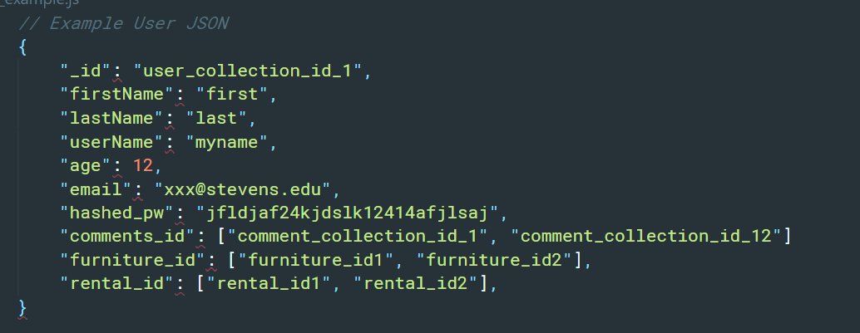

|  |  |  |
| --- | --- | --- |
| **Name** | **Type** | **Description** |
| _id | ObjectId | unique id for each user |
| firstName | String | user first name |
| lastName | String | user last name |
| userName | String | user account name |
| age | Number | user age |
| email | String | user email |
| hashed_pw | String | account password |
| comments_id | Array | array with string type comment id |
| furniture_id | Array | array with string type furniture id |
| rental_id | Array | array with string type rental house id |

Rental House

The rental house collection will contain all the posted rental sublets. Each of the sublets will be related to information about labels, locations, prices, room types, descriptions, photos, utilities, contacts. Comments, likes, dislikes will be updated after users add comments or click on “likes” or “dislikes” button.

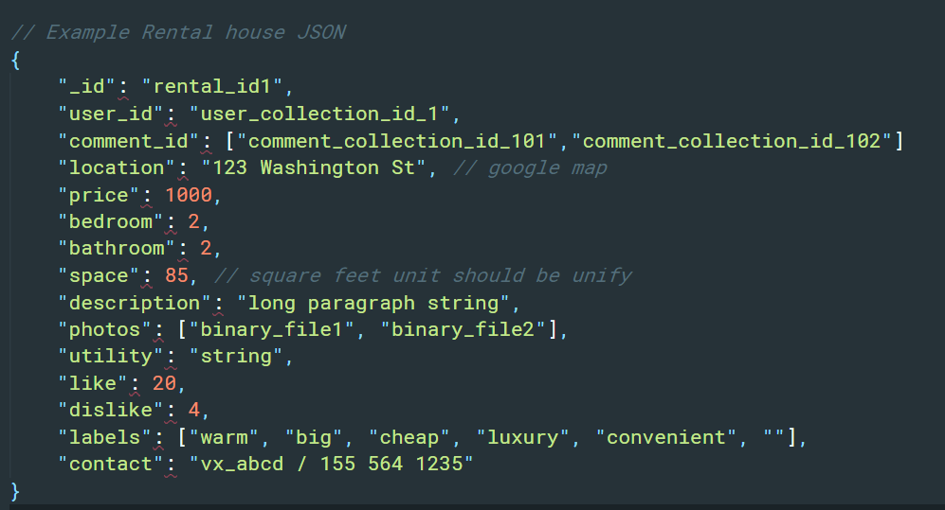

|  |  |  |
| --- | --- | --- |
| **Name** | **Type** | **Description** |
| _id | ObjectId | unique id for each rental house |
| user_id | String | user id |
| comment_id | Array | the array with string type comment id |
| location | String | the address of the rental house |
| price | Number | the monthly price of rental house |
| bedroom | Number | the number of bedrooms |
| bathroom | Number | the number of bathrooms |
| space | Number | the number of room size (sqft) |
| description | String | description of the room or house on rent |
| photos | **Object** | a photo uploaded |
| utility | Array | utilities in the house |
| like | Number | the number of likes |
| dislike | Number | the number of dislikes |
| labels | Array | the array contains strings of labels of the house |
| contact | String | the contact information of the user who sublet the house |

Furniture

The furniture collection will contain all the posted second-hand furniture. Each of the goods will be related to information about categories, prices, locations, descriptions, photos, likes, dislikes, purchase links, contact, and sold or not. Comments, likes, dislikes will be updated after users add comments or click on “likes” or “dislikes” button.

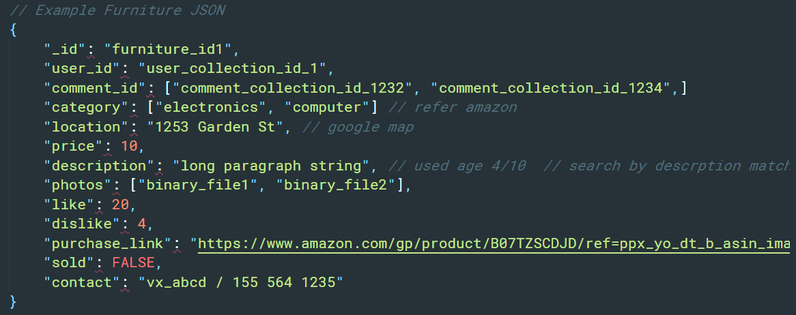

|  |  |  |
| --- | --- | --- |
| **Name** | **Type** | **Description** |
| _id | ObjectId | unique id for each rental house |
| user_id | String | user id |
| comment_id | Array | the array with string type comment id |
| category | Array | an array containing the categories of the goods |
| location | String | the location where to pick up the furniture |
| price | Number | the price of furniture |
| description | String | the description of the furniture |
| photos | **Object** | photos uploaded |
| like | Number | the number of likes |
| dislike | Number | the number of dislikes |
| purchase_link | String | the purchase link of the goods which can show the original price and photos of the goods |
| sold | Boolean | a Boolean which shows whether the furniture is sold |
| contact | String | the contact information of the user who is selling |

Comments

The comments collection will contain all comments posted on individual furniture or individual rent. The comment will be a string. The value of “report_count” will be added by 1 after one user reports the specific comment. After the value of “report_count” reach 50, the comment will be hidden. The value of “helpful_count” will be added by 1 after one user click on the “helpful” button.

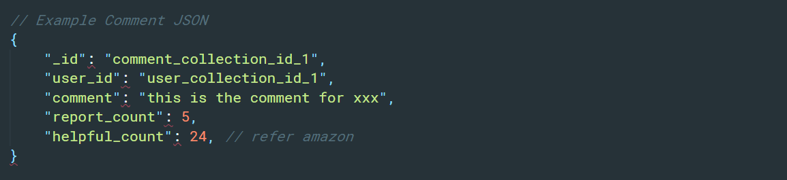

|  |  |  |
| --- | --- | --- |
| **Name** | **Type** | **Description** |
| _id | ObjectId | unique id for each rental house or furniture |
| user_id | String | user id |
| comment | String | User’s comment with this id |
| report_count | Number | the count of reporting flag for this comment |
| helpful_count | Number | the count of helpful flag for this comment |