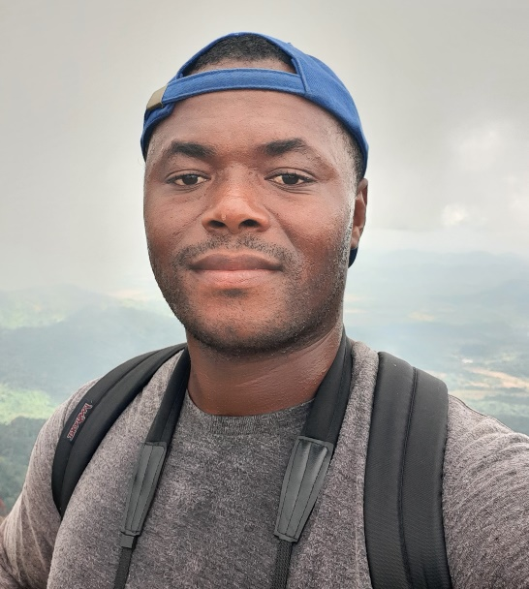

Benedictus (Ben) Freeman is a Liberian conservationist dedicated to protecting his country's rich biodiversity. As a lecturer at the University of Liberia and Coordinator for U.S. Forest Service International Programs and Trade in Liberia, he brings nearly a decade of experience to his work in conservation, research, and capacity building. Ben's cutting-edge research uses ecological niche modeling, GIS, and remote sensing to predict how climate and land-use changes will affect species distribution. His goal is to provide crucial data to inform effective conservation strategies. His research interests span conservation biology, forestry, ornithology, and restoration ecology, with a focus on using biodiversity informatics to drive decision-making. Passionate about both nature and mentorship, Ben is committed to training young conservationists in Liberia. In his free time, you can find him in the garden or out birdwatching. He holds a B.S. from the University of Liberia, an M.S. from the University of Jos, Nigeria, and a Ph.D. from the University of Kansas.

