Tech Stack
Frontend
- React.js
- Vite
- Tailwind CSS
- React Router DOM
- Axios
- Context API or Redux Toolkit
- Framer Motion
- React Icons
- React Hot Toast
Backend
- Node.js
- Express.js
- MongoDB
- Mongoose
- JWT Authentication
- bcryptjs
- dotenv
- cors
- cookie-parser
- multer (optional)
Database
- MongoDB Atlas
Deployment
- Frontend → Vercel / Netlify
- Backend → Render / Railway
- Database → MongoDB Atlas

DEVELOPMENT PHASES
Guide me through ALL phases.
Phase 1 – Planning
- Requirements gathering
- Feature planning
- System architecture
- Database planning
- UI planning
Phase 2 – Environment Setup
- Install Node.js
- Install VS Code extensions
- Create React app using Vite
- Setup backend
- Setup MongoDB Atlas
- Connect database
Phase 3 – Backend Development
- Express server
- MongoDB connection
- Authentication
- JWT setup
- Middleware
- API routes
- Controllers
- CRUD operations
- Error handling
Phase 4 – Frontend Development
- Tailwind setup
- Navbar
- Hero section
- Authentication pages
- Dashboard pages
- Menu cards
- Cart system
- Order pages
- Admin panel
- Vendor dashboard
Phase 5 – Integration
- Connect frontend to backend
- Axios configuration
- Authentication flow
- Protected routes
- API integration
Phase 6 – Advanced Features
- Charts
- Analytics
- Dark mode
- Search and filtering
- Pagination
- Notifications
- Image upload
- Performance optimization
Phase 7 – Testing
- API testing
- Frontend testing
- Bug fixing
- Responsive testing
Phase 8 – Deployment
- Deploy backend
- Deploy frontend
- Environment variables
- Production setup
Phase 9 – Documentation
- README
- API documentation
- Project report
- Viva preparation

AUTHENTICATION REQUIREMENTS
Implement:
- JWT Authentication
- Password hashing with bcrypt
- Role-based authentication
- Protected routes
- Middleware authorization
- Secure token handling
- Login persistence
Roles:
- student
- vendor
- admin

PROFESSIONAL UI COMPONENTS
Create:
- Responsive Navbar
- Sidebar
- Hero Section
- Food Cards
- Dashboard Cards
- Stats Cards
- Order Tables
- Forms
- Modals
- Loaders
- Empty States
- Charts
- Footer

DASHBOARD REQUIREMENTS
Student Dashboard
- My Orders
- Current Orders
- Payment Status
- Favorite Meals
- Profile Settings
Vendor Dashboard
- Add Menu
- Manage Menu
- View Orders
- Analytics
- Revenue Stats
Admin Dashboard
- Total Orders
- Total Students
- Total Vendors
- Revenue Graphs
- User Management

📋 PHASE 1 – PROJECT PLANNING
Step 1.1 – Understanding What We Are Building
🎯 What is Campus Mess Food System?
Imagine your university has a food mess/cafeteria. Currently students:
- Stand in long queues
- Don't know what food is available today
- Can't pre-order their meals
- Waste time and money
Our system solves ALL of these problems digitally.
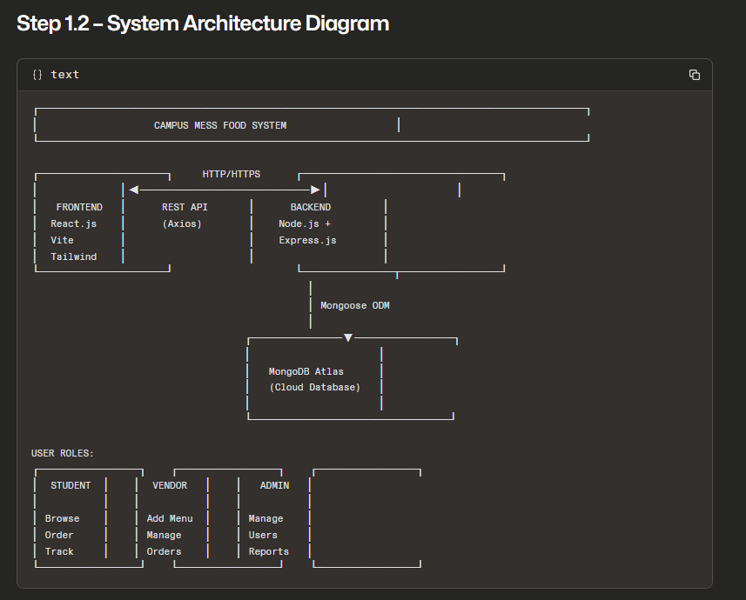

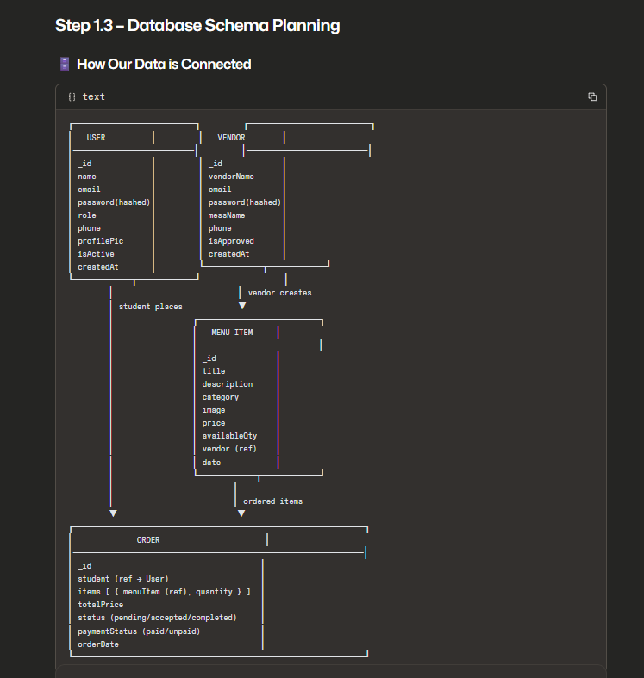

API ENDPOINT PLANNING:
