How to create a support ticket?

## Objective

This document will give you an overview of helpdesk functionality and its Use case.

**Step 1:** After logging into the application, hover over the question mark icon at the top right next to the language dropdown list and click **Help Desk**.

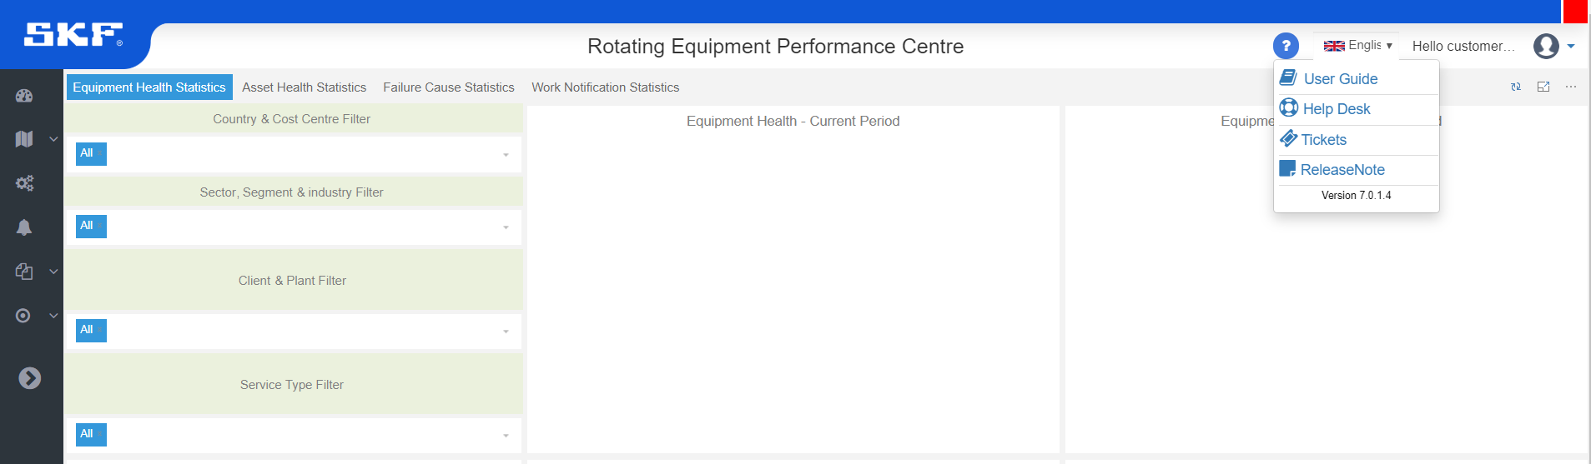

Click here to open Helpdesk

**Step 2:** Now the **Help Desk** screen will pop-up on screen.

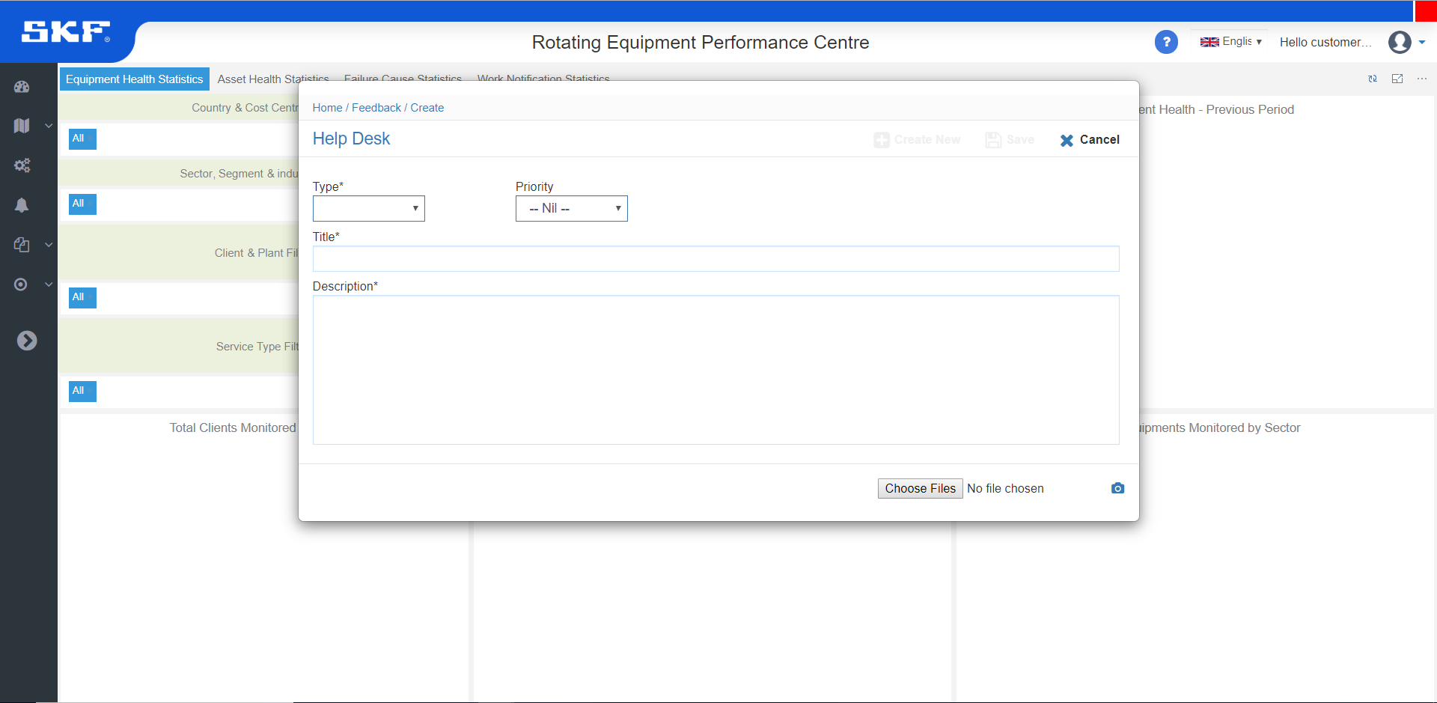

Choose the Request Type as either **Bug/Issue or New Request/Enhancement.**

Capture screenshot of current screen in the background.

Attach file from local System.

Enter detailed description of the ticket.

Provide Title here.

Set priority for the ticket as **High, Medium or Low.**

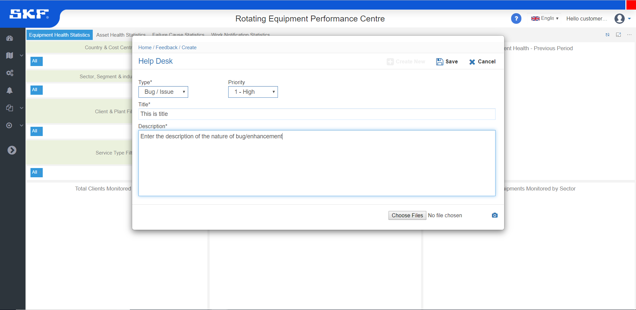

Save the ticket.

**Step 3:** Once you have filled the required data and have saved the ticket, it will be notified to the support team followed with a Unique Reference Number to track the status.

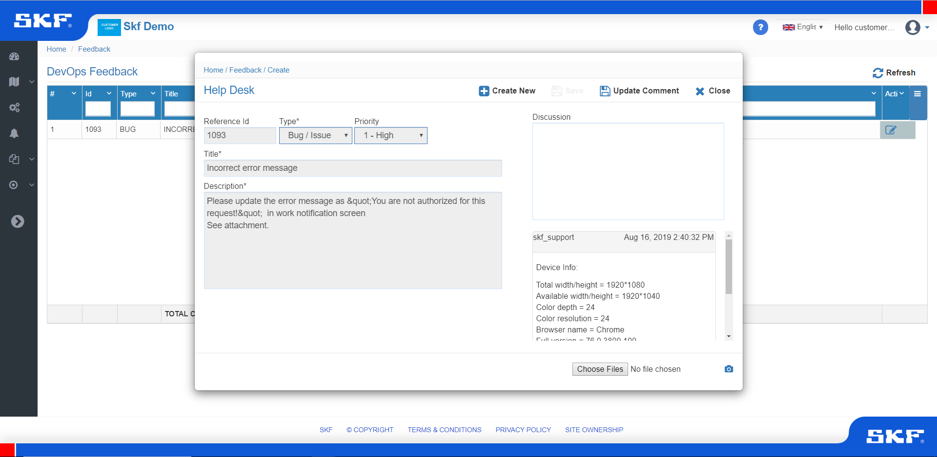

Reference Id will be the unique Helpdesk Id for tracking

Further, you can discuss with Support Team

Click here to Raise New Ticket

Update comment/ upload attachments if required at any phase and click here to update your ticket.

**Step 4:** Hover over the question mark icon at the top right next to the language dropdown list and click **Tickets**.

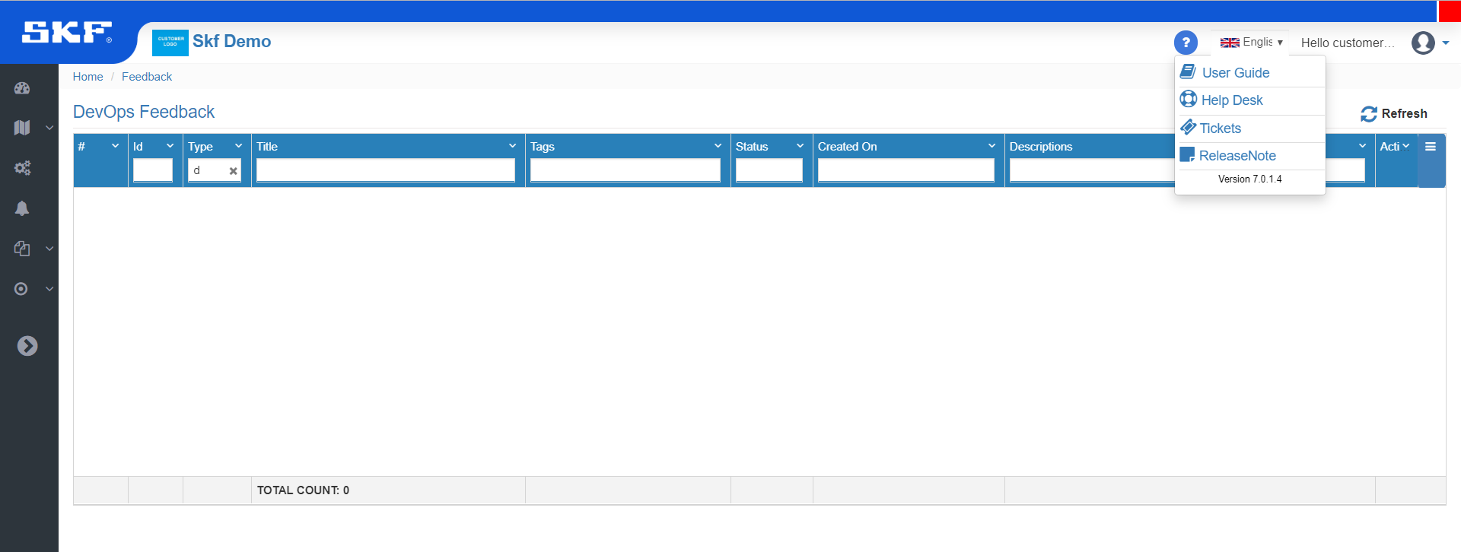

Click here to view your Tickets.

Click edit and update Comment / Discussion if required.

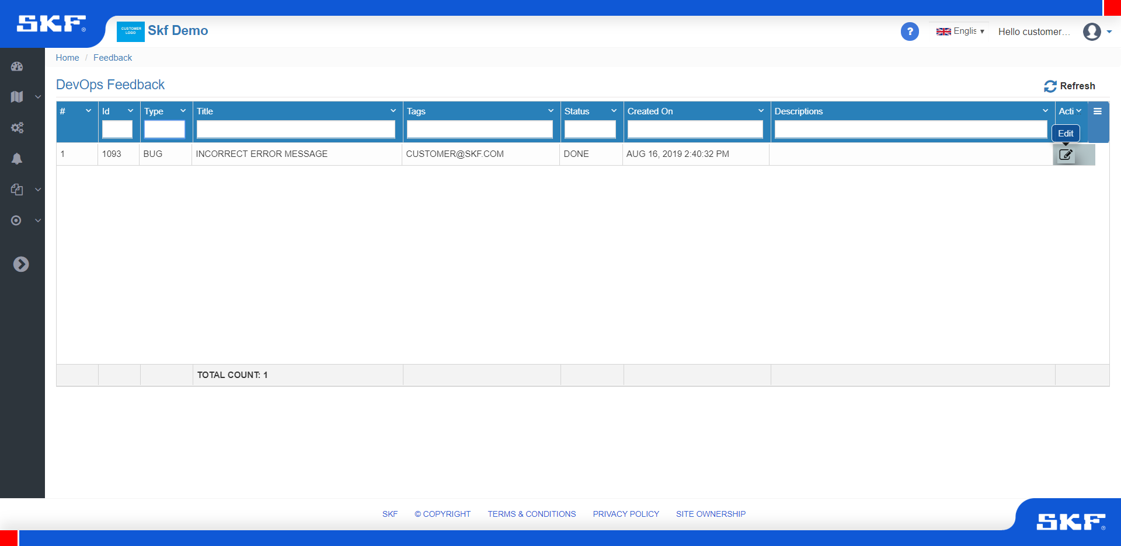

Click here to view in detail or update the comments.

Refresh to see the updated status and comments.

List of raised tickets and its present status.

# Step 5: In ProjectManagementTool, the support team will receive the posted Help Desk Tickets. Further, if any clarification required, the team will update their comments in discussion and it will reflect in eMaintenance system for the user to respond/clarify.

# 