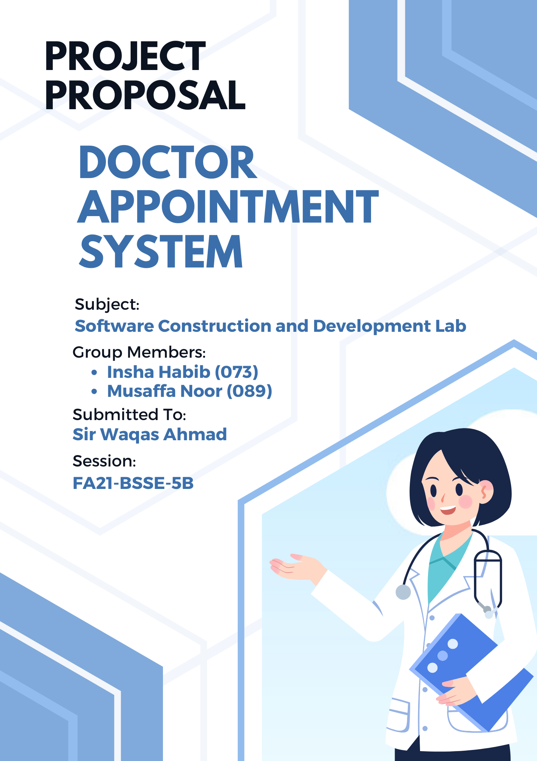**Introduction / Background:**

**Introduction / Background:**

In an era of rapidly advancing technology and an ever-growing demand for accessible healthcare services, I am delighted to introduce a revolutionary solution that will transform the way patients and healthcare providers engage with the process of scheduling medical appointments.

Healthcare is a fundamental aspect of our lives, and the ability to access timely medical care is critical to overall well-being. Traditional methods of appointment scheduling in the healthcare industry have often been marked by inefficiencies, long waiting times, and administrative complexities. Patients, doctors, and administrative staff have grappled with the challenges of managing appointments through manual processes, phone calls, and paperwork.

**Problem Statement:**

The traditional approach to appointment scheduling often relies on manual, time-consuming processes that result in long wait times for patients. This inefficiency can lead to delayed access to medical care and decreased patient satisfaction.

**Business Objectives and Preliminary Requirements**

* **Business Objectives:**
* Enhance Patient Experience.
* Improve Resource Utilization.
* Reduce No-Show Rates.
* Ensure Data Security and Compliance.
* Facilitate Effective Communication.
* **Preliminary Requirements:**
* User-friendly appointment scheduling.
* Seamless integration with existing systems.
* Robust data security measures.
* Cost transparency for patients.
* Flexible appointment booking options.

**Current Situation and Opportunity Statement**

* **Current Situation:**
* Manual and inefficient appointment scheduling.
* High no-show rates and patient dissatisfaction.
* Limited data analysis capabilities.
* **Opportunity Statement:**
* Develop an efficient Doctor-Appointment System.
* Enhance patient experience and resource utilization.
* Reduce no-show rates and ensure data security.
* Enable effective communication and patient-centered care.

**Options and Recommendations:**

1. **Options Considered**

In developing the Doctor-Appointment System, we carefully evaluated several options to address the challenges in healthcare appointment scheduling. Each option was assessed based on its feasibility, effectiveness, and alignment with our business objectives. The following options were considered:

* **Current Situation**
* **Description:** Maintaining the current manual and paper-based appointment scheduling processes without introducing any technological solutions.
* **Evaluation:** This option would perpetuate the existing inefficiencies and challenges, failing to address the identified problems effectively.
* **Hybrid Solution (Combining Existing Solutions)**
* **Description:** Combining existing scheduling software with some custom development to address specific requirements.
* **Evaluation:** This hybrid approach offers a balance between customization and existing solutions but may result in integration challenges and limited flexibility.
* **Custom In-House Development**
* **Description:** Developing a custom appointment scheduling system in-house.
* **Evaluation:** This option provides the flexibility to tailor the system to our exact needs and objectives, offering the highest level of control and customization.

**2. Recommended Solution**

After a comprehensive evaluation of the options, we firmly recommend the development of a custom in-house Doctor-Appointment System as the most effective and strategic solution to address the identified problems and achieve our business objectives. This approach offers several key advantages:

* **Tailored to Our Needs:** A custom solution allows us to design the system precisely to meet our unique requirements, including the integration of cost transparency for patients, which aligns with our commitment to patient-centric care.
* **Integration Capabilities:** We can seamlessly integrate the system with existing healthcare management systems, ensuring a unified view of patient information and streamlined operations.
* **Data Security:** With full control over the development process, we can implement robust data security measures, ensuring strict compliance with healthcare regulations and safeguarding patient data.
* **Flexibility:** Custom development provides the flexibility to adapt and evolve the system as our needs change, accommodating technological advancements and the evolving healthcare landscape.
* **Alignment with Business Objectives:** The custom solution perfectly aligns with our business objectives of enhancing the patient experience, improving resource allocation, reducing no-show rates, ensuring data security and compliance, enabling effective communication, supporting patient-centered care, and providing valuable data-driven insights.

**Schedule Estimate:**

The project's estimated completion time aligns with the end of the semester, as we work diligently to meet the various class requirements while delivering a high-quality Doctor-Appointment System.

**Potential Risks and Mitigation Plan:**

* **Technical Complexity**
* **Risk:** Possible technical challenges.
* **Mitigation:** Conduct technical feasibility analysis and allocate time for research and prototyping.
* **Resource Constraints**
* **Risk:** Insufficient skilled resources.
* **Mitigation:** Ensure access to necessary resources and explore outsourcing options if needed.
* **Scope Management**
* **Risk:** Scope expansion.
* **Mitigation:** Maintain scope documentation, and assess changes carefully.