Omkar Masur
180905330
DS Lab End Sem

Q1)
Write a socket program in python using TCP :Client should send a number to the server. Server should find the sumof even digitsand return the result to the client.

client.py:
import socket

number = int(input('Enter number to send '))

server_address=('127.0.0.1',8000)

client_sock =socket.socket(socket.AF_INET,socket.SOCK_STREAM)

client_sock.connect(server_address)

client_sock.send(str(number).encode())

data=client_sock.recv(1024)

data=data.decode()

print(f'Recieved {data} from server')

server.py:
import socket

def find_sum(number:str)->int:
sum =0
for digit in number:
digit=int(digit)
if digit%2==0:
sum+=digit

return sum

address=('127.0.0.1',8000)

server_sock=socket.socket(socket.AF_INET,socket.SOCK_STREAM)

server_sock.bind(address)

print(f'Server started at {address}')

server_sock.listen(1)

try:
while True:
acc_socket,addr=server_sock.accept()
message=acc_socket.recv(1024)

print(f'Received {message.decode()} from {addr}')

num=message.decode()
sum=find_sum(num)

acc_socket.send(str(sum).encode())

except KeyboardInterrupt:
print('\nClosing server')
server_sock.close()

Logic Used:

Client is a normal client which is making a TCP Connection to the server and waiting for a reply from the server

Server is binding to address 127.0.0.1:8000 and accepting connections on the same through TCP connections. When it accepts a connection, it accepts the data it has received. The function find_sum(number:str) accepts a number in the string format and return an integer which is the desired sum. It computes the sum of all the digits which are even.

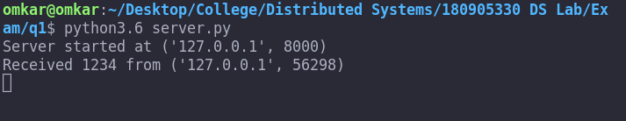
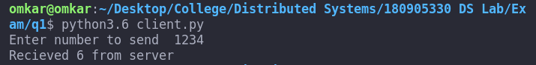

Q2)
Write a map reduce program that returns the total numberof confirmedCovid casesfor each Country/ Regionin the dataset covid_data_lab_ds.csv

mapper.py:

import pandas as pd
import numpy as np

df=pd.read_csv('covid_data_lab_ds.csv')

#Data Preprocessing
df=df.drop(labels=['SNo','ObservationDate','Province/State','Last Update','Deaths','Recovered'],axis=1)

df.dropna(inplace=True)

#Mapping
for index,row in df.iterrows():
print(f"{row['Country/Region']}\t{int(row['Confirmed'])}")

reduce.py:

import sys

import sys
mappings= {}

for data in sys.stdin:

country,count = data.strip().split('\t')
count =int(count)
mappings[country] = mappings.get(country,0)+count

for country,count in mappings.items():
print(f"{country}\t{count}")

Logic used:

In the mapper function, I am first reading the csv file into a dataframe using pandas. Then i am preprocessing the data by first dropping all columns which are not required and then dropping all NaN rows.

In the reducer, I am computing the sum of all ‘Confirmed’ based on the ‘Country/Region’.

