**CSE 3330 – 004 (Project 2 – Part 3)**

**GROUP 14 (Araohat Kokate, Inshaad Merchant , Athrva Arora)**

**HONOR CODE-**

I pledge, on my honor, to uphold UT Arlington's tradition of academic integrity, a tradition that values hard work and honest effort in the pursuit of academic excellence.

I promise that I will submit only work that I personally create or that I contribute to group collaborations, and I will appropriately reference any work from other sources. I will follow the highest standards of integrity and uphold the spirit of the Honor Code

**TASK1:** We are using view.sql file for displaying the given tables.

view.sql –

.headers on

.mode column

SELECT * FROM BOOK_LOANS ;

Query 1:

ALTER TABLE BOOK_LOANS

ADD COLUMN Late INT;

UPDATE BOOK_LOANS

SET Late = CASE

    WHEN Returned_Date IS NULL OR Due_Date IS NULL THEN NULL

    WHEN Returned_Date > Due_Date THEN 1

    WHEN Returned_Date > Due_Date THEN 1

    ELSE 0

END;

Output :

view.sql –

.headers on

.mode column

SELECT * FROM LIBRARY_BRANCH ;

Query2:

ALTER TABLE LIBRARY_BRANCH

ADD COLUMN LateFee INT;

UPDATE LIBRARY_BRANCH

SET LateFee = CASE

    WHEN Branch_id = 1 THEN 1

    WHEN Branch_id = 2 THEN 2

    WHEN Branch_id = 3 THEN 3

    WHEN Branch_id = 4 THEN 4

    WHEN Branch_id = 5 THEN 5

    ELSE 0

END;

Output:

view.sql –

.headers on

.mode column

SELECT * FROM vBookLoanInfo ;

Query3:

DROP VIEW IF EXISTS vBookLoanInfo;

CREATE VIEW vBookLoanInfo AS

SELECT

    bl.Card_no,

    b.Name AS "Borrower Name",

    bl.Date_out,

    bl.Due_Date,

    bl.Returned_date,

    CAST((julianday(bl.Returned_date) - julianday(bl.Date_out)) AS INTEGER) AS TotalDays,

    bo.Title AS "Book Title",

    ba.Book_id,

    CASE

        WHEN bl.Returned_date <= bl.Due_Date THEN 0

        ELSE CAST((julianday(bl.Returned_date) - julianday(bl.Due_Date)) AS INTEGER)

    END AS "Number of days returned late",

    bl.Branch_id,

    CASE

        WHEN bl.Returned_date <= bl.Due_Date THEN 0

        ELSE CAST((julianday(bl.Returned_date) - julianday(bl.Due_Date)) AS INTEGER) * lb.LateFee

    END AS LateFeeBalance

FROM

    BOOK_LOANS bl

JOIN BORROWER b ON bl.Card_no = b.Card_no

JOIN BOOK bo ON bl.Book_id = bo.Book_id

JOIN BOOK_AUTHORS ba ON bo.Book_id = ba.Book_id

JOIN LIBRARY_BRANCH lb ON bl.Branch_id = lb.Branch_id;

Output:

**TASK 2:**

1. **Query 1**

Editable Queries Used :

SELECT B.Book_id, B.Title, COUNT(BC.no_of_copies) AS per_Book_copies, BC.Branch_Id

        FROM BOOK_COPIES as BC

        INNER JOIN BOOK as B ON B.Book_id = BC.Book_id

        GROUP BY B.Book_id, BC.Branch_Id

Explanation –

There are total of 3 copies of Book with Book_id – 1 at the Branch_id – 1 and when we checkout one of the copies and it gives us the remaining number of copies :2 as the output.

1. **Query 2**

Editable Queries Used:

"INSERT INTO BORROWER(Name, address, phone) VALUES (:Name, :address, :phone)",

                   {

                       'Name': name.get(),

                       'address': addr.get(),

                       'phone': phone.get()

                   }

Output:

Explanation:

Since Card_no is Autoincremented when we add a borrower with no Card_no it will automatically assign it a new Card_no which will be one greater than the Highest Card_no value.

1. **Query 3**

Editable Queries Used:

'INSERT INTO BOOK (Title, Publisher_Name) VALUES (?, ?)', (book_title_t, publisher_name_t)

'INSERT INTO BOOK_AUTHORS (Book_Id, Author_Name) VALUES (?, ?)', (book_id, author_name_t)

'INSERT INTO BOOK_COPIES (Book_Id, Branch_Id, no_of_copies) VALUES (?, ?, ?)', (book_id, i, 5)

Output:

Explanation:

It can be confirmed from the table BOOK in lms.db that the entry was added.

1. **Query 4**

Editable SQL Queries –

SELECT Branch_Name, COUNT(*) FROM BOOK_LOANS as BL,LIBRARY_BRANCH as LB, BOOK as B WHERE BL.Branch_id = LB.Branch_id AND BL.Book_id = B.Book_id AND Title like ? GROUP BY Branch_name",(t,)

Output:

Explanation:

There is only 1 book at branch “Main Branch” of the book named 1984 it can also be seen in BOOK_LOANS Table as well.

1. **Query 5**

Editable SQL Query-

SELECT Book_id, Branch_id, Card_No, Date_Out, Due_Date, Returned_date, CAST(JULIANDAY(Returned_date) AS INTEGER) - CAST(JULIANDAY(Due_Date)AS INTEGER) AS num_days_late FROM BOOK_LOANS WHERE Late = '1' AND (Due_Date < ? AND   Due_Date > ?) "

Output-

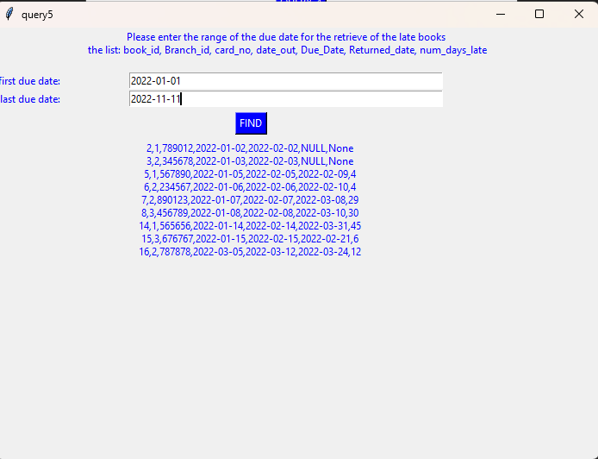

Explanation-

There are a total of 9 Books that have Due Dates between “2022-01-01” and “2022-11-11” and the attributes Book_id, Branch_id, Card_No, Date_Out, Due_Date, Returned_date and Number of Days Late have been listed in the above output.

1. Query 6a –

Editable Sql Query-

When Both Borrower_id and Name is Entered:

"SELECT DISTINCT vBookLoanInfo.Card_no, BORROWER.Name, IFNULL(LateFeeBalance, 0) "

"FROM vBookLoanInfo "

"LEFT JOIN BORROWER ON vBookLoanInfo.Card_no = BORROWER.Card_no "

"WHERE vBookLoanInfo.Card_no = ? AND BORROWER.Name LIKE '%'||?||'%'"

When Just Borrower_id is entered:

"SELECT DISTINCT vBookLoanInfo.Card_no, BORROWER.Name, IFNULL(LateFeeBalance, 0) "

"FROM vBookLoanInfo "

"LEFT JOIN BORROWER ON vBookLoanInfo.Card_no = BORROWER.Card_no "

"WHERE vBookLoanInfo.Card_no = ?"

When Just Name is entered:

"SELECT DISTINCT vBookLoanInfo.Card_no, BORROWER.Name, IFNULL(LateFeeBalance, 0) "

"FROM BORROWER "

"LEFT JOIN vBookLoanInfo ON BORROWER.Card_no = vBookLoanInfo.Card_no "

"WHERE BORROWER.Name LIKE '%'||?||'%'"

When Nothing is Entered:

"SELECT DISTINCT vBookLoanInfo.Card_no, BORROWER.Name, IFNULL(LateFeeBalance, 0) "

"FROM vBookLoanInfo "

"LEFT JOIN BORROWER ON vBookLoanInfo.Card_no = BORROWER.Card_no "

"ORDER BY LateFeeBalance DESC"

Output –

When Nothing is Entered:

When Just Name is entered:

When Just Borrower_id is entered:

When Both Borrower_id and Name is Entered:

1. Query 6b-

Editable Query –

"SELECT v.Card_no, BORROWER.name, b.Title, "

"CASE WHEN LateFeeBalance IS NULL THEN 'Non-Applicable' "

"ELSE '$' || printf('%.2f', LateFeeBalance) END AS LateFeeBalance "

"FROM vBookLoanInfo v "

"JOIN BOOK b ON v.Book_id = b.Book_id "

"JOIN BORROWER ON v.Card_no = BORROWER.Card_no "

"WHERE v.Card_no = ? OR v.Book_id = ? OR b.Title LIKE '%' || ? || '%' "

"ORDER BY LateFeeBalance DESC",

(borrower_id, book_info, book_info)

Output –

When Nothing is Entered -

When Partial Name is Entered with Borrower Id–

When Book_id is Entered with Borrower Id-

**TEAM CONTRIBUTIONS**

1. GUI Frontend- Inshaad Merchant
2. GUI Backend- Athrva Arora and Araohat Kokate
3. Task 1 –
4. Query1- Inshaad Merchant
5. Query2- Araohat Kokate
6. Query3- Athrva Arora
7. Task 2 –
8. Query 1- Inshaad Merchant
9. Query 2- Araohat Kokate
10. Query 3- Athrva Arora
11. Query 4- Inshaad Merchant
12. Query 5- Araohat Kokate
13. Query 6- Athrva Arora and Inshaad Merchant and Araohat Kokate
14. README – Athrva Arora
15. Report - Athrva Arora and Araohat Kokate