

**AI-B(24)**

**ICAT PROJECT**

**AI Powered E-Com Website**

|  |
| --- |
| Members: |
| Ismail Shah |
| Muhammad Rehan |
| Muhammad Moeen |
| Muhammad Inshal Rabbani |
| Muhammad Anas |

## AI Powered E-Com Website Documentation

## Introduction

This website is an advanced e-commerce platform designed for seamless online shopping. It integrates AI chatbot support to assist users and ensure smooth navigation.

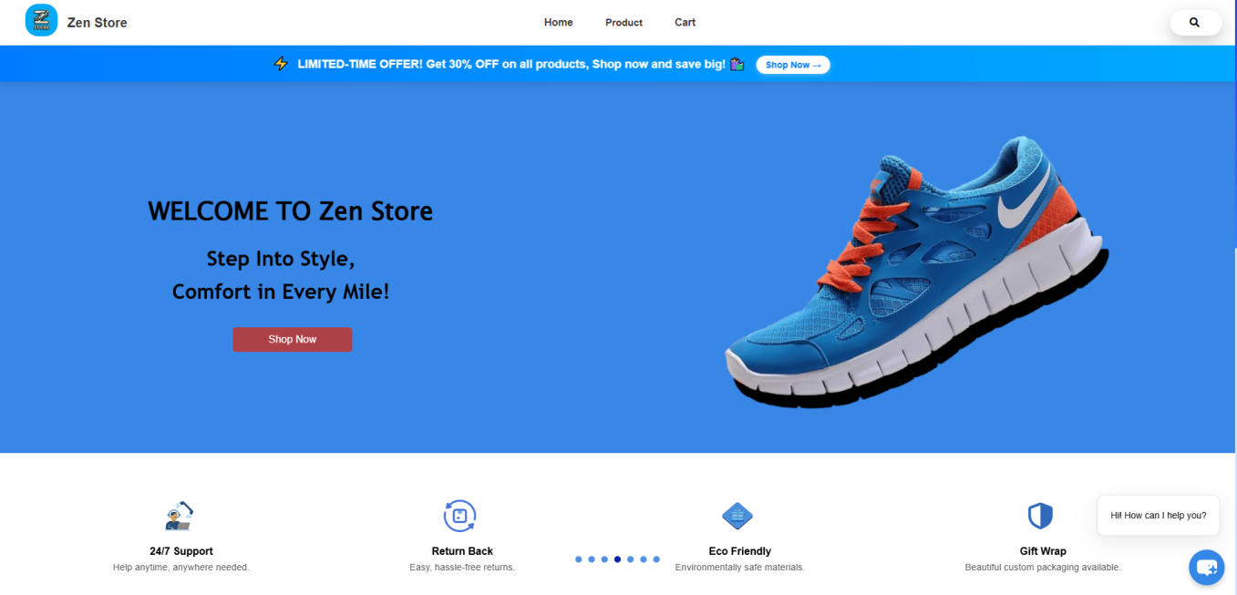

Website Structure and Flow

The website consists of multiple pages for product browsing, user authentication, checkout, and an admin dashboard.

Webpages in Your Website

1. Home Page (01.home.html)

2. Product Pages (Dynamic)

* 02.men.html – Displays men's products.
* 02.women.html – Displays women's products.
* 02.sports.html – Displays sports-related products.
* 02_p_description.html – Product description page, possibly dynamically generated for different products.

3. Shopping Cart & Checkout

* 03.cart.html – Shows selected products before purchase.
* 07.checkout.html – Handles the final purchasing process.

4. User Authentication

* 05.login.html – User login page.
* 06.signup.html – User registration page.

5. User Profile

* 08.profile.html – User profile page, possibly displaying personal details.

6. Admin

* admin.html -- payment accepted or rejected by Admin.

7. Order summary

* thankyou.html-- Display order receipt.

## Flow-Charts

### User Navigation Flowchart

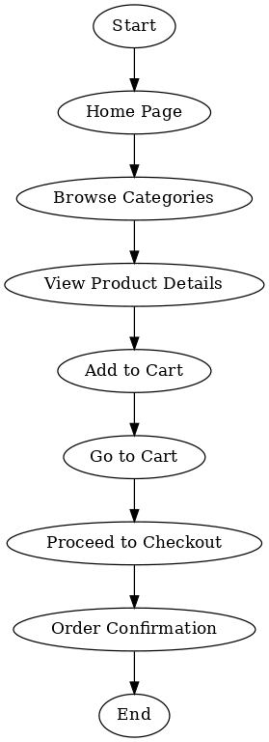

* Authentication Flowchart

This flowchart explains the authentication flowchart.

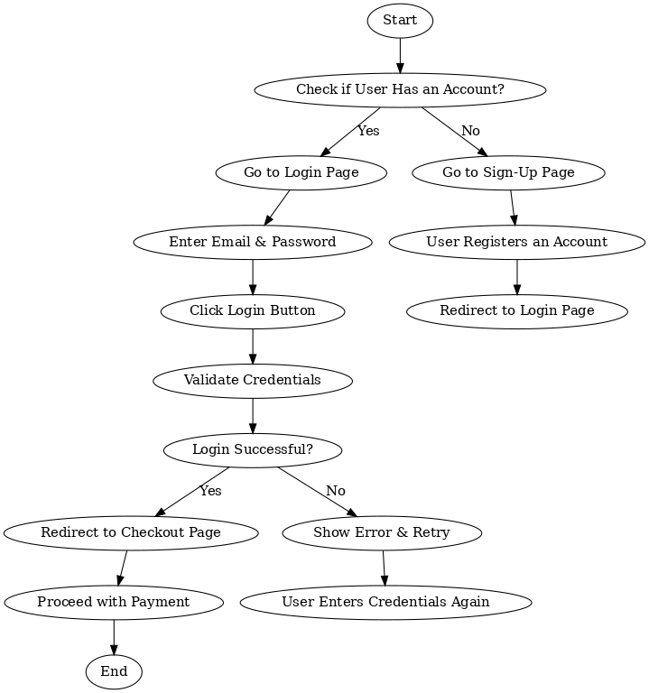

### Shopping & Checkout Flowchart

This flowchart explains the shopping

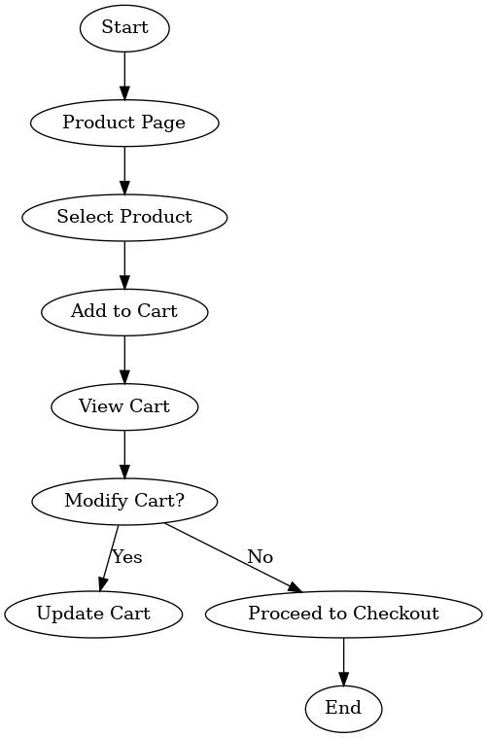

### Chatbot Interaction Flowchart

This flowchart explains the chatbot interaction flowchart.

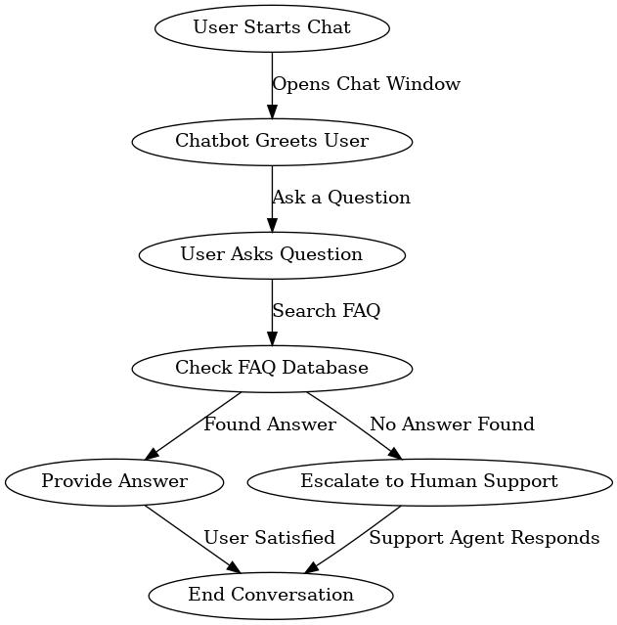

### Admin Panel Flowchart

This flowchart explains the Admin panel flowchart.

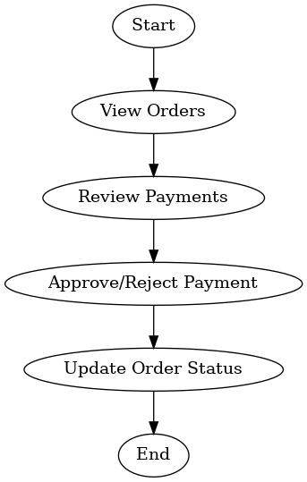

## AI Technology Used

The website includes an AI-powered chatbot that uses Natural Language Processing (NLP) to understand user queries and provide appropriate responses.

Purpose of the website

The primary purpose of our website is to simplify online shopping with a user-friendly interface and AI-assisted support.

## Project Tools

The project is developed using the following tools:

• HTML, CSS, JavaScript – For building the website structure and design.

• AI Chatbot (Integrated from Chatbase.co) – Helps users with queries and navigation.

Algorithms Used

• User Authentication Algorithm – Validates login credentials before granting access.

• Shopping Cart Algorithm – Calculates product prices, and processes orders.

• Chatbot Algorithm – Searches for answers in a database and escalates to human support if needed.

Libraries Used

• Bootstrap – Provides a responsive layout.

• NLP Library – Enables the chatbot to understand and respond to users effectively.

## **Literature Review (Existing Work)**

Many **popular e-commerce platforms**, such as **Amazon, Shopify, and eBay**, have implemented AI-driven features to enhance user experience. AI is used in various aspects of online shopping, including:

* **Personalized Recommendations:**
  + Platforms like **Amazon and Netflix** use AI to analyze user preferences and suggest products or content.
* **Chatbots for Customer Support:**
  + Companies like **H&M and Sephora** have AI-driven chatbots to handle customer inquiries, reducing the need for human support.
* **Smart Search Algorithms:**
  + AI-powered search engines improve product discoverability through advanced filters and image recognition.

This project incorporates these AI-driven methodologies, **adapting them to a dynamic e-commerce setting with a user-friendly, interactive chatbot and a streamlined shopping experience.**

## **Future Work**

While the current version of the AI-powered e-commerce website is functional, several improvements can enhance its capabilities:

1. **Advanced AI Chatbot Capabilities:**
   * Implement **machine learning-based recommendations** to personalize user experiences even further.
2. **Augmented Reality (AR) Shopping:**
   * Allow users to **visualize products in real life** before making a purchase.
3. **Blockchain-Based Secure Payments:**
   * Introduce **cryptocurrency payments** and **blockchain verification** for added security.
4. **Voice Search Integration:**
   * Enable users to search for products using **voice commands** instead of typing.
5. **AI-Powered Fraud Detection:**
   * Implement fraud detection systems to **identify suspicious transactions and prevent fraud**.

### **Conclusion**

This **AI-powered e-commerce website** is a **step toward the future** of online shopping, where artificial intelligence plays a crucial role in enhancing customer interactions. With **real-time chatbot support, recommendations from chat bot, and a streamlined shopping experience**, this project lays the foundation for a more **efficient and intelligent e-commerce platform**. Future enhancements such as **voice search, AR shopping, and blockchain payments** will further improve the system, making it a **cutting-edge solution** in the e-commerce industry.