

ASSIGNMENT 1

Name: Inshal Zafar
Roll No: SP23-BDS-021
Course: Topics in Cloud Computing (DevOps)
Submitted to: Qasim Malik
Submission Date: 14th March 2026

Assignment Title
Deployment of a Flask Web Application using AWS EC2 and Elastic Beanstalk

Introduction
This assignment demonstrates how a web application can be deployed on cloud infrastructure using Amazon Web Services (AWS). The project used a Flask based tourism website called 'Tourism Explorer'. The application was deployed using two different cloud service models: Infrastructure as a Service (IaaS) using EC2 and Platform as a Service (PaaS) using Elastic Beanstalk.

Technologies Used
• Python
• Flask Framework
• HTML Templates
• AWS EC2
• AWS Elastic Beanstalk
• Amazon S3

PART 1 – Deployment using EC2 (IaaS)

Step 1: Launch EC2 Instance
An EC2 instance was launched from AWS console using a t3.micro instance.
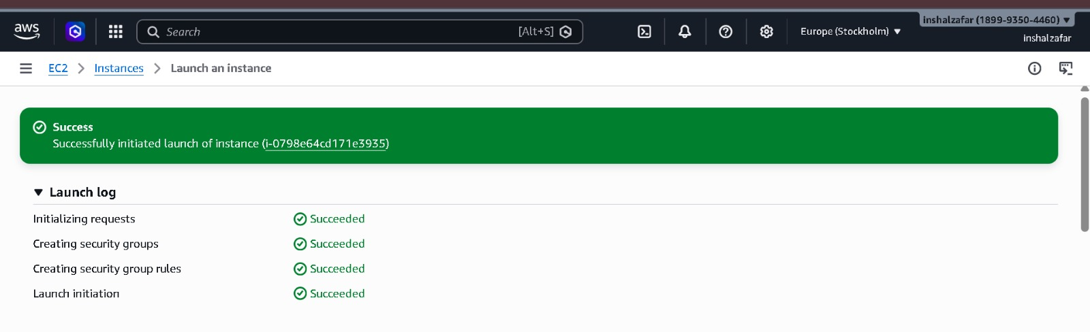

Step 2: Connect to Instance
The instance was connected using SSH and the .pem key file.
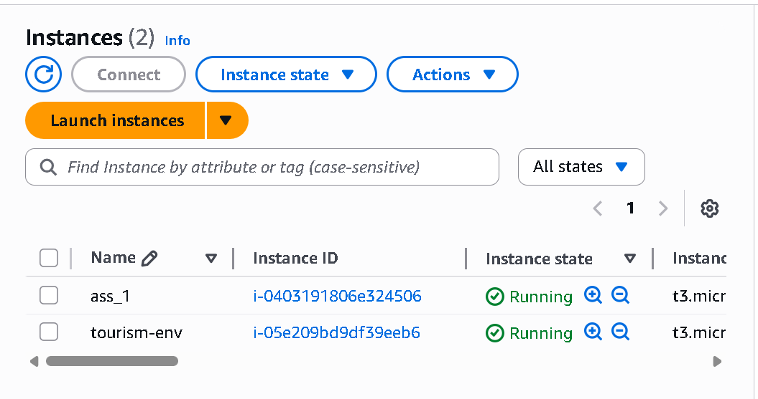

Step 3: Install Dependencies
Python, pip and required Flask libraries were installed on the server.
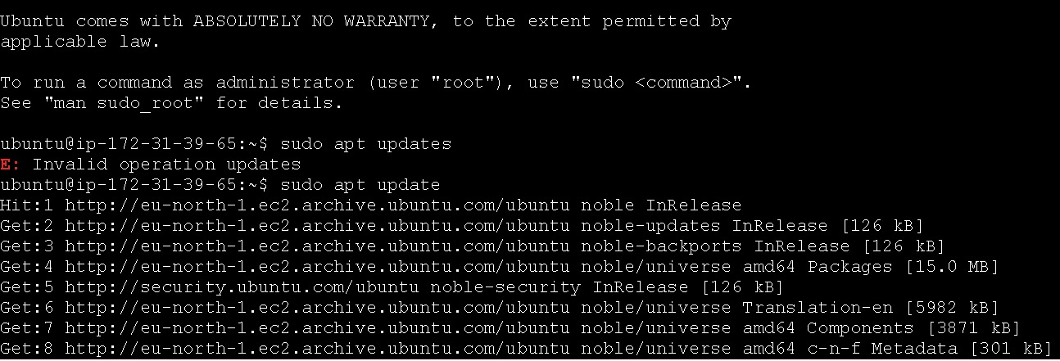

Step 4: Run Flask Application
The application was started and accessed using the EC2 public IP address.
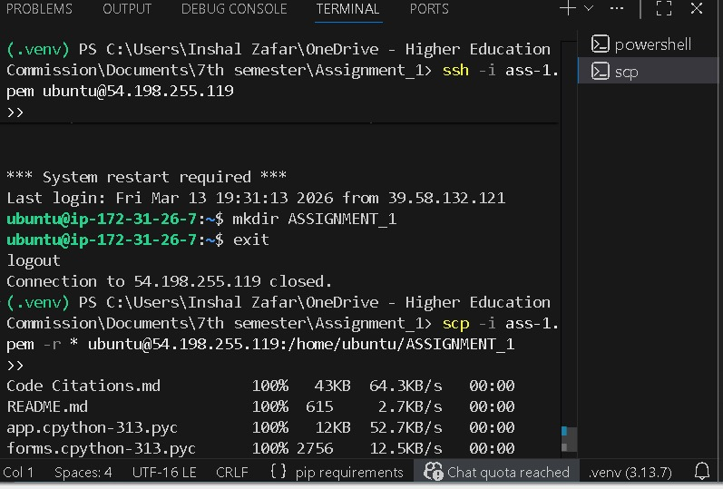
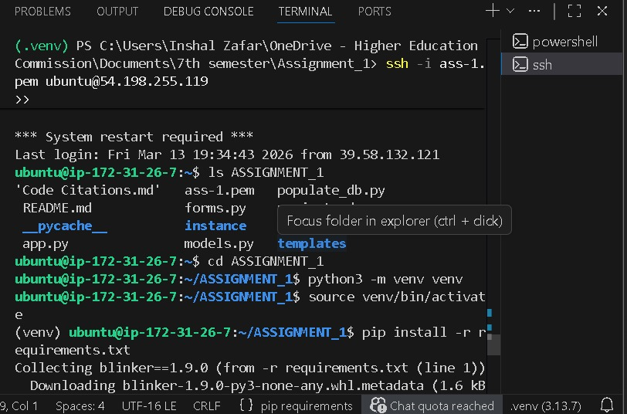
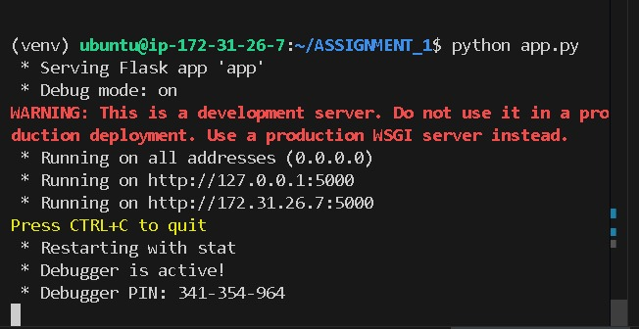


PART 2 – Deployment using Elastic Beanstalk (PaaS)

Step 1: Prepare Project Files
The Flask project was prepared with the required files including requirements.txt and Procfile. All project files were compressed into a ZIP archive.
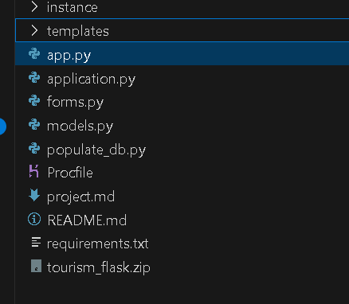

Step 2: Create Elastic Beanstalk Environment AND S3 Bucket
A new Elastic Beanstalk environment was created using the Python platform. The environment automatically created the EC2 instance and configured the server.
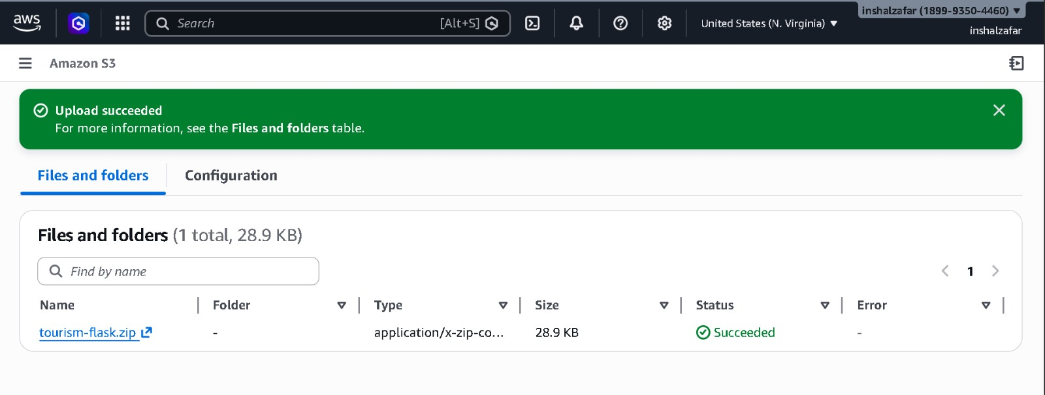
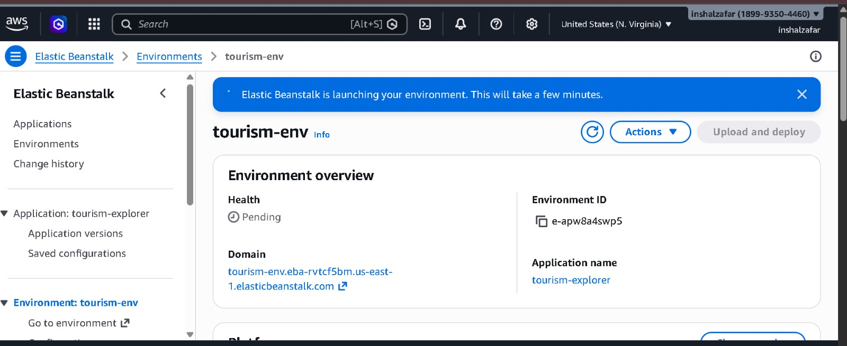

Step 3: Upload and Deploy Application
The ZIP project file was uploaded and deployed through Elastic Beanstalk. A public URL was generated for accessing the application.
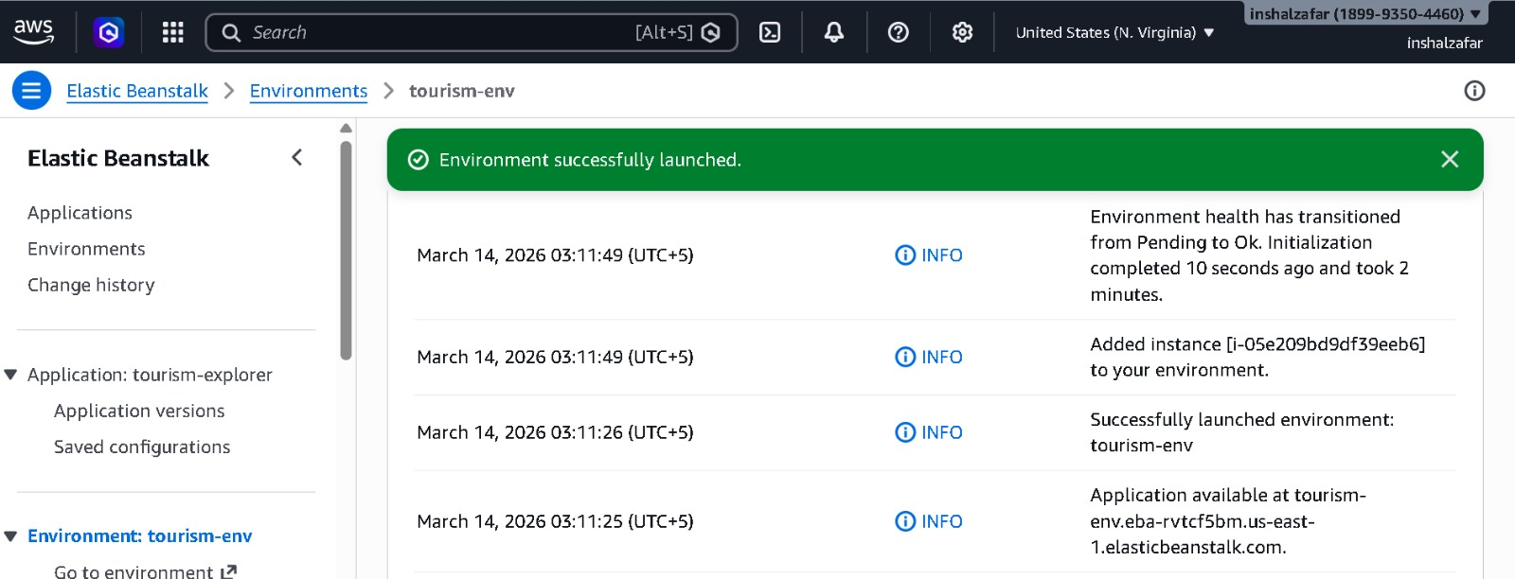


Step 4: Application Running
The application was successfully deployed and accessed through the Elastic Beanstalk domain link.
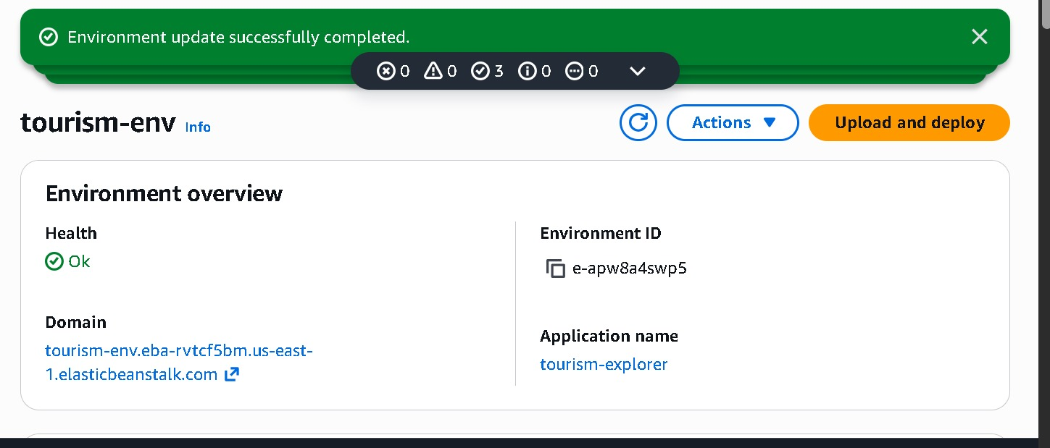

Conclusion
This assignment demonstrated how cloud computing platforms simplify application deployment. Using EC2 required manual setup while Elastic Beanstalk automated the deployment process. The Tourism Explorer application was successfully hosted on AWS and made accessible through the internet.

