Dataset:

LaLiga 1971-2022

Introduction:
This project documentation focuses on our analysis of the “laliga-1971-2022” i.e. we named this dataset as (Football) obtained from Kaggle. We followed a series of steps to extract valuable insights and predictions from the dataset. We began by identifying a predictive problem and exploring the dataset thoroughly. Wrangling operations were applied to clean and transform the data into a tidy format. A suitable predictive algorithm was selected, and its predictions were visualized using multiple techniques. Classification and clustering algorithms were also employed, and their results were compared. We used box plots to identify the algorithm with the most stable outcomes. Finally, we built an interface to showcase the wrangling, classification, comparison, and results for an interactive experience. Through this project, we aimed to demonstrate the power of data analysis and predictive modeling using the available dataset.

Information About Dataset:
The "Football (LaLiga)" is a comprehensive collection of data encompassing various aspects of football matches. The dataset incorporates a multitude of independent variables, including details about individual matches, team statistics, and performance metrics. It provides a valuable resource for gaining insights into the factors influencing match outcomes, team efficiency, and player performance.
Key variables within the dataset include match details such as date, time, venue, and round. Outcome-related features, such as goals scored and goals conceded, offer a comprehensive view of team performance. Additional metrics, like possession, shots taken, and shot efficiency, contribute to a thorough analysis of team strategies and offensive capabilities.
Furthermore, the dataset includes information on specific events during matches, such as penalties and free kicks, allowing for a detailed examination of critical moments. Expected goals and actual goals provide a nuanced understanding of team effectiveness in converting scoring opportunities.
Player-specific details, such as the captain, formation, and referee, contribute to the overall context of each match. The dataset also covers various team-related statistics like average goals per team and average possession by competition.
The visualizations generated from this dataset, including scatter plots, box plots, and histograms, facilitate a comprehensive exploration of the relationships between different variables. The implementation of linear regression models for predicting outcomes, k-means clustering for grouping similar data points, and the potential inclusion of Naive Bayes for classification tasks further enhances the analytical capabilities of this dataset.

A Glimpse of Dataset:
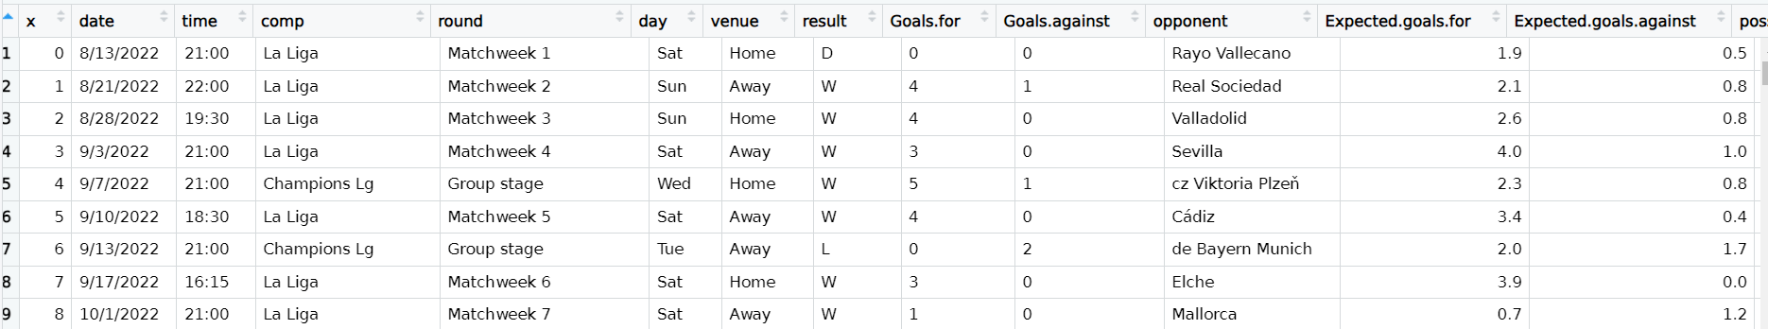
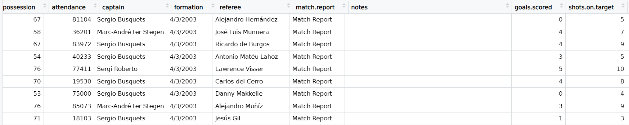
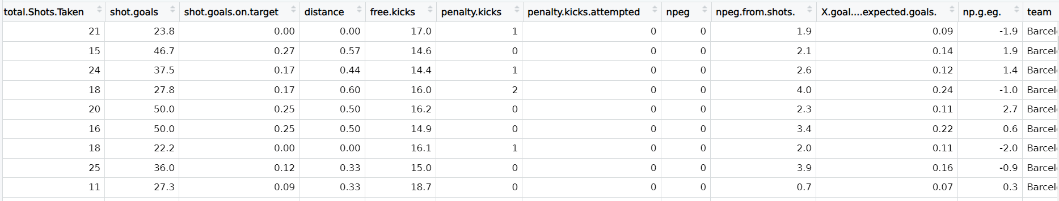

Project Overview:
This project aimed to analyze a dataset by performing exploration, tidying, wrangling, and addressing predictive problems using graphing and plots, regression analysis, k-means clustering, and logistics regression. The dataset was thoroughly explored to understand its structure and variables, and visualizations were utilized for data analysis. Regression analysis was applied to establish relationships between variables and make predictions. K-means clustering was used to identify distinct groups in the dataset, while logistics regression was employed for classification tasks. The performance of these techniques was compared using evaluation metrics. The project findings were presented through visual representations, aiding in the interpretation of patterns and differences between the approaches. Overall, this project contributed to academic data analysis and predictive modeling research.

Libraries & Functions used:
We used the following libraries & packages in R-script to perform the analysis:
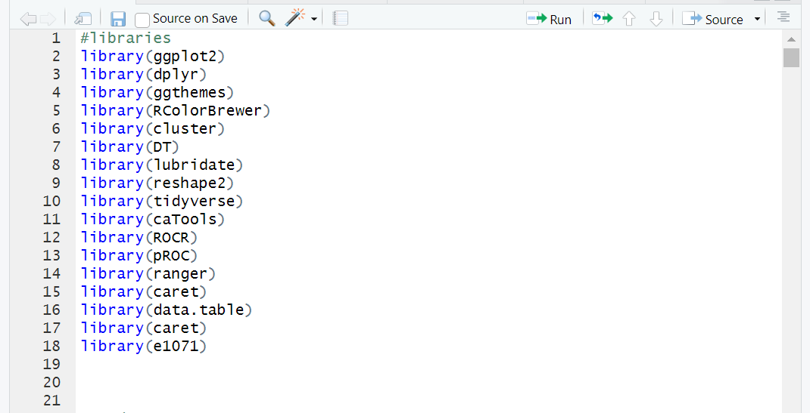
Snapshots of code along with their output:

Inspection Of Dataset:
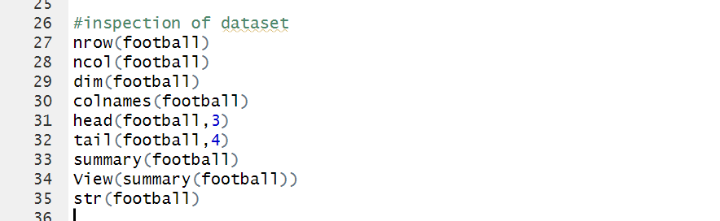
Output:
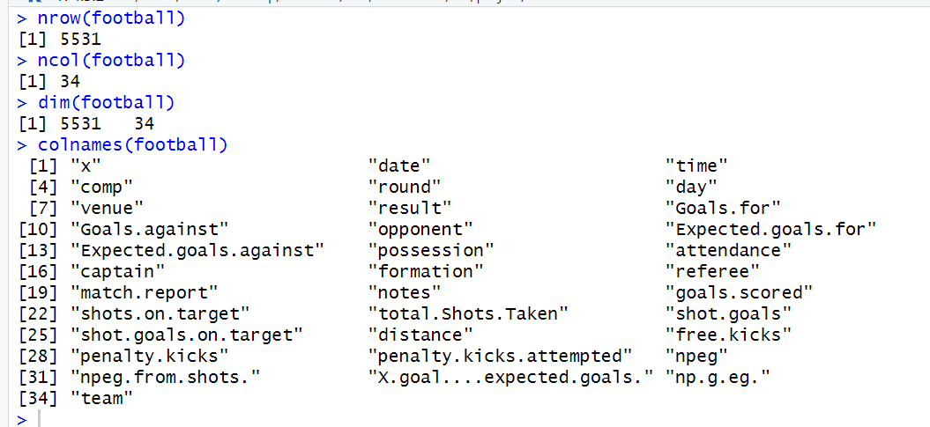
Head:
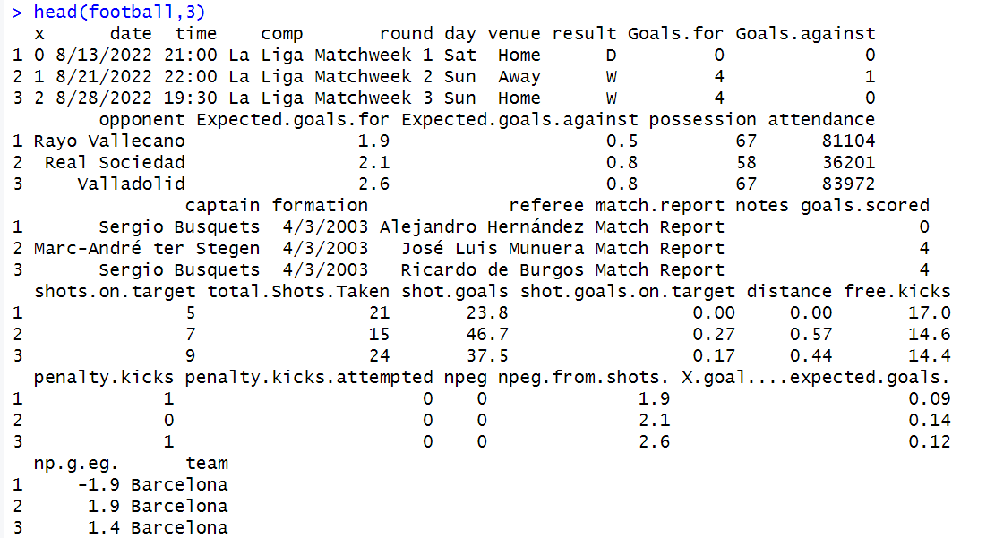
Tail:
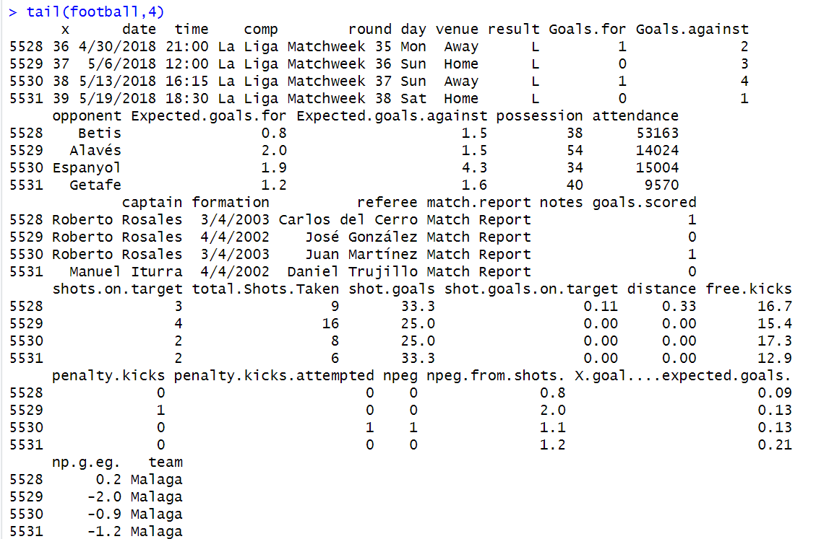

Summary:
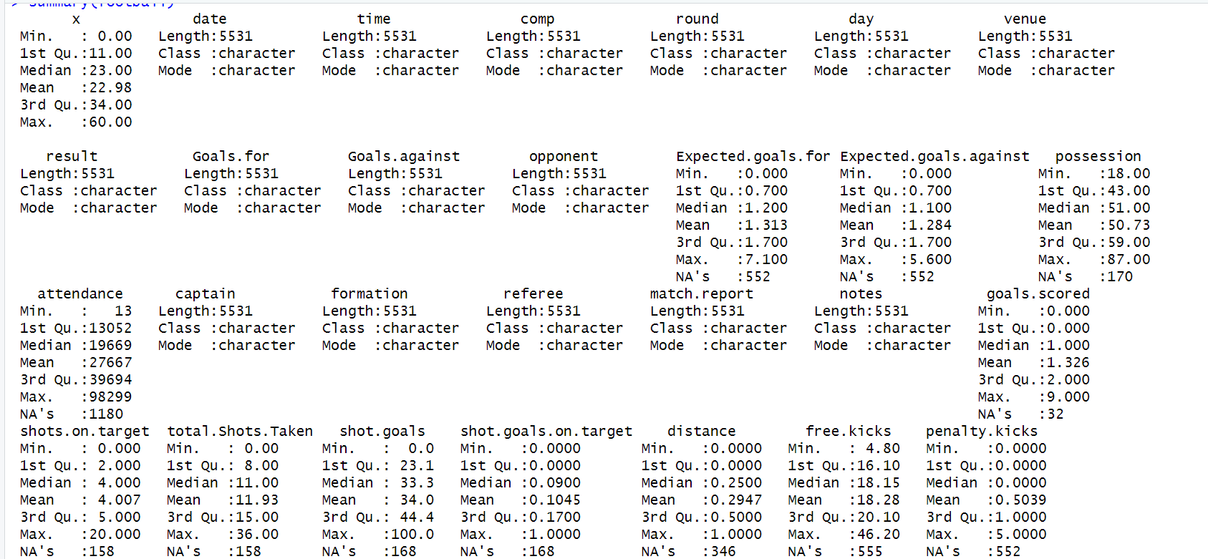
Structure:
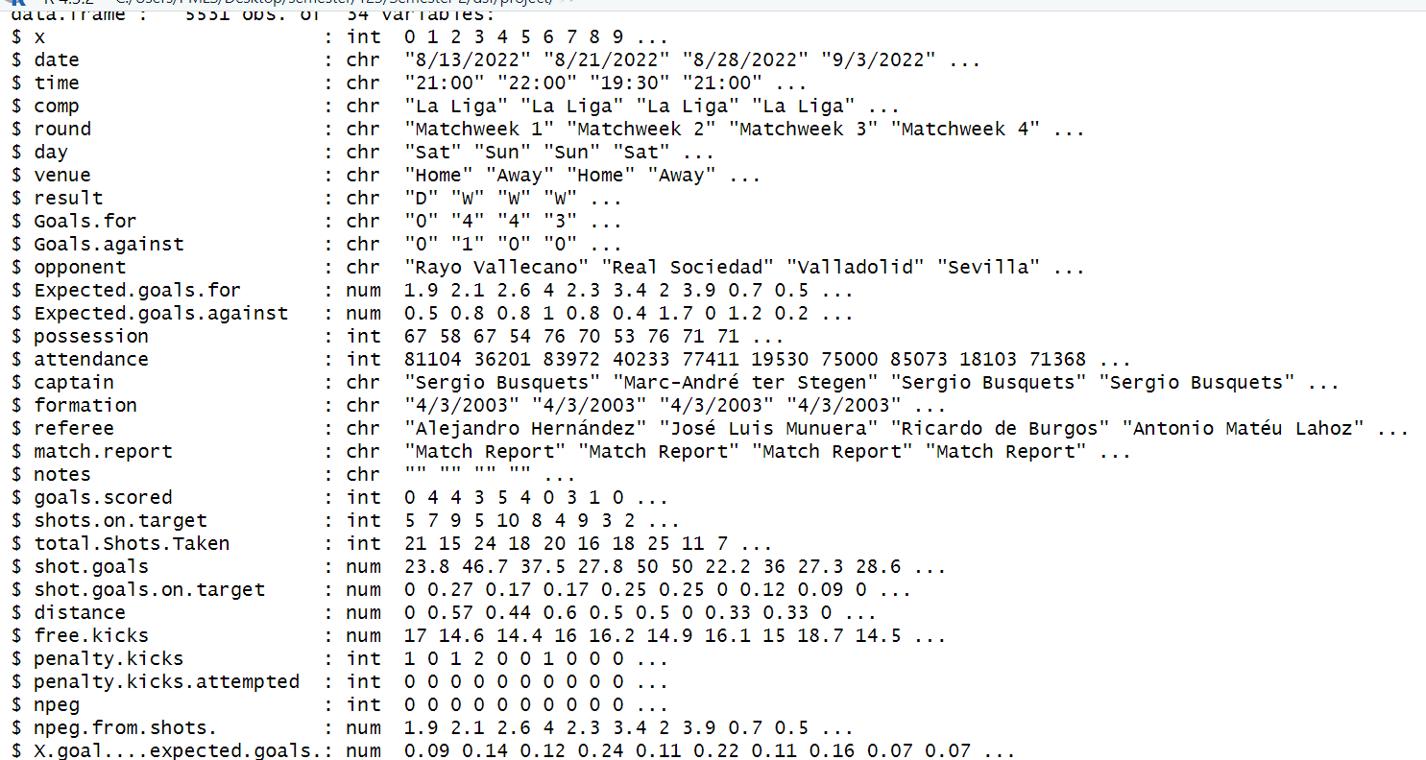

Identifying missing values of the Dataset:
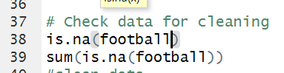
Output:
True indicates missing values
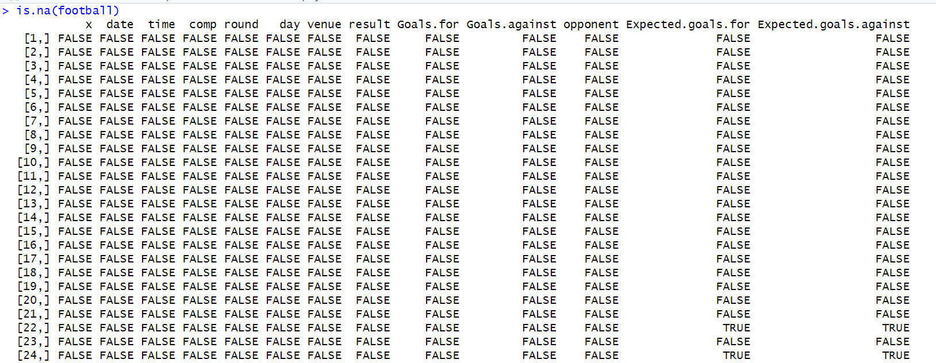
Count of missing values:
Output:
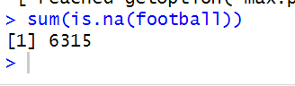
Removing missing values & displaying rows:
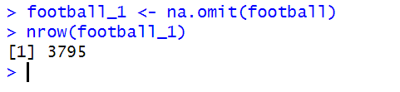
Output:
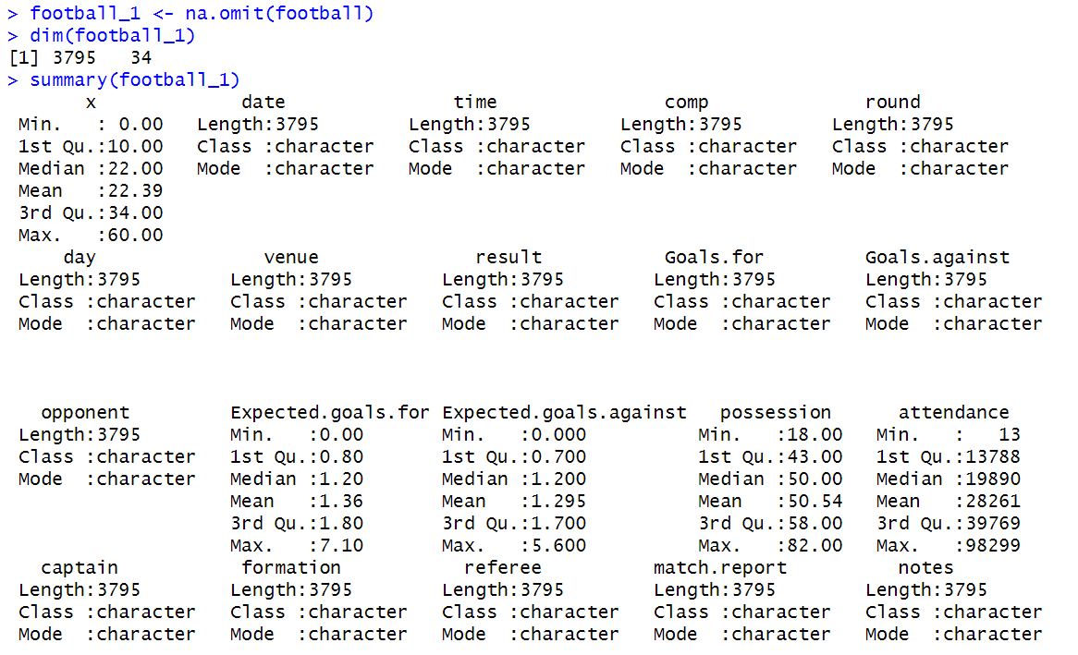
After tidying the dataset, the number of rows are reduced from 5531to 3795.
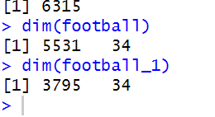

Outliers:
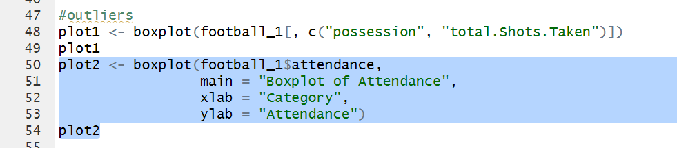
Output:
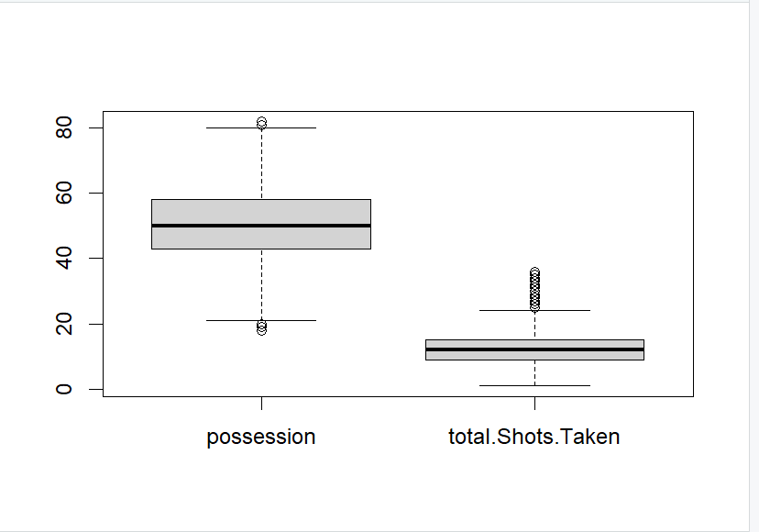
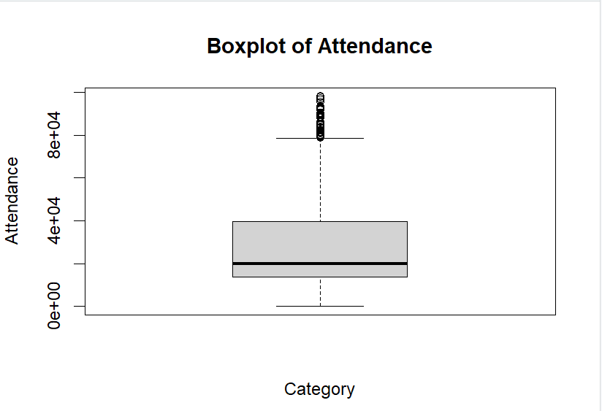

Data Wrangling
- Select:
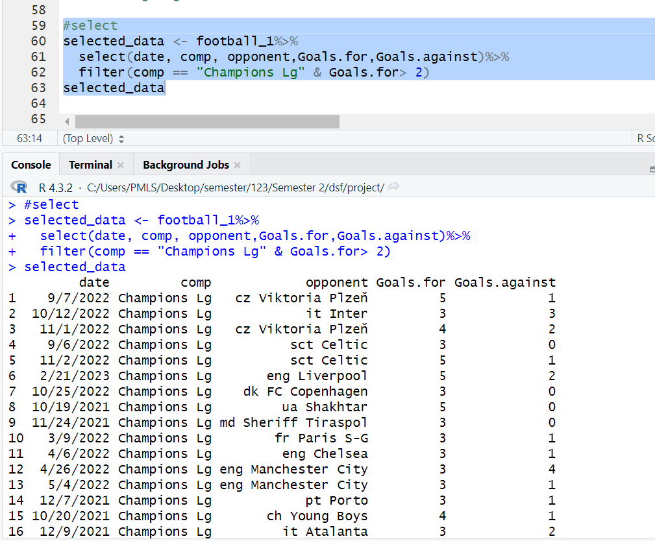

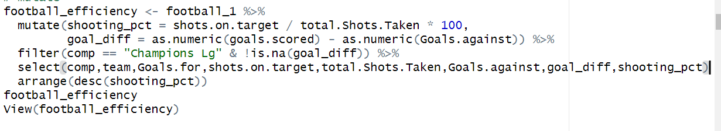
- Mutate:

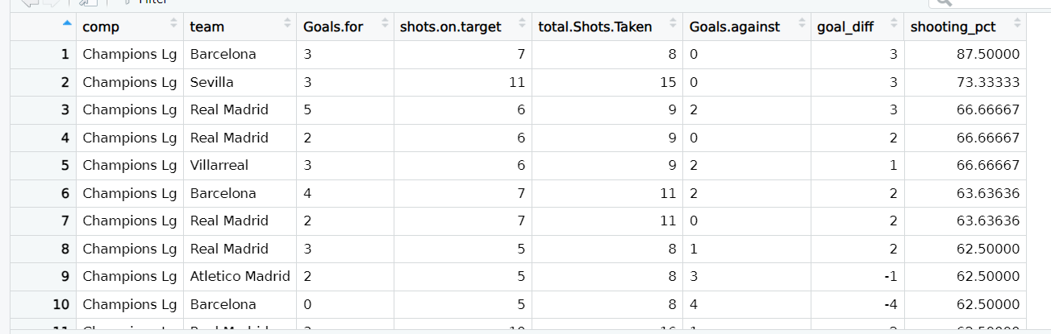

- Summarize:
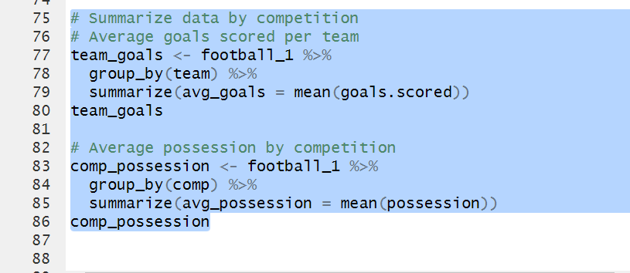
Output:
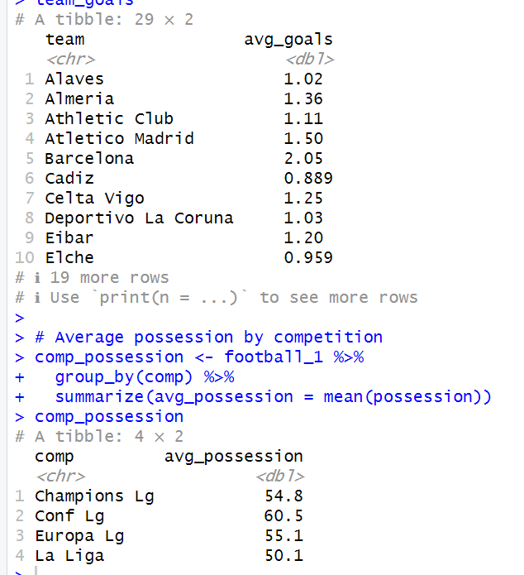

Corelation:
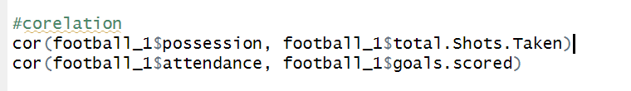
Output:
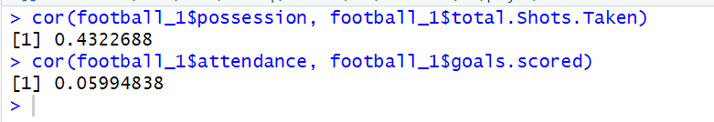

Visualization:
- Facets:
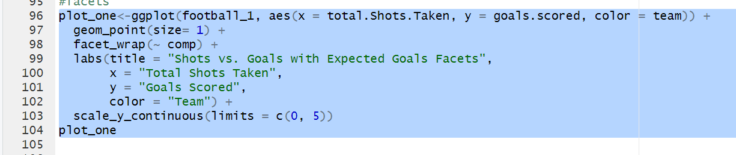
Output:
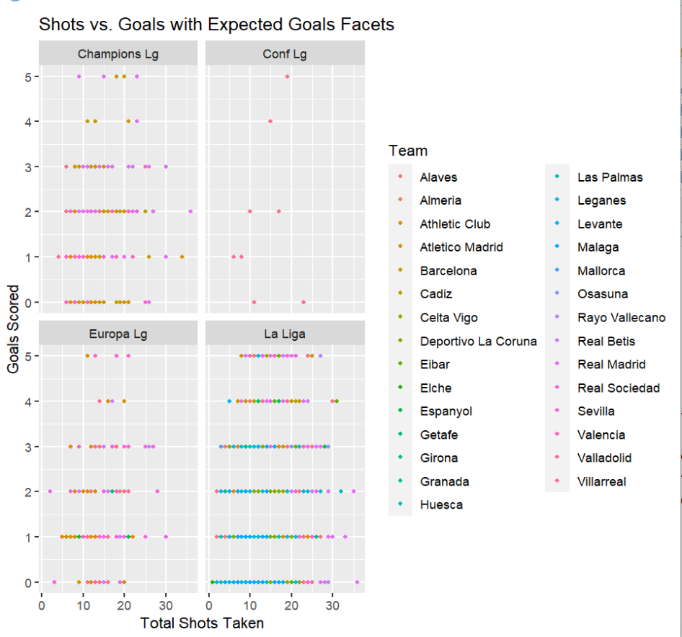
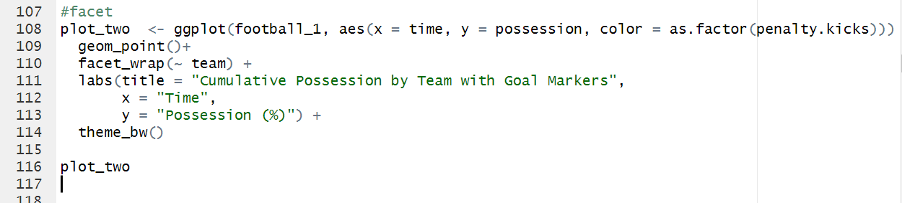
- Facets:
Output:
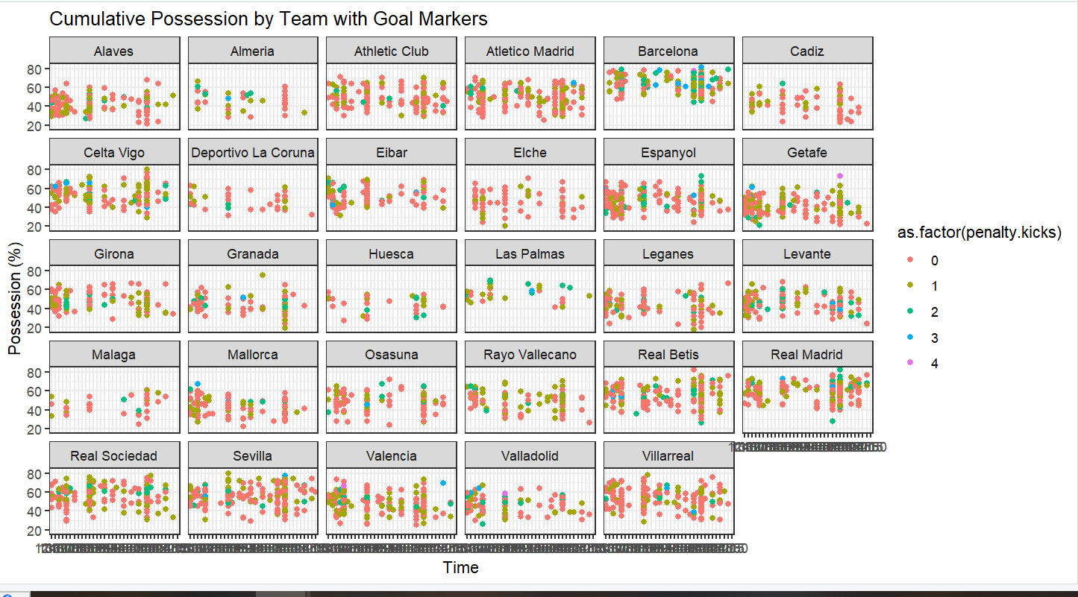

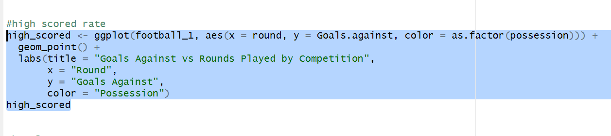
- Scattered point plot:
Output:
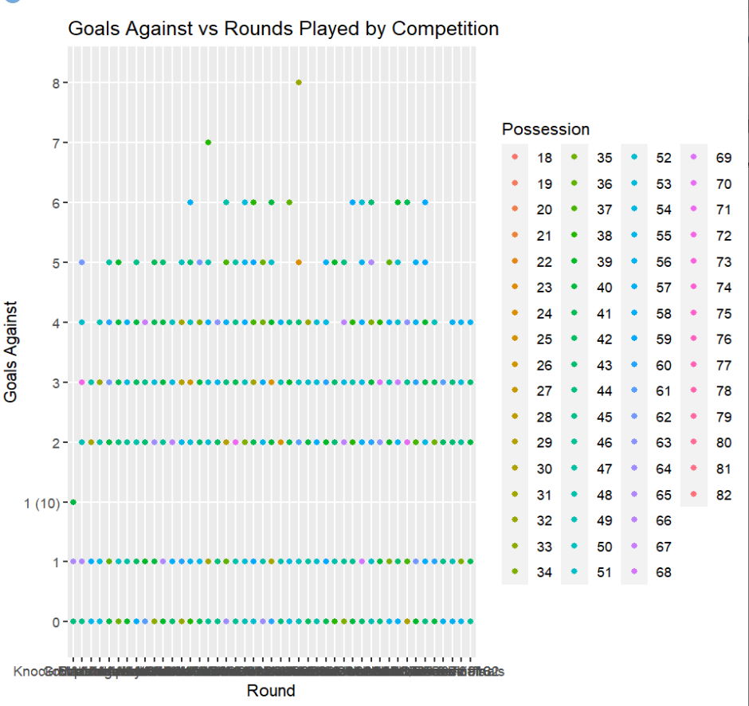
- Boxplot:
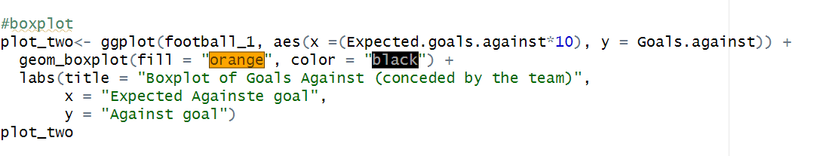Output:

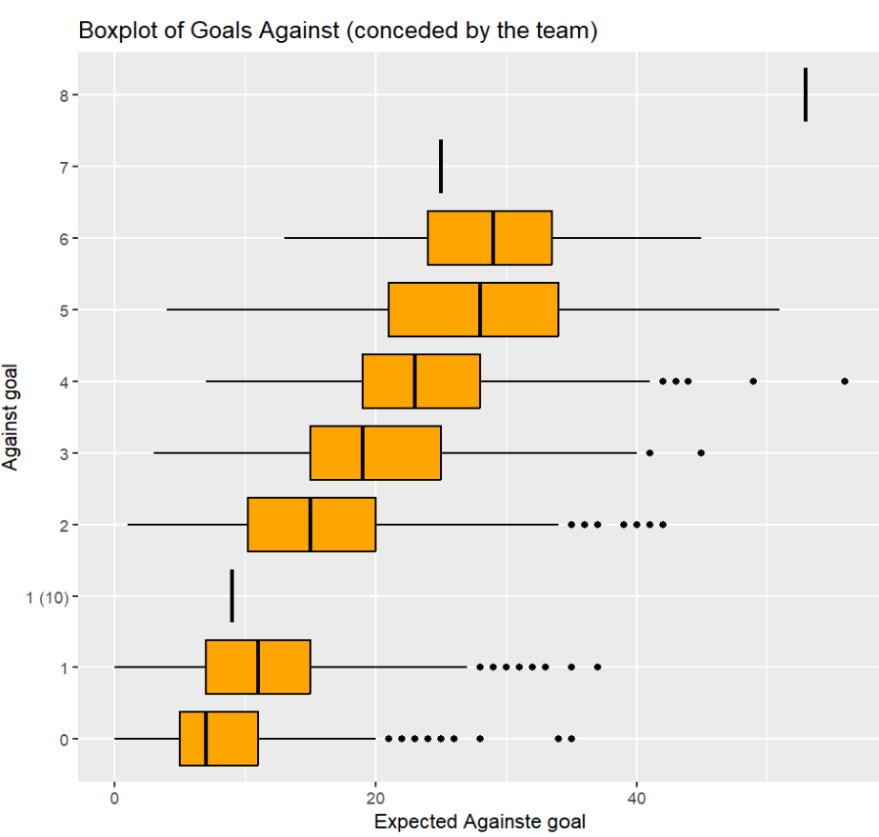
- Histogram:

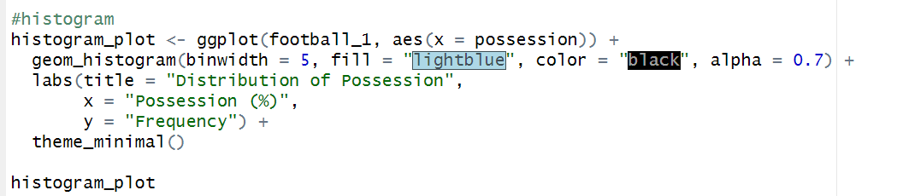
Output: 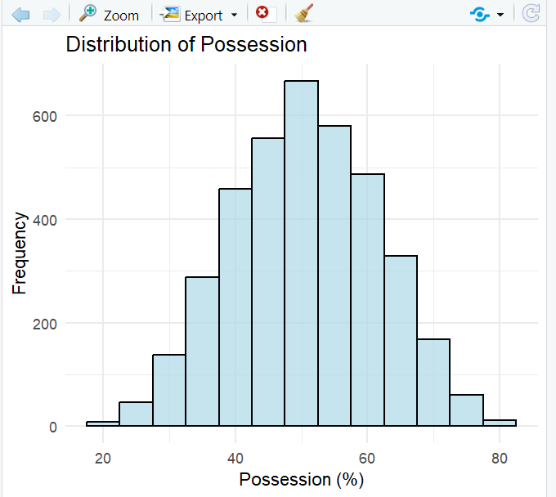

Linear regression
Between Possession and shot. Goals
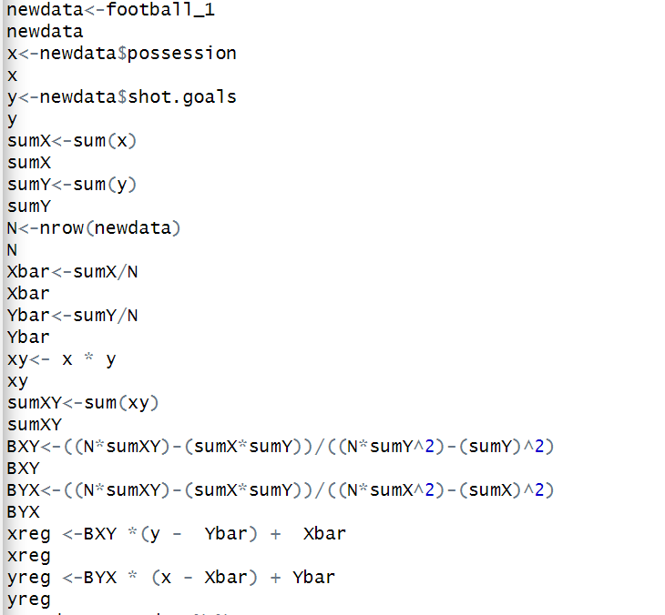
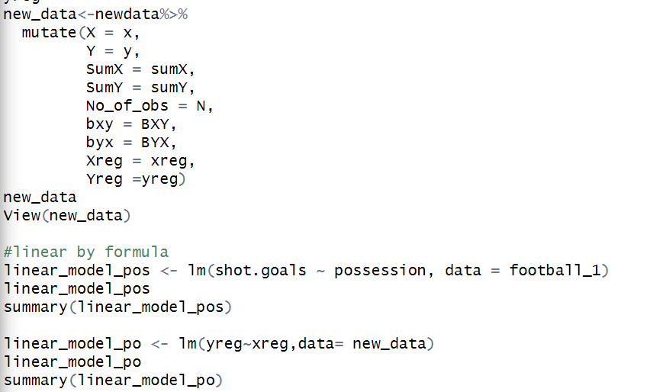

Output:
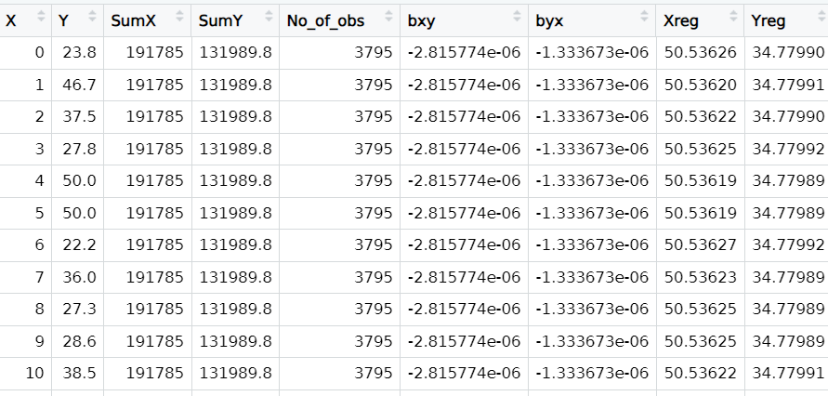
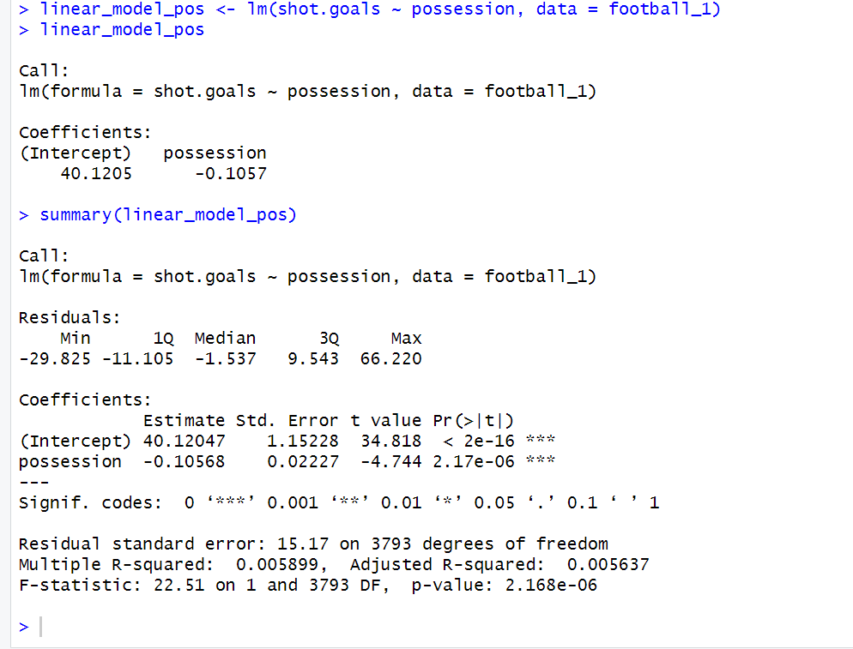

Visualize the relationship between possession and Shot goals!
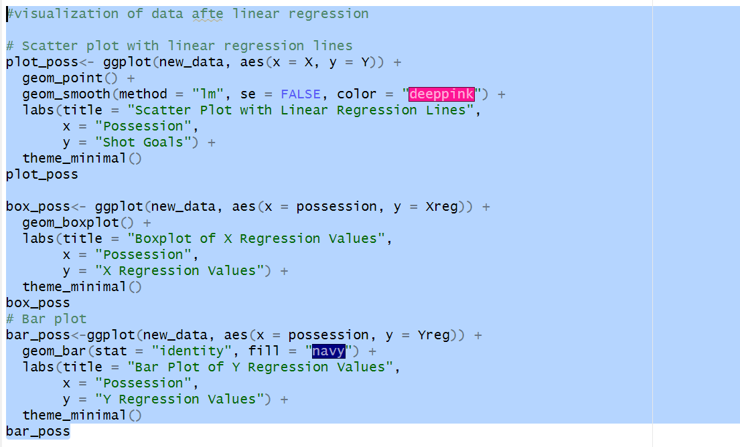
Output:
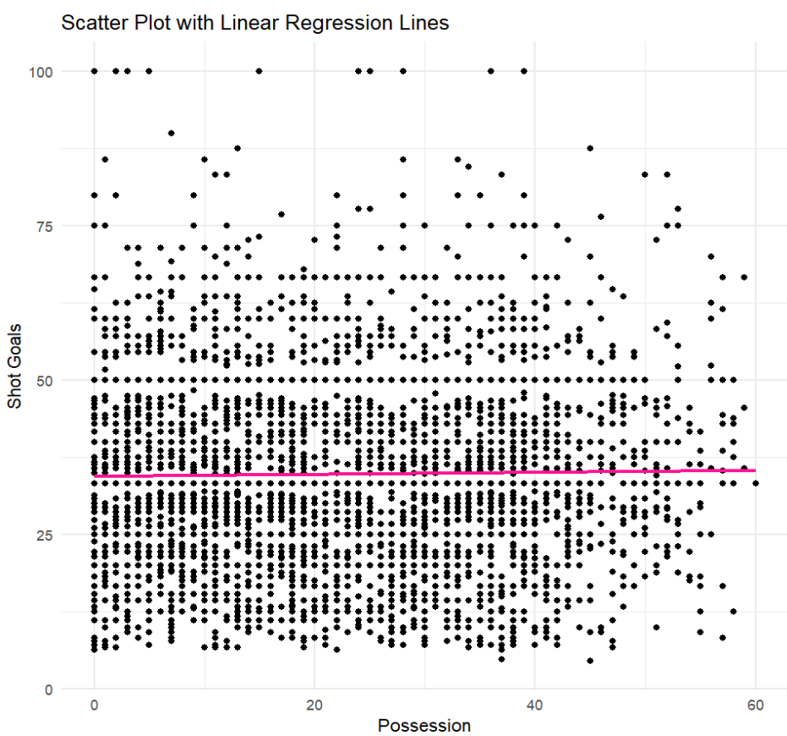
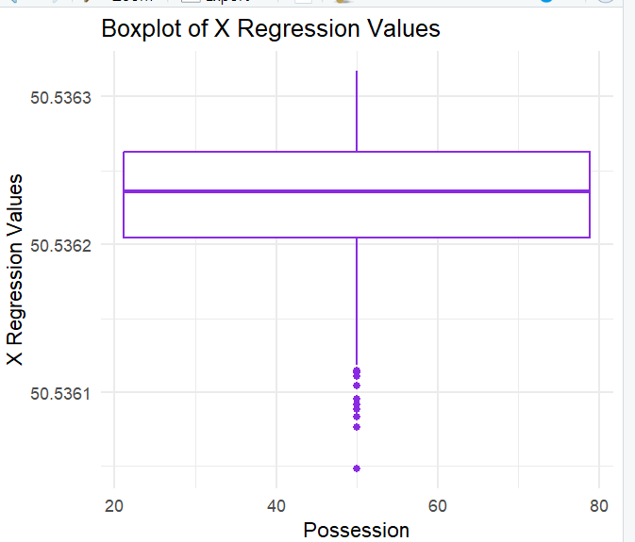
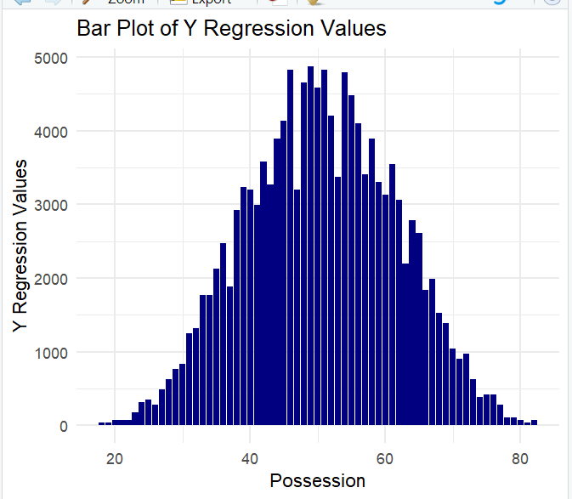

k-means cluster:
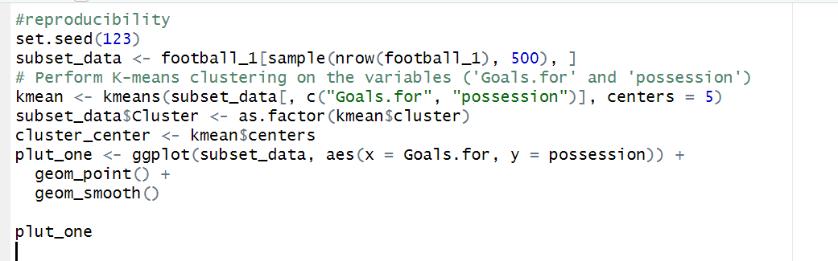
Output:
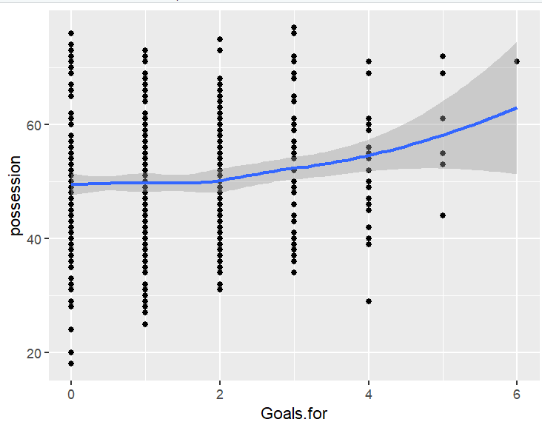

Scatter Plot between Goals.for and Possession:
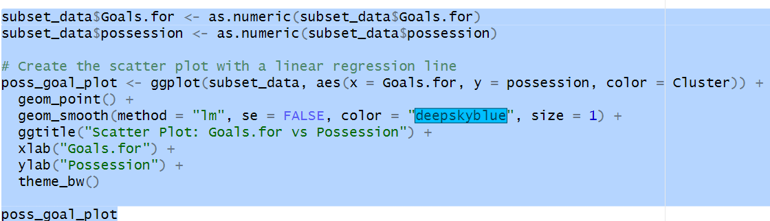
Output:
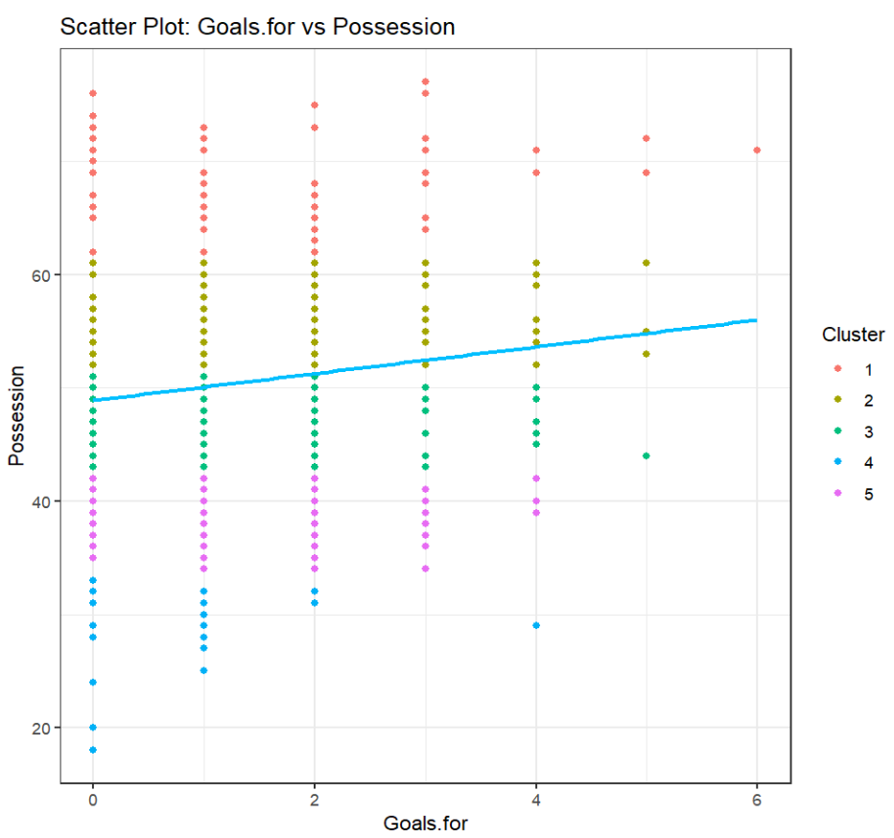

Bar plot visualizing the relationship between Goals For and Possession
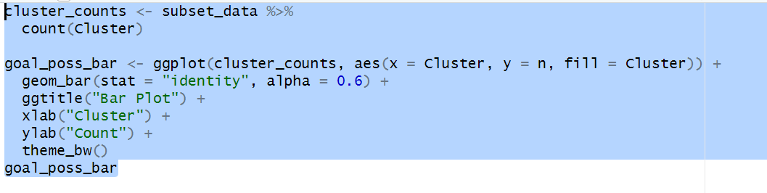
Output:
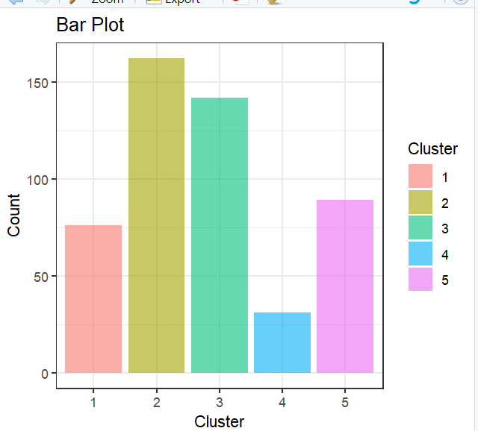

Boxplot visualizing the relationship between Goals For and Possession
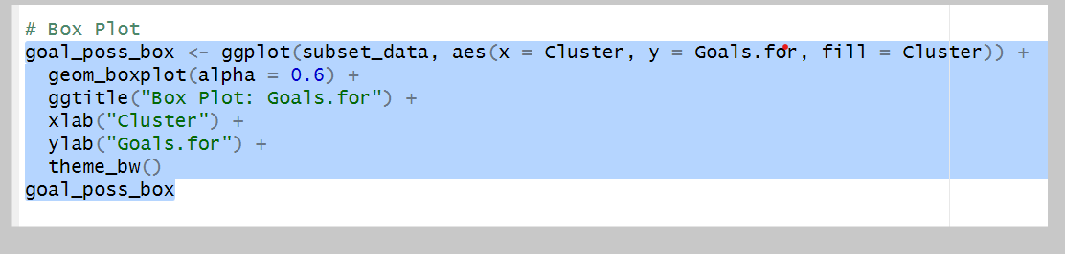
Output:
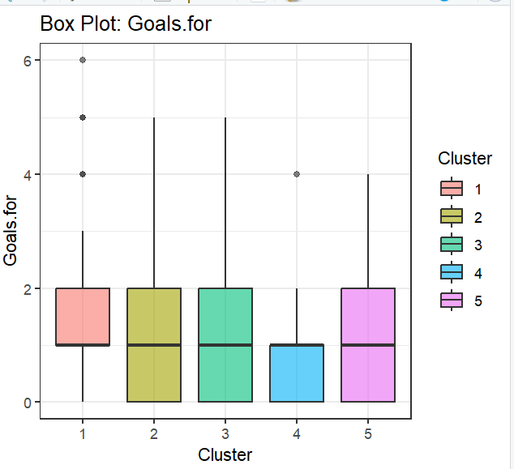

Heat maps:
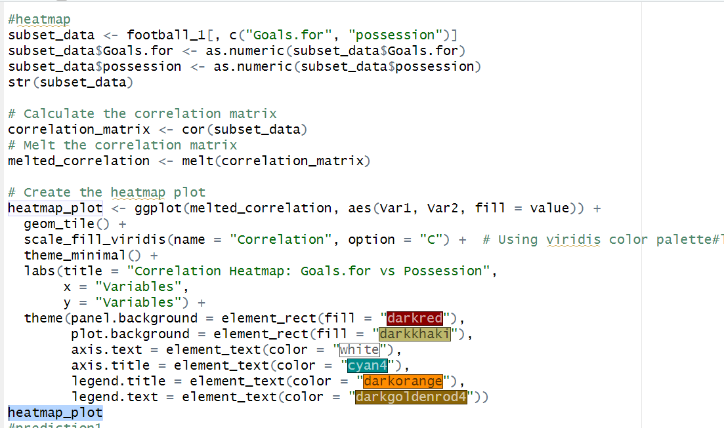
Output:
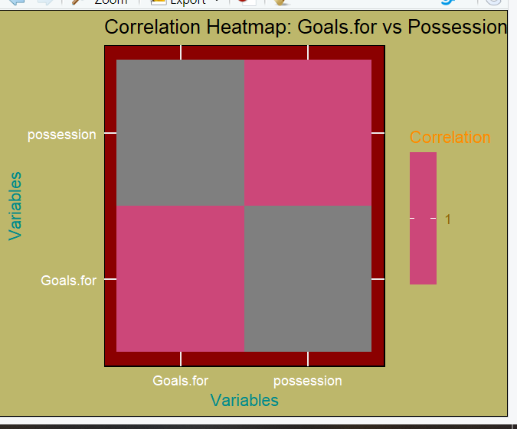

The predictive problem from the dataset:
We used the “test and train data” technique to “Predict the number of goals (Goals.for) based on possession.”
- Model the data to train data and test data

Possession and goals for

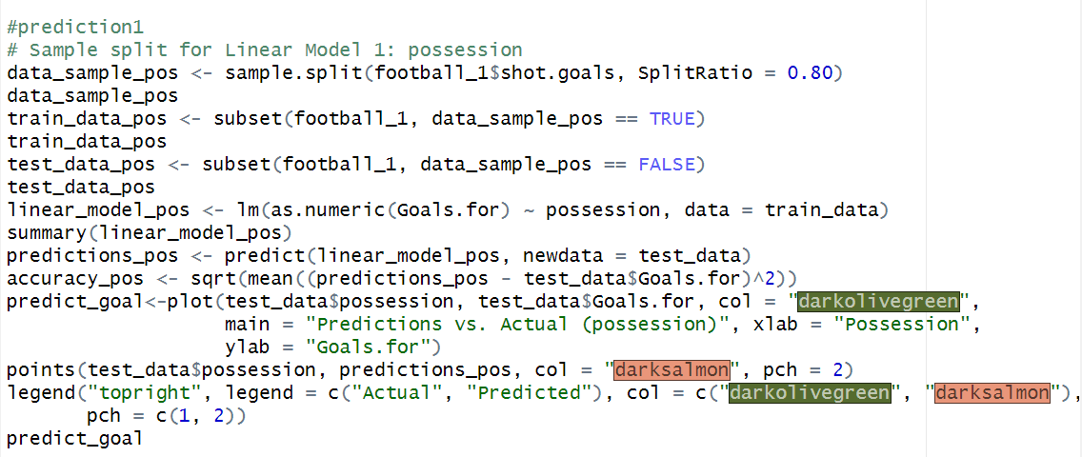

Output:
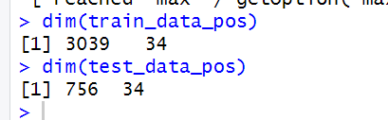
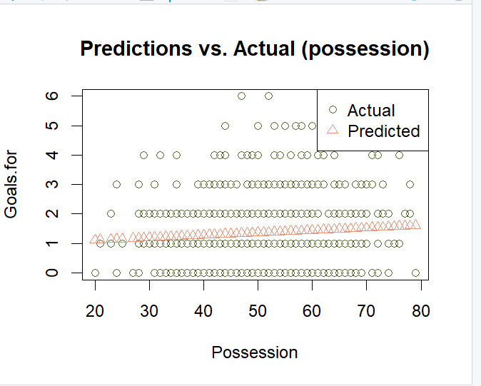

Goals.scored vs Goals shot:
We used the “test and train data” technique to “Predict the number of shot goals based on goal scored”.
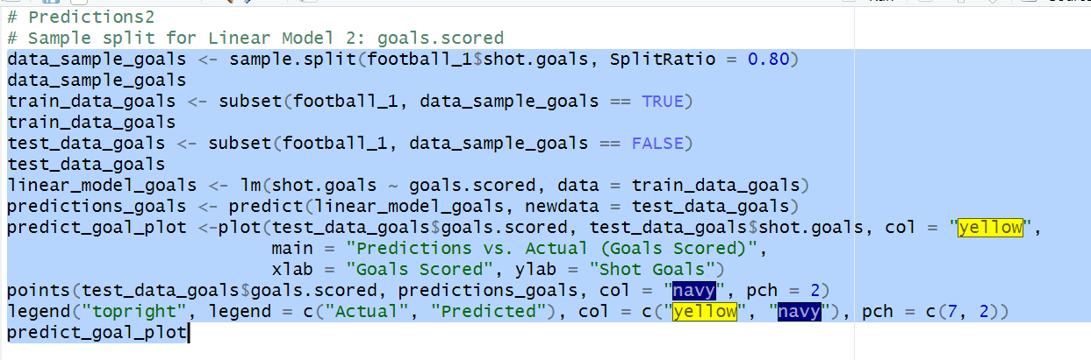

Output:
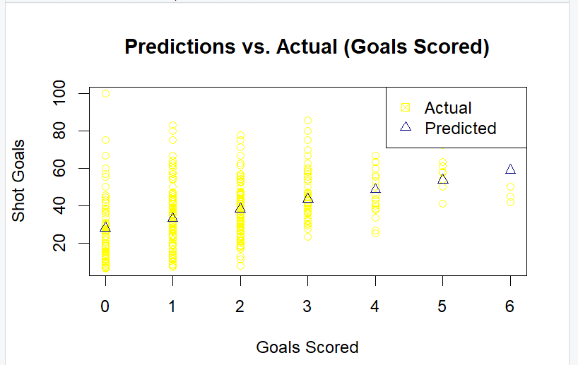

Distance vs Goals shot:
We used the “test and train data” technique to “Predict the number of shot goals based on distance”.
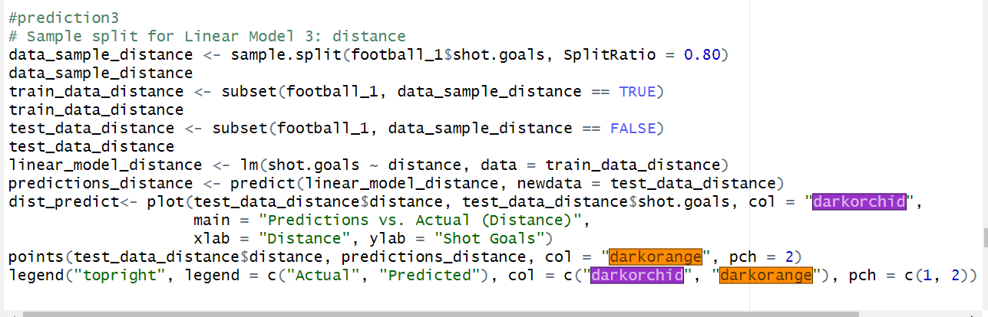
Logistic regression:
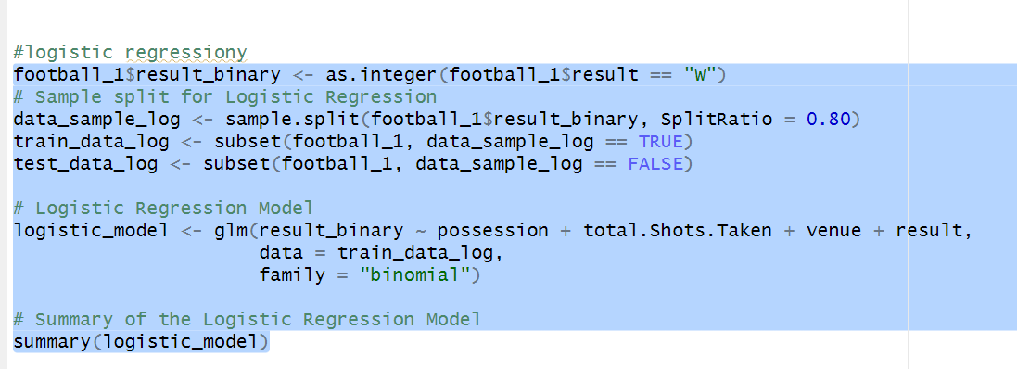
Output:
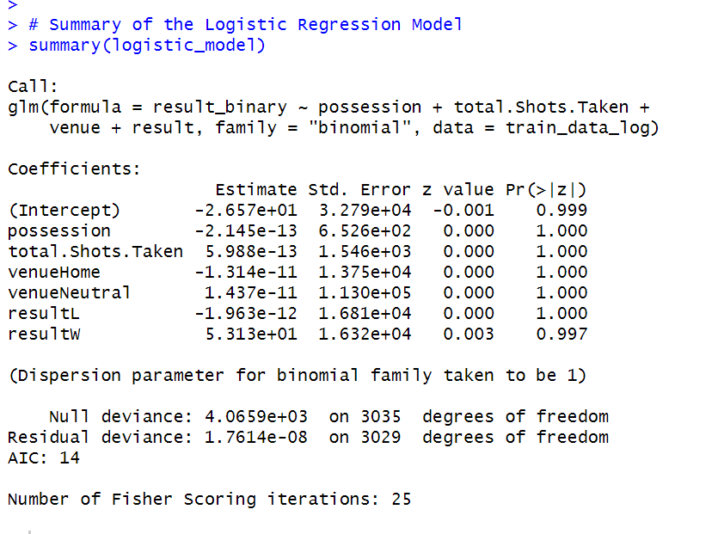
Prediction on the Logistic regression:
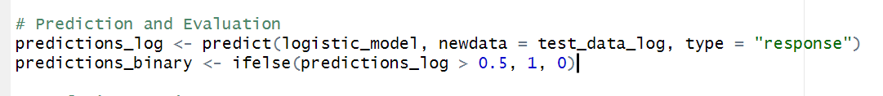
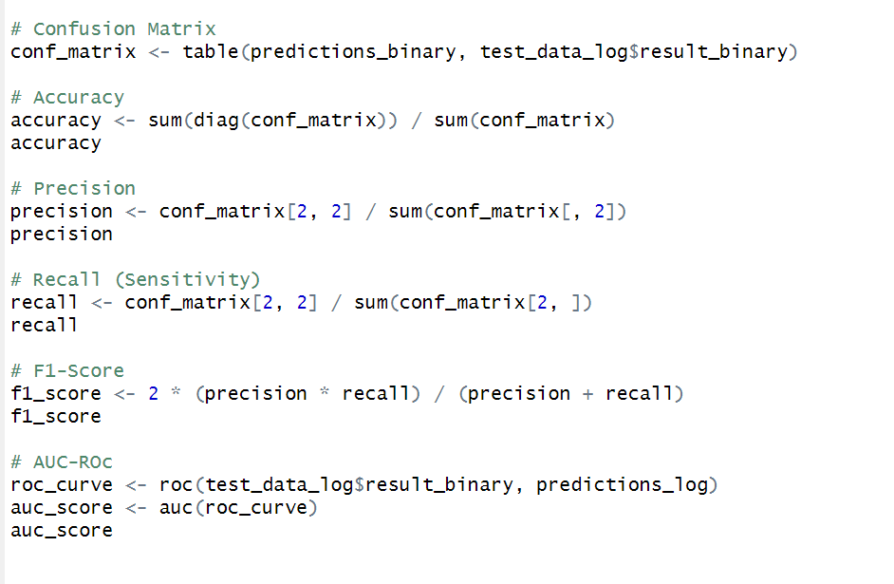
- Confusion Matrix:
Output:
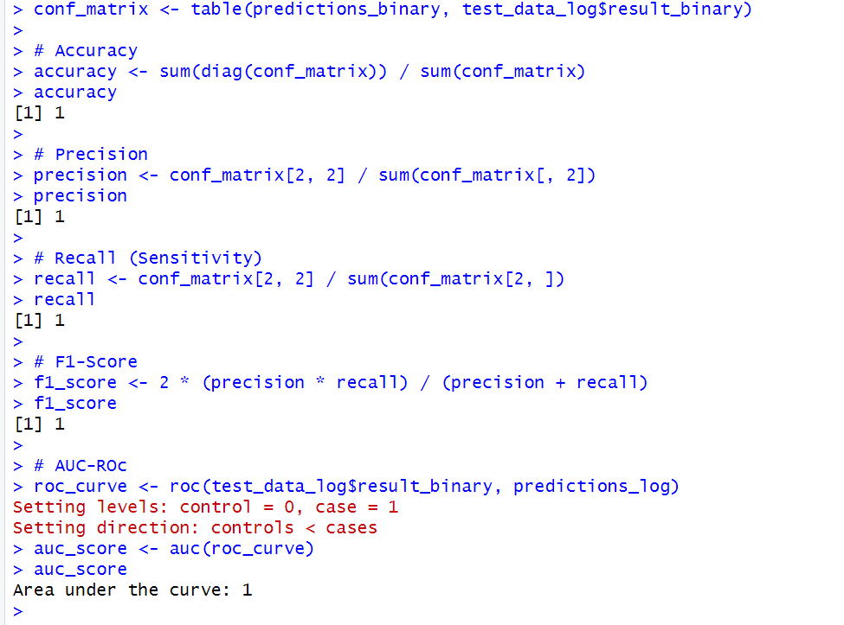

Plot:
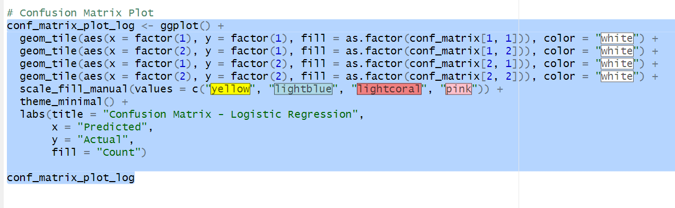
Output:
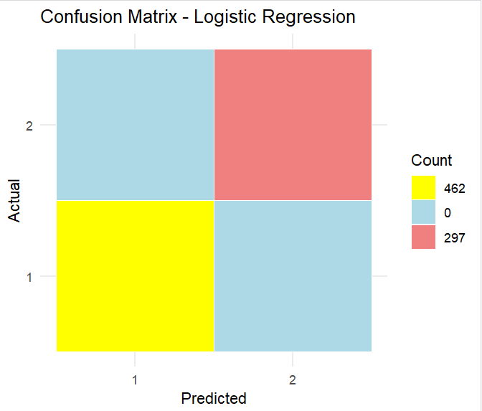

Naïve Bayes:
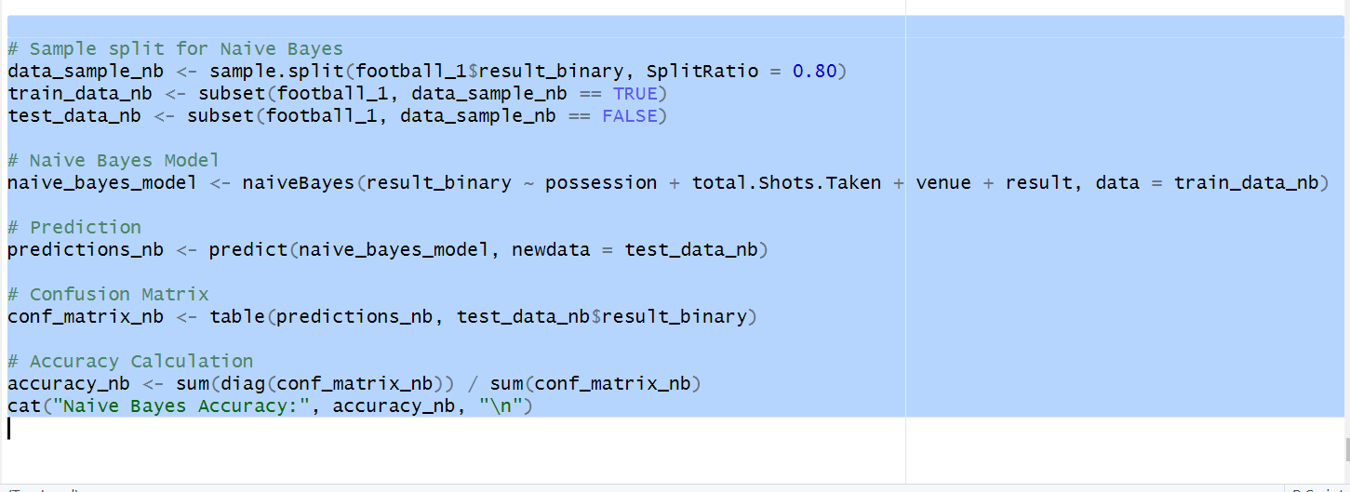
Output:
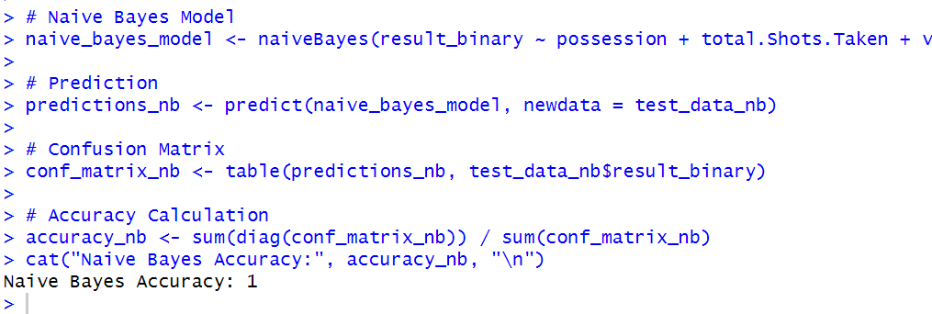
Plot:
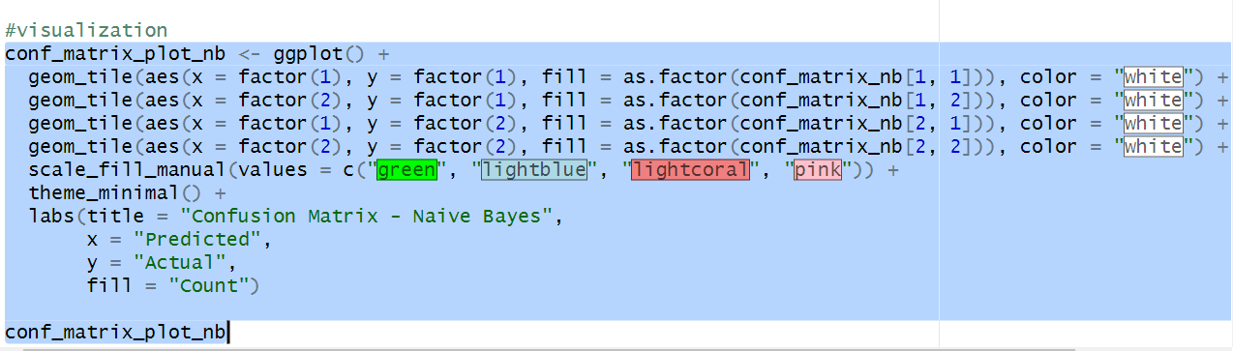
Output:
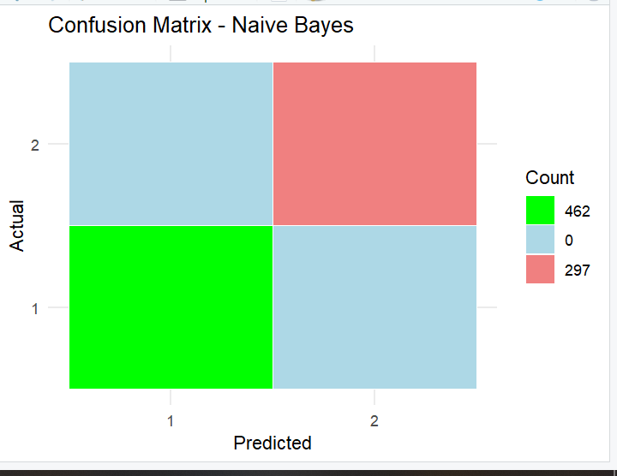

Identify a Predictive Problem from the Dataset
The dataset "LaLiga.csv" is used for predictive analysis. The predictive problem identified is to understand the factors influencing the number of goals scored by a football team.
Conclusion:
In this predictive analysis, we explored multiple models, including Linear Regression, Logistic Regression ,K-means Clustering, to understand their performance on the given dataset.
1. Linear Regression Models:
The linear regression models were built to understand the relationships between key variables and the number of shot goals.The model based on possession suggested that possession percentage might have a linear impact on the number of shot goals.Similarly, the models based on goals scored and distance provided insights into how these factors influence the number of shot goals.
2. K-means Clustering:
The application of K-means clustering on 'Goals.for' and 'possession' helped identify distinct clusters in the data. Clustering revealed groups of observations that share similar characteristics in terms of goals scored and possession, providing a segmentation of the dataset.

3. Logistic Regression:
Logistic regression was employed for binary outcome prediction, specifically to predict whether a match resulted in a win ('W') or loss ('L').The selected features for prediction included possession, total shots taken, venue, and match result.
It gives accurate answers that make our prediction worth

- Evaluation of Logistic Regression:
Evaluation metrics, such as accuracy, precision, recall, F1-score, and AUC-ROC, were used to assess the performance of the logistic regression model. metrics provided a comprehensive view of the model's ability to correctly predict outcomes and handle imbalances in the dataset.

5. Naive Bayes Model:
- A Naive Bayes model was implemented for binary outcome prediction, following a probabilistic approach based on the chosen features.The model aimed to classify matches into win or loss categories.
The analyses conducted encompassed various aspects of data exploration, modeling, and evaluation. Linear regression models revealed relationships, K-means clustering identified patterns, and logistic/Naive Bayes models provided binary outcome predictions. The choice of models and evaluation metrics depended on the specific goals of the analysis, such as understanding influences on shot goals, clustering similar matches, and predicting match outcomes.Overall, the combination of exploratory and predictive analytics techniques contributed to a comprehensive understanding of the dataset, enabling insights and informing potential strategies or further investigations in the context of football match statistics.

MY R CODE
#libraries
library(ggplot2)
library(dplyr)
library(ggthemes)
library(RColorBrewer)
library(cluster)
library(DT)
library(lubridate)
library(reshape2)
library(tidyverse)
library(caTools)
library(ROCR)
library(pROC)
library(ranger)
library(caret)
library(data.table)
library(caret)
library(e1071)

#read
football<- read.csv("C:/Users/PMLS/Desktop/LaLiga.csv")
View(football)

#inspection of dataset
nrow(football)
ncol(football)
dim(football)
colnames(football)
head(football,3)
tail(football,4)
summary(football)
View(summary(football))
str(football)

# Check data for cleaning
is.na(football)
sum(is.na(football))
#clean data
football_1 <- na.omit(football)
nrow(football_1)
dim(football_1)
summary(football_1)
View(football_1)

#outliers
plot1 <- boxplot(football_1[, c("possession", "total.Shots.Taken")])
plot1
plot2 <- boxplot(football_1$attendance,
main = "Boxplot of Attendance",
xlab = "Category",
ylab = "Attendance")
plot2

#dplyr functions
#data wrangling

#select
selected_data <- football_1%>%
select(date, comp, opponent,Goals.for,Goals.against)%>%
filter(comp == "Champions Lg" & Goals.for> 2)
selected_data

# mutate
football_efficiency <- football_1 %>%
mutate(shooting_pct = shots.on.target / total.Shots.Taken * 100,
goal_diff = as.numeric(goals.scored) - as.numeric(Goals.against)) %>%
filter(comp == "Champions Lg" & !is.na(goal_diff)) %>%
select(comp,team,Goals.for,shots.on.target,total.Shots.Taken,Goals.against,goal_diff,shooting_pct)%>%
arrange(desc(shooting_pct))
football_efficiency
View(football_efficiency)

# Summarize data by competition
# Average goals scored per team
team_goals <- football_1 %>%
group_by(team) %>%
summarize(avg_goals = mean(goals.scored))
team_goals

# Average possession by competition
comp_possession <- football_1 %>%
group_by(comp) %>%
summarize(avg_possession = mean(possession))
comp_possession

#corelation
cor(football_1$possession, football_1$total.Shots.Taken)
cor(football_1$attendance, football_1$goals.scored)

#visualization
#plots
#facets
plot_one<-ggplot(football_1, aes(x = total.Shots.Taken, y = goals.scored, color = team)) +
geom_point(size= 1) +
facet_wrap(~ comp) +
labs(title = "Shots vs. Goals with Expected Goals Facets",
x = "Total Shots Taken",
y = "Goals Scored",
color = "Team") +
scale_y_continuous(limits = c(0, 5))
plot_one

#facet
plot_two <- ggplot(football_1, aes(x = time, y = possession, color = as.factor(penalty.kicks))) +
geom_point()+
facet_wrap(~ team) +
labs(title = "Cumulative Possession by Team with Goal Markers",
x = "Time",
y = "Possession (%)") +
theme_bw()

plot_two

#high scored rate
high_scored <- ggplot(football_1, aes(x = round, y = Goals.against, color = as.factor(possession))) +
geom_point() +
labs(title = "Goals Against vs Rounds Played by Competition",
x = "Round",
y = "Goals Against",
color = "Possession")
high_scored

#boxplot
plot_two<- ggplot(football_1, aes(x =(Expected.goals.against*10), y = Goals.against)) +
geom_boxplot(fill = "orange", color = "black") +
labs(title = "Boxplot of Goals Against (conceded by the team)",
x = "Expected Againste goal",
y = "Against goal")
plot_two

#histogram
histogram_plot <- ggplot(football_1, aes(x = possession)) +
geom_histogram(binwidth = 5, fill = "lightblue", color = "black", alpha = 0.7) +
labs(title = "Distribution of Possession",
x = "Possession (%)",
y = "Frequency") +
theme_minimal()

histogram_plot
# Linear Regression
# Linear Regression Model 1:
#possession
#apply regression manually
newdata<-football_1
newdata
x<-newdata$possession
x
y<-newdata$shot.goals
y
sumX<-sum(x)
sumX
sumY<-sum(y)
sumY
N<-nrow(newdata)
N
Xbar<-sumX/N
Xbar
Ybar<-sumY/N
Ybar
xy<- x * y
xy
sumXY<-sum(xy)
sumXY
BXY<-((N*sumXY)-(sumX*sumY))/((N*sumY^2)-(sumY)^2)
BXY
BYX<-((N*sumXY)-(sumX*sumY))/((N*sumX^2)-(sumX)^2)
BYX
xreg <-BXY *(y - Ybar) + Xbar
xreg
yreg <-BYX * (x - Xbar) + Ybar
yreg
new_data<-newdata%>%
mutate(X = x,
Y = y,
SumX = sumX,
SumY = sumY,
No_of_obs = N,
bxy = BXY,
byx = BYX,
Xreg = xreg,
Yreg =yreg)
new_data
View(new_data)

#linear by formula
linear_model_pos <- lm(shot.goals ~ possession, data = football_1)
linear_model_pos
summary(linear_model_pos)

linear_model_po <- lm(yreg~xreg,data= new_data)
linear_model_po
summary(linear_model_po)
#visualization of data afte linear regression

# Scatter plot with linear regression lines
plot_poss<- ggplot(new_data, aes(x = X, y = Y)) +
geom_point() +
geom_smooth(method = "lm", se = FALSE, color = "deeppink") +
labs(title = "Scatter Plot with Linear Regression Lines",
x = "Possession",
y = "Shot Goals") +
theme_minimal()
plot_poss

box_poss<- ggplot(new_data, aes(x = possession, y = Xreg)) +
geom_boxplot(color="blueviolet") +
labs(title = "Boxplot of X Regression Values",
x = "Possession",
y = "X Regression Values") +
theme_minimal()
box_poss
# Bar plot
bar_poss<-ggplot(new_data, aes(x = possession, y = Yreg)) +
geom_bar(stat = "identity", fill = "navy") +
labs(title = "Bar Plot of Y Regression Values",
x = "Possession",
y = "Y Regression Values") +
theme_minimal()
bar_poss

# Linear Regression Model 2:
#goals.scored
goal_data<-football_1
x<-goal_data$goals.scored
x
y<-goal_data$shot.goals
y
sumX<-sum(x)
sumX
sumY<-sum(y)
sumY
N<-nrow(goal_data)
N
Xbar<-sumX/N
Xbar
Ybar<-sumY/N
Ybar
xy<- x * y
xy
sumXY<-sum(xy)
sumXY
BXY<-((N*sumXY)-(sumX*sumY))/((N*sumY^2)-(sumY)^2)
BXY
BYX<-((N*sumXY)-(sumX*sumY))/((N*sumX^2)-(sumX)^2)
BYX
xreg <-BXY *(y - Ybar) + Xbar
xreg
yreg <-BYX * (x - Xbar) + Ybar
yreg
goal_data<-goal_data%>%
mutate(X = x,
Y = y,
SumX = sumX,
SumY = sumY,
No_of_obs = N,
bxy = BXY,
byx = BYX,
Xreg = xreg,
Yreg =yreg)
goal_data
View(goal_data)
#linear regression without library
linear_model_goals <- lm(shot.goals ~ goals.scored, data = football_1)
summary(linear_model_goals)
linear_reg <-lm(yreg~xreg,data=goal_data)
summary(linear_reg)

#visualization
goal_plot<- ggplot(goal_data, aes(x = X, y = Y)) +
geom_point() +
geom_smooth(method = "lm", se = FALSE, color = "deeppink") +
labs(title = "Scatter Plot with Linear Regression Lines",
x = "Goal Scored",
y = "Shot Goals") +
theme_minimal()
goal_plot
goal_box <- ggplot(goal_data, aes(x = goals.scored, y = Xreg)) +
geom_boxplot(color= "navy",fill = "grey") +
labs(title = "Boxplot of X Regression Values",
x = "Goal Scored",
y = "X Regression Values") +
theme_minimal()
goal_box

# Bar plot
goal_bar <- ggplot(goal_data, aes(x = goals.scored, y = Yreg)) +
geom_bar(stat = "identity", fill = "lightgreen") +
labs(title = "Bar Plot of Y Regression Values",
x = "Goal scored",
y = "Y Regression Values") +
theme_minimal()
goal_bar

# Linear Regression Model 3:
#distance
#manually
dis_data<-football_1
dis_data
summary(dis_data)
x<-dis_data$distance
x
y<-dis_data$shot.goals
y
sumX<-sum(x)
sumX
sumY<-sum(y)
sumY
N<-nrow(dis_data)
N
Xbar<-mean(x)
Xbar
Ybar<-mean(y)
Ybar
xy<- x * y
xy
sumXY<-sum(xy)
sumXY
BXY<-((N*sumXY)-(sumX*sumY))/((N*sumY^2)-(sumY)^2)
BXY
BYX<-((N*sumXY)-(sumX*sumY))/((N*sumX^2)-(sumX)^2)
BYX
xreg <-BXY *(y - Ybar) + Xbar
xreg<-na.omit(xreg)
xreg
summary(xreg)
yreg <-BYX * (x - Xbar) + Ybar
yreg<-na.omit(yreg)
yreg
summary(yreg)
dis_data<-dis_data%>%
mutate(X = x,
Y = y,
SumX = sumX,
SumY = sumY,
No_of_obs = N,
bxy = BXY,
byx = BYX,
Xreg = xreg,
Yreg =yreg)
dis_data
View(dis_data)
#reg by formula
linear_model_distance <- lm(shot.goals ~ distance, data = football_1)
summary(linear_model_distance)

#visualization
# Check the structure of dis_data
str(dis_data)

dis_data <- dis_data %>%
mutate(X = distance,
Y = shot.goals)
dis_plot <- ggplot(dis_data, aes(x = X, y = Y)) +
geom_point(color = "cadetblue") +
geom_smooth(method = "lm", se = FALSE, color = "blueviolet") +
labs(title = "Scatter Plot with Linear Regression Lines",
x = "Distance",
y = "Shot Goals") +
theme_minimal()
dis_plot

dis_box <- ggplot(dis_data, aes(x = distance, y = Xreg)) +
geom_boxplot(color= "navy",fill = "darkgoldenrod") +
labs(title = "Boxplot of X Regression Values",
x = "Distance",
y = "X Regression Values") +
theme_minimal()
dis_box

# Bar plot
dis_bar <- ggplot(dis_data, aes(x = distance, y = Yreg)) +
geom_bar(stat = "identity", fill = "chocolate") +
labs(title = "Bar Plot of Y Regression Values",
x = "Distance",
y = "Y Regression Values") +
theme_minimal()
dis_bar

#reproducibility
set.seed(123)
subset_data <- football_1[sample(nrow(football_1), 500), ]
# Perform K-means clustering on the variables ('Goals.for' and 'possession')
kmean <- kmeans(subset_data[, c("Goals.for", "possession")], centers = 5)
subset_data$Cluster <- as.factor(kmean$cluster)
cluster_center <- kmean$centers
plut_one <- ggplot(subset_data, aes(x = Goals.for, y = possession)) +
geom_point() +
geom_smooth()

plut_one

subset_data$Goals.for <- as.numeric(subset_data$Goals.for)
subset_data$possession <- as.numeric(subset_data$possession)

# Create the scatter plot with a linear regression line
poss_goal_plot <- ggplot(subset_data, aes(x = Goals.for, y = possession, color = Cluster)) +
geom_point() +
geom_smooth(method = "lm", se = FALSE, color = "deepskyblue", size = 1) +
ggtitle("Scatter Plot: Goals.for vs Possession") +
xlab("Goals.for") +
ylab("Possession") +
theme_bw()

poss_goal_plot

# Cluster Diagram
library(cluster)
cluster_plot <- ggplot(subset_data, aes(x = Goals.for, y = possession, fill = Cluster)) +
geom_point(alpha = 0.2) +
stat_summary(fun.y = "mean", geom = "point", size = 3, shape = 10) +
stat_ellipse(aes(fill = Cluster), geom = "polygon", alpha = 0.2, show.legend = FALSE) +
ggtitle("Cluster Diagram: Goals.for VS Possession") +
xlab("Goals.for") +
ylab("Possession") +
theme_bw()

cluster_plot

# Bar Plot
cluster_counts <- subset_data %>%
count(Cluster)

goal_poss_bar <- ggplot(cluster_counts, aes(x = Cluster, y = n, fill = Cluster)) +
geom_bar(stat = "identity", alpha = 0.6) +
ggtitle("Bar Plot") +
xlab("Cluster") +
ylab("Count") +
theme_bw()
goal_poss_bar

# Box Plot
goal_poss_box <- ggplot(subset_data, aes(x = Cluster, y = Goals.for, fill = Cluster)) +
geom_boxplot(alpha = 0.6) +
ggtitle("Box Plot: Goals.for") +
xlab("Cluster") +
ylab("Goals.for") +
theme_bw()
goal_poss_box

#heatmap
subset_data <- football_1[, c("Goals.for", "possession")]
subset_data$Goals.for <- as.numeric(subset_data$Goals.for)
subset_data$possession <- as.numeric(subset_data$possession)
str(subset_data)

# Calculate the correlation matrix
correlation_matrix <- cor(subset_data)
# Melt the correlation matrix
melted_correlation <- melt(correlation_matrix)

# Create the heatmap plot
heatmap_plot <- ggplot(melted_correlation, aes(Var1, Var2, fill = value)) +
geom_tile() +
scale_fill_viridis(name = "Correlation", option = "C") + # Using viridis color palette#library
theme_minimal() +
labs(title = "Correlation Heatmap: Goals.for vs Possession",
x = "Variables",
y = "Variables") +
theme(panel.background = element_rect(fill = "darkred"),
plot.background = element_rect(fill = "darkkhaki"),
axis.text = element_text(color = "white"),
axis.title = element_text(color = "cyan4"),
legend.title = element_text(color = "darkorange"),
legend.text = element_text(color = "darkgoldenrod4"))
heatmap_plot
#prediction1
# Sample split for Linear Model 1: possession
data_sample_pos <- sample.split(football_1$shot.goals, SplitRatio = 0.80)
data_sample_pos

train_data_pos <- subset(football_1, data_sample_pos == TRUE)
train_data_pos

test_data_pos <- subset(football_1, data_sample_pos == FALSE)
test_data_pos
dim(test_data_pos)
dim(train_data_pos)
dim(data_sample_pos)

# Linear Regression Model with Original 'possession'
linear_model_pos <- lm(as.numeric(Goals.for) ~ possession, data = train_data_pos)
predictions_pos <- predict(linear_model_pos, newdata = test_data_pos)

# Plot 1: Predictions vs. Actual (Original 'possession')
predict_plot_1 <- plot(test_data_pos$possession, test_data_pos$Goals.for, col = "darkolivegreen",
main = "Predictions vs. Actual (possession)", xlab = "Possession", ylab = "Goals.for")
points(test_data_pos$possession, predictions_pos, col = "darksalmon", pch = 2)
legend("topright", legend = c("Actual", "Predicted"), col = c("darkolivegreen", "darksalmon"),
pch = c(1, 2))

# Predictions2
# Sample split for Linear Model 2: goals.scored
data_sample_goals <- sample.split(football_1$shot.goals, SplitRatio = 0.80)
data_sample_goals
train_data_goals <- subset(football_1, data_sample_goals == TRUE)
train_data_goals
test_data_goals <- subset(football_1, data_sample_goals == FALSE)
test_data_goals
linear_model_goals <- lm(shot.goals ~ goals.scored, data = train_data_goals)
predictions_goals <- predict(linear_model_goals, newdata = test_data_goals)
predict_goal_plot <-plot(test_data_goals$goals.scored, test_data_goals$shot.goals, col = "yellow",
main = "Predictions vs. Actual (Goals Scored)",
xlab = "Goals Scored", ylab = "Shot Goals")
points(test_data_goals$goals.scored, predictions_goals, col = "navy", pch = 2)
legend("topright", legend = c("Actual", "Predicted"), col = c("yellow", "navy"), pch = c(7, 2))
predict_goal_plot

#prediction3
# Sample split for Linear Model 3: distance
data_sample_distance <- sample.split(football_1$shot.goals, SplitRatio = 0.80)
data_sample_distance
train_data_distance <- subset(football_1, data_sample_distance == TRUE)
train_data_distance
test_data_distance <- subset(football_1, data_sample_distance == FALSE)
test_data_distance
linear_model_distance <- lm(shot.goals ~ distance, data = train_data_distance)
predictions_distance <- predict(linear_model_distance, newdata = test_data_distance)
dist_predict<- plot(test_data_distance$distance, test_data_distance$shot.goals, col = "darkorchid",
main = "Predictions vs. Actual (Distance)",
xlab = "Distance", ylab = "Shot Goals")
points(test_data_distance$distance, predictions_distance, col = "darkorange", pch = 2)
legend("topright", legend = c("Actual", "Predicted"), col = c("darkorchid", "darkorange"), pch = c(1, 2))

#logistic regression
football_1$result_binary <- as.integer(football_1$result == "W")
# Sample split for Logistic Regression
data_sample_log <- sample.split(football_1$result_binary, SplitRatio = 0.80)
train_data_log <- subset(football_1, data_sample_log == TRUE)
test_data_log <- subset(football_1, data_sample_log == FALSE)

# Logistic Regression Model
logistic_model <- glm(result_binary ~ possession + total.Shots.Taken + venue + result,
data = train_data_log,
family = "binomial")

# Summary of the Logistic Regression Model
summary(logistic_model)
# Prediction and Evaluation
predictions_log <- predict(logistic_model, newdata = test_data_log, type = "response")
predictions_binary <- ifelse(predictions_log > 0.5, 1, 0)
# Confusion Matrix
conf_matrix <- table(predictions_binary, test_data_log$result_binary)
# Accuracy
accuracy <- sum(diag(conf_matrix)) / sum(conf_matrix)
accuracy
# Precision
precision <- conf_matrix[2, 2] / sum(conf_matrix[, 2])
precision
# Recall (Sensitivity)
recall <- conf_matrix[2, 2] / sum(conf_matrix[2, ])
recall
# F1-Score
f1_score <- 2 * (precision * recall) / (precision + recall)
f1_score
# AUC-ROc
roc_curve <- roc(test_data_log$result_binary, predictions_log)
auc_score <- auc(roc_curve)
auc_score

# Confusion Matrix Plot
conf_matrix_plot_log <- ggplot() +
geom_tile(aes(x = factor(1), y = factor(1), fill = as.factor(conf_matrix[1, 1])), color = "white") +
geom_tile(aes(x = factor(2), y = factor(1), fill = as.factor(conf_matrix[1, 2])), color = "white") +
geom_tile(aes(x = factor(1), y = factor(2), fill = as.factor(conf_matrix[2, 1])), color = "white") +
geom_tile(aes(x = factor(2), y = factor(2), fill = as.factor(conf_matrix[2, 2])), color = "white") +
scale_fill_manual(values = c("yellow", "lightblue", "lightcoral", "pink")) +
theme_minimal() +
labs(title = "Confusion Matrix - Logistic Regression",
x = "Predicted",
y = "Actual",
fill = "Count")

conf_matrix_plot_log

#naive_bayes_model
# Sample split for Naive Bayes
data_sample_nb <- sample.split(football_1$result_binary, SplitRatio = 0.80)
train_data_nb <- subset(football_1, data_sample_nb == TRUE)
test_data_nb <- subset(football_1, data_sample_nb == FALSE)
# Naive Bayes Model
naive_bayes_model <- naiveBayes(result_binary ~ possession + total.Shots.Taken + venue + result, data = train_data_nb)
# Prediction
predictions_nb <- predict(naive_bayes_model, newdata = test_data_nb)
# Confusion Matrix
conf_matrix_nb <- table(predictions_nb, test_data_nb$result_binary)
# Accuracy Calculation
accuracy_nb <- sum(diag(conf_matrix_nb)) / sum(conf_matrix_nb)
cat("Naive Bayes Accuracy:", accuracy_nb, "\n")

#visualization
conf_matrix_plot_nb <- ggplot() +
geom_tile(aes(x = factor(1), y = factor(1), fill = as.factor(conf_matrix_nb[1, 1])), color = "white") +
geom_tile(aes(x = factor(2), y = factor(1), fill = as.factor(conf_matrix_nb[1, 2])), color = "white") +
geom_tile(aes(x = factor(1), y = factor(2), fill = as.factor(conf_matrix_nb[2, 1])), color = "white") +
geom_tile(aes(x = factor(2), y = factor(2), fill = as.factor(conf_matrix_nb[2, 2])), color = "white") +
scale_fill_manual(values = c("green", "lightblue", "lightcoral", "pink")) +
theme_minimal() +
labs(title = "Confusion Matrix - Naive Bayes",
x = "Predicted",
y = "Actual",
fill = "Count")

conf_matrix_plot_nb

