Assignment 10
Automated Article Summarization with n8n

Objective
This assignment automates the process of reading article links from a Google Sheet, sending each article's content to an AI Agent for critical analysis, and writing the structured summary back into the correct row of the same sheet — on a daily schedule, without manual copying.

Workflow Overview
The workflow follows this pipeline: Schedule Trigger → Google Sheets (Read) → Filter (Pending rows only) → Loop Over Items → HTTP Request (fetch article HTML) → Code (clean article text) → AI Agent (Gemini) → Code (parse AI JSON output) → Google Sheets (Update row) → back to Loop, until all pending rows are processed.
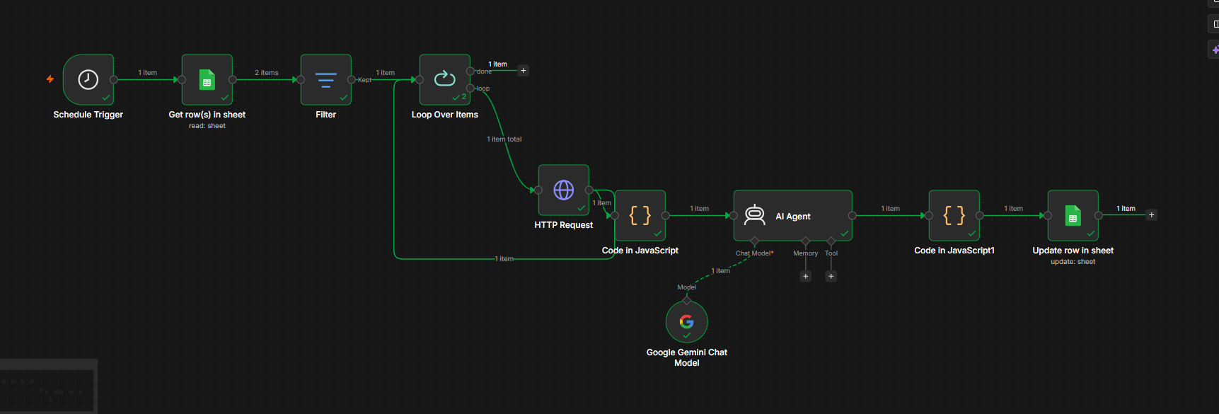

1. Google Sheet Setup
The Google Sheet was prepared with the following columns: Article URL, Title, Summary, Pros, Cons, Long-Term View, Author Verdict, Status, Processed At. Three article links were added with Status set to "Pending" as the starting point.

1a. Empty Sheet (before processing)
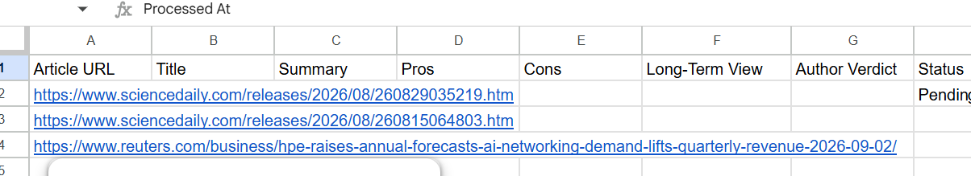

1b. Completed Sheet (after processing)
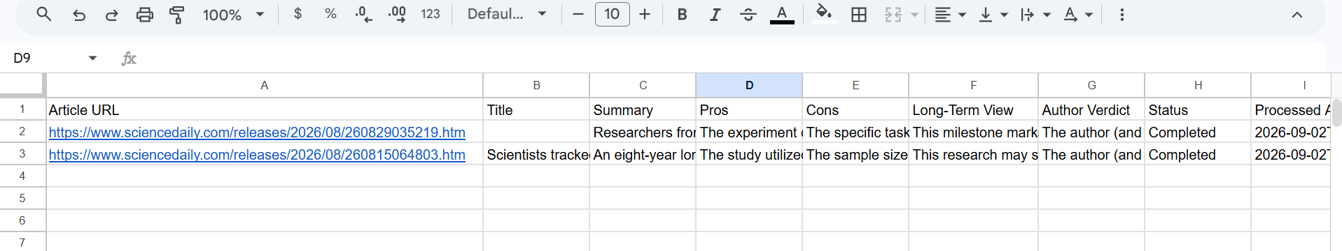

2. Schedule Trigger
Configured to run automatically once per day using n8n's Schedule Trigger node.
Trigger Interval | Days
Time | 08:00 (Hour: 8, Minute: 0)
Timezone | Asia/Karachi

3. Reading Pending Rows
The Google Sheets "Get row(s) in sheet" node reads all rows. A Filter node then keeps only rows where:
- Article URL is not empty
- Status is not equal to "Completed"
This ensures already-processed rows are skipped on re-runs, preventing duplicate processing.

4. Processing Each Article
A "Loop Over Items" node (batch size 1) processes rows one at a time. For each row:
- An HTTP Request node fetches the raw HTML of the Article URL.
- A Code node strips scripts, styles, and HTML tags, collapsing the result into clean, readable article text (this ensures the AI Agent receives real article content, not just a URL).

5. AI Agent Configuration
Model used: Google Gemini (via the Google Gemini Chat Model node in n8n).
System message given to the agent:
"You are a critical article-analysis assistant. Read only the supplied article content. Return: (1) title, (2) a meaningful concise summary, (3) key pros, (4) key cons, (5) long-term implications, and (6) a critical analysis of the author's verdict. Separate facts from the author's opinion. Do not invent information. If the content is unavailable or incomplete, clearly return an error instead of guessing."
The agent is instructed to respond only in structured JSON (title, summary, pros, cons, longTermView, authorVerdict, error), which is then parsed by a Code node into individual fields ready for mapping into the sheet.

6. Updating Google Sheets
A Google Sheets "Update Row" node writes the parsed fields back into the same row, matched by Article URL (so the correct row is always updated, and the URL itself is never changed):
- Title, Summary, Pros, Cons, Long-Term View, Author Verdict ← parsed AI output
- Status ← "Completed"
- Processed At ← current timestamp
The Update node loops back into "Loop Over Items" so the next pending row is processed automatically until the batch is finished.

7. Error Handling
If an article link cannot be fetched (blocked site, invalid URL, timeout), the row's Status is set to "Error" with a short message, and the workflow continues to the next article rather than stopping.

Testing Summary
Test | Result
Manual execution | Pending links read and summarized successfully
Google Sheets update | Output written to the correct row; Status became Completed
Refresh and rerun | Completed rows were skipped, not reprocessed
Invalid link | Marked as Error; workflow continued with next article

Successful Execution Screenshot
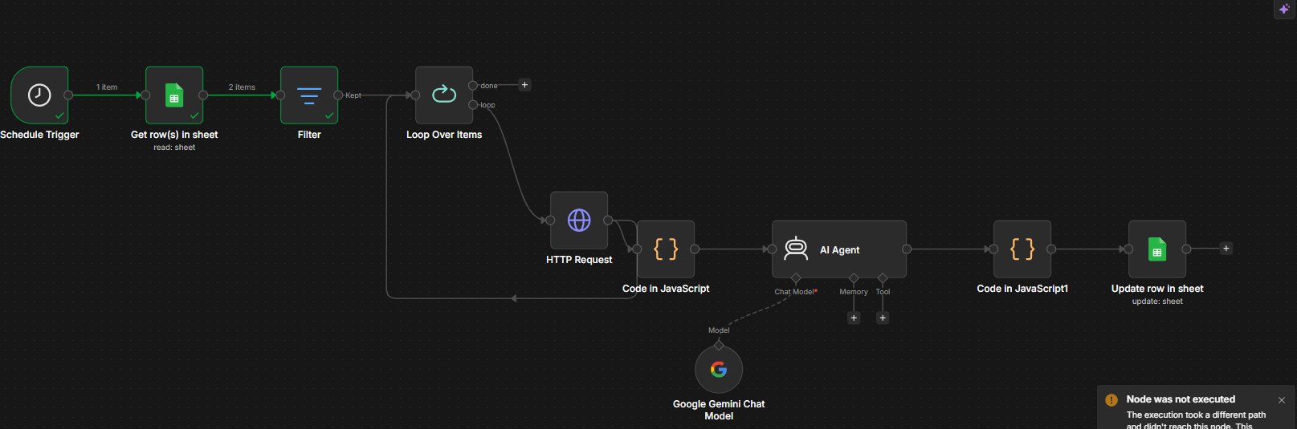

Submission Note
- Schedule time: 08:00 daily
- Timezone: Asia/Karachi
- AI model: Google Gemini (gemini-3-flash-preview)
- Article-reading method: HTTP Request node fetches the raw page; a Code node strips HTML tags/scripts to produce clean readable text before sending it to the AI Agent

