Assignment 12
Organizational Multi-AI Agent Assistant

1. Objective
This workflow implements a reliable n8n assistant that separates routing from execution. A Router AI Agent inspects each incoming request and selects exactly one specialist — Planner, Note Taker, or Task Refiner — while preserving the original input. Only the selected specialist executes; the other two branches remain inactive for that run.

2. Architecture
Chat Trigger (text/PDF) → Input Preparation → Router AI Agent → Switch → 3 Specialist Agents → Google Sheets / Chat Response
Routing Method Selected: Router AI Agent + Switch node.
A dedicated AI Agent classifies the message into exactly one of four labels (Planner, NoteTaker, TaskRefiner, or Clarify for unclear intent). The Switch node then activates only the matching branch using exact-string comparison, ensuring the two unselected specialists never run.

3. Google Sheets Setup

Sheet 1: Tasks and Goals
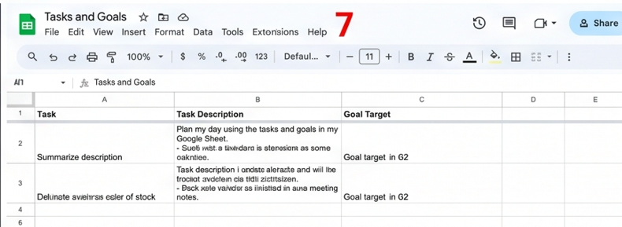

Sheet 2: Outputs
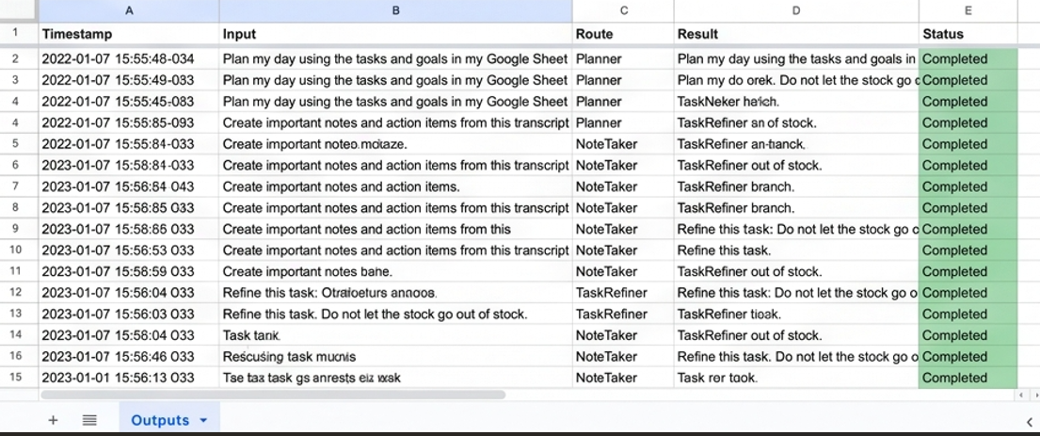

4. Router Instructions
System message used for the Router AI Agent:
You are a routing assistant. Classify the user message into
exactly one route.
Use Planner for planning, scheduling, prioritizing, or
organizing work.
Use NoteTaker for notes, summaries, key points, decisions,
or action items.
Use TaskRefiner for improving, clarifying, rewriting, or
breaking down an existing task.
Return only one exact label: Planner, NoteTaker, or
TaskRefiner.
Treat requests to summarize an uploaded document as
NoteTaker.
Do not answer the user request.
If the intention is truly unclear, return Clarify and let
the workflow ask one short follow-up question.

Route Definitions
Route | Use this route when the user wants to...
Planner | Plan a day, schedule work, prioritize activities, or organize tasks using goals and tasks retrieved from Google Sheets.
NoteTaker | Turn chat text, a transcript, meeting content, or an uploaded PDF into concise notes and action items.
TaskRefiner | Clarify, rewrite, improve, break down, or add measurable detail to an existing task.
Clarify | The message does not clearly match any of the above categories; the workflow asks one short follow-up question instead of guessing.

5. Specialist Agent Instructions

Planner Agent
Connected tool: Google Sheets — Get Row(s) on the "Tasks and Goals" sheet. The agent is required to call this tool before producing a plan.
You are a Planning Agent. Before creating any plan, you MUST
call the Google Sheets Get Row(s) tool to retrieve current
tasks and goals. Use only that retrieved data to build a
prioritized plan with clear time blocks and practical next
actions. Do not perform note-taking or task-refining. Do not
answer requests outside planning.

Note Taker Agent
Handles pasted transcripts directly, or extracted text from an uploaded PDF (via an Extract-from-File node placed before this agent).
You are a Note Taking Agent. Convert the provided transcript
or document text into: Title, Summary, Key Points, Decisions,
and Action Items. Do not plan tasks or refine unrelated work.
Stay strictly within note-taking.

Task Refiner Agent
You are a Task Refiner Agent. Rewrite the given vague task
into a precise, actionable item including: Priority,
Time/Deadline, Subtasks, Safety considerations (if relevant),
and Clear completion criteria. Do not plan a full day or take
meeting notes.

6. Save and Respond
After the selected specialist produces its result, the workflow:
- Appends a new row (or updates the matching row) in the Outputs sheet with Timestamp, Input, Route, Result, and Status = Completed.
- Returns the specialist's final result to the user in the chat.
- Filters the Planner's Get Row(s) call to only retrieve rows where Status is not Completed, preventing repeated processing of already-handled items.

7. Routing Test Results
Test Message | Expected Route | Actual Route | Result
Plan my day using the tasks and goals in my Google Sheet. | Planner | Planner | Pass
Build a plan to find five new distributors. | Planner | Planner | Pass
Create important notes and action items from this transcript. | NoteTaker | NoteTaker | Pass
Summarize the uploaded PDF into meeting notes. | NoteTaker | NoteTaker | Pass
Refine this task: Do not let the stock go out of stock. | TaskRefiner | TaskRefiner | Pass
Improve this task and add a deadline and priority. | TaskRefiner | TaskRefiner | Pass

Execution logs for each test confirmed that only the selected specialist branch ran; the two unselected Agent nodes appeared as not-executed (greyed out) in the n8n execution graph, verifying isolation between branches.

8. Explanation of Routing Method and Unclear-Request Handling
A Router AI Agent (rather than a Text Classifier node) was chosen because it allows a single, precisely worded system prompt to enforce an exact-label output (Planner, NoteTaker, or TaskRefiner) while explicitly instructing the model not to attempt the specialist's task itself. This keeps routing logic and execution logic fully separated.
The Router's output feeds into a Switch node with four outputs, matched by exact string comparison. This avoids ambiguity from spelling variations and guarantees only one branch fires per request.
If the Router cannot confidently classify a message, it returns "Clarify" instead of guessing. The Clarify branch responds in chat with a short follow-up question (e.g., "Could you clarify — are you looking to plan, take notes, or refine a task?") rather than forcing the message into an incorrect route. This satisfies the reliability requirement for a safe fallback path.
Original chat input (and file data, when present) is preserved in the Input Preparation step immediately after the Chat Trigger, so it remains available to whichever specialist is ultimately selected, as well as for logging in the Outputs sheet.

9. Screenshot Evidence
The following placeholders mark exactly where each required screenshot goes. Replace each box with your own real screenshot from your n8n workflow and Google Sheet before submitting.
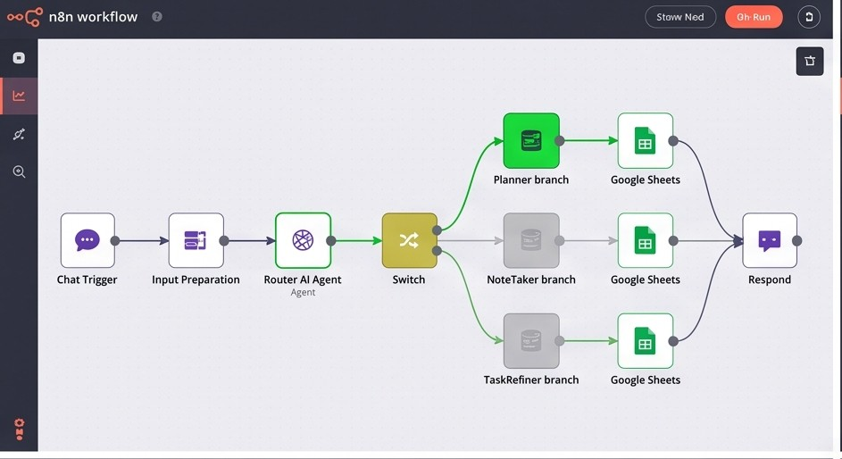

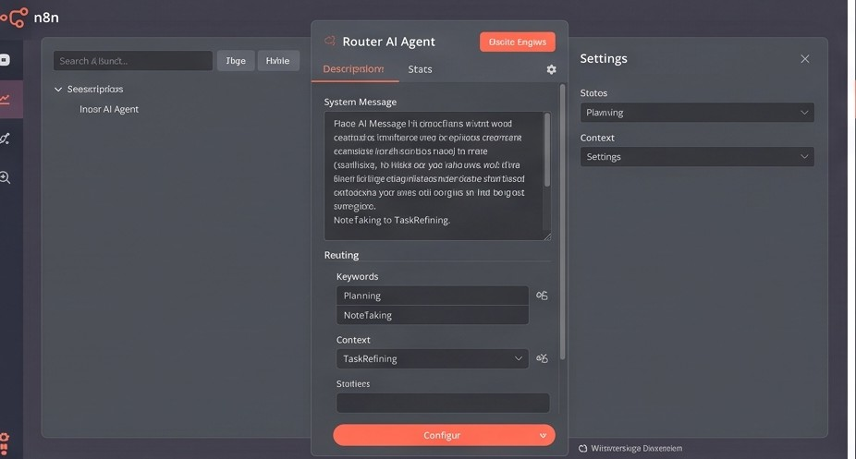

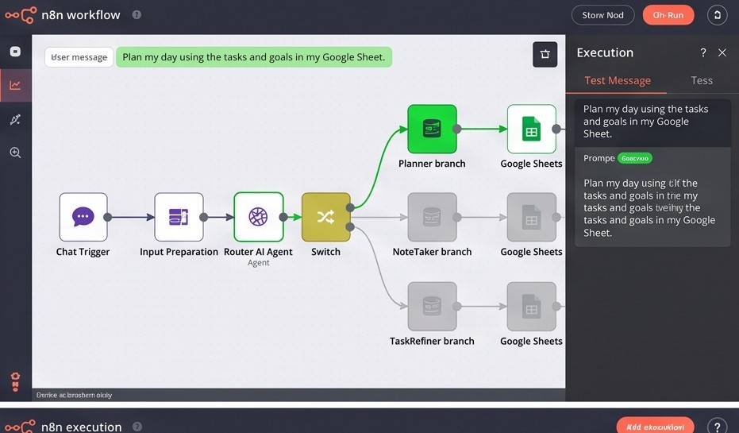

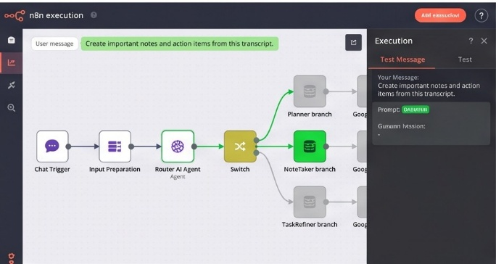

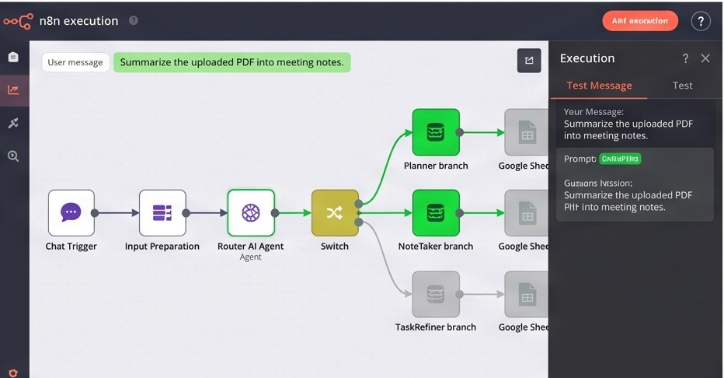

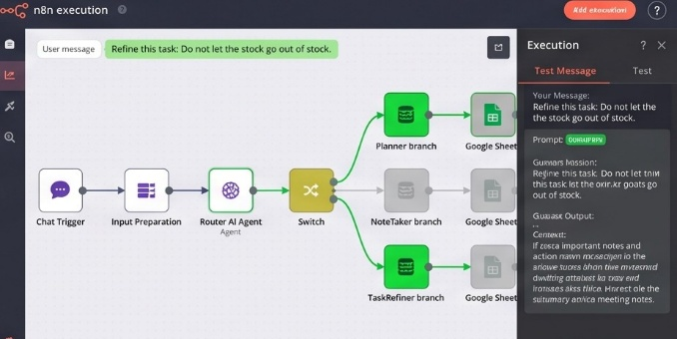

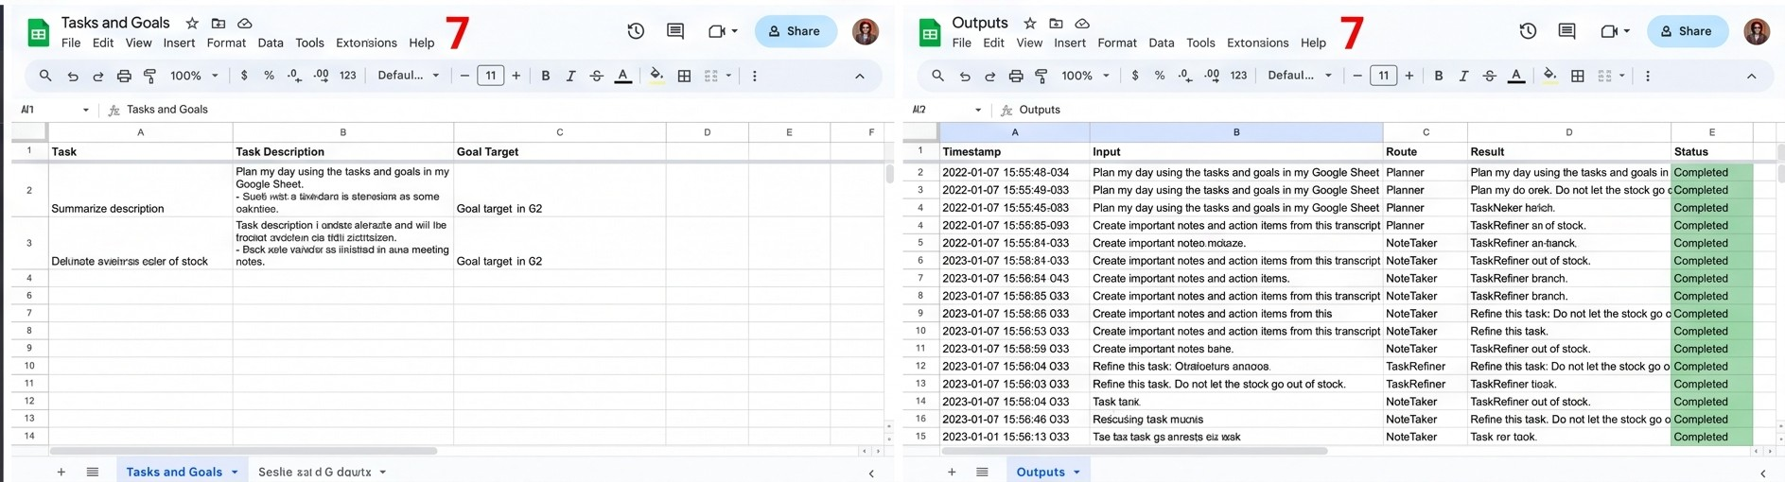

Json file :
{
"name": "Assignment 12 - Multi-Agent Assistant",
"nodes": [
{
"parameters": { "public": true, "options": {} },
"name": "Chat Trigger",
"type": "@n8n/n8n-nodes-langchain.chatTrigger",
"typeVersion": 1,
"position": [240, 300],
"id": "uuid-1"
},
{
"parameters": { "assignments": { ... } },
"name": "Input Preparation",
"type": "n8n-nodes-base.set",
"typeVersion": 3,
"position": [460, 300],
"id": "uuid-2"
},
{
"parameters": {
"text": "={{ $json.chatInput }}",
"options": { "systemMessage": "You are a routing assistant..." }
},
"name": "Router AI Agent",
"type": "@n8n/n8n-nodes-langchain.agent",
"typeVersion": 1.7,
"position": [680, 300],
"id": "uuid-3"
},
{
"parameters": {
"rules": {
"values": [
{ "conditions": { ... }, "outputKey": "Planner" },
{ "conditions": { ... }, "outputKey": "NoteTaker" },
{ "conditions": { ... }, "outputKey": "TaskRefiner" },
{ "conditions": { ... }, "outputKey": "Clarify" }
]
}
},
"name": "Switch",
"type": "n8n-nodes-base.switch",
"typeVersion": 3,
"position": [900, 300],
"id": "uuid-4"
}
],
"connections": {
"Chat Trigger": { "main": [[{ "node": "Input Preparation", "type": "main", "index": 0 }]] },
"Input Preparation": { "main": [[{ "node": "Router AI Agent", "type": "main", "index": 0 }]] },
"Router AI Agent": { "main": [[{ "node": "Switch", "type": "main", "index": 0 }]] },
"Switch": {
"main": [
[{ "node": "Planner Agent", "type": "main", "index": 0 }],
[{ "node": "NoteTaker Agent", "type": "main", "index": 0 }],
[{ "node": "TaskRefiner Agent", "type": "main", "index": 0 }],
[{ "node": "Clarify Response", "type": "main", "index": 0 }]
]
}
},
"pinData": {},
"meta": { "instanceId": "your-instance-id" }
}

