Assignment 7
Supplier Research Automation with Apify & Make.com

Objective
Build an end-to-end automation in Make.com that reads brand names from a Google Sheet, searches for each brand using Apify, extracts contact details from the search results using a second Apify actor, and writes the final results back into a Google Sheet — brand name, source URL, and contact details.

Workflow Overview — 6 Modules
The scenario follows six functional steps in this fixed order. Make.com may assign different internal module numbers, but the sequence and data mapping below must be followed.
# | Module | Action | Purpose
1 | Google Sheets | Search Rows | Read brand names from the input sheet (column: Brand_Name)
2 | Apify | Run an Actor | Run a Google Search actor using the brand name as the query
3 | Apify | Get Dataset Items | Fetch the search-result URLs produced by the Google Search actor
4 | Apify | Run an Actor | Run a Contact Details actor using URLs from Module 3 as input
5 | Apify | Get Dataset Items | Fetch the extracted contact details from the Contact Details actor
6 | Google Sheets | Add a Row | Write Brand Name, Source URL, and Contact Details to the output sheet

Setup — Before Building in Make.com

1. Input Google Sheet
- Create a new Google Sheet (e.g. "Supplier Research – Input").
- Column A header: Brand_Name
- Add at least 3–5 brand names to test with.

2. Output Google Sheet
- Create a new Google Sheet (e.g. "Supplier Research – Output").
- Headers in row 1: Brand_Name, Source_URL, Contact_Details
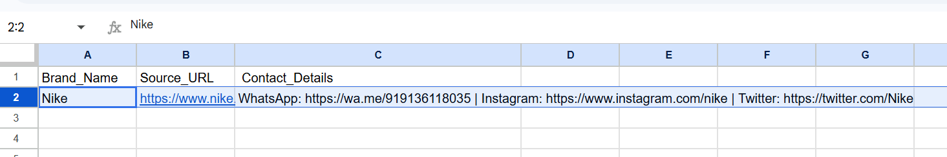

3. Apify Account & Actors
- Sign up at apify.com and go to Settings → Integrations to copy the API token.
- From the Apify Store, activate a Google Search actor (used to find brand search results).
- From the Apify Store, activate a Contact Details / contact-extraction actor (used to pull emails, phones, and other contact info from a URL).
- Click "Try for free" on each actor's page so it becomes available in your Apify account.

4. Connections in Make.com
- Add a Google Sheets connection (OAuth sign-in).
- Add an Apify connection using the copied API token.

Building the Scenario in Make.com

Module 1 — Google Sheets: Search Rows
- Add a new scenario and search for the Google Sheets app.
- Select the "Search Rows" action.
- Connect the Google account when prompted.
- Select the input spreadsheet and the correct sheet/tab.
- Run the module once to confirm the brand rows are being read correctly.

Module 2 — Apify: Run an Actor (Google Search)
- Add an Apify module and select the "Run an Actor" action.
- Connect the Apify account using the API token.
- Select the Google Search actor.
- Map the search query input field to the Brand_Name value coming from Module 1.
- Enable "Run synchronously" so Make waits for the actor to finish before continuing.
- Save and run once to confirm the actor completes successfully and returns a Dataset ID.

Module 3 — Apify: Get Dataset Items (search results)
- Add another Apify module and select "Get Dataset Items".
- Map the Dataset ID field to the dataset ID output from Module 2 (not typed manually — selected from the field picker).
- Set Format to JSON and an appropriate Limit.
- Run once and confirm the module returns a list of organic search results, each with a URL field.

Module 4 — Apify: Run an Actor (Contact Details)
- Add an Apify module and select "Run an Actor".
- Select the Contact Details actor.
- Map the actor's start-URL input to the URL field coming from Module 3.
- Enable "Run synchronously".
- Save and run once to confirm the actor succeeds and returns a new Dataset ID.

Module 5 — Apify: Get Dataset Items (contact details)
- Add another "Get Dataset Items" module.
- Map the Dataset ID field to the dataset ID output from Module 4.
- Run once and confirm contact fields are returned (emails, phones, social links, or other available contact data).

Module 6 — Google Sheets: Add a Row
- Add a Google Sheets module and select "Add a Row".
- Select the output spreadsheet and sheet/tab.
- Map Brand_Name to the value from Module 1.
- Map Source_URL to the URL field from Module 3 (or Module 5, whichever reflects the page that was scraped).
- Map Contact_Details to the relevant fields from Module 5 (emails, phones, and/or social contact links combined into one field).
- Save and run once to confirm a new row is written correctly to the output sheet.

Full Scenario
Once all six modules are connected in order, the scenario should look like a single continuous flow with no broken connections or warning icons on any module.
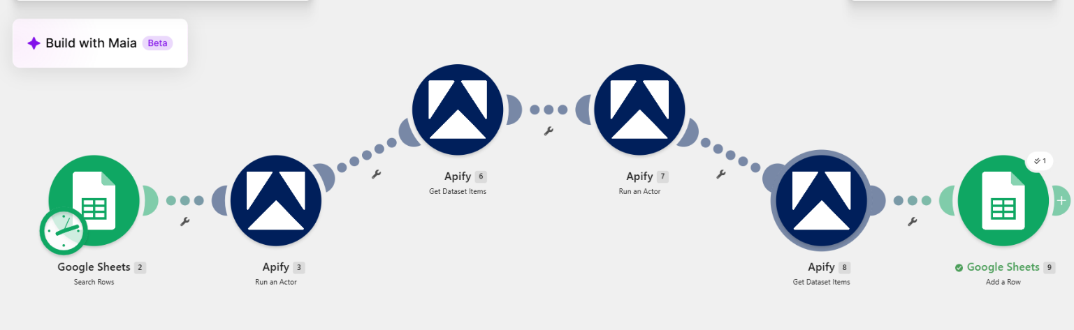

Testing
The scenario was tested end-to-end with at least three different brand names. For each brand, the following was confirmed:
- The row was written to the output sheet automatically (no manual entry).
- Source_URL and Contact_Details were not empty.
- Data was correctly aligned with the corresponding brand in the same row.
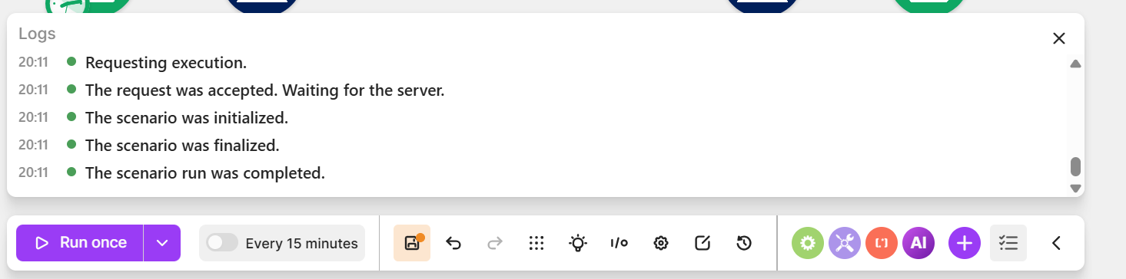

Required Output Format
Brand Name | Source URL | Contact Details
Original input brand | Website or search-result URL used | Email, phone, contact person, address, or other available data

Apify Actors Used
- Actor 1 (Google Search): [name of the Google Search actor used, e.g. "Google Search Results Scraper"] — used in Module 2 to find search-result URLs for each brand.
- Actor 2 (Contact Extraction): [name of the Contact Details actor used] — used in Module 4 to extract contact information from those URLs.

