Session 6 Assignment: Certificate Automation with Make.com
Submitted by: Inshal Zafar

1. Objective
Built a Make.com scenario that reads a student's Name, Date, and Email from a Google Sheet, generates a personalized certificate from a Google Slides template, exports it as a PDF, and emails it to the student automatically — with no manual editing or manual sending.

2. Automation Flow
- Google Sheets — Watch New Rows (reads Name, Date, E-mail, Status)
- Google Slides — Create a Presentation from a Template (replaces {{Name}} and {{Date}} tags)
- Google Drive — Download a File (exports the Slides file as PDF)
- Gmail — Send an Email (sends the PDF certificate to the student's email)

3. Google Sheet — Input Data
Sheet columns: Name, Date, E-mail, Status. Three test rows were added (Inshal, Taha, Rashida) with valid email addresses and Status set to Pending.
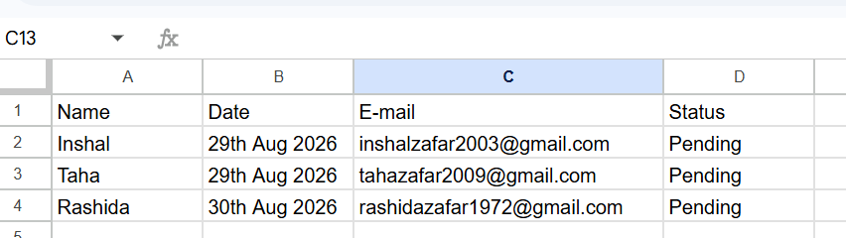

4. Google Slides — Certificate Template
A master certificate template was designed with a title, a decorative border, and two placeholder tags — {{Name}} and {{Date}} — positioned where the student's details should appear. This master file is never edited directly; Make.com duplicates it for each new entry.
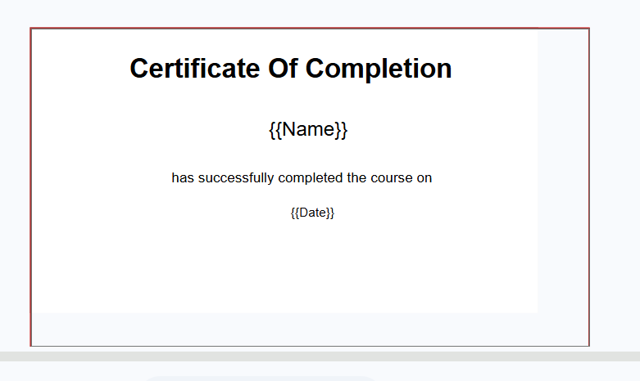

5. Make.com Scenario — Full Setup
All four modules were connected in sequence: Google Sheets to Google Slides to Google Drive to Gmail, with correct field mapping at each step (Name and Date mapped into the template, the generated file's ID passed to Drive for PDF export, and the resulting PDF attached to the Gmail module).
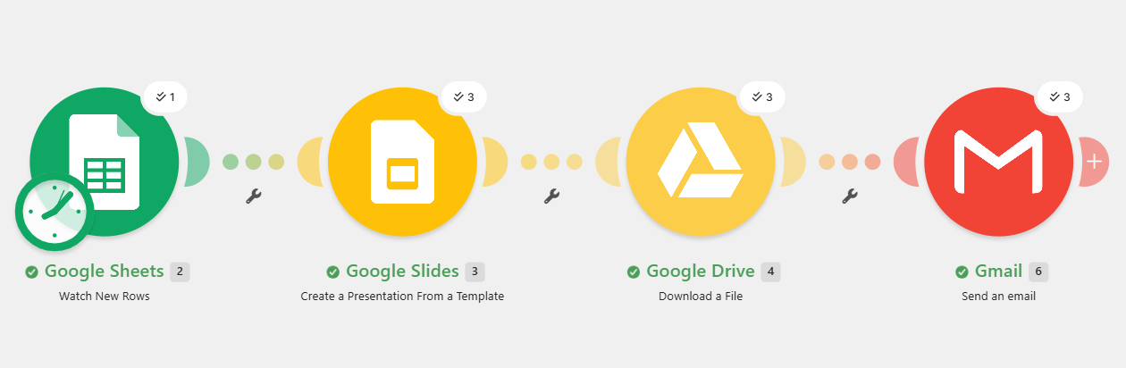

6. Test Run — Execution Logs
The scenario was run manually using "Run once." All modules completed successfully with green checkmarks, and the run logs confirm the scenario was initialized, executed, and finalized without errors.
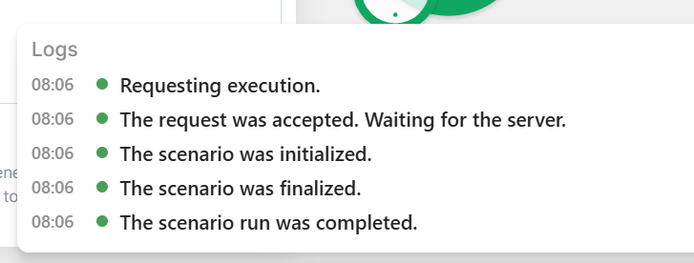

7. Generated Certificate & Email Delivery
The generated certificate PDF was checked in Google Drive to confirm the {{Name}} and {{Date}} tags were correctly replaced with real data from the sheet, and the test inbox was checked to confirm the email arrived with the PDF attached and readable.
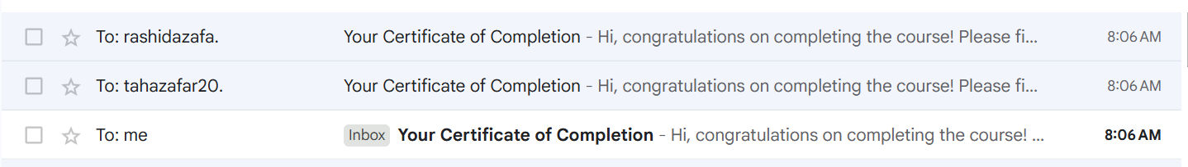
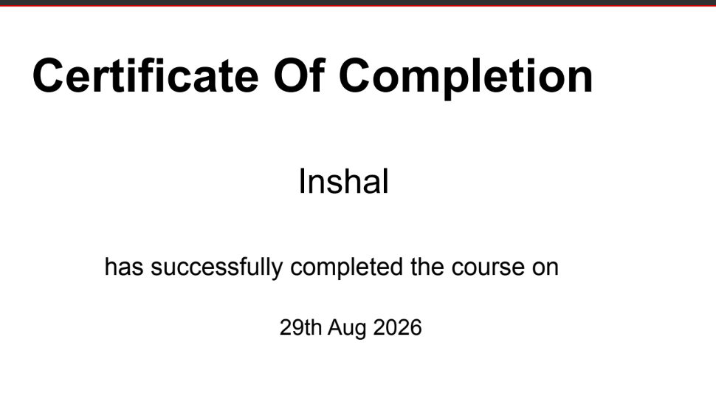

8. Issues Faced & Fixes Applied
- Google Sheets module returned a 404 error — fixed by replacing the spreadsheet name with the actual Spreadsheet ID copied from the sheet's URL.
- Gmail attachment validation failed initially — fixed by disabling raw "Map" mode and instead using the built-in "Google Drive - Download a File" attachment option, which correctly bundles filename and file data together.
- Google Drive File ID field was defaulting to a static file instead of the dynamically created certificate — fixed by switching the field to "Enter manually" and mapping it to the Presentation ID output from the Google Slides module.

9. Acceptance Criteria — Status
Item | Status
Sheet input: Name, Date, and Email read from the same row | Met
Certificate: New Slides file created from template with correct values | Met
Delivery: Correct recipient receives certificate as PDF attachment | Met
Reliability: Three test rows succeed without errors | Met

10. Submission Checklist
Item | Status
Screenshot of complete Make.com scenario (all modules connected) | Attached
Screenshot/recording of one successful scenario run | Attached
Google Sheet screenshot with test data | Attached
Google Slides template screenshot with tags | Attached
Generated certificate PDF sample | Attached
Proof of received email | Attached
Short screen recording of full run | To be linked separately

11. Final Note
The full workflow runs end to end with no manual steps — the certificate is generated, converted to PDF, and emailed automatically once a new row is detected in the Google Sheet.

