MealPlan
Recipe & Meal Planning App with Automated Grocery List Generation

Final Capstone Project Report
Vibe Coding and AI Automation Course
Submitted by: Inshal Zafar
Date: 20th September ,2026
Live App Link: meaplanner.netlify.app
GitHub Repository: https://github.com/InshalZafar/capstone

Table of Contents
Table of Contents
1. Problem Statement 4
1.1 Target Users 4
1.2 User Roles 4
2. Objectives 4
2.1 Measurable Success Criteria 4
3. Scope & Assumptions 5
3.1 In Scope 5
3.2 Out of Scope 5
3.3 Assumptions 5
4. Core Features 5
4.1 Feature List 5
4.2 Pages 6
4.3 User Flow 6
5. Data Model 6
5.1 Entity Relationship Overview 6
5.2 Tables 6
5.3 Constraints & Access Rules 7
6. System Architecture 7
6.1 Technology Stack 7
6.2 Architecture Diagram 7
6.3 Project Structure 7
7. Core Business Logic: Shopping List Generation 8
7.1 Algorithm 8
7.2 Example 8
8. Security 8
9. Testing 9
9.1 Testing Approach 9
9.2 Test Cases & Results 9
9.3 Screenshots — Responsive Layout 9
10. Deployment 9
10.1 Platform Decision 9
10.2 Deployment Steps 10
10.3 Verification 10
11. Known Limitations 11
12. Conclusion 11
13. Appendix 11
13.1 Local Setup Instructions 11

1. Problem Statement
Home cooks who plan meals ahead of time often struggle with three recurring problems: forgetting ingredients while shopping, buying duplicate items because ingredients are scattered across multiple recipes, and wasting time manually consolidating a grocery list every week. Existing note-taking or spreadsheet approaches do not scale well and require significant manual effort.
MealPlan addresses this by letting a user save their recipes once, assign those recipes to specific days and meal slots across a week, and automatically generate a single, merged shopping list where shared ingredients across recipes are combined into one line item.

1.1 Target Users
- Primary user: home cooks who meal-plan on a weekly basis (busy professionals, students, families).
- Secondary use case: anyone who wants a simple, centralized place to store recipes and generate shopping lists.

1.2 User Roles
The application uses a single authenticated user role. Each user's recipes, meal plans, and shopping lists are private to their account. A single-role design was chosen deliberately to keep the scope realistic and to keep the core workflow (recipe → plan → shopping list) as the primary focus of the capstone.

2. Objectives
- Apply the full development lifecycle: requirements, data modeling, frontend, backend, database integration, security, testing, and deployment.
- Build a genuinely useful tool with a complete, working CRUD workflow backed by a live database — not a static or mock-data prototype.
- Demonstrate backend logic beyond basic CRUD through the shopping list ingredient-merging algorithm.
- Deliver a secure, responsive, production-ready application that can be deployed and used by a real person.

2.1 Measurable Success Criteria
- A user can create at least 3 recipes, assign them across a full week's meal plan, and generate a shopping list.
- Ingredients shared between two or more recipes are correctly summed into a single shopping list line (verified by testing — see Section 9).
- All data persists correctly across page refreshes and login sessions.
- The application is usable on both mobile and desktop screen sizes.
- Protected routes and data cannot be accessed by unauthenticated users or by other users' accounts.

3. Scope & Assumptions

3.1 In Scope
- Recipe management: create, read, update, delete recipes with ingredients and instructions.
- Weekly meal planning: assign recipes to a day-of-week / meal-type grid.
- Automatic shopping list generation with ingredient merging.
- User authentication and per-user data isolation.
- Responsive UI for mobile and desktop.

3.2 Out of Scope
- Multi-user households or shared meal plans (single-user accounts only).
- Fuzzy ingredient matching (e.g. treating "garlic" and "garlic clove" as the same item).
- Nutrition tracking or calorie counting.
- Password reset via email (would require email-sending infrastructure).
- Recipe image uploads.

3.3 Assumptions
- Each user manages their own personal recipe collection; recipes are not shared publicly between users.
- A "week" always starts on Sunday for the purposes of the meal planner grid.
- Ingredient units are restricted to a fixed, predefined set to keep quantity merging mathematically reliable.

4. Core Features

4.1 Feature List
Feature | Description
User Authentication | Signup, login, logout with hashed passwords and session-based access control.
Recipe Management | Full CRUD for recipes, including a dynamic ingredient list (add/remove rows) per recipe.
Weekly Meal Planner | A 7-day × 4-meal-slot grid where the user assigns saved recipes to specific slots.
Shopping List Generation | Merges ingredients across every recipe planned for the week, summing quantities per (ingredient, unit) pair.
Shopping List Checklist | Users can check off items while shopping; state persists.
Dashboard | At-a-glance summary of recipe count, meals planned this week, and shopping list preview.

4.2 Pages
- Home (public landing page)
- Sign up / Log in
- Dashboard
- Recipes — list, create, view, edit
- Meal Planner — weekly grid
- Shopping List — view and check off items

4.3 User Flow
Sign up or log in → Dashboard → add recipes (Recipes page) → open Meal Planner and assign recipes to day/meal slots for the current week → click "Generate shopping list" → review and check off items on the Shopping List page.
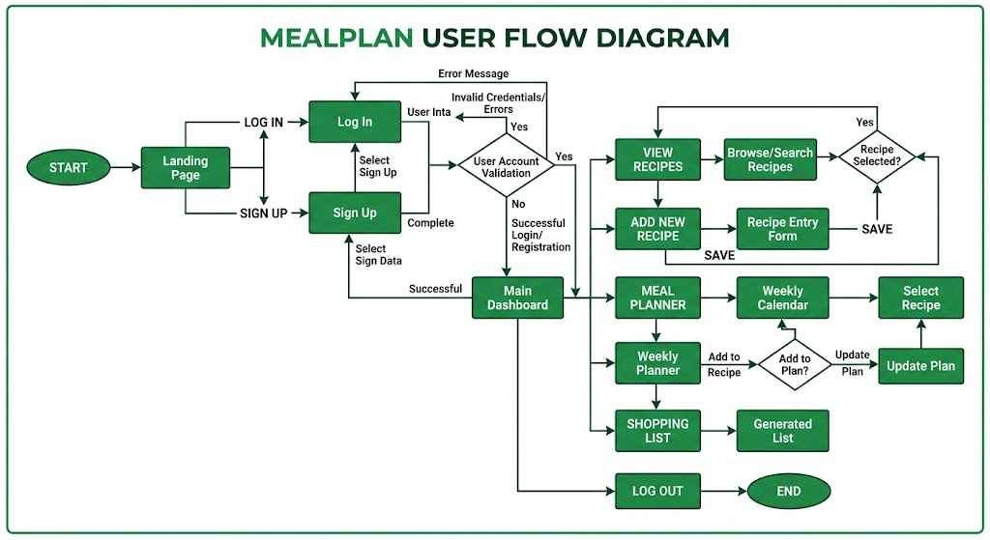

5. Data Model
The database was designed before implementation, with tables, relationships, and constraints planned to support the full CRUD workflow and to make the shopping-list merge logic reliable.

5.1 Entity Relationship Overview
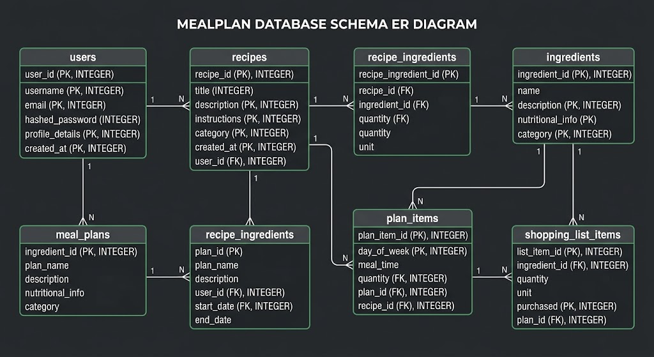

5.2 Tables
Table | Key Columns
users | id, name, email (unique), password_hash, created_at
recipes | id, user_id (FK → users), title, description, instructions, servings, prep_time_minutes, tags
ingredients | id, recipe_id (FK → recipes), name, quantity, unit
meal_plans | id, user_id (FK → users), week_start_date (unique per user)
plan_items | id, meal_plan_id (FK → meal_plans), recipe_id (FK → recipes), day_of_week, meal_type
shopping_list_items | id, meal_plan_id (FK → meal_plans), ingredient_name, total_quantity, unit, is_checked

5.3 Constraints & Access Rules
- quantity and servings must be greater than 0 (enforced with CHECK constraints).
- unit is restricted to a fixed set of values (g, kg, ml, l, tsp, tbsp, cup, oz, lb, piece, pinch) so that ingredient merging by unit is reliable.
- day_of_week is constrained to 0–6; UNIQUE(meal_plan_id, day_of_week, meal_type) ensures each slot holds exactly one recipe.
- All foreign keys use ON DELETE CASCADE, so deleting a recipe or plan automatically cleans up dependent rows.
- Every query is scoped to the authenticated user's user_id, either directly or via a join to a parent row the user owns — this is the primary access-control mechanism.

6. System Architecture

6.1 Technology Stack
Layer | Choice & Rationale
Frontend | Server-rendered EJS templates, vanilla JavaScript for dynamic form rows, custom CSS design system (responsive, mobile-first)
Backend | Node.js with Express — route handlers organized by resource (auth, recipes, planner, shopping list)
Database | SQLite (via better-sqlite3), file-based relational database
Authentication | express-session with a SQLite-backed session store; bcryptjs for password hashing
Validation | express-validator for server-side input validation

6.2 Architecture Diagram
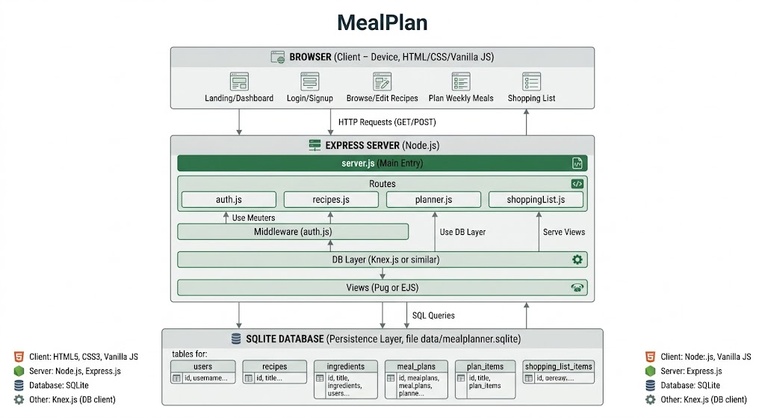

6.3 Project Structure
server.js (entry point) → routes/ (auth, recipes, planner, shoppingList) → db/ (schema, connection, business logic) → middleware/ (auth guard) → views/ (EJS templates) → public/ (CSS/JS assets).
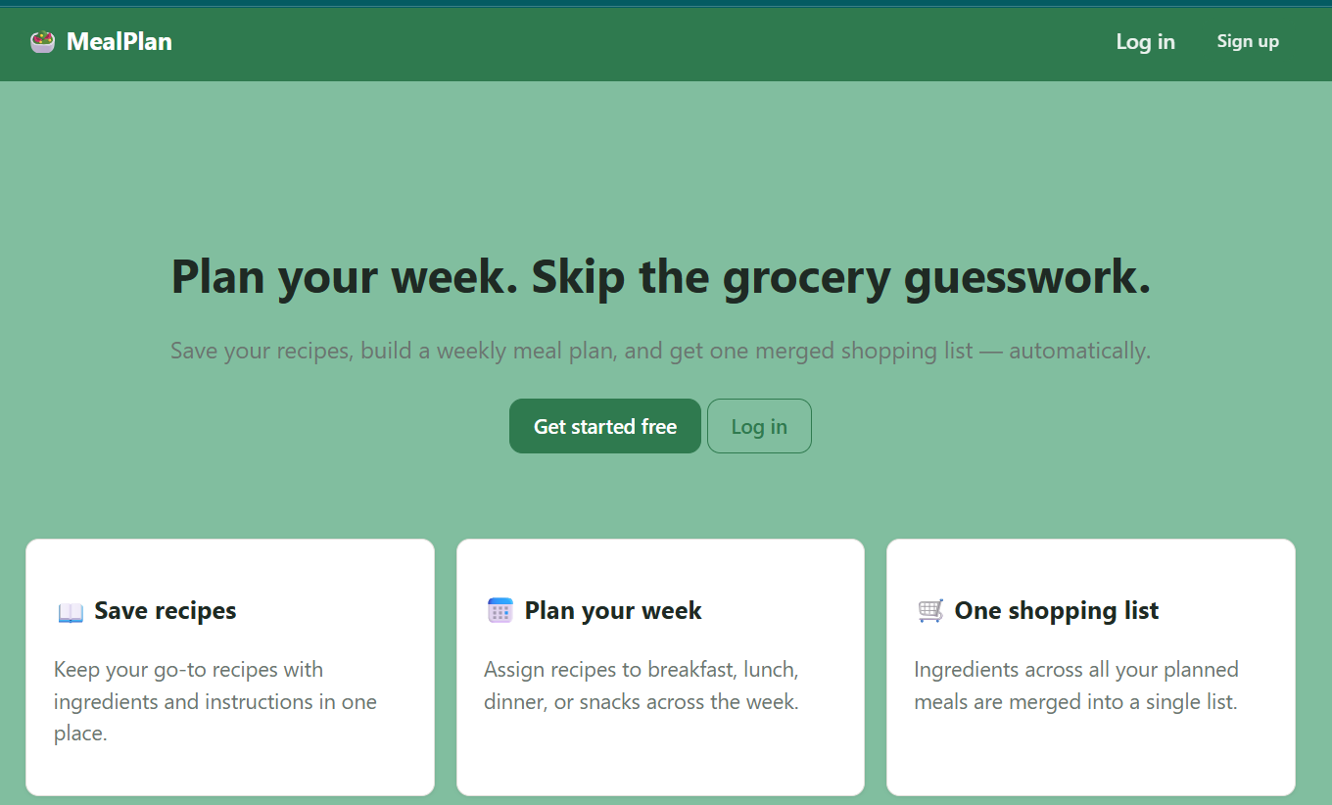

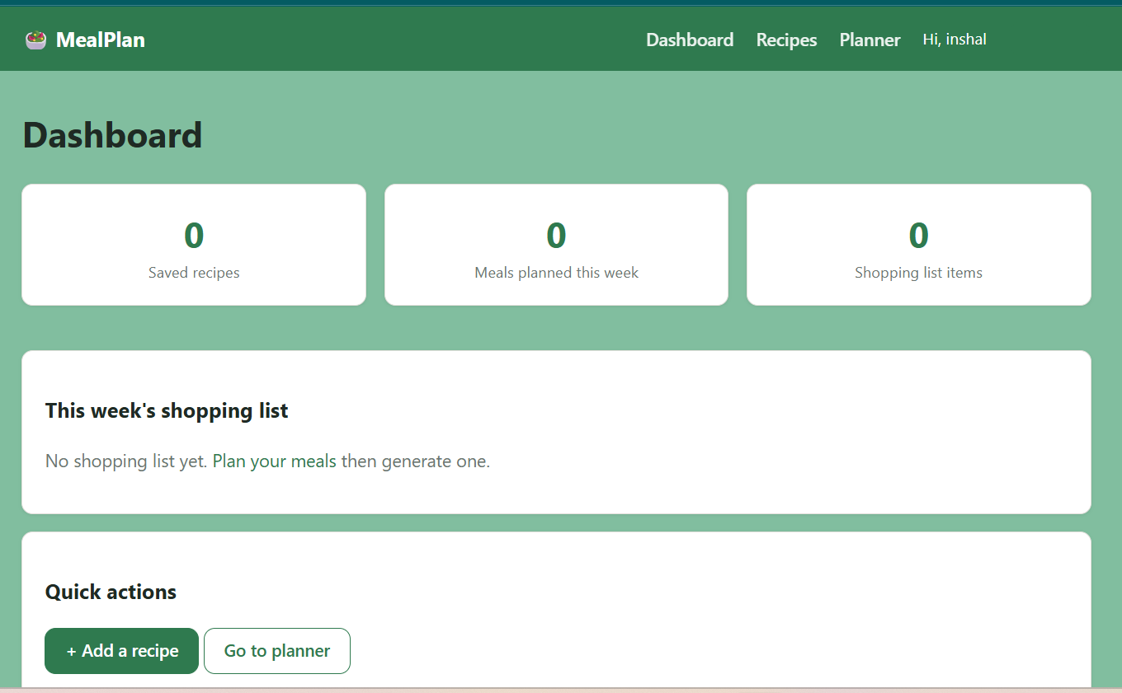
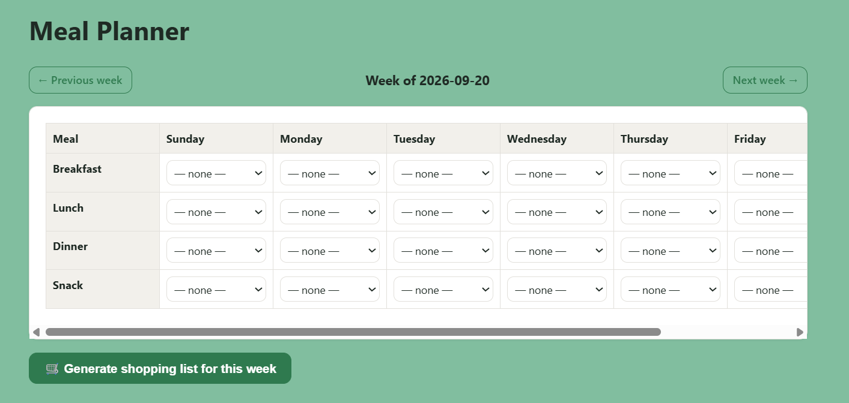

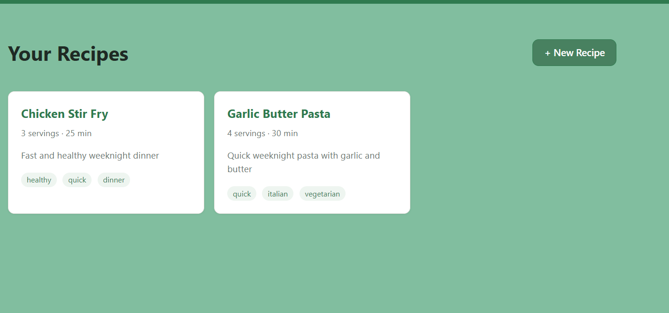

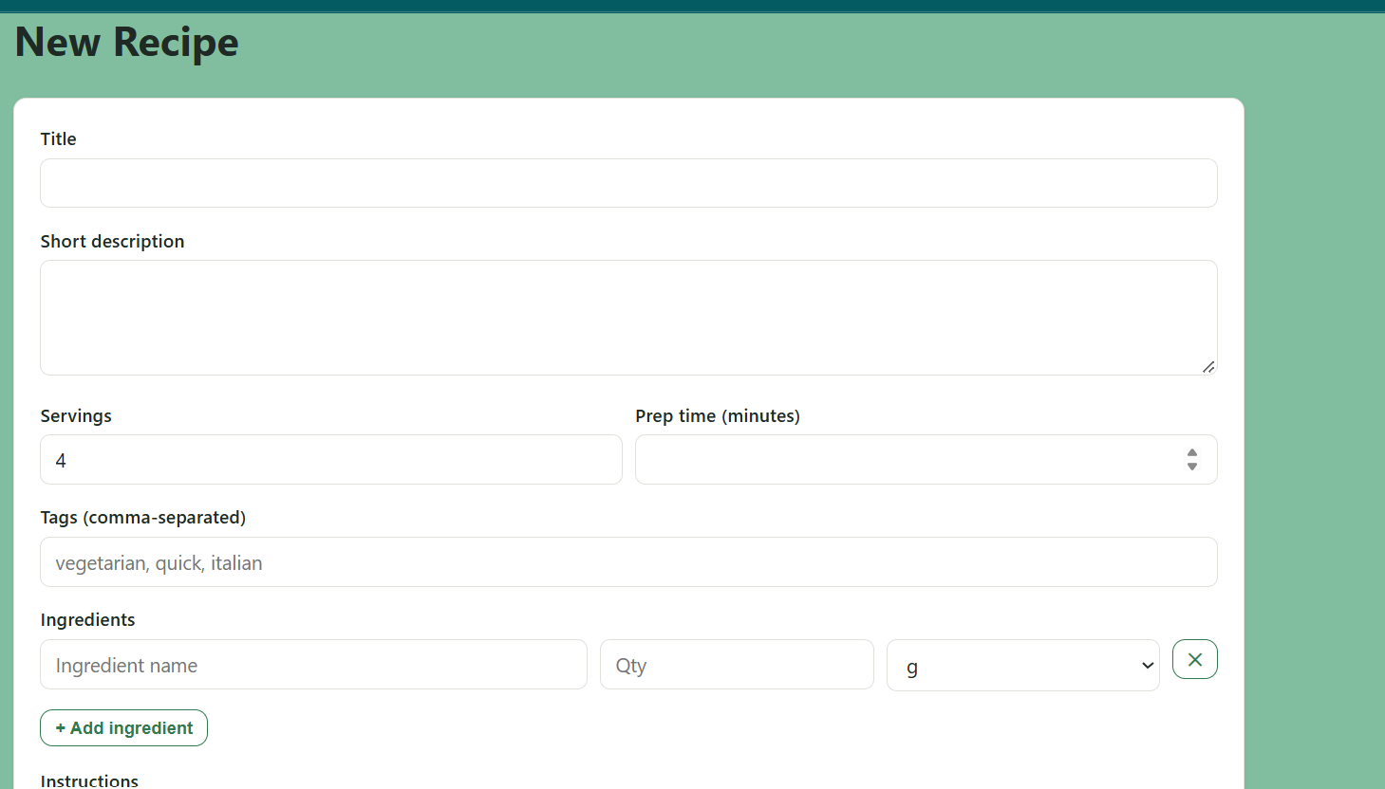

7. Core Business Logic: Shopping List Generation
This is the most significant piece of backend logic in the application, going beyond simple CRUD operations.

7.1 Algorithm
- 1. Verify the requesting user owns the meal plan (authorization check).
- 2. Count how many times each recipe appears across the week's plan_items (a recipe used 3 times needs 3x its ingredient quantities).
- 3. Retrieve every ingredient for each planned recipe.
- 4. Normalize each ingredient name (trim whitespace, lowercase) so that formatting differences don't create duplicate lines.
- 5. Group ingredients by (normalized name, unit) and sum their quantities, weighted by recipe usage count.
- 6. Replace the plan's existing shopping_list_items with the freshly computed, merged list inside a single database transaction.

7.2 Example
If "Garlic Pasta" (2 pieces of garlic) and "Garlic Bread" (3 pieces of garlic) are both planned in the same week, the generated shopping list contains a single line: "5 piece — garlic" — rather than two separate lines. This was verified directly during testing (see Section 9.2).
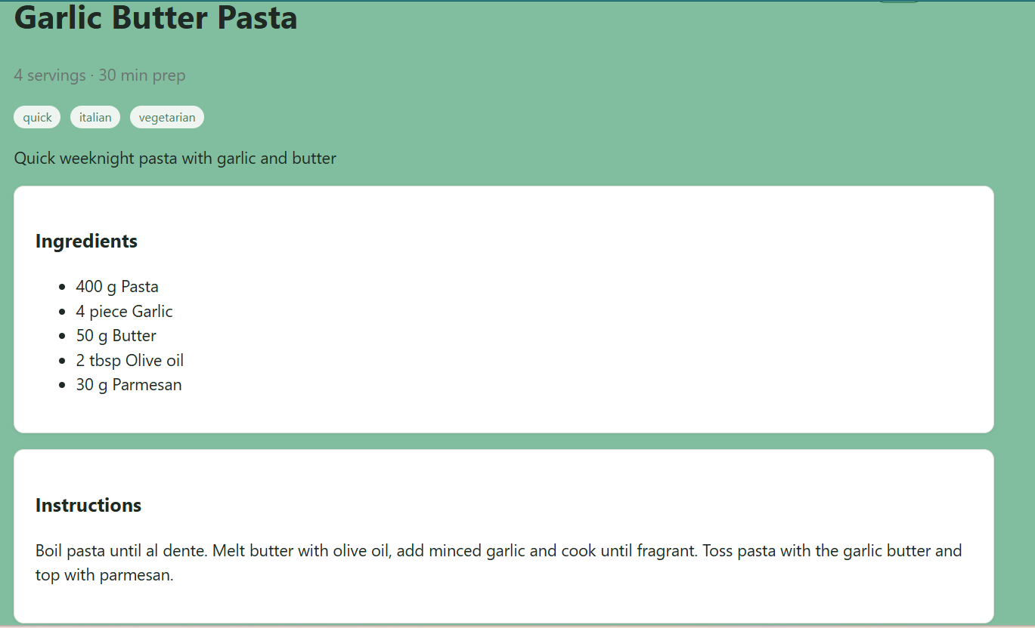

8. Security
- Passwords are hashed with bcryptjs (10 salt rounds) — plain-text passwords are never stored.
- Session-based authentication using express-session, backed by a server-side SQLite session store (not vulnerable to client-side token tampering).
- Every protected route is wrapped in a requireAuth middleware that redirects unauthenticated requests to the login page.
- Every database query is scoped by the authenticated user's ID (directly or via a join to an owned parent row), preventing users from viewing or modifying another user's data.
- All form input is validated server-side with express-validator, independent of any client-side validation.
- Secrets (session secret, environment-specific config) are kept in a .env file, excluded from version control via .gitignore.

9. Testing

9.1 Testing Approach
The application was tested manually across the main user journey, invalid inputs, permissions boundaries, data persistence, and responsive layout, in addition to functional verification of the shopping-list merge algorithm.

9.2 Test Cases & Results
Test Case | Result
Signup with duplicate email | Rejected with a clear validation error — Pass
Login with incorrect password | Rejected with a generic "invalid email or password" message — Pass
Create recipe with multiple ingredients | Recipe and ingredients saved correctly and displayed on detail page — Pass
Edit and delete a recipe | Changes persist; deletion cascades to remove associated ingredients — Pass
Assign recipes to meal plan slots | Assignments saved and correctly displayed in the weekly grid — Pass
Generate shopping list (shared ingredient across 2 recipes) | Ingredient quantities correctly summed into a single merged line (2 + 3 = 5 pieces of garlic) — Pass
Toggle shopping list item checkbox | Checked state persists correctly after page reload — Pass
Access protected page while logged out | Redirected to login page (HTTP 302); no data exposed — Pass
Mobile layout (narrow viewport) | Planner table scrolls horizontally; recipe grid reflows to a single column — Pass

10. Deployment

10.1 Platform Decision
SQLite is a file-based database and requires persistent disk storage, which rules out purely serverless platforms such as Netlify (whose functions have no persistent filesystem between invocations). The application is instead deployed to a platform that supports a persistent disk or volume alongside a long-running Node.js process.

10.2 Deployment Steps
- 1. Push the project to a GitHub repository.
- 2. Create a new Web Service on the hosting platform (e.g. Render or Railway) connected to that repository.
- 3. Set the build command to "npm install" and the start command to "npm start".
- 4. Attach a persistent disk/volume so the SQLite database file survives restarts and redeploys.
- 5. Configure the SESSION_SECRET environment variable.
- 6. Deploy and verify the public URL, confirming that signup, login, and live database read/write operations work correctly after deployment.

10.3 Verification
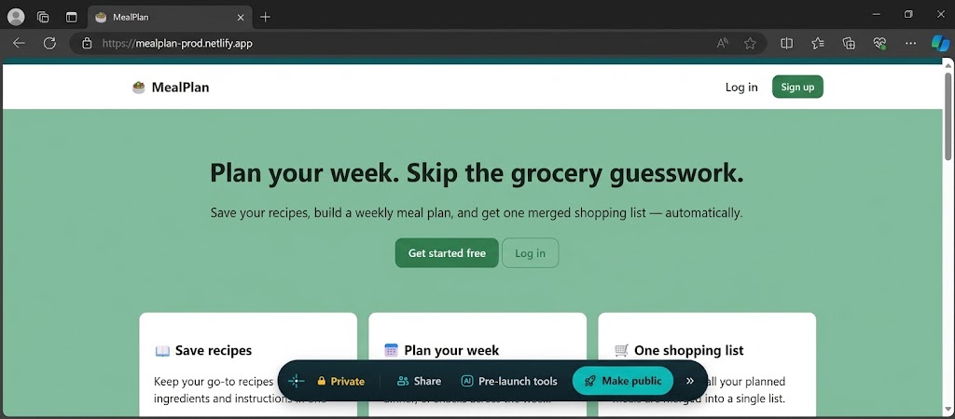

11. Known Limitations
- Ingredient merging matches on exact normalized name and unit; "garlic" and "garlic clove" are treated as different ingredients (no fuzzy matching).
- Single user role only — no shared households or admin oversight.
- No password-reset flow, which would require email-sending infrastructure.
- No recipe image uploads; recipes are text-only.
- The chosen deployment platform must support persistent disk storage; this constrains hosting options compared to a fully serverless database.

12. Conclusion
MealPlan successfully demonstrates the complete application development lifecycle covered in this course: problem definition, data modeling, frontend and backend development, database integration, security, testing, and deployment. The application solves a genuine, well-scoped problem for a clearly defined user, and its core shopping-list generation feature demonstrates backend logic that goes meaningfully beyond basic CRUD operations.
All success criteria defined in Section 2.1 were met and verified through manual testing. The project is complete, live, and usable, with known limitations documented transparently rather than hidden, and with a clear path for future enhancement (fuzzy ingredient matching, shared households, and richer notifications are natural next steps).

13. Appendix

13.1 Local Setup Instructions
1. Install dependencies: npm install
2. Copy environment variables: cp .env.example .env
3. Start the application: npm start
4. Open http://localhost:3000 — the SQLite database is created automatically on first run.

