Pexels Image Download Chatbot — n8n Automation
Assignment: AI Workflow Automation Course — Assignment 10
Author: Inshal Zafar
Date: 6th September 2026

1. Overview
This document describes a conversational n8n automation that allows a user to request an image in natural language via chat. The workflow interprets the request using an AI Agent, searches the Pexels API for a matching photo, downloads the image as binary data, uploads it to a specified Google Drive folder, and confirms the result back to the user in the chat.
Workflow Flow:
Chat Trigger -> AI Agent (+ Pexels HTTP Tool) -> Parse/Validate -> Download Image (HTTP Request, binary) -> Google Drive Upload -> Chat Response

2. Configuration Summary
Item | Value
AI Model used | Gemini 3.5 Flash
Pexels image field used | src.large (or src.large2x)
Binary property name | data
Google Drive destination folder | Pexels Chatbot Images
Pexels per_page setting | 3
Filename convention | {search_term}_{photo_id}_{timestamp}.jpg

3. Prerequisites Completed
☐ Pexels account created and API key generated
☐ Pexels API key stored securely as an n8n credential (HTTP Header Auth) — never placed directly in visible node fields or prompts
☐ Google Drive OAuth2 credential connected in n8n
☐ Destination Google Drive folder created and its ID/name noted
☐ Chat model (AI provider) credential connected in n8n

4. Node-by-Node Build Documentation

4.1 Chat Trigger
Node type: Chat Trigger ("When chat message received")
Purpose: Entry point that accepts natural-language image requests from the user (e.g., "Download a professional office team image").
Configuration notes: Default settings; output field used downstream is chatInput.

4.2 AI Agent
Node type: AI Agent
Connected Chat Model: Gemini 3.5 Flash
System Message used:
You are an image-search assistant. Understand the user's request and create a
concise Pexels search query using the subject and any useful style, orientation,
setting, or color details. Use the Pexels search tool, select a relevant photo,
and continue the download-and-upload workflow. Never reveal credentials. If the
request is empty, unsafe, or returns no photo, explain the issue clearly. After
upload, confirm the filename, Drive destination, photographer, and source page.
Tools attached: Pexels Search HTTP Request Tool (see 4.3)
Output format: Agent instructed to return structured JSON containing query, imageUrl, photographer, photoId, and pageUrl for use in downstream nodes.

4.3 Pexels Search (HTTP Request Tool)
Node type: HTTP Request Tool (attached to AI Agent)
Method: GET
URL: https://api.pexels.com/v1/search
Query Parameters:
- query — supplied dynamically by the Agent
- per_page — 3
Headers:
- Authorization — Pexels API key (via n8n credential, not hardcoded)
Tool description given to Agent: Explains that the tool returns a photos array, each with src.large, photographer, id, and url fields.

4.4 Parse / Validate Node
Node type: Set / Code node
Purpose: Extracts query, imageUrl, photographer, photoId, pageUrl from the Agent's structured JSON output; builds a unique filename.
Filename logic:
const term = $json.query.replace(/\s+/g, '_').toLowerCase();
const timestamp = Date.now();
const filename = `${term}_${$json.photoId}_${timestamp}.jpg`;
return { ...$json, filename };

4.5 IF Node — Validation Check
Node type: IF
Condition: Checks whether imageUrl exists and is non-empty (i.e., Pexels returned at least one result).
True branch: Proceeds to Download Image node.
False branch: Routes to an error-response Set node returning: "No matching photo found. Try a different search term."

4.6 Download Image (HTTP Request)
Node type: HTTP Request
Method: GET
URL: {{ $json.imageUrl }} (the selected src.large URL)
Response Format: File (produces binary output)
Binary property name: data

4.7 Google Drive Upload
Node type: Google Drive
Operation: Upload File
Binary Property: data
File Name: {{ $json.filename }}
Destination Folder: Pexels Chatbot Images
Error handling: "Continue on Fail" enabled; downstream IF node checks for returned file ID before confirming success.
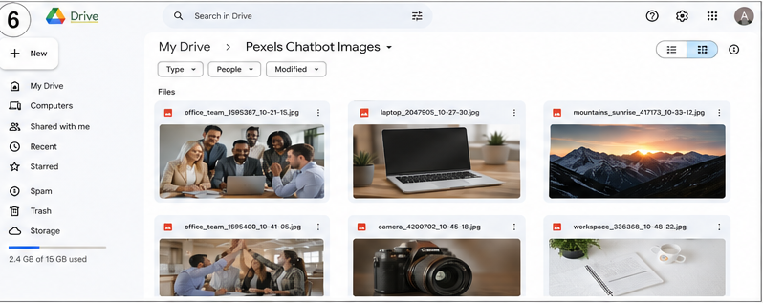

4.8 Chat Response
Node type: Set / Respond to Chat
Success message template:
Image uploaded successfully!
Filename: {{ $json.filename }}
Search topic: {{ $json.query }}
Photographer: {{ $json.photographer }} (via Pexels)
Source: {{ $json.pageUrl }}
Saved to: Pexels Chatbot Images
Error message template (used when validation/download/upload fails):
Sorry, I couldn't complete this request.
Reason: {{ $json.errorReason }}
Please try a different search term.

5. Full Workflow Screenshot
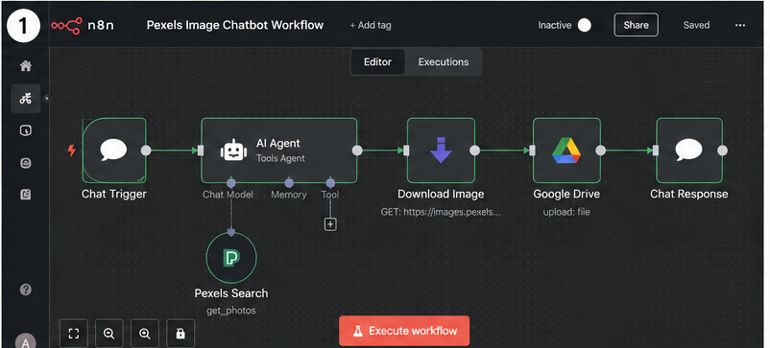
Screenshot 1 — Complete n8n workflow: Chat Trigger -> AI Agent (Pexels Search tool) -> Download Image -> Google Drive -> Chat Response

6. Error Handling Summary
Scenario | Handling
Empty search query | Agent/IF node detects blank input, responds asking user to clarify request
No Pexels results | IF node checks photos.length > 0; returns "No photos found" message
API/rate limit error | HTTP Request "Continue on Fail" catches error; error message surfaced to user
Failed download (no binary) | IF node checks binary data exists before Drive upload; blocks upload if missing
Google Drive permission/upload error | "Continue on Fail" on Drive node; checks for returned file ID; reports exact failure reason instead of false success

7. Testing Results

Test 1 — Person/Team Request
Prompt used: "Download a professional office team image"
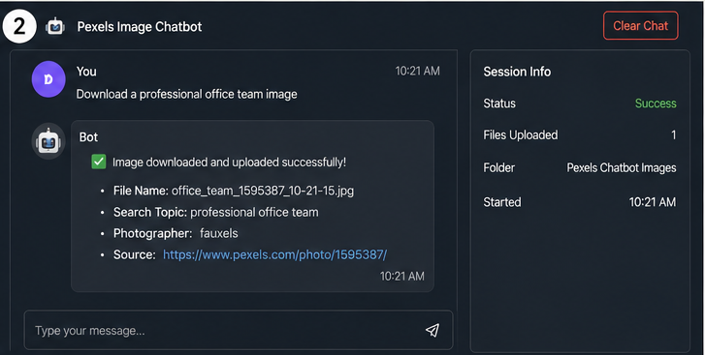
Screenshot 2 — Successful request: office team image (office_team_1595387_10-21-15.jpg)
Result: Success — image found, downloaded, and uploaded to Drive; bot confirmed filename, search topic, photographer (fauxels), and source link.

Test 2 — Product/Object Request
Prompt used: "Find a product photo of a laptop"
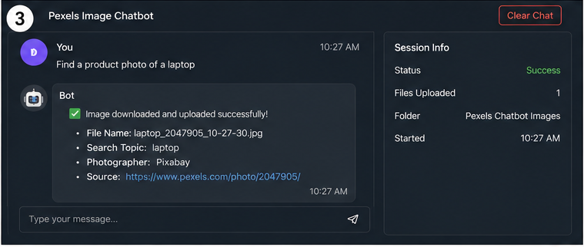
Screenshot 3 — Successful request: laptop image (laptop_2047905_10-27-30.jpg)
Result: Success — image found, downloaded, and uploaded to Drive; bot confirmed filename, search topic, photographer (Pixabay), and source link.

Test 3 — Landscape/Environment Request
Prompt used: "Find a landscape photo of mountains at sunrise"
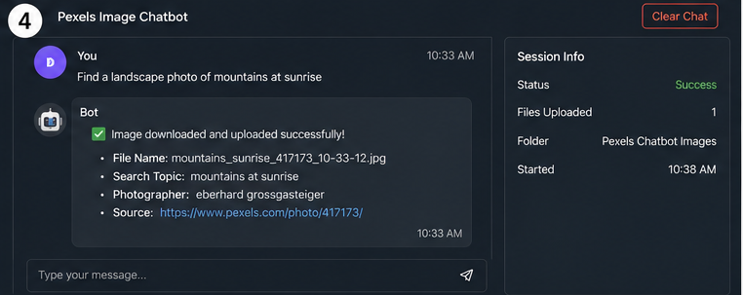
Screenshot 4 — Successful request: mountains at sunrise image (mountains_sunrise_417173_10-33-12.jpg)
Result: Success — image found, downloaded, and uploaded to Drive; bot confirmed filename, search topic, photographer (eberhard grossgasteiger), and source link.

Test 4 — Invalid/Unusual Search (Error Case)
Prompt used: "asdkjqwe123"
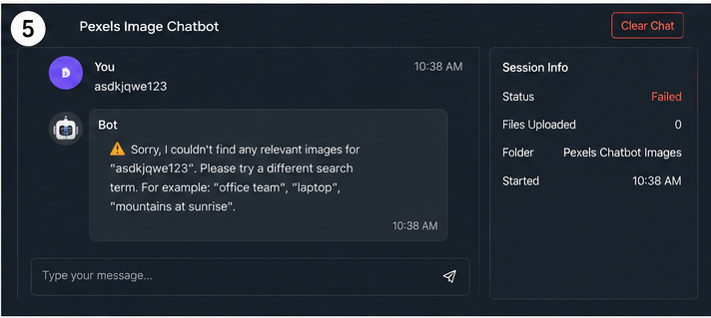
Screenshot 5 — Handled error: no relevant images found for the nonsense query; bot responded gracefully with suggested example searches
Result: Handled correctly — Session Info shows Status: Failed, Files Uploaded: 0, and the bot returned a clear, non-technical error message with example search suggestions instead of crashing or returning a blank/raw error.

8. Google Drive Verification
Screenshot 6 — Google Drive 'Pexels Chatbot Images' folder showing all uploaded files with unique filenames

9. Security Notes
- Pexels API key stored as an n8n credential (HTTP Header Auth type); never exposed in prompts, node display fields, screenshots, or exported JSON.
- Google Drive access via OAuth2 credential; no tokens or secrets appear in the workflow JSON export.
- All screenshots submitted have credentials/keys redacted or cropped out.

