Credits Link-
1. Ghost model link - https://www.cgtrader.com/items/6144230/download-page
2. Asylum: https://assetstore.unity.com/search#q=Horror%20house&firstResult=96
Demon:
https://assetstore.unity.com/packages/3d/characters/creatures/scary-evil-313024
Vodoo doll link:
https://www.turbosquid.com/3d-models/simple-burlap-pin-effigy-3d-model-1968030
Setup tutorial Video:
https://www.youtube.com/watch?v=vGZlTfZIfRo&list=PLX8u1QKl_yPD4IQhcPlkqxMt35X2COvm0&index=2&ab_channel=FistFullofShrimp
Fire Particle System Asset:
https://assetstore.unity.com/packages/vfx/particles/legacy-particle-pack-73777

Vodoo Doll whispers:
https://pixabay.com/users/freesound_community-46691455/

Fuse Box:
https://assetstore.unity.com/packages/3d/props/electrical-shield-118266
Torch:
Prefab: https://assetstore.unity.com/packages/3d/props/furniture/electric-torch-224071
Click sound: https://pixabay.com/sound-effects/search/torch%20click%20off/
Door Closing:
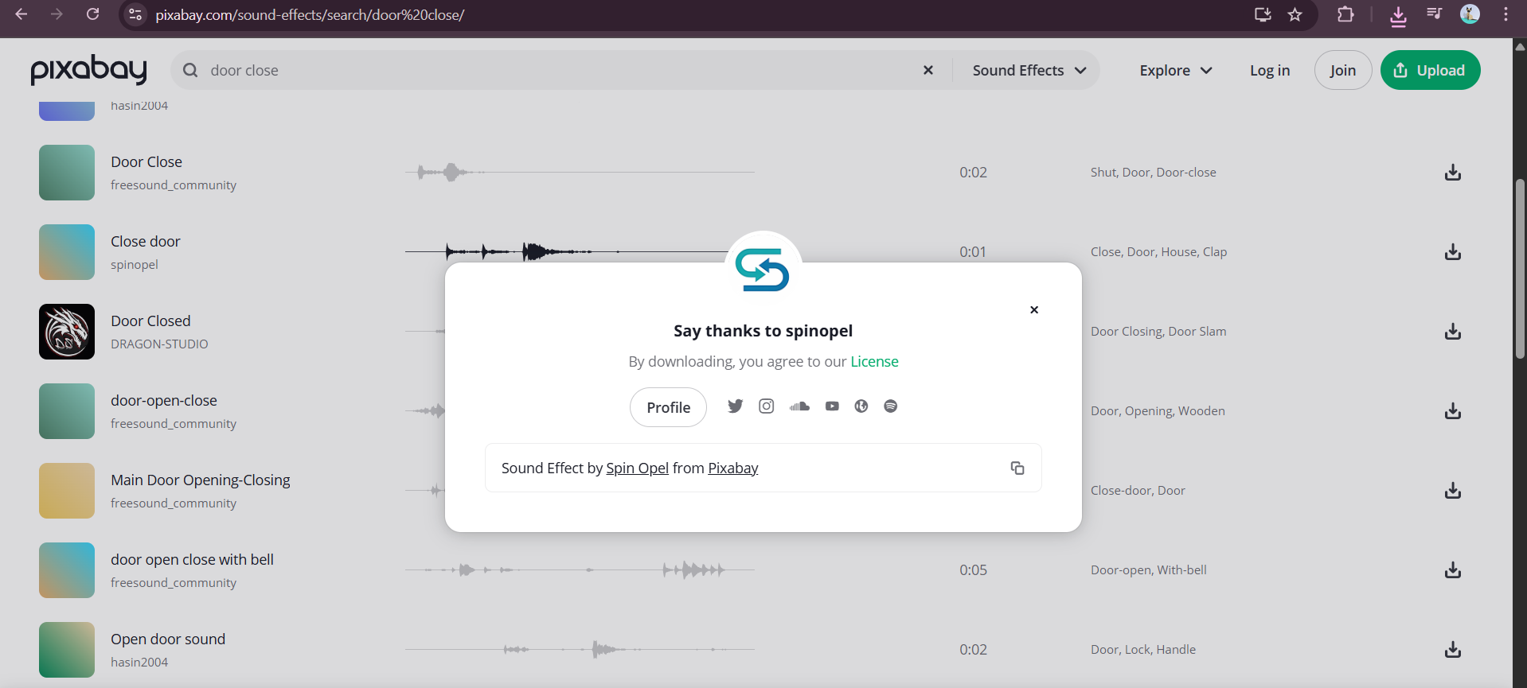
https://pixabay.com/sound-effects/search/door%20close/
Fuse Box:
https://pixabay.com/sound-effects/search/fuse%20box/
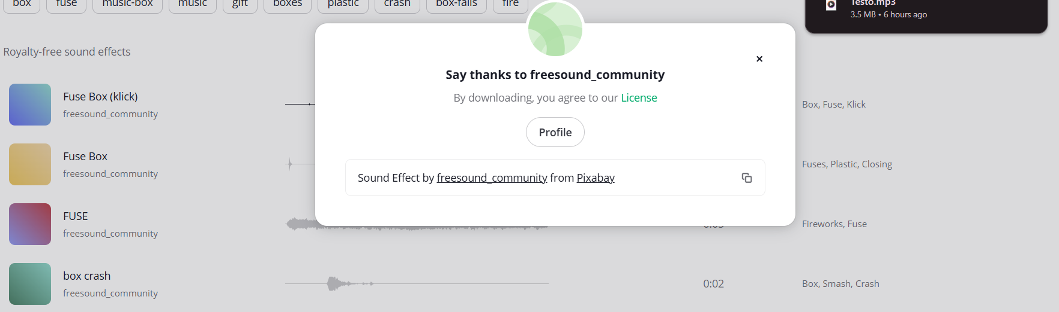
Ghost Chase sound- 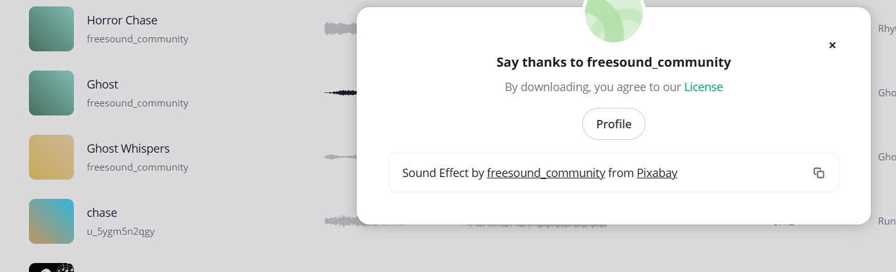
https://pixabay.com/sound-effects/search/ghost%20chase/
Ghost Whispers- 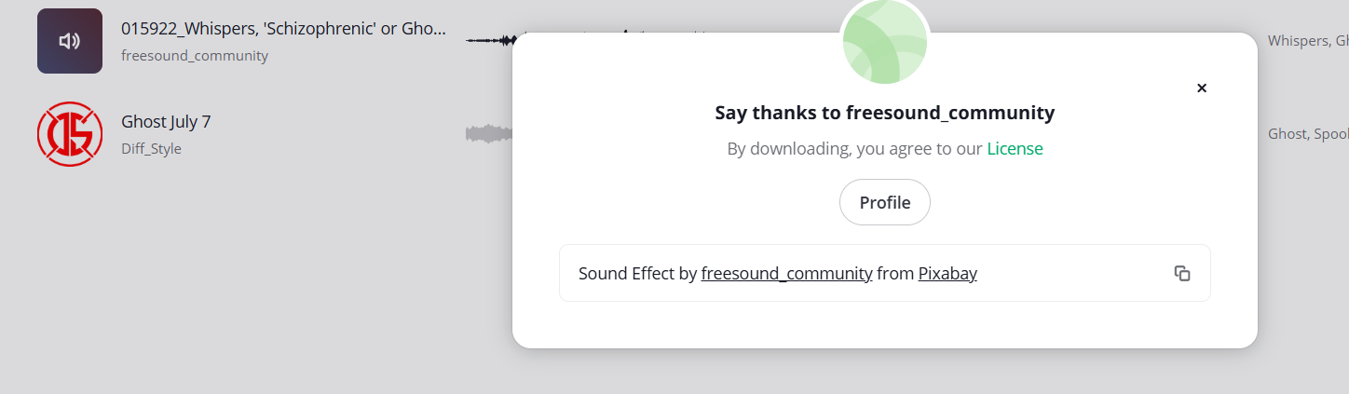
https://pixabay.com/sound-effects/search/ghost%20chase/
Ghost Singing -
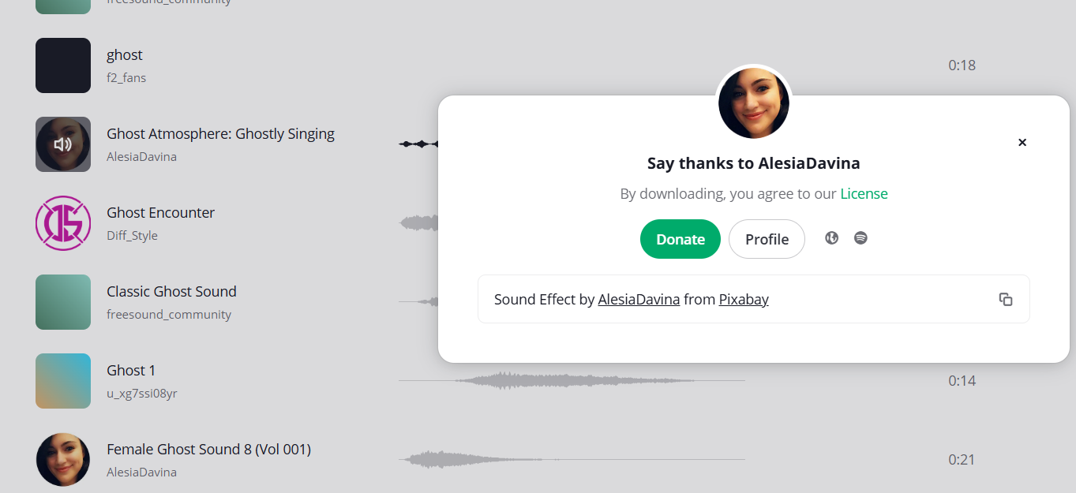
https://pixabay.com/sound-effects/search/ghost%20chase/?pagi=2
Bulb Explode-
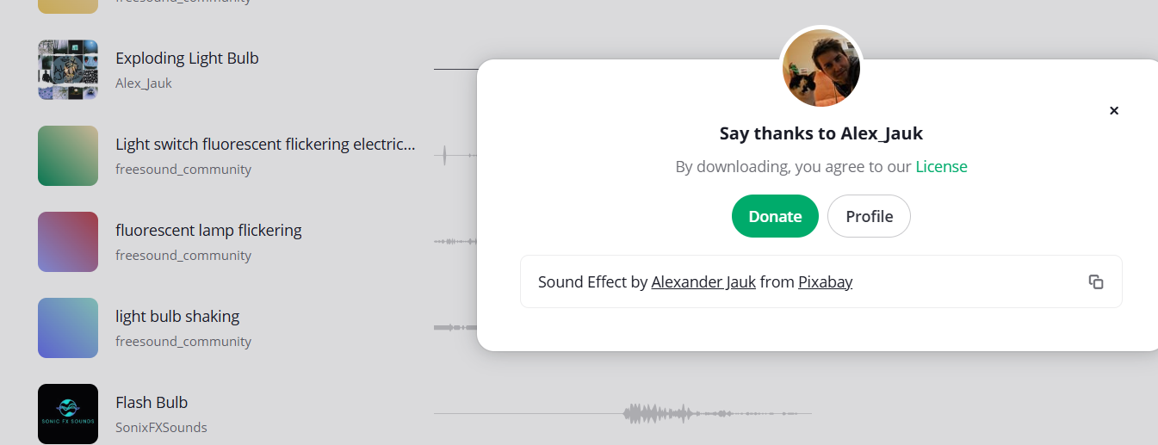
https://pixabay.com/sound-effects/search/flickering%20light%20bulb/
Hell Drums-
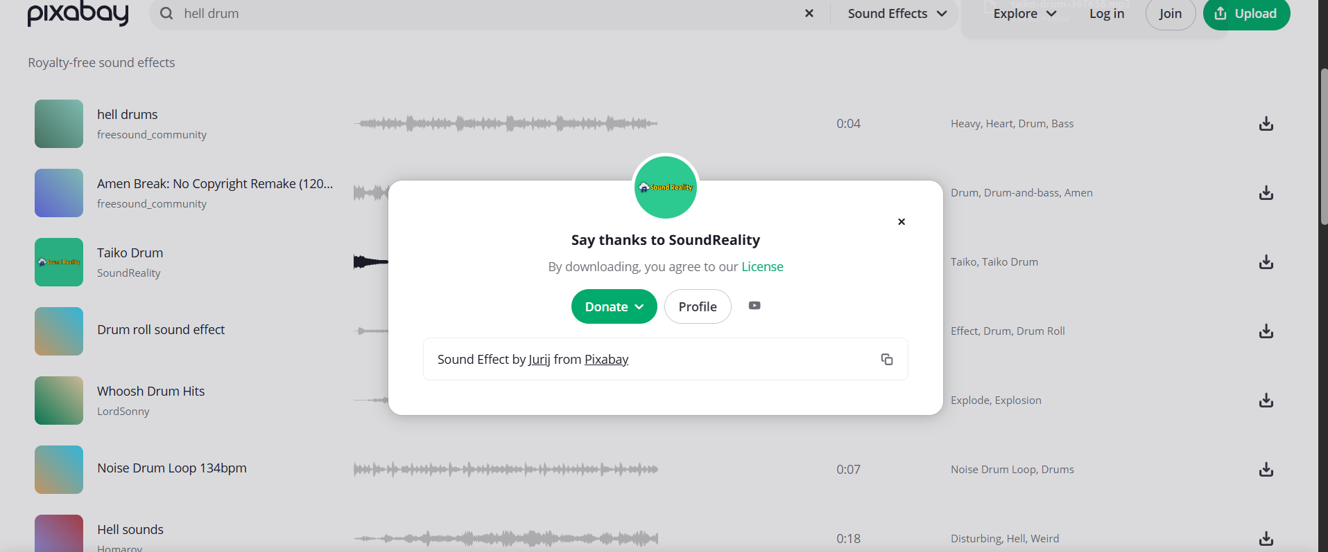
https://pixabay.com/sound-effects/search/hell%20drum/

Book:
https://assetstore.unity.com/packages/3d/props/grimoire-style-book-3996
pickup- https://pixabay.com/sound-effects/search/book%20grab/
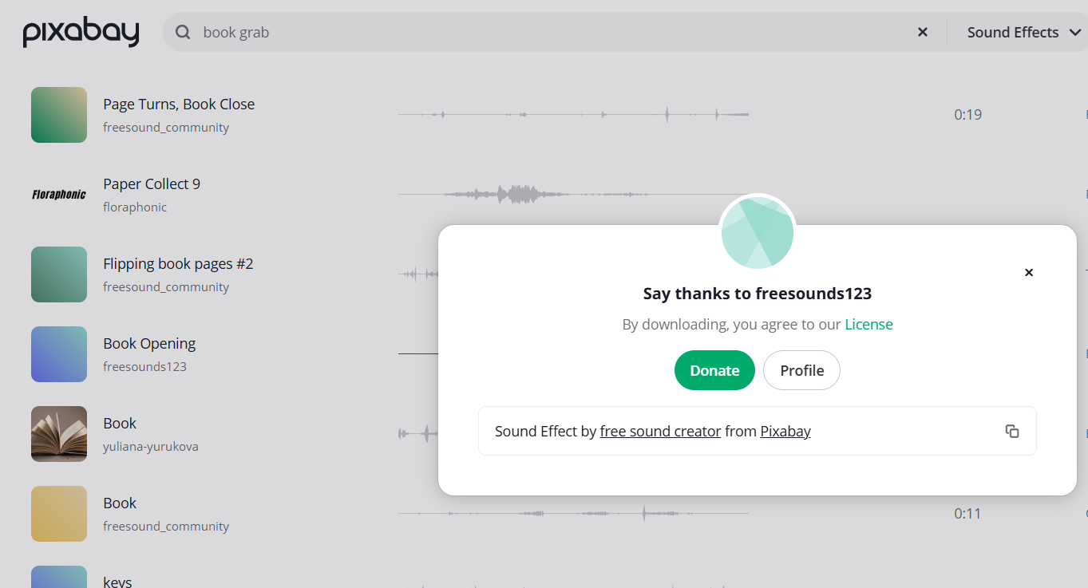
Jumpscare:
Sting sound clip: https://pixabay.com/sound-effects/search/horror%20jump%20stings/
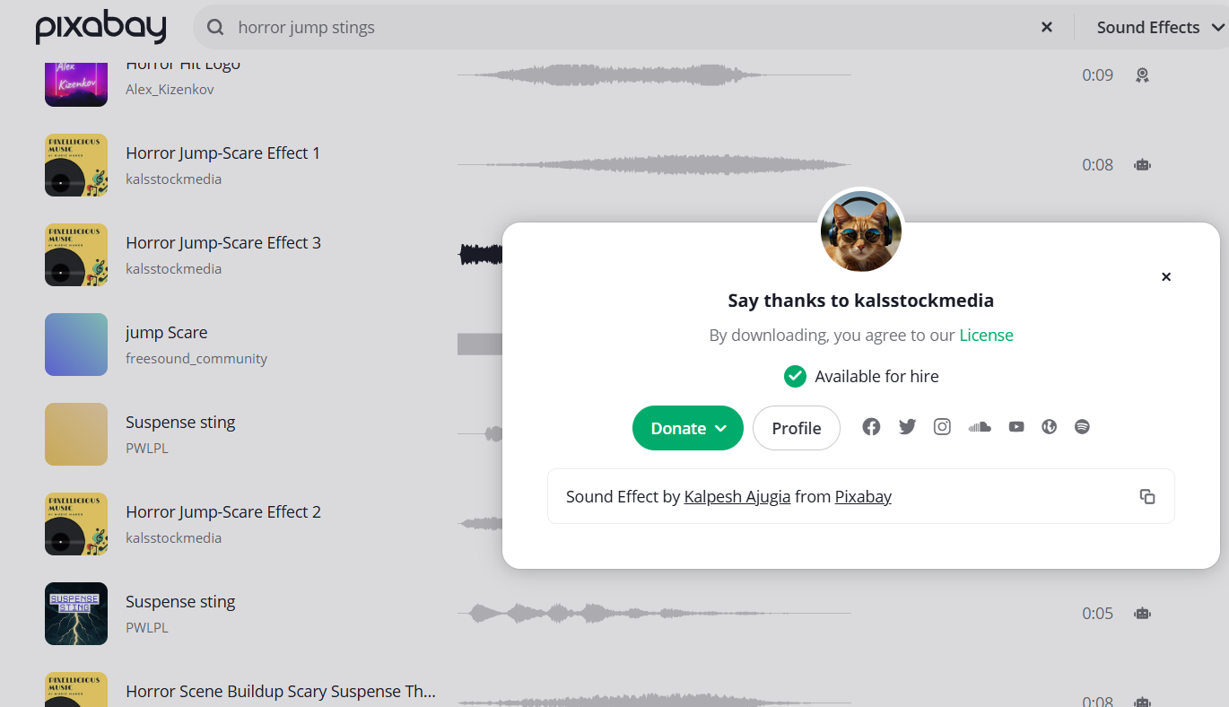
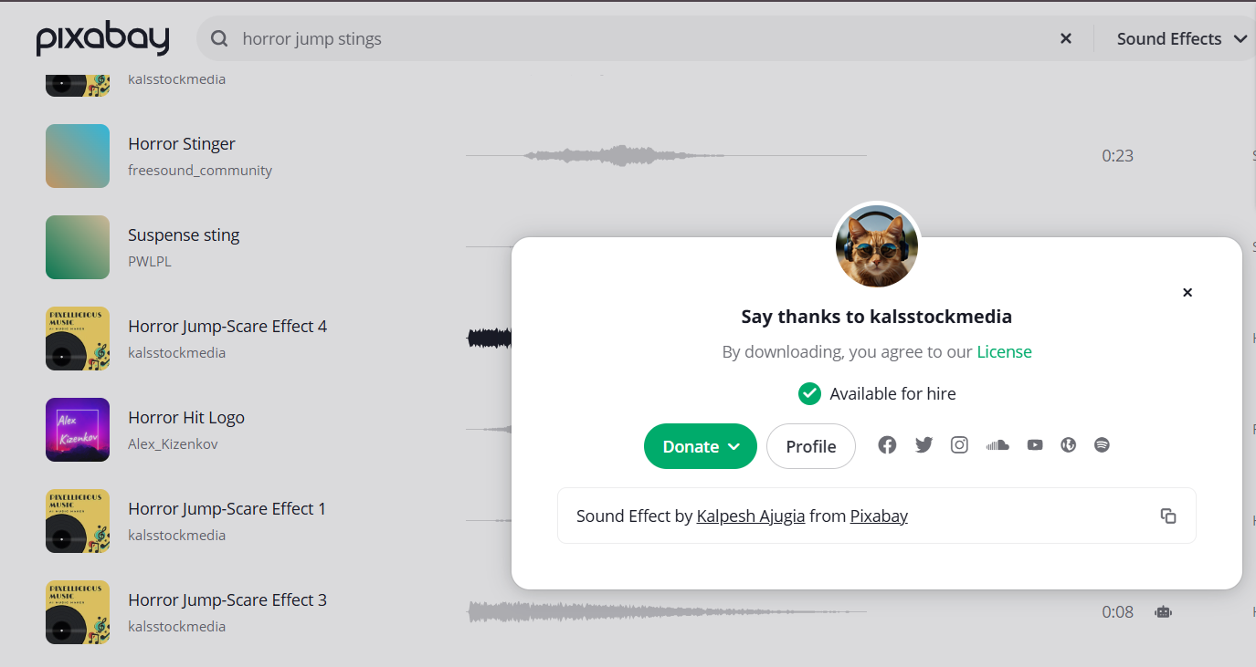
Behind you: https://pixabay.com/sound-effects/search/scary%20whispers%20behind/
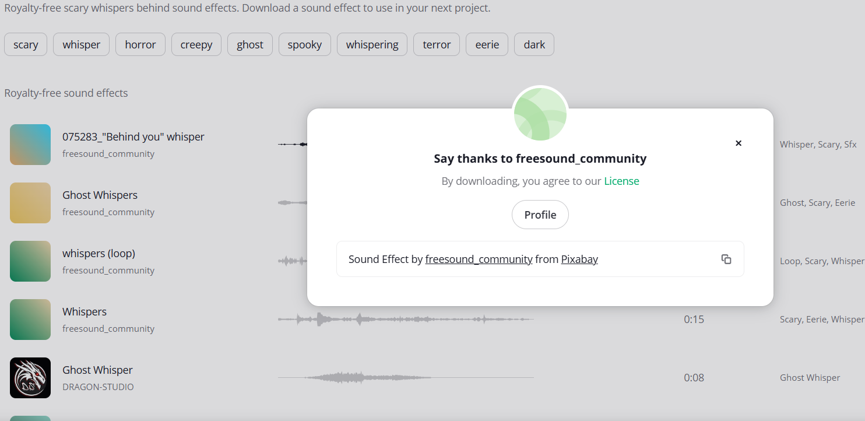

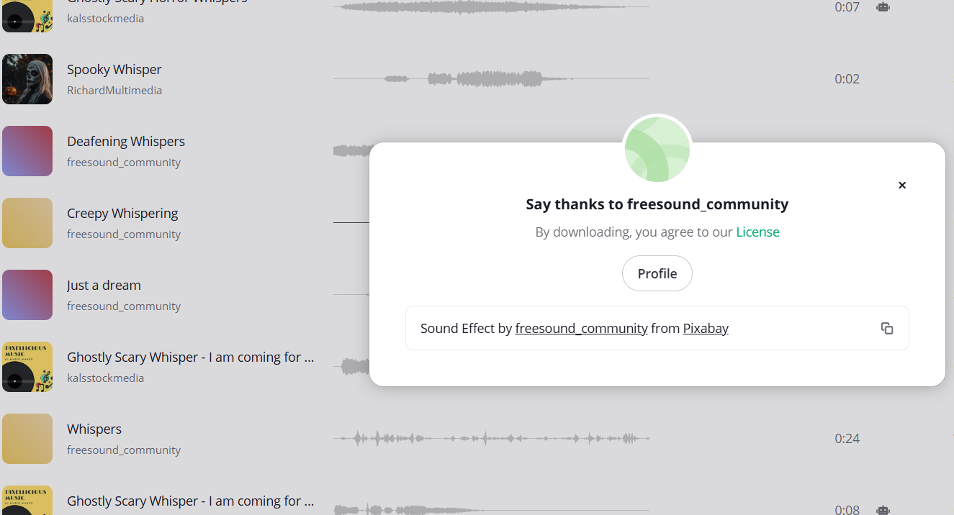
Door Slam: https://pixabay.com/sound-effects/search/door%20slam/ 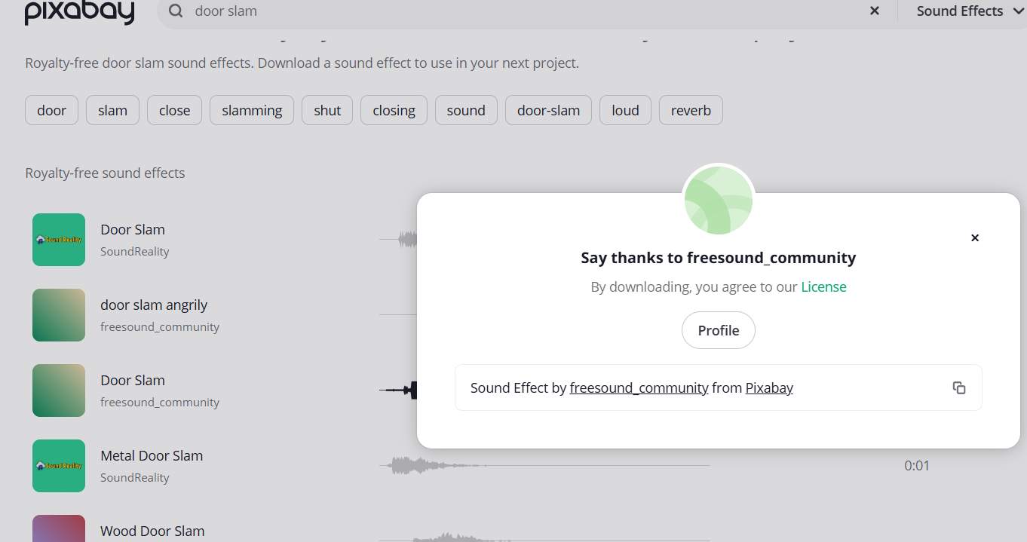

Breathing: https://pixabay.com/sound-effects/search/breathing/
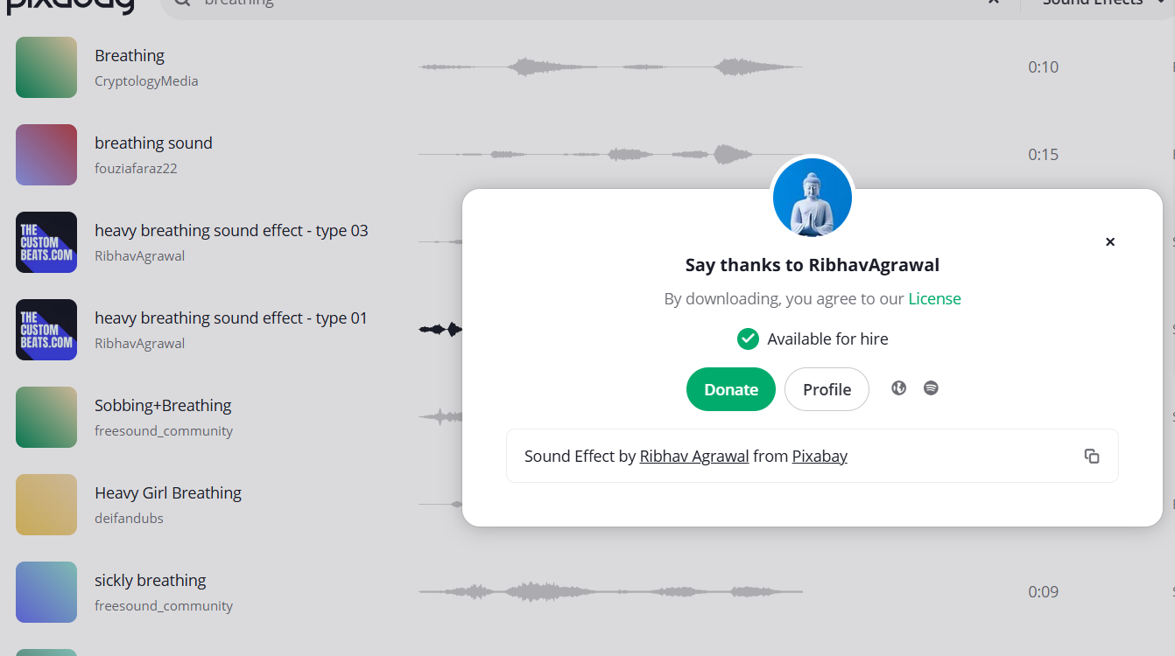

Stairs Running: https://pixabay.com/sound-effects/search/stairs%20running%20scary/?pagi=2 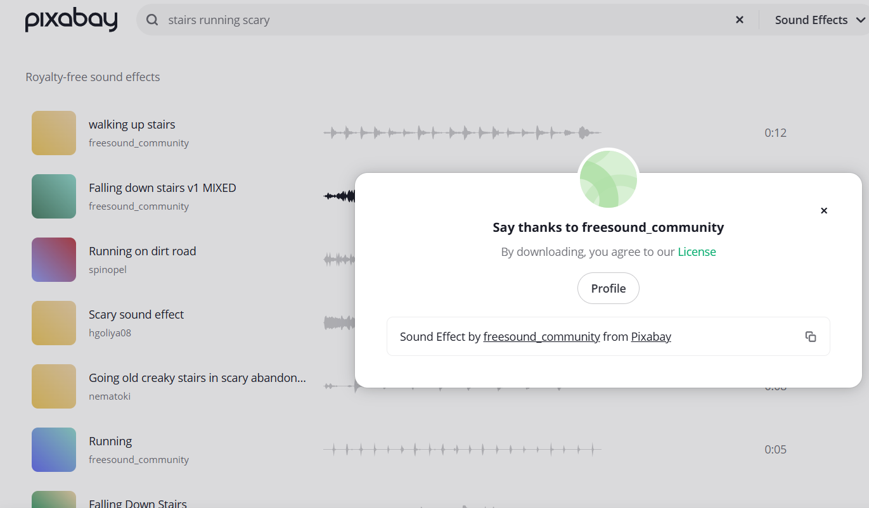

Horror Climax: https://pixabay.com/sound-effects/search/horror%20climax%20/ 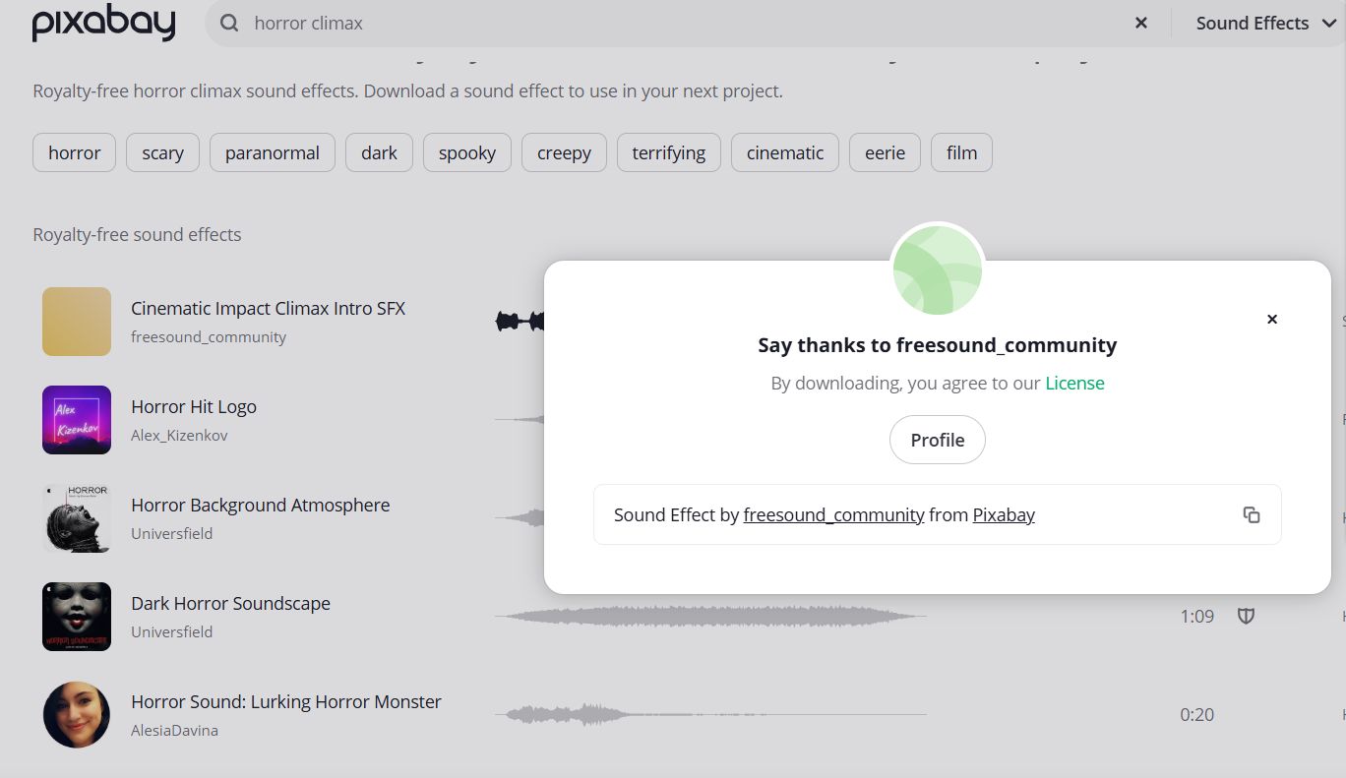

Final door open: https://pixabay.com/sound-effects/search/escape%20through%20door/ 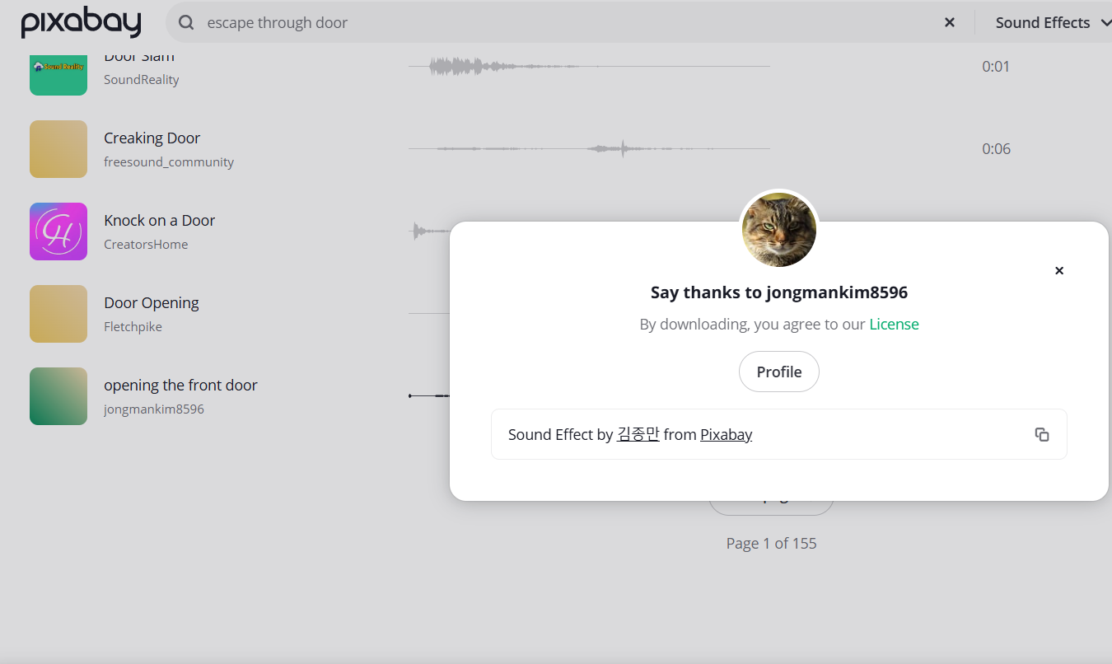
Whoosh sound- https://pixabay.com/sound-effects/search/heavenly%20sound/?pagi=2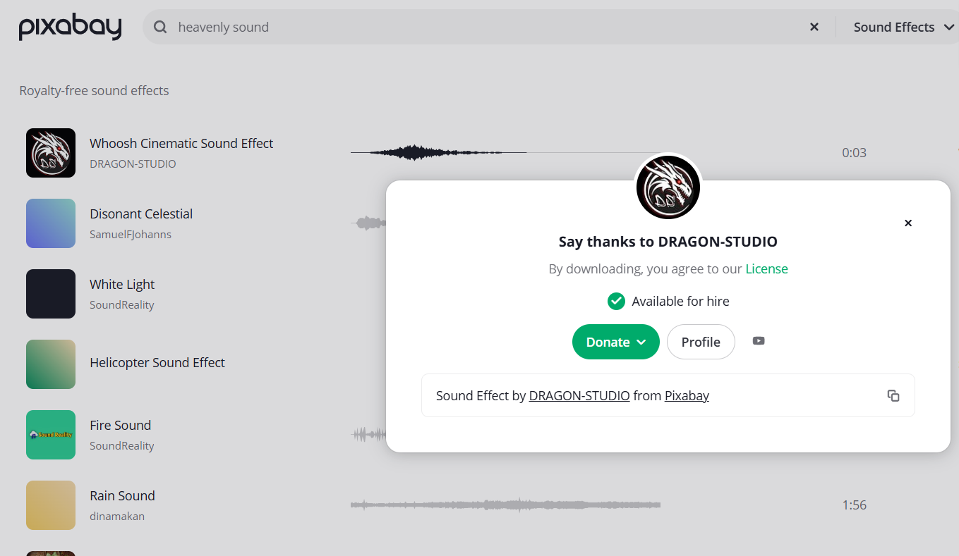
Game Over: https://pixabay.com/sound-effects/search/horror%20game%20over/
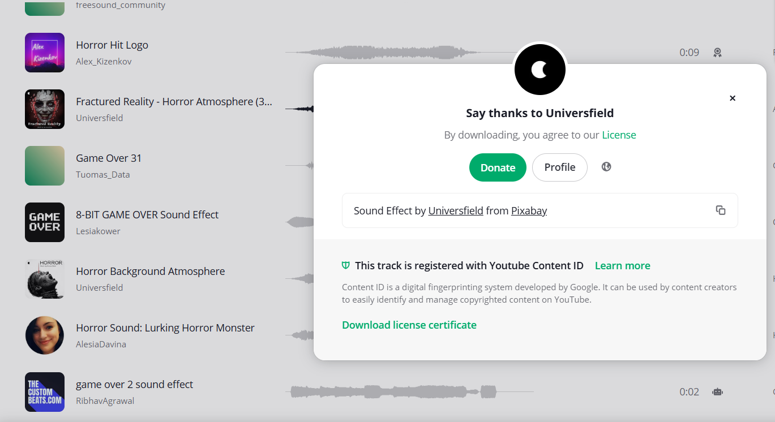

Atmosphere: https://pixabay.com/sound-effects/search/horror%20background%20music/ 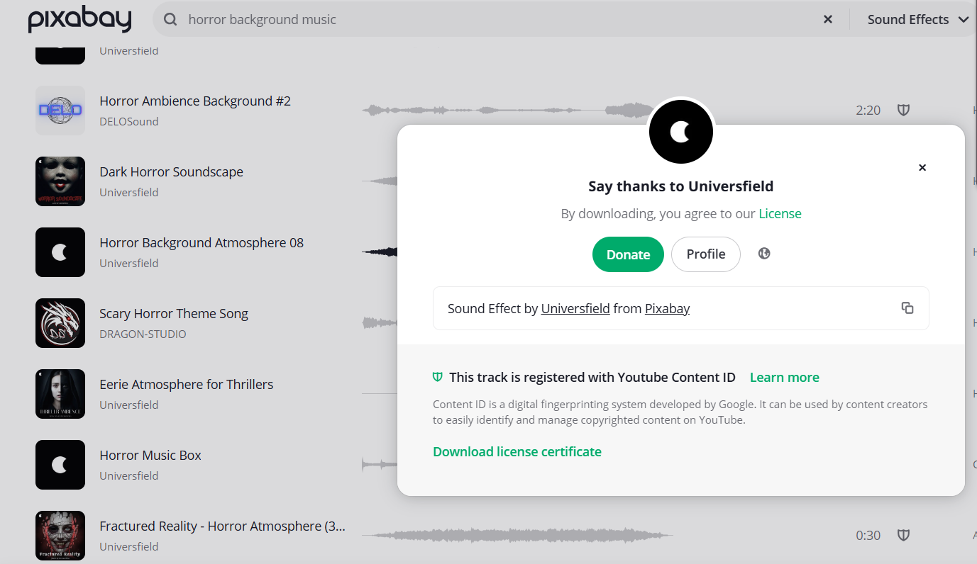
Game End: https://pixabay.com/sound-effects/search/horror%20outro/
